|  |  |
| --- | --- |
| Description: images.jpg | **H.O. : Kandhari Plaza,**  **Opp. Annapurna Temple, Indore**  **B.O. : Punjab Jewelers, M.G. Road Opp. T.I. Indore 0731- 4208853**  **B.O. : 24-B Scheme No. 71**  **Behind Ranjeet Hanuman Mandir indore** |

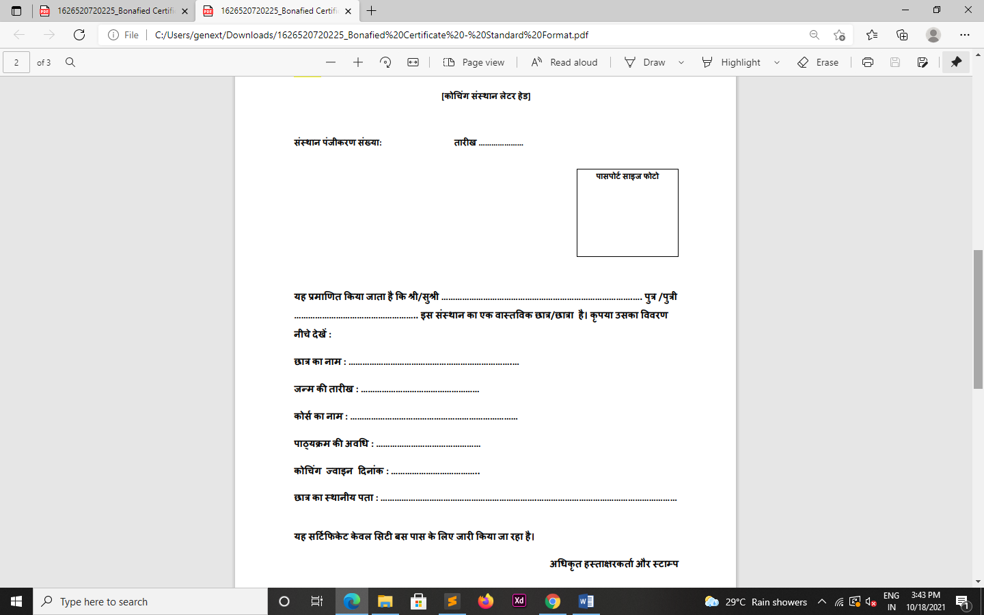

**Mubaraka Chomela**

**Mubaraka Chomela**

**Java Programming**

**437, Noorani Nagar Indore**

**8 Month**

**22-Sep-2005**

**10-Nov-2024**

**Reg.5160957255**

**Mr. Mustafa Chomela**