1. **随着我国经济的快速增长，城市交通问题日益突出，作为交通工程师，你认为应该重点解决哪些问题？请先解释“交通工程”定义。**

交通运输工程应用于交通设施的规划、功能设计、控制、管理等方面，面向各种交通方式，为乘客或商品的运输提供安全、快速、舒适、便利、经济及环保的保障。

交通工程是交通运输工程的分支，解决道路、街道、公路及其网络、站点、邻近土地的规划、几何设计及其交通运行，与其他运输方式的关系。

Transportation engineering is the application of technology and scientific principles to the planning，functional design，operation，and management of facilities for any mode of transportation in order to provide for the safe，rapid，comfortable，convenient，economical，and environmentally compatible movement of people and goods.

Traffic engineering is that phase of transportation engineering which deals with the planning, geometric design and traffic operations of roads, streets, and highways, their networks, terminals, abutting lands, and relationships with other modes of transportation.

城市交通的主要问题就是拥堵，拥堵产生的根源是交通的供需不平衡。随着经济增长，交通运输业得到了大力发展，城市道路里程数增加，道路等级提高，路网密度加大，提高了城市交通的供给能力。但随着人民物质和精神文化生活水平的提高和城镇化进程的加快，机动车保有量成倍增加，人们的出行需求也大大增加，由于交通基础设施投资大、建设周期长，人们对交通的需求超过了交通系统的供给能力，于是交通需求与交通供给之间的严重失衡。解决交通问题就是要解决交通供给与需求之间的矛盾。作为交通工程师应关心的不是要提供多少通行能力来满足需求，而是控制进入道路的交通量，通过需求管理来解决拥堵问题。所以应提高城市交通的管理水平，在合理建设道路设施的同时，要提高已有路网的运行效率，引导人们使用更有利于路网畅通的交通方式，应重点需要解决以下几个问题：

1. 城市道路等级分配不合理，道路功能与等级不一致，路网中存在断头路；
2. 公共交通设施建设不完善，服务水平低，公共交通分担比例小；
3. 步行、自行车、公共交通运行环境未得到明显改善；
4. 机动车和非机动车的停车问题；
5. 城市交通设施设计、设置方面存在很多不合理的现象和安全隐患。
6. **根据下图，请解释在信号交叉口延误分析时用到的下列名词的含义：**
   1. Stopped-time delay;
   2. Approach delay;
   3. Travel time delay;
   4. Time-in queue delay;

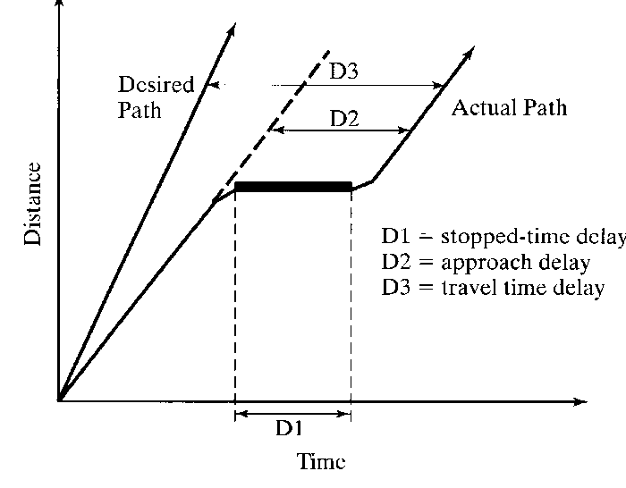

1. Stopped-time delay: stopped-time delay is defined as the time a vehicle is stopped in queue while waiting to pass through the intersection;
2. Approach delay: approach delay includes stopped-time delay but adds the time loss due to deceleration from the approach speed to stop and the time loss due to reacceleration back to the desired speed.
3. Travel time delay: It is the deference between the driver’s expected time through the intersection or any roadway segment and the actual time taken.
4. Time-in queue delay: The time between a vehicle joining the end of a queue at a signalized or STOP-controlled intersection and the time it crosses the STOP line to proceed through the intersection.
5. 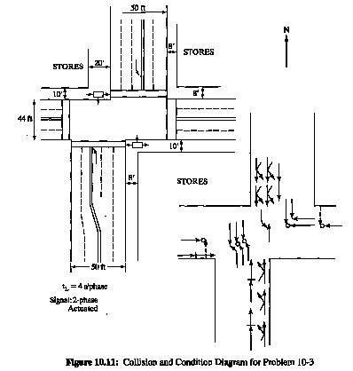**请看下图，图中表示某一交叉口碰撞及周边环境图，请你给出可能产生交通事故的主要原因，提出改善措施并在图中表示出来。**

该图中的交叉口为错位交叉口，在一定情况下，错位交叉口可以看作是两个T型交叉口的连接。当两个T型交叉口之间的间距足够长时，是有利于减少冲突，提高交通安全性的。但是假如错位道路上有大量直行车辆，并且因为转弯车辆运动发生大量碰撞，并且两个T型路口之间间距过短，则会使冲突数增加，冲突区范围扩大，从而导致增加延误，使交通安全性下降。

* 该错位交叉口南北向的直行车道位置是面对面的，在上游假如没有必要的交通标示标志牌，很容易使得车辆如闯入对向车道，导致迎面碰撞的产生。
* 信号控制有严重的交通隐患。由于南北向路口都没有采用禁左等交通控制信号，而是类似十字交叉路口的左直右均有信号的控制方法，会使得南北向直行与左转之间的冲突增加，增大发生交通事故的几率。
* 地面缺少相应的标志标线，如转向线、导流线、渠化线等。
* 错位交叉口南北向机动车入口直接对上了行人与非机动车道，并且缺少必要的非机动车道路使用者的交通设施。
* 视距不足，两边建筑物阻挡了南北向直行车辆驾驶员的视线。

改善方法有：

* 建议采用两套具有线空功能的交通控制信号，使南北向直行车流采用偏移直行的方法，先右转再直行。
* 考虑是否可以取消左转，采用禁左的交通管理措施。或者也可以给南北向车流专有的左转信号，减少与对向直行车流之间的冲突。
* 在交叉口功能区范围内，增加必要的交通标示标线，做好交叉口的渠化。
* 在每条道路的上游，设立必要的交通指示标志，告知驾驶员以及其他道路使用者前方交叉口的信息，明确路权。
* 设立必要的交通安全措施，减少机动车与非机动车、机动车与行人之间的交通冲突，使非机动车、行人与机动车之间尽量实现物理上的隔离和时间上的隔离。假如行人与非机动车过多，可以考虑给非机动车与行人专有的信号，或者设置过街天桥与过街地下通道等。
* 在允许的情况下，这样的错位交叉口应该整合为一个十字交叉口，以达到减少冲突，提高交通安全的目的。

1. **由于前方有个弯道，车辆必须从110km/h减到70km/h，警告标志能被看到的距离是30m，求该警告标志应设立在离曲线起点多远的地方才能保证车辆安全减速？假定F=0.30，反应时间取2秒。**

Analysis： 

where：d =total stopping distance, m;

Si=initial speed, km/h;

Sj=final speed, km/h;

t=reaction time, s;

F=coefficient of forward rolling or skidding friction;

G=grade, %.



Visibility distance=30m

So, Advance distance=155.60-30=125.60m.

1. **下列OD调查表是从5个OD调查点通过车牌抽样获得的，请依据全样起终点车辆调查数据将该OD进行扩样**。

|  |  |  |  |  |  |  |
| --- | --- | --- | --- | --- | --- | --- |
| Initial original and destination mutches from sample license-plate observations | | | | | | |
| Destination station | Origin station | | | | | Total destination  Count(vehs) |
| 1 | 2 | 3 | 4 | 5 |
| 1 | 50 | 120 | 125 | 210 | 75 | 1200 |
| 2 | 105 | 80 | 143 | 305 | 100 | 2040 |
| 3 | 125 | 100 | 128 | 328 | 98 | 1500 |
| 4 | 82 | 70 | 100 | 125 | 101 | 985 |
| 5 | 201 | 215 | 180 | 208 | 210 | 2690 |
| Total origin  Count(vehs) | 1820 | 1225 | 1750 | 2510 | 1110 | 8415 |

1. **请看下图，图中表示某一小区交通存在的问题，请你根据这些问题给出解决方案，可在图上画出并用文字描述。**
2. 在学校门口设置Closures（封闭）避免交通对学生出行的影响或Speed Tables（减速装置）、Neighborhood Traffic Cycle（环岛）, Chokers（变窄）, Chicanes（弯曲）降低车速，同时方便学生过街。
3. 对于使用支路和街区道路作为通过性交通设施的情况，可以在某些道路上设置Closures（Full、Partial）、Diverters(Semi、Diagonal)等。
4. 在Broad Street上设置Median Barriers，这样禁止左转进入街区以及直接在两个街区之间出去。
5. 在有很大的停车需求的地方，可以设置单行线，以为路边停车提供空间，在相邻的道路上设置禁止停车标志。
6. 对交通事故多发点，可以设置Neighborhood Traffic Cycle（交通岛）或者Roundabout（大环岛，渠化）。
7. 设置Speed Tables或Speed Humps（速度阻碍）降低车速。
8. No Right Turn Signs prevent use of shortcut

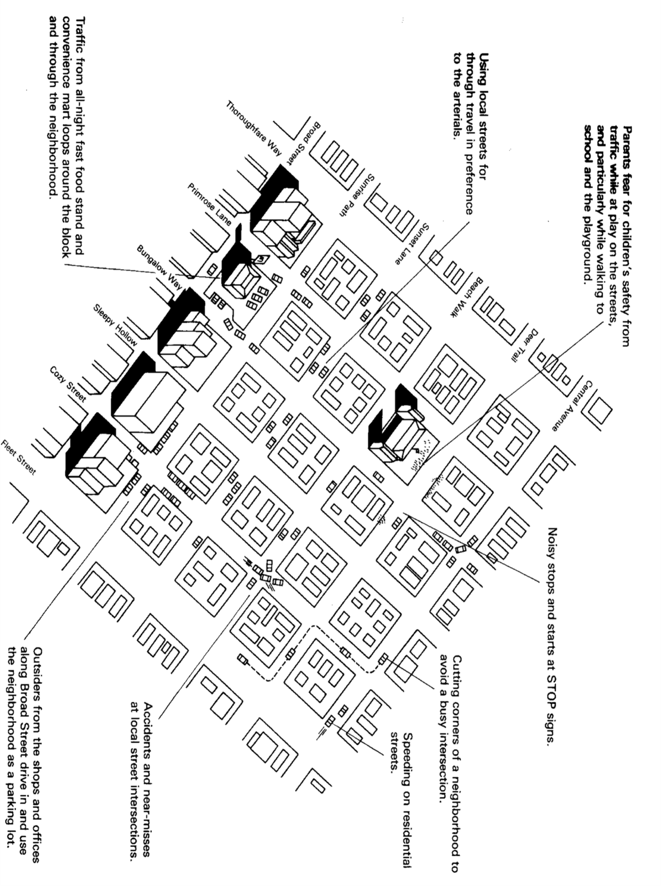

名词解释：

**饱和车头时距saturation headway**道路流量达到通行能力时，同向行驶的一列车队中，相邻两辆车的车头之间的时间间隔

**饱和流率saturation flow rate**假定引道在全绿灯条件下，即绿信比为1.0的情况下，所能通过的最大流量

**启动损失时间start-up lost time**

**保护型左转相位protected left turns.** A “protected” left turn movement is made without an opposing vehicular flow. The signal plan protects left-turning vehicles by stopping the opposing through movement. This requires that the left turns and the opposing through flow be accommodated in separate signal phases and leads to multiphase (more than two) signalization. In some cases, left turns are “protected” by geometry or regulation.

**许可性左转相位permitted left turns.** A “permitted left turn movement is one that is made across an opposing flow of vehicles. The driver is permitted to cross through the opposing flow but must select an appropriate gap in the opposing traffic stream through which to turn.

**二路停车控制two-way stop control**

**半感应式信号控制semi-actuated control.** In semi-actuated operation, detectors are placed on the minor approach(es) to the intersection; there are no detectors on the major street. The light is green for the major street at all times except when a “call” or actuation is noted on one of the minor approaches. Then, subject to limitation such as a minimum major-street green, the green is transferred to the minor street. The green returns to the major street when the maximum minor-street green is reached or when the detector senses there is no further demand on the minor street.

**服务水平LOS**. Level of service is a quality measure describing operational conditions within a traffic stream, generally in terms of such service measures as speed and travel time, freedom to maneuver, traffic interruptions, and comfort and convenience.

**服务流率service flow rates.** A SF rate is defined as the maximum rate of flow that can be reasonably expected on a lane or roadway under prevailing roadway, traffic, and control conditions while maintaining a particular level of service.

**双车道公路超车视距passing sight distance on rural two-lane highways** is the minimum sight distance required to safely begin and complete a passing maneuver on two-lane highways.

**行程延误**：车辆通过某一路段的实际时间与计算时间之差。计算时间为车辆在交通不拥挤的条件下以畅行车速通过该路段的时间。

**停车延误：**指刹住车轮及车辆停止不动的时间，等于停车时间，其中包括车辆由停车到起动时驾驶员的反应时间。

**时间平均速度(time mean speed)和空间平均速度(space mean speed)是如何定义的？试证明时间平均速度≥空间平均速度，两者何时相等？**

在单位时间内测得通过道路某断面各合理的地点车速，这些速度的算术平均值即为该断面的时间平均速度。

$$\overline{V_{t}}=\frac{1}{n}\sum_{i=1}^{n}{V_{i}}$$

在某一特定瞬间，行驶于道路某一特定长度内的全部车辆的车速分布的平均值，当观测长度一定时，其值为地点车速观测值的调和平均值

$$\overline{V_{s}}=\frac{1}{\frac{1}{n}\sum_{i=1}^{n}{\frac{1}{V_{i}}}}=\frac{ns}{\sum_{i=1}^{n}{t_{i}}}$$

由时间平均车速可以推算空间平均速度，反之亦可：

$$\overline{V_{s}}=\overline{V_{t}}-\frac{σ_{t}^{2}}{{\overline{V}}_{t}}$$

$$\overline{V_{t}}=\overline{V_{s}}+\frac{σ_{s}^{2}}{{\overline{V}}_{s}}$$

$σ_{t}$——时间平均车速观测值的均方差。

$σ_{s}$——空间平均车速观测值的均方差。

所以时间平均速度≥空间平均速度，且当 $σ_{t}=0$ 或 $σ_{s}=0$ 时，两者相等，即等速行驶时。

**度量交通事故死亡率的指标有哪些？何种指标更合理？为什么？**

* Population-based rates：

Fatalities per 100,000 area population

Per 10,000 registered vehicles

Per 10,000 licensed drivers

Per 1,000 miles of highway

These values are relatively static (they do not change radically over short periods of time) and do not depend on vehicle usage or the total amount of travel. They are useful in quantifying overall risk to individuals on a comparative basis. Number of registered vehicles and licensed drivers may also partially reflect usage.

* Exposure-based rates：

Per 100,000,000 vehicle-miles traveled

Per 10,000,000 vehicle-hours traveled

The two can vary widely depending on the speed of travel, and comparisons based on mileage can yield different insights from those based on hours of exposure. For point locations, such as intersections, vehicle-miles or vehicle-hours have very little significance. Exposure rates for such cases are “event-based” using total volume passing through the point to define “events.”

True “exposure” to risk involves a great deal more than just time or mileage. Exposure to vehicular or other conflicts that are susceptible to accident occurrence varies with many factors, including volume levels, roadside activity, intersection frequency, degree of access control, alignment and many others. Data requirements make it difficult to quantify all of these factors in defining exposure. The traffic engineer should be cognizant of these and other factors when interpreting exposure-based accident rates.

Per 1,000,000 entering vehicles

十万人口死亡率，每十万车死亡率，每十万驾驶员死亡率，每千英里公路死亡率，每亿车英里死亡率，每千万车小时死亡率，每百万进入交叉口车辆死亡率

**从交通安全和运营两个方面阐述下图一个十字交叉口改建为两个T型交叉口的特点。**

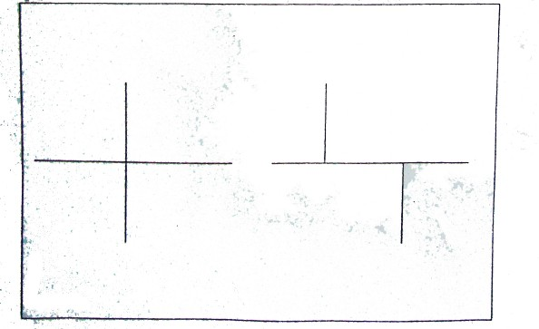P450如果两个T型交叉口的距离太近，该交叉口就变成错位交叉口，图中为向左错位交叉口。The left-turn interaction with the opposing through flow is not as critical. The pedestrian-right-turn interaction is serious. The left-turn trajectory through the offset intersection is quite different from an aligned intersection, but the left-turn movement does not thrust the vehicle immediately into the path of the oncoming through movement. Sideswipe accidents are a risk, and extended lane markings would be used to minimize this risk. Where the intersection is signalized, the left-turn conflict can be eliminated through the use of protected left-turn phase in the direction of the offset. This requires, however, that one of the existing lane be designated an exclusive turning lane or that a left-turn lane can be added to each offset leg. If this is not possible, a more extreme remedy is to provide each of the offset legs with an exclusive signal phase. Although this separates the left-turning vehicles from the opposing flows, it is an inefficient signal plan and can lead to four-phase signalization if left-turn phases are needed on the aligned arterial. At a left-offset intersection, the diagonal pedestrian path is more difficult because it brings the pedestrian into immediate conflict with right-turning vehicles more quickly than at an aligned intersection. For this reason, diagonal crossings are generally not recommended at left-offset intersections. The signing, marking, and signalization of perpendicular pedestrian crossing is similar to that at right-offset intersection.

When at all possible, offset intersections should be avoided.

如果两个T型交叉口距离较远，东西向直行车流与南北向转向车流直接的交叉冲突分离，若要在不能提供专用左转车道的情况下，消除两者直接的冲突，不用采取四相位的信号，提高了交叉口的运行效率。同时也没有增加行人过街的安全隐患。