Project Name: Mortgage_Process_IND_Project

(This doc includes screenshots of key components)

Contents

Whole Project flow: 2

Validation rule: 3

Mortgage decision table: 4

Mortgage inlimit MR calculation: 5

Mortgage InLimit value set MR decision table: 6

# Whole Project flow:

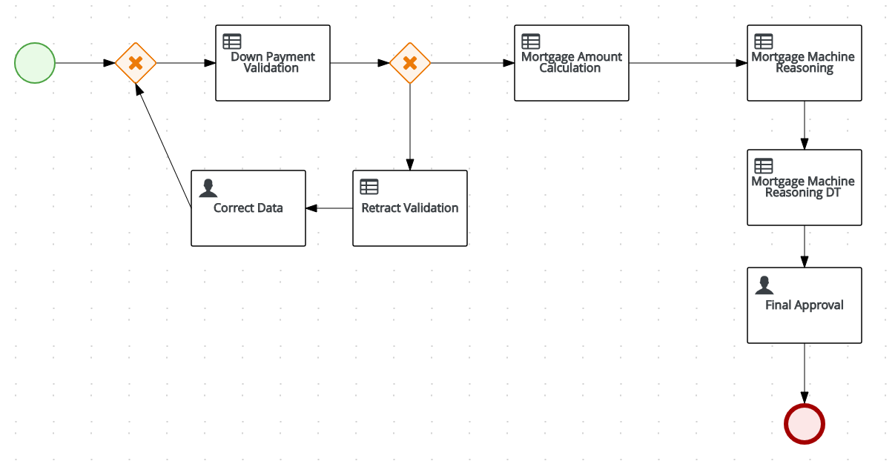

# Validation rule:

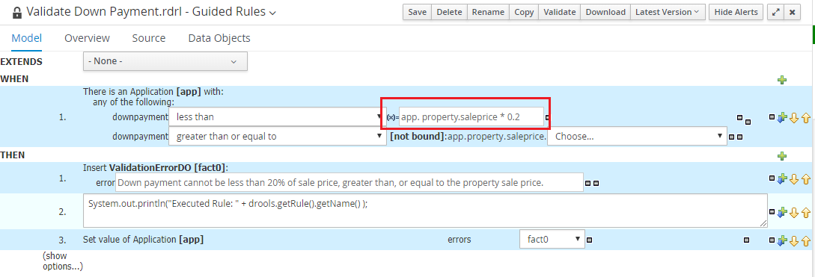

# Mortgage decision table:

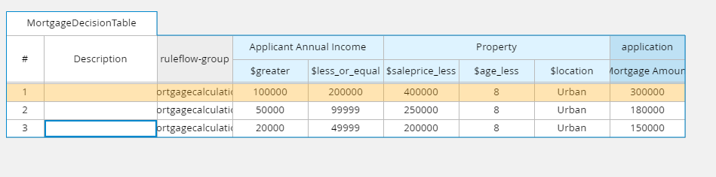

# Mortgage inlimit MR calculation:

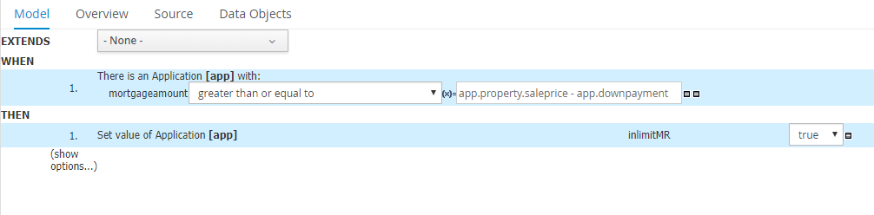

# Mortgage InLimit value set MR decision table:

