Project Name: Mortgage_Process_IND_Project

(Project verification steps are included in this document)

Contents

Verify Down Payment Validation and InLimitMR true 2

Input an application 2

Check Process Flow 3

Check error message: 4

Correct input: 5

Check instance flow: 6

Check inLimitMR value 7

Complete the mortgage flow: 8

Verify InLimitMR false 9

Input an application 9

Check process flow: 10

Check InLimitMR value: 11

Complete the mortgage flow: 12

# Verify Down Payment Validation and InLimitMR true

## Input an application

Down payment less than 20% of sale price, but applicant with a job.

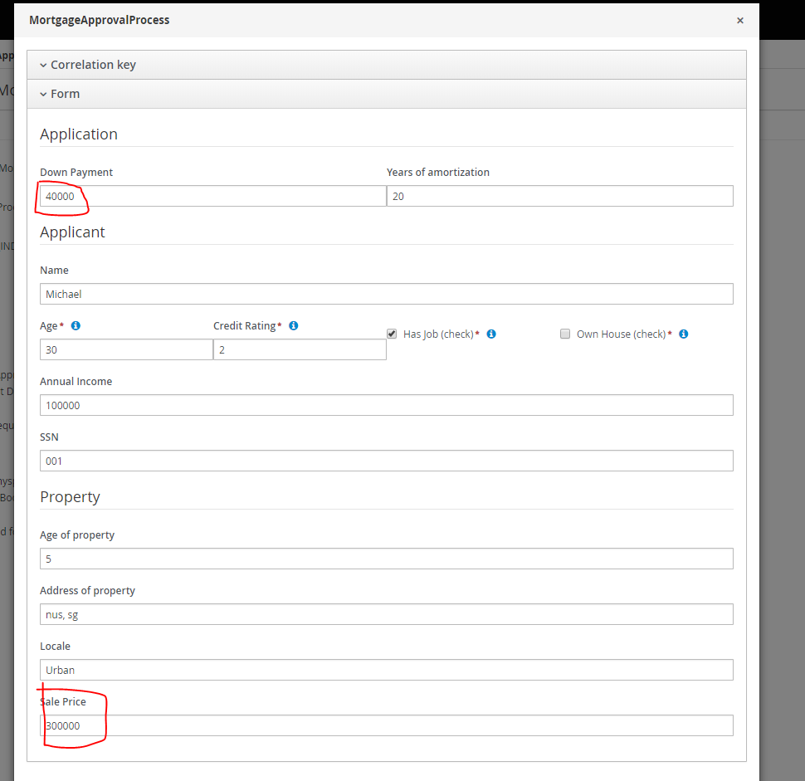

## Check Process Flow

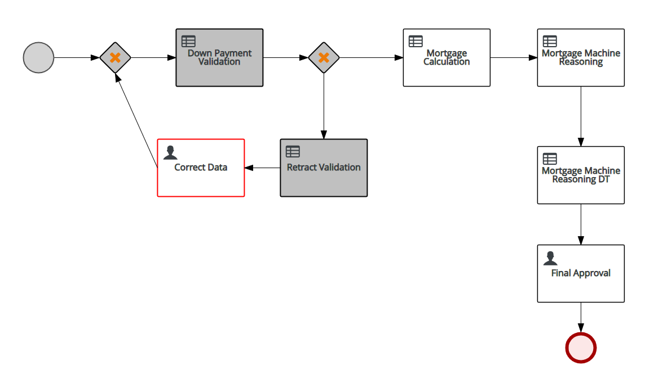

## Check error message:

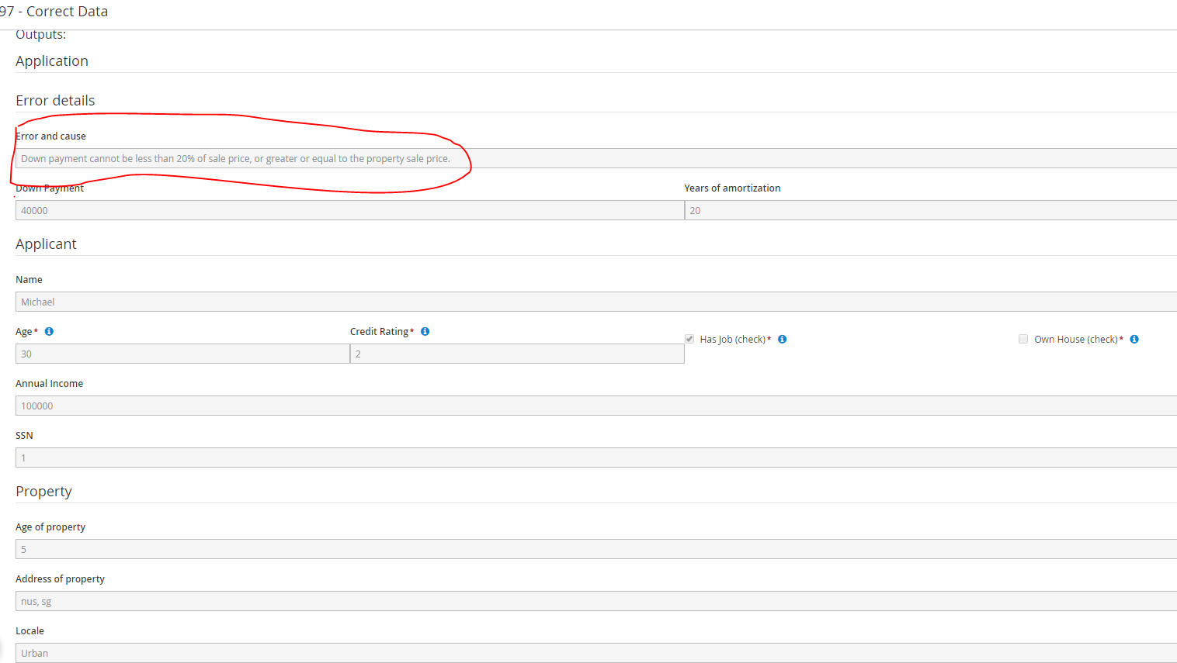

## Correct input:

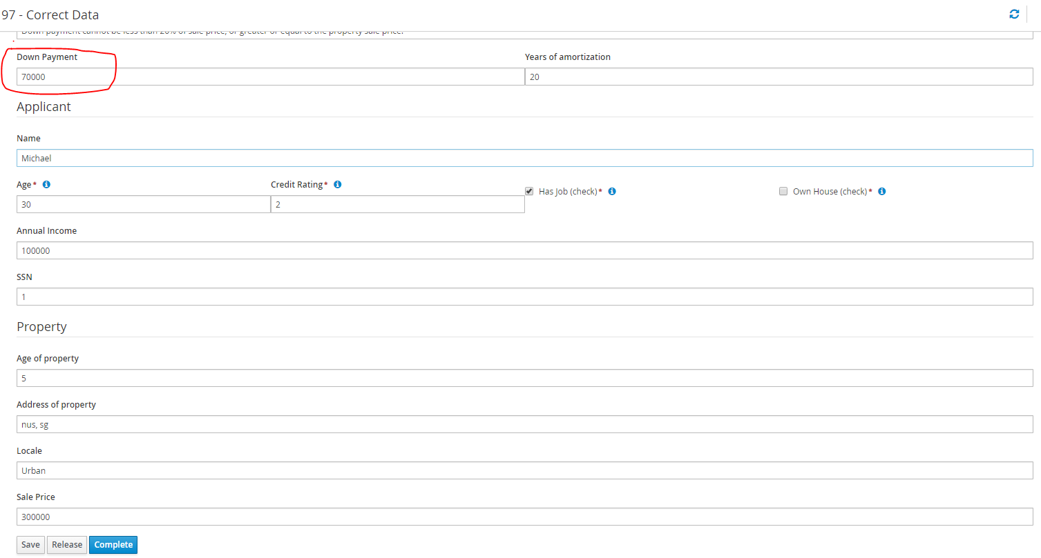

## Check instance flow:

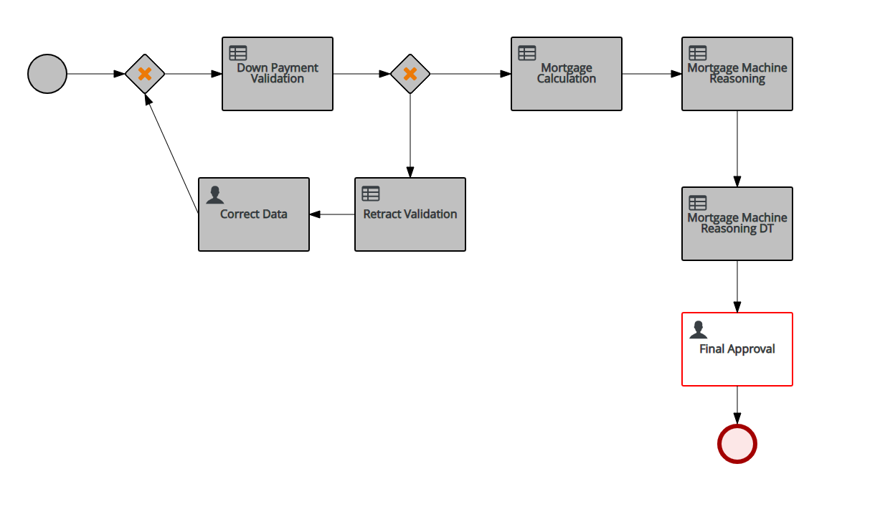

## Check inLimitMR value

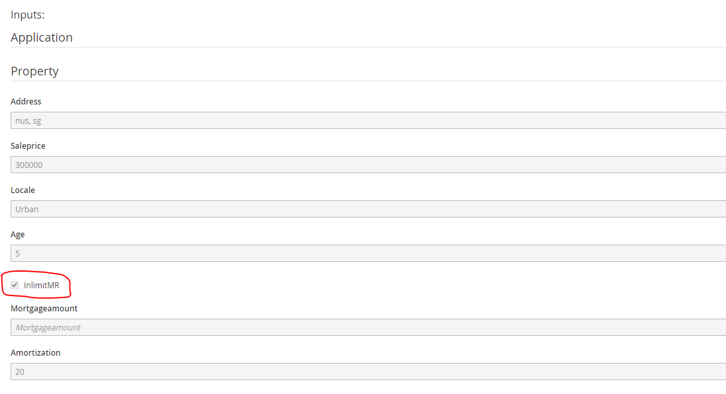

## Complete the mortgage flow:

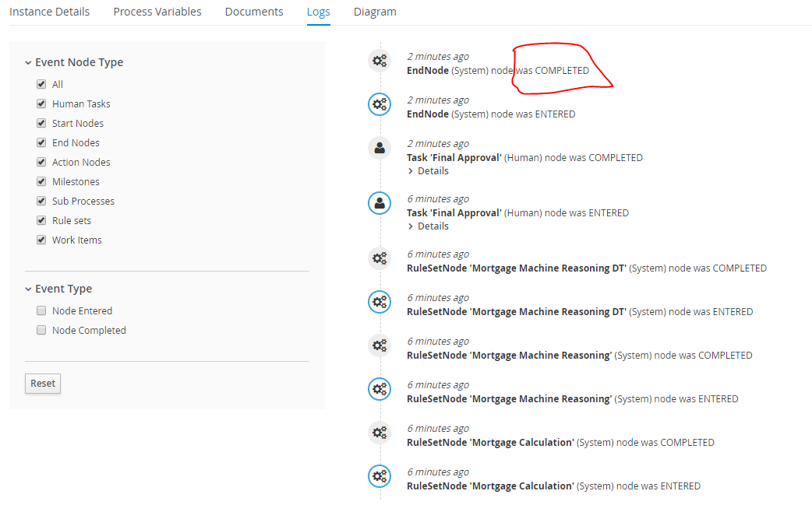

# Verify InLimitMR false

## Input an application

With down payment more 20% of sale price, but applicant doesn’t have a job.

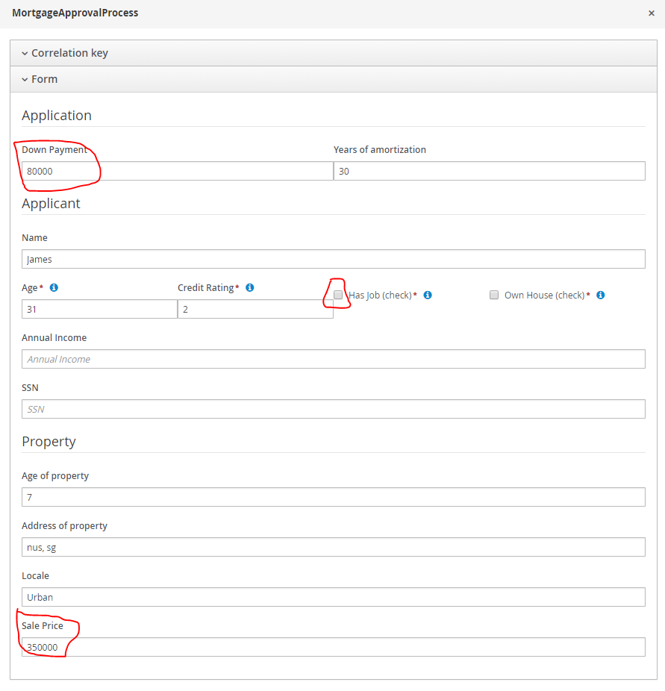

## Check process flow:

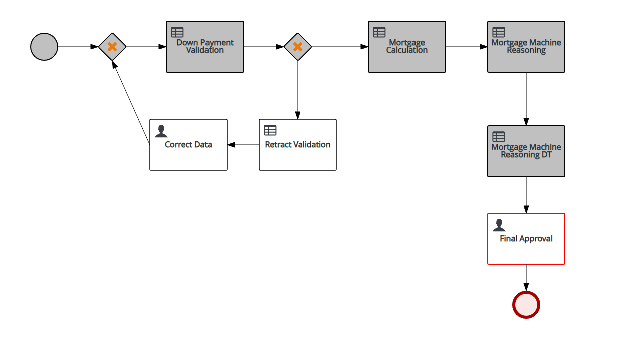

## Check InLimitMR value:

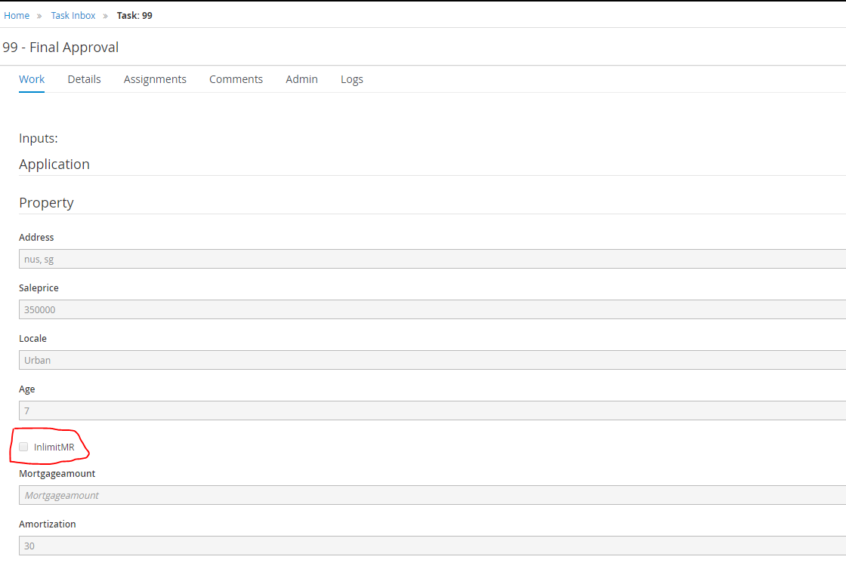

## Complete the mortgage flow:

