**Workshop 1**

**Calculation Sheet**

In this workshop, we assume that last link is parallel to ground plane. This is to enable the end effector to be perpendicular to cylinder surface to allow better gripping.

Since M2,M3,M4 are on side plane, performing inverse kinematics starting from here.

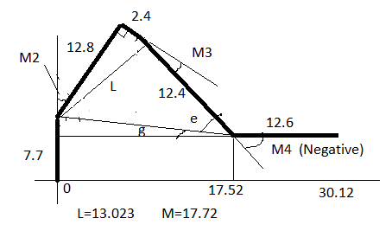

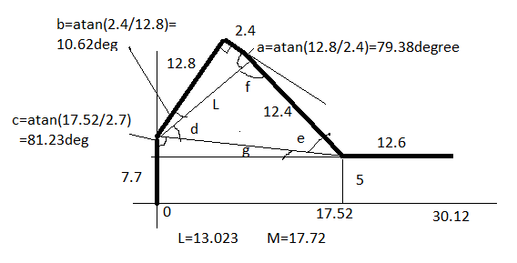

$$L={√((12.8)}^{2}+{2.4}^{2})=13.023$$

$$M={√((30.12-12.6)}^{2}+{(7.7-5)}^{2})=17.72$$

Using Cosine rule:

$$d=\operatorname{acos}\left(\frac{(M^{2}+L^{2}-{12.4}^{2})}{2ML}\right)=44.38deg=0.7747rad$$

$$e=\operatorname{acos}\left(\frac{(M^{2}+{12.4}^{2}-L^{2})}{2M(12.4)}\right)=47.27deg=0.825rad$$

M2=90-(b+c+d-90)=43.77deg=0.7639rad



f=180-d-e=88.35deg

M3=180-f-a=12.27deg=0.2141rad

g=atan(2.7/17.52)=8.76deg

M4=-(e+g)=-56.03deg=-0.9779rad

M1=0 at the beginning (starting position)

After starting the simulation using Gazebo, M1 is set to 1.57rad (90 degree position). During this time, M2 is kept to -0.5radian and M3/M4 to 0 radian so to avoid any collision between the cylinder and the robotic arm.

Then M2, M3, and M4 move to the calculated positions based on Inverse Kinematics as follows:

1. M2 = 0.7639 rad,
2. M3 = 0.2141 rad,
3. M4 = 0.9779 rad

After some delay, the gripper is closed (M5)

To ensure a collision-free movement, M2 is set to -0.5radian, and M3/M4 are set back to 0 radian.

After some delay, M1 is set to -1.57radian (to the destination). (To ensure steady movement, set via point where M1 is set to 0, keeping M2/M3/M4 to the same angle)

Finally, the arm moves to the destination with M1 set to -1.57radian, M2/M3/M4 to angles calculated thru inverse kinematics.

After some delay, the gripper is open and the cylinder is released.