Instructions for Object-oriented Motion Encoder

Masaki (Masateru) Hiramoto & Hollis Cline 11/08/2026

A newly discovered Brain-Derived Motion Encoder Enables Recognition of Motion Differences in Unknown Features
For Phenotypic Drug Discovery and Screening
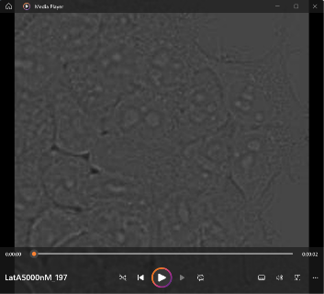
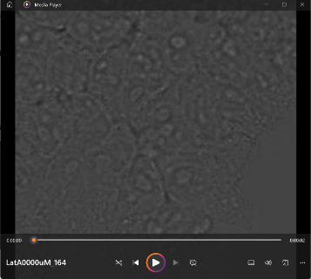
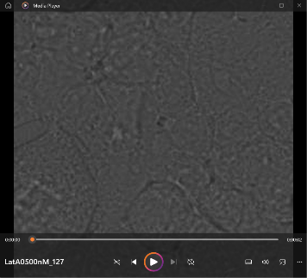

HEK293 cells in LatA 0nM 500nM 5000nM
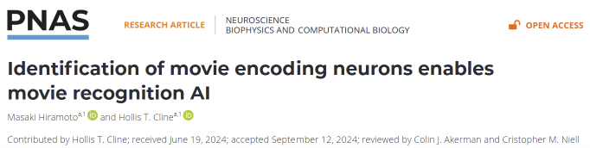

System requirements:
Windows10 or later, MATLAB2024a or later, RTX3060 6GB or higher (Nvidia GPU only), 32-64GB RAM, 12th gen Core i7 or later

Input data (sample): 800x800 pix X 60 frames
Acceptable Folder structures: “Parent folder/CategoryName_***.avi” or
“Grandparent folder/CategoryFolder/***.avi”

This software consists of three modules
Module0: Encoder generator (generates encoder from data movies). This process can be skipped when motion encoders generated from real animals are used.
Module1: Encoding (convolute movie data with encoders generated above or animal’s encoders)
Module2: Machine Learning (CNN-based network model for classification)
Module3: Identify locations of recognized features (guided GradCAM)

Code Location
Module0: pn = “_0_MotionEncoder”, main program = “Make_Movie_Filter.m”
Module1: pn = “_2_MakeCC_GPU_nEncoder”, main program = “MakeCC_main.m”
Module2: pn = “ScanData”, main program = “Plot_train_batch.m”
Module3: pn = “_3_Activation_analysis”, main program = “Batch_guided_GradCAM.m”

[Modules]
Module0: generate encoders
Input = parent folder/CategoryName_*.avi or grandparent folder/category folder/*.avi
Output = “DataBase_RFMap_b.mat” and other data files saved in “MadeEnc” folder.
Module1: encoding
Input = parent folder/CategoryName_*.avi or grandparent folder/category folder/*.avi
& “DataBase_RFMap_b.mat” if encoder generated from movies are used.
Output = Convoluted image data saved in “CC_var_hyper_3ChStack” folder and “CC_var_rev_hyper_3ChStack” folder
Module2: training network model
Input = “CC_var_hyper_3ChStack” or “CC_var_rev_hyper_3ChStack”, Module1 generated
Output = trained network model, training results
Module3: Identify locations of recognized features by guided GradCAM
Input = “CC_var_hyper_3ChStack” or “CC_var_rev_hyper_3ChStack”, Module1&2 generated,
AND parent folder/CategoryName_*.avi
Output = guided_GradCAM image data
“Results(id_movie).guided_GradCAM_bestCh”, in _SliceOfAllCh/ Results.mat file

Sample data:
Sample input movie data are included in the same repository.
[HEK293 cell movements induced by Latrunculin A (LatA)]
https://github.com/gengoroo/MotionEncoderSet/tree/main/SampleData/

Additional sample movie datasets are available at:
[Seizure of animals induced by pentylenetetrazol (PTZ)]
https://github.com/gengoroo/MovieEncoder_public/tree/4abd7e770704a7a378495f440ebdf7acedc2a858/Movies

Note:
Follow the instructions displayed by the program. Press Enter to accept the default setting whenever the message indicates that pressing Enter alone is an available option.
A RAM disk is recommended for storing the input movie files.
In this version, loops are intentionally used to demonstrate the logical structure of the algorithm.

Procedures
Module0: Make_Movie_Filter.m
- Prepare *.avi files
Size: ~800 pix square x ~60 frames. Optimal frame length depends on those motion encoders. Motion encoders (5~30 frames) scan a movie to find the best (single) matching cut.
Use short filenames, as long filenames cause errors in saving or loading.

- Organize *.avi folders
The *.avi files can be saved in either style; “grandparent folder/category folder/*.avi” or “parent folder/CategoryName_*.avi”. In the second style, the first “_” in the filename is used as a delimiter for category recognition.

- Run “Make_Movie_Filter.m”

- Options/Parameters:
- Select number of movie files per category to generate motion encoders. 5-10 files, depending on the number of objects of interest in a frame.
- Selection of ON-to-OFF sequences: can be selected by limiting the range of the spatial distances between ON and OFF centers, length of ON to OFF frames, and the square frame size that cover both ON and OFF Gaussian gradients. Default: select all without setting limit.
- XY size of motion encoders (critical, influences accuracy): can be specified by numbers. Default = 1.3 X mode(square frame size that cover both ON and OFF Gaussian gradients of selected ON-to-OFF sequences)
- Frame length of motion encoders (critical, influences accuracy): can be specified by numbers. Default = mode(frame length of selected ON-to-OFF sequences)
- SOM: Embedding by 3DCNN can be used before SOM, as an option. This mode gives higher accuracy to “CC_var_hyper_3ChStack” than “CC_var_rev_hyper_3ChStack”.
- XY size of the generated encoders can be resized, which is uncommon.

Module1: Make_CC_main.m
- Prepare *.avi files in a folder (two possible styles) as shown in the procedures for Module0.
- Prepare “DataBase_RFMap_b.mat “ by Module0, or use “DataBase_Dipole_Rank.mat” (animal-derived encoders) stored in the program folder.
- Run “Make_CC_main.m”
- Options/Parameters:
  - Select “DataBase_Dipole_Rank.mat” (animal-derived encoders) or “DataBase_RFMap_b.mat “ generated by Module0
  - If “DataBase_Dipole_Rank.mat” (animal-derived encoders) is selected, XY size of input movies is resized so that the moving features match the encoder size (20 pixels).
- Output:
Encoded output files are generated in “CC_var_hyper_3ChStack” folder (Outputs from multiple encoders are clustered by positions) or “CC_var_rev_hyper_3ChStack” folder (Outputs from different location encoded by the same encoders are clustered).

Module2: Plot_train_batch.m
- Prepare “CC_var_hyper_3ChStack” or “CC_var_rev_hyper_3ChStack” folders by Module1.
- Run “Plot_train_batch.m”
- Options/Parameters:
  - “filtersize” needs to match the square of the number of encoders for “CC_var_hyper_3ChStack” files, or pixel length of one side of encoded images divided by the number of encoders for “CC_var_rev_hyper_3ChStack” files.

Module3: Batch_guided_GradCAM.m
- Prepare “CC_var_hyper_3ChStack” or “CC_var_rev_hyper_3ChStack” folders by Module1&2. Module2 adds trained network model in the folders. Movies prepared for Module 0 or 1 are also required.
- Run “Batch_guided_GradCAM.m”
- Options/Parameters:
  - Data of the movie size, the number of used encoders, pixel size of one encoder are required.
  - If movie XY size is resized, type “y” when it is aked.
  - guided_GradCAM is saved in “_SliceOfAllCh/Results.mat” file. The data is obtained as Results(movie_id).guided_GradCAM_bestCh
  - Results for each movies are displayed and saved by selecting “make&display& save figures in each category folder?” option, however, it takes time.

Example Results/Output
Module0: Make_Movie_Filter.m
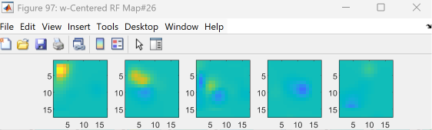
Module1: Make_CC_main.m
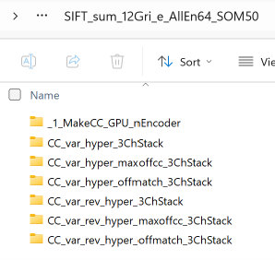

Module2: Plot_train_batch.m
An example from “CC_var_hyper_3ChStack” folder (Outputs from multiple encoders are clustered by positions, encoded by animals’ encoders)
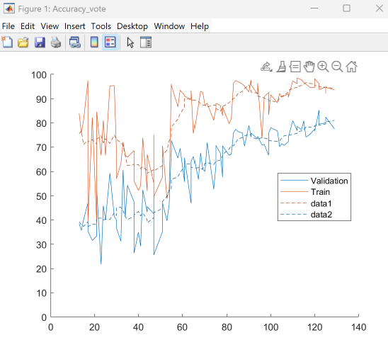

Module3: Plot_train_batch.m
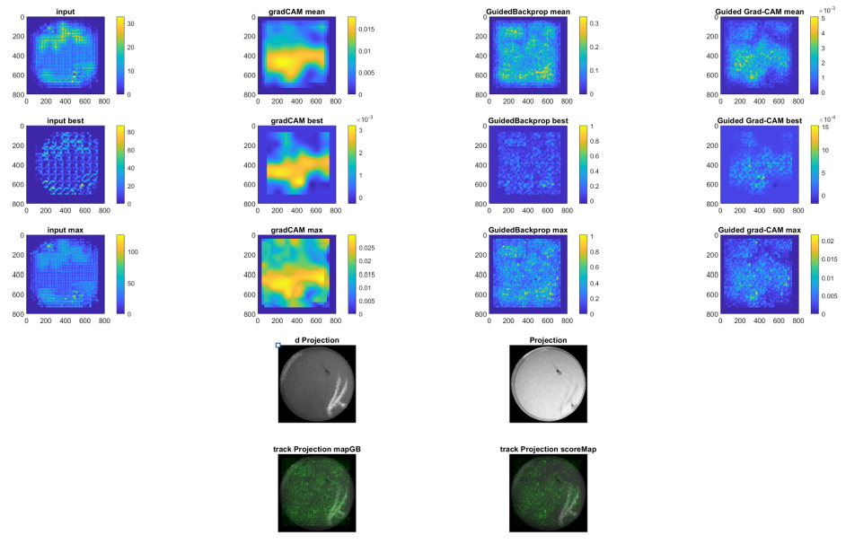
Top row: summation of all encoders’ outputs
The 2nd row: Output from the encoder with the best p-values
The 3rd row: maximum values of all encoders’ outputs

Principles of the algorithm

Module0: generate encoders
Encoders can be obtained either by 1. Electrophysiological recording from animal’s brain or 2. Computer.
The animal’s spatiotemporal receptive fields (stRFs) suggest that the visual system recognizes sequences starting from emergence to disappearance of objects in the visual field. Furthermore, 1. all visual scenes are decomposed into components of white dot-to-black dot sequences of salient features. 2. The interval between black dot input and the output (spiking) are consistent across neurons. This suggests that the visual system integrates inputs from multiple neurons, which have different input selectivity, by synchronizing the timing of the black dot input. (Hiramoto & Cline, PNAS, 2024)
This discovery inspires motion encoders that recognize the components of white dot-to-black dot sequences of salient features. Since photoreceptor cells recognize luminance change, rather than the absolute luminance, differentials between each movie frame are used as an input. In a visual field where an object emerges and disappears, a sequence of white-to-black transitions emerge. Proxies of the salient features are identified by applying SIFT to the image sequences [= im (x, y, t)]. Modeling using a gaussian filter symbolizes the sequence of white-to-black transitions. The salient features are cropped and used for generation of encoders. The encoder side length influences classification accuracy.
In the visual cortex, columnar organization emerges through the Hebbian plasticity rule. SOM (self-organization map) is used to mimic the development of the columnar structure. SOM extracts less redundant repertories of the stRFs. Data for embedding is simply obtained by linearizing the XYT pixel data. 3DCNN encoder can be used to generate the embedding data (this option is available during the execution of the code), however, it did not yield high accuracy encoders.
The obtained stRFs are used for motion encoders as a proxy of animal’s stRFs.

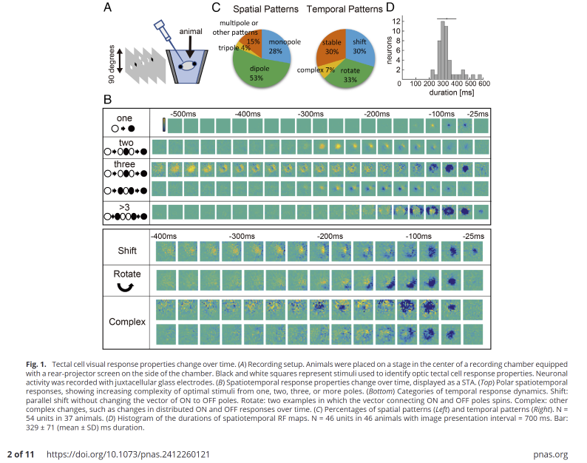

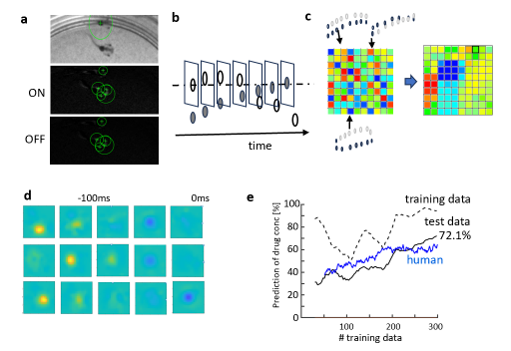
Fig. 2 Generation of movie encoder from input movies
a. Location of features detected by SIFT. sigma = 1.6 is used. Features in differential of neighboring image frames were analyzed by splitting into positive (ON) and negative (OFF) components. The features were detected for all image sequences. b. Trajectories of feature points in ON and OFF components. A pair of frames in which the white and black circles overlap are selected for the start and stop frames of movie encoders. c. Self-organization map was used to find representative movie encoders. d. Examples of representative movie encoders. Learning curve of a network model implemented with the generated movie encoders.

Module1: Encoding
Selection of encoding time windows
Encoding process is performed by calculating cross-correlation between the input movies and the motion encoder. Animals’ stRFs show that neurons evoke spikes immediately after the OFF inputs, while interval between white inputs and the spike timing are variable. This indicates that the neurons encode a sequence before strong OFF inputs. To mimic this feature by computer encoding, the frame of the strongest OFF signal is temporally aligned to the OFF timing of the motion encoder before calculating the cross-correlation. Since the interval between OFF inputs and the spike timing is consistent across neurons in animals, the OFF timing of multiple encoders is adjusted to the same frame of the input movie.
Integration of outputs from multiple encoders
In the hyper column structure of the visual cortex, visual information is represented in a hierarchical structure. The neurons recognizing similar features are clustered, which forms a larger cluster that receives input from the closer visual area. This feature is reflected in integrating outputs from multiple encoders in the computer algorithm. To create image input for CNN, output data from multiple motion encoders are clustered by the location of visual input. If the number of the encoders is 25, 5x5 grids representing the output from 25 encoders covers the whole area. The opposite organization can be also used, depending on the feature of the movie inputs.
Integration of outputs from spatially displaced encoders
To increase spatial resolution of the encoding, the same set of encoders are used encode motions by shifting their positions by 1/3 grids of the set of encoders described above in X and Y directions, which generates nine output images from the same movie. Nine CNNs are trained with these data independently.

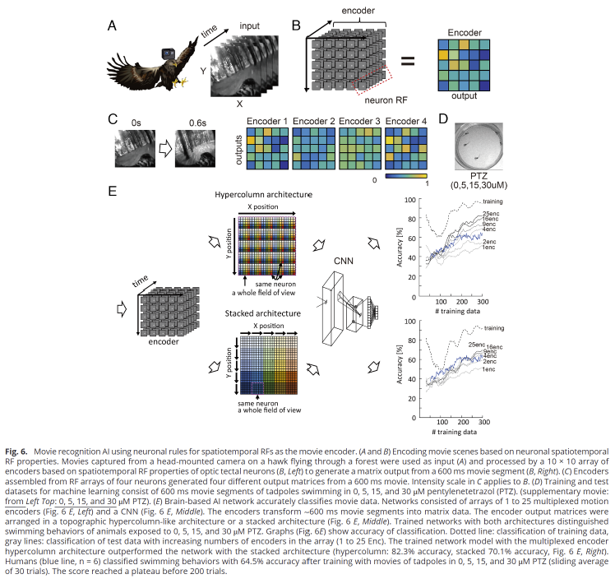

Module2: Training network models
Parameters
Used parameters are different from training for the common image recognition. The first layer uses a filter of a large size that matches the grid of the set of motion encoder. If the number of encoders is 25, the filter size is sqrt(25) =5. Similarly, stride needs to be the same as the filter size.
Integration
Grid groups of different displacements are trained independently. The responses can be integrated in multiple ways. We found that taking responses from network model that yields the highest P gives the best accuracy rate.

Module3: Activation analysis
Guided-GradCAM is applied to the network model trained with the encoder outputs. The activation signals are overlaid on the projected images of the original movies.
1. The same set of encoders encode motions by shifting their positions by 1/3 grids in X and Y directions, which generates nine output images from the same movie. Nine CNNs are trained with these data independently. The responses from the network models (shown as “best Ch” in results) are integrated either by selecting response with the highest probability. The position of the activation signals are displayed on the grid group without displacement.
2. An output image from a set of encoders is arranged in grids forming a square and is used for training or classification. Therefore, the position in the output image from the encoder includes object location in the original movie and the identity of the encoder.

