2015010912014 耿瑞旭

M3_1: 1

1.源代码： 1

2.思路： 2

3.运行结果 2

4. 优化方案 3

M3-2 4

1. 源代码 4

3. 运行结果 11

4. 改进方案 12

M3_1:

1.源代码：

% Program 3_1

% Discrete-Time Fourier Transform Computation

%

% Read in the desired number of frequency samples

%2015010912014

k = input('Number of frequency points = ');

r = input('r=');

sita = input('sita=')

% Read in the numerator and denominator coefficients

c1 = -2*r*cos(sita)

c2 = r*r

num = [1]

den = [1,c1,c2];

% Compute the frequency response

w = 0:pi/(k-1):pi;

h = freqz(num, den, w);

%interpreter grx

% freqz Frequency response of digital filter

%

% [H,W] = freqz(B,A,N) returns the N-point complex frequency response

% vector H and the N-point frequency vector W in radians/sample of

% % the filter:

% jw -jw -jmw

% jw B(e) b(1) + b(2)e + .... + b(m+1)e

% H(e) = ---- = ------------------------------------

% jw -jw -jnw

% A(e) a(1) + a(2)e + .... + a(n+1)e

% % Plot the frequency response

% H = freqz(...,W) returns the frequency response at frequencies

% designated in vector W, in radians/sample (normally between 0 and pi).

% W must be a vector with at least two elements.

%2015010912014

subplot(2,2,1)

plot(w/pi,real(h));grid

title('Real part')

xlabel('\omega/\pi'); ylabel('Amplitude')

subplot(2,2,2)

plot(w/pi,imag(h));grid

title('Imaginary part')

xlabel('\omega/\pi'); ylabel('Amplitude')

subplot(2,2,3)

plot(w/pi,abs(h));grid

title('Magnitude Spectrum')

xlabel('\omega/\pi'); ylabel('Magnitude')

subplot(2,2,4)

plot(w/pi,unwrap(angle(h)));grid %È¡ÏàÎ»

title('Phase Spectrum')

xlabel('\omega/\pi'); ylabel('Phase, radians')

2.思路：

A．利用help freqz命令看懂例题中的代码

B．3-1问其实就是改变了系数而已，因此将系数设置为r，sita的函数即可，如下所示：

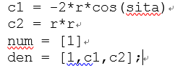

C．使用input函数，将r，sita值的决定权下放给使用者

D．加入‘2015010912014‘ 和 ‘grx’等字样

3.运行结果

例如

Number of frequency points = 500

r=0.55

sita=0.9



4. 优化方案

A．加入GUI界面

如下图所示：

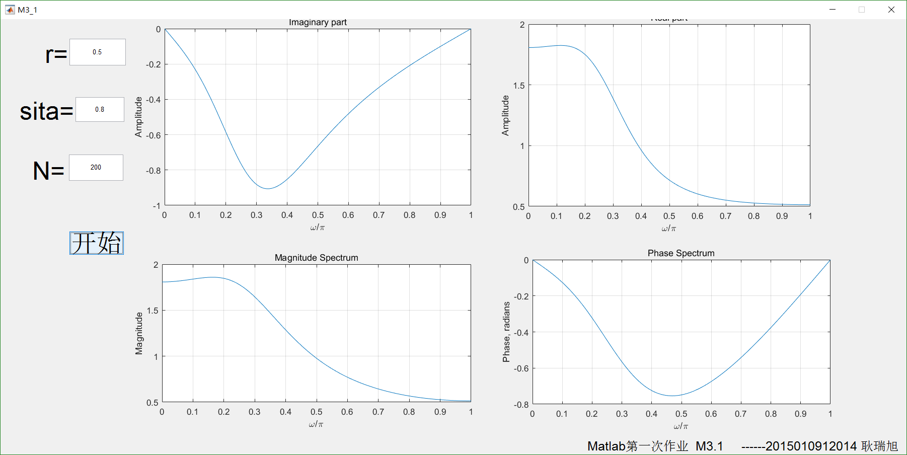

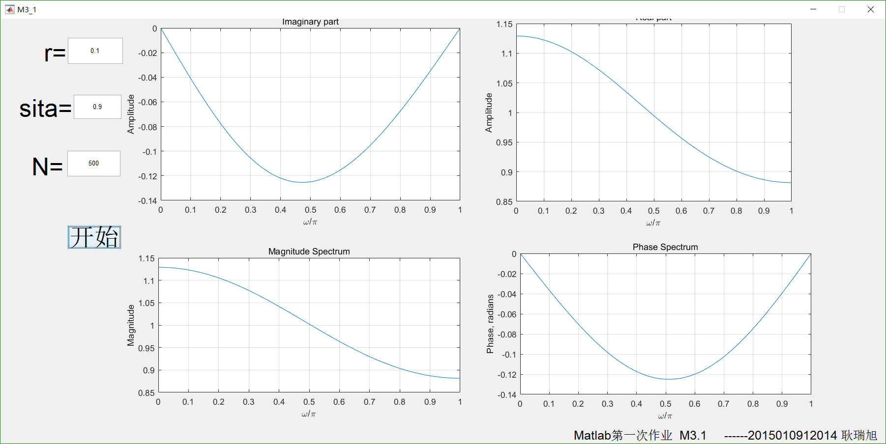

M3-2

1. 源代码

共分为5部分，分别代表了5问

% Program 3_1

% Discrete-Time Fourier Transform Computation bodified by grx

% grx

% Read in the desired number of frequency samples

k = input('Number of frequency points = ');

% Read in the numerator and denominator coefficients

num1 = zeros(1,15);

den1 = zeros(1,15);

num1(1) = 1;

num1(11) = 1;

den1(11) = 1;

den1(12) = -1;

% Compute the frequency response

w = 0:pi/(k-1):pi;

num1

den1

h1 = freqz(num1, den1, w);

% freqz Frequency response of digital filter

% added by grx

% [H,W] = freqz(B,A,N) returns the N-point complex frequency response

% vector H and the N-point frequency vector W in radians/sample of

% % the filter:

% jw -jw -jmw

% jw B(e) b(1) + b(2)e + .... + b(m+1)e

% H(e) = ---- = ------------------------------------

% jw -jw -jnw

% A(e) a(1) + a(2)e + .... + a(n+1)e

% % Plot the frequency response

% H = freqz(...,W) returns the frequency response at frequencies

% designated in vector W, in radians/sample (normally between 0 and pi).

% W must be a vector with at least two elements.

subplot(5,4,1)

plot(w/pi,real(h1));grid

title('Real part(a)')

xlabel('\omega/\pi'); ylabel('Amplitude')

subplot(5,4,2)

plot(w/pi,imag(h1));grid

title('Imaginary part')

xlabel('\omega/\pi'); ylabel('Amplitude')

subplot(5,4,3)

plot(w/pi,abs(h1));grid

title('Magnitude Spectrum')

xlabel('\omega/\pi'); ylabel('Magnitude')

subplot(5,4,4)

plot(w/pi,unwrap(angle(h1)));grid %È¡ÏàÎ»

title('Phase Spectrum')

xlabel('\omega/\pi'); ylabel('Phase, radians')

%%%%%%%%%%%%%%%%%%%%%%%%%%%%%%%%%%%%%%%%%%%%%%%%%%%%%%%%%%%%%%%%%%%%%%%%%%%%%%%5

%%%%%%%%%%%%%%%%%%%%%%%%%%%%%%%%%%%%%%%%%%%%%%%%%%%%%%%%%%%%g%%r%%x%%%%%%%%%%%%5

%%%%%%%%%%%%%%%%%%%%%%%%%%%%%%%%%%%%µÚ¶þÎÊ¿ªÊ¼%%%%%%%%%%%%%%%%%%%%%%%%%%%%%%%

num2 = zeros(1,15);

den2 = zeros(1,15);

num2(1) = 1;

num2(11) = -1;

den2(1) = 1;

den2(2) = -1;

w = 0:pi/(k-1):pi;

num2

den2

h2 = freqz(num2, den2, w);

subplot(5,4,5)

plot(w/pi,real(h2));grid

title('Real part(b)')

xlabel('\omega/\pi'); ylabel('Amplitude')

subplot(5,4,6)

plot(w/pi,imag(h2));grid

title('Imaginary part')

xlabel('\omega/\pi'); ylabel('Amplitude')

subplot(5,4,7)

plot(w/pi,abs(h2));grid

title('Magnitude Spectrum')

xlabel('\omega/\pi'); ylabel('Magnitude')

subplot(5,4,8)

plot(w/pi,unwrap(angle(h2)));grid %È¡ÏàÎ»

title('Phase Spectrum')

xlabel('\omega/\pi'); ylabel('Phase, radians')

%%%%%%%%%%%%%%%%%%%%%%%%%%%%%%%%%%%%%%%%%%%%%%%%%%%%%%%%%%%%%g%%r%%x%%%%%%%%%%5

%%%%%%%%%%%%%%%%%%%%%%%%%%%%%%%%%%%%µÚÈýÎÊ¿ªÊ¼%%%%%%%%%%%%%%%%%%%%%%%%%%%%%%%

num3 = zeros(1,15);

den3 = zeros(1,15);

num3(1) = 1;

num3(11) = 1;

num3(6) = -2;

den3(11) = 1;

den3(12) = -2;

den3(13) = 1

w = 0:pi/(k-1):pi;

num3

den3

h3 = freqz(num3, den3, w);

subplot(5,4,9)

plot(w/pi,real(h3));grid

title('Real part(c)')

xlabel('\omega/\pi'); ylabel('Amplitude')

subplot(5,4,10)

plot(w/pi,imag(h3));grid

title('Imaginary part')

xlabel('\omega/\pi'); ylabel('Amplitude')

subplot(5,4,11)

plot(w/pi,abs(h3));grid

title('Magnitude Spectrum')

xlabel('\omega/\pi'); ylabel('Magnitude')

subplot(5,4,12)

plot(w/pi,unwrap(angle(h3)));grid %È¡ÏàÎ»

title('Phase Spectrum')

xlabel('\omega/\pi'); ylabel('Phase, radians')

%%%%%%%%%%%%%%%%%%%%%%%%%%%%%%%%%%%%%%%%%%%%%%%%%%%%%%%%%%%%%%%%%%%%%%%%%%%%5

%%%%%%%%%%%%%%%%%%%%%%%%%%%%%%%%%%%%µÚËÄÎÊ¿ªÊ¼%%%%%%%%%%%%%%%%%%%%%%%%%%%%%%%

num4 = zeros(1,21);

den4 = zeros(1,15);

num4= [1,2,3,4,5,6,7,8,9,10,11,10,9,8,7,6,5,4,3,2,1];

den4(11) = 1;

w = 0:pi/(k-1):pi;

num4

den4

h4 = freqz(num4, den4, w);

subplot(5,4,13)

plot(w/pi,real(h4));grid

title('Real part(d)')

xlabel('\omega/\pi'); ylabel('Amplitude')

subplot(5,4,14)

plot(w/pi,imag(h4));grid

title('Imaginary part')

xlabel('\omega/\pi'); ylabel('Amplitude')

subplot(5,4,15)

plot(w/pi,abs(h4));grid

title('Magnitude Spectrum')

xlabel('\omega/\pi'); ylabel('Magnitude')

subplot(5,4,16)

plot(w/pi,unwrap(angle(h4)));grid %È¡ÏàÎ»

title('Phase Spectrum')

xlabel('\omega/\pi'); ylabel('Phase, radians')

%%%%%%%%%%%%%%%%%%%%%%%%%%%%%%%%%%%%%%%%%%%%%%%%%%%%%%%%%%%%%%%%%%%%%%%%%%%%5

%%%%%%%%%%%%%%%%%%%%%%%%%%%%%%%%%%%%µÚÎåÎÊ¿ªÊ¼%%%%%%%%%%%%%%%%%%%%%%%%%%%%%%%

num5 = zeros(1,21);

den5 = zeros(1,15);

num5= [cos(0.5*pi),cos(0.45*pi),cos(0.4*pi),cos(0.35*pi),cos(0.3*pi),cos(0.25*pi),cos(0.2*pi),cos(0.15*pi),cos(0.1*pi),cos(0.05*pi),1,cos(0.05*pi),cos(0.1*pi),cos(0.15*pi),cos(0.2*pi),cos(0.25*pi),cos(0.3*pi),cos(0.35*pi),cos(0.4*pi),cos(0.45*pi),cos(0.5*pi)];

den5(11) = 1;

w = 0:pi/(k-1):pi;

num5

den5

h5 = freqz(num5, den5, w);

subplot(5,4,17)

plot(w/pi,real(h5));grid

title('Real part(e)')

xlabel('\omega/\pi'); ylabel('Amplitude')

subplot(5,4,18)

plot(w/pi,imag(h5));grid

title('Imaginary part')

xlabel('\omega/\pi'); ylabel('Amplitude')

subplot(5,4,19)

plot(w/pi,abs(h5));grid

title('Magnitude Spectrum')

xlabel('\omega/\pi'); ylabel('Magnitude')

subplot(5,4,20)

plot(w/pi,unwrap(angle(h5)));grid %È¡ÏàÎ»

title('Phase Spectrum')

xlabel('\omega/\pi'); ylabel('Phase, radians')

1. 思路
2. 仍要使用freqz函数，故需要求出对应的系数。这个系数可直接使用公式求出：

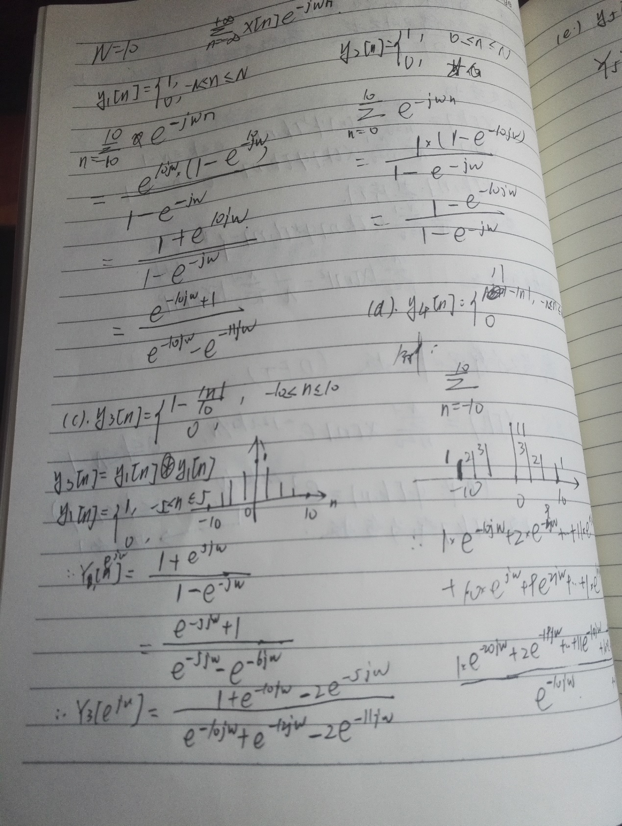

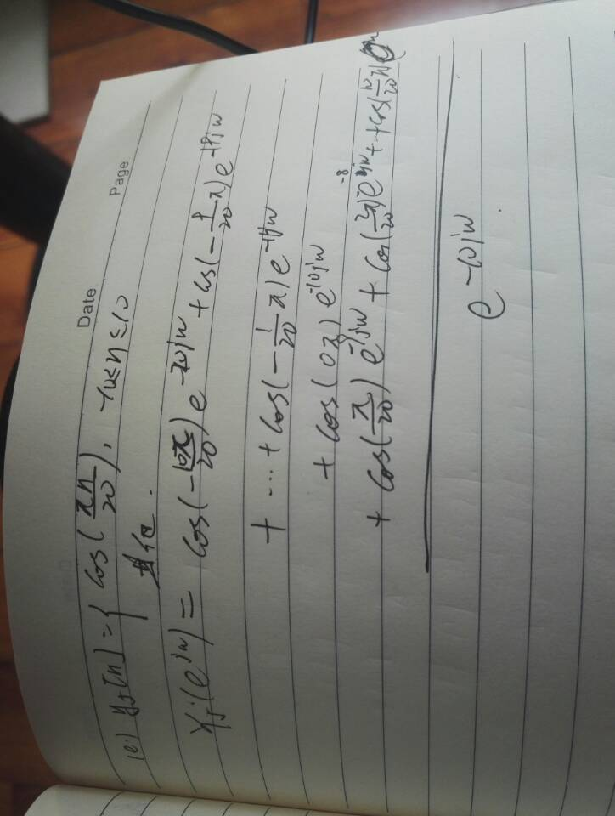

在程序中则通过如下代码实现：

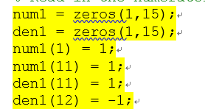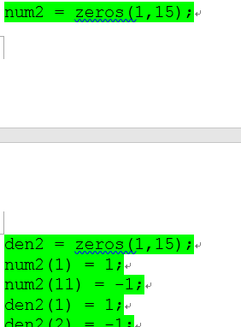

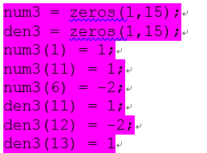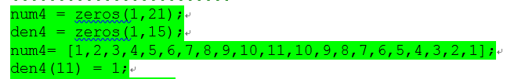

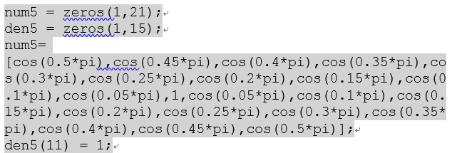

1. 绘图函数：例题中原函数的绘图已比较规范，故仅仅将4个子图扩展为20个，以满足5道小题所需
2. 采样数：

为了方便，采样点数在程序开始时一次输入即可。（若要修改也容易完成）

1. 为了防止卷帘现象的发生，在画相位的plot函数中加入了unwrap函数
2. 加入‘2015010912014‘ 和 ‘grx’等字样
3. 运行结果



1. 改进方案
2. 制作GUI

