The Delay Circuit GPIO Pull-up

To calculate the RC time constant, τ of the following circuit.

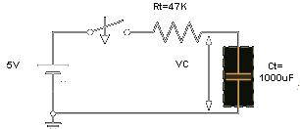

The time constant, τ is found using the formula T = R x C in seconds.
Therefore the time constant τ is given as:
T = R x C = 47k x 1000uF = 47 Secs

