Evaluating adaptive graph fusion for short-range weather forecasting with conditional local convolution
Xinchen Geng
University of Southern California, Los Angeles, CA 90089, USA
Corresponding author: gengx@usc.edu
  - Abstract
I evaluate an adaptive graph-fusion (AGF) extension to the Conditional Local Convolution Recurrent Network (CLCRN), originally proposed by Haitao Lin et al., on four coarse-grid WeatherBench-derived tasks. The encoder gates a graph-aggregated projection against a node-wise residual projection before the CLConv recurrent backbone. I newly train 40 primary models (two variants, four tasks and five seeds) and six mean-fusion ablations, each for 100 epochs in FP32. Training, validation and testing consistently include finite targets equal to zero; checkpoints are selected using validation MAE alone. Across five training seeds per variant, AGF reduces relative-humidity MAE by 2.38% and RMSE by 3.29% (Benjamini–Hochberg adjusted q=0.00604 and 0.000653, respectively, across eight primary tests). The other six comparisons do not establish a difference at q<0.05. I additionally report latitude-weighted scores, horizon-specific errors and sampled missing-input diagnostics. The evidence concerns training-seed variability on one fixed split and does not establish competitive skill against large-scale global weather models.

1 Introduction
Numerical weather prediction integrates physical governing equations and remains central to operational forecasting ¹. WeatherBench and the ERA5 reanalysis have also enabled systematic evaluation of data-driven weather models ^{2,3}. Recent global models, including FourCastNet, Pangu-Weather, GraphCast, and probabilistic forecasters, address multivariate medium-range prediction at much finer spatial resolution than small graph-recurrent benchmarks ^{4,5,6,7}. Compact models remain useful for controlled experiments on training cost, task-specific adaptation, and reproducibility, provided that their narrower forecasting scope is stated explicitly.
This study builds on the Conditional Local Convolution Recurrent Network (CLCRN), proposed by Haitao Lin et al. ⁸. CLCRN and its Conditional Local Convolution (CLConv) operator are contributions of that prior work. The present study adds an AGF input extension and evaluates its effects under matched conditions. CLConv uses geographic information to construct location-dependent kernels. The present data occupy a regular $32×64$ latitude–longitude grid embedded on the sphere, rather than an irregular sampling grid. Geometry-conditioned local aggregation is the published backbone contribution. The question studied here is whether augmenting that backbone with a learned graph yields a reproducible benefit for 12-hour forecasting (Supplementary Fig. S1).
Learned adjacency and gating are established ideas. Diffusion and graph-convolutional recurrent networks ^{9,16} and spatio-temporal graph convolution ¹⁰ provide fixed-graph baselines. Graph WaveNet, AGCRN, and learned graph-structure models ^{11,12,13} motivate topology estimated from data. Attention-based forecasting further demonstrates the value of learned dependencies ^{15,14}. The adaptive-graph and fusion design is inspired by ASTTN ²⁰, which combines representations from geographical and learned graphs. Here I use a compact graph aggregation and node-wise residual projection before CLConv, without ASTTN’s Gumbel graph masking or spatial–temporal multi-head attention. I do not claim the ingredients of the AGF encoder as individually novel. It is a compact combination of node embeddings, directed adjacency, top-$k$ aggregation, and gated residual mixing used to test an incremental change to an existing geometry-conditioned model.
The contribution of this study is the AGF input extension to the published CLCRN framework and its controlled empirical evaluation: identical data, training schedules, and budgets for CLCRN and CLCRN-AGF; five seed replicates; uncertainty estimates and multiplicity correction; and a traceable connection between results, checkpoints, and figures. I also report component ablations, diagnostic analyses, and negative or inconclusive results. The manuscript follows a Methods–Results–Discussion structure so that the implementation and evaluation conventions are specified before the numerical findings.

2 Methods

2.1 Data, chronological split, and normalization
I use the four WeatherBench-derived tasks adopted by CLCRN ^{8,2}: 2-m temperature (K), relative humidity (percentage points), 10-m wind components ($u,v$; m s$​^{−1}$), and total cloud cover (fraction). The two wind components are predicted together; the other tasks are trained separately. Hourly data from 1 January 2010 through 31 December 2018 are supplied on a regular $32×64$ latitude–longitude grid ($N=2,048$).
Each example contains 12 hourly inputs followed by 12 hourly targets. Windows start 24 hours apart, yielding 3,286 examples. Chronological, unshuffled train/validation/test partitions contain 2,300/329/657 examples. Thus successive examples do not share a 24-hour input–target window. For each physical variable (and separately for each wind component), the normalization mean and standard deviation are computed over the training input arrays across examples, input times, and nodes. The same statistics transform inputs and targets. In the frozen implementation, these statistics are computed from the original training-input arrays. Inputs and targets are then cast to float32 before in-place subtraction of the training mean and division by the training standard deviation. This float32-before-standardization order is used for training, validation and test inference and is recorded in the processing-version manifest. Forecast errors are calculated after inverse standardization.

2.2 Backbone and implementation-aligned AGF encoder
The CLConv–GRU encoder–decoder is based on the public CLCRN implementation. CLConv uses coordinates, geodesic distance, and orientation information to condition local convolution. These operators and the recurrent update are retained; AGF augments the encoder input rather than replacing CLConv. Both local variants use trainable node embeddings, whereas the upstream reference implementation registers its node embeddings as a fixed buffer. Thus the control is a matched local CLCRN implementation retaining the published CLConv–GRU operators, rather than an unchanged reproduction of every upstream implementation choice. During training, the autoregressive decoder uses curriculum-based teacher forcing. At evaluation, it consumes its own previous predictions.
Let ${\overset{‾}{x}}_{bti}∈R^{C}$ be the standardized input at example $b$, time $t$, and node $i$. A linear weather projection and a learned node embedding, each of dimension 8, form the AGF input
$$F_{bti}=ϕ_{x}({\overset{‾}{x}}_{bti})‖e_{i}^{node}∈R^{16}.$$
Source and destination embeddings $E_{s},E_{t}∈R^{N×10}$ define a directed, row-normalized adjacency,
$$A_{ij}=\frac{exp(e_{i}^{s⊤}e_{j}^{t})}{\sum_{ℓ=1}^{N}{exp}(e_{i}^{s⊤}e_{ℓ}^{t})}.$$
This adjacency uses the same softmax of source–destination embedding products as ASTTN (Eq. 8) ²⁰; the graph aggregation and fusion implementation used here is specified below. This graph is parameter dependent but does not change with the input weather sample. The implementation retains the self-edge and the largest $k−1$ non-self entries, with $k=4$, then renormalizes:
Tk(i)={i}∪topk−1{Aij:j≠i}, Aij=Aijℓ∈Tk(i)​Aiℓ (j∈Tk(i)).
Here ${top}_{k−1}$ returns indices. Selection does not exclude geographically nearby nodes, so the learned edges are potentially long-range but are not guaranteed to be nonlocal. Aggregation, projections, and fusion follow the source-code order:
mbti&=j∈Tk(i)​AijFbtj,qbti&=Wmmbti+bm,&rbti&=WrFbti+br,gbti&=σWg[rbti‖qbti]+bg,zbti&=gbti⊙qbti+(1−gbti)⊙rbti∈R8.
Both branches act on the same pre-CLConv input. In particular, $r$ is a node-wise residual linear projection, not a geometry-conditioned CLConv representation. The encoder receives $[F‖\overset{‾}{x}‖z]$; the control receives $[F‖\overset{‾}{x}]$. The corresponding input widths are 25 versus 17 for the scalar tasks and 26 versus 18 for wind. There is no calendar input, periodic encoding, or multi-head attention in the primary configuration. Figure 1 shows the corrected computation.
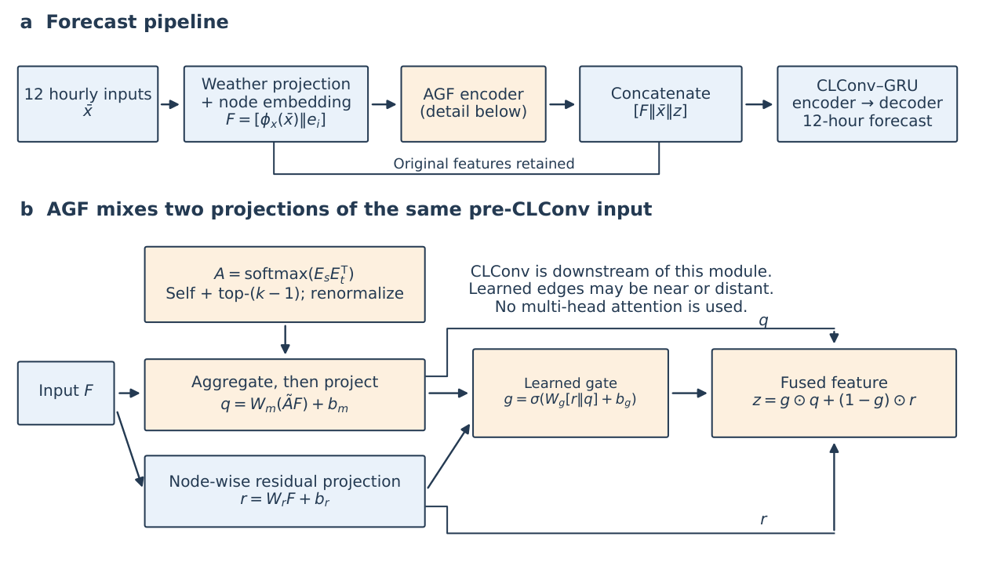
Figure 1. Implementation-aligned architecture. (a) AGF augments the input before the CLConv–GRU encoder. The original weather and node features are retained through concatenation. (b) The graph-aggregated projection $q$ and residual projection $r$ share the same input $F$. The gate mixes these projections; it does not directly mix a CLConv output with a graph output. The geographic CLConv operations occur downstream.

2.3 Matched new training and checkpoint selection
Both models use two recurrent layers with 32 hidden units, 8-dimensional feature and node embeddings, one CLConv propagation view, and 25 geographic neighbours. Adam uses learning rate 0.01 and $ϵ=0.001$, batch size 32, gradient-norm clipping at 5, and MultiStepLR milestones $\{10,20,30,40,50\}$ with factor 0.95. Every run completes 100 epochs; early stopping is disabled. The curriculum-learning decay parameter is 2,000. All primary and ablation runs use FP32, with automatic mixed precision and TF32 disabled. Training and validation MAE are evaluated after inverse standardization, including every finite target, including physically valid zero values. Testing uses the same zero-inclusive support. Every epoch is saved atomically; the earliest epoch attaining the minimum full-validation MAE is selected, without consulting the test set. Checkpoints retain optimizer, scheduler, random-number-generator and scaler states to permit interruption recovery. All trainable parameters are materialized before optimizer construction, and optimizer membership and gradient coverage are checked explicitly.
The prior archive used a zero-exclusive objective. Its scores are superseded by the newly trained results reported here. The correction therefore applies to optimization and validation selection, rather than solely rescoring historical checkpoints. Code is frozen before training, and per-run manifests record source hashes, configuration, seed, precision and environment.
The recorded training interpreter is Python 3.13.7, with PyTorch 2.10.0+cu128. GPU information is recorded as “NVIDIA GeForce RTX 5090 Laptop GPU, 610.88, 24463 MiB”.

2.4 Test metrics and replicate-level inference
The primary MAE and RMSE pool all finite targets over test examples, the 12 forecast times, nodes, and output components with equal weight:
$$MAE=\frac{1}{M}\sum_{a=1}^{M}{|}{\hat{y}}_{a}−y_{a}|, RMSE=\sqrt{\frac{1}{M}\sum_{a=1}^{M}{(}{\hat{y}}_{a}−y_{a})^{2}}.$$
These are unweighted grid-point metrics, not area-weighted scores. I also report a latitude-weighted sensitivity analysis, replacing the unit weights with $w_{i}=cosϕ_{i}$ (latitude $ϕ_{i}$ in radians) and dividing weighted error sums by the sum of weights over valid entries. This changes the evaluation metric only; it does not change the training objective or checkpoint selection. For cumulative horizon $h$, errors pool steps $1,…,h$; exact-step scores use only step $h$. Persistence repeats the last input observation and is scored by the same test implementation.
Each primary task has five independently trained control and five AGF replicates. Reusing seed labels does not create matched random streams, because AGF changes the parameter initialization sequence. I report means, sample standard deviations, AGF-minus-control differences, two-sided Welch 95% confidence intervals, and two-sided Welch tests. Benjamini–Hochberg correction is applied across the eight task/metric tests. The 95% intervals are marginal, not simultaneous or multiplicity-adjusted intervals; the adjusted $q$ values govern the primary significance statements. A two-sided exact permutation test of the difference in means provides a sensitivity check under the null of exchangeable group labels, over the $\left({10 \atop 5}\right)=252$ group allocations. This replaces the previous paired sign-test interpretation. With only five seeds per group, these intervals characterize training variability on one fixed split; they do not quantify uncertainty across climates, datasets, or test periods. A non-significant result is not evidence of equivalence. With five replicates per group, distributional assumptions are difficult to assess; the exact permutation check is also conditional on exchangeability and does not remove this small-sample limitation.

2.5 Provenance and supplementary experiments
The fixed experiment manifest contains 40 newly trained primary models: control and AGF for four tasks and seeds 2021–2025. Six additional newly trained mean-fusion models cover temperature and humidity with seeds 2023–2025. Every model completes the same 100-epoch FP32 protocol. The corresponding control and gated-AGF ablation rows reuse exactly those three seeds from the primary experiment; they are not separately selected favourable runs. Without AGF, the entire input augmentation is removed. Without a learned gate, the fusion is $z=(q+r)/2$.
All accuracy tables, horizon plots, weighted scores and gate diagnostics are regenerated from this common set of new checkpoints. Missing-input diagnostics use a documented shared subset. Historical tuning trials and short screening runs are not used as substitutes for these replicates. Source and checkpoint hashes, seed-level CSV files, validation-selection records and figure metadata are retained with the analysis.
The external CLCRN reference means are traceable to Table 2 of the published AAAI paper ⁸. Temperature and wind scores retain their displayed units; humidity errors are multiplied by 10 and cloud-cover errors divided by 10 to match the units used here. These historical values were not recomputed with the present evaluator. WeatherBench’s standard evaluator uses cosine-latitude weights, whereas the released CLCRN evaluator uses unweighted means and masks zero targets. I therefore state both conventions explicitly without assuming that a historical reference shares the corrected zero-inclusive protocol. The source audit and unit-conversion table are retained in the accompanying reproducibility materials under historical_context; the primary table contains only matched scores.

2.6 Computational scope
The AGF implementation constructs a dense $N×N$ similarity matrix before top-$k$ selection, so graph construction has quadratic intermediate memory despite sparse aggregation. CLConv also materializes dense kernel operators. The recorded trainable parameter counts are 39,268 for the scalar control and 80,892 for scalar AGF; wind uses 39,437 and 81,061, respectively. The inherited inference microbenchmark is identified separately as a measurement of historical weights. Its timings are not relabelled as measurements of the newly trained checkpoints.

2.6.0.1 AI-assisted preparation.
AI tools assisted language editing, code review, analysis scripting and figure preparation. Their use is described in the Generative AI and AI-Assisted Technologies Disclosure section.

3 Results

3.1 Primary five-seed comparison
The primary results use the same zero-inclusive, spatially unweighted evaluator for all 40 newly trained primary checkpoints. Table 1 and Fig. 2 show the five-seed comparison. Only relative-humidity MAE and RMSE meet the primary threshold after Benjamini–Hochberg correction across eight tests. The remaining comparisons are inconclusive at $q<0.05$.
For relative humidity, mean MAE decreases from 4.648 to 4.537 percentage points (2.38%; $q=0.00604$), and mean RMSE from 7.248 to 7.010 percentage points (3.29%; $q=0.000653$). Temperature and wind have higher point estimates for both metrics with AGF, while cloud-cover MAE is slightly higher and RMSE slightly lower. The intervals for all six of these differences include zero; the experiment does not establish either improvement or equivalence for these tasks.
Table 1. New five-seed comparison. Values are mean and sample standard deviation; differences are AGF minus control. Two-sided Welch tests and 95% intervals describe independent training replicates. BH correction covers all eight rows; the 95% intervals are unadjusted marginal intervals. Units are K for temperature, percentage points for relative humidity, m s$​^{−1}$ for wind, and fraction for cloud cover.
Task | Metric | Control ($μ±s$) | AGF ($μ±s$) | Difference [95% CI] | $p$ | BH $q$
Temperature | MAE | $1.258±0.060$ | $1.291±0.107$ | $+0.033$ [$−0.100,+0.166$] | 0.5701 | 0.7601
Temperature | RMSE | $2.101±0.045$ | $2.118±0.129$ | $+0.017$ [$−0.141,+0.174$] | 0.7942 | 0.7942
Relative humidity | MAE | $4.648±0.017$ | $4.537±0.039$ | $−0.111$ [$−0.158,−0.063$] | 0.00151 | 0.00604
Relative humidity | RMSE | $7.248±0.043$ | $7.010±0.055$ | $−0.239$ [$−0.311,−0.166$] | 8.168e-05 | 0.0006534
Surface wind | MAE | $1.242±0.011$ | $1.256±0.037$ | $+0.014$ [$−0.032,+0.059$] | 0.4699 | 0.7601
Surface wind | RMSE | $1.972±0.023$ | $2.016±0.093$ | $+0.043$ [$−0.071,+0.158$] | 0.3657 | 0.7601
Cloud cover | MAE | $0.1479±0.0017$ | $0.1484±0.0020$ | $+0.0005$ [$−0.0022,+0.0031$] | 0.7077 | 0.7942
Cloud cover | RMSE | $0.2500±0.0017$ | $0.2490±0.0028$ | $−0.0010$ [$−0.0045,+0.0025$] | 0.5103 | 0.7601
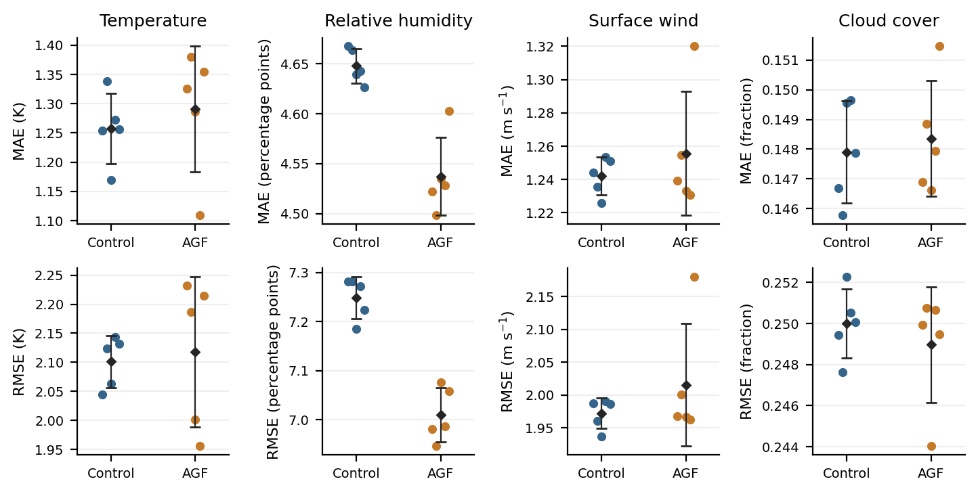
Figure 2. Cumulative 12-hour MAE (top) and RMSE (bottom) from the same 40 checkpoints used in Table 1. Coloured points are five independently trained replicates per variant; black diamonds/error bars denote mean plus or minus sample standard deviation. No pairing of seed labels is assumed.

3.2 Statistical and spatial-weighting sensitivity
The exact permutation analysis supports the same two relative-humidity comparisons after separate BH correction across its eight tests ($q=0.03175$ for both MAE and RMSE). The other six adjusted values range from 0.771 to 0.778. Welch tests remain the primary analysis; the permutation results are a sensitivity check with the exchangeability qualification in Methods. Supplementary Fig. S2 displays the primary mean differences and marginal Welch intervals on a relative scale.
Latitude weighting changes only the evaluation metric. The Supplementary Information section “Latitude-weighted sensitivity” reports cosine-latitude-weighted scores from the same new checkpoints. Relative humidity again has lower mean MAE and RMSE (2.73% and 3.86%, respectively); its adjusted values are 0.01076 and 0.000871. These eight Welch tests form a separate sensitivity family, not additional primary discoveries.

3.3 Common-split context and forecast horizon
Persistence repeats the final input observation. The Supplementary Information section “Persistence on the same split” and Supplementary Fig. S3 compare persistence with the new model means in each target’s physical units. Published CLCRN scores remain source context rather than matched baselines. The exact-step and cumulative horizon curves (Fig. 3) use the same seeds; the cumulative 12-hour endpoints equal Table 1.
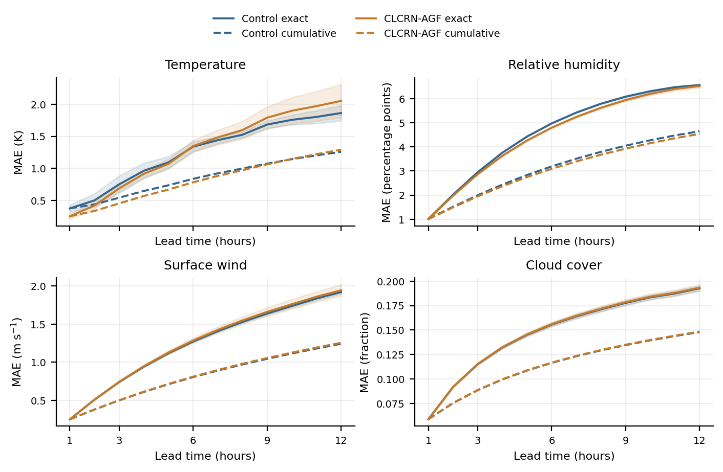
Figure 3. Exact-lead MAE (solid) and cumulative MAE from lead 1 to each plotted hour (dashed), averaged over the same five seeds per variant as Table 1. Shading denotes plus or minus sample SD across seeds for exact-lead MAE. Cumulative endpoints at 12 hours equal the corresponding Table 1 MAEs; panels use task-specific units.

3.4 Precision-matched component comparison
The temperature and humidity ablations use seeds 2023–2025 for all three variants, each with 100 epochs and FP32. Control and gated AGF are the corresponding primary subset; six mean-fusion runs are newly trained under the same protocol. The means and sample standard deviations describe these three replicates. For humidity, the gated model has lower mean MAE and RMSE than mean fusion. For temperature, the ordering depends on the metric: the control has the lowest MAE, whereas mean fusion has the lowest RMSE (Table 2). These are descriptive comparisons with only three replicates per variant; they neither establish a universal gate benefit nor enter the eight-test primary family. Removing AGF removes the complete augmentation, including its residual projection, and changes parameter count, so this comparison does not isolate the learned adjacency alone.
Table 2. Full-budget component comparison, seeds 2023–2025. Values are means $±$ sample SD (K for temperature and percentage points for humidity); these three-seed summaries are descriptive. Removing AGF also changes input width and parameter count.
Task | Variant | Precision | MAE | RMSE
Temperature | Control (no AGF) | FP32 | $1.2325±0.0555$ | $2.1129±0.0433$
Temperature | Mean fusion | FP32 | $1.2672±0.0656$ | $2.0468±0.1027$
Temperature | Full CLCRN-AGF | FP32 | $1.2500±0.1268$ | $2.0575±0.1382$
Relative humidity | Control (no AGF) | FP32 | $4.6361±0.0086$ | $7.2266±0.0430$
Relative humidity | Mean fusion | FP32 | $4.5993±0.0236$ | $7.1322±0.0622$
Relative humidity | Full CLCRN-AGF | FP32 | $4.5550±0.0412$ | $7.0403±0.0475$

3.5 Missing-input robustness
Both variants are evaluated on 64 deterministically spaced common test windows. Node-mask ratios 0.1, 0.2, 0.3 and 0.4 use mask seeds 11, 22 and 33, shared between variants. Masks remain fixed across input hours and signal channels; masked standardized values are replaced by zero, corresponding to the training mean. Masks are averaged within each training seed before summarizing five seeds. These sampled diagnostics (Fig. 4) neither establish full-test robustness nor provide a significance test for robustness differences.
At 40% masking, mean relative MAE changes from each checkpoint’s clean score are Temperature: AGF +465.9%, control +474.1%; Relative humidity: AGF +74.7%, control +73.0%; Surface wind: AGF +84.7%, control +85.7%; Cloud cover: AGF +37.5%, control +35.5%. Each checkpoint supplies its own clean-score denominator, and all variants share the evaluated windows and mask seeds. The large temperature degradation reflects this training-mean-imputation stress test and does not demonstrate behaviour under naturally occurring missingness.
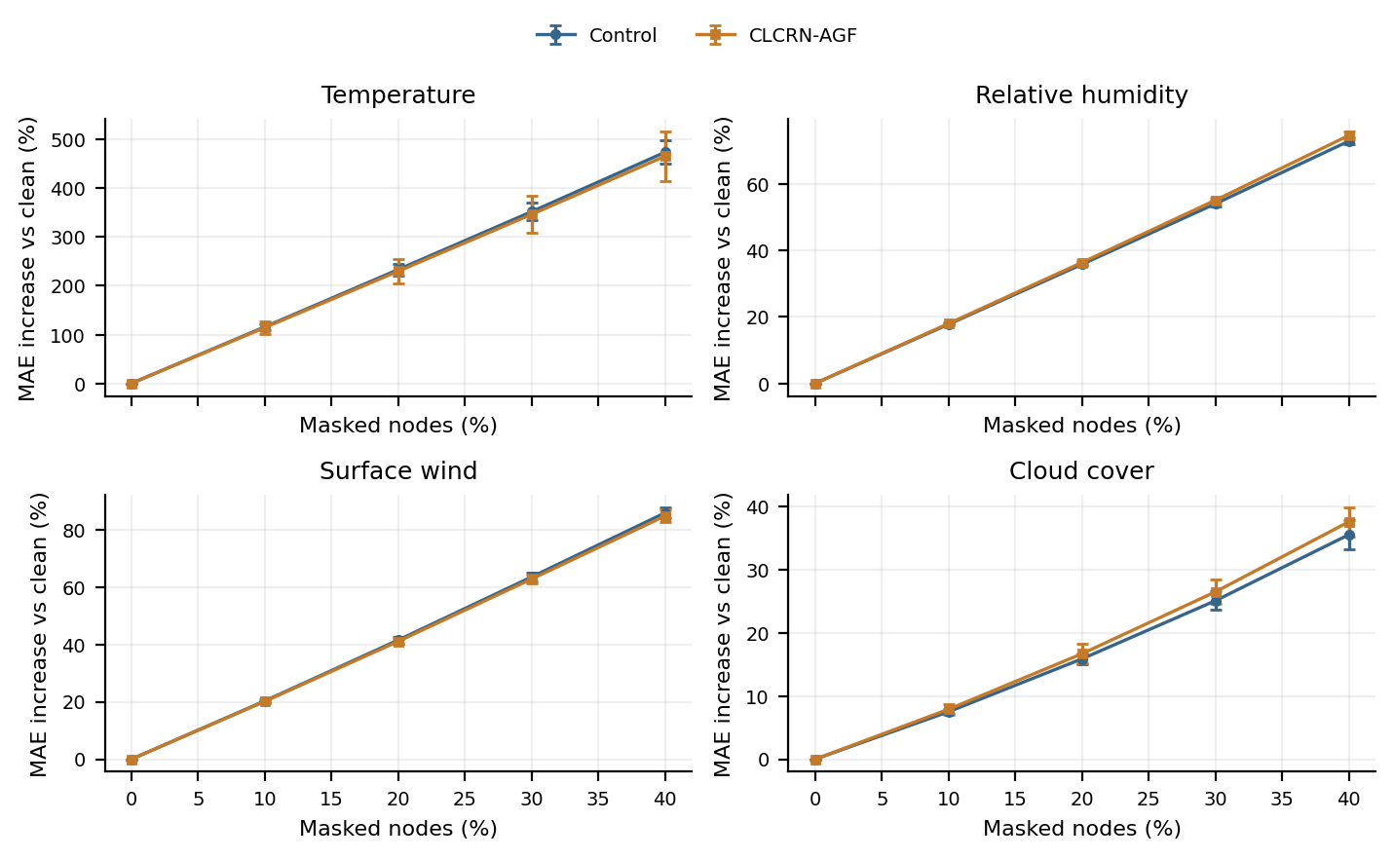
Figure 4. Exploratory missing-input stress test using 64 deterministically spaced test windows, the same five trained seeds per variant as Table 1, and three mask seeds (11, 22, 33) at each nonzero ratio. A node mask is fixed across 12 input hours and all signal channels; standardized inputs are set to zero (training-mean imputation). Changes are relative to the clean score on the same 64 windows for each checkpoint. Masks are averaged within a trained seed; points/error bars show mean plus or minus sample SD across five trained seeds. These are sampled diagnostics, not complete-test performance or statistical significance tests.

3.6 Full-test gate diagnostics
Gate statistics retain all scalar channels, nodes, input hours, test windows and five AGF seeds per task (Table 3; Supplementary Fig. S4). The pooled activation standard deviation is not a between-seed standard error. A coefficient near one half does not imply equal information contribution, and a gate pattern alone does not establish a meteorological mechanism.
Table 3. Gate statistics pooled across the five newly trained AGF seeds. Rounded extrema may equal 0 or 1; this does not imply universal saturation.
Task | Mean | Pooled SD | Min | Max | Scalar gates
Temperature | 0.600 | 0.196 | 0.001 | 1.000 | 645,857,280
Relative humidity | 0.570 | 0.244 | 0.001 | 1.000 | 645,857,280
Surface wind | 0.508 | 0.130 | 0.049 | 0.954 | 645,857,280
Cloud cover | 0.475 | 0.208 | 0.002 | 0.997 | 645,857,280

3.7 Computational cost in context
Across the 46 completed runs, the sum of recorded epoch training-plus-validation durations is 56.34 GPU wall-clock hours on a serial single-GPU queue. This sum excludes initialization, final test inference, interruption/restart overhead and supplementary analysis; it is not an end-to-end campaign-duration or energy estimate.

3.7.0.1 Historical-weight inference microbenchmark.
The following inherited timing evidence uses archived temperature seed-2021 weights, not the newly trained weights in the accuracy tables. It measures a fixed batch of 32 standardized windows, FP32, 12 inputs and 12 outputs, on an RTX 5090 Laptop GPU after 10 warm-up iterations and 30 synchronized repetitions. Historical control/AGF mean batch latencies were 220.53/205.60 ms (iteration SD 18.53/5.43 ms), with peak allocated memory 333.65/614.50 MiB. This sequential repeated-batch profile does not establish a speed advantage, does not measure new-weight inference, and excludes preprocessing. The historical benchmark data remain separately labelled in the supplied revision package.

3.7.0.2 Context relative to recent global weather models.
The scope of CLCRN-AGF is a controlled, task-specific forecast on a $32×64$ grid, using 12 hourly inputs to predict the next 12 hours. Recent global ensemble systems address a substantially broader task (Table 4). WeatherNext 3 reports improved probabilistic skill over WeatherNext 2 for most upper-level targets and surface fields in its 2024 evaluation, with some exceptions at short lead times ¹⁷. FourCastNet 3 reports skill competitive with GenCast and better than IFS-ENS in its 2020 WeatherBench 2-style evaluation ¹⁹. These reports do not establish an accuracy ranking against CLCRN-AGF: the verification years, initial conditions, spatial resolutions, variables, forecast horizons, spatial weighting and deterministic versus probabilistic scores differ. In particular, pressure-level specific humidity is not interchangeable with the relative-humidity target used here. A numerical head-to-head comparison would require harmonized data and verification.

3.7.0.3 Training cost and practical scope.
The reported training resources also differ substantially. WeatherNext 3 uses about 6.7 wall-clock days per model seed; its two seeds jointly require about 4.8 TPUv4 chip-years and 8.9 TPU7x chip-years ¹⁷. FourCastNet 3 reports three stages: 78 h on 1,024 H100 GPUs, 15 h on 512 A100 GPUs, and 8 h on 256 H100 GPUs ¹⁹. These resources are reported separately from inference, and different accelerator types are not converted into a common cost unit. The single-member inference timings in Table 4 are neither full-ensemble timings nor measurements on the hardware used here. CLCRN-AGF is therefore positioned as a compact setting for retraining and controlled methodological studies; this experiment does not establish competitive operational forecast skill or superior speed at matched resolution and forecast coverage.
Table 4. Context from published global-model reports, not a common-test accuracy or hardware benchmark. WeatherNext 3 specifications are taken from the official documentation checked on 8 October 2026. Timings are per ensemble member as reported by the respective research papers.
System | Spatial/temporal output and horizon | Predicted fields | Reported inference
CLCRN-AGF (this study) | $32×64$; hourly; 12 h | Separate temperature, relative-humidity, wind and cloud-cover tasks | Single RTX 5090 Laptop GPU; historical-weight batch profile only; no new-weight timing claim
WeatherNext 3 ^{17,18} | ${0.1}^{∘}$ surface, ${0.25}^{∘}$ pressure levels, ${0.05}^{∘}$ station head; hourly surface output; 15 days for main cycles | Surface/upper-air fields, cloud, radiation, precipitation and station temperature/dewpoint | About 6.3 min per member on 4 TPUv5p chips
FourCastNet 3 ¹⁹ | ${0.25}^{∘}$; 6-hourly; 15-day skill evaluation, rollouts assessed to 60 days | 72 channels: 7 surface fields and 5 variables at 13 pressure levels | About 1 min per 15-day member on one H100 GPU

4 Discussion
The evidence supports a modest relative-humidity improvement from AGF under this fixed protocol, with lower MAE and RMSE after the eight-test correction. It does not support a general improvement across weather targets. The temperature, wind and cloud-cover estimates remain inconclusive, and the broad temperature and wind intervals leave room for both benefit and harm.
The results now address the corrected optimization protocol directly: all primary and mean-fusion models are newly trained with zero-inclusive training and validation, saved every epoch and selected by validation alone. This resolves the earlier training/evaluation support mismatch in the reported accuracy study. It does not guarantee that AGF improves a given target. Negative and inconclusive outcomes are retained in the same tables.
The gate combines graph and residual projections of a common pre-CLConv input. Neither its learned edges nor its scalar coefficients are identified as meteorological teleconnections, moisture transport or causal contribution. The component comparison is precision matched, but only three seeds and two tasks are available for the mean-fusion ablation. Missing-input diagnostics use a sampled test subset and should not be generalized to other types of missingness. No new season-stratified experiment is claimed.
Five independently initialized runs per variant on one chronological split give limited precision and no uncertainty assessment across different climate periods. These seed-level intervals do not treat individual correlated grid points or forecast hours as independent experimental replicates. The fixed test split was used in earlier development and revision work; the new seeds therefore do not constitute an evaluation on a newly reserved test period. The coarse grid, separate task targets and 12-hour horizon remain distinct from modern multivariate medium-range forecasting. Contemporary models require harmonized data, compute and verification before a direct accuracy ranking is meaningful. Dense graph construction limits scaling, and the historical-weight microbenchmark is not a new-weight runtime study.

5 Conclusion
In this controlled experiment, AGF lowers relative-humidity MAE and RMSE by 2.38% and 3.29%, respectively, with both comparisons meeting the eight-test BH threshold. No difference is established for the other six primary comparisons. The result is a task-specific finding about training-seed variability on the existing chronological split. The completed 40-run primary study and six precision-matched ablations provide a traceable test of an incremental AGF input augmentation. The revised claims follow the observed effects, marginal uncertainty intervals and multiplicity-adjusted tests; they do not assert architectural priority for the individual AGF ingredients or parity with global weather models.

6 Funding
This research received no specific grant from any funding agency in the public, commercial, or not-for-profit sectors.

7 Author Contributions
Xinchen Geng conceived the extension, implemented the software, conducted the experiments and analysis, prepared the visualizations, and drafted, reviewed and revised the manuscript.

8 Data Availability
The ERA5-derived WeatherBench data are available from https://mediatum.ub.tum.de/1524895; underlying ERA5 data are available through https://cds.climate.copernicus.eu/. The original CLCRN preprocessed-data link is documented at https://github.com/EDAPINENUT/CLCRN. Third-party weather arrays are not duplicated in full in the revision package. A standardized 32-window temperature batch is retained under historical_context solely for the separately labelled historical inference microbenchmark. The supplementary analysis files contain the primary seed-level metrics, checkpoint provenance, refreshed figure data, and validation records. The earlier public archive at https://github.com/gengx-prog/CLCRN-AGF-Scientific-Reports/releases/tag/v0.1-review is a historical release; it should not be assumed to contain the software and figures supplied with this revision. The new seed-level results and revised analysis are provided in the dated release https://github.com/gengx-prog/CLCRN-AGF-Scientific-Reports/releases/tag/v0.2-retraining-20261008.

9 Code Availability
The accompanying review package contains frozen training and analysis sources, the fixed 46-run plan, configurations, dependency and environment records, seed-level metrics, and scripts to regenerate the tables and figures. It includes one validation-selected checkpoint for each of the 46 runs, together with the complete 100-epoch training histories, run summaries, model configurations and checkpoint hashes. These selected checkpoints support re-evaluation; the package does not contain all 4,600 epoch checkpoints. The full epoch archives remain in the local experiment directory. Recovery states stored in a selected checkpoint pertain to its selected epoch, not necessarily epoch 100. Third-party weather arrays must be obtained from the cited sources and are not included in full. The existing public repository is https://github.com/gengx-prog/CLCRN-AGF-Scientific-Reports. The new training results, revised software and selected checkpoints are provided in release v0.2-retraining-20261008 (8 October 2026): https://github.com/gengx-prog/CLCRN-AGF-Scientific-Reports/releases/tag/v0.2-retraining-20261008.

10 Competing Interests
The author declares no competing interests.

11 Generative AI and AI-Assisted Technologies Disclosure
During preparation of this revision, the author used AI tools for language editing and assistance with code review, analysis scripting, and figure preparation. These tools assisted preparation of the materials; scientific interpretation and responsibility for the manuscript rest with the author.

References
[1] Bauer, P., Thorpe, A. & Brunet, G. The quiet revolution of numerical weather prediction. Nature 525, 47–55 (2015).
[2] Rasp, S. et al. WeatherBench: A benchmark data set for data-driven weather forecasting. J. Adv. Model. Earth Syst. 12, e2020MS002203 (2020).
[3] Hersbach, H. et al. The ERA5 global reanalysis. Q. J. R. Meteorol. Soc. 146, 1999–2049 (2020).
[4] Pathak, J. et al. FourCastNet: A global data-driven high-resolution weather model using adaptive Fourier neural operators. Preprint at https://arxiv.org/abs/2202.11214 (2022).
[5] Bi, K. et al. Accurate medium-range global weather forecasting with 3D neural networks. Nature 619, 533–538 (2023).
[6] Lam, R. et al. Learning skillful medium-range global weather forecasting. Science 382, 1416–1421 (2023).
[7] Price, I. et al. Probabilistic weather forecasting with machine learning. Nature 637, 84–90 (2025).
[8] Lin, H. et al. Conditional local convolution for spatio-temporal meteorological forecasting. Proc. AAAI Conf. Artif. Intell. 36, 7470–7478 (2022). https://doi.org/10.1609/aaai.v36i7.20711.
[9] Li, Y., Yu, R., Shahabi, C. & Liu, Y. Diffusion convolutional recurrent neural network: Data-driven traffic forecasting. In ICLR (2018).
[10] Yu, B., Yin, H. & Zhu, Z. Spatio-temporal graph convolutional networks: A deep learning framework for traffic forecasting. In IJCAI 3634–3640 (2018).
[11] Wu, Z., Pan, S., Long, G., Jiang, J. & Zhang, C. Graph WaveNet for deep spatial-temporal graph modeling. In IJCAI 1907–1913 (2019).
[12] Bai, L., Yao, L., Li, C., Wang, X. & Wang, C. Adaptive graph convolutional recurrent network for traffic forecasting. In NeurIPS 17804–17815 (2020).
[13] Shang, C., Chen, J. & Bi, J. Discrete graph structure learning for forecasting multiple time series. In ICLR (2021).
[14] Liu, H. et al. Spatio-temporal adaptive embedding makes vanilla transformer SOTA for traffic forecasting. In CIKM 4125–4129 (2023).
[15] Vaswani, A. et al. Attention is all you need. In NeurIPS 5998–6008 (2017).
[16] Seo, Y., Defferrard, M., Vandergheynst, P. & Bresson, X. Structured sequence modeling with graph convolutional recurrent networks. In ICONIP 362–373 (2018).
[17] Rasp, S. et al. WeatherNext 3: Increasing resolution and performance of global weather models with raw observations. arXiv preprint arXiv:2609.03582 (2026). https://doi.org/10.48550/arXiv.2609.03582.
[18] Google. WeatherNext 3. Google for Developers https://developers.google.com/weathernext/guides/models (updated 28 September 2026; accessed 8 October 2026).
[19] Bonev, B. et al. FourCastNet 3: A geometric approach to probabilistic machine-learning weather forecasting at scale. arXiv preprint arXiv:2507.12144 (2025). https://doi.org/10.48550/arXiv.2507.12144.
[20] Feng, A. & Tassiulas, L. Adaptive graph spatial-temporal transformer network for traffic flow forecasting. Preprint at https://arxiv.org/abs/2207.05064 (2022).

