Supplementary Information
Evaluating adaptive graph fusion for short-range weather forecasting with conditional local convolution
Xinchen Geng
University of Southern California, Los Angeles, CA 90089, USA
Correspondence: gengx@usc.edu
8 October 2026

S1. Scope, model inventory and evidence authority
This supplement documents 46 newly trained models: 40 primary models (four tasks, two variants, five seeds) and six additional mean-fusion ablations (two tasks, three seeds). Every model completed 100 epochs in FP32 with zero-inclusive training, validation selection and test scoring. All reported accuracy values originate from the new-training evidence package. Historical checkpoint rescoring, screening trials and previous zero-exclusive results do not supply values to these tables.
The Conditional Local Convolution Recurrent Network (CLCRN) and Conditional Local Convolution (CLConv) were introduced by Lin et al.[1]. The present contribution is an incremental adaptive graph-fusion (AGF) input extension and a controlled evaluation. The control is a matched local implementation: both variants use trainable node embeddings, whereas the upstream reference implementation registers those embeddings as a fixed buffer. The experiment therefore does not reproduce every upstream implementation choice.
The 40 primary replicates use seeds 2021–2025. The mean-fusion models use seeds 2023–2025 for temperature and humidity; the other 12 ablation entries reuse the corresponding control and AGF primary models. Thus the 18 ablation entries represent 18 selected models, of which only six are additional to the 40 primary models. The complete 46-row inventory, selected epochs, validation MAE, test scores, parameter counts, relative checkpoint paths and full SHA256 hashes are supplied in data/model_inventory_46.csv.

S2. Data, preprocessing and training protocol
The four WeatherBench-derived tasks are 2-m temperature, relative humidity, joint 10-m wind components ($u,v$), and total cloud cover. Hourly 2010–2018 fields occupy a regular $32×64$ latitude–longitude grid (2,048 nodes). Each example has 12 input hours and 12 target hours. Window starts are separated by 24 hours, and the chronological, unshuffled split contains 2,300 training, 329 validation and 657 test examples. There is one fixed split; training seeds are not cross-validation folds.
Normalization moments are computed from the original training-input arrays, separately for each physical variable and each wind component. Both inputs and targets are cast to float32 before in-place subtraction and division by these moments. This ordering is frozen as curated_float32_then_train_only_standardization_v1. Validation and test data use training moments. Predictions and targets are inverse-transformed to physical units before scoring.
Table S1: Fixed protocol shared by every primary and ablation run.
Item | Specification
Training budget | 100 epochs; early stopping disabled
Optimizer | Adam; learning rate 0.01; $ϵ=0.001$
Batch size | 32 for training, validation and testing
Schedule | MultiStepLR at epochs 10, 20, 30, 40, 50; factor 0.95
Gradient clipping | Global gradient norm 5
Recurrent backbone | Two layers; 32 hidden units; one CLConv view
Geographic neighbours | 25
Feature and backbone node embeddings | 8 dimensions each
AGF node embedding / output width | 10 / 8 dimensions
AGF retained neighbours | Top 4 per directed adjacency row
Decoder curriculum | Decay parameter 2,000
Additional context | No calendar features or periodic encoding
Precision | FP32; AMP and TF32 disabled
Checkpoint selection | Earliest minimum full-validation zero-inclusive MAE
Runtime recorded in training manifest | Python 3.13.7; PyTorch 2.10.0+cu128
GPU recorded in training manifest | NVIDIA GeForce RTX 5090 Laptop GPU; driver 610.88
Table S2: Training-input normalization moments recorded by the evaluator. Physical units apply to both mean and standard deviation.
Variable | Unit | Mean | Std. dev. | Raw dtype
Temperature | K | 278.69592285 | 21.08552551 | float32
Relative humidity | percentage points | 78.13786316 | 18.10952377 | float32
Surface wind ($u$) | m s$​^{−1}$ | -0.11169575 | 5.61085892 | float32
Surface wind ($v$) | m s$​^{−1}$ | 0.22041868 | 4.80938816 | float32
Cloud cover | fraction | 0.67634958 | 0.36162654 | float32
Training and validation MAE include all finite targets, including valid zeros and negative values. A nonfinite prediction at a valid target raises an error. The new inference pass also rejects nonfinite error arrays instead of silently reducing the evaluation support. MAPE is not a primary metric. The raw target-zero audit is shown below; these zeros are observed values, not evidence of missing observations.
Table S3: Exactly zero raw targets by split. Wind combines its two output components.
Task | Split | Zero count | Total targets | Zero fraction (%)
Temperature | Train | 0 | 56,524,800 | 0.00000
Temperature | Validation | 0 | 8,085,504 | 0.00000
Temperature | Test | 0 | 16,146,432 | 0.00000
Humidity | Train | 0 | 56,524,800 | 0.00000
Humidity | Validation | 0 | 8,085,504 | 0.00000
Humidity | Test | 0 | 16,146,432 | 0.00000
Wind | Train | 0 | 113,049,600 | 0.00000
Wind | Validation | 0 | 16,171,008 | 0.00000
Wind | Test | 0 | 32,292,864 | 0.00000
Cloud cover | Train | 2,234,618 | 56,524,800 | 3.95334
Cloud cover | Validation | 315,357 | 8,085,504 | 3.90028
Cloud cover | Test | 626,840 | 16,146,432 | 3.88222
The cloud-cover training correction changes the optimization objective as well as model selection. Raw cloud zeros can acquire small floating-point residuals after standardization and inversion; zero-inclusive support is defined by finiteness and does not depend on exact inverse-transformed equality to zero. The absence of exact raw zeros in the other tasks does not remove the need for a consistent evaluator.
All trainable parameters are materialized before constructing the optimizer. The frozen training workflow audits optimizer membership and gradient coverage. Checkpoints include optimizer, scheduler and random-number-generator states for interrupted-run recovery. cuDNN deterministic mode is enabled and benchmarking is disabled; this does not establish bitwise equivalence across different hardware or software environments.

S3. Validation selection and individual model results
The selected checkpoint is the first epoch achieving the minimum MAE over the complete validation split among epochs 1–100. Test values do not enter selection. All 46 recorded histories contain epochs 1–100 exactly once; the inventory was checked against their earliest minima and against checkpoint/configuration/history SHA256 hashes. The following tables show the selected checkpoint and its cumulative 12-hour test scores. Validation MAE and test errors use the physical units indicated in each caption. Five seed labels do not imply paired stochastic streams across architectures.
Table S4: Temperature primary models (K). Every model trained for 100 epochs.
Variant | Seed | Selected epoch | Validation MAE | Test MAE | Test RMSE
Control | 2021 | 90 | 1.2411 | 1.2543 | 2.0440
Control | 2022 | 80 | 1.3251 | 1.3380 | 2.1234
Control | 2023 | 92 | 1.1584 | 1.1691 | 2.0634
Control | 2024 | 66 | 1.2534 | 1.2722 | 2.1440
Control | 2025 | 92 | 1.2576 | 1.2563 | 2.1314
AGF | 2021 | 67 | 1.3028 | 1.3252 | 2.2316
AGF | 2022 | 100 | 1.3533 | 1.3797 | 2.1862
AGF | 2023 | 87 | 1.2724 | 1.2862 | 2.0017
AGF | 2024 | 78 | 1.1045 | 1.1091 | 1.9559
AGF | 2025 | 90 | 1.3439 | 1.3548 | 2.2149
Table S5: Relative humidity primary models (percentage points). Every model trained for 100 epochs.
Variant | Seed | Selected epoch | Validation MAE | Test MAE | Test RMSE
Control | 2021 | 100 | 4.5983 | 4.6677 | 7.2808
Control | 2022 | 89 | 4.6034 | 4.6638 | 7.2816
Control | 2023 | 82 | 4.5761 | 4.6394 | 7.1854
Control | 2024 | 85 | 4.5756 | 4.6426 | 7.2712
Control | 2025 | 66 | 4.5664 | 4.6263 | 7.2232
AGF | 2021 | 97 | 4.4640 | 4.5222 | 6.9809
AGF | 2022 | 85 | 4.4390 | 4.4986 | 6.9468
AGF | 2023 | 78 | 4.4750 | 4.5348 | 7.0764
AGF | 2024 | 87 | 4.4650 | 4.5279 | 6.9864
AGF | 2025 | 94 | 4.5336 | 4.6024 | 7.0580
Table S6: Surface wind primary models (m s$​^{−1}$). Every model trained for 100 epochs.
Variant | Seed | Selected epoch | Validation MAE | Test MAE | Test RMSE
Control | 2021 | 78 | 1.2470 | 1.2441 | 1.9872
Control | 2022 | 93 | 1.2382 | 1.2357 | 1.9607
Control | 2023 | 98 | 1.2289 | 1.2258 | 1.9365
Control | 2024 | 84 | 1.2547 | 1.2533 | 1.9908
Control | 2025 | 89 | 1.2557 | 1.2512 | 1.9863
AGF | 2021 | 86 | 1.2436 | 1.2392 | 1.9674
AGF | 2022 | 82 | 1.2571 | 1.2548 | 2.0004
AGF | 2023 | 98 | 1.2351 | 1.2334 | 1.9667
AGF | 2024 | 84 | 1.2327 | 1.2309 | 1.9629
AGF | 2025 | 94 | 1.3165 | 1.3201 | 2.1803
Table S7: Cloud cover primary models (fraction). Every model trained for 100 epochs.
Variant | Seed | Selected epoch | Validation MAE | Test MAE | Test RMSE
Control | 2021 | 100 | 0.1472 | 0.1467 | 0.2494
Control | 2022 | 99 | 0.1465 | 0.1458 | 0.2476
Control | 2023 | 91 | 0.1501 | 0.1496 | 0.2523
Control | 2024 | 91 | 0.1503 | 0.1496 | 0.2505
Control | 2025 | 88 | 0.1485 | 0.1479 | 0.2501
AGF | 2021 | 92 | 0.1475 | 0.1469 | 0.2499
AGF | 2022 | 99 | 0.1494 | 0.1488 | 0.2508
AGF | 2023 | 74 | 0.1472 | 0.1466 | 0.2440
AGF | 2024 | 84 | 0.1485 | 0.1480 | 0.2507
AGF | 2025 | 88 | 0.1521 | 0.1515 | 0.2495
Table S8: Six additional mean-fusion models; temperature is in K and humidity in percentage points.
Task | Seed | Selected epoch | Validation MAE | Test MAE | Test RMSE
Temperature | 2023 | 89 | 1.2360 | 1.2544 | 1.9302
Temperature | 2024 | 52 | 1.2059 | 1.2089 | 2.1240
Temperature | 2025 | 98 | 1.3268 | 1.3382 | 2.0860
Humidity | 2023 | 84 | 4.5342 | 4.5981 | 7.1015
Humidity | 2024 | 93 | 4.5124 | 4.5763 | 7.0913
Humidity | 2025 | 84 | 4.5603 | 4.6234 | 7.2037

S4. Primary statistics and exact-permutation sensitivity
Primary MAE and RMSE pool errors over all 657 test examples, 12 leads, 2,048 nodes and output components. With $e_{a}={\hat{y}}_{a}−y_{a}$, $M$ is the total number of scalar targets:
$$MAE=M^{−1}\sum_{a=1}^{M}{|}e_{a}|, RMSE=\sqrt{M^{−1}\sum_{a=1}^{M}{e_{a}^{2}}}.$$
Aggregation uses double precision on differences formed from inverse-transformed FP32 tensors. RMSE is obtained from the pooled squared errors, not an average of per-window or per-lead RMSEs. The scalar tasks have 16,146,432 targets per model; wind has 32,292,864.
For each task/metric, the unit of statistical analysis is a trained model. I report group means and sample standard deviations ($n=5$ per group), the difference $Δ={\overline{x}}_{AGF}−{\overline{x}}_{control}$, and the unadjusted two-sided 95% Welch interval. With $v_{g}=s_{g}^{2}/n_{g}$, the standard error is $\sqrt{v_{A}+v_{C}}$ and the Welch–Satterthwaite degrees of freedom are
$$ν=\frac{(v_{A}+v_{C})^{2}}{v_{A}^{2}/(n_{A}−1)+v_{C}^{2}/(n_{C}−1)}.$$
The interval is $Δ±t_{0.975,ν}\sqrt{v_{A}+v_{C}}$. Two-sided Welch $p$ values receive Benjamini–Hochberg (BH) correction over all eight task/metric tests. Intervals are pointwise, not simultaneous confidence intervals.
Table S9: Primary unweighted estimates. Errors retain task-specific physical units; differences are AGF minus control.
Task | Metric | Control (mean $±s$) | AGF (mean $±s$) | $Δ$ [95% CI]
Temperature | MAE | $1.2580±0.0603$ | $1.2910±0.1075$ | $+0.0330$ $[−0.1004,+0.1664]$
Temperature | RMSE | $2.1012±0.0445$ | $2.1181±0.1292$ | $+0.0168$ $[−0.1408,+0.1745]$
Humidity | MAE | $4.6480±0.0174$ | $4.5372±0.0389$ | $−0.1108$ $[−0.1584,−0.0632]$
Humidity | RMSE | $7.2484±0.0427$ | $7.0097±0.0550$ | $−0.2387$ $[−0.3113,−0.1661]$
Wind | MAE | $1.2420±0.0114$ | $1.2557±0.0372$ | $+0.0137$ $[−0.0318,+0.0591]$
Wind | RMSE | $1.9723±0.0234$ | $2.0155±0.0933$ | $+0.0432$ $[−0.0711,+0.1576]$
Cloud cover | MAE | $0.1479±0.0017$ | $0.1484±0.0020$ | $+0.0005$ $[−0.0022,+0.0031]$
Cloud cover | RMSE | $0.2500±0.0017$ | $0.2490±0.0028$ | $−0.0010$ $[−0.0045,+0.0025]$
The exact-permutation sensitivity uses the absolute difference in group means and enumerates all $\left({10 \atop 5}\right)=252$ allocations, including the observed allocation. Its two-sided $p$ value is the fraction at least as extreme as observed (with ${10}^{−12}$ numerical comparison tolerance). Exactness holds under exchangeable group labels, not the weaker equal-means null with arbitrary unequal variances. Its eight $p$ values form a separate BH family; this sensitivity does not replace primary Welch inference. No paired sign test is used.
Table S10: Primary significance and permutation sensitivity; each pair of $q$ columns uses its own eight-comparison family.
Task | Metric | Change (%) | Welch $p$ | Welch $q$ | Exact $p$ | Exact $q$
Temperature | MAE | +2.625 | 0.570054 | 0.760072 | 0.555556 | 0.770975
Temperature | RMSE | +0.800 | 0.794234 | 0.794234 | 0.777778 | 0.777778
Humidity | MAE | -2.384 | 0.001510 | 0.006040 | 0.007937 | 0.031746
Humidity | RMSE | -3.294 | 0.000082 | 0.000653 | 0.007937 | 0.031746
Wind | MAE | +1.100 | 0.469944 | 0.760072 | 0.634921 | 0.770975
Wind | RMSE | +2.193 | 0.365690 | 0.760072 | 0.452381 | 0.770975
Cloud cover | MAE | +0.306 | 0.707722 | 0.794234 | 0.674603 | 0.770975
Cloud cover | RMSE | -0.408 | 0.510257 | 0.760072 | 0.619048 | 0.770975
Only humidity MAE and RMSE satisfy $q<0.05$ in both families. Their mean reductions are 2.38% and 3.29%, respectively. For both humidity metrics the permutation $p$ is $2/252=0.007937$ and the separately corrected $q$ is 0.031746. The other six comparisons do not establish differences at the stated threshold. Failure to reject a null is not proof of equal performance. These tests quantify training-seed variation on the fixed split and do not estimate variation across climates, periods, splits or datasets.

S5. Latitude-weighted sensitivity
For latitude $ϕ_{i}$, I replace unit weights by $w_{i}=cosϕ_{i}$ and calculate
MAEw=a​wa|ea|a​wa, RMSEw=a​waea2a​wa.
The evaluator normalizes node weights to mean one; repeating them over windows, leads and channels is algebraically equivalent to the displayed denominator. This changes evaluation only, not training, validation selection or checkpoints. Its eight Welch tests constitute a separate sensitivity family. Humidity remains the only task with both corrected metrics below 0.05.
Table S11: Latitude-weighted scores, pointwise Welch intervals and separately corrected $q$ values.
Task | Metric | Control mean | AGF mean | $Δ$ [95% CI] | BH $q$
Temperature | MAE | 1.1722 | 1.2383 | $+0.0661$ $[−0.0971,+0.2293]$ | 0.659747
Temperature | RMSE | 2.0135 | 2.0503 | $+0.0369$ $[−0.1136,+0.1873]$ | 0.659747
Humidity | MAE | 4.6573 | 4.5300 | $−0.1273$ $[−0.1910,−0.0637]$ | 0.010764
Humidity | RMSE | 7.2278 | 6.9485 | $−0.2793$ $[−0.3689,−0.1896]$ | 0.000871
Wind | MAE | 1.2191 | 1.2312 | $+0.0121$ $[−0.0331,+0.0572]$ | 0.659747
Wind | RMSE | 1.9173 | 1.9585 | $+0.0412$ $[−0.0729,+0.1553]$ | 0.659747
Cloud cover | MAE | 0.1595 | 0.1600 | $+0.0005$ $[−0.0024,+0.0034]$ | 0.692620
Cloud cover | RMSE | 0.2528 | 0.2518 | $−0.0009$ $[−0.0044,+0.0025]$ | 0.659747

S6. Persistence on the same split
Persistence repeats the final observed input over all 12 forecast leads. It is evaluated once, with the same inverse transformation, test split, zero-inclusive target support and unweighted aggregation as the trained models. It has no training-seed standard deviation. Control and AGF entries below are means of their five trained replicates. The table is descriptive; persistence is not an additional primary hypothesis test. Historical published CLCRN scores have different evaluation provenance and are not included in this matched table.
Table S12: Current-split cumulative 12-hour error. Humidity units are percentage points; cloud cover is a fraction.
Task | Method | Training replicates | MAE | RMSE
Temperature | Persistence | – | 1.4214 | 2.7001
Temperature | Control | 5 | 1.2580 | 2.1012
Temperature | CLCRN-AGF | 5 | 1.2910 | 2.1181
Humidity | Persistence | – | 6.4248 | 10.4471
Humidity | Control | 5 | 4.6480 | 7.2484
Humidity | CLCRN-AGF | 5 | 4.5372 | 7.0097
Wind | Persistence | – | 1.5372 | 2.5354
Wind | Control | 5 | 1.2420 | 1.9723
Wind | CLCRN-AGF | 5 | 1.2557 | 2.0155
Cloud cover | Persistence | – | 0.1620 | 0.2725
Cloud cover | Control | 5 | 0.1479 | 0.2500
Cloud cover | CLCRN-AGF | 5 | 0.1484 | 0.2490

S7. Three-seed component ablation
The no-AGF condition removes the complete input augmentation and is exactly the matched control. Mean fusion retains the two AGF projections but uses $z=(q+r)/2$ instead of the learned gate. Full AGF uses $z=g⊙q+(1−g)⊙r$. Both branches use the same pre-CLConv input: $q$ is graph-aggregated and $r$ is a node-wise residual linear projection. Neither branch is a CLConv output. All conditions receive the same 100-epoch FP32 budget, and every row uses seeds 2023–2025.
Table S13: Aligned three-seed ablation. Values are mean $±$ sample standard deviation, not five-seed summaries.
Task | Variant | MAE | RMSE
Temperature | No AGF (control) | $1.2325±0.0555$ | $2.1129±0.0433$
Temperature | Mean fusion | $1.2672±0.0656$ | $2.0468±0.1027$
Temperature | Full AGF | $1.2500±0.1268$ | $2.0575±0.1382$
Humidity | No AGF (control) | $4.6361±0.0086$ | $7.2266±0.0430$
Humidity | Mean fusion | $4.5993±0.0236$ | $7.1322±0.0622$
Humidity | Full AGF | $4.5550±0.0412$ | $7.0403±0.0475$
Humidity has progressively lower mean errors from control to mean fusion to learned gating in this subset. Temperature is metric-dependent: control has the lowest mean MAE, while mean fusion has the lowest mean RMSE. The three-seed ablation is descriptive and does not establish that gating is universally necessary. Individual control/AGF values are reported above; the six additional models appear in Table S8. The complete 18-row aligned file is data/ablation_per_seed.csv.

S8. Missing-input diagnostic: 64 windows and three masks
The diagnostic uses 64 deterministic, approximately equally spaced test indices spanning the 657-window chronology, including indices 0 and 656. The exact indices are recorded separately for each task. All primary models share this subset and mask seeds 11, 22 and 33. For each test example and nonzero nominal ratio $r∈\{0.1,0.2,0.3,0.4\}$, the evaluator samples $⌊2048r⌋$ nodes without replacement. The example’s mask is held fixed over all 12 input hours and all input channels. Different examples receive different draws. For a given ratio/mask seed, the same masks are reused across architectures and training seeds.
Masked standardized inputs are set to zero, corresponding to the training mean in physical units. This is input replacement, not target masking, and is distinct from the valid zero-target protocol. Training is unchanged. At each ratio, three relative MAE increases are averaged within each trained seed; the displayed mean and sample standard deviation are then computed across the five trained seeds. Masks are nested technical repeats, not 15 independent training replicates. Each relative increase uses the same checkpoint’s clean MAE on the same 64-window subset:
$$100 \frac{{MAE}_{masked,s,m}−{MAE}_{clean,s}}{{MAE}_{clean,s}}.$$
Table S14: Relative MAE increase (%) on the shared 64-window subset. At zero missingness every relative increase is zero by definition.
Task | Nominal ratio | Masked nodes | Control (mean $±s$) | AGF (mean $±s$)
Temperature | 0.1 | 204 | $115.80±5.96$ | $114.32±12.85$
Temperature | 0.2 | 409 | $233.37±11.93$ | $229.99±25.54$
Temperature | 0.3 | 614 | $352.13±17.85$ | $346.55±38.11$
Temperature | 0.4 | 819 | $474.09±23.92$ | $465.95±50.67$
Humidity | 0.1 | 204 | $17.79±0.31$ | $18.01±0.30$
Humidity | 0.2 | 409 | $35.87±0.58$ | $36.42±0.61$
Humidity | 0.3 | 614 | $54.12±0.82$ | $55.18±0.89$
Humidity | 0.4 | 819 | $72.99±1.02$ | $74.71±1.19$
Wind | 0.1 | 204 | $20.29±0.64$ | $20.12±0.22$
Wind | 0.2 | 409 | $41.47±1.12$ | $41.03±0.70$
Wind | 0.3 | 614 | $63.44±1.57$ | $62.73±1.39$
Wind | 0.4 | 819 | $85.75±1.92$ | $84.67±2.28$
Cloud cover | 0.1 | 204 | $7.50±0.41$ | $7.89±0.85$
Cloud cover | 0.2 | 409 | $15.86±0.89$ | $16.67±1.50$
Cloud cover | 0.3 | 614 | $25.05±1.48$ | $26.45±1.97$
Cloud cover | 0.4 | 819 | $35.49±2.24$ | $37.52±2.29$
AGF does not show uniform missing-input robustness: relative increases are slightly lower for temperature and wind, but higher for humidity and cloud cover. Relative degradation is not a comparison of absolute masked errors between models with different clean errors. Absolute clean/masked MAE and RMSE for all 520 records are supplied in data/robustness_per_seed_mask.csv. This sampled input-replacement diagnostic is not a full-test benchmark or a test of actual missing-observation patterns, and no robustness significance claim is made.

S9. Full-test gate statistics
The gate is $g=σ(W_{g}[r‖q]+b_{g})$ and its value weights the graph-aggregated branch in the fusion above. Statistics are collected from all scalar gate outputs before any channel averaging. Each AGF model contributes $657×12×2048×8=129,171,456$ values; the five-model task pool has 645,857,280 values. All 100 histogram bins over $[0,1]$ sum to the corresponding scalar count. A value displayed as 1.0000 can result from floating-point sigmoid saturation or rounding; it does not indicate a hard selection mechanism.
Table S15: Gate statistics for every AGF training seed. Standard deviation describes scalar gate dispersion within a model.
Task | Seed | Mean | Population SD | Minimum | Maximum
Temperature | 2021 | 0.6156 | 0.2331 | 0.0014 | 0.9967
Temperature | 2022 | 0.6230 | 0.2706 | 0.0010 | 1.0000
Temperature | 2023 | 0.6260 | 0.1393 | 0.1331 | 0.9825
Temperature | 2024 | 0.5789 | 0.1512 | 0.0427 | 0.9746
Temperature | 2025 | 0.5573 | 0.1381 | 0.0640 | 0.9644
Humidity | 2021 | 0.5853 | 0.2412 | 0.0018 | 0.9995
Humidity | 2022 | 0.5685 | 0.2130 | 0.0088 | 0.9992
Humidity | 2023 | 0.6644 | 0.2369 | 0.0164 | 0.9990
Humidity | 2024 | 0.5236 | 0.2417 | 0.0018 | 0.9981
Humidity | 2025 | 0.5107 | 0.2569 | 0.0014 | 0.9993
Wind | 2021 | 0.4950 | 0.1133 | 0.0994 | 0.8989
Wind | 2022 | 0.5045 | 0.1439 | 0.0705 | 0.9541
Wind | 2023 | 0.5129 | 0.1210 | 0.0600 | 0.9177
Wind | 2024 | 0.4954 | 0.1241 | 0.0845 | 0.9529
Wind | 2025 | 0.5304 | 0.1427 | 0.0486 | 0.9418
Cloud cover | 2021 | 0.4632 | 0.2173 | 0.0175 | 0.9850
Cloud cover | 2022 | 0.4416 | 0.2180 | 0.0088 | 0.9970
Cloud cover | 2023 | 0.5452 | 0.1870 | 0.0418 | 0.9799
Cloud cover | 2024 | 0.4603 | 0.1958 | 0.0023 | 0.9763
Cloud cover | 2025 | 0.4666 | 0.2044 | 0.0101 | 0.9702
Table S16: Gate moments pooled across five AGF seeds, with equal scalar support per model.
Task | Mean | Pooled population SD | Minimum | Maximum
Temperature | 0.6001 | 0.1963 | 0.0010 | 1.0000
Humidity | 0.5705 | 0.2445 | 0.0014 | 0.9995
Wind | 0.5076 | 0.1302 | 0.0486 | 0.9541
Cloud cover | 0.4754 | 0.2080 | 0.0023 | 0.9970
The pooled variance includes both within-model dispersion and differences among seed means; it is not the standard deviation of five seed means. The gate values are correlated over space and time and are not independent inferential samples. Their magnitudes do not prove physical interpretability, causal importance or forecast improvement. Both projections have learned scales, so a numerical gate coefficient alone does not measure a branch’s contribution to output error.

S10. Forecast-lead support and reproducibility boundaries
Exact-lead scores use only lead $h$; cumulative scores pool leads 1 through $h$. They must not be interchanged. The machine-readable horizon file contains 480 rows ($40×12$), each with both definitions. At lead 12, every cumulative value agrees with its primary aggregate. The table below illustrates exact-lead scores at 6 and 12 hours; all leads remain available in data/horizon_per_seed.csv. No additional per-lead significance family is claimed.
Table S17: Exact-lead scores (mean $±$ sample SD over five models), in the task-specific physical units.
Task | Variant | Lead (h) | Exact MAE | Exact RMSE
Temperature | Control | 6 | $1.3388±0.0776$ | $2.1614±0.0615$
Temperature | Control | 12 | $1.8639±0.1216$ | $2.8042±0.1336$
Temperature | AGF | 6 | $1.3488±0.0931$ | $2.1260±0.0900$
Temperature | AGF | 12 | $2.0530±0.2591$ | $2.9300±0.2845$
Humidity | Control | 6 | $4.9726±0.0206$ | $7.3972±0.0539$
Humidity | Control | 12 | $6.5617±0.0295$ | $9.2681±0.0595$
Humidity | AGF | 6 | $4.7942±0.0387$ | $6.9943±0.0730$
Humidity | AGF | 12 | $6.5154±0.0749$ | $9.2202±0.0819$
Wind | Control | 6 | $1.2720±0.0095$ | $1.8948±0.0193$
Wind | Control | 12 | $1.9213±0.0247$ | $2.7604±0.0395$
Wind | AGF | 6 | $1.2857±0.0337$ | $1.9330±0.0749$
Wind | AGF | 12 | $1.9446±0.0745$ | $2.8249±0.1559$
Cloud cover | Control | 6 | $0.1555±0.0019$ | $0.2560±0.0019$
Cloud cover | Control | 12 | $0.1927±0.0026$ | $0.3051±0.0020$
Cloud cover | AGF | 6 | $0.1560±0.0021$ | $0.2550±0.0028$
Cloud cover | AGF | 12 | $0.1933±0.0032$ | $0.3034±0.0046$
All 46 inference records were checked against their checkpoint, configuration, summary, training-history and run-manifest digests. The independent supplement audit recomputes means, sample standard deviations, Welch statistics and intervals, all 252 permutation allocations, BH corrections, nested robustness summaries and pooled gate moments. This audit validates the released records and calculations; it is not a new training experiment or an independent implementation of the network.
The maximum absolute difference between the new inference MAE/RMSE and the new training-summary metrics is $4.061×{10}^{−10}$. Small differences arise from aggregation order; historical metrics are not used as the reference for this check.
The source snapshot and supplied processed arrays are the operational reproduction boundary. Data-source JSON files record the SHA256 hashes of trn.pkl, val.pkl, test.pkl and position_info.pkl, together with dimensions and scaler moments. This package does not establish a checksum-verified reconstruction from the original ERA5 archive, broader weather-model competitiveness, uncertainty under alternative data splits, or attribution to a particular physical process. Full retraining requires the processed input arrays, frozen training source, configurations and compatible accelerator environment. Re-running build_supplement.py rebuilds this supplement and its numerical audit from the recorded results; it does not rerun inference.
No fresh training-throughput, inference-latency or memory benchmark is introduced here. Analysis wall-clock fields include evaluation and diagnostics and are not matched timing measurements. Any historical efficiency measurements discussed in the main article retain their separate provenance and must not be presented as measurements of these 46 new checkpoints.

S11. Evidence files accompanying this supplement
The accompanying data/ directory contains the following inspectable records. Complete file digests and original source locations are listed in supplement_sources.json; the supplement’s own audit results are in supplement_validation.json.
- model_inventory_46.csv: the complete new-model inventory with selected validation epochs and full checkpoint hashes.
- primary_per_seed.csv, table1_primary_statistics.csv: 40 primary model values and eight unweighted comparisons, including Welch and exact-permutation statistics.
- latitude_weighted_sensitivity.csv: separately corrected spatial-weighting sensitivity.
- ablation_per_seed.csv, table3_ablation_statistics.csv: 18 aligned entries and six three-seed summaries.
- table2_current_context.csv, persistence_*.json: same-split persistence and model context.
- raw_target_zero_fractions.csv, dataset_*.json: raw-zero support, split dimensions, moments and input-file hashes.
- horizon_per_seed.csv: 480 exact-lead/cumulative records.
- robustness_indices_*.json, robustness_per_seed_mask.csv, robustness_summary.csv: exact 64-window subsets, 520 clean/masked records, and summaries respecting mask nesting.
- gate_per_seed.csv, gate_histogram.csv, table4_gate_statistics.csv: 20 model-level records, 100-bin histograms and pooled full-test gate statistics.
- inference_*.json: 46 new-checkpoint inference records, selected epochs, configuration/checkpoint/history hashes, metric sufficient sums and diagnostics where applicable.
- verification_report.json, provenance_manifest.json, analysis_code_manifest.json: original completion/selection checks, source identities and frozen analysis-code provenance.
Full-resolution supplementary figures follow. Figure S1 is conceptual; Figures S2–S4 are generated from the same new evidence described above. They do not introduce additional trained models or statistical families.

References
[1] Lin, H. et al. Conditional local convolution for spatio-temporal meteorological forecasting. Proc. AAAI Conf. Artif. Intell. 36, 7470–7478 (2022).

S12. Supplementary figures
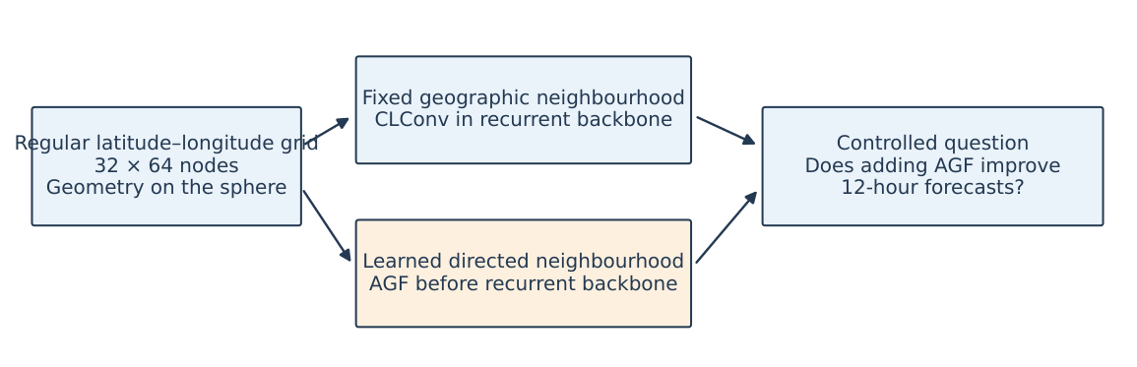
Figure S1: Scope of the controlled comparison. The fixed geographic neighbourhood is used by CLConv in both models. CLCRN-AGF adds a learned directed neighbourhood before the recurrent backbone. This conceptual diagram makes no claim that either neighbourhood identifies a particular physical process or that a measured form of geometric overfitting is reduced.
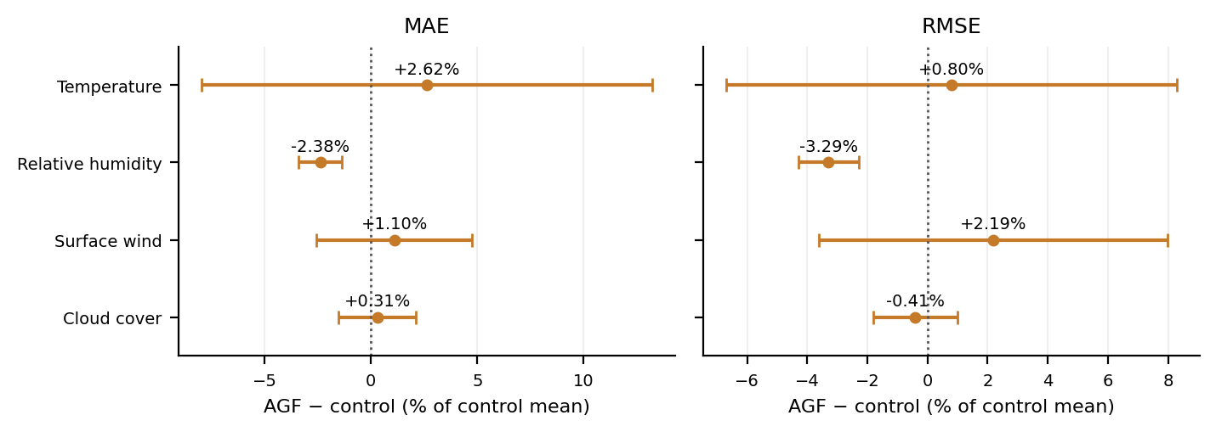
Figure S2: AGF-minus-control mean differences and 95% Welch intervals from Table S9, divided by the corresponding observed control mean and expressed as percentages. Negative values favour AGF. These are rescaled difference intervals, not confidence intervals from a separate ratio estimator. No single selected AGF run or historical schedule result enters this figure.
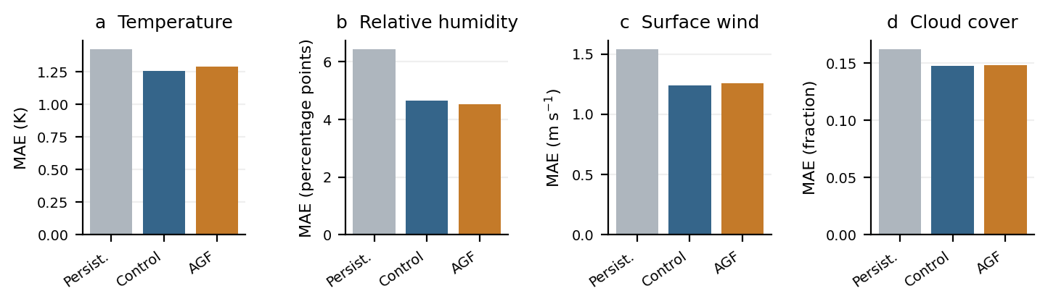
Figure S3: Current-split cumulative 12-hour MAE. Persistence is deterministic; control and AGF are five-seed means. All results use the same zero-inclusive, spatially unweighted evaluator. Panels have task-specific physical units. This is contextual, not a causal decomposition of schedule changes.
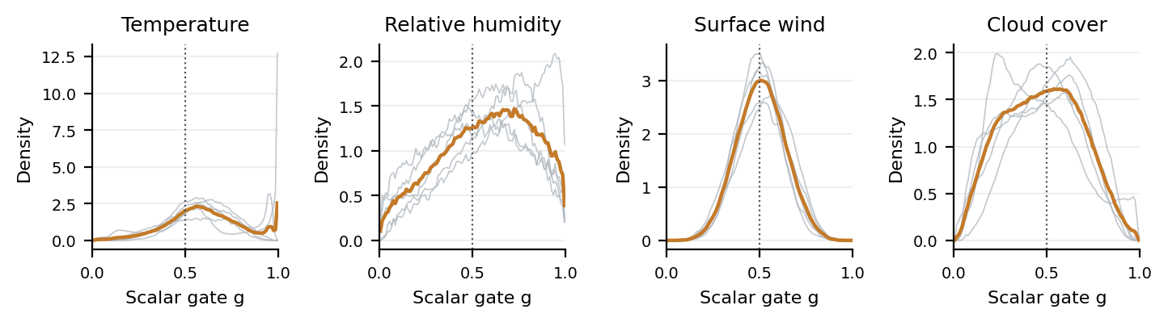
Figure S4: Full-test distributions of scalar sigmoid gates for all four tasks and the same five AGF checkpoints as the primary model tables above. Gates are collected over 657 test windows, 12 input hours, 2048 nodes and 8 output channels per seed. Thin grey curves are individual seeds and the coloured curve is the pooled 100-bin density. The gate mixes adaptive graph aggregation and a nodewise residual projection before CLConv. Gate magnitudes do not by themselves measure the relative contribution of the two branches.

