Heap – data structure

Video related to this lesson: https://www.youtube.com/watch?v=B7hVxCmfPtM&t=83s
I.Introduction to Heap
Motivation :
1. Definition of Heap: An array visualized as a nearly complete binary tree.
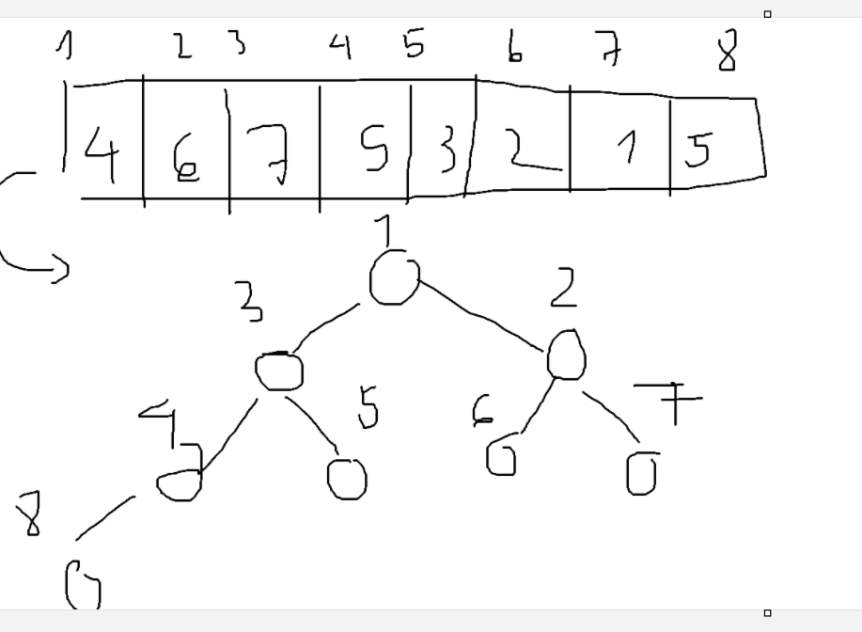
2. Heap as a tree : (these properties are the same as segment tree or other tree datastructures ‘ properties).
- root of the tree : first element ( I = 1)
- parent(i) = I / 2
- left_child(i) = 2 * I , right_child(i) = 2 * I + 1
3. Some types of Heap: Max_heaps , Min_heaps.
II. Max_heaps property: The key of the node >= their children keys.
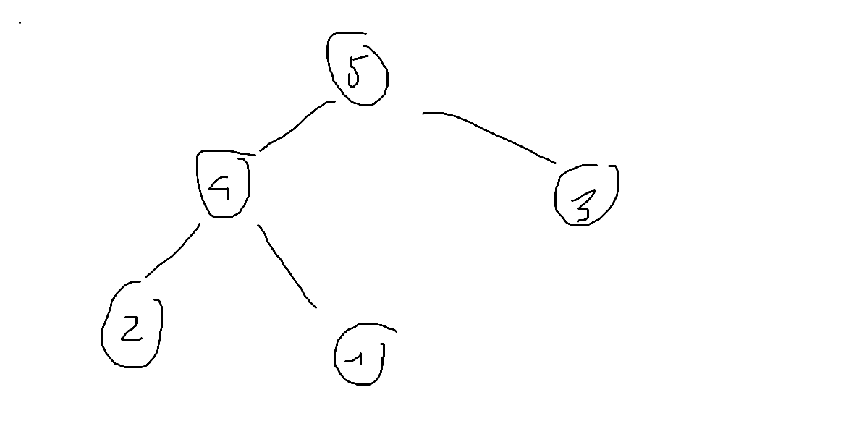
Heap is often related to sorting, and if we combine two algorithms together, we can have a fascinated sorting algorithm. But there is an issue “How we can deal with unsorted array”. 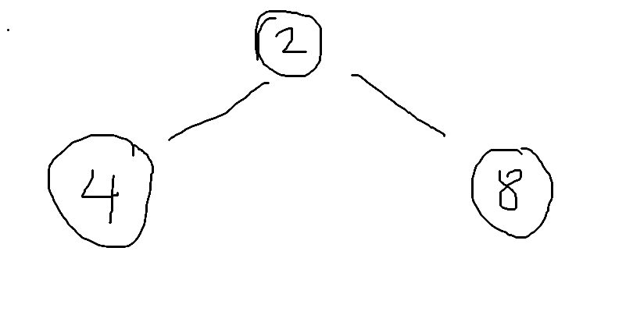
This problem is a motivation for max heap’s operation that I discuss below :
- Build_max_heaps : produce a max heap from unordered array.
To conduct this operation, we must have another operation that allow fixing violations in heaps, therefore we have max_heapify to do that.
- Max_heapify : an operation that allow us to fix single violation with a tree, rooted by a subtree’s root. For example :
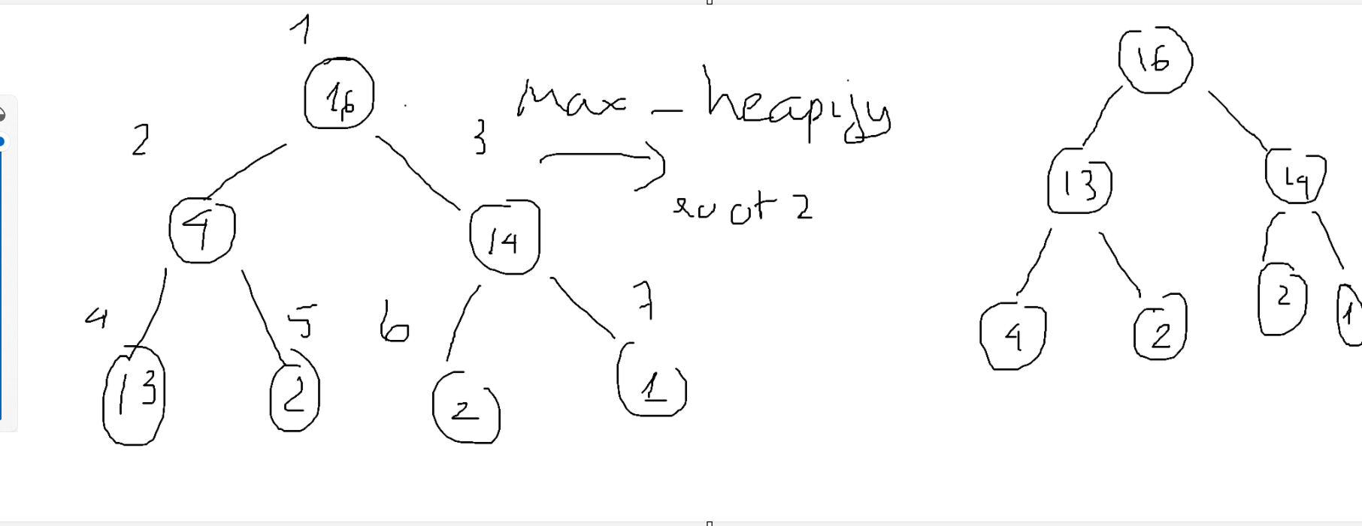

When we do the operation, we must follow the rule of exchanging : always exchange with the bigger child as after exchanging, that node can be a root of subtree.

How can we conduct

