A PROJECT REPORT
ON
FURNITURE AND APPLIANCE
RENTAL MANAGEMENT SYSTEM

A MERN Stack application

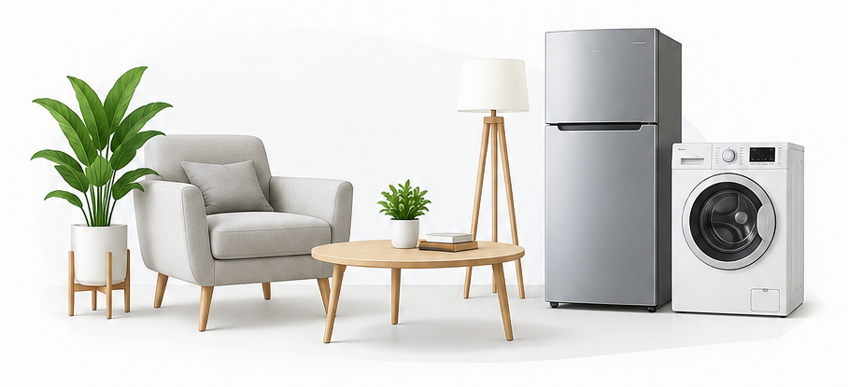

Submitted by: Rohit Thakur
Contact: 8847482208
Email: rohitthakur792002@gmail.com
Github: https://github.com/geniusHit
Linkedin: https://www.linkedin.com/in/rohit-thakur-370778240/

DECLARATION
I hereby declare that the project titled “Furniture and Appliance Rental Management System” is my original work and has been developed as part of my project work at Unified Mentor.
The project has been designed and implemented using the MERN Stack (MongoDB, Express.js, React.js, and Node.js). I confirm that the work presented in this project report has been completed by me and that all external resources, references, and technologies used during the development have been appropriately acknowledged.
I further declare that the information provided in this report is accurate to the best of my knowledge and that the project has been developed for educational and practical learning purposes.

ABSTRACT
The Furniture and Appliance Rental Management System is a web-based application developed using the MERN stack. The primary objective of the system is to provide users with an easy and convenient platform for renting furniture and household appliances for a specified period.
The application allows users to register and log in, browse available products, view product details, add products to their rental selection, and make rental payments. The system also provides authentication and secure management of user information. Administrators can manage products and rental-related information.
The project uses React.js for the frontend, Node.js and Express.js for backend development, and MongoDB for database management. Additional technologies and services are integrated where required for authentication, payment processing, and deployment.

TABLE OF CONTENTS

INTRODUCTION
Renting furniture and household appliances has become an attractive alternative to purchasing expensive products, particularly for students, working professionals, people who frequently relocate, and temporary residents.
Traditional rental processes often involve visiting physical stores, manually checking product availability, and completing paperwork. The proposed system provides an online platform where customers can browse furniture and appliances, check their details, select rental periods, and complete the rental process digitally.
The system is developed using the MERN stack, consisting of MongoDB, Express.js, React.js, and Node.js.

PROBLEM STATEMENT
Purchasing furniture and appliances can require significant financial investment, especially when the products are needed only for a limited period. Existing rental processes may involve physical visits, limited product information, manual records, and inefficient communication.
Therefore, there is a need for an online rental platform that allows users to easily discover products, view their details, check availability, and rent them through a convenient digital process.

OBJECTIVES
Main objectives
- Develop an online furniture and appliance rental platform.
- Allow users to register and securely log in.
- Provide users with a catalog of rental products.
- Allow users to view detailed product information.
- Allow users to select products for rental.
- Implement rental/payment functionality.
- Maintain user and product information using MongoDB.
- Provide secure communication between frontend and backend.
- Provide an administrative mechanism for managing products.
- Deploy the application so it can be accessed online.

SCOPE OF THE PROJECT

Customer
Customers can:
- Create an account
- Log in
- Browse products
- Search/filter products
- View product details
- Select rental products
- Make payments
- View their rental information
- Log out

Administrator
Depending on what you've implemented, administrators can:
- Add products
- Update products
- Delete products
- Manage product availability
- View rental information
- Manage users

EXISTING SYSTEM

In a traditional furniture rental system, customers may need to visit rental stores physically. Product information, availability, rental duration, and pricing may be communicated manually. This process can be time-consuming and inconvenient.

Its disadvantages :
- Physical visits may be required.
- Limited product visibility.
- Manual record keeping.
- Time-consuming rental process.
- Difficult availability management.
- Limited accessibility.

PROPOSED SYSTEM

The proposed system provides an online platform where customers can browse and rent furniture and appliances from a single application. The system automates several parts of the rental process and provides a user-friendly interface for customers.

Advantages
- Online access
- Easy product browsing
- Centralized database
- Faster rental process
- Secure authentication
- Online payment
- Better product management
- Reduced manual work

TECHNOLOGY STACK

Technology | Purpose
React.js | Frontend/UI
Node.js | Backend runtime
Express.js | REST API/server
MongoDB | Database
Mongoose | MongoDB interaction
JavaScript | Application logic
HTML | Page structure
CSS | Styling
JWT | Authentication
Cashfree | Payment processing
Git/GitHub | Version control
Vercel | Deployment

SYSTEM REQUIREMENTS

Hardware Requirements
- Processor: Intel Core i3 or equivalent
- RAM: 4 GB minimum
- Internet connection

Software Requirements
- Windows/Linux/macOS
- Node.js
- npm
- MongoDB
- VS Code
- Git
- Modern web browser

SYSTEM DESIGN

Architecture Diagram
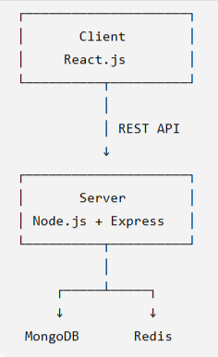

DATABASE DESIGN

User
|----- name
|----- email
|----- phone
|----- password
|----- pincode
|----- address
|----- loggedInIPS
|----- IP
|----- expireAt

Products
|----- imageNames
|----- name
|----- sku
|----- category
|----- condition
|----- brand
|----- material
|----- description
|----- price
|----- quantity
|----- securityDeposit
|----- stockKeepingUnit
|----- deliveryCharge
|----- returnPolicy
|----- assemblyRequired
|----- notes
Rental Items
|----- user
|------ name
|------ email
|------ pincode
|------ address
|----- name
|----- imageNames
|----- productName
|----- sku
|----- condition
|----- brand
|----- material
|----- description
|----- price
|----- quantity
|----- securityDeposit
|----- stockKeepingUnit
|----- deliveryCharge
|----- returnPolicy
|----- assemblyRequired
|----- notes
|----- rentDays
|----- rentedDate
|----- deliveryStatus

Logged Users
|----- email
|----- IP
|----- expiry

Modules of the Project
- Signup & OTP Module
This module handles new user registration with email OTP verification and password encryption.
- OTP Generation & Email Verification: A six-digit OTP is randomly generated and sent to the user's registered email address using Nodemailer with Gmail SMTP.
- OTP Validation: The frontend verifies the OTP entered by the user before allowing the registration to proceed.
- User Registration: After successful OTP verification, the user's details are sent to the backend and stored in MongoDB.
- Password Security: The password is encrypted using bcrypt hashing with 10 salt rounds before being saved to the database.
- IP Tracking: The user's public IP address is obtained using the IPify API and included during registration.
In short: The module provides a secure signup process by verifying the user's email through OTP and protecting their password using bcrypt hashing.

- User Login & Session Management Module
This module handles user authentication and login session management.
- User Authentication: The system searches for the user by email and verifies the entered password against the stored bcrypt-hashed password.
- JWT Authentication: After successful login, a JWT token is generated containing the user's basic account information and is returned to the frontend for authentication.
- IP-Based Login Tracking: The user's IP address is recorded along with an expiry time to track active login sessions.
- Duplicate Session Handling: If the same IP is already logged in, the previous entry is removed and the latest login session is stored.
- Logged User Management: The system maintains a separate collection of logged-in users by removing the existing session for the IP and saving the new session.
- Error Handling: Invalid login requests or server errors return an error response, which the frontend displays as a password error.
In short: This module provides secure user login using bcrypt password verification, JWT authentication, IP-based session tracking, and login-session management.
- Home Page Module
This module implements the main landing page of the rental application and provides users with quick access to products and categories.
- Navigation: Displays the common navigation bar and footer for accessing different sections of the application.
- Image Carousel: A Bootstrap carousel displays multiple furniture images and automatically changes slides every 3 seconds.
- Catalog Navigation: The Browse Catalog button redirects users to the product catalog and clears any previous search.
- Featured Categories: Provides clickable categories such as Living Room, Bedroom, Office, and Outdoor. Selecting a category stores the search keyword in local storage and redirects the user to the catalog.
- Visual Presentation: Uses furniture images, promotional text, and a working-section image to create an attractive landing page.
- React Navigation: useNavigate() is used to navigate users programmatically to the catalog based on their selection.
In short: The Home Page module provides an attractive landing page with an automatic image carousel, featured product categories, catalog navigation, and responsive visual content, helping users quickly explore available rental products.
- Product Catalog, Search & Rental Payment Module
This module manages the complete product browsing, searching, rental, and payment workflow of the application.
- Product Listing: Fetches all products from MongoDB and displays their images, names, prices, availability, and rental duration options.
- Product Search: Allows users to search products by name, brand, condition, description, notes, or category using MongoDB regular-expression queries.
- User Identification: Retrieves the currently logged-in user using their IP address and obtains their account details for the rental process.
- Rental & Payment: When a user selects Rent Now, the system creates a Cashfree test payment link containing the product and customer details and redirects the user to the payment page.
- Payment Verification: After returning from payment, the system decodes the stored payment token, verifies the payment status through Cashfree, and proceeds only when the payment status is PAID.
- Rental Creation: After successful payment, the selected product is added to the user's rental items with details such as rental days, delivery status, address, price, and rental date.
- Inventory Management: After adding a rental, the product quantity is decreased by one to maintain availability.
- Payment Token Management: The payment token is temporarily stored in MongoDB and deleted after the rental process is completed.
- User Feedback: A modal displays the result of the rental operation, such as successful addition or an already-existing rental item.
In short: This module provides the complete product catalog → search → user verification → payment → payment verification → rental registration → inventory update workflow of the rental system.
- How It Works Module

This module explains the furniture rental process and highlights the key benefits offered by the FurniRent platform.
- Rental Process: The system presents the rental journey in four simple steps: Browse & Choose, Select Rental Plan, Delivery & Setup, and Enjoy & Return.
- Step-Based Guidance: Each step uses icons, numbering, titles, and descriptions to clearly explain the rental process.
- Key Features: The page highlights important benefits such as Affordable Pricing, Quality Assurance, 24/7 Support, Flexible Rental Plans, and Fast Delivery.
- Hero Section: Provides an introduction to the furniture rental service along with relevant visual content.
- Call to Action: A dedicated section encourages users to browse the available furniture catalog.
- Reusable Components: The steps and features are stored in arrays and rendered dynamically using React's map() function, making the content easy to maintain and extend.

In short: The How It Works module provides users with a clear overview of the rental procedure, platform benefits, and next steps, making the rental process easy to understand.

My Rental Items Module

This module allows a logged-in user to view the furniture items they have currently rented.
- User Identification: The system retrieves the user's IP address and uses it to identify the currently logged-in user.
- Login Verification: The user's login information is fetched from the backend using their IP address before rental items are requested.
- Rental Items Retrieval: The backend searches the rental-items collection using the user's email address and returns the items associated with that user.
- Rental Item Display: The frontend displays each rented product with its image, name, and monthly rental price.
- Empty State Handling: If no valid logged-in user is found, the rental-items list is cleared.

In short: The My Rental Items module provides users with a personalized view of their rented furniture by identifying the logged-in user and retrieving their rental records from MongoDB.

Screenshots
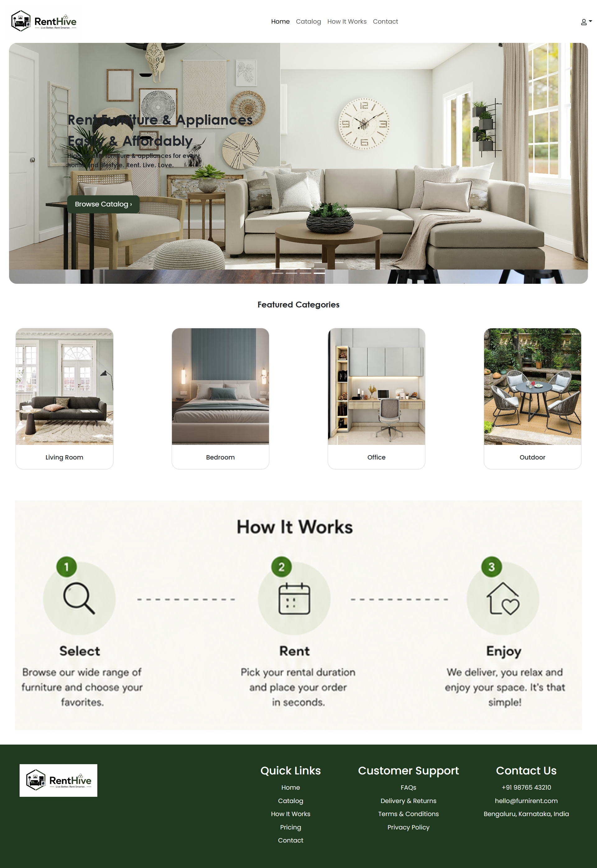
Catalog :
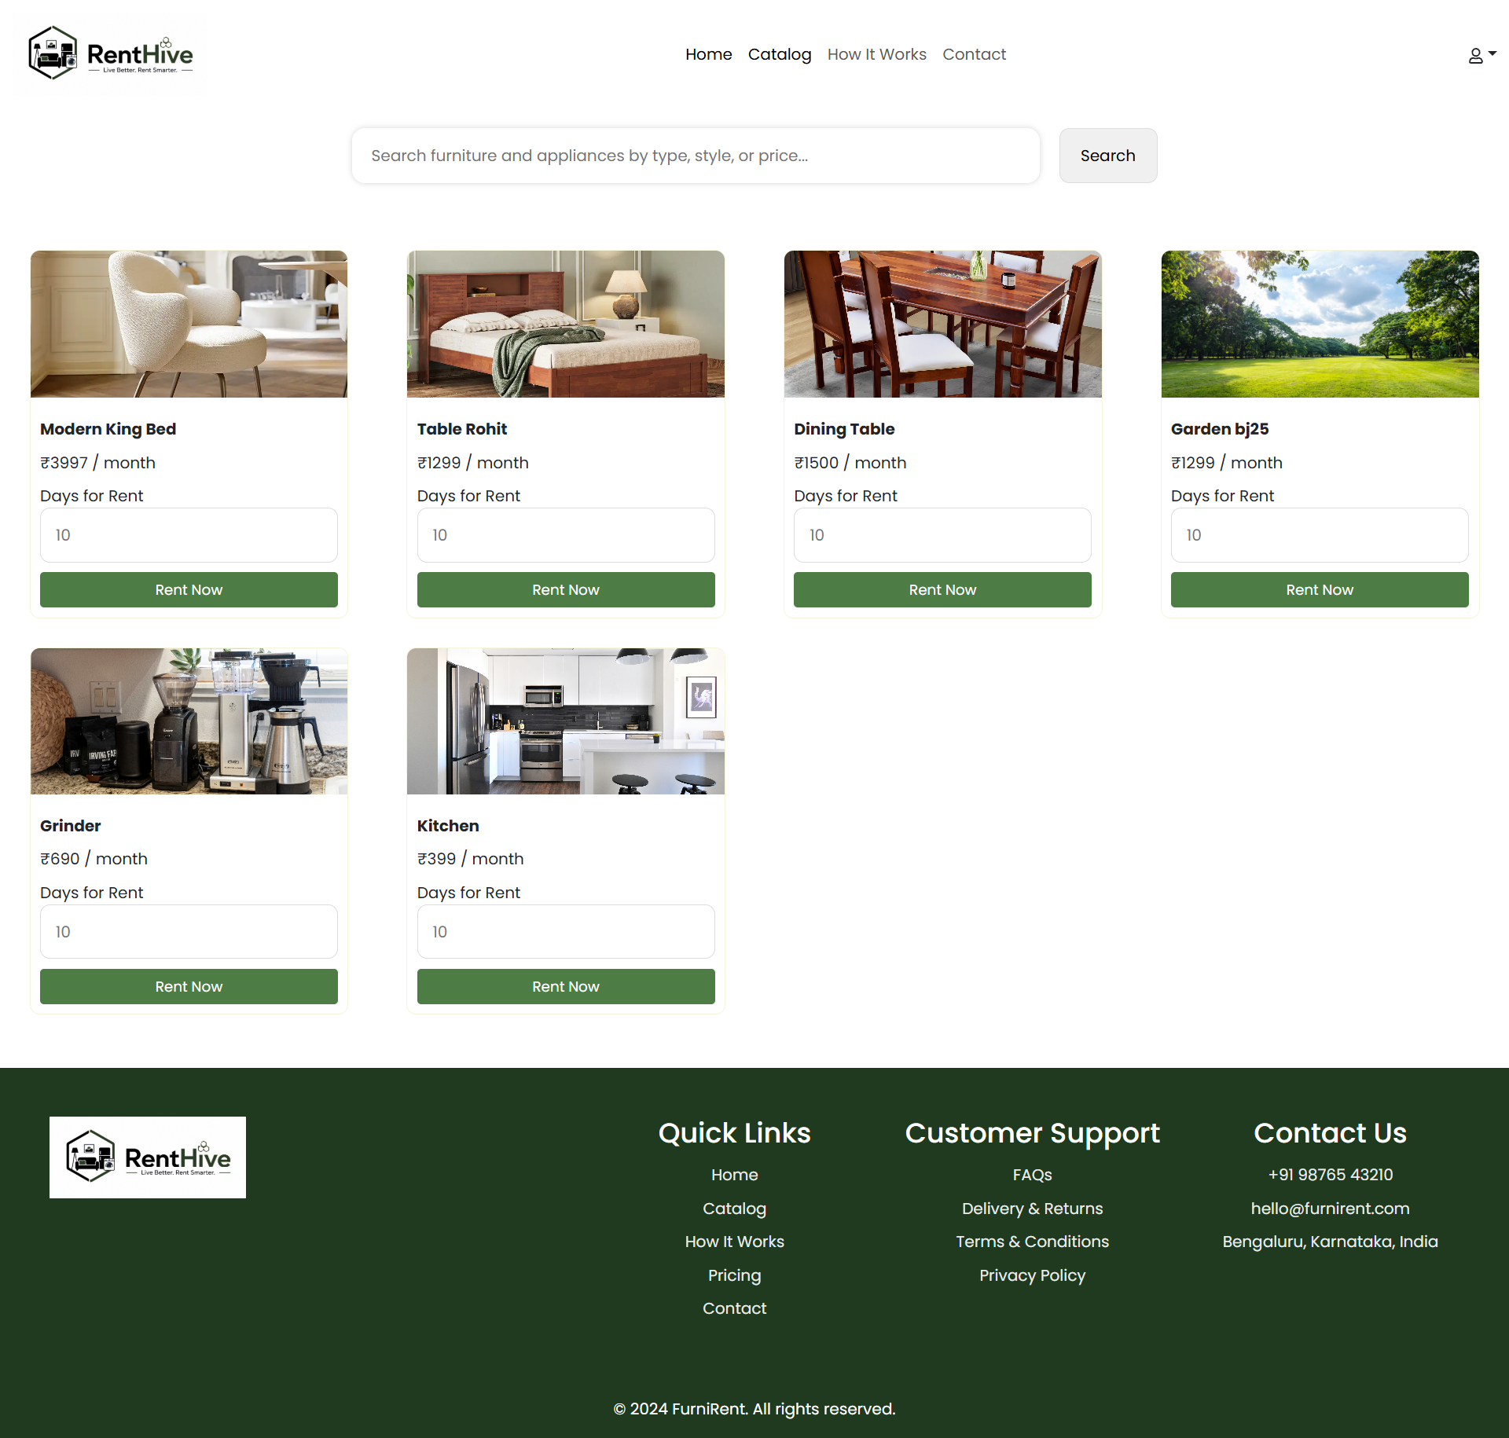

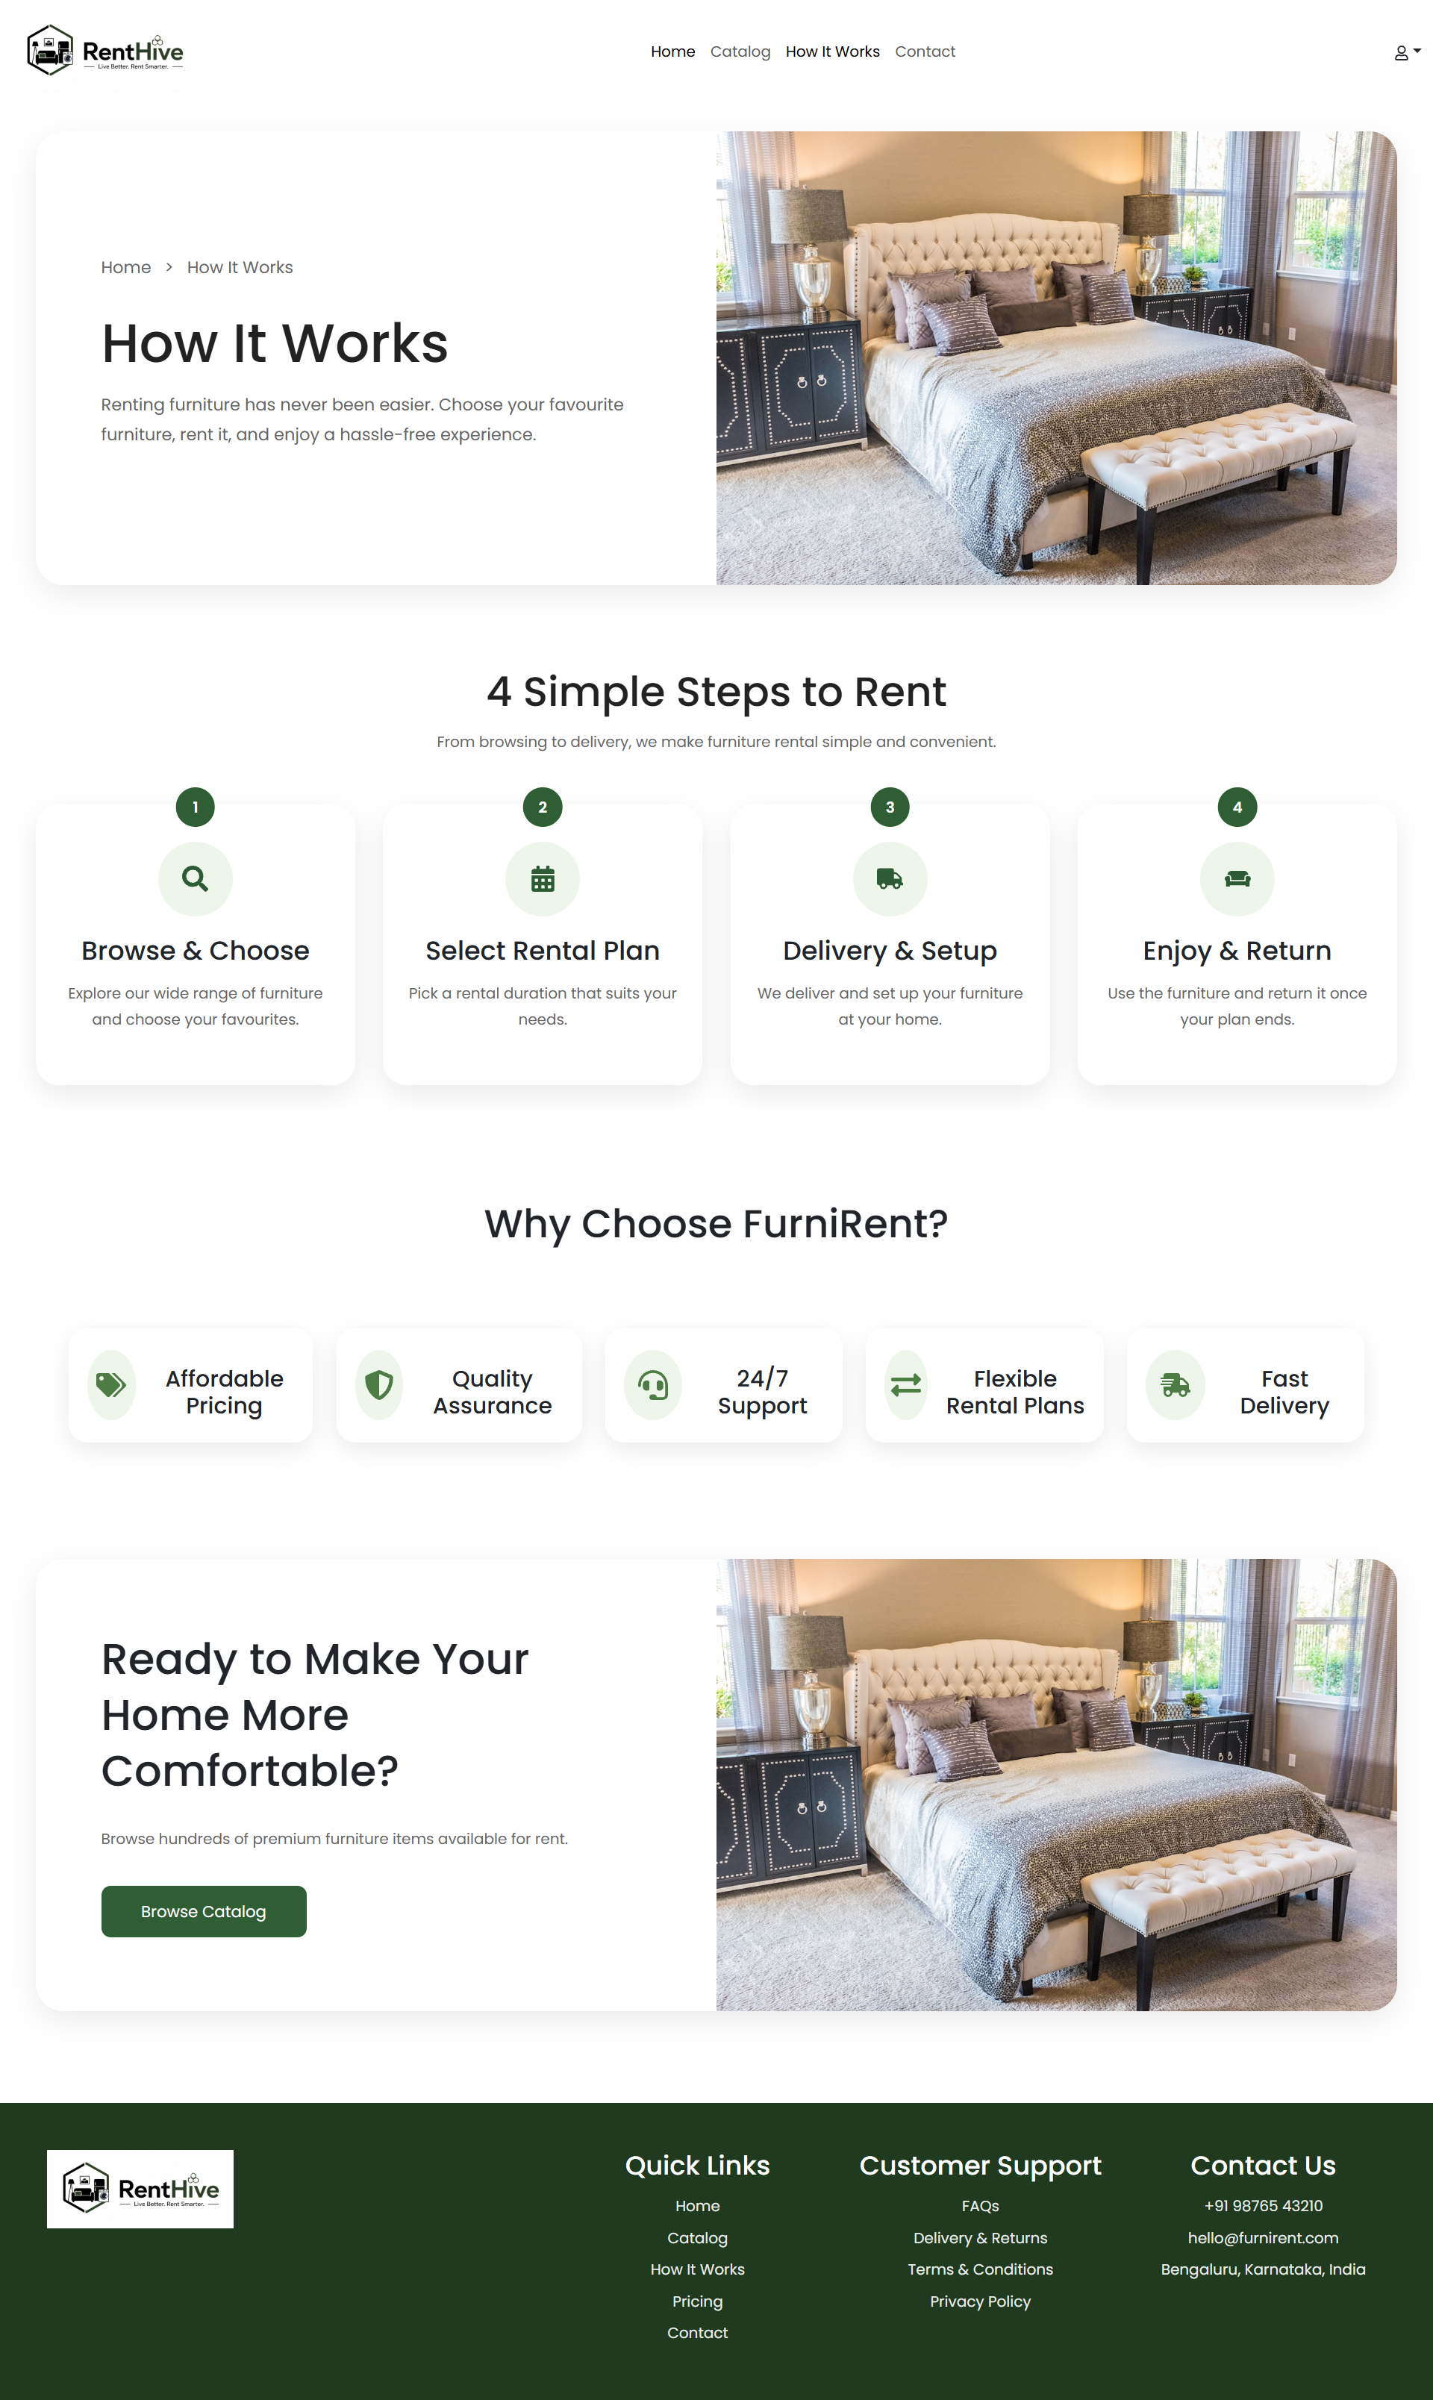
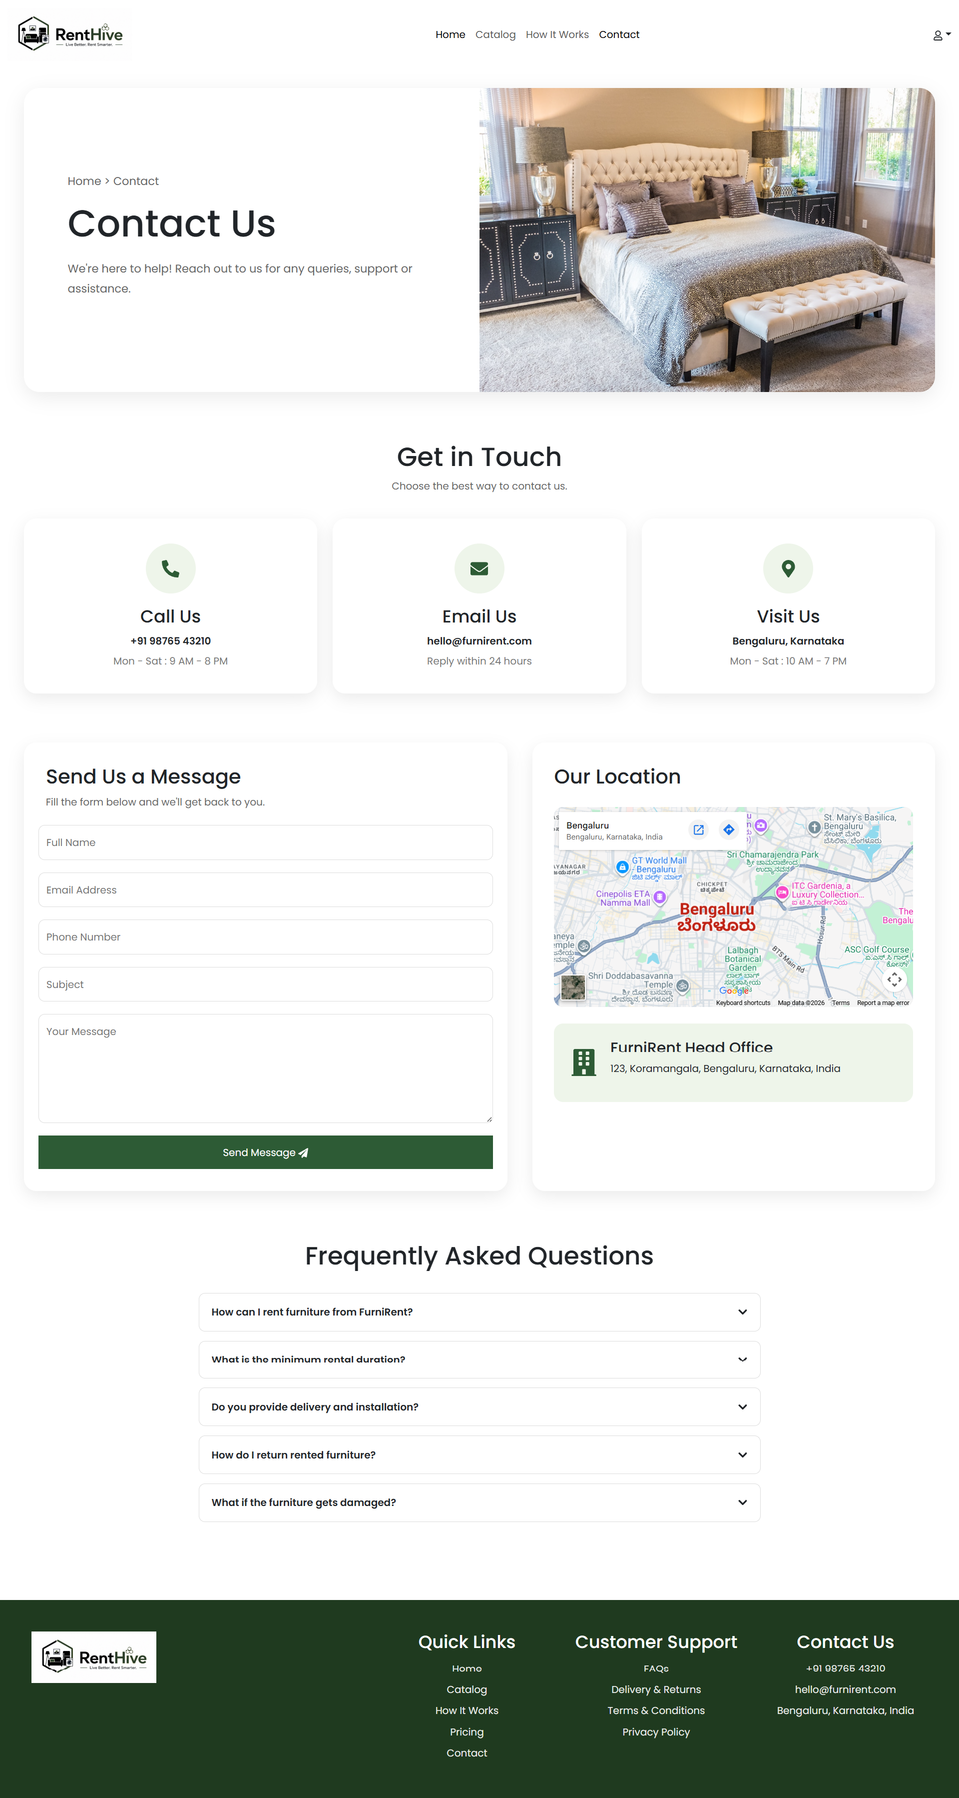
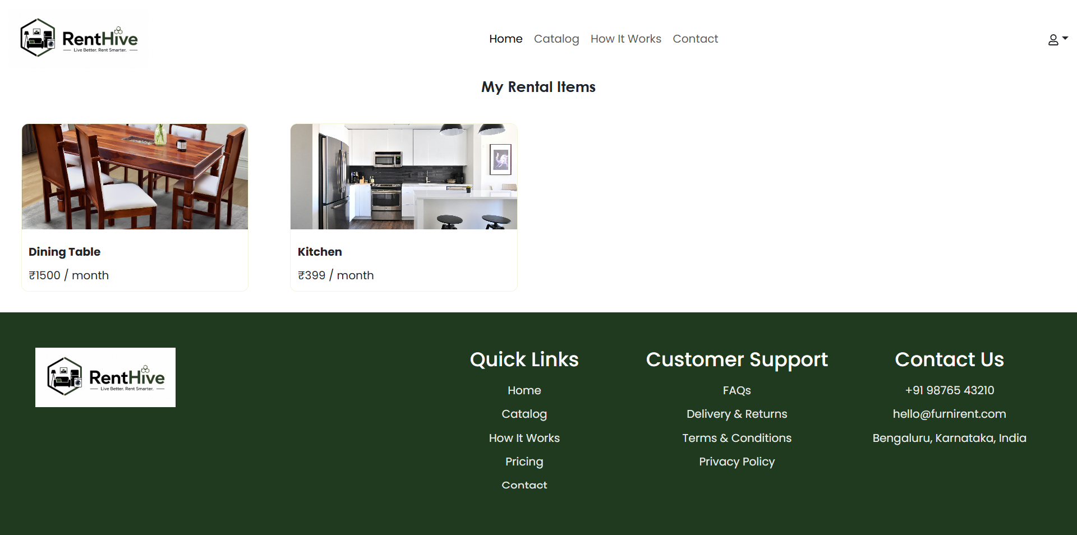

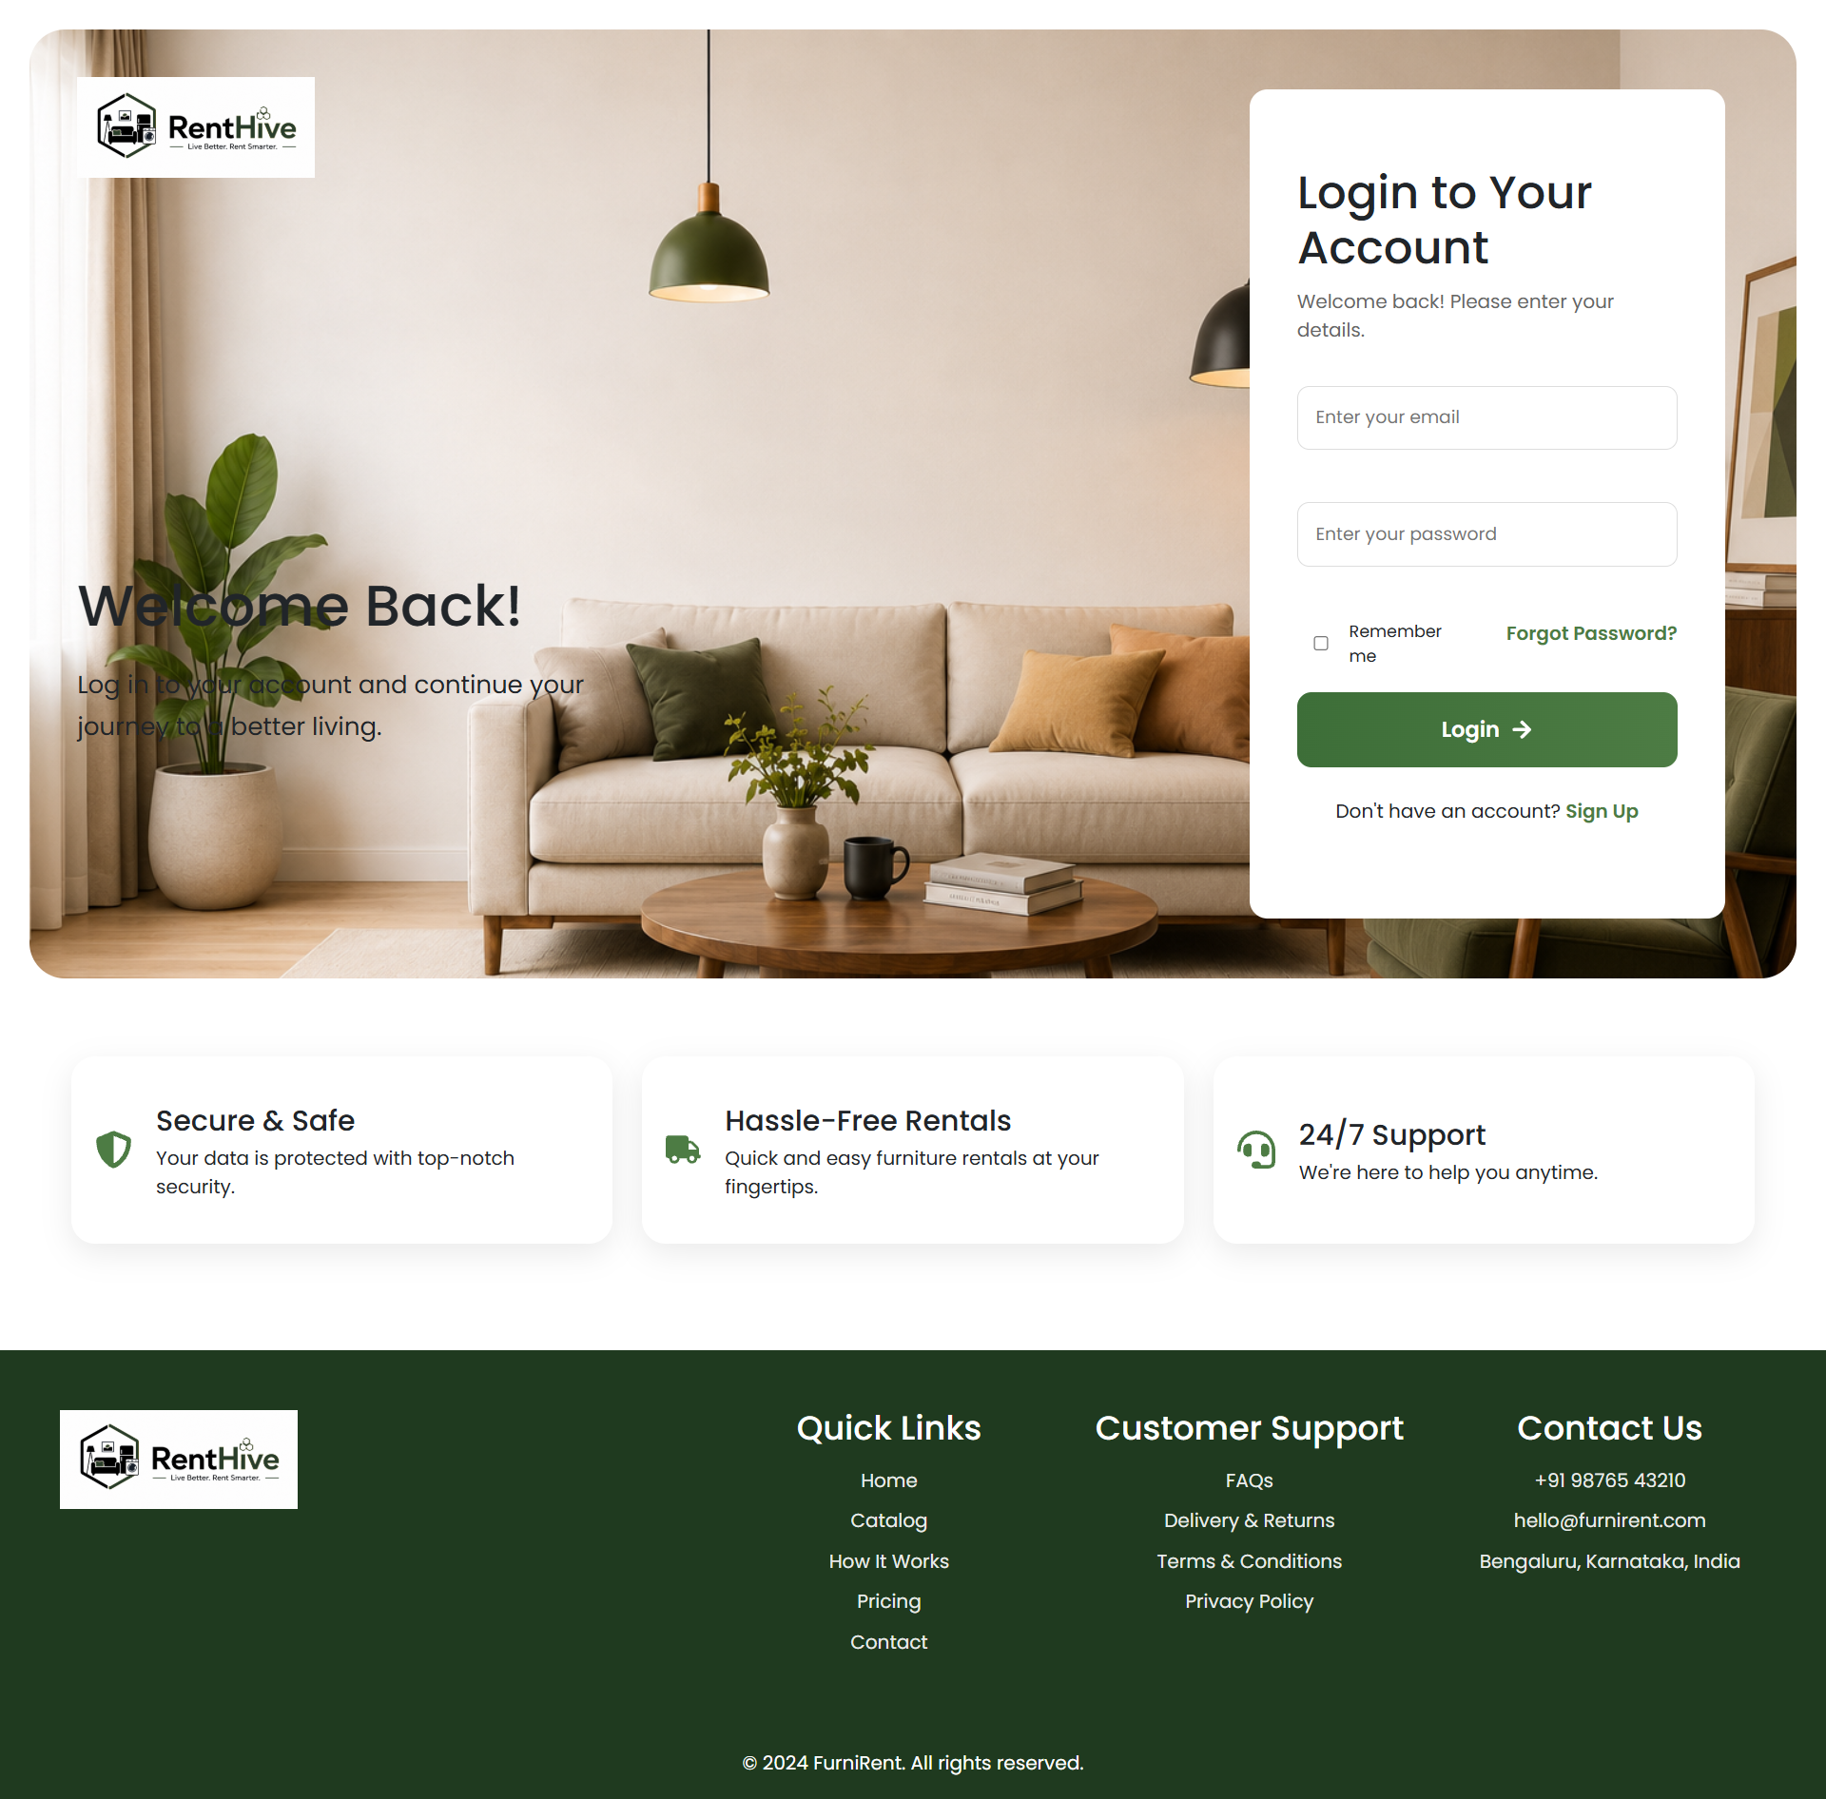

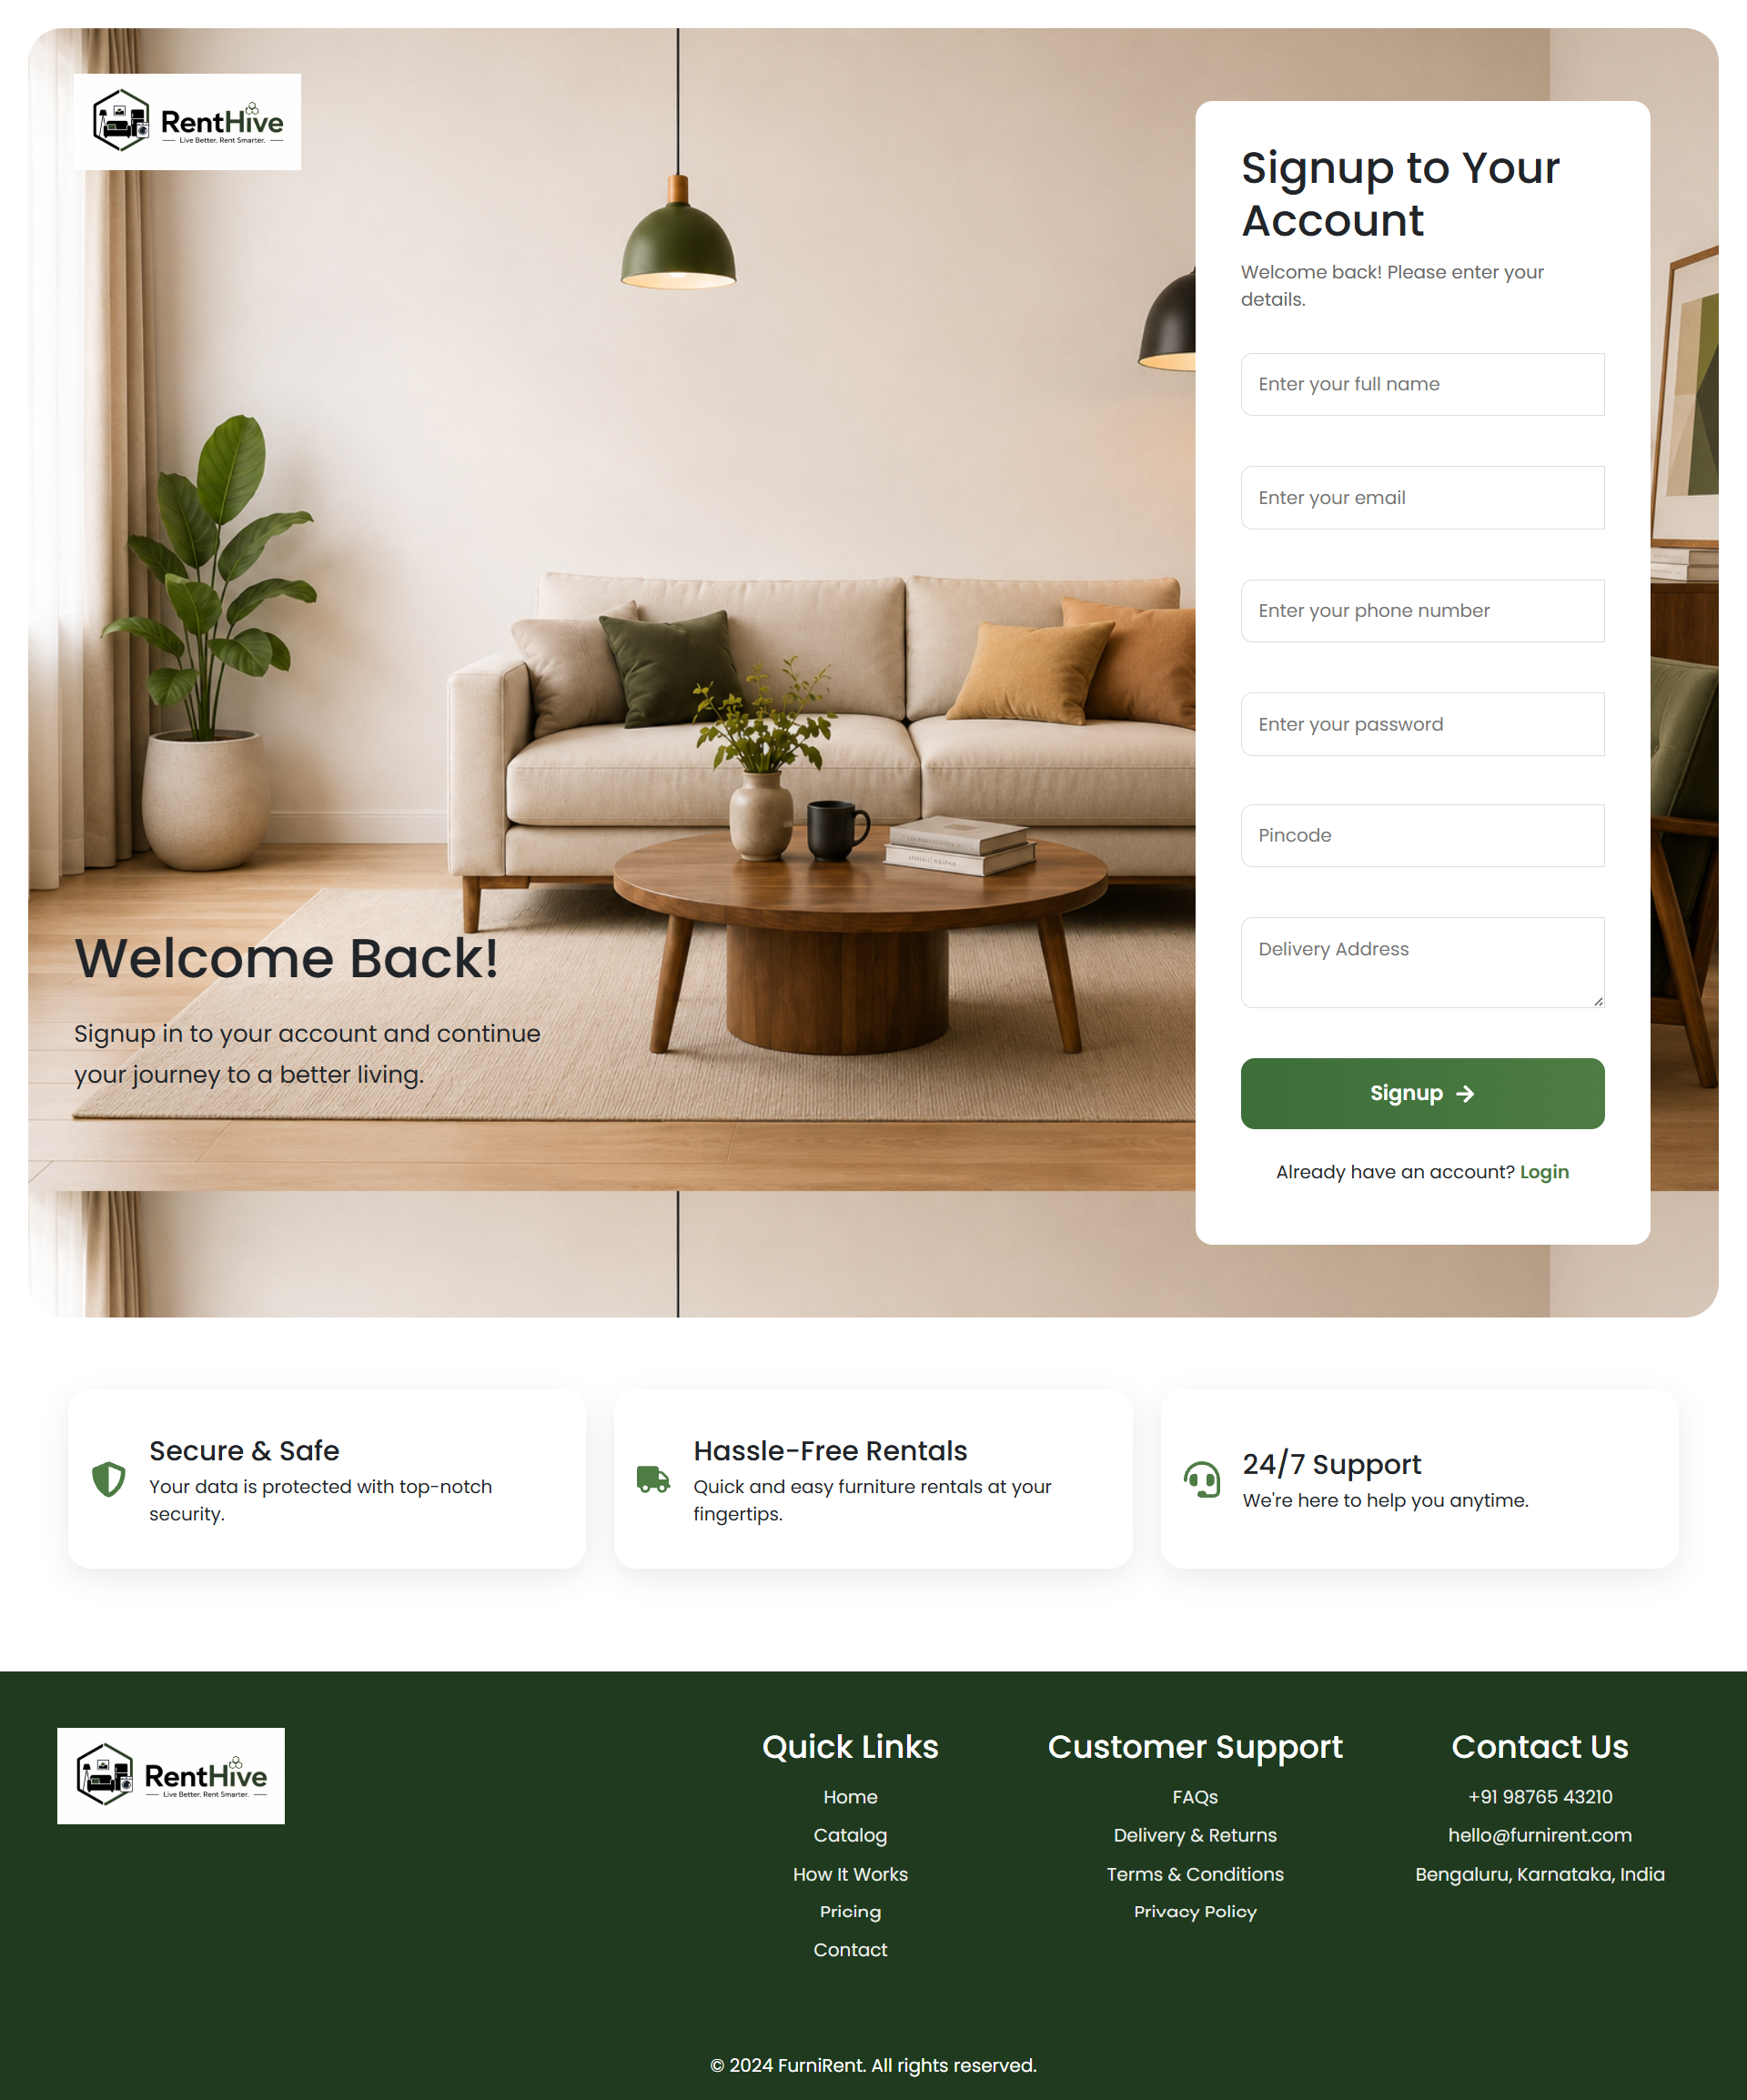

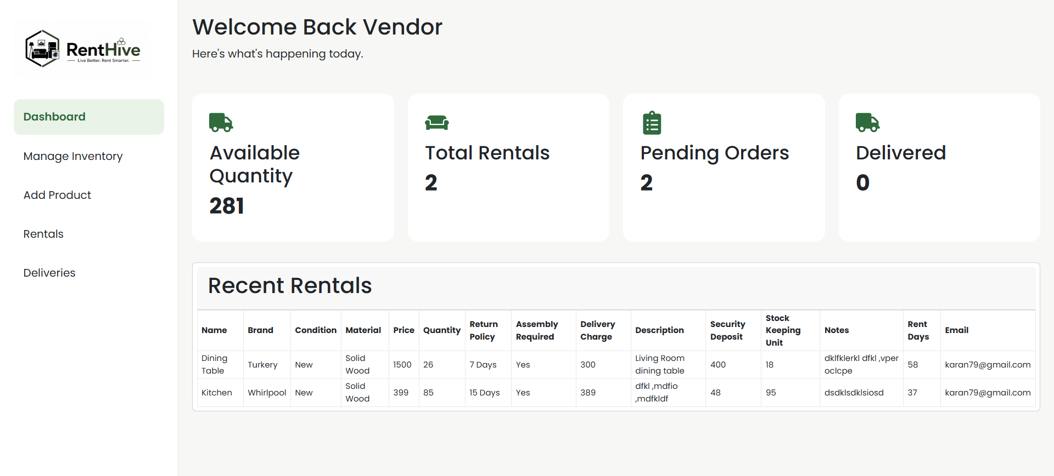

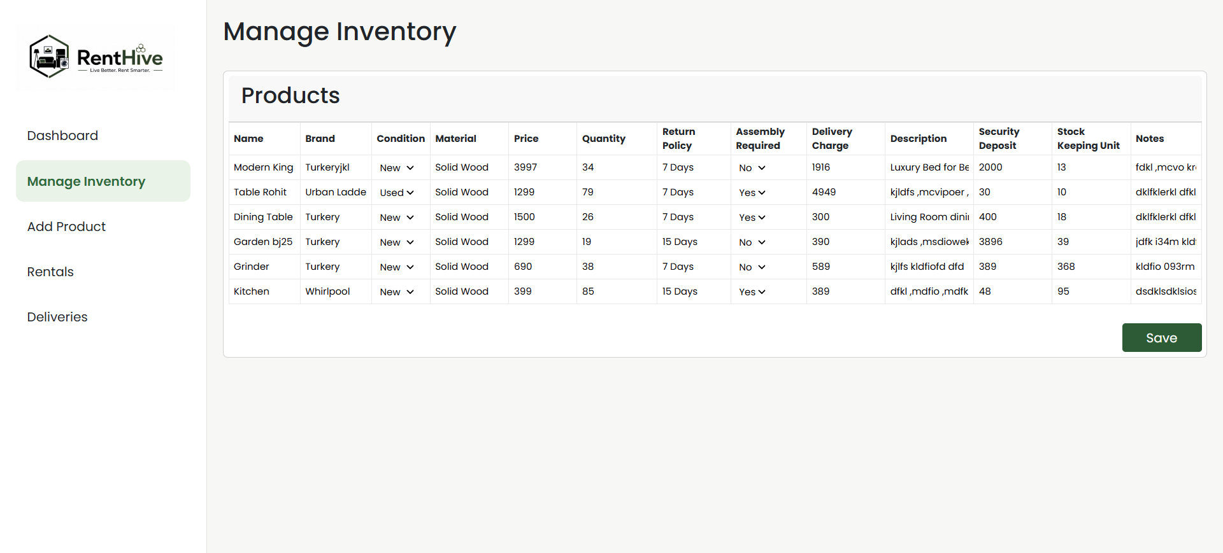
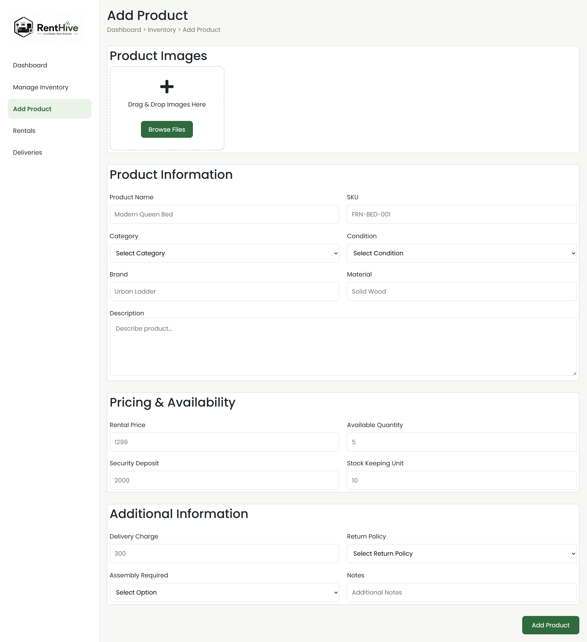
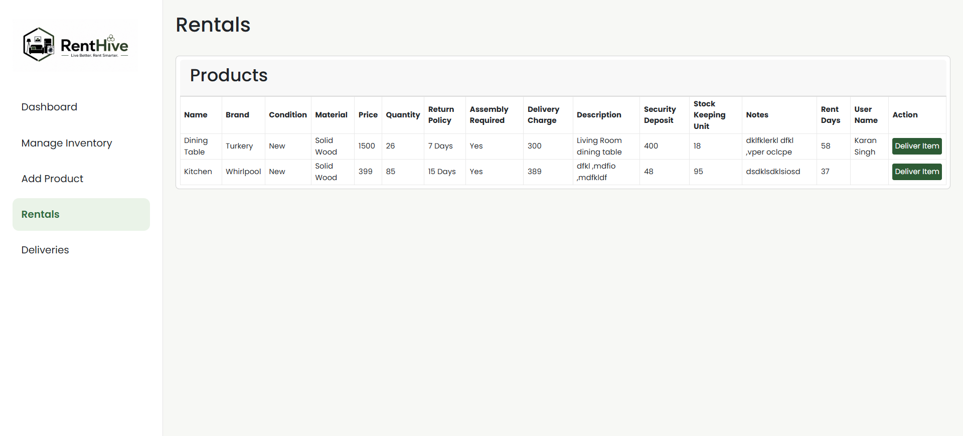
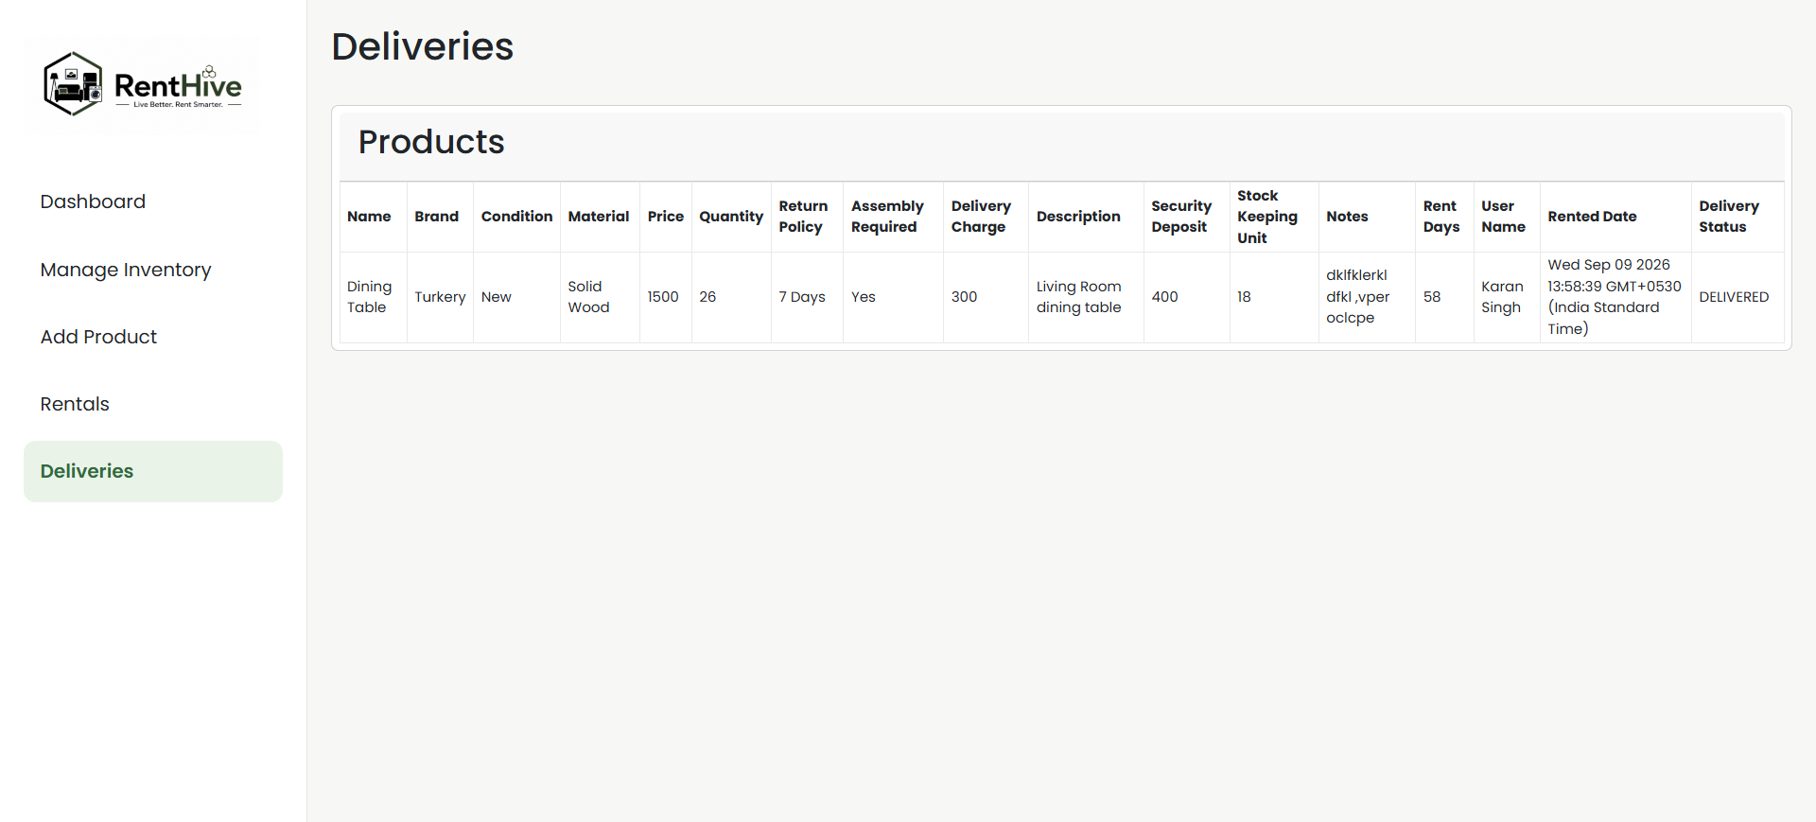

Testing

Test Case | Input | Expected Result | Status
User Registration | Valid details | Account created | Pass
User Registration | Existing email | Error displayed | Pass
Login | Correct credentials | User logged in | Pass
Login | Wrong password | Error displayed | Pass
Product Search | Valid product | Products displayed | Pass
Product Selection | Select product | Product added | Pass
Payment | Valid payment | Payment processed | Pass
Unauthorized Page | No JWT | Access denied | Pass

Security
Since your project has authentication/payment, this is worth including.
Discuss things such as:
- Password hashing
- JWT authentication
- Protected API routes
- Input validation
- Environment variables
- CORS configuration
- Secure API communication
- Payment verification
- Avoiding exposure of API secrets

Deployment

Frontend
↓
Vercel

Backend
↓
Cloud Server / Hosting Platform

Database
↓
MongoDB Atlas

Challenges Faced

Authentication
Implementing user authentication required managing login user’s data on database and validation.

Payment Integration
Integrating the payment gateway required creating payment requests and verifying payment status before confirming a rental.

Deployment
The application worked correctly in the local environment, but deployment introduced configuration issues related to environment variables, CORS, and external services.

Database
Designing relationships between users, products, rentals, and payments required careful schema planning.

Conclusion

The Furniture and Appliance Rental Management System successfully demonstrates how a modern web application can be developed using the MERN stack. The system provides users with a convenient platform to browse products, manage rentals, and complete payments online.
The project provided practical experience in frontend development using React.js, backend API development using Node.js and Express.js, database management using MongoDB, authentication, payment integration, and deployment.
The developed system can be further enhanced with features such as recommendation systems, delivery tracking, reviews, mobile applications, and automated rental notifications.

