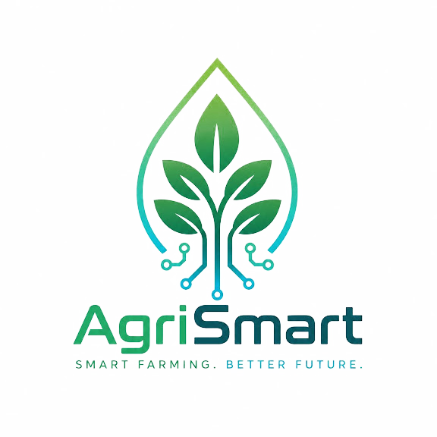
Task 3 — Develop and Track Your Prototype Progress
Project: AgriSmart — IoT Smart Irrigation for Egyptian Farmers
Contact: agrismart.global@gmail.com

MVP Goal
Deliver a working prototype that measures soil moisture, temperature, and salinity/EC at the root zone using an ESP32-based field unit, transmits that data to the AgriSmart backend, and surfaces it to the farmer through an Arabic-first mobile application — with the option to remotely open/close an irrigation valve from the app. The MVP is deliberately scoped to a single sensing/control zone rather than a multi-zone or multi-farm deployment, consistent with the system design validated in Task 2.

What Has Been Implemented
Backend (complete and tested)
- Device authentication, independent from user/farmer login, so each ESP32 unit is verified by its own credentials before any telemetry or command is accepted.
- Telemetry ingestion and schema validation for soil moisture, temperature, and EC readings.
- Irrigation command state machine (queued → sent → acknowledged → executing → completed/failed), so a command being sent is never assumed to mean the valve actually moved.
- Farm-scoped authorization (anti-IDOR) ensuring a farmer can only see and control their own farm’s devices and valves.
- Full backend test suite passing, and lint/dependency-audit checks clean.
Mobile application (design stage)
- UI/UX wireframes completed for the Arabic-first interface: live sensor readings, historical data view, and the irrigation valve control screen.
Note for the team: The wireframes exist but the app has no functional code connected to the backend API yet — this is explicitly in progress, not complete. See Next Sprint below.
Hardware (assembled, firmware pending)
- All core components (ESP32, capacitive soil moisture probe, digital temperature probe, EC probe, relay, and solenoid valve) have been procured and physically assembled/wired together on the bench.
Note for the team: The hardware is wired but not yet running its own firmware — the ESP32 does not yet read the sensors or talk to the backend. This is the main item being closed out this week; see Next Sprint below.

Hardware Components Status

Component | Procurement Status | Build/Integration Status
ESP32 microcontroller module | Procured & assembled | Wired to sensors and relay; firmware not yet loaded
Capacitive soil moisture probe | Procured & assembled | Physically connected to ESP32 analog input; reading routine not yet coded
Waterproof digital soil temperature probe | Procured & assembled | Physically connected; reading routine not yet coded
Soil EC / salinity probe | Procured & assembled | Physically connected; reading routine not yet coded
Relay + solenoid irrigation valve | Procured & assembled | Wired to ESP32 relay output; command-trigger firmware not yet coded
Power supply (bench power for current testing) | In place for bench testing | Solar/battery field-power path not yet built — bench-only at this stage
Field enclosure (IP65/IP67) | Not yet sourced | Planned after the electronics are confirmed working on the bench

Evidence of Work
The following evidence supports the status reported above and should be attached to this document before submission:
- Screenshot(s) of the backend automated test suite passing (terminal output showing test counts and results).
- Screenshot(s) of the Arabic-first mobile app wireframes.
- Photo(s) of the physically assembled ESP32 + sensor + relay bench setup.
- Optional: a short (≤60 second) video of the wiring, once firmware is loaded and the first sensor reading is captured.
Note for the team: No evidence files have been attached to this draft yet — placeholders only. Please send the actual screenshots/photos so they can be inserted before submission; nothing should be represented as demonstrated unless it is actually captured.

Challenges Encountered
- Coordinating hardware assembly (multiple analog/digital sensors sharing one ESP32’s limited GPIO/ADC pins) with the backend’s already-defined telemetry schema, to make sure firmware output matches what the API expects without rework.
- Sequencing the mobile app build so that it consumes the already-authenticated device/telemetry API correctly on the first attempt, rather than needing a second integration pass.
- Compressed timeline: hardware, firmware, and app functional development are converging in the same week ahead of the deadline.
Note for the team: These are the challenges as currently understood by the team; edit or add to this list with anything specific that came up during actual assembly/coding, so the report reflects what genuinely happened rather than a generic list.

Next Sprint Plan
Target: complete the remaining integration work within this week, ahead of the next checkpoint.
- Write and load ESP32 firmware to read all three sensors and publish telemetry to the backend’s existing ingestion endpoint.
- Implement firmware handling of the irrigation command flow (receive command → drive relay → report acknowledgment/execution result back to the backend), matching the state machine already built server-side.
- Build the functional mobile app screens on top of the completed wireframes, wired to the live backend API (live readings, history view, valve control).
- Run a first end-to-end integration test: real sensor reading → backend → app display, and app-issued command → backend → relay → valve.
- Capture real evidence (screenshots of live data flowing, a short demo video) once the end-to-end test succeeds, to attach to the next progress report.

This report reflects actual project status as of the date below: backend complete and tested; hardware procured and assembled with firmware pending; mobile app wireframed with functional development pending. No completed hardware/app functionality is claimed beyond what is stated here.

