SC2002 Group Assignment
Restaurant Rush
A turn-based restaurant management game in Java: design report
Item | Value
Group | <LAB GROUP> / Group <N>
Members | <NAME 1, NAME 2, NAME 3, NAME 4, NAME 5>
Repository | <PASTE GITHUB REPOSITORY URL>
Stage tags | stage-1 (706c320) stage-2 (beb2923) stage-3 (027c290)
Video | <LINK, or "included in the zip">

Text in <angle brackets> is for the group to fill in before submitting (names, links, reflections). Everything else was generated from the code and the actual test runs.

1. Overview
Restaurant Rush is a command-line, turn-based game. The player is the restaurant manager with one Waiter, one Chef and one Cashier (and, in Stage 3, a Host). Each staff member can do one task per turn, so the manager has to decide whom to seat, whose order to take, what to serve and what the Chef cooks first. The game runs exactly 18 turns. The player wins if at least 4 customers pay, revenue is at least $45.00 and the average satisfaction of paid customers is at least 60.
The game was built in three stages. Each stage is a tagged, runnable version in GitHub, and each builds on the one before.
Stage | Adds | Tag / commit | Result
1 | Regular customers, menu, Waiter, Chef, Cashier, Table, Order, waiting queue, the six-step turn, abandonment, payment, victory and defeat | stage-1 706c320 | Runs on its own; victory and defeat runs reproducible
2 | VIP and Critic customers (different patience, bill and ordering), dispatched through the customer objects | stage-2 beb2923 | Runs on its own; Stage 1 replays unchanged
3 | Host, ComboMeal, Happy Hour | stage-3 027c290 | Runs on its own; Stage 1 and 2 replay word for word

How to run. scripts/build.sh compiles with plain javac (JDK 17 or newer); scripts/run.sh plays the Stage 3 game, scripts/run.sh --classic the Stage 2 base setting and scripts/run.sh --regular-only the Stage 1 setting. mvn test runs the 68 unit tests. Every recorded run can be replayed with scripts/replay.sh <script>.
Architecture. The code follows Boundary / Control / Entity. ConsoleUI (boundary) only reads choices and prints state. GameController (control) runs the turn sequence and the victory check. All game rules live in entity classes such as Customer, Order, Waiter and HappyHour. Main source: 30 files, about 1,900 lines; tests: about 1,400 lines.

2. UML class diagram (final design, matches stage-3)
Visibility: + public, - private, # protected, ~ package-private. Multiplicities are shown on the associations. Annotations for encapsulation, polymorphism, composition and inheritance are on the diagram. A script (scripts/check_diagram.py) checks that every class, attribute and operation in the diagram exists in the code with the same number of parameters, and that every type in the code appears in the diagram.
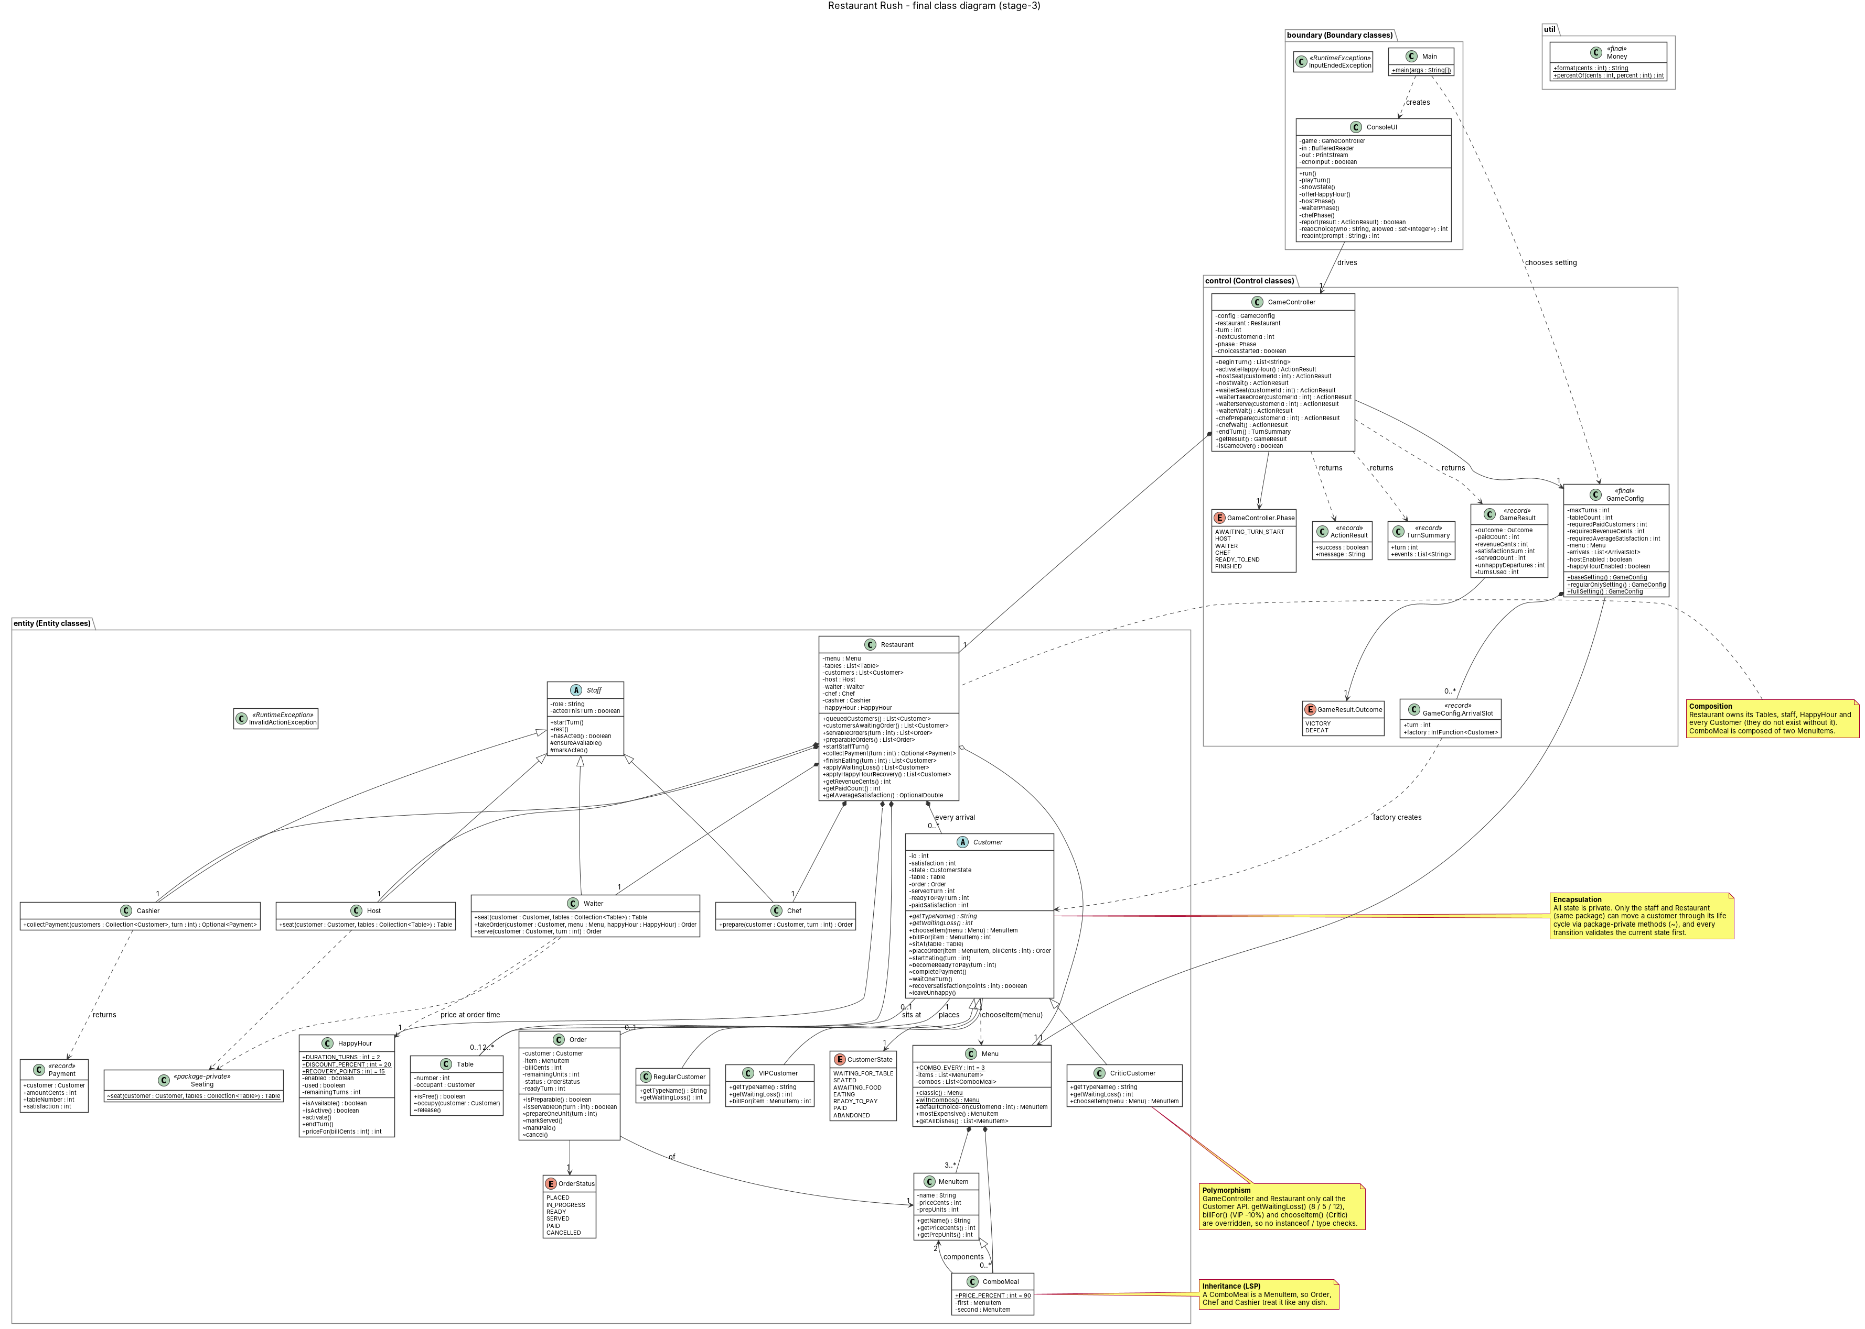
Figure 1. Complete class diagram (boundary, control, entity, util). Vector graphic: zoom in the PDF to read the members. Also in docs/diagrams/class-diagram.svg

2.1 Focused views of the class diagram
The views below are generated from the same class blocks as Figure 1, so they are consistent with it, and are easier to read.

View A: restaurant, staff and Happy Hour
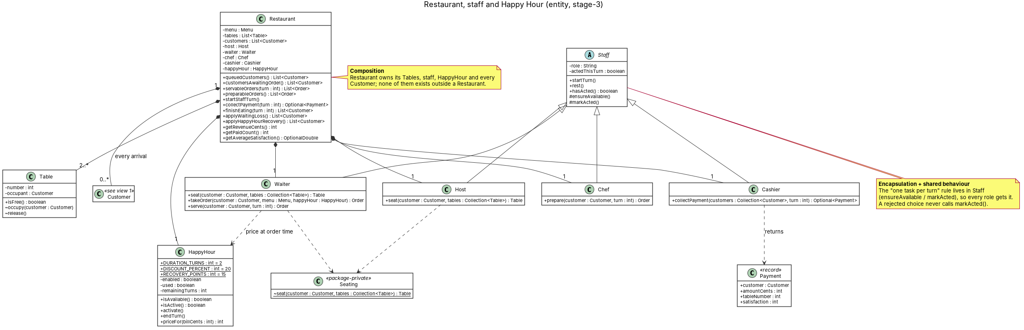
Figure 2. The Restaurant aggregate, the staff hierarchy and the pricing policy.
- Composition. Restaurant owns its tables, its four staff members, its HappyHour policy and every customer who arrives. They have no meaning outside it. ComboMeal is composed of two MenuItems.
- Shared behaviour in the base class. The rule "one task per turn" is implemented once in Staff (ensureAvailable, markActed). markActed is only reached after an action has succeeded, so a rejected choice never uses up the task.
- Seating is a rule shared by Waiter and Host; it lives in the package-private Seating so the two roles cannot drift apart.

View B: customers, orders and the menu
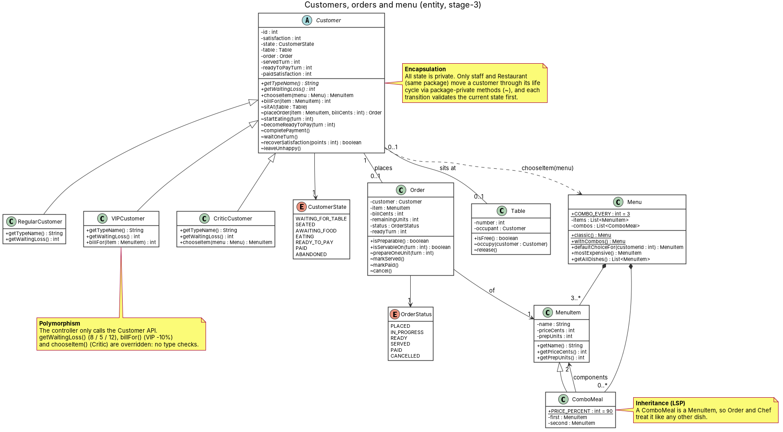
Figure 3. Customer hierarchy, order life cycle and menu (including ComboMeal).
- Encapsulation. All Customer state is private. Only classes in the entity package (the staff and Restaurant) can move a customer through its life cycle, through package-private methods such as sitAt, placeOrder, startEating and completePayment, and each one first checks the current state. The controller and the UI cannot put a customer into an impossible state.
- Polymorphism. getWaitingLoss() (8 / 5 / 12), billFor() (VIP 10% off) and chooseItem() (Critic orders the most expensive dish) are overridden in the subclasses. GameController and Restaurant only call the Customer API, so the turn logic has no instanceof or type checks (a test checks this).
- Inheritance and substitution. ComboMeal is a MenuItem (price and units computed from its two components), so Order, Chef and the Cashier handle a combo exactly like a single dish.

View C: boundary and control
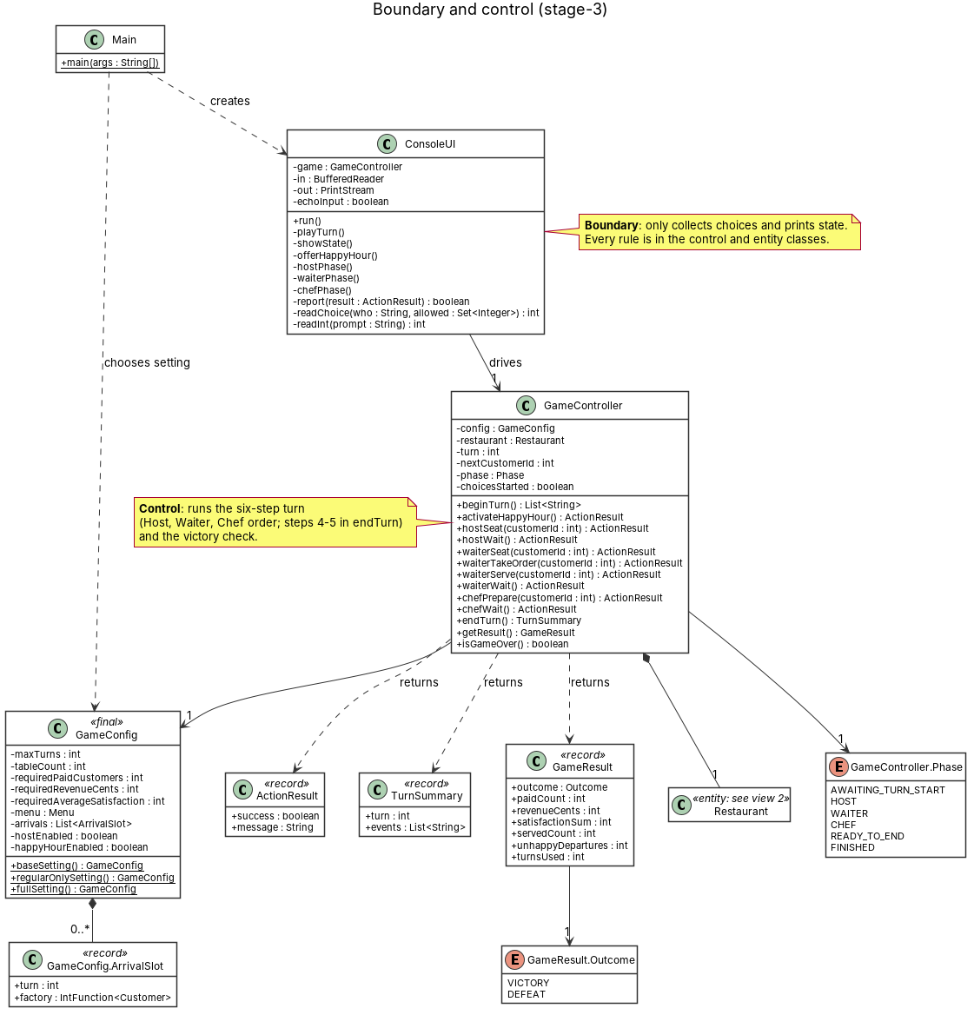
Figure 4. The boundary class talks to one control class; control returns small result records.
- ConsoleUI has no rules. It asks GameController to do something and prints the ActionResult. A failed choice is explained and the same question is asked again.
- GameController enforces the order of a turn with an explicit Phase (Host, Waiter, Chef, end of turn) and decides the result after turn 18.
- GameConfig holds every number of a game and is the only place that names concrete customer classes (as IntFunction<Customer> factories).

3. UML sequence diagram
Scenario. The VIP (customer 2) arrives on turn 4. The manager switches Happy Hour on, the Host seats the VIP, the Waiter takes the order, the Chef cooks it, the dish becomes READY, is SERVED on turn 5, the VIP eats during turn 5 and finishes on turn 6, and the Cashier collects the payment on turn 7. After turn 18 the result is checked. The diagram includes one invalid manager choice (guard and loop), the Happy Hour guard, and the VIP discount followed by the Happy Hour discount.
How the manager's choice changes the outcome. If the manager answers "No" to Happy Hour, the VIP orders the same Burger but the bill is locked at $13.50 and the VIP pays with satisfaction 95. With Happy Hour the VIP pays $10.80 ($15.00 x 0.9 x 0.8) with satisfaction 100. The same run played both ways ends with revenue $91.50 without Happy Hour and $88.80 with it, and total satisfaction 399 against 404 (average 79.8 against 80.8).
The full diagram is split into four parts so it stays readable (the unsplit version is docs/diagrams/sequence-diagram.svg).
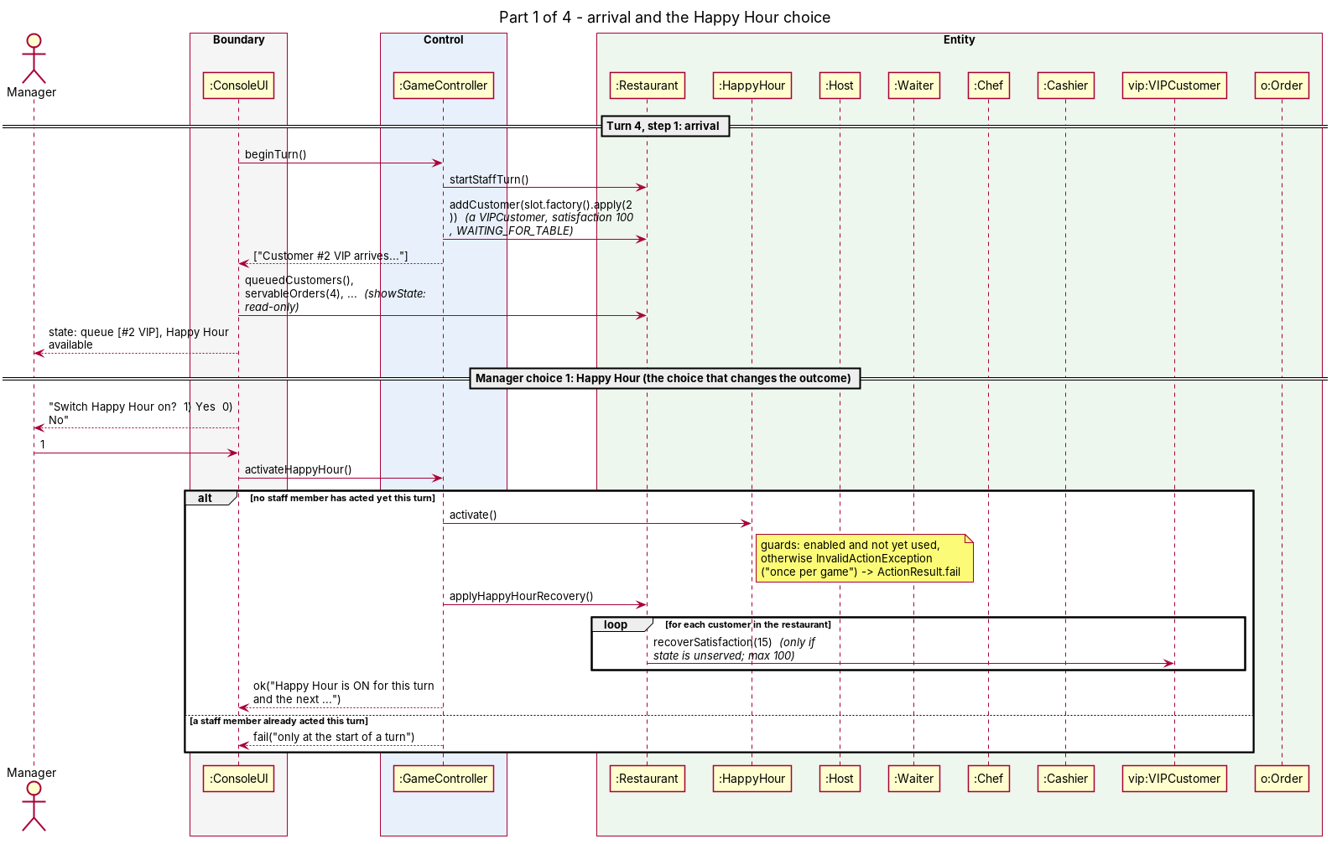
Figure 5. Part 1: arrival (step 1) and the Happy Hour choice, with its guard.

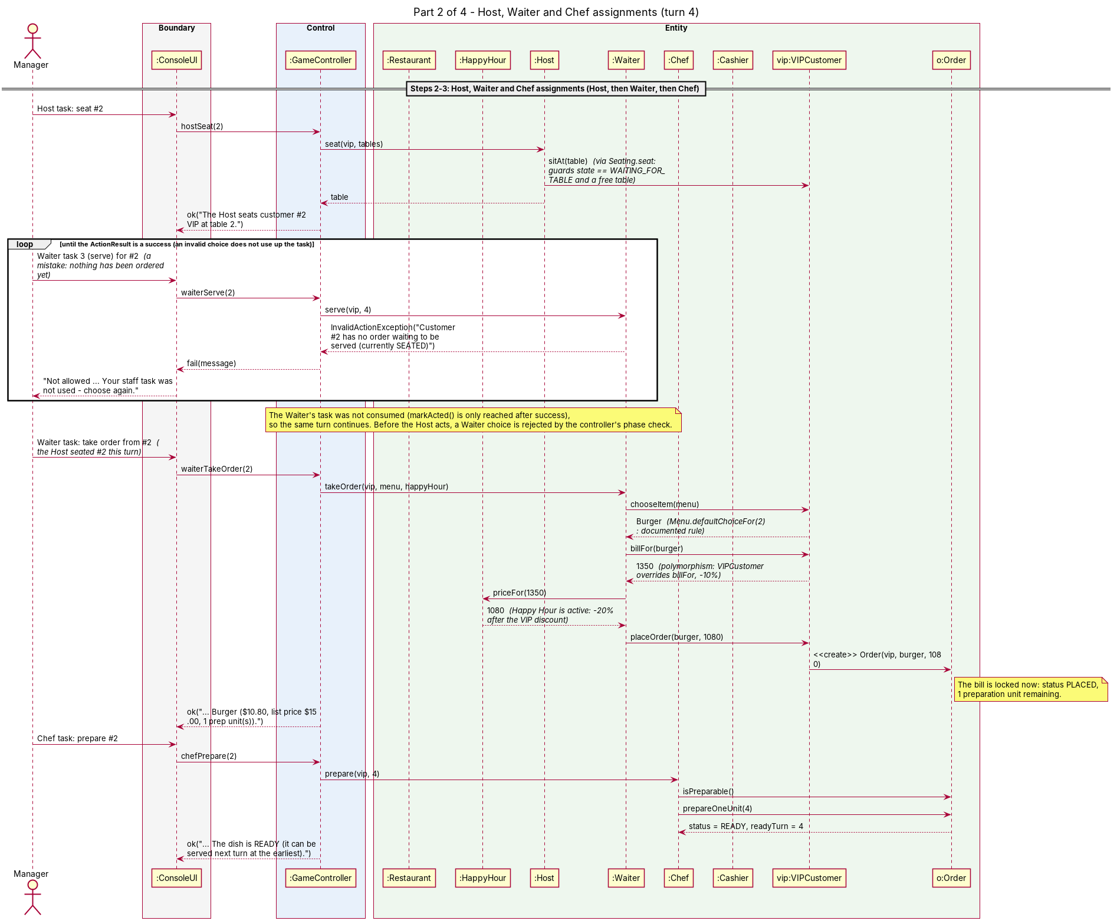
Figure 6. Part 2: Host, Waiter and Chef assignments (steps 2 and 3). The invalid choice is rejected without using the task, and the loop asks again.

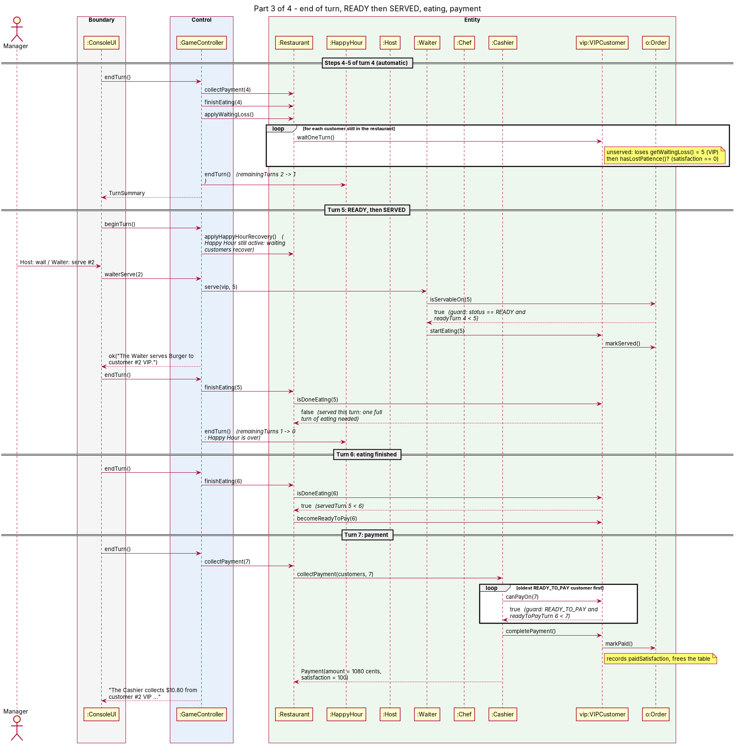
Figure 7. Part 3: end of turn 4, READY then SERVED on turn 5, eating, and payment on turn 7, with the guards on the one-turn delays.
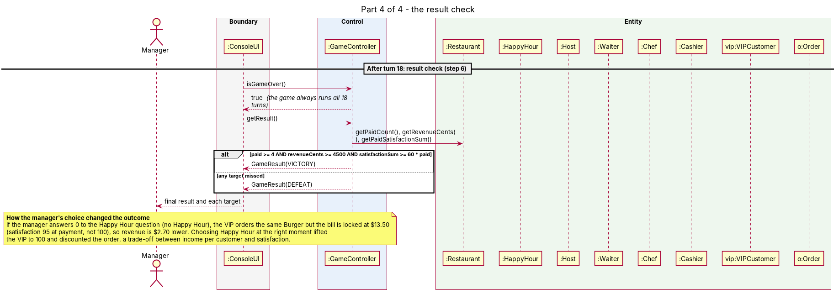
Figure 8. Part 4: the result check after turn 18 and how the manager's choice changed the outcome.

4. Design discussion

4.1 Key abstractions and their responsibilities
Class | Responsibility (what it knows and does)
Customer (abstract), RegularCustomer, VIPCustomer, CriticCustomer | Own satisfaction and life cycle (queue, seated, awaiting food, eating, ready to pay, paid, abandoned). Define how fast patience runs out, how the bill is calculated and what is ordered. Subclasses override only those three things.
Order, OrderStatus | One customer's order: dish, locked bill, remaining preparation units and status. Knows when it can be served (isServableOn).
MenuItem, ComboMeal, Menu | Dishes with price in cents and preparation units. ComboMeal composes two dishes. Menu holds the dishes and the documented rule for what a customer orders.
Table | Occupied until the customer pays or leaves.
Staff (abstract), Waiter, Host, Chef, Cashier | Each performs the tasks of one role and validates them. Staff enforces one task per turn.
Restaurant | Aggregate of tables, staff, customers and Happy Hour. Answers "who can be seated / served?", runs the automatic end-of-turn steps, and derives all statistics (revenue, paid count, average satisfaction) from customer state.
HappyHour | Availability (once per game), duration (two turns), 20% price rule and the recovery amount.
GameController, GameConfig | Control: order of the six steps and phases, result after turn 18; the numbers of a game and the arrival schedule.
ConsoleUI | Boundary: reads and validates the format of input, prints state and messages. No rules.
ActionResult, TurnSummary, GameResult | Small immutable records returned by the controller.
Money | Integer-cent formatting and half-up percentage rounding, so no floating-point money.

4.2 Design principles (only where the code really shows them)
Principle | Where it is reflected | Honest limits
SRP | ConsoleUI only does I/O. GameController only sequences a turn. Customer owns its life cycle, HappyHour owns its numbers, Seating owns the seating rule, Money owns rounding. | Restaurant has several jobs (queries, automatic steps, statistics); we kept them together because they all need the same collections.
OCP | Stage 1 to 2 changed 6 main files (+96 / -5 lines). The turn logic in GameController was not touched (4 added lines in a message string). A new customer kind is a new subclass plus one line in GameConfig. ComboMeal needed no change in Order, Chef or Cashier. | Stage 3 did modify earlier classes: Waiter.takeOrder gained a parameter, Menu.defaultChoiceFor gained the combo rule, and the controller gained a Host phase. These were justified in the README.
LSP | Every Customer subclass can replace another in the same flow (test: all three kinds go from seating to payment through the same calls). A ComboMeal can be used wherever a MenuItem is. Every Staff subclass honours the one-task rule. | Subclasses change only numbers and choices, never the preconditions of the shared methods.
ISP | We deliberately created no interfaces (the brief says not to create them for a checklist). The customer's life-cycle methods are package-private, so other layers see only a small public API. | Weak: ConsoleUI sees the whole GameController API, including Host methods when there is no Host.
DIP | The controller depends on the Customer abstraction: GameConfig supplies customers as IntFunction<Customer> and is the only place that names the concrete classes. Orders and staff depend on MenuItem, not on ComboMeal. | ConsoleUI depends on the concrete GameController, and Restaurant creates its staff directly. Acceptable with a single implementation of each.

4.3 Trade-offs
Decision | Benefit | Cost
Rule violations throw InvalidActionException; the controller turns it into an ActionResult | The state is untouched when a choice fails, one message path, and the staff task is only marked used after success | Exceptions used for expected input errors
Statistics derived from customer state, no counters | Revenue cannot include an unpaid or abandoned order; nothing to keep in sync | Recomputed on every call (trivial at 6 customers)
Package-private life-cycle methods | Real encapsulation of customer and order state | Entity rule tests must be in the same package; staff classes must live in the entity package
Host, combos and Happy Hour are switches in GameConfig | Stage 1 and 2 runs replay word for word on the Stage 3 code | A few conditionals on hostEnabled in the controller
Explicit Phase in the controller | The order Host, Waiter, Chef is enforced and testable | One more piece of state to keep correct
A choice takes effect as soon as it is made (not queued until step 3) | The Chef's list already contains the order the Waiter just took, as the brief requires | Step 3 is not a separate method; the readyTurn guard makes the one-turn delay explicit
Scripted input echoed to the output | Reproducible, reviewable runs and transcripts | Prompts must stay stable (scripts are per stage)

4.4 An alternative design we considered
Alternative: one `Customer` class with a `CustomerType` enum and a `switch` in the turn controller. Satisfaction loss, discount and food choice would be switch (customer.type) blocks inside GameController. It is shorter for Stage 2 (no new classes), but every new kind of customer, and every new rule that depends on the kind, would edit the controller; the brief also forbids this for Stage 2. We rejected it. With the subclass design, Stage 2 added two small classes and did not touch the turn logic.
We also considered a Command pattern for staff actions (SeatCommand, ServeCommand, ...). It would give uniform logging and undo, but for six actions it adds many classes without a requirement for them. Methods on Staff subclasses plus controller wrappers were enough.

4.5 How the player's choices change the result
Choice | Evidence (same crowd, base setting) | Effect
Act or do nothing | Passive manager (always Wait) vs. the greedy manager (serve first, then order, then seat; Chef takes the shortest job) | Passive: DEFEAT, 0 paid, $0.00, 2 unhappy departures. Greedy: VICTORY, 5 paid, $91.50 (Stage 3, no Happy Hour).
Switch Happy Hour on when the VIP arrives | Stage 3 run with and without Happy Hour | VIP bill $10.80 instead of $13.50 and satisfaction 100 instead of 95. Revenue $88.80 vs $91.50; average satisfaction 80.8 vs 79.8.
Whom the Waiter helps first | Every turn the Waiter can do only one of: seat, take an order, serve | A dish that is READY waits for the Waiter while customers keep losing 8 / 5 / 12 points per turn, so the order of tasks decides who reaches 0 and leaves unpaid.
Using the Host | Host seats before the Waiter acts | A customer seated by the Host can have the order taken the same turn, and the dish can be served one turn earlier.

5. Functional evidence

5.1 Automated tests (68, all passing)
Test class | Tests | What it proves
TurnRulesTest | 15 | The brief's worked example turn by turn; Waiter before Chef; one task per turn; READY then served next turn; invalid choices keep the task; abandonment cancels the order and frees the table; revenue excludes unpaid orders; targets are inclusive; 18 turns always; at most five can pay
EntityRulesTest | 10 | Food rule; Cashier one payment per turn, oldest first, never on the turn they became ready; payment frees the table; served customers lose nothing; satisfaction never below 0
CustomerBehaviourTest (stage 2) | 8 | Waiting loss 8 / 5 / 12; VIP 10% off; Critic orders the most expensive dish; all kinds follow the same flow; the controller has no type checks
StageThreeEntityTest (stage 3) | 11 | Combo price, units and rounding; who orders a combo; VIP then Happy Hour = $10.80; Happy Hour duration, once only, recovery capped at 100; Host and Waiter share seating rules
StageThreeFeaturesTest (stage 3) | 14 | Host acts first and in addition to the Waiter; Happy Hour only at turn start; remaining duration 2 then 1; recovery on both turns; price locked at order time; full setting winnable
ScriptedRunTest | 8 | All six victory and defeat scripts through the real UI; Stage 1 and 2 runs replay word for word on the Stage 3 code; bad input is rejected and asked again
MoneyTest | 2 | Integer cents formatting and half-up rounding

5.2 Reproducible runs (base setting)
Stage | Run | Command | Result
1 | Victory | scripts/replay.sh scripts/stage1-victory.txt --regular-only | VICTORY: 5 paid, $66.00, average 79.2
1 | Defeat | scripts/replay.sh scripts/stage1-defeat.txt --regular-only | DEFEAT: 0 paid, 2 unhappy departures
2 | Victory | scripts/replay.sh scripts/stage2-victory.txt --classic | VICTORY: 5 paid, $73.50, average 75.6
2 | Defeat | scripts/replay.sh scripts/stage2-defeat.txt --classic | DEFEAT: 0 paid, 2 unhappy departures
3 | Victory | scripts/replay.sh scripts/stage3-victory.txt | VICTORY: 5 paid, $88.80, average 80.8 (Happy Hour used)
3 | Defeat | scripts/replay.sh scripts/stage3-defeat.txt | DEFEAT: 0 paid, 2 unhappy departures
Full transcripts are in docs/runs/. The Stage 1 and 2 transcripts replay word for word on the Stage 3 code (checked by ScriptedRunTest), which is our evidence that earlier behaviour still works.

5.3 Excerpt: turn 4 of the Stage 3 victory run
=========================== TURN 4 of 18 ===========================
Customer #2 VIP arrives and joins the waiting queue (satisfaction 100).
Happy Hour is available (once per game; this turn and the next: 20% off new orders ...).
Switch it on now? 1) Yes 0) No
Happy Hour choice> 1
-> Happy Hour is ON for this turn and the next: new orders get 20% off. ...
Host choice> 1
Customer id to seat> 2
-> The Host seats customer #2 VIP at table 2.
After the Host - Waiter can: seat [none] | take order [#2] | serve [none]
Waiter choice> 2
-> The Waiter takes the order of customer #2 VIP: Burger ($10.80, list price $15.00, 1 prep unit(s)).
Chef choice> 1
-> The Chef prepares Burger for customer #2 VIP (unit 1/1). The dish is READY (it can be served next turn at the earliest).
--- End of turn 4 ---

5.4 Where each rule of the brief is implemented and tested
Rule | Implemented in | Test
Base setting (18 turns, 2 tables, arrivals, targets) | GameConfig.baseSetting() | baseSettingMatchesTheBrief
Waiter acts before Chef | GameController phases | waiterMustChooseBeforeTheChef
A dish finished this turn is served next turn at the earliest | Order.isServableOn | aDishFinishedThisTurnIsOnlyServedNextTurn
Cashier: one payment per turn, oldest first, not on the turn ready | Cashier.collectPayment | cashierPaysOneCustomerPerTurn...
Unserved customers lose satisfaction; at 0 they leave | Restaurant.applyWaitingLoss | customerLeavesAtZeroSatisfaction...
Invalid choice explains why and does not use the task | Staff.markActed after success; ActionResult | invalidChoiceExplainsWhy...
Revenue never includes unpaid or abandoned orders | Restaurant.getRevenueCents (derived) | customerLeavesAtZeroSatisfaction...
The game always runs all 18 turns; victory targets | GameController.getResult | victoryRequiresAllThreeTargets...
At most five customers can pay | Turn arithmetic | atMostFiveCustomersCanPay...
VIP and Critic through the customer objects | Customer overrides | theTurnControllerNeverChecksCustomerTypes
Host seats one extra customer per turn | Host, Seating | theHostSeatsOneCustomerIn...
ComboMeal: units added, 90% price rounded | ComboMeal | comboPriceIsNinetyPercent...
Happy Hour: once, two turns, 20% off after VIP, +15 recovery, price locked | HappyHour, Waiter.takeOrder | StageThreeFeaturesTest
Money in integer cents | Money | MoneyTest
Rules out of the UI | ConsoleUI only calls the controller | ScriptedRunTest (whole game through the UI)

6. Thinking and development process

6.1 Stage snapshots
Tag | Commit | Main files changed | What the snapshot shows
stage-1 | 706c320 | 24 main + 7 test files (whole project) | A complete playable game with the Boundary/Control/Entity split, 30 unit and scripted tests, reproducible victory and defeat runs
stage-2 | beb2923 | 6 files changed or added (+96 / -5 lines) | Two new customer classes; the turn logic untouched; Stage 1 transcripts identical
stage-3 | 027c290 | 12 files changed or added (+451 / -31 lines) | Host, ComboMeal, Happy Hour; seating rule extracted; earlier transcripts identical

6.2 Change analysis
The class diagram as it was at each earlier tag is in Appendix B (and docs/diagrams/stages/); the same script checks each one against the source of its own tag.
Stage 1 to 2. New: VIPCustomer, CriticCustomer. Changed: Menu (added mostExpensive), GameConfig (the base setting schedules a VIP and a Critic; regularOnlySetting keeps Stage 1), GameController (one message shows the list price when a discount applies; the turn logic is untouched), Main (a flag). Nothing was deleted. The change was small because Stage 1 already made Customer abstract with overridable patience, bill and food choice.
Stage 2 to 3. New: Host, Seating, ComboMeal, HappyHour. Changed: Waiter (seating delegated to Seating; takeOrder takes the Happy Hour so the bill is discounted once, when the order is taken), Menu (combos and their ordering rule), Customer (recoverSatisfaction), Restaurant (owns Host and Happy Hour), GameController (Host phase, Happy Hour), GameConfig (two switches), ConsoleUI and Main. Nothing was deleted. The six steps of a turn were not rewritten, and the saved Stage 1 and 2 transcripts still match, so earlier behaviour was not broken.

6.3 Team contribution and use of AI
Member | Main responsibility | Video segment
<Name 1> | <e.g. controller and turn loop> | <#>
<Name 2> | <e.g. customers and billing> | <#>
<Name 3> | <e.g. staff, tables, Host> | <#>
<Name 4> | <e.g. console UI, combos, Happy Hour> | <#>
<Name 5> | <e.g. tests, diagrams, report> | <#>
<Describe, honestly, how the group used AI assistance on this project (for example: code, tests, diagrams and this report were drafted with Claude and then reviewed, run and edited by the group). Each member also submits the course Declaration on Use of GAI Assistance.>

7. Reflections

7.1 Project-level lessons (draft: edit to match your experience)
- Design for the next stage in the first stage. Making Customer abstract with overridable patience, billing and food choice in Stage 1 meant Stage 2 did not touch the turn logic. A CustomerType switch would have needed controller edits for every new rule.
- Where the design was not closed to change. Stage 3 still needed edits to Waiter.takeOrder, Menu.defaultChoiceFor and the controller (a Host phase). Making features configuration switches limited the damage and let us prove with saved transcripts that earlier behaviour was unchanged.
- Diagrams must be checked against the code. The first draft of the sequence diagram showed the Waiter rejecting a choice made before the Host had acted, but in the code the controller's phase check rejects it before the Waiter is called. We corrected the diagram, and added a script that checks the class diagram against the source.
- Make a rule an object, then test it once. Keeping "one task per turn" in Staff and the seating rule in Seating meant the Host got both for free and the tests were written once.
- What we would do differently. Introduce an interface between the UI and the controller if a second boundary (for example a GUI) were needed, and consider command objects for staff actions if undo or logging were required.

7.2 Individual reflections
<Each member: one short paragraph on the part you built or explained in the video, one thing you learned about object-oriented design from it, and one thing you would change.>
Member | Reflection
<Name 1> | <...>
<Name 2> | <...>
<Name 3> | <...>
<Name 4> | <...>
<Name 5> | <...>

Appendix A: how we read the brief
The full list is in docs/GAME_NOTES.md. The main decisions:
- Arrivals happen before the start-of-turn display, so the manager sees the new customer.
- Customer ids follow arrival order. What customers order is deterministic: customer n orders dish (n - 1) mod 3 (Salad, Burger, Pasta, ...). With combos on the menu, customers 3 and 6 order a combo instead.
- The manager chooses whom to seat; the customer sits at the lowest-numbered free table.
- Critic special behaviour (our definition): always orders the most expensive dish on the menu.
- "Oldest first" for the Cashier means longest in READY_TO_PAY (ties: lower id).
- A dish that is READY but not yet served still counts as "not served", so that customer keeps losing satisfaction.
- The Host acts before the Waiter, so a customer seated by the Host can order in the same turn.
- Happy Hour is offered at the very start of a turn while unused; switching it on at turn n covers turns n and n+1; the price is locked when the order is taken; the VIP discount is applied first, then Happy Hour.
- The average-satisfaction target is compared with integers (sum >= 60 x paid customers), so there is no rounding error.

Appendix B: the class diagram at stage-1 and stage-2
Derived from the final diagram by scripts/stage_diagrams.py and checked against the source at each tag. Compare with Figure 1 to see what each stage added: Stage 2 adds VIPCustomer and CriticCustomer (and Menu.mostExpensive); Stage 3 adds Host, Seating, ComboMeal, HappyHour and the Host phase, and Waiter.takeOrder gains the HappyHour parameter.
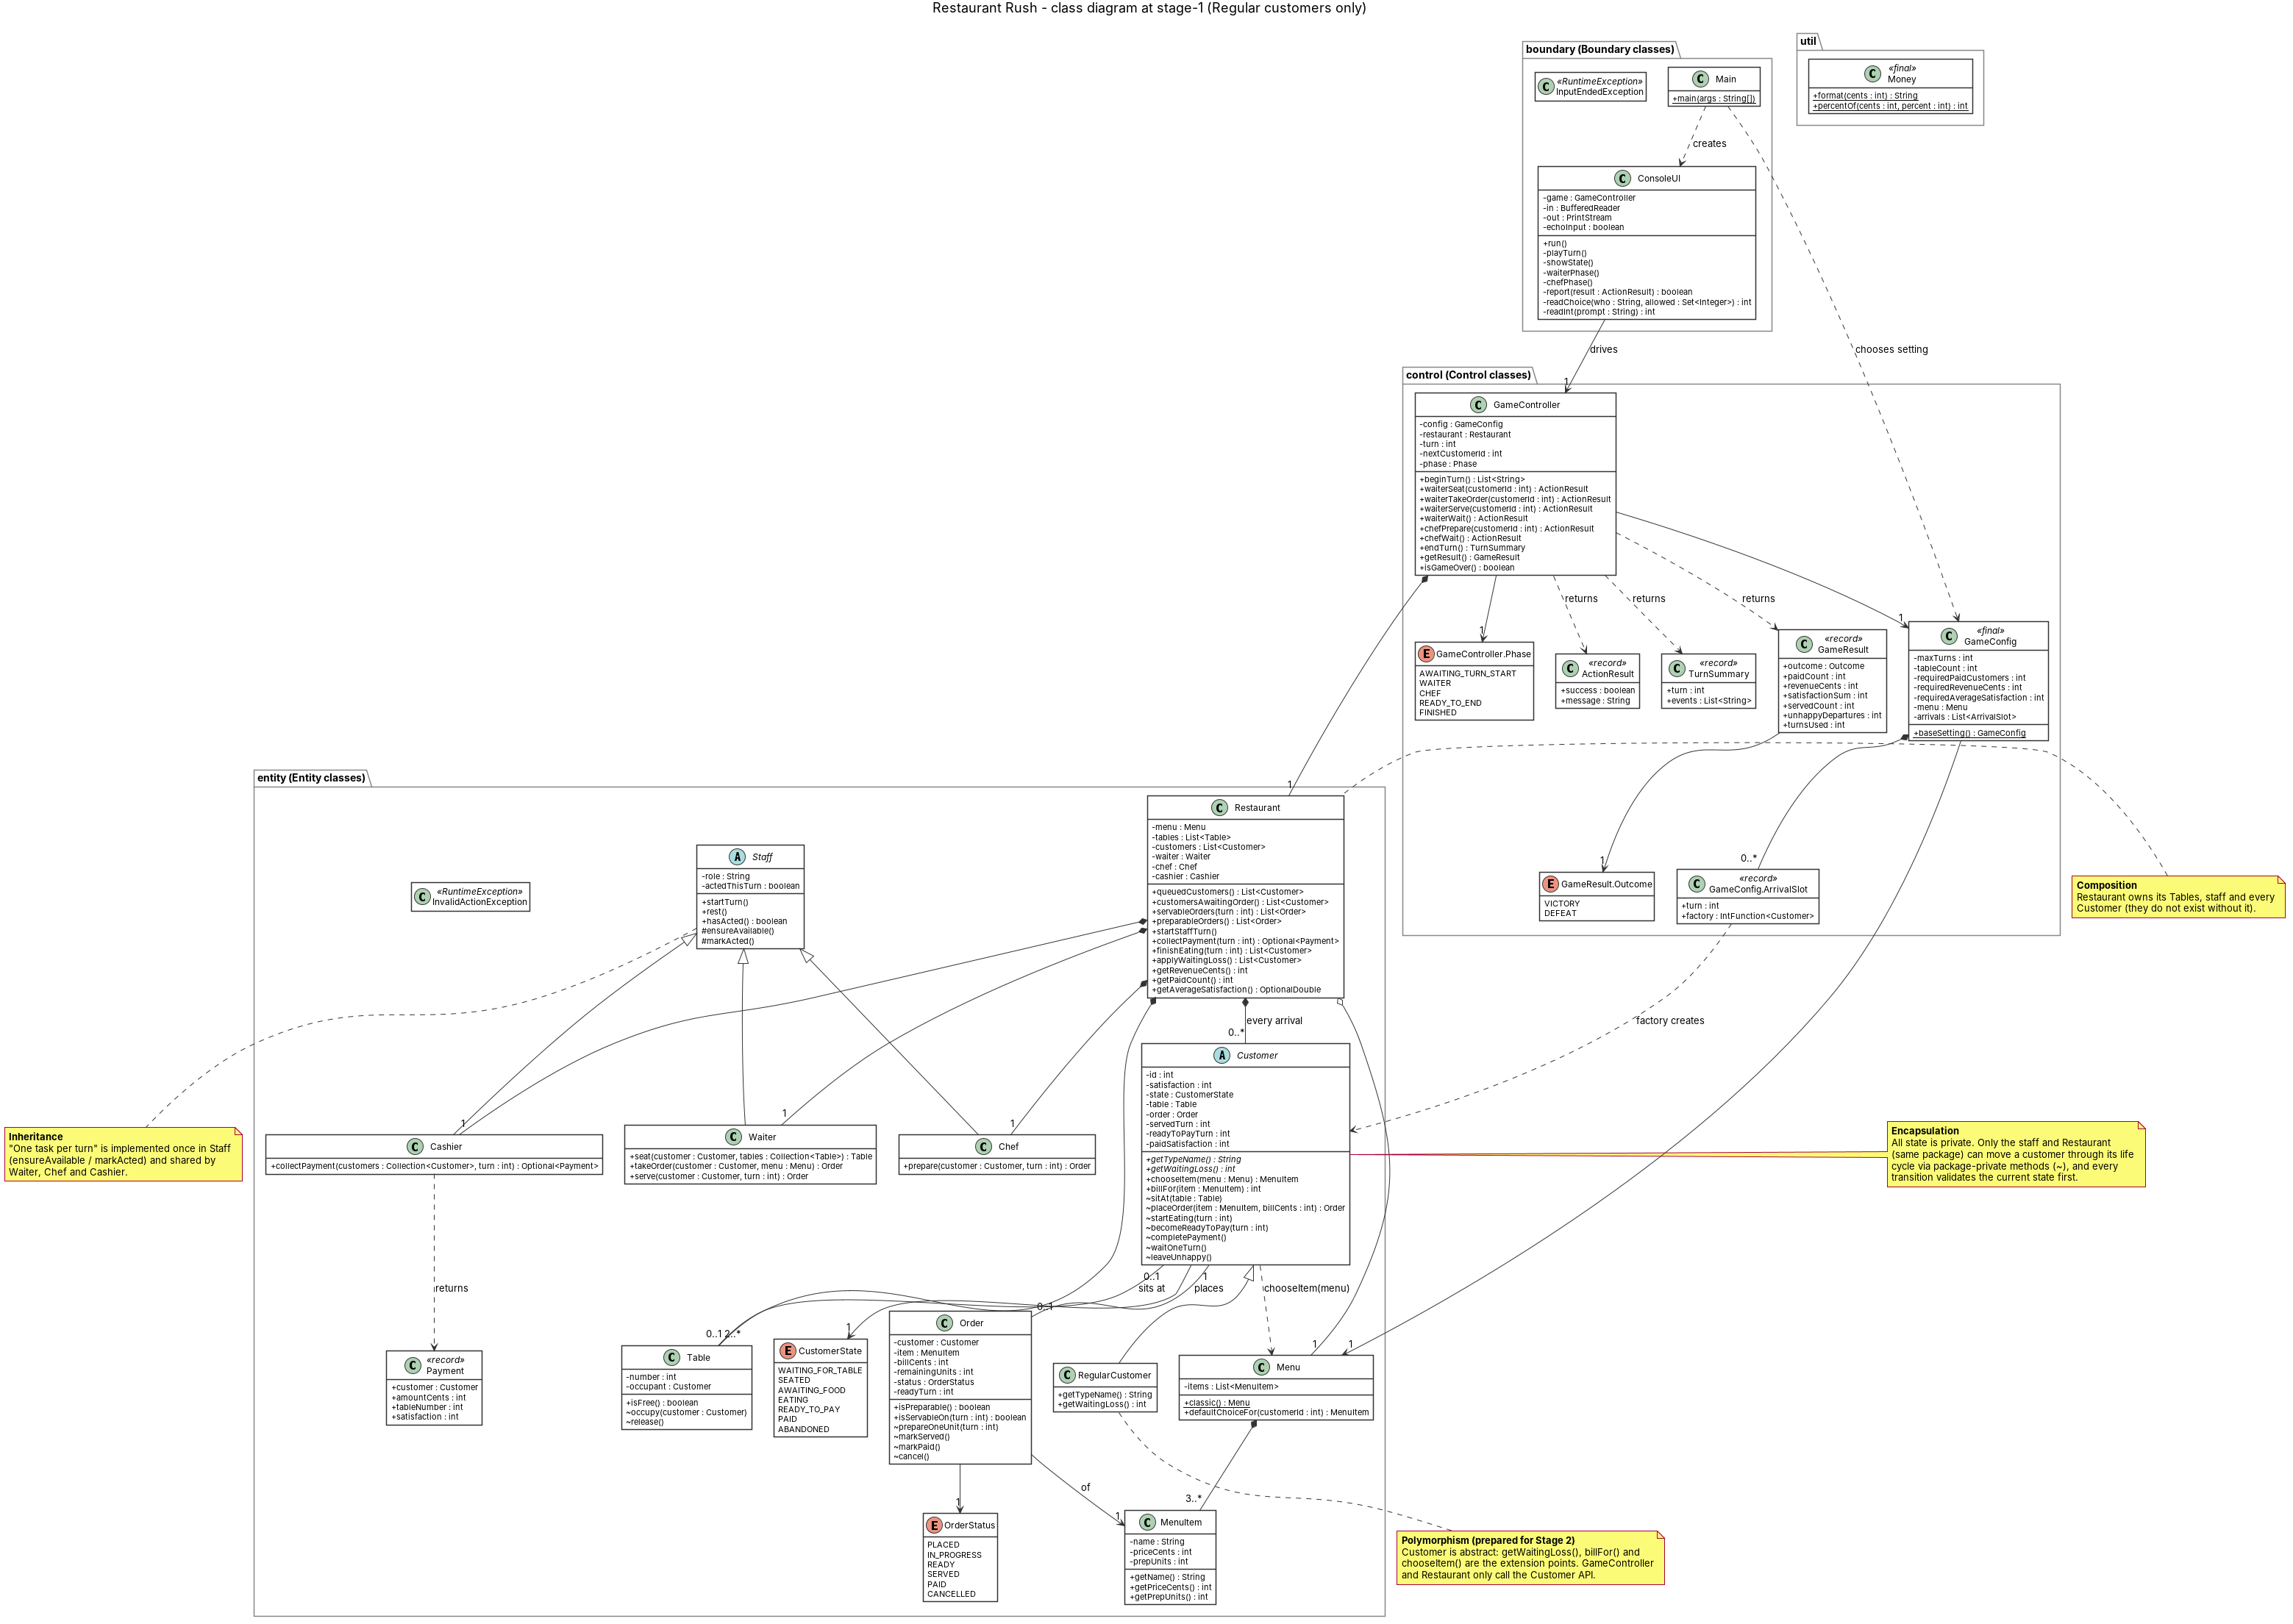
Figure B1. Class diagram at tag stage-1 (Regular customers only). Vector graphic: zoom to read.

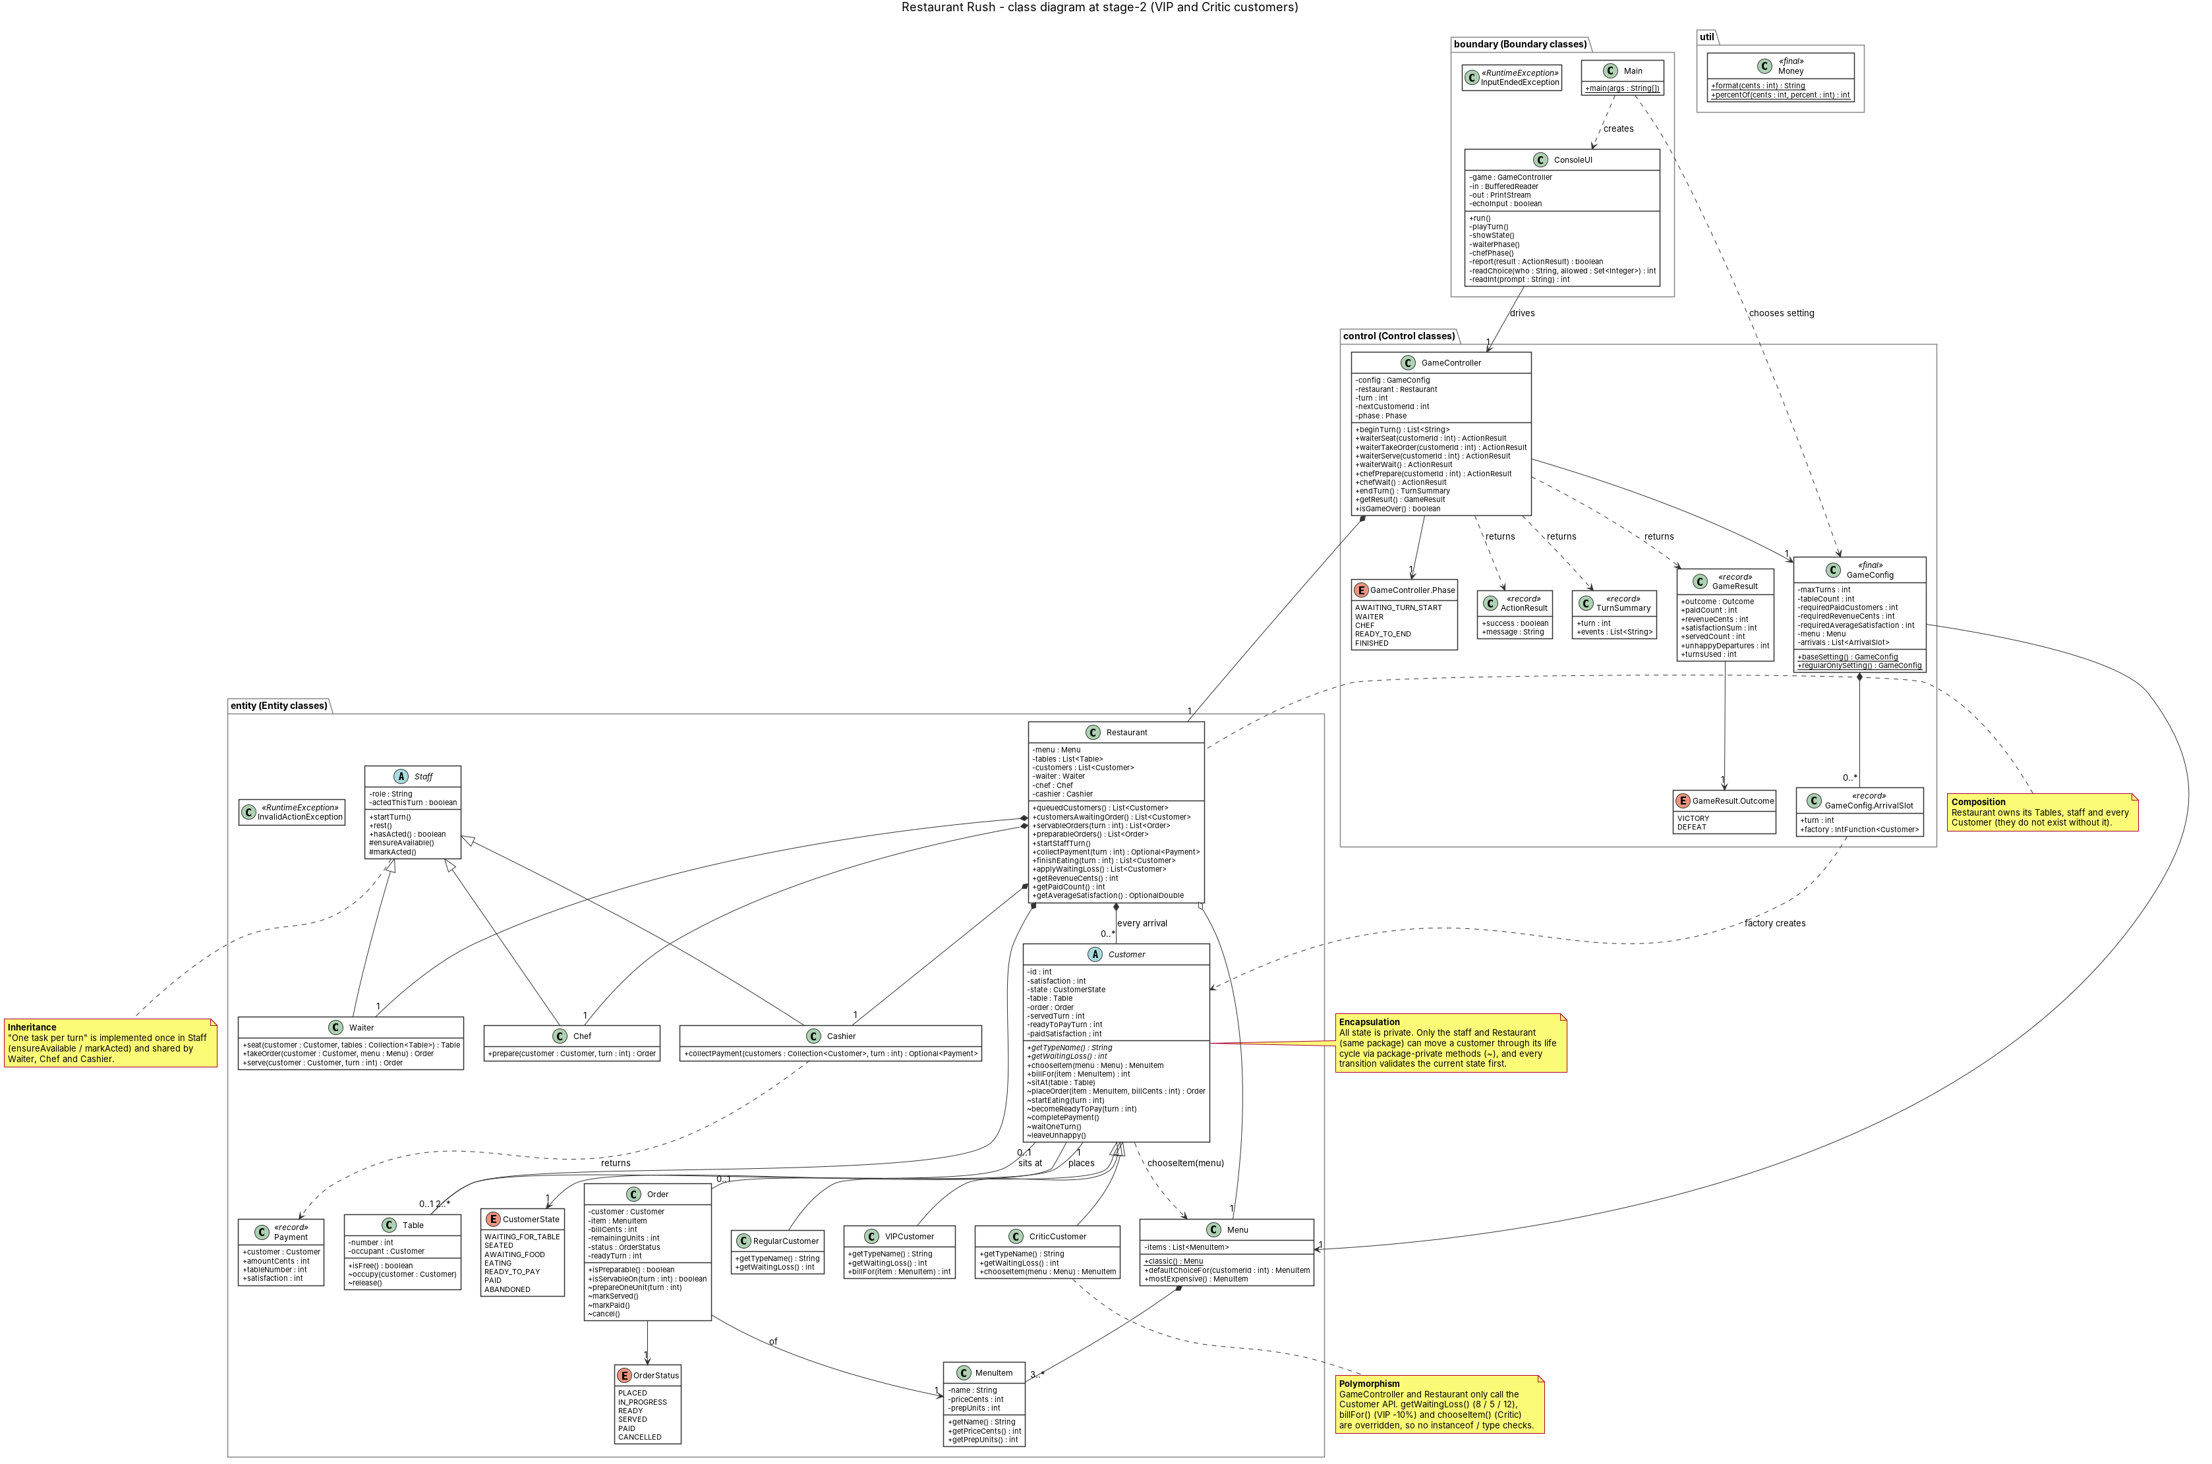
Figure B2. Class diagram at tag stage-2 (VIP and Critic customers). Vector graphic: zoom to read.

