**Please find the below details for obtaining the WPP trace logs from driver.**

Following MSDN link explains about Tools for Software Tracing.

<http://msdn.microsoft.com/en-us/library/windows/hardware/ff552961(v=vs.85).aspx>

It is needed to have **TraceView.exe** to see the wpp logs from the driver.

In Windows XP versions of OS, it needs ‘**dbghelp.dll**’ to be present in the folder where **TraceView.exe** ispresentwhich uses to viewwpp logs from the driver.

**TraceView.exe** and ‘**dbghelp.dll**’ are located in the tools\tracing\<Platform> subdirectory of windows Driver Kit (WDK) in the respective Windows OS, where <Platform> is either i386, amd64, or ia64.

Following MSDN link explains how to use the features of TraceView.

<http://msdn.microsoft.com/en-us/library/windows/hardware/ff556063(v=vs.85).aspx>

**Notes**  :TraceView runs on Microsoft Windows 2000 and later versions of Windows, although some features are restricted on Windows 2000.

For more information about these restrictions, see [TraceView Limitations](http://msdn.microsoft.com/en-us/library/windows/hardware/ff553887(v=vs.85).aspx).

This document explains in details about how to get WPP trace logs from  VeriFone USB UART Driver Vx_1.0.0.61 driver.

Driver pdb file(**VFIUSBF.pdb**) will be available in the driver installed path either in i386 or in amd64 folder of the respective OS driver got installed.

Eg: Let VeriFone USB UART Driver Vx_1.0.0.61 driver installed on Win-7 32 bit PC.

       Then Following is the screenshot of the pdb  file to be used for WPP tracing with trace view.

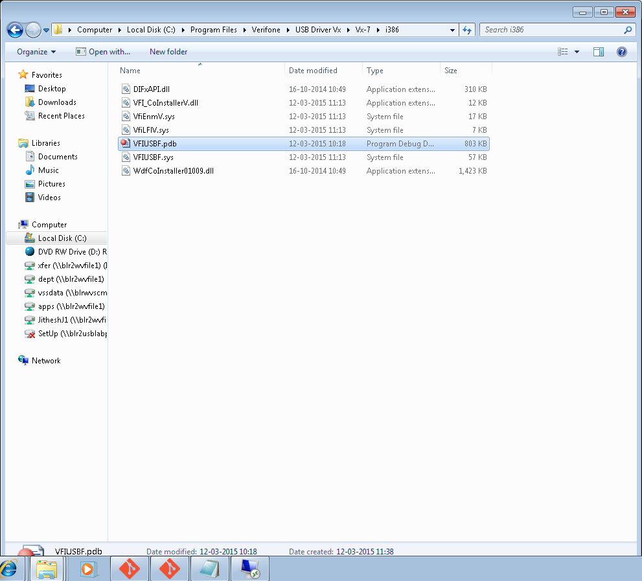

**Steps for Getting the WPP Logs is described below.**

Step1:

Run the Trace View as administrator(note choose the correct trace view based on the bits 32/64 and processor and windows OS version.

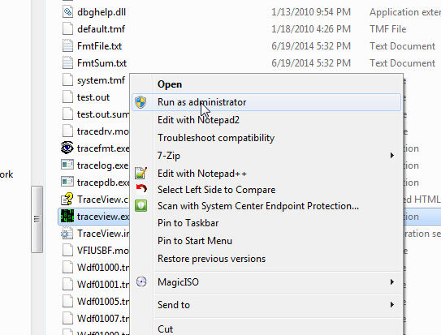

Step2:

Choose Create new Log session.

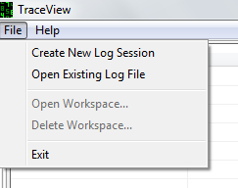

Step3:

In the Create New Log Session Popup Click on the Button Add Provider, This Prompt the Provider Control GUID Setup Popup as shown below.

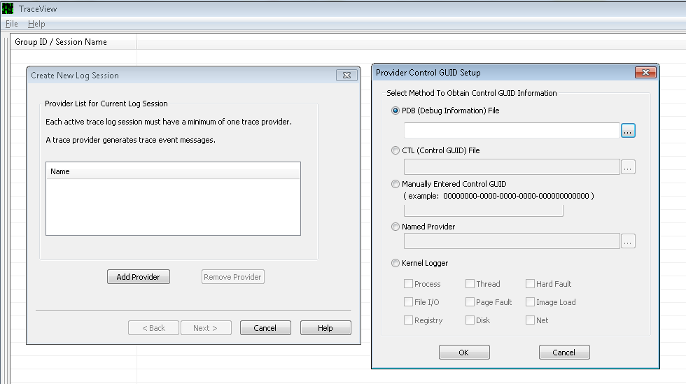

Step4:

Choose PDB(Debug Information) File ,and give the correct path of the PDB file.

Note: Care should be taken to choose the correct PDB based on Bit(32/64) and also processor type.

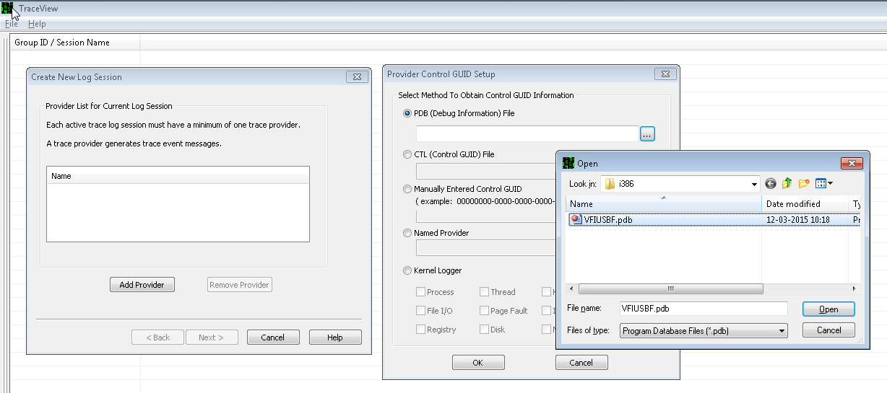

Step 5:

Click the Next Button

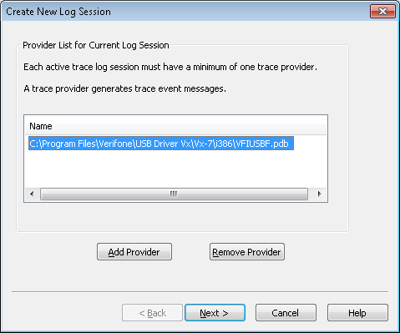

Step 6:

This will prompt the next Screen as below.

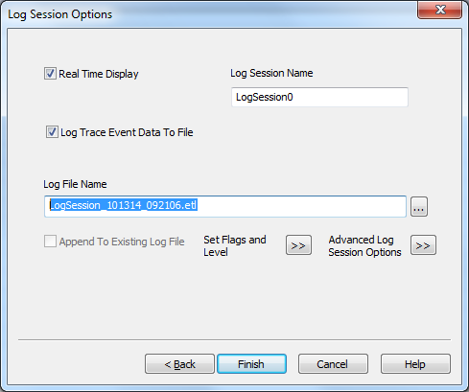

Step7:

Check ‘Log Trace Event Data To File’, this will enable ‘Log File Name’(.etl file).

Click on the `Set Flags and Level’ button, and choose level ->Information as below.

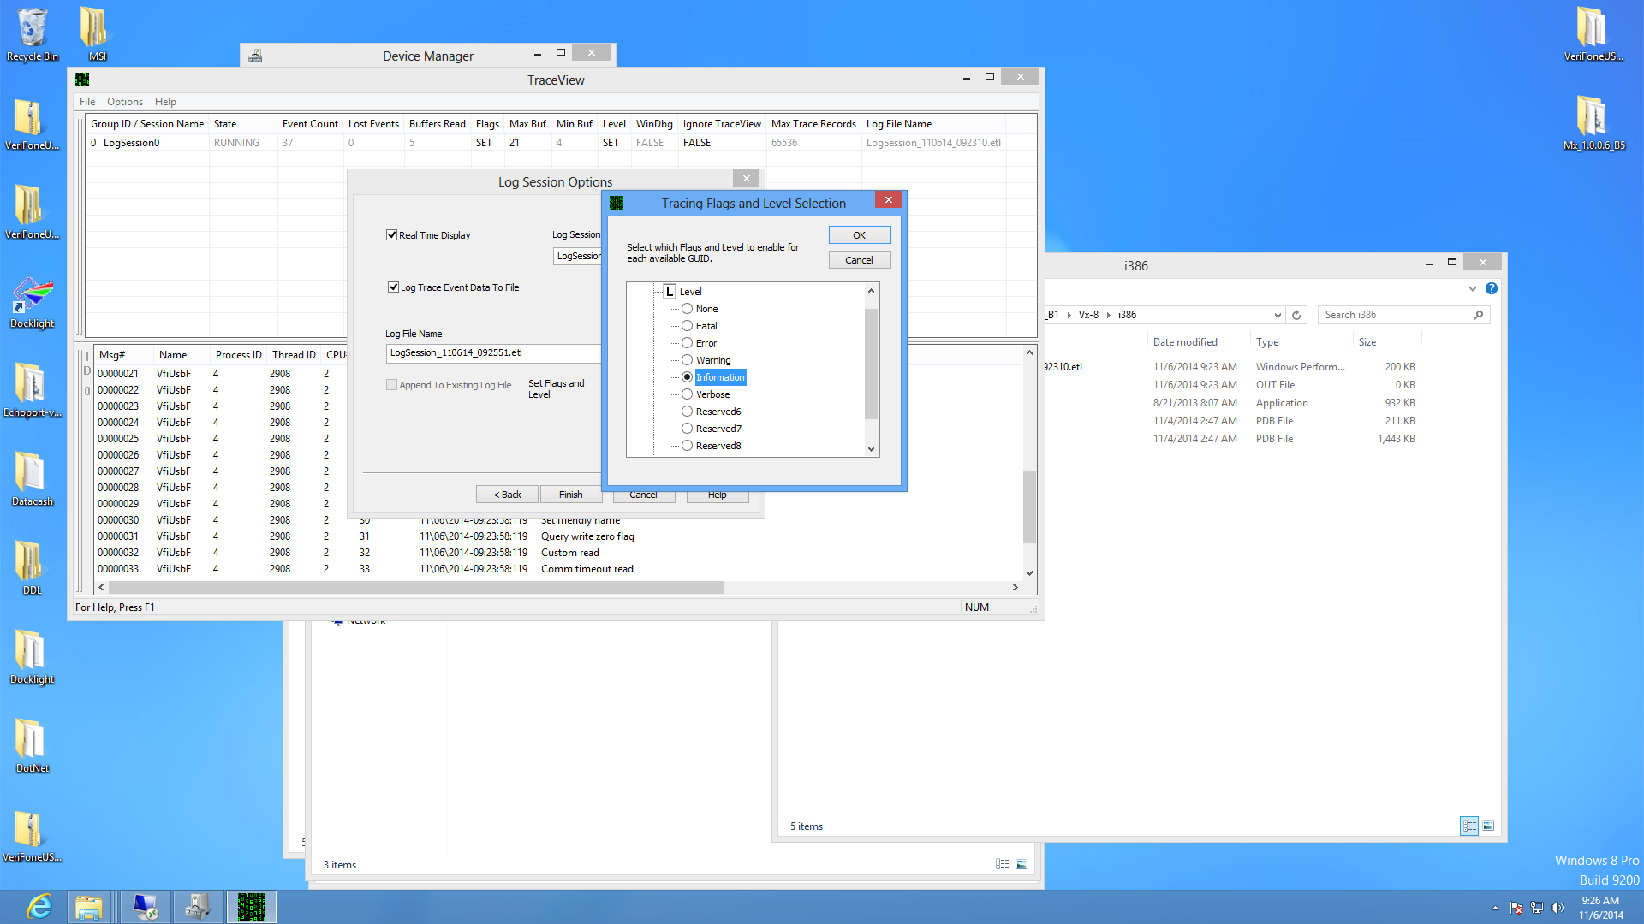

Step 8:

Also choose flags option and check only DBG_INIT, DBG_PNP,DBG_WRITE and DBG_READ

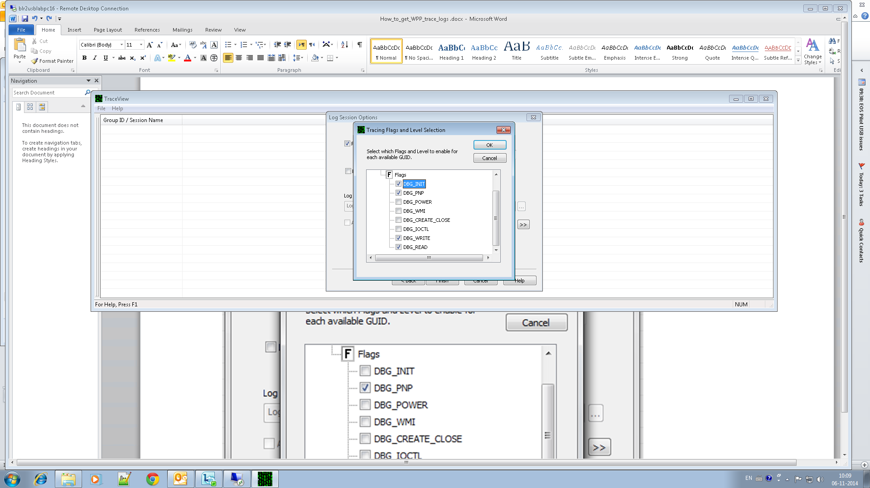

Step 9:

On the same Log Sessions Options Screen ,check on ‘Create Listing File’ and give the path of the out file where logs can be stored and click on the Finish Button

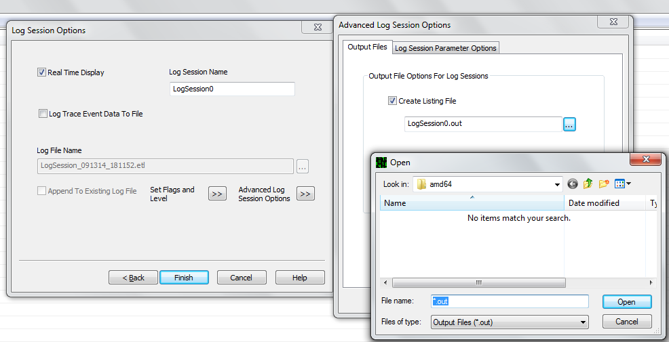

Step10:

Trace view is now ready for collecting the logs from the USB Driver

