CLOUD DEVELOPMENT B · CLDV7112w · ADADw1
Improving the Customer Experience
How Azure Event Hubs and Azure Service Bus would add value to the ABC Retail application
Student name
Genius Mhirizhonga
Student number
ST10541838
Module code
CLDV7112w
Assessment
ICE Task 4
The application discussed
https://st10541838.azurewebsites.net

1. The application these services would serve
The application I am discussing is the ABC Retail storage console I built across the earlier tasks in this module. Customer profiles, the product catalogue and orders are held in Azure Table Storage, product images sit in Blob Storage, order and inventory work is queued on Azure Queue Storage, and every action is logged to an Azure Files share. Four Azure Functions sit in front of those services.
That matters here because the two services in this task are not replacements for what is already there. They would sit alongside it and carry two kinds of traffic the current design does not handle well.
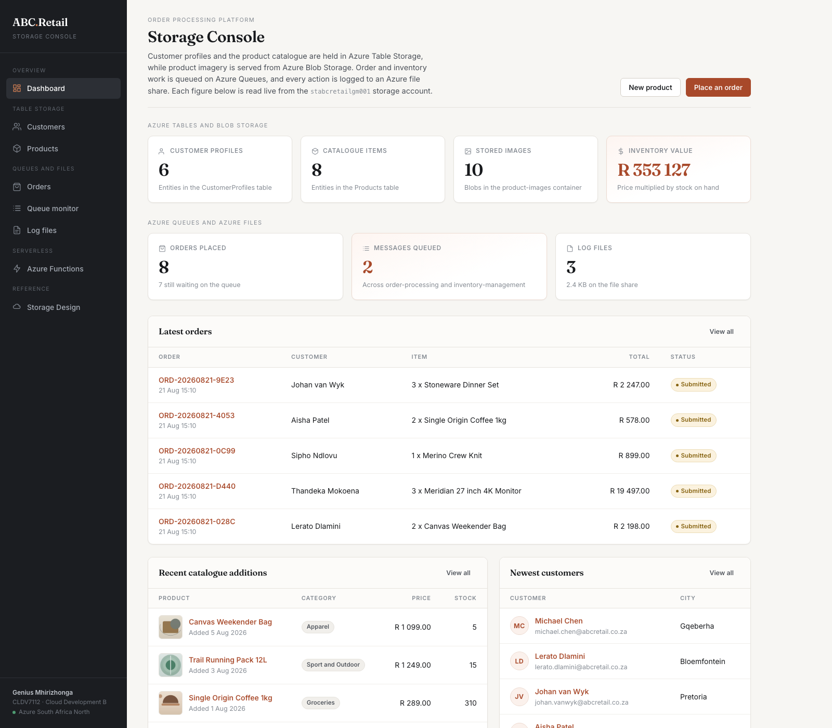
Figure 1. The application as it stands, with every figure read live from the storage account.
The gap is visible in the ABC Retail background. It describes delays in order processing, inconsistent messaging delivery, and an analytics platform that cannot keep pace with the volume and variety of customer data. Azure Queue Storage, which the application uses today, is a simple queue. It is cheap and reliable, but it holds one message for one consumer and then the message is gone. It has no publish and subscribe, no ordering guarantee and no way to park a message that keeps failing.

2. Where the two services would fit
Neither service is deployed. The diagram below shows what each one would carry if it were added to the application as it stands.
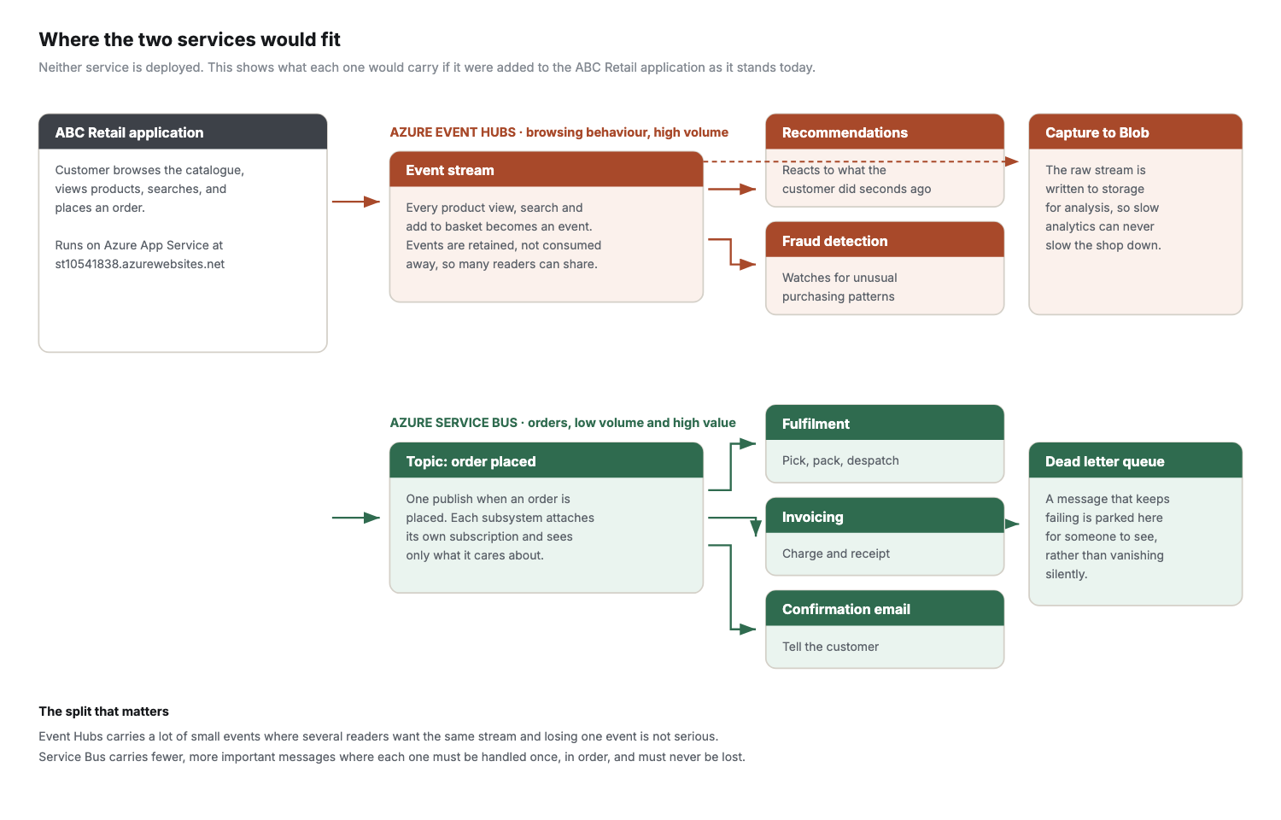
Figure 2. Event Hubs would carry browsing behaviour, and Service Bus would carry orders.

3. Azure Event Hubs

Description of service
Event Hubs is Azure’s event ingestion and streaming service. It is built to take in very large numbers of small events from many producers at once and hold them in an ordered log that several different consumers can read independently.
The important distinction is that it is not a queue. A queue hands each message to one consumer and the message is then gone. An event hub keeps its events for a retention period and lets anything that is interested read the same stream, which is exactly what you want when several parts of a business care about the same customer behaviour for different reasons.

Mechanism
Producers send events to an event hub over AMQP, HTTPS or the Kafka protocol. The hub divides the stream across partitions, and events within a partition keep the order they arrived in.
Consumers read through consumer groups, and each consumer group keeps its own offset, meaning its own position in the stream. That is the mechanism that lets a recommendation engine and a fraud check read exactly the same events without competing for them or even knowing the other exists. Because events are retained rather than consumed away, a consumer that falls behind or crashes resumes from its last offset instead of losing what it missed, and a consumer added months later can replay history it was never present for.
Event Hubs Capture can additionally write the raw stream straight into Blob Storage on a schedule with no code at all, which hands an analytics team the data without the shop front doing any extra work.

How it adds value to end users
The obvious use for ABC Retail is browsing behaviour. Every product view, search and add to basket becomes an event. Because the stream is read in near real time, recommendations can reflect what the customer did a few seconds ago rather than what they did yesterday, and that is the difference between a suggestion that feels useful and one that feels random.
The same stream serves several consumers at once. One consumer group updates recommendations, another watches for unusual purchasing that might be card fraud, and a third keeps a live view of what is moving so a low stock warning appears before an item sells out. The customer never sees Event Hubs. What they see is a shop that reacts to them, warns them an item is nearly gone, and does not let them order something that is no longer there.
It also answers the analytics complaint in the ABC Retail background directly. Streaming events into an event hub and capturing them into storage separates collecting the data from analysing it, so slow analysis can never slow down the shop. At the moment those two things compete.

4. Azure Event Bus
A note on the name before anything else. The task lists this service as Azure Event Bus, but there is no Azure product with that name. Azure offers Event Grid, Event Hubs and Service Bus. Since it is paired here with Event Hubs and the subject is messaging, I have taken it to mean Azure Service Bus and discussed it as such.

Description of service
Service Bus is a fully managed enterprise message broker. It provides queues for point to point messaging and topics for publish and subscribe, and it adds the guarantees a business transaction needs: ordering, dead lettering, duplicate detection, scheduled delivery and transactions spanning several messages.
It is the service Azure Queue Storage grows into when simple is no longer enough. The application already uses Queue Storage, so this is a concrete upgrade path rather than a hypothetical one.

Mechanism
A producer sends a message to a queue or to a topic. A queue delivers to one consumer. A topic delivers a copy to every subscription attached to it, and each subscription can carry a filter so it only receives the messages it cares about. One publish can therefore feed several subsystems without the publisher knowing any of them exist.
Delivery uses peek lock. The consumer takes a lock on the message, does the work, then completes it. If the work fails the message is abandoned and becomes visible again, and after a configured number of failed attempts it is moved to a dead letter queue rather than being lost or retried forever. Sessions group related messages so they are handled strictly in order, which matters when the events belonging to one order must not overtake each other.

How it adds value to end users
The clearest gain is what happens after an order is placed. Today the order goes onto one queue and one consumer handles it. With a Service Bus topic, placing an order publishes once and fulfilment, invoicing, the confirmation email and loyalty points each receive their own copy through their own subscription. Adding a step later, a delivery partner for instance, means adding a subscription rather than changing the ordering code.
Dead lettering is the feature a customer actually feels, even though they never hear the name. If the confirmation email fails, the message lands in the dead letter queue where a person can see it and act on it, instead of disappearing and leaving the customer wondering whether their order went through at all. That one feature turns a silent failure into a visible one.
Sessions keep an order’s events in sequence, so a cancellation cannot be processed before the order it cancels. Scheduled delivery lets a despatch notification be queued now and released when the courier actually collects. Duplicate detection stops a customer being charged twice if a request is retried on a bad connection. Every one of those is a reliability feature, and reliability is precisely what the ABC Retail background says their legacy middleware failed to deliver.

5. Choosing between them
The two are not alternatives and I would use both, because they solve different problems.
 | Azure Event Hubs | Azure Service Bus
Built for | Very high volumes of small events | Smaller numbers of important messages
Reading model | Many consumers read the same stream | Each message is handled by one consumer
After reading | The event stays for the retention period | The message is removed once completed
If one is lost | Tolerable, it is one data point | Not tolerable, it is somebody’s order
In this application | Browsing, searching, adding to basket | Orders, invoices, notifications

Put simply, browsing behaviour belongs on Event Hubs and an order belongs on Service Bus. Sending orders through Event Hubs would give up the delivery guarantees that make an order safe, and sending every page view through Service Bus would be slow and expensive for data that does not need any of those guarantees.
Neither replaces the Azure Queue Storage the application uses today. Queue Storage remains the right choice for simple background work where one consumer picks up one message, and it costs a fraction of what the other two do. The point of adding these services would be to handle the two kinds of traffic Queue Storage was never designed for.

References
Microsoft. 2026. Azure Event Hubs documentation. [Online]. Available at: https://learn.microsoft.com/azure/event-hubs/ [Accessed 17 September 2026].
Microsoft. 2026. Azure Service Bus documentation. [Online]. Available at: https://learn.microsoft.com/azure/service-bus-messaging/ [Accessed 17 September 2026].
Microsoft. 2026. Choose between Azure messaging services. [Online]. Available at: https://learn.microsoft.com/azure/service-bus-messaging/compare-messaging-services [Accessed 17 September 2026].

