CLOUD DEVELOPMENT B · CLDV7112w · ADADw1
Integrating Azure Services
Four Azure Functions across the ABC Retail storage services, and two services that would improve the customer experience
Student number
ST10541838
Student name
Genius Mhirizhonga
Module code
CLDV7112w
Assessment
Project 2
URL of the deployed application
https://st10541838.azurewebsites.net
GitHub repository for the source code
https://github.com/geniustaku/abc-retail-storage-console

This project needs expanding the application built for Project 1 with four functions calling the storage services it already uses, and then to discuss two Azure services that could improve the customer experience.
Requirement | Where it is in this document
A function that stores information in Azure tables | Section 3, StoreTableEntity
A function that writes to Azure Blob Storage | Section 4, UploadBlob
A function that reads from and writes to the Azure queue | Section 5, QueueTransaction
A function that sends a file to Azure Files | Section 6, WriteFile
Discussion of two services for the customer experience | Sections 8 and 9
Deployed application, tested locally and on App Service | Section 10

All four functions are deployed to the function app func-abcretail-gm and are called by the web application at https://st10541838.azurewebsites.net.

2. How the four functions fit together
Before this project the web application wrote to the storage account itself. For these four operations it now posts to a function, and the function does the storage work.
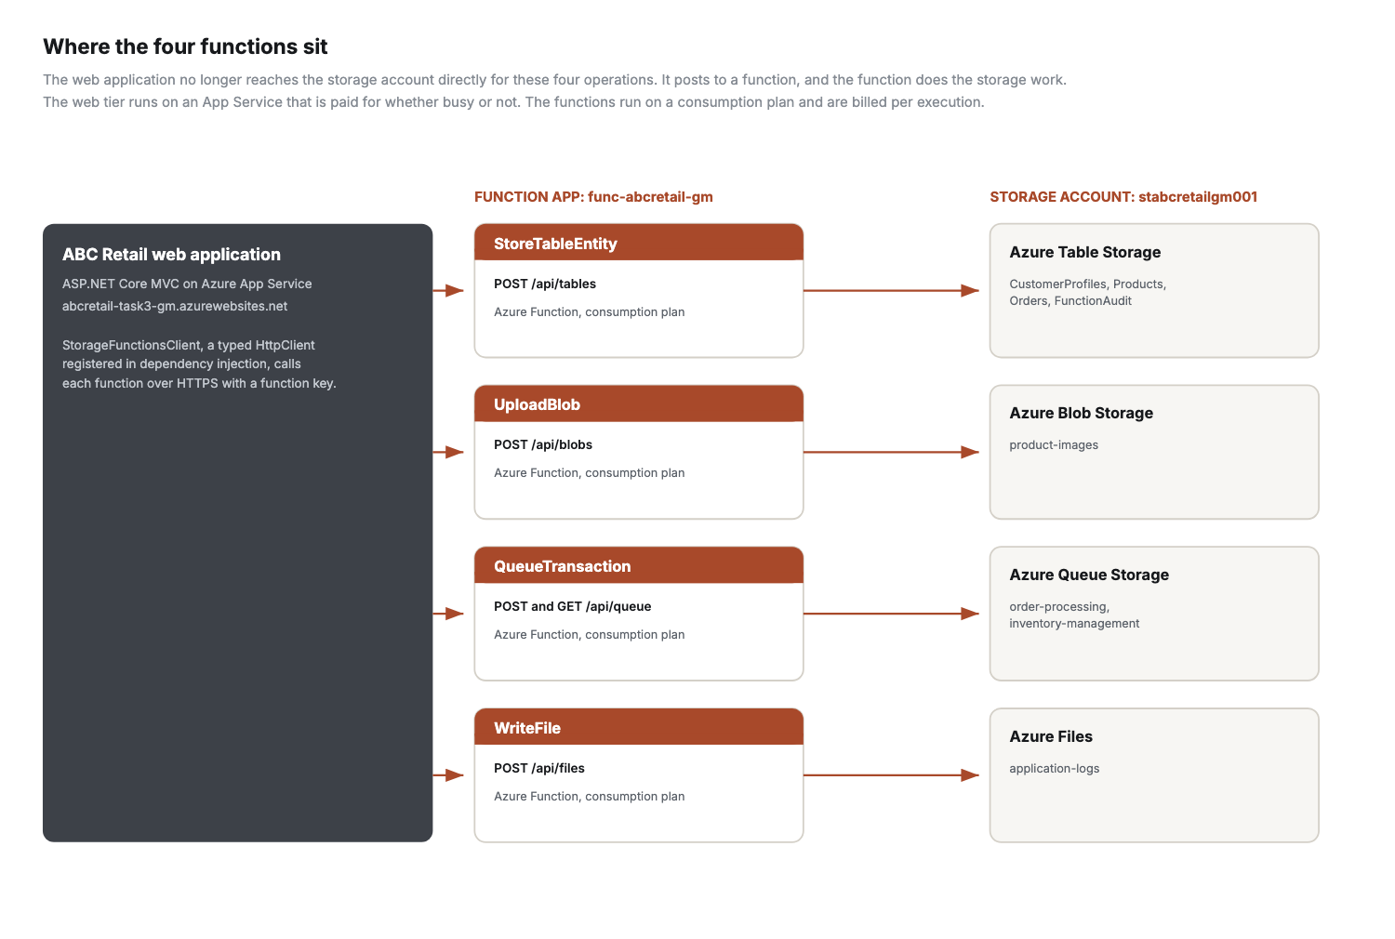
Figure 1. Each function handles one storage service. The web application calls them over HTTPS using a function key.
The two halves are deployed and billed separately, which is the point of the change. The App Service, while the functions sit on a consumption plan and cost nothing when idle.

3. Function one: StoreTableEntity, storing information in Azure Tables
This function accepts a table name, a partition key, a row key and a set of properties, and writes the entity to Azure Table Storage. The table name arrives in the request rather than being fixed in the function, so one deployment serves CustomerProfiles, Products, Orders and the FunctionAudit table the web application writes to.
- Route: POST /api/tables, secured at function authorisation level so a key is required.
- The table is created if it does not exist, so a first call on a fresh account still works.
- It upserts rather than inserts. A repeated call updates the entity instead of failing on a duplicate key, which matters because the web application may retry.
- The response says which service and table were written to, so the caller can report it without a second lookup.

Code
/// <summary>
/// Function 1 of 4. Writes an entity to Azure Table Storage.
/// </summary>
/// <remarks>
/// The table name arrives in the request rather than being fixed in the function, so the
/// same function serves CustomerProfiles, Products and Orders instead of needing one
/// deployment per table.
/// </remarks>
public class StoreTableEntityFunction
{
private readonly ILogger<StoreTableEntityFunction> _logger;

public StoreTableEntityFunction(ILogger<StoreTableEntityFunction> logger)
{
_logger = logger;
}

[Function("StoreTableEntity")]
public async Task<HttpResponseData> Run(
[HttpTrigger(AuthorizationLevel.Function, "post", Route = "tables")] HttpRequestData request)
{
var payload = await Json.ReadAsync<TableEntityRequest>(request);

if (payload is null || string.IsNullOrWhiteSpace(payload.Table))
{
return await Json.WriteAsync(request, HttpStatusCode.BadRequest,
new { error = "A table name is required." });
}

var partitionKey = string.IsNullOrWhiteSpace(payload.PartitionKey) ? "DEFAULT" : payload.PartitionKey;
var rowKey = string.IsNullOrWhiteSpace(payload.RowKey) ? Guid.NewGuid().ToString() : payload.RowKey;

var table = new TableClient(StorageConnection.Resolve(), payload.Table);
await table.CreateIfNotExistsAsync();

var entity = new TableEntity(partitionKey, rowKey);
foreach (var pair in payload.Properties ?? new Dictionary<string, string>())
{
entity[pair.Key] = pair.Value;
}

// Upsert rather than insert, so a repeated call from the web application updates
// the entity instead of failing on a duplicate key.
await table.UpsertEntityAsync(entity, TableUpdateMode.Replace);

_logger.LogInformation("Stored entity {Partition}/{Row} in {Table}", partitionKey, rowKey, payload.Table);

return await Json.WriteAsync(request, HttpStatusCode.OK, new
{
status = "stored",
service = "Azure Table Storage",
table = payload.Table,
partitionKey,
rowKey,
propertyCount = payload.Properties?.Count ?? 0,
writtenAtUtc = DateTimeOffset.UtcNow
});
}
}

/// <summary>Shared JSON handling so every function reads and replies the same way.</summary>
internal static class Json
{
private static readonly JsonSerializerOptions Options = new()
{
PropertyNameCaseInsensitive = true
};

public static async Task<T?> ReadAsync<T>(HttpRequestData request)
{
using var reader = new StreamReader(request.Body);
var body = await reader.ReadToEndAsync();

if (string.IsNullOrWhiteSpace(body))
{
return default;
}

return JsonSerializer.Deserialize<T>(body, Options);
}

public static async Task<HttpResponseData> WriteAsync(HttpRequestData request, HttpStatusCode status, object payload)
{
var response = request.CreateResponse(status);
await response.WriteAsJsonAsync(payload);
response.StatusCode = status;
return response;
}
}

Evidence
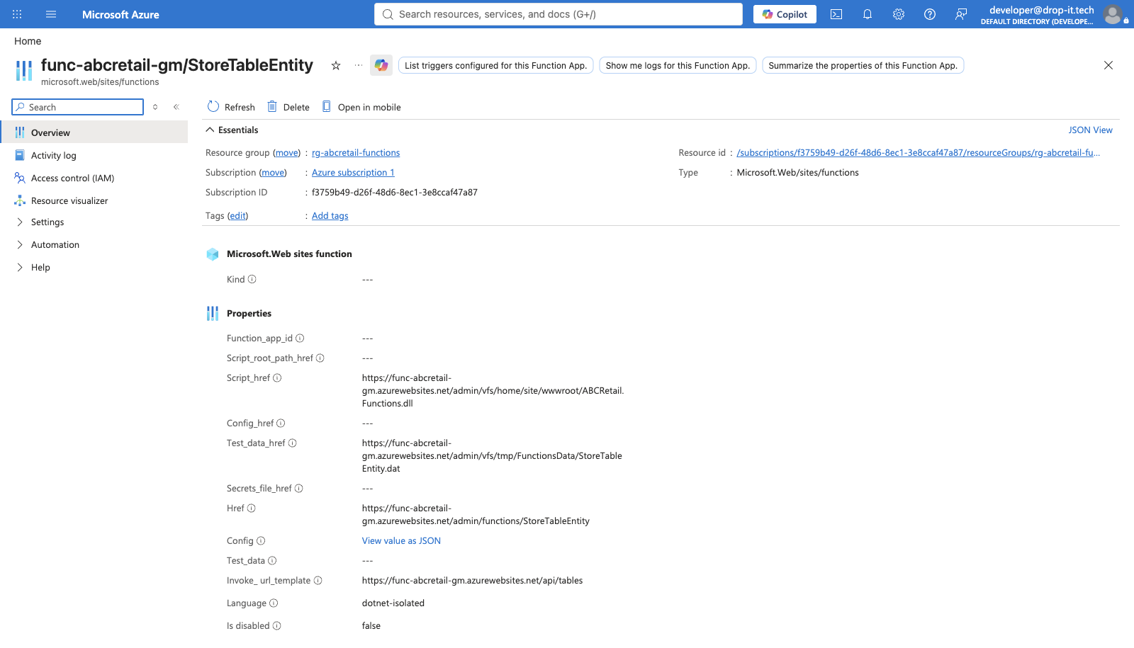
Figure 2. The StoreTableEntity function in the Azure function app.

4. Function two: UploadBlob, writing to Azure Blob Storage
This function takes a file as base64 inside the request body, writes it to a blob container and returns the URL the browser can use to fetch it.
- Route: POST /api/blobs.
- Content over 5 MB is rejected before anything is sent to storage.
- The blob name is generated rather than taken from the caller, so a caller cannot overwrite somebody else’s blob or shape the path inside the container.
- The content type from the request is applied to the blob, along with a long cache header, so the browser can cache the image instead of fetching it again on every page view.

Code
/// <summary>
/// Function 2 of 4. Writes a file to Azure Blob Storage and returns its URL.
/// </summary>
public class UploadBlobFunction
{
private const int MaxBytes = 5 * 1024 * 1024;

private readonly ILogger<UploadBlobFunction> _logger;

public UploadBlobFunction(ILogger<UploadBlobFunction> logger)
{
_logger = logger;
}

[Function("UploadBlob")]
public async Task<HttpResponseData> Run(
[HttpTrigger(AuthorizationLevel.Function, "post", Route = "blobs")] HttpRequestData request)
{
var payload = await Json.ReadAsync<BlobRequest>(request);

if (payload is null || string.IsNullOrWhiteSpace(payload.ContentBase64))
{
return await Json.WriteAsync(request, HttpStatusCode.BadRequest,
new { error = "File content is required, encoded as base64." });
}

byte[] bytes;
try
{
bytes = Convert.FromBase64String(payload.ContentBase64);
}
catch (FormatException)
{
return await Json.WriteAsync(request, HttpStatusCode.BadRequest,
new { error = "The content supplied is not valid base64." });
}

if (bytes.Length > MaxBytes)
{
return await Json.WriteAsync(request, HttpStatusCode.RequestEntityTooLarge,
new { error = $"Files must be {MaxBytes / 1024 / 1024} MB or smaller." });
}

var container = new BlobContainerClient(
StorageConnection.Resolve(),
string.IsNullOrWhiteSpace(payload.Container) ? "product-images" : payload.Container);

await container.CreateIfNotExistsAsync(PublicAccessType.Blob);

// The supplied file name is only used for its extension. The stored name is
// generated so a caller cannot overwrite an existing blob or shape the blob path.
var extension = Path.GetExtension(payload.FileName ?? string.Empty).ToLowerInvariant();
var blobName = $"{Guid.NewGuid():N}{extension}";
var blob = container.GetBlobClient(blobName);

using var stream = new MemoryStream(bytes);
await blob.UploadAsync(stream, new BlobUploadOptions
{
HttpHeaders = new BlobHttpHeaders
{
ContentType = string.IsNullOrWhiteSpace(payload.ContentType) ? "application/octet-stream" : payload.ContentType,
CacheControl = "public, max-age=31536000"
}
});

_logger.LogInformation("Uploaded blob {BlobName} ({Bytes} bytes)", blobName, bytes.Length);

return await Json.WriteAsync(request, HttpStatusCode.OK, new
{
status = "uploaded",
service = "Azure Blob Storage",
container = container.Name,
blobName,
url = blob.Uri.ToString(),
sizeBytes = bytes.Length,
writtenAtUtc = DateTimeOffset.UtcNow
});
}
}

Evidence
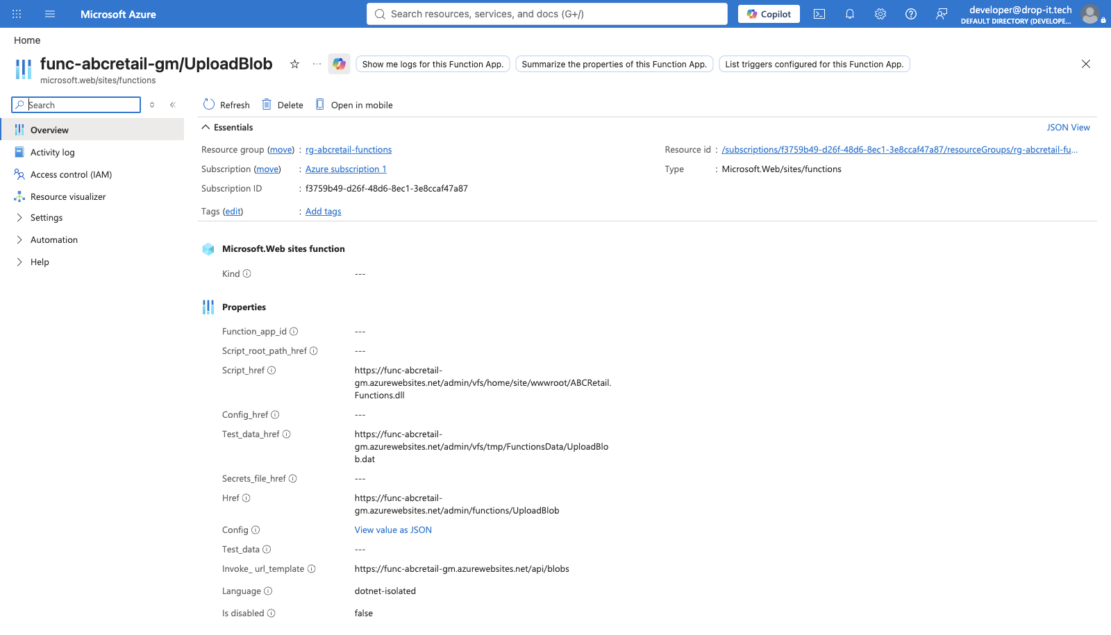
Figure 3. The UploadBlob function in the Azure function app.

5. Function three: QueueTransaction, writing to and reading from the queue
This function handles both directions of the queue, which is what the brief asks for. A POST places a transaction message on the queue and a GET reads it back, either peeking or dequeuing depending on the mode requested.
- Route: POST and GET /api/queue.
- The message body is JSON carrying a readable description and the reference a consumer needs, so one message serves both a monitoring screen and the processing code.
- A read defaults to peeking. Receiving a message would start its visibility timeout and hide it from the real consumer, so monitoring the queue would interfere with the work being done.
- When dequeuing, the message is deleted only after it has been read successfully. A failure before that point returns it to the queue for another attempt, which is the at-least-once behaviour Queue Storage is built on.
- Both directions live in one function deliberately. A producer and a consumer that quietly disagree about the shape of a message is a common way for a queue to go wrong, and keeping them together makes the contract obvious.

Code
/// <summary>
/// Function 3 of 4. Writes transaction messages to a queue and reads them back off it.
/// </summary>
/// <remarks>
/// Both directions live in one function because the brief treats the queue as a single
/// concern, and because a producer and a consumer that disagree about the message format
/// is a common source of defects. Keeping them together makes the contract obvious.
/// </remarks>
public class QueueTransactionFunction
{
private readonly ILogger<QueueTransactionFunction> _logger;

public QueueTransactionFunction(ILogger<QueueTransactionFunction> logger)
{
_logger = logger;
}

[Function("QueueTransaction")]
public async Task<HttpResponseData> Run(
[HttpTrigger(AuthorizationLevel.Function, "post", "get", Route = "queue")] HttpRequestData request)
{
return request.Method.Equals("POST", StringComparison.OrdinalIgnoreCase)
? await WriteAsync(request)
: await ReadAsync(request);
}

private async Task<HttpResponseData> WriteAsync(HttpRequestData request)
{
var payload = await Json.ReadAsync<QueueRequest>(request);

if (payload is null || string.IsNullOrWhiteSpace(payload.Message))
{
return await Json.WriteAsync(request, HttpStatusCode.BadRequest,
new { error = "A message is required." });
}

var queue = await ResolveAsync(payload.Queue);

// The body carries JSON rather than bare text so a consumer gets the reference it
// need to act on the message without a second lookup.
var body = JsonSerializer.Serialize(new
{
kind = "Transaction",
message = payload.Message,
reference = payload.Reference,
queuedAtUtc = DateTimeOffset.UtcNow
});

var receipt = await queue.SendMessageAsync(body);
var properties = await queue.GetPropertiesAsync();

_logger.LogInformation("Queued a transaction on {Queue}", queue.Name);

return await Json.WriteAsync(request, HttpStatusCode.OK, new
{
status = "queued",
service = "Azure Queue Storage",
direction = "write",
queue = queue.Name,
messageId = receipt.Value.MessageId,
approximateDepth = properties.Value.ApproximateMessagesCount,
queuedAtUtc = DateTimeOffset.UtcNow
});
}

private async Task<HttpResponseData> ReadAsync(HttpRequestData request)
{
var parameters = System.Web.HttpUtility.ParseQueryString(request.Url.Query);
var queue = await ResolveAsync(parameters["queue"]);
var remove = string.Equals(parameters["mode"], "dequeue", StringComparison.OrdinalIgnoreCase);

if (!remove)
{
// Peeking leaves the message visible to the real consumer, so reading the queue
// for monitoring does not interfere with the work being processed.
var peeked = await queue.PeekMessagesAsync(10);
var properties = await queue.GetPropertiesAsync();

return await Json.WriteAsync(request, HttpStatusCode.OK, new
{
status = "read",
service = "Azure Queue Storage",
direction = "read (peek)",
queue = queue.Name,
approximateDepth = properties.Value.ApproximateMessagesCount,
messages = peeked.Value.Select(m => new { m.MessageId, body = m.Body.ToString(), m.InsertedOn })
});
}

var received = await queue.ReceiveMessagesAsync(1);
var message = received.Value.FirstOrDefault();

if (message is null)
{
return await Json.WriteAsync(request, HttpStatusCode.OK, new
{
status = "empty",
service = "Azure Queue Storage",
direction = "read (dequeue)",
queue = queue.Name
});
}

// Deleted only after it has been read successfully. A failure before this point
// returns the message to the queue for another attempt.
await queue.DeleteMessageAsync(message.MessageId, message.PopReceipt);

return await Json.WriteAsync(request, HttpStatusCode.OK, new
{
status = "dequeued",
service = "Azure Queue Storage",
direction = "read (dequeue)",
queue = queue.Name,
messageId = message.MessageId,
body = message.Body.ToString(),
dequeueCount = message.DequeueCount
});
}

private static async Task<QueueClient> ResolveAsync(string? name)
{
var queue = new QueueClient(
StorageConnection.Resolve(),
string.IsNullOrWhiteSpace(name) ? "order-processing" : name);

await queue.CreateIfNotExistsAsync();
return queue;
}
}

Evidence
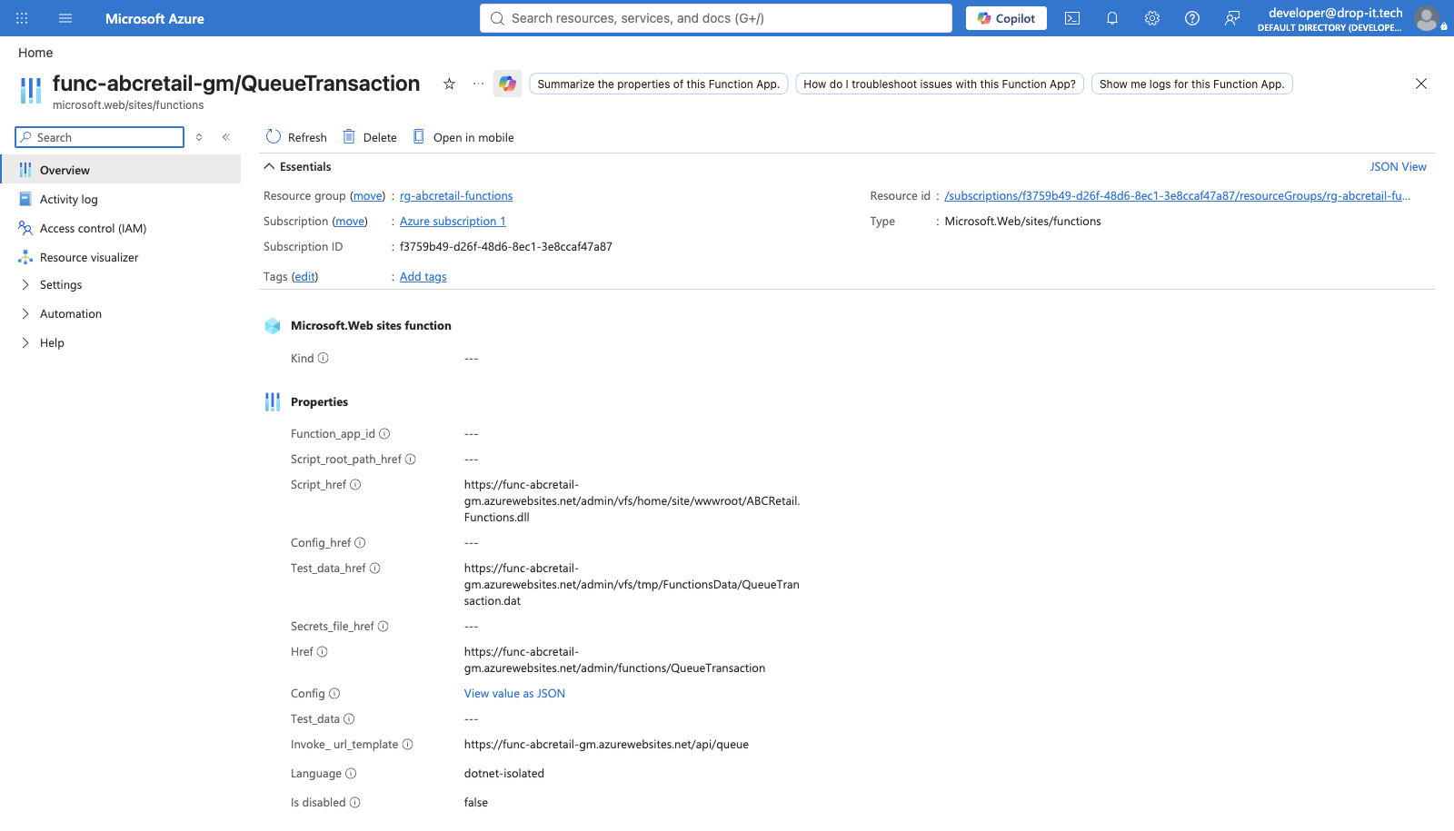
Figure 4. The QueueTransaction function in the Azure function app.
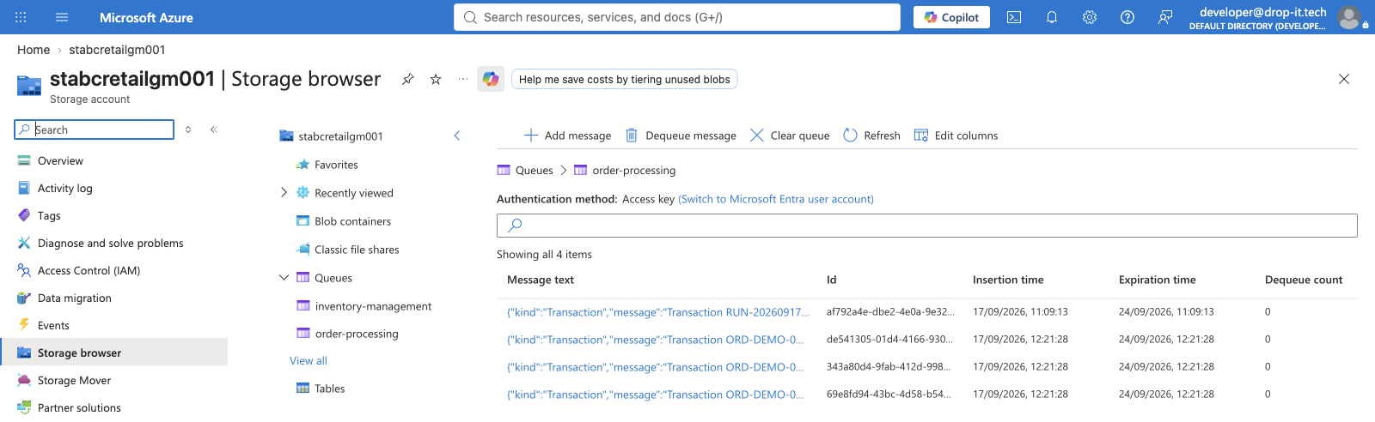
Figure 5. A message written by the function, sitting on the order-processing queue in the storage account.

6. Function four: WriteFile, sending a file to Azure Files
This function appends a timestamped line to a dated log file on the application-logs file share, creating the share, the directory and the file when they do not already exist.
- Route: POST /api/files.
- Azure Files has no append operation, unlike an append blob. A line is added by reading the file’s current length, growing the file by the length of the new bytes, and writing those bytes into the range that growth created.
- That sequence is three calls and is not atomic, which is worth knowing: with several writers the correct answer would be a lease on the file.
- A file share was used rather than a blob because a share is a real SMB file system and can be mounted as a drive, which is what an operations team wants from a log.

Code
/// <summary>
/// Function 4 of 4. Appends a line to a log file on the Azure Files share.
/// </summary>
/// <remarks>
/// Azure Files has no append operation, unlike an append blob. A line is added by reading
/// the file's current length, growing the file by the length of the new bytes, and writing
/// those bytes into the range that growth created.
/// </remarks>
public class WriteFileFunction
{
private const string ShareName = "application-logs";

private readonly ILogger<WriteFileFunction> _logger;

public WriteFileFunction(ILogger<WriteFileFunction> logger)
{
_logger = logger;
}

[Function("WriteFile")]
public async Task<HttpResponseData> Run(
[HttpTrigger(AuthorizationLevel.Function, "post", Route = "files")] HttpRequestData request)
{
var payload = await Json.ReadAsync<FileRequest>(request);

if (payload is null || string.IsNullOrWhiteSpace(payload.Line))
{
return await Json.WriteAsync(request, HttpStatusCode.BadRequest,
new { error = "A line of text is required." });
}

var directoryName = string.IsNullOrWhiteSpace(payload.Directory) ? "logs" : payload.Directory;
var fileName = string.IsNullOrWhiteSpace(payload.FileName)
? $"functions-{DateTimeOffset.UtcNow:yyyy-MM-dd}.log"
: payload.FileName;

var share = new ShareClient(StorageConnection.Resolve(), ShareName);
await share.CreateIfNotExistsAsync();

var directory = share.GetDirectoryClient(directoryName);
await directory.CreateIfNotExistsAsync();

var file = directory.GetFileClient(fileName);
var text = $"{DateTimeOffset.UtcNow:yyyy-MM-dd HH:mm:ss} [FUNCTION] {payload.Line}{Environment.NewLine}";
var bytes = Encoding.UTF8.GetBytes(text);

long offset;
if (await file.ExistsAsync())
{
ShareFileProperties properties = await file.GetPropertiesAsync();
offset = properties.ContentLength;
await file.SetHttpHeadersAsync(new ShareFileSetHttpHeadersOptions { NewSize = offset + bytes.Length });
}
else
{
offset = 0;
await file.CreateAsync(bytes.Length);
}

using var stream = new MemoryStream(bytes);
await file.UploadRangeAsync(new HttpRange(offset, bytes.Length), stream);

_logger.LogInformation("Appended {Bytes} bytes to {Directory}/{File}", bytes.Length, directoryName, fileName);

return await Json.WriteAsync(request, HttpStatusCode.OK, new
{
status = "appended",
service = "Azure Files",
share = ShareName,
path = $"{directoryName}/{fileName}",
bytesWritten = bytes.Length,
fileSizeBytes = offset + bytes.Length,
writtenAtUtc = DateTimeOffset.UtcNow
});
}
}

Evidence
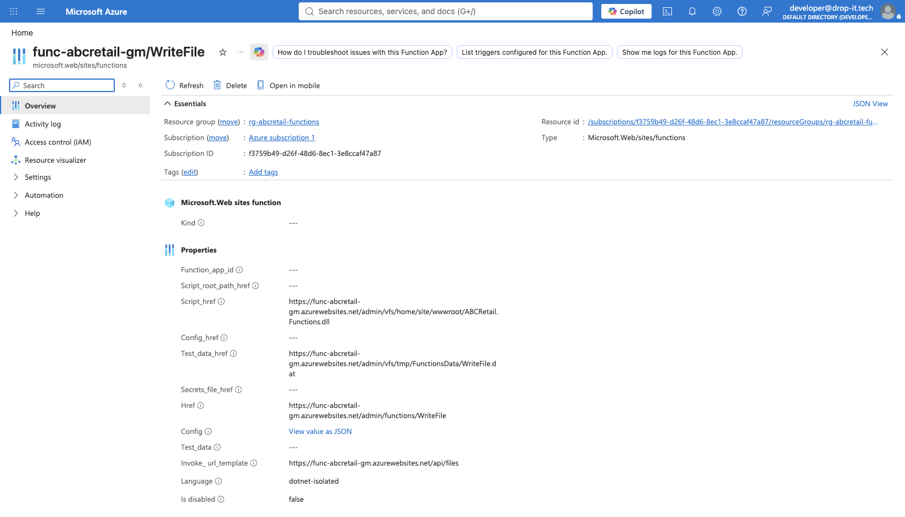
Figure 6. The WriteFile function in the Azure function app.
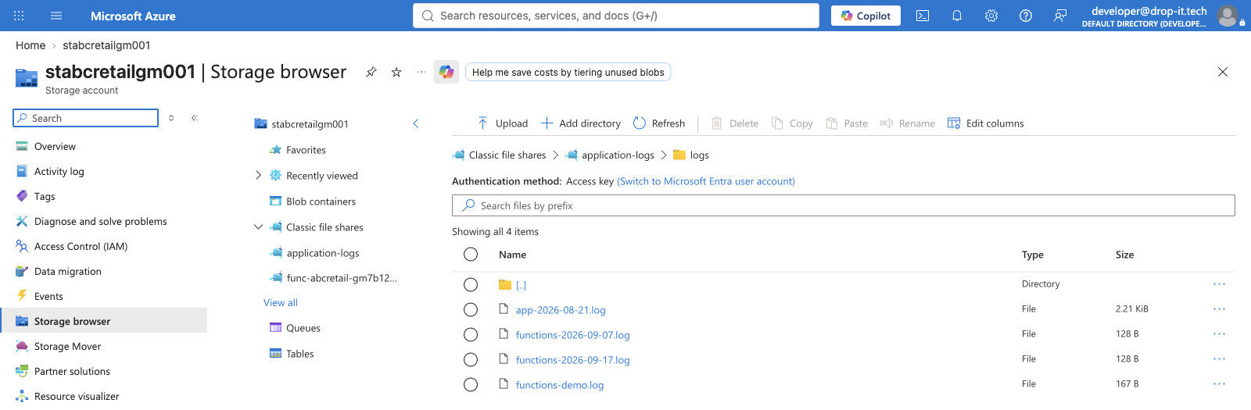
Figure 7. The log file the function wrote, on the application-logs file share.

7. The web application calling all four
The application reaches the functions through StorageFunctionsClient, a typed HttpClient registered in dependency injection with AddHttpClient, which gives it a pooled message handler rather than a new HttpClient per call. Every call is timed, and a function that cannot be reached returns a failed result the page can display rather than throwing. On a consumption plan the first call after an idle period is always slow, and a cold start should not take a page down.
The function key is never in the repository. It is held as the Functions__Key application setting on the App Service, the same way the storage connection string is handled, and appsettings.json carries the key with an empty value so it is clear one is expected.
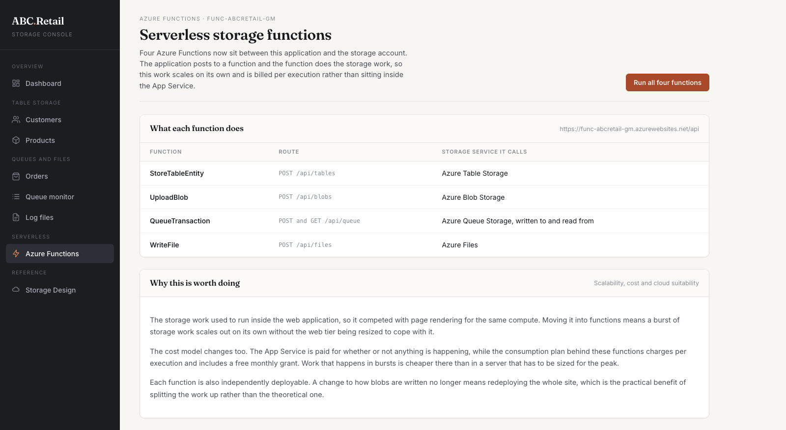
Figure 8. The Azure Functions page in the deployed application, listing each function, its route and the service it calls.
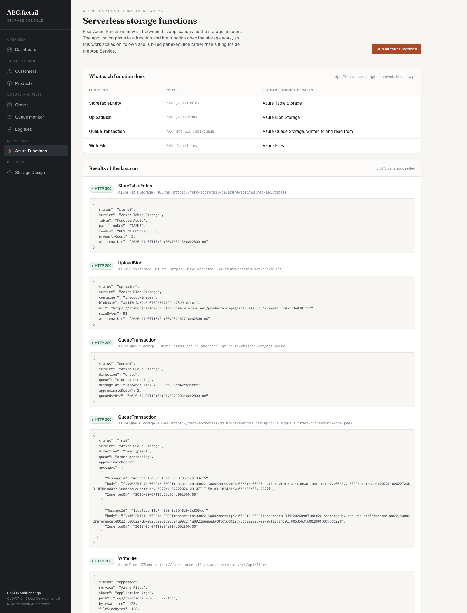
Figure 9. All four functions invoked from the deployed application. Five calls, all HTTP 200: a table write, a blob upload returning the blob URL, a queue write, a queue read showing the messages on the queue, and an append to the file share.
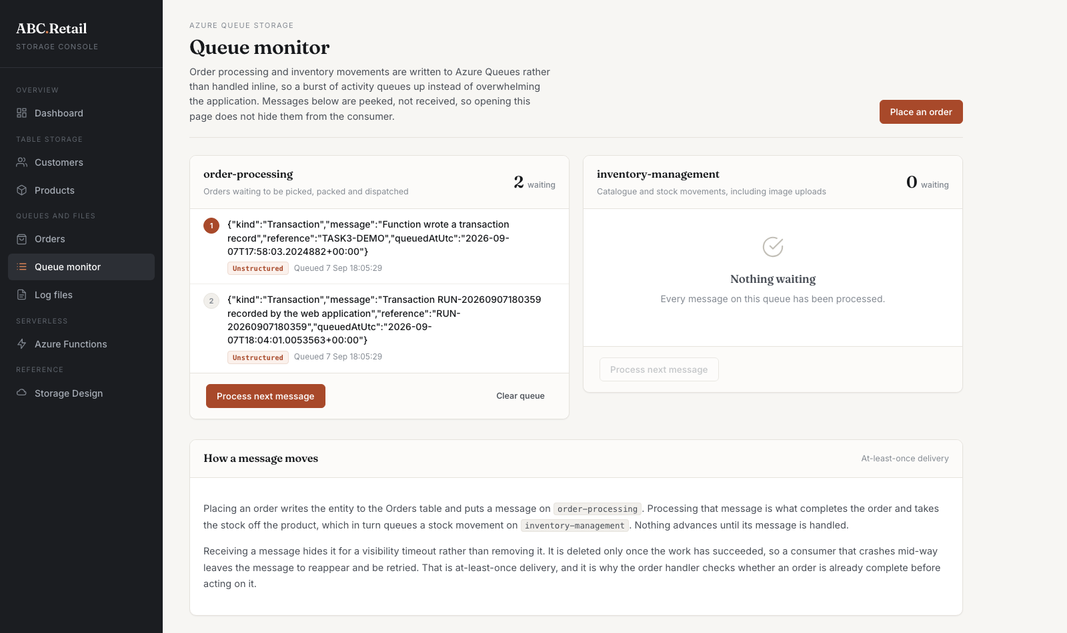
Figure 10. The queue monitor in the application showing the transaction messages the function placed on order-processing.
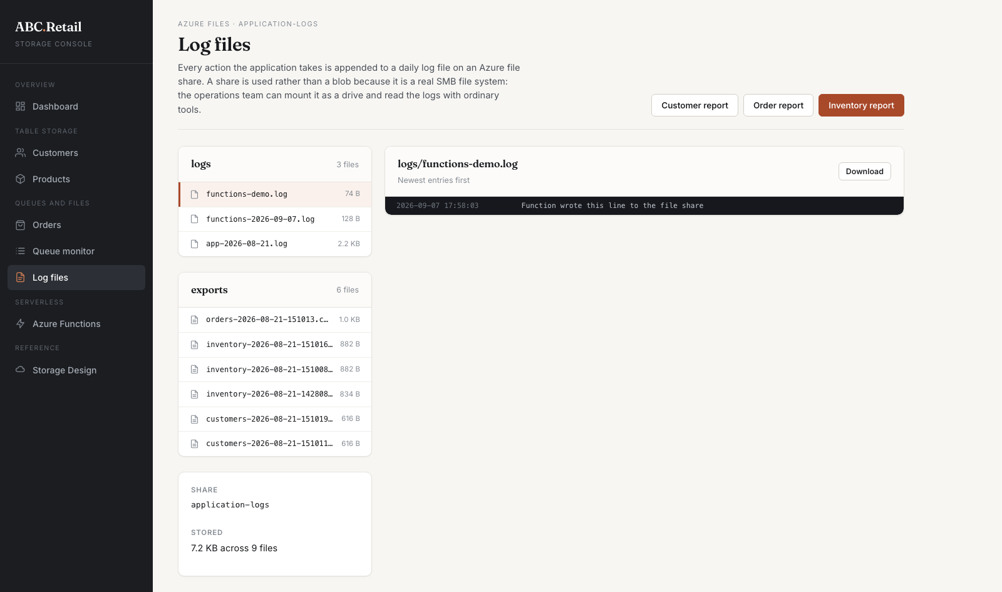
Figure 11. The application-logs share in the application, showing the dated log file the function created.

8. Azure Event Hubs

Description of service
Event Hubs is Azure’s event ingestion and streaming service. It is built to take in very large numbers of small events from many producers at once and hold them in an ordered log that several different consumers can read independently. It is not a queue. A queue hands each message to one consumer and then the message is gone, while an event hub keeps the events for a retention period and lets anything that is interested read the same stream.

Mechanism
Producers send events to an event hub over AMQP, HTTPS or Kafka protocol. The hub divides the stream across partitions, and events within a partition keep their order. Consumers read through consumer groups, and each consumer group keeps its own offset, its own position in the stream. That is what lets a recommendation engine and a fraud check read exactly the same events without competing for them or knowing about each other.
Because events are retained rather than consumed away, a consumer that falls behind or fails can pick up from its last offset rather than losing what it missed, and a new consumer can be added later and replay history it was never present for. Event Hubs Capture can also write the raw stream straight into Blob Storage on a schedule, with no code, which gives an analytics team the data without the shop front doing any extra work.

How it adds value to end users
For ABC Retail the obvious use is browsing behaviour. Every product view, search and add to basket becomes an event. Because the stream is read in near real time, recommendations can reflect what the customer did a few seconds ago instead of what they did yesterday, which is the difference between a useful suggestion and an irrelevant one.
The same stream serves other consumers at the same time. One consumer group updates recommendations, another watches for unusual purchasing that might be card fraud, and a third keeps a live view of which items are moving so stock warnings appear before something sells out. The customer never sees Event Hubs, but they see a shop that reacts to them, warns them that an item is nearly gone, and does not let them order something that is no longer there.
It also answers the analytics problem in the ABC Retail background directly. The brief says their existing tools cannot keep pace with the volume and variety of customer data. Streaming events into an event hub and capturing them into storage separates collecting the data from analysing it, so slow analysis can never slow down the shop.

9. Azure Service Bus
The brief lists this service as Azure Event Bus. There is no Azure product with that name; Azure offers Event Grid, Event Hubs and Service Bus. Since it is paired with Event Hubs and the topic is messaging, I have taken it to mean Azure Service Bus and written it up as such.

Description of service
Service Bus is a fully managed enterprise message broker. It offers queues for point to point messaging and topics for publish and subscribe, and it adds the guarantees that a business transaction needs: ordering, dead lettering, duplicate detection, scheduled delivery and transactions across several messages. It is the service Azure Queue Storage grows into when simple is no longer enough.

Mechanism
A producer sends a message to a queue or to a topic. A queue delivers to one consumer. A topic delivers a copy to every subscription attached to it, and each subscription can carry a filter so it only receives the messages it cares about. That means one publish can feed several subsystems without the publisher knowing any of them exist.
Delivery uses peek lock. The consumer takes a lock on the message, does the work, and then completes it. If the work fails the message is abandoned and becomes available again, and after a configured number of failed attempts it is moved to a dead letter queue rather than being lost or retried forever. Sessions group related messages so they are processed strictly in order, which matters when the events for one order must not overtake each other.

How it adds value to end users
The clearest gain for ABC Retail is what happens after an order is placed. Today the order goes onto one queue. With a Service Bus topic, placing an order publishes once and fulfilment, invoicing, the confirmation email and loyalty points each receive their own copy through their own subscription. Adding a new step later, a delivery partner for instance, means adding a subscription rather than changing the ordering code.
Dead lettering is what the customer actually feels. If the confirmation email fails, the message lands in the dead letter queue where someone can see it and act, instead of vanishing and leaving the customer wondering whether their order went through. That single feature turns a silent failure into a visible one.
Sessions keep an order’s events in order, so a cancellation cannot be processed before the order it cancels. Scheduled delivery lets a despatch notification be queued now and released when the courier collects. Duplicate detection stops a customer being charged twice if a request is retried. All of these are reliability features, and reliability is what the ABC Retail background says their legacy middleware failed to provide.

Why both, rather than one
The two are not alternatives. Event Hubs is for very high volumes of small events where many consumers read the same stream and losing one event is not serious. Service Bus is for smaller numbers of important messages where each one must be handled exactly once and in the right order. Browsing behaviour belongs on Event Hubs. An order belongs on Service Bus.

10. Deployment and testing
The application is deployed to Azure App Service and is reachable at https://st10541838.azurewebsites.net. The functions are deployed to the function app func-abcretail-gm on a consumption plan.
I tested in two stages. First I called each function directly with its key, before any of the web application code existed, to confirm the function itself worked and the data reached the storage account. Then I tested through the deployed application, which is what figure 12 shows: all five calls returning HTTP 200, with the blob URL, the queue message identifiers and the file path in the responses.
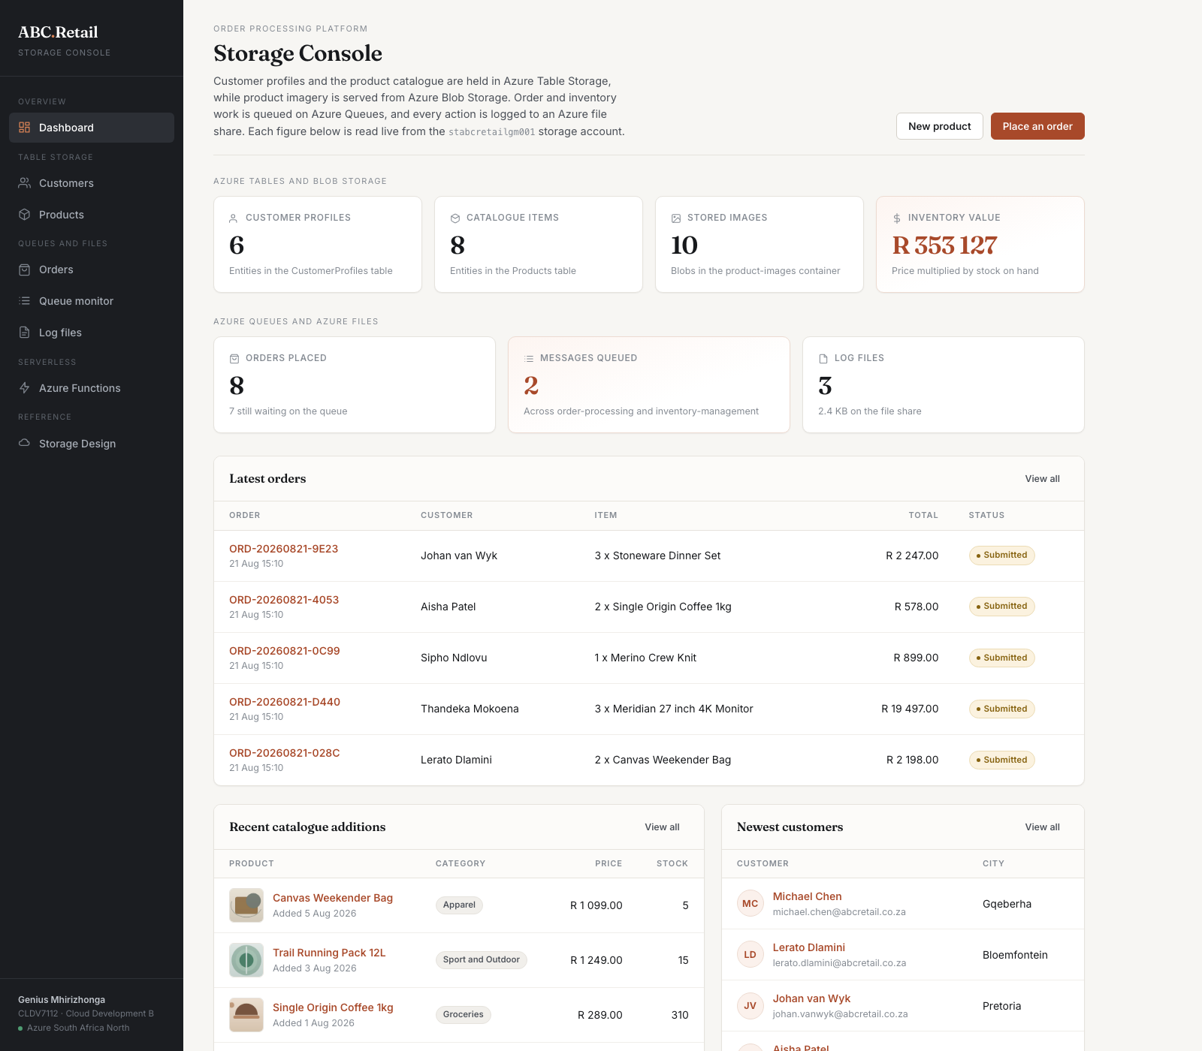
Figure 12. The deployed application, with every figure read live from the storage account.
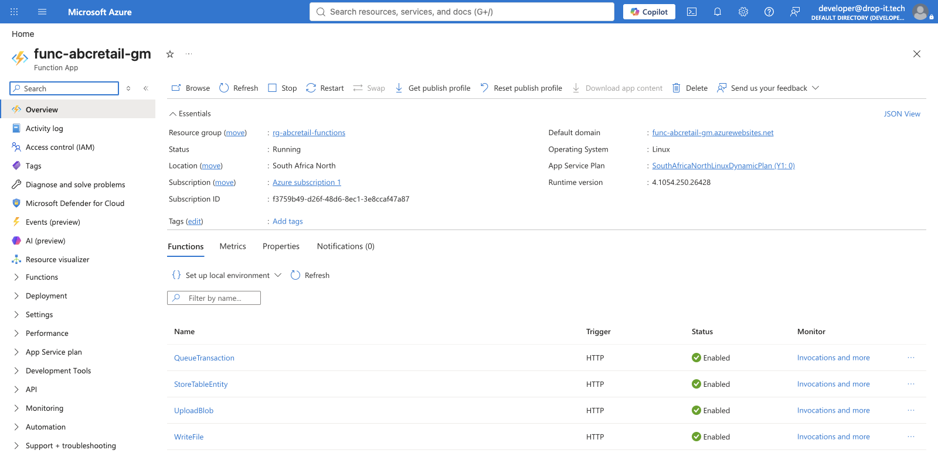
Figure 13. The function app in the Azure portal, showing all four functions enabled.

11. Azure resources and cost
Resource | Name | Tier
Web app | st10541838 | F1 Free, Linux, .NET 10
Function app | func-abcretail-gm | Consumption, Linux, .NET 8 isolated
App Service plan | asp-abcretail-free | F1 Free
Storage account | stabcretailgm001 | StorageV2, Standard LRS, Hot
Resource groups | rg-abcretail-cldv7112, rg-abcretail-functions | South Africa North

