CLOUD DEVELOPMENT B · CLDV7112/w · ADADw1
ABC Retail Storage Console
A web application built on Azure Tables, Blob Storage, Queue Storage and Azure Files
Student name
Genius Mhirizhonga
Student number
ST10541838
Module code
CLDV7112/w
Assessment
Project 1
Semester
Semester 2, 2026
URL of the deployed web application
https://st10541838.azurewebsites.net
GitHub repository for the source code
https://github.com/geniustaku/abc-retail-storage-console

1. Overview
ABC Retail runs its order processing on an ageing on-premises platform. A single relational database absorbs both the read traffic of customers browsing the catalogue and the write traffic of orders landing, which is why it struggles during peak seasons such as Christmas. Product images sit on network shared drives that are slow to read and awkward to grow, and the legacy message queuing middleware delivers inconsistently.
This application moves each of those concerns onto the Azure Storage service best suited to it. Customer, product and order records are held in Azure Table Storage. Product imagery is held in Azure Blob Storage and served directly from the storage account. Order processing and inventory movements are queued on Azure Queue Storage rather than handled inline. Every action is logged to a file share on Azure Files.
The application is an ASP.NET Core MVC web application written in C# on .NET 10, deployed to an Azure App Service and reachable at the URL on the cover page.

2. Requirements and how each was met
Requirement | How it is satisfied
Store customer profiles and product related information using Azure Tables | Three tables are used. CustomerProfiles holds one entity per customer, Products holds one entity per catalogue item partitioned by category, and Orders holds one entity per order. All three support create, read, update and delete from the web application.
Host images and multimedia content using Azure Blob Storage | Product images are uploaded through a file control on the product form to the product-images container, and the resulting blob URL is stored on the product record so the browser fetches each image directly from the storage account.
Details relating to the processing of orders and inventory management should be stored in Azure Queues | Two queues are used. order-processing carries messages such as "Processing order ORD-20260821-512B for Michael Chen", and inventory-management carries messages such as "Uploading image 7d727e6c...jpg", "Inventory item created" and "Stock adjusted".
Log files should be stored using Azure Files | Every action is appended to logs/app-YYYY-MM-DD.log on the application-logs file share. Generated reports are written to exports/ on the same share and can be downloaded from the site.
Use the relevant controls to upload or download, and display the data stored | Forms provide file upload, dropdown and numeric controls; tables and card grids display stored data; and log files and CSV reports are downloadable from the file share through the browser.
Deploy to an Azure App Service and make it accessible through a link | The application is deployed to Azure App Service by a GitHub Actions workflow on every push to main, and is reachable at https://st10541838.azurewebsites.net.

3. Azure resources
Every resource sits in one resource group in the South Africa North region, which is the closest region to the user base and keeps latency between the App Service and the storage account low.
Resource | Name | Tier and notes
Resource group | rg-abcretail-cldv7112 | South Africa North
Storage account | stabcretailgm001 | StorageV2, Standard LRS, Hot access tier
App Service plan | asp-abcretail-free | F1 Free, Linux
Web app | st10541838 | .NET 10, deployed from GitHub Actions
Tables | CustomerProfiles, Products, Orders | Azure Table Storage
Blob container | product-images | Blob level anonymous read
Queues | order-processing, inventory-management | Azure Queue Storage
File share | application-logs | 5 GiB quota, logs/ and exports/ directories

Every resource is created by infra/provision.sh in the repository, which makes the environment reproducible rather than assembled by hand in the portal.

4. Database table design
Azure Table Storage is a NoSQL key value store. It offers no joins, no aggregate functions and no secondary indexes, so the partition key and row key carry the weight that indexes carry in a relational database. The diagram below is therefore an entity design rather than a classical relational diagram: the tables are independent, and every association shown is held by convention inside the entity itself.
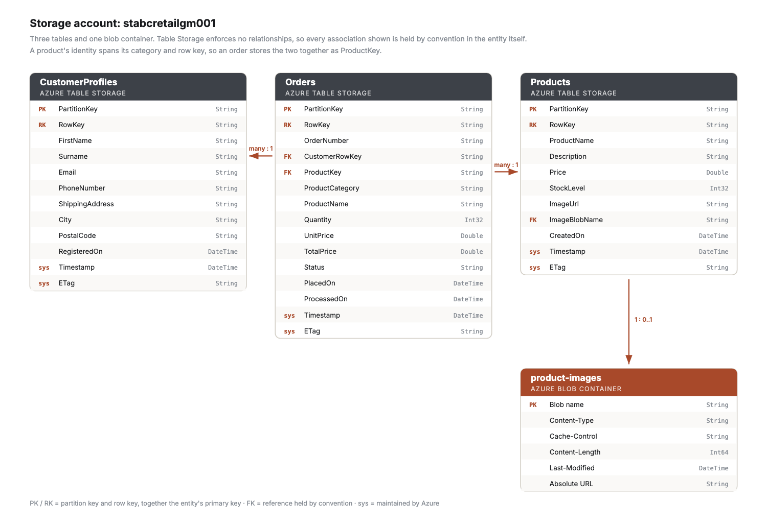
Figure 1. The three tables, the blob container, and the associations between them.

CustomerProfiles
Every customer sits in a single partition, CUSTOMER, with a generated GUID as the row key. At profile volumes one partition is comfortable, and keeping the table that way means any group of customers can still be written in one entity group transaction, because those are scoped to a partition. If the customer base outgrew a single partition server, region would be the natural key to split on, since fulfilment queries are already regional.

Products
Category is the partition key. The catalogue is browsed one category at a time far more often than it is read whole, so partitioning this way turns the dominant query into a single partition scan instead of a full table scan, and spreads writes across partition servers during a bulk catalogue load. The cost is that the partition key forms part of an entity identity, so moving a product between categories is a delete followed by an insert rather than an update in place, and the edit path handles that case explicitly.
Prices are stored as Double because Table Storage has no decimal type.

Orders
An order is created in the Submitted state and only advances once its message has been taken off the order-processing queue. Because a product identity spans both its category and its row key, an order stores the two together as ProductKey and splits them when it needs to fetch the product.

Why images are not stored in the table
Table Storage caps an entity at one megabyte and a single property at sixty-four kilobytes, so imagery belongs in Blob Storage regardless of preference. The product entity holds the blob URL, so a view can point an image tag straight at it, and the blob name, so the blob can be replaced or removed when the product changes.

5. How work moves through the system
The queue is not a record of what already happened. It is what causes the work to happen, and that distinction is what makes the design worth anything under load.
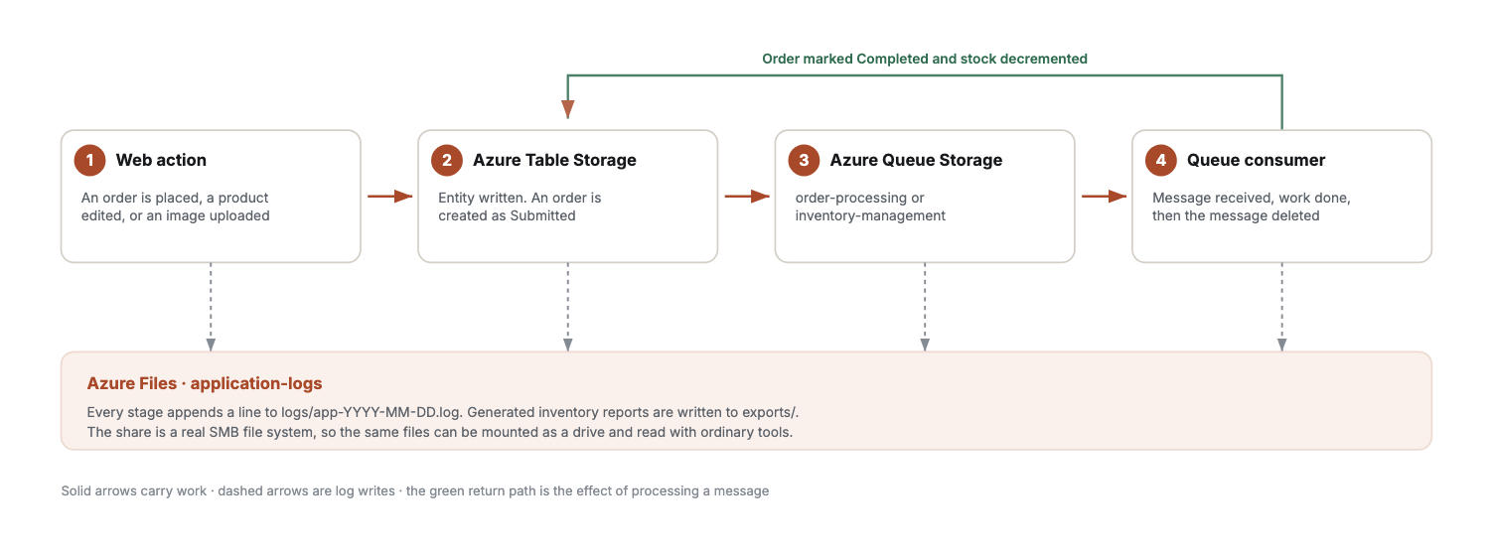
Figure 2. An action passes through Table Storage, onto a queue, and only takes effect once its message is consumed. Every stage writes to the file share.
Placing an order writes it to the Orders table as Submitted and queues a message. Nothing else happens yet. Processing that message is what marks the order complete and takes the stock off the product, which in turn queues a stock movement on the inventory queue. A burst of Christmas orders therefore accumulates on a queue built to absorb it rather than contending for the same database rows, which is precisely the failure described in the background to this project.

6. Azure Table Storage
Three tables are in use, and each holds well over five records. The screenshots below are of the deployed application reading them live from the storage account.

CustomerProfiles table, 6 records
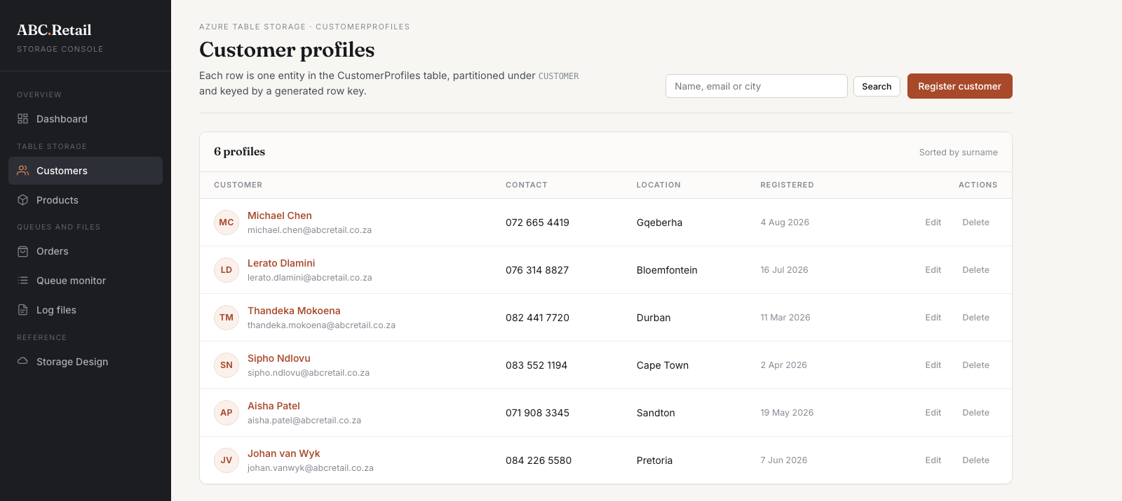
Figure 3. Six customer profiles read from the CustomerProfiles table. Each row is one entity partitioned under CUSTOMER and keyed by a generated row key.

Products table, 8 records
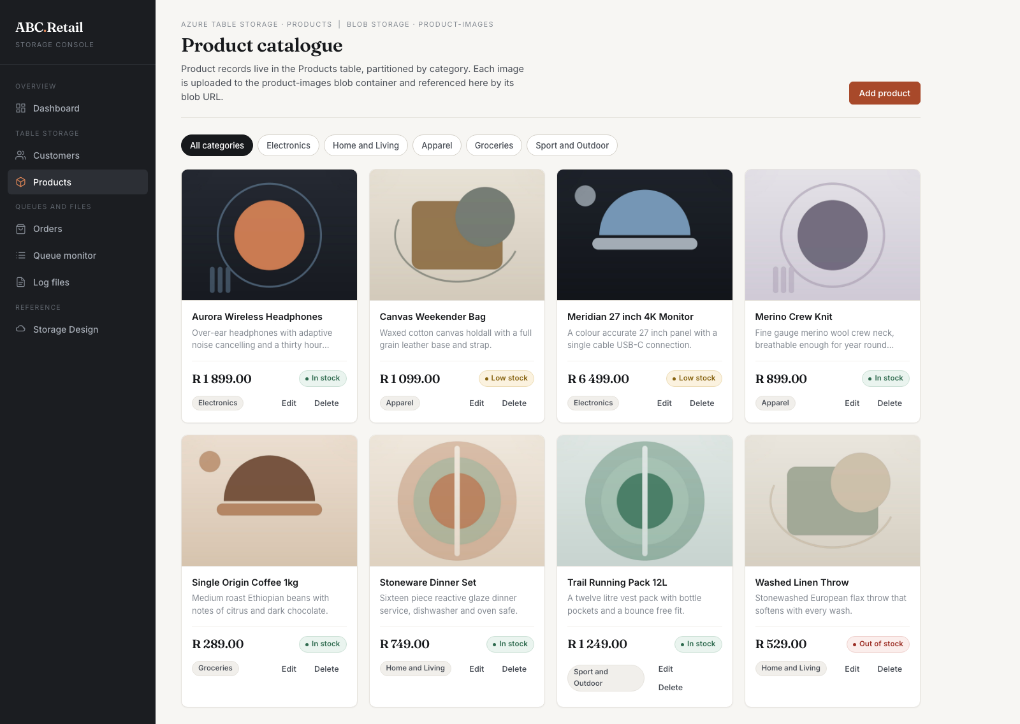
Figure 4. Eight catalogue items read from the Products table, partitioned by category. The category filter along the top issues a single partition query.

Orders table, 8 records
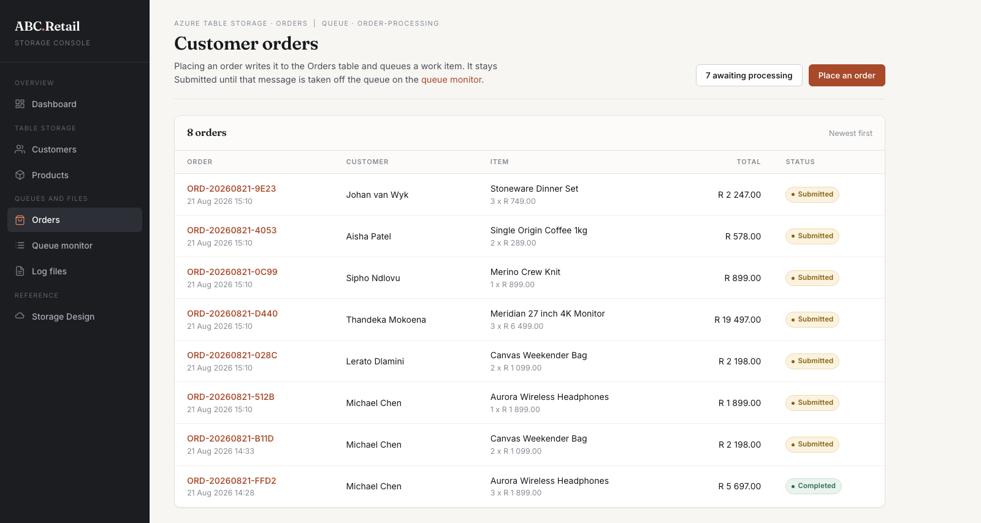
Figure 5. Eight orders read from the Orders table. The status column reflects queue state directly: an order stays Submitted until its message has been processed.

Writing to a table through a web control
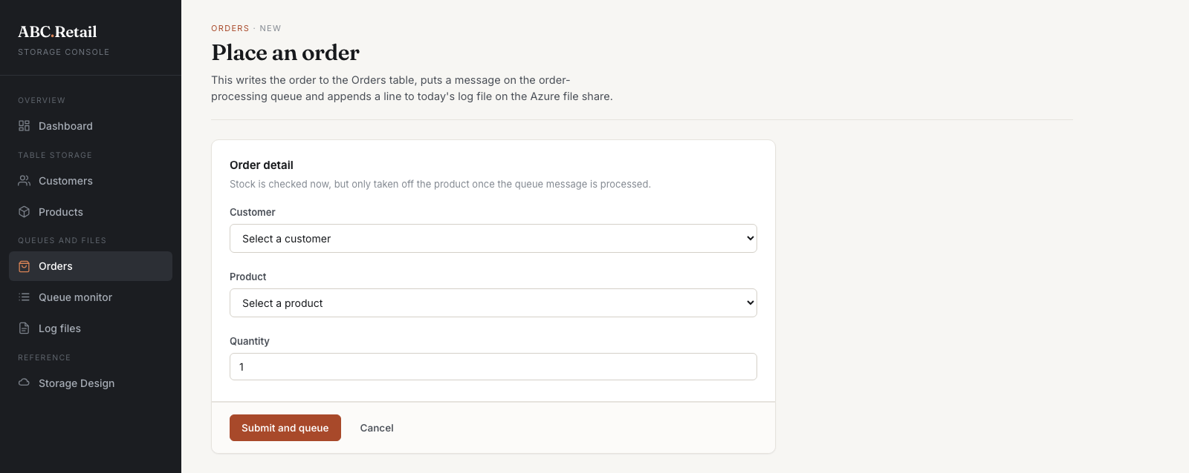
Figure 6. The order form. Dropdown and numeric controls write a new entity to the Orders table and queue the work in one submission.

7. Azure Blob Storage
Product imagery is held in the product-images container, which currently holds eight blobs. The container grants anonymous read at blob level, so the browser fetches each image directly from the storage account rather than routing the bytes through the web application. That keeps thumbnail traffic off the App Service compute budget entirely. Where the imagery was not already public, a shared access signature would be the alternative, at the cost of a signing round trip per image.

Eight images served from the blob container

Figure 7. Every image on the catalogue page is fetched by the browser directly from the product-images container using the blob URL stored on the product record.

A single record showing its blob URL
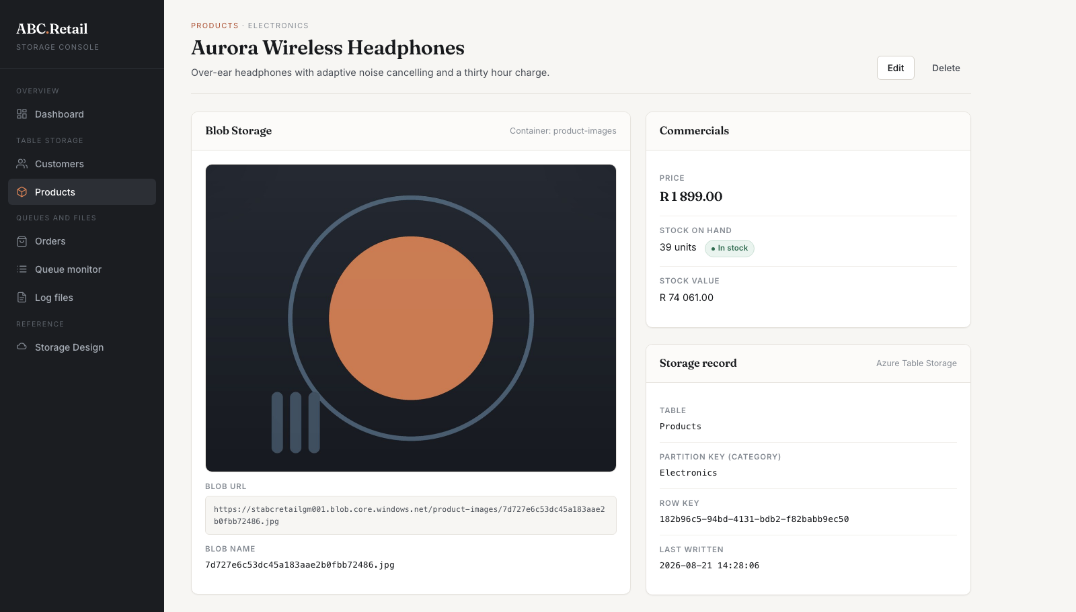
Figure 8. One product showing the blob URL and blob name held in Blob Storage on the left, beside the table, partition key and row key held in Table Storage on the right.

Uploading to Blob Storage through a web control
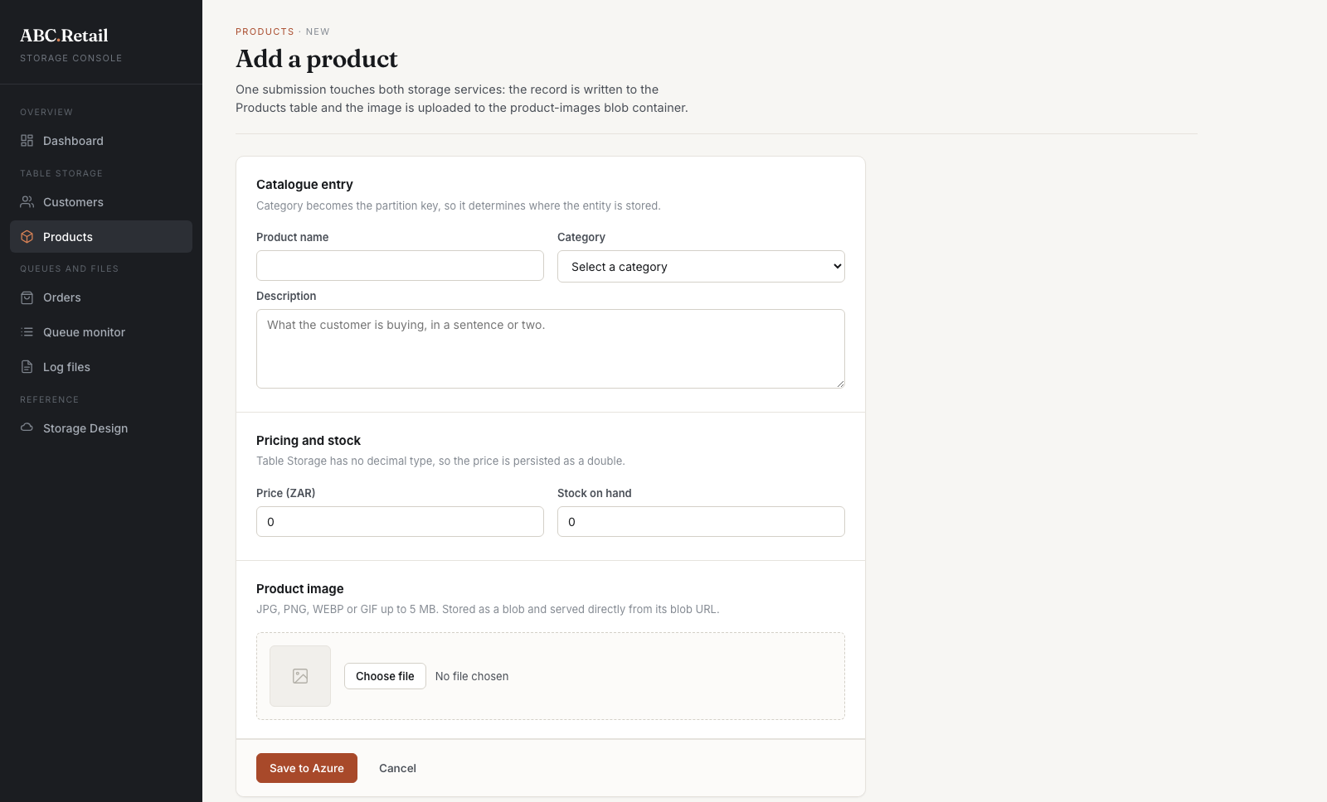
Figure 9. The product form. The file control validates content type and size in the application before the upload is attempted, and the blob is written before the table entity so a failure cannot leave a product pointing at an image that does not exist.

8. Azure Queue Storage
Two queues carry the work the application generates. Splitting them means a backlog of catalogue edits cannot delay a customer order, and either queue can be given its own consumer or scaled independently without touching the other.
Queue | Carries
order-processing | Orders waiting to be picked, packed and dispatched. For example: Processing order ORD-20260821-512B for Michael Chen, 1 x Aurora Wireless Headphones.
inventory-management | Catalogue and stock movements. For example: Uploading image "7d727e6c53dc45a183aae2b0fbb72486.jpg", Inventory item created, Stock adjusted, Report generated.

A queue message body is a string, so each one carries JSON holding a readable description for the operator alongside the reference a consumer needs to act on it. One message therefore serves both the monitoring screen and the processing code without a second lookup.

Both queues, seven messages each
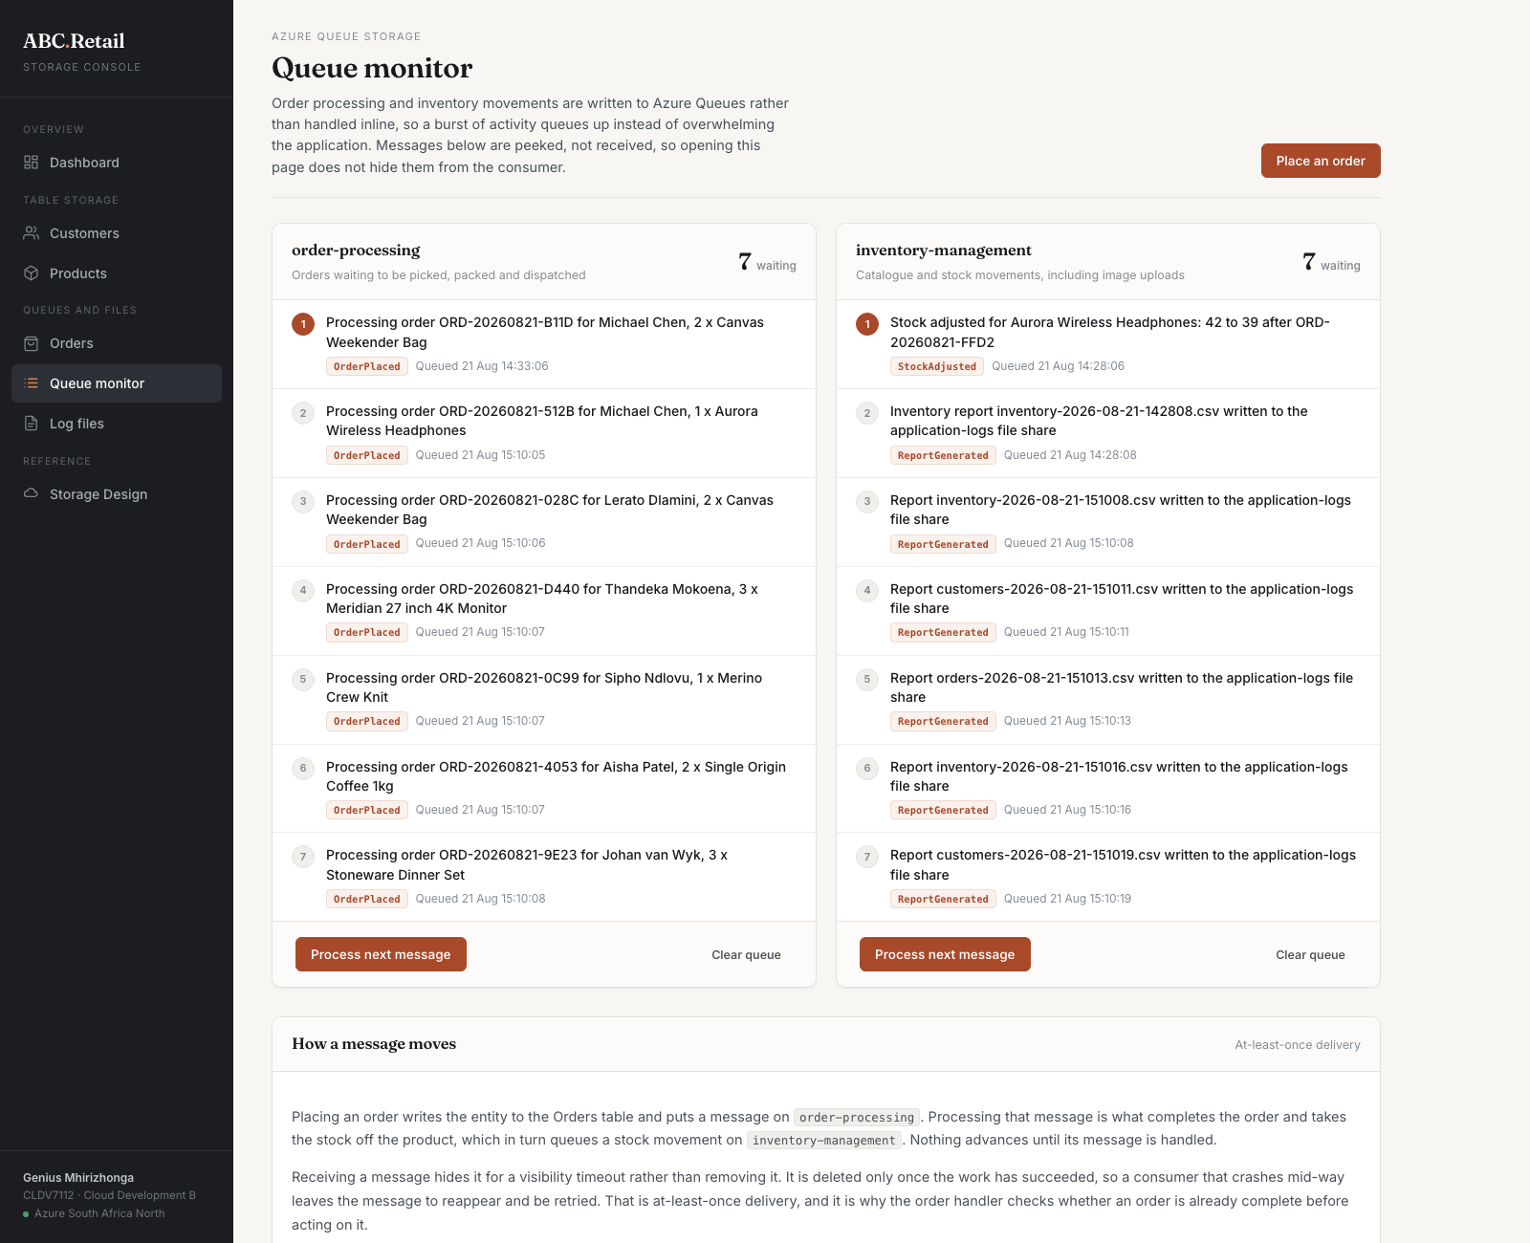
Figure 10. The queue monitor showing seven messages waiting on order-processing and seven on inventory-management, with the message text, operation kind and the time each was queued.
Messages are peeked rather than received on this screen. Receiving them would start their visibility timeout and hide them from the code that is supposed to process them, so simply opening a dashboard would interfere with the workflow.

At least once delivery
Receiving a message does not remove it. Queue Storage hides it for a visibility timeout, and it is deleted only once the work has succeeded. A consumer that fails part way through leaves the message to reappear and be retried, which is what makes the queue reliable rather than merely fast. The consequence is that a message can be delivered more than once, so the order handler checks whether an order is already complete before acting on it instead of assuming each message arrives exactly once.

9. Azure Files
Log files are stored on the application-logs file share rather than in a blob container. A share is a real SMB file system: it can be mounted as a drive on a server or a workstation and read with ordinary tools, which is what an operations team actually wants from a log. A blob would have to be downloaded first.
The share currently holds seven files across two directories, each stored and listed by its own file name.

Seven files on the share, listed by name
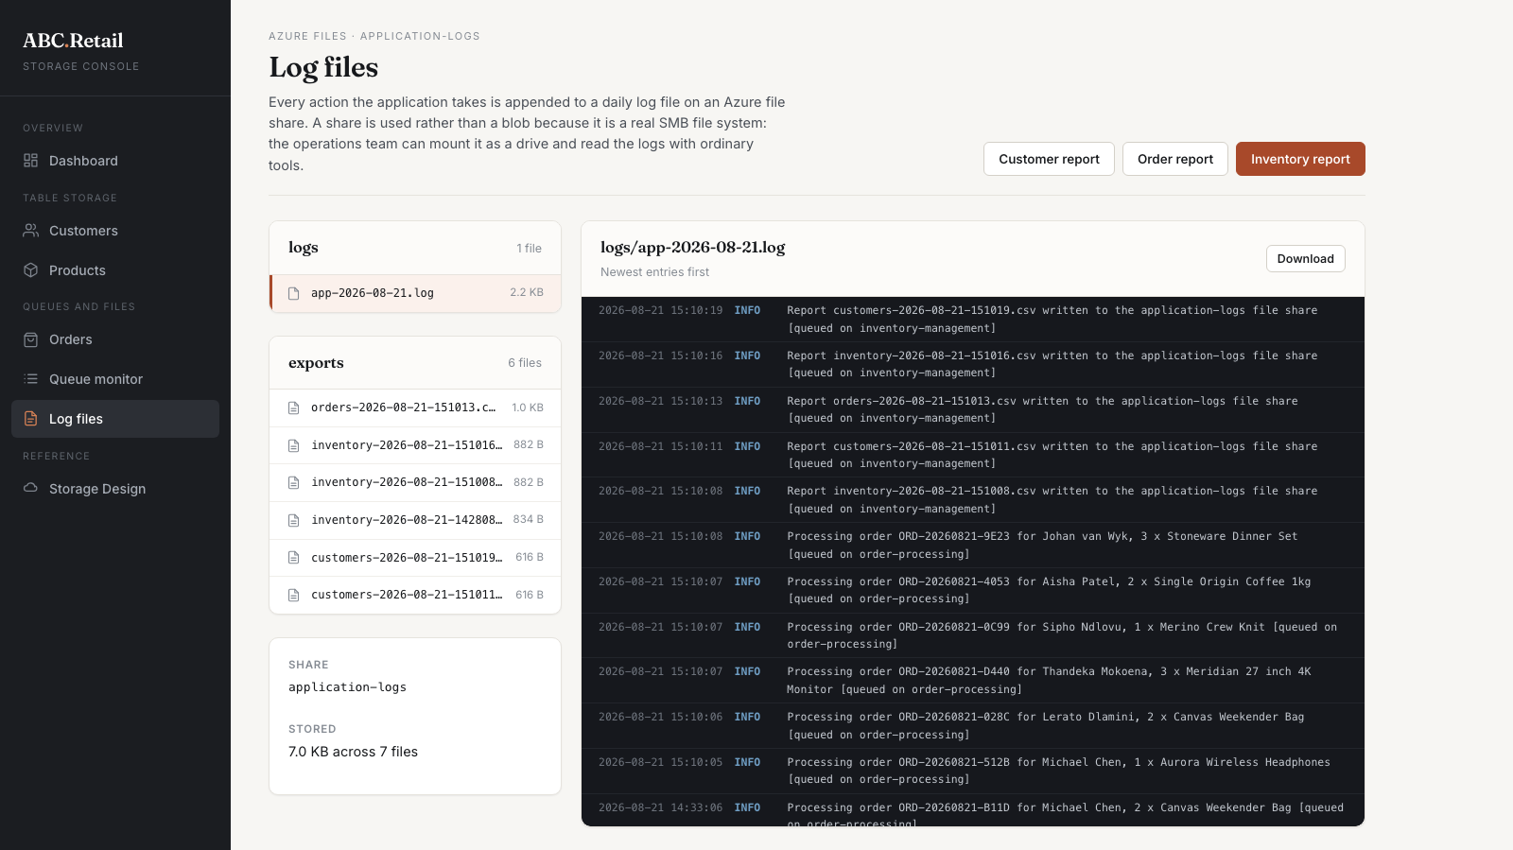
Figure 11. The application-logs share. The logs directory holds the daily log file and the exports directory holds six generated CSV reports, each with its file name and size read from Azure. The contents of the selected file are rendered on the right, and any file can be downloaded.

Appending, which Azure Files does not offer directly
Unlike an append blob, an Azure file has no append operation. Adding a line means reading the file current length, growing the file by the size of the new bytes, and then writing those bytes into the range that growth created. That sequence is three calls and is not atomic, so writers are serialised within the application. Across several App Service instances the correct answer would be a lease on the file; on the single instance this application runs on, serialising is sufficient and is documented as such rather than left implicit.
A failure writing to the share is reported to the platform log and swallowed, and the user action is allowed to complete. A customer losing an order because the log file was momentarily busy would plainly be the worse outcome.

10. Deployment to Azure App Service
The application is deployed to Azure App Service by a GitHub Actions workflow that runs on every push to main. The workflow restores, builds and publishes the project, then deploys the published output to the App Service using a publish profile held as an encrypted repository secret. The storage account key is not involved in deployment, because the deployed build reads it from its own application settings at start up.

A successful deployment run
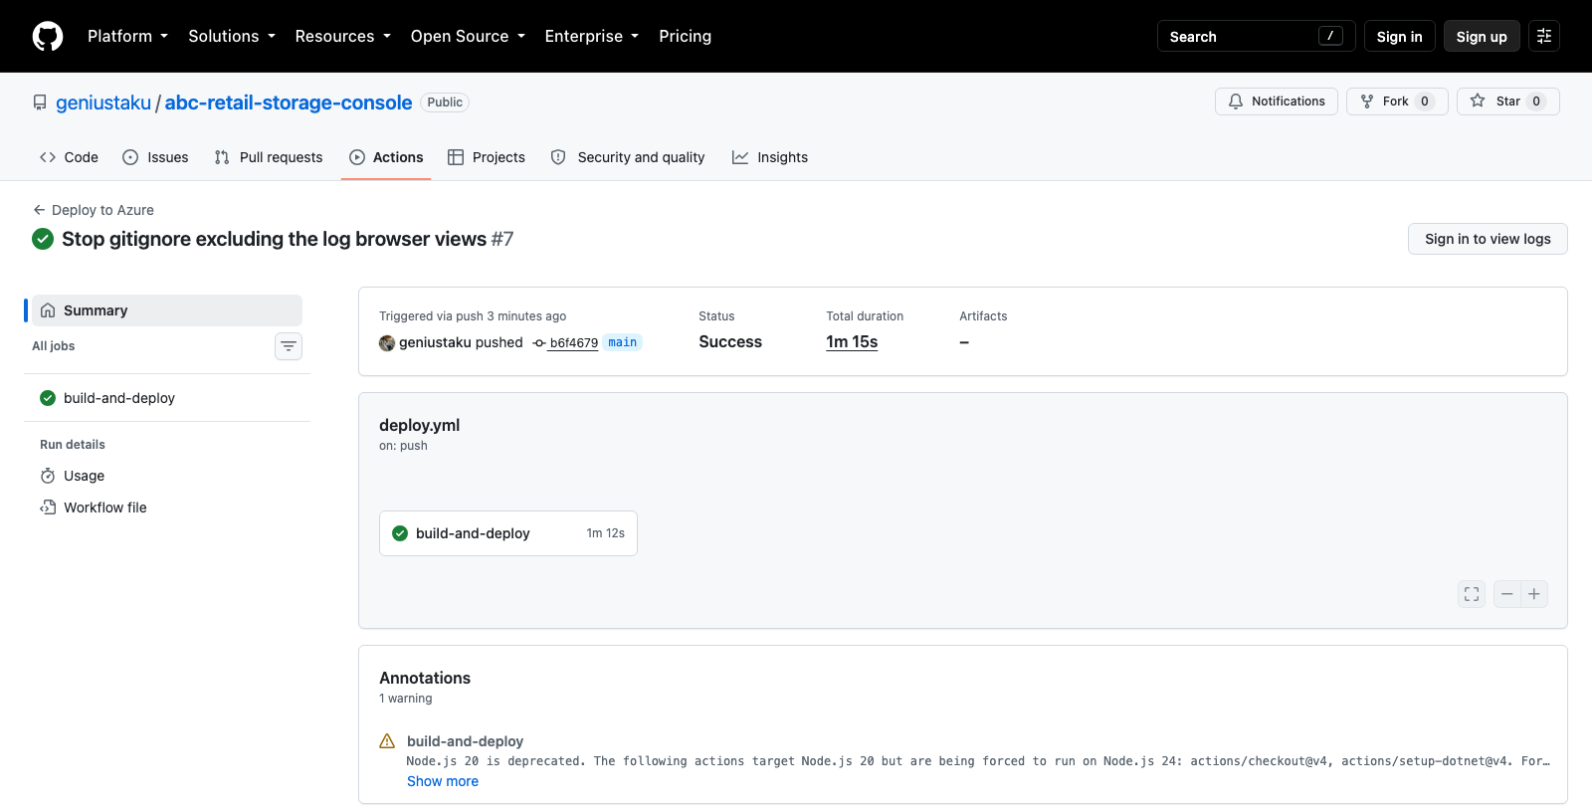
Figure 12. A successful deployment run in GitHub Actions, triggered by a push to main and completing in one minute and fifteen seconds.

The public repository
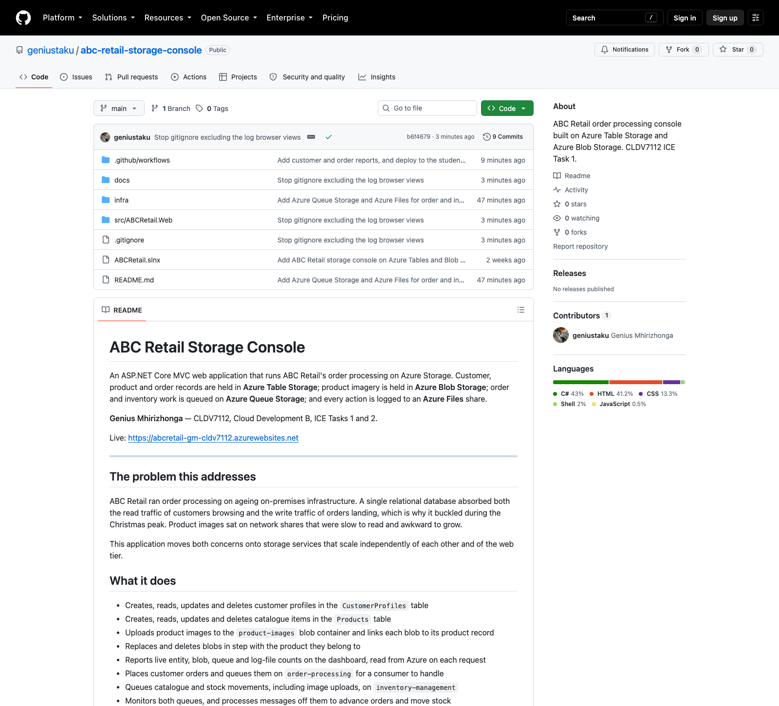
Figure 13. The public GitHub repository holding the full source: project files, views, provisioning script and deployment workflow.

The deployed application
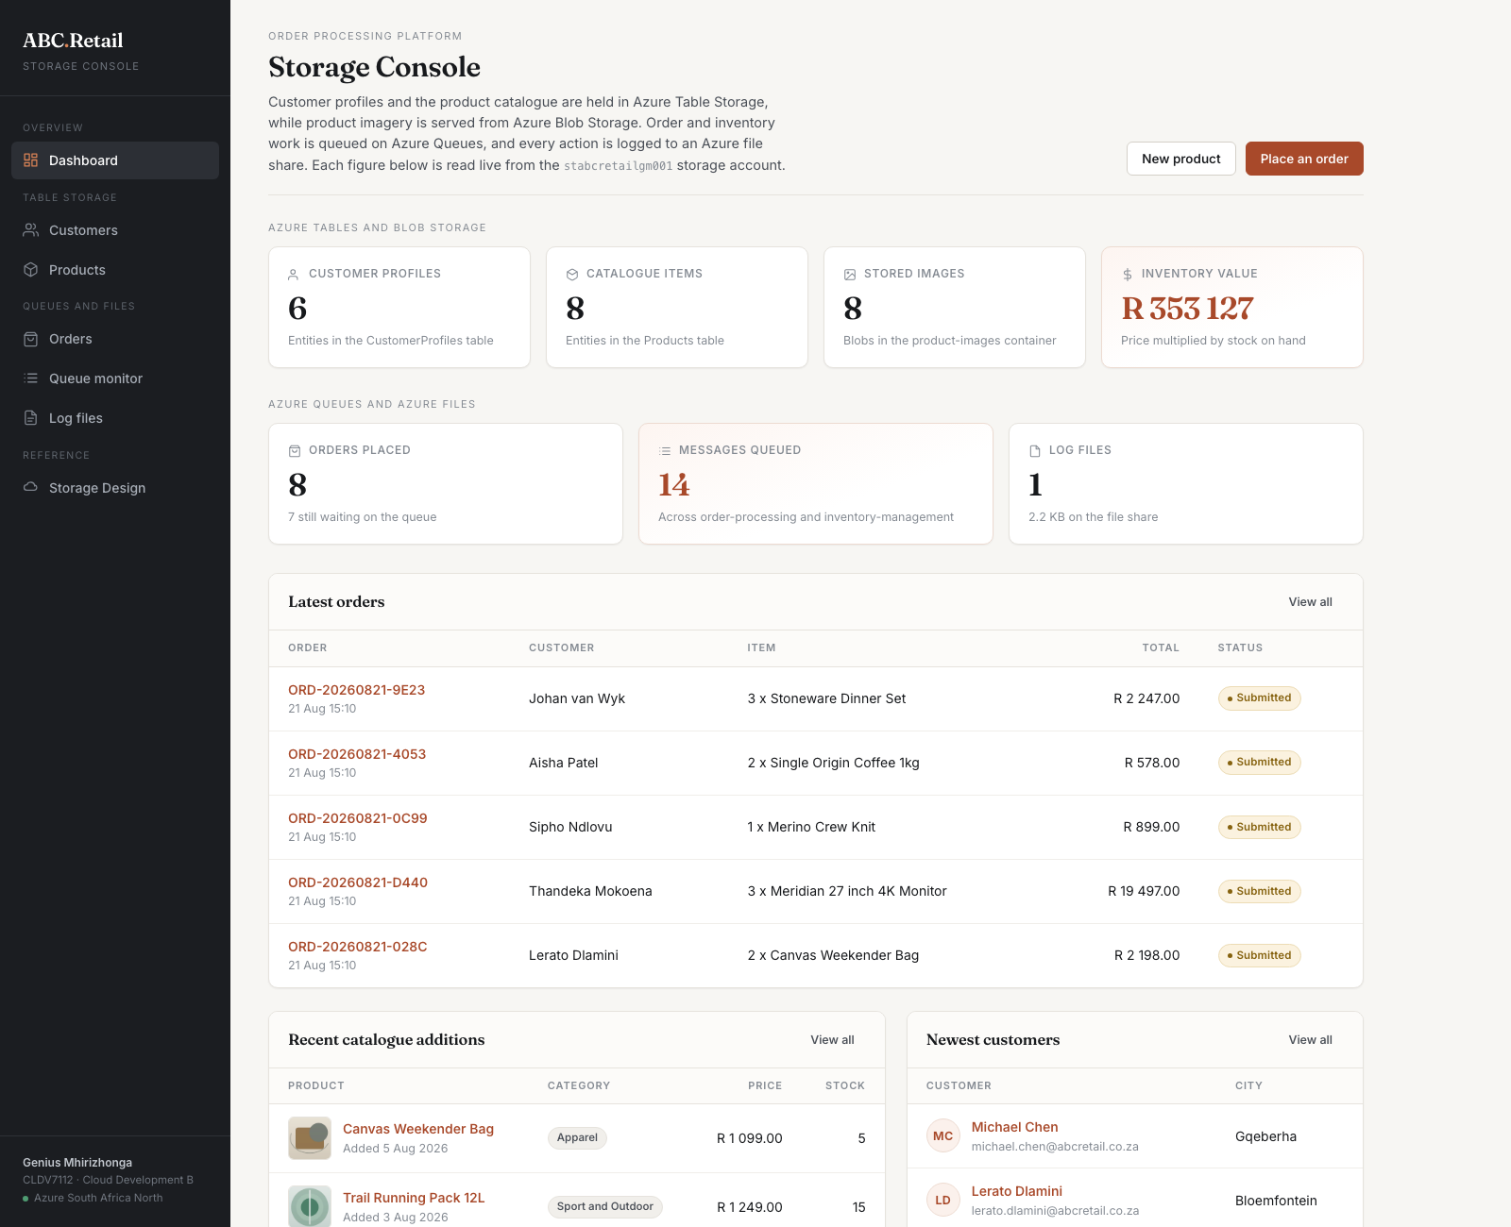
Figure 14. The deployed application at https://st10541838.azurewebsites.net. Every figure on the dashboard is read live from the storage account on each request, across all four storage services.

11. Scalability, reliability and cost effectiveness

Scalability
- Partition keys are chosen from the dominant query rather than from convenience. Products partition by category because the catalogue is browsed a category at a time, which turns the common read into a single partition scan and spreads writes across partition servers.
- Queues absorb bursts. Order processing is not performed inline, so a seasonal spike accumulates on a queue built for it instead of contending for the same rows.
- Images are served directly from Blob Storage by the browser, so image traffic never consumes App Service compute and scales with the storage account rather than the web tier.
- Every storage service sits behind an interface resolved through dependency injection, so the in-application queue consumer can be replaced by a background worker or an Azure Function without changing anything that produces messages.

Reliability
- Queue Storage gives at least once delivery. A message is deleted only after the work succeeds, so a consumer that crashes leaves it to be retried, and the order handler is written to tolerate a repeated delivery.
- Writes are ordered so that a partial failure is the cheaper one to reconcile. A blob is uploaded before its table entity is written and deleted before its entity is removed, so a failure leaves an unreferenced blob rather than a record pointing at a missing image.
- Logging never takes a request down with it. A failure writing to the file share is reported and swallowed rather than propagated to the customer.
- Storage clients are registered as singletons. They are thread safe and pool their connections, which avoids the socket exhaustion that follows from constructing a client per request.

Cost effectiveness
- The App Service plan is the F1 Free tier, so the compute is free.
- The storage account uses Standard LRS, the cheapest replication tier, which is appropriate because the data can be regenerated and does not warrant geo redundancy at this stage.
- The Hot access tier suits data that is read on nearly every page view.
- Serving blobs directly rather than through the application avoids paying for compute to move bytes that the storage account can serve itself.
- The total running cost of the deployment is the few cents of storage the data actually occupies.

12. Testing and verification
The application was tested both locally and on the App Service, as the brief requires, and the storage behaviour was verified against the live account rather than assumed.
- Creating a product wrote its entity to the Products table and raised the blob count in the container from eight to nine; deleting the same product removed both and returned the count to eight.
- Placing an order wrote the entity, raised the depth of order-processing and appended a log line. Processing that message marked the order complete, moved the stock for Aurora Wireless Headphones from 42 to 39, queued the resulting movement on inventory-management and logged both steps.
- Writing reports produced named CSV files in the exports directory on the share, each of which was then read back and rendered in the browser.
- The queue depths reported by the application were checked against the storage account directly and matched.
Two defects were found and fixed during that testing. The first was a culture defect: a number input always posts its value in invariant form, so on a host whose locale separates decimals with a comma a valid price such as 439.50 failed to bind and the form rejected it. The application now pins itself to the invariant culture and formats amounts for display through a dedicated helper, so a local run and an App Service instance behave identically.
The second was a packaging defect. The standard .NET gitignore excludes any directory matching [Ll]ogs/, which is intended for build output but also matched the views for the log file browser. Those views were therefore never committed, so a build made from a clean checkout produced a deployment that returned an error on the log file page even though a local publish worked. The ignore rule was corrected and the views committed, and every page was then re-verified on both hostnames from a clean continuous integration build.

