CLOUD DEVELOPMENT B · CLDV7112w · ADADw1
Integrating Functions
Four Azure Functions in front of the ABC Retail storage services
Student name
Genius Mhirizhonga
Student number
ST10541838
Assessment
ICE Task 3
Web application for this task
https://abcretail-task3-gm.azurewebsites.net
Function app
https://func-abcretail-gm.azurewebsites.net
Source code, ice-task-3 branch
https://github.com/geniustaku/abc-retail-storage-console/tree/ice-task-3

1. What the task asked, and how it was met
This task asked me to expand the application I built for Project 1 by adding four functions that call the storage services the application already uses. I read functions here as Azure Functions rather than ordinary methods, because the task measures them against scalability, cost effectiveness and cloud suitability, and a method inside my own application changes none of those three.
What was required | What I built
Store information into Azure Tables | StoreTableEntity, an HTTP function that upserts an entity into any table in the account. It writes to a FunctionAudit table when the application calls it, and the same function can serve CustomerProfiles, Products or Orders because the table name arrives in the request.
Write to Blob Storage | UploadBlob, which accepts a file as base64, writes it to the product-images container and returns the blob URL. The stored name is generated rather than taken from the caller.
A queue is written to and from for transaction information | QueueTransaction handles both directions. A POST puts a transaction message on the queue, and a GET reads it back, either peeking or dequeuing depending on the mode requested.
Write to Azure Files | WriteFile, which appends a line to a dated log file on the application-logs share.
Screenshots of the services | Section 5, figures 2 to 7.

Nothing from Project 1 was removed. The application still holds the same data in the same four services. What changed is who does the writing.

2. Where the functions sit
The web application used to talk to the storage account directly. For these four operations it now posts to a function instead, and the function does the storage work.
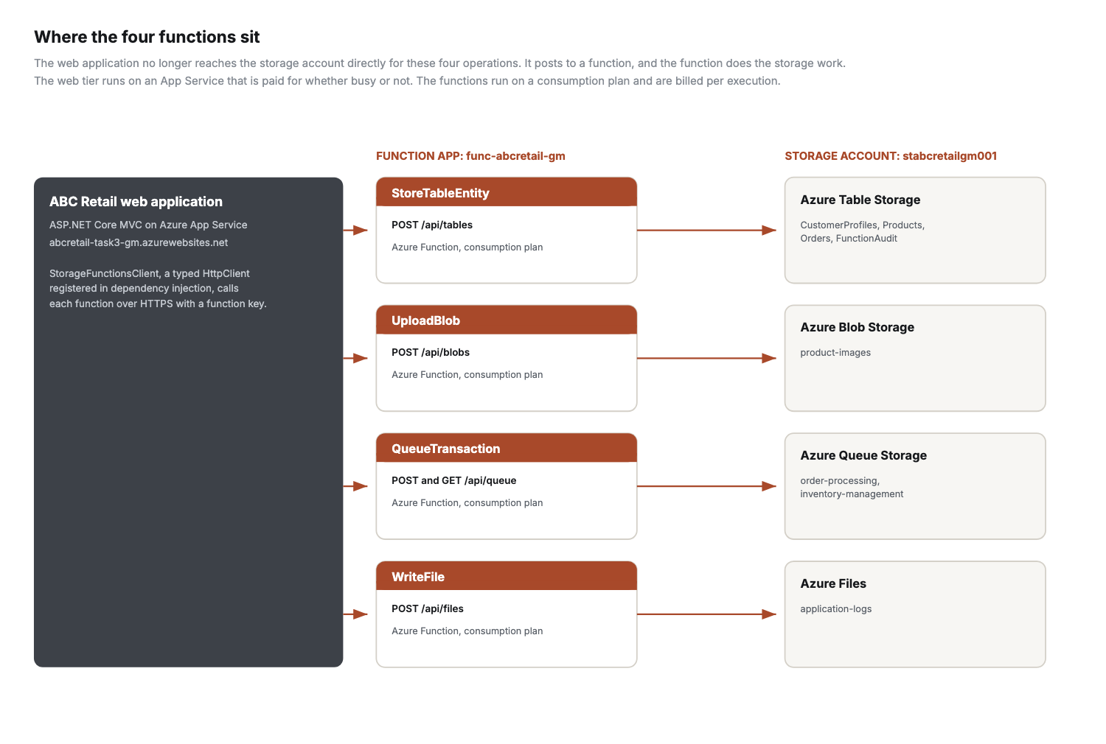
Figure 1. Each of the four functions handles one storage service. The web application reaches them over HTTPS using a function key.
The two halves are deployed and billed separately, which is the whole point of the change. The App Service is paid for whether anything is happening or not. The functions sit on a consumption plan, so they cost nothing when idle and scale out on their own when they are busy.

3. The four functions
All four are HTTP triggered and run on .NET 8 isolated. Each returns JSON saying which storage service it wrote to and what it did, which is what makes the results screen in section 5 readable rather than a wall of status codes.
Function | Route | What it does
StoreTableEntity | POST /api/tables | Creates the table if needed, then upserts an entity from the partition key, row key and properties in the request. Upsert rather than insert, so a repeated call updates instead of failing on a duplicate key.
UploadBlob | POST /api/blobs | Decodes the base64 content, rejects anything over 5 MB, generates a blob name and uploads with the right content type and a long cache header. Returns the URL.
QueueTransaction | POST and GET /api/queue | POST writes a JSON transaction message and reports the new queue depth. GET reads the queue, peeking by default so monitoring does not hide messages from the real consumer, or dequeuing and deleting when asked.
WriteFile | POST /api/files | Appends a timestamped line to a dated log file on the share, creating the share, directory and file when they do not exist yet.

Two details worth pointing out
Azure Files has no append operation, unlike an append blob. WriteFile therefore reads the file's current length, grows the file by the length of the new line, and writes those bytes into the range that growth created. It is three calls rather than one, and it is the reason that function is longer than the other three.
QueueTransaction handles both directions in one function on purpose. The task asks for a queue that is written to and from, and keeping the producer and the consumer in one place makes the message format obvious to anyone reading it. A producer and a consumer that quietly disagree about the shape of a message is a common way for a queue to go wrong.

4. How the web application calls them
The application talks to the functions through StorageFunctionsClient, a typed HttpClient registered in dependency injection with AddHttpClient. That gives it a pooled message handler, which avoids the socket exhaustion that comes from creating an HttpClient per call.
Every call is timed and returns a result object holding the status code, the response body and how long it took. If a function cannot be reached, the client catches it and returns that as a failed result rather than throwing. A cold starting function therefore shows as a failed row on the page instead of taking the page down, which matters on a consumption plan where the first call after an idle period is always the slow one.
The function key is never in the repository. It is held as the Functions__Key application setting on the App Service, the same pattern used for the storage connection string in Project 1, and appsettings.json carries the key with an empty value so it is clear one is expected.

5. Screenshots
All screenshots are of the deployed application at https://abcretail-task3-gm.azurewebsites.net and the function app at https://func-abcretail-gm.azurewebsites.net, working against the live storage account.

The four functions in the application
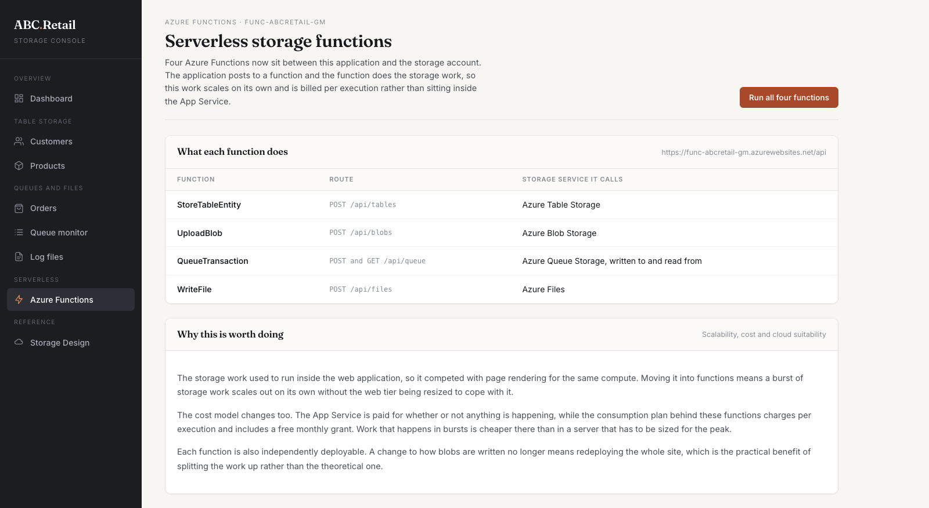
Figure 2. The Azure Functions page, listing each function, its route and the storage service it calls.

All four invoked, with the responses
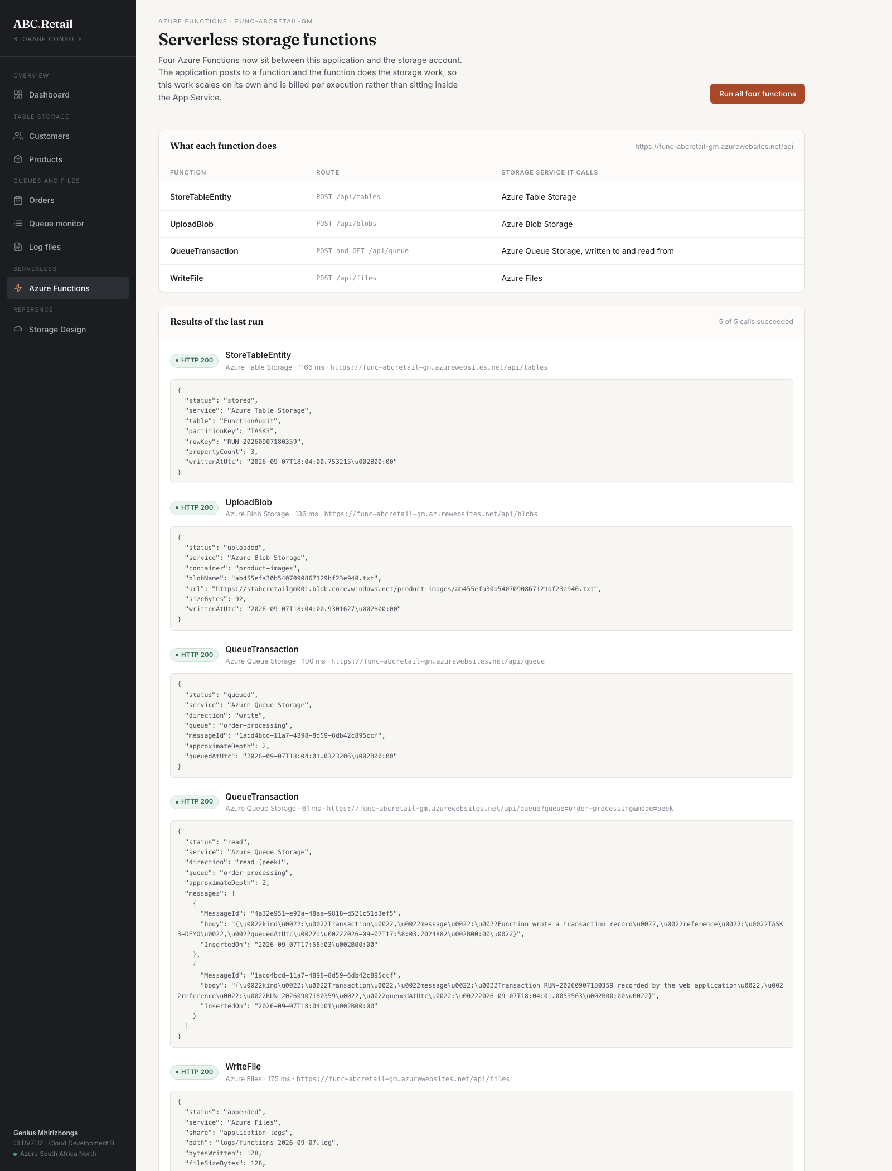
Figure 3. The result of pressing Run all four functions. Five calls, all HTTP 200: a table write, a blob upload with the returned blob URL, a queue write, a queue read showing the messages on the queue, and an append to the file share.

The queue after the function wrote to it
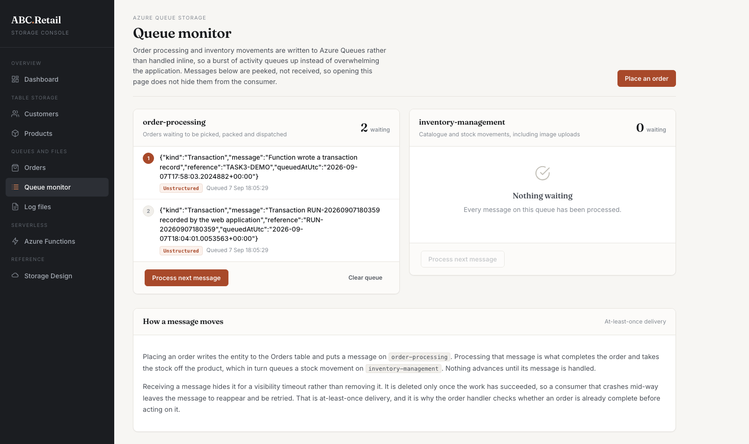
Figure 4. The queue monitor showing the transaction messages the QueueTransaction function placed on order-processing.

The file share after the function wrote to it
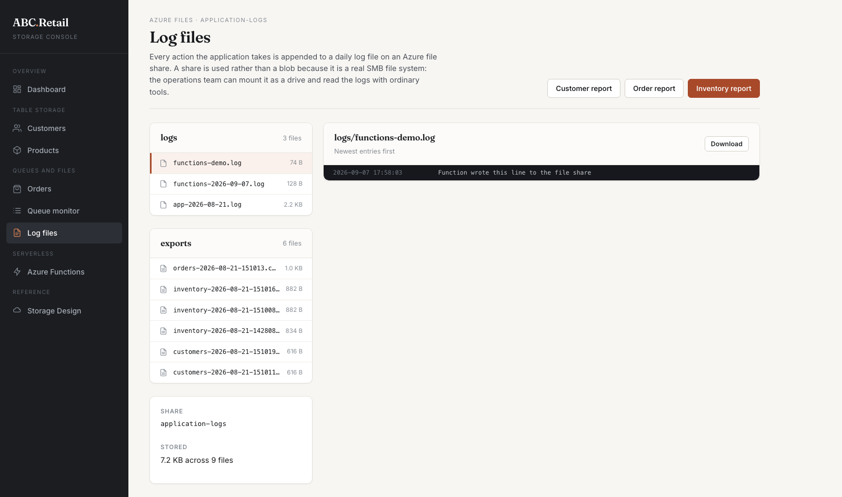
Figure 5. The application-logs share showing the dated log file the WriteFile function created and appended to.

The application as a whole
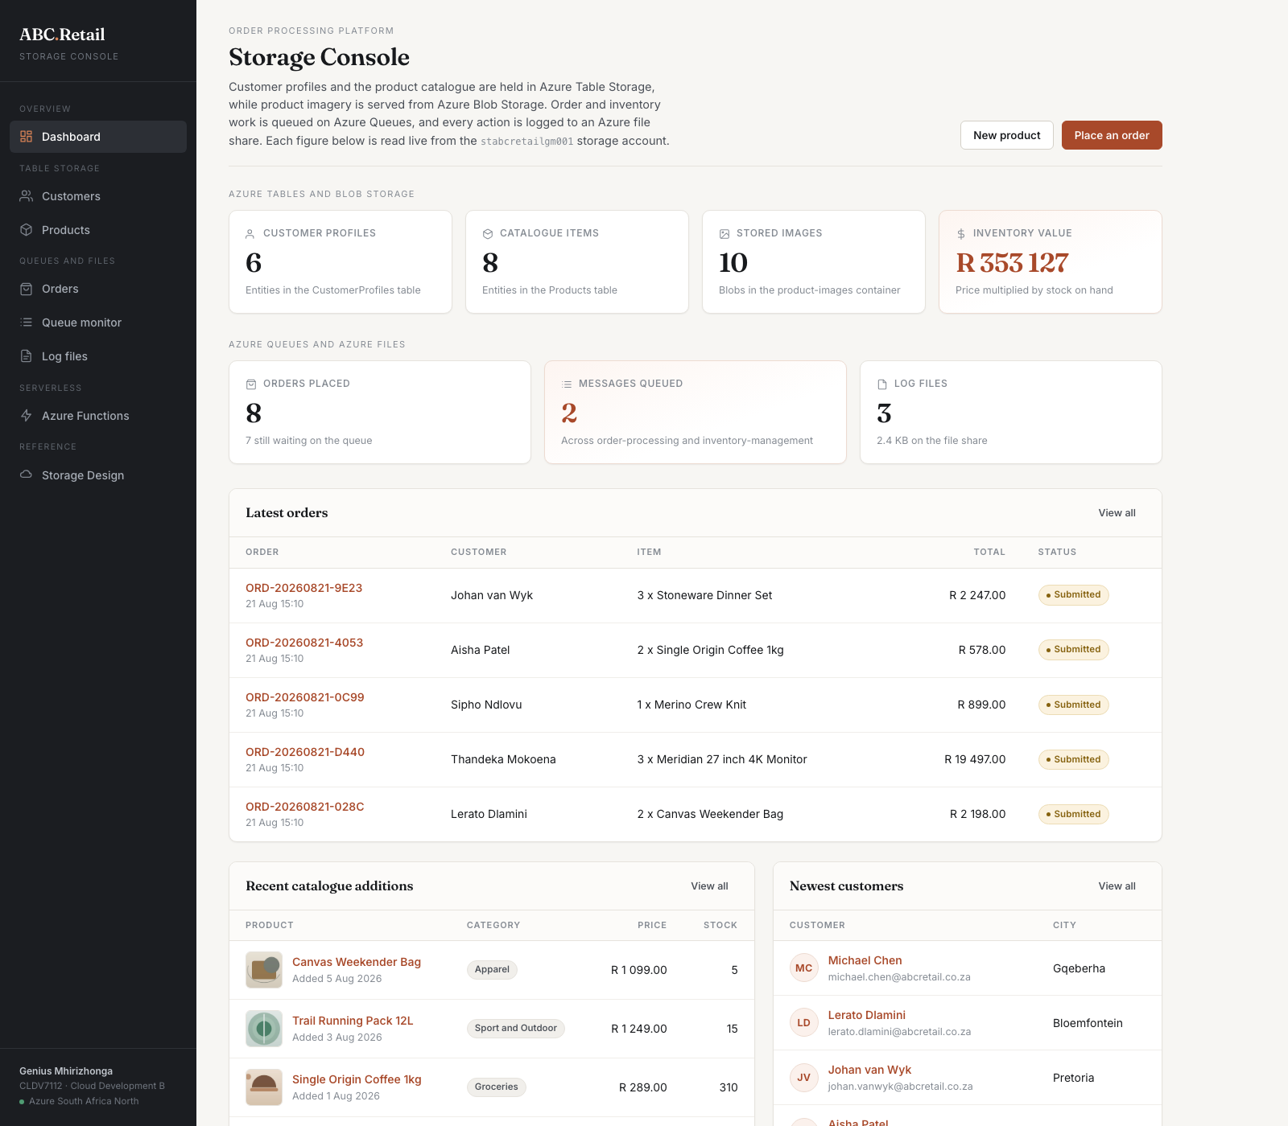
Figure 6. The dashboard, with every figure read live from the storage account across all four services.

The source code
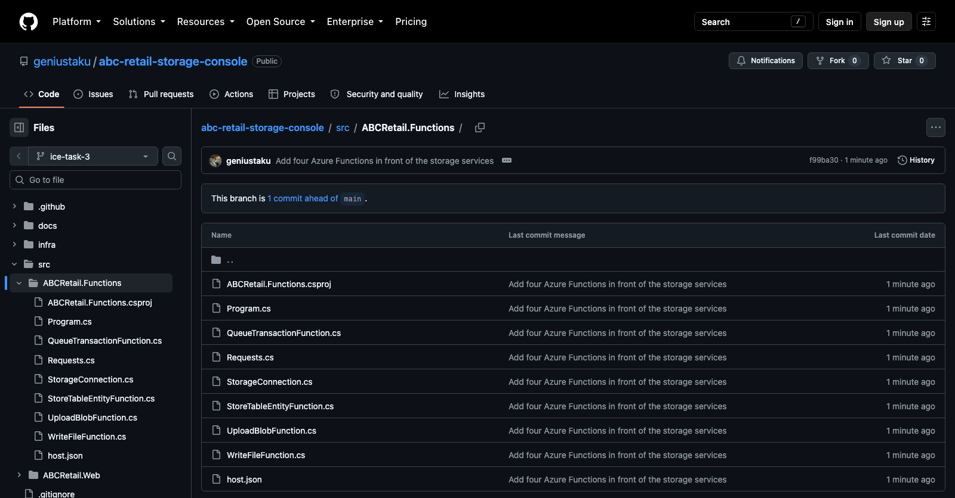
Figure 7. The functions project in the repository on the ice-task-3 branch.

6. Scalability, cost effectiveness and cloud suitability

Scalability
- The storage work no longer competes with page rendering for the same compute. A burst of writes scales the functions out on their own without the App Service being resized to cope with it.
- Each function scales independently. Heavy image uploading does not slow down the queue, because UploadBlob and QueueTransaction are separate units.
- The consumption plan adds instances automatically. Nothing has to be provisioned in advance for the seasonal peak the brief describes.

Cost effectiveness
- The consumption plan charges per execution and includes a free monthly grant of one million executions, so at this volume the functions cost nothing.
- An App Service is paid for whether or not it is doing anything. Work that arrives in bursts is cheaper on a plan that bills for the bursts.
- The function app reuses the storage account that already exists, so no second account and no second set of credentials had to be created.

Cloud suitability
- Each function is independently deployable. Changing how blobs are written no longer means redeploying the whole website.
- Functions are reachable by anything that can make an HTTP request, so a mobile app or a partner system could use the same endpoints without the web application in the middle.
- Access is controlled by function keys rather than the storage account key, so a caller can be given the ability to write a blob without being handed the keys to the entire account.

7. Verification
I tested the functions directly before wiring anything up, and then again through the deployed application. Both times all four returned HTTP 200 and the data appeared in the storage account: an entity in the FunctionAudit table, a file in the product-images container, a message on order-processing, and a line in the log file on the share. Figure 3 is the second of those runs.
One problem is worth recording because it cost time. The function app was first created on .NET 10 isolated, which Azure lists as a supported runtime for Linux consumption. The host returned 503 on every request and no functions ever registered, even though the deployment package was correct and contained all four entries in functions.metadata. Moving the runtime back to .NET 8 isolated fixed it immediately, and the first call after that returned 401 rather than 503, which was the function key check working as it should. The lesson is that a runtime being listed as available is not the same as it being served on the stamp you land on.
A second issue was that Azure refuses to put a Linux consumption plan in a resource group that already contains a Linux App Service plan. The function app therefore sits in its own resource group, rg-abcretail-functions, while the web application and storage stay where they were.

8. Keeping the Project 1 submission intact
Project 1 is built from the same code and is still being marked, so this task had to be added without disturbing what was submitted. I did four things.
- Tagged the exact commit that Project 1 was submitted from as project-1-submission, so that state is permanently recorded and can be recovered.
- Did all of this work on a branch named ice-task-3. The deployment workflow only runs on pushes to main, so it is not possible for this work to redeploy over the Project 1 site by accident.
- Deployed this task to a new web application rather than the existing one, so the URL printed in the Project 1 document still serves the version that matches its screenshots.
- Put the function app in its own resource group. It reads and writes the same storage account, which is the point, but no existing resource was reconfigured.
Requesting /Functions on the Project 1 site still returns 404, which confirms that site is running the code that was submitted rather than this one.

9. Azure resources and cost
Resource | Name | Tier
Function app | func-abcretail-gm | Consumption, Linux, .NET 8 isolated
Resource group for the functions | rg-abcretail-functions | South Africa North
Web app for this task | abcretail-task3-gm | F1 Free, on the existing plan
Storage account | stabcretailgm001 | Standard LRS, reused from Project 1

Nothing in this task added a paid resource. The function app runs on consumption with a free monthly grant, the new web app sits on the F1 free plan that already existed, a resource group costs nothing, and the storage account is the one already in use. The running cost is the same few cents of storage it was before.

