INSTALLATION
- Remove the plastic lid of the battery compartment located at the bottom of the phone and insert the 3 x AAA rechargeable batteries. Close the lid
- The power adapter automatically charges the rechargeable batteries. Fully charged batteries will last up to 50 hours during a power failure. We recommend that you replace the batteries every 2 to 5 years
- Plug one end of the coiled cord into the handset and the other end into the telephone.
- Plug one end of the flat telephone cord into the telephone ‘Line Jack’ and the other end into the ‘Connect To Phone’ jack on the wall-socket. Plug the DC connector of the power adapter into the ‘AC/DC Adapter In’ Jack of wall-socket. (Please reference figure 1 below).
- Connect one end of the Data cable into the telephone Line Jack and the other end into the PC connector. (Please reference figure 2 below).
- To use the headset (not included) , plug into the headset socket on the side of the phone.
- Adjust the headset transmitter and receiver volume controls to the most comfortable setting
- Contact your PBX supplier for the relevant PBX settings (i.e. transfer signal).
- To mount your phone on the wall, remove then rotate the wall-mount clip 180 degrees. Re insert the wall mount clip to ensure that the handset stays in place when the phone is mounted on the wall.

INSTALLATION
Figure 1.
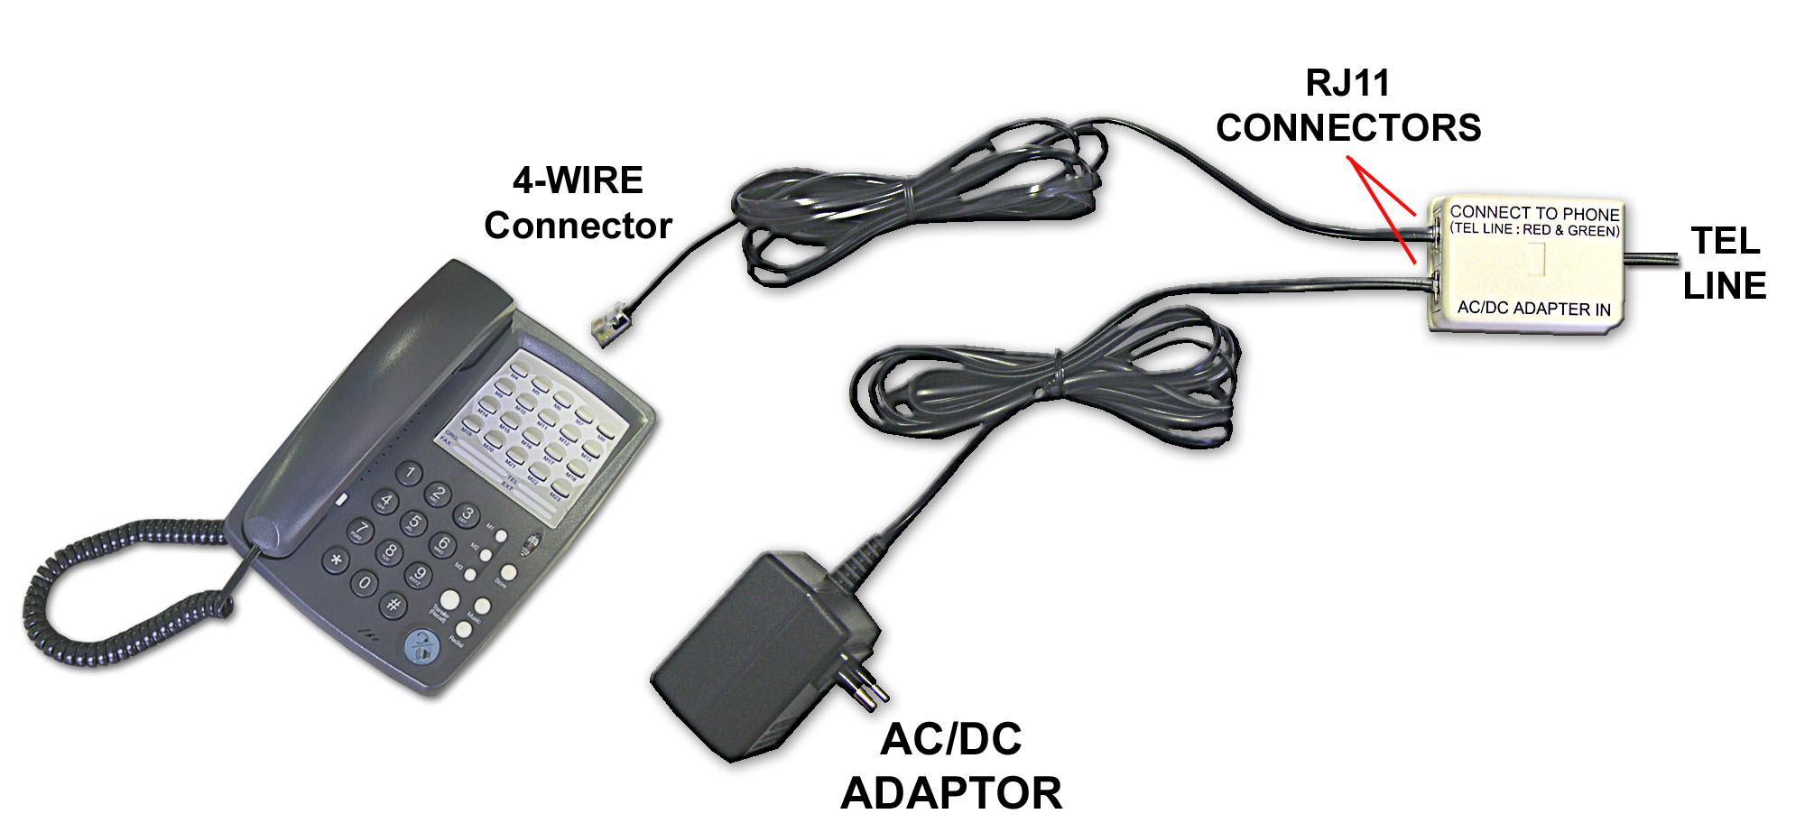
Figure 2.
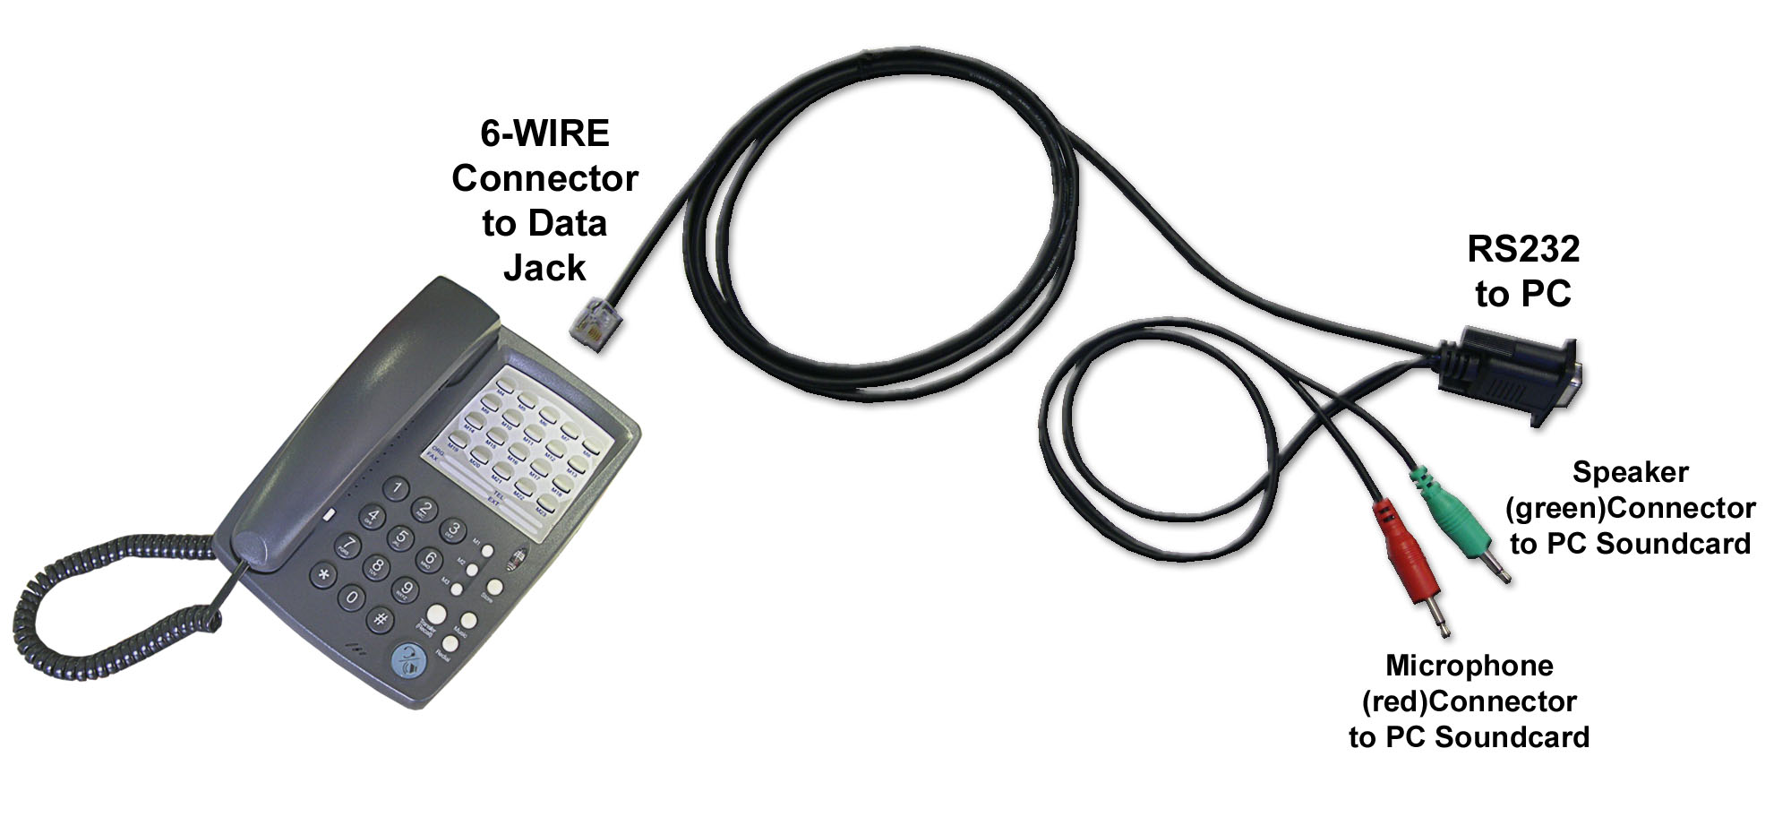

INSTALLATION

Front View

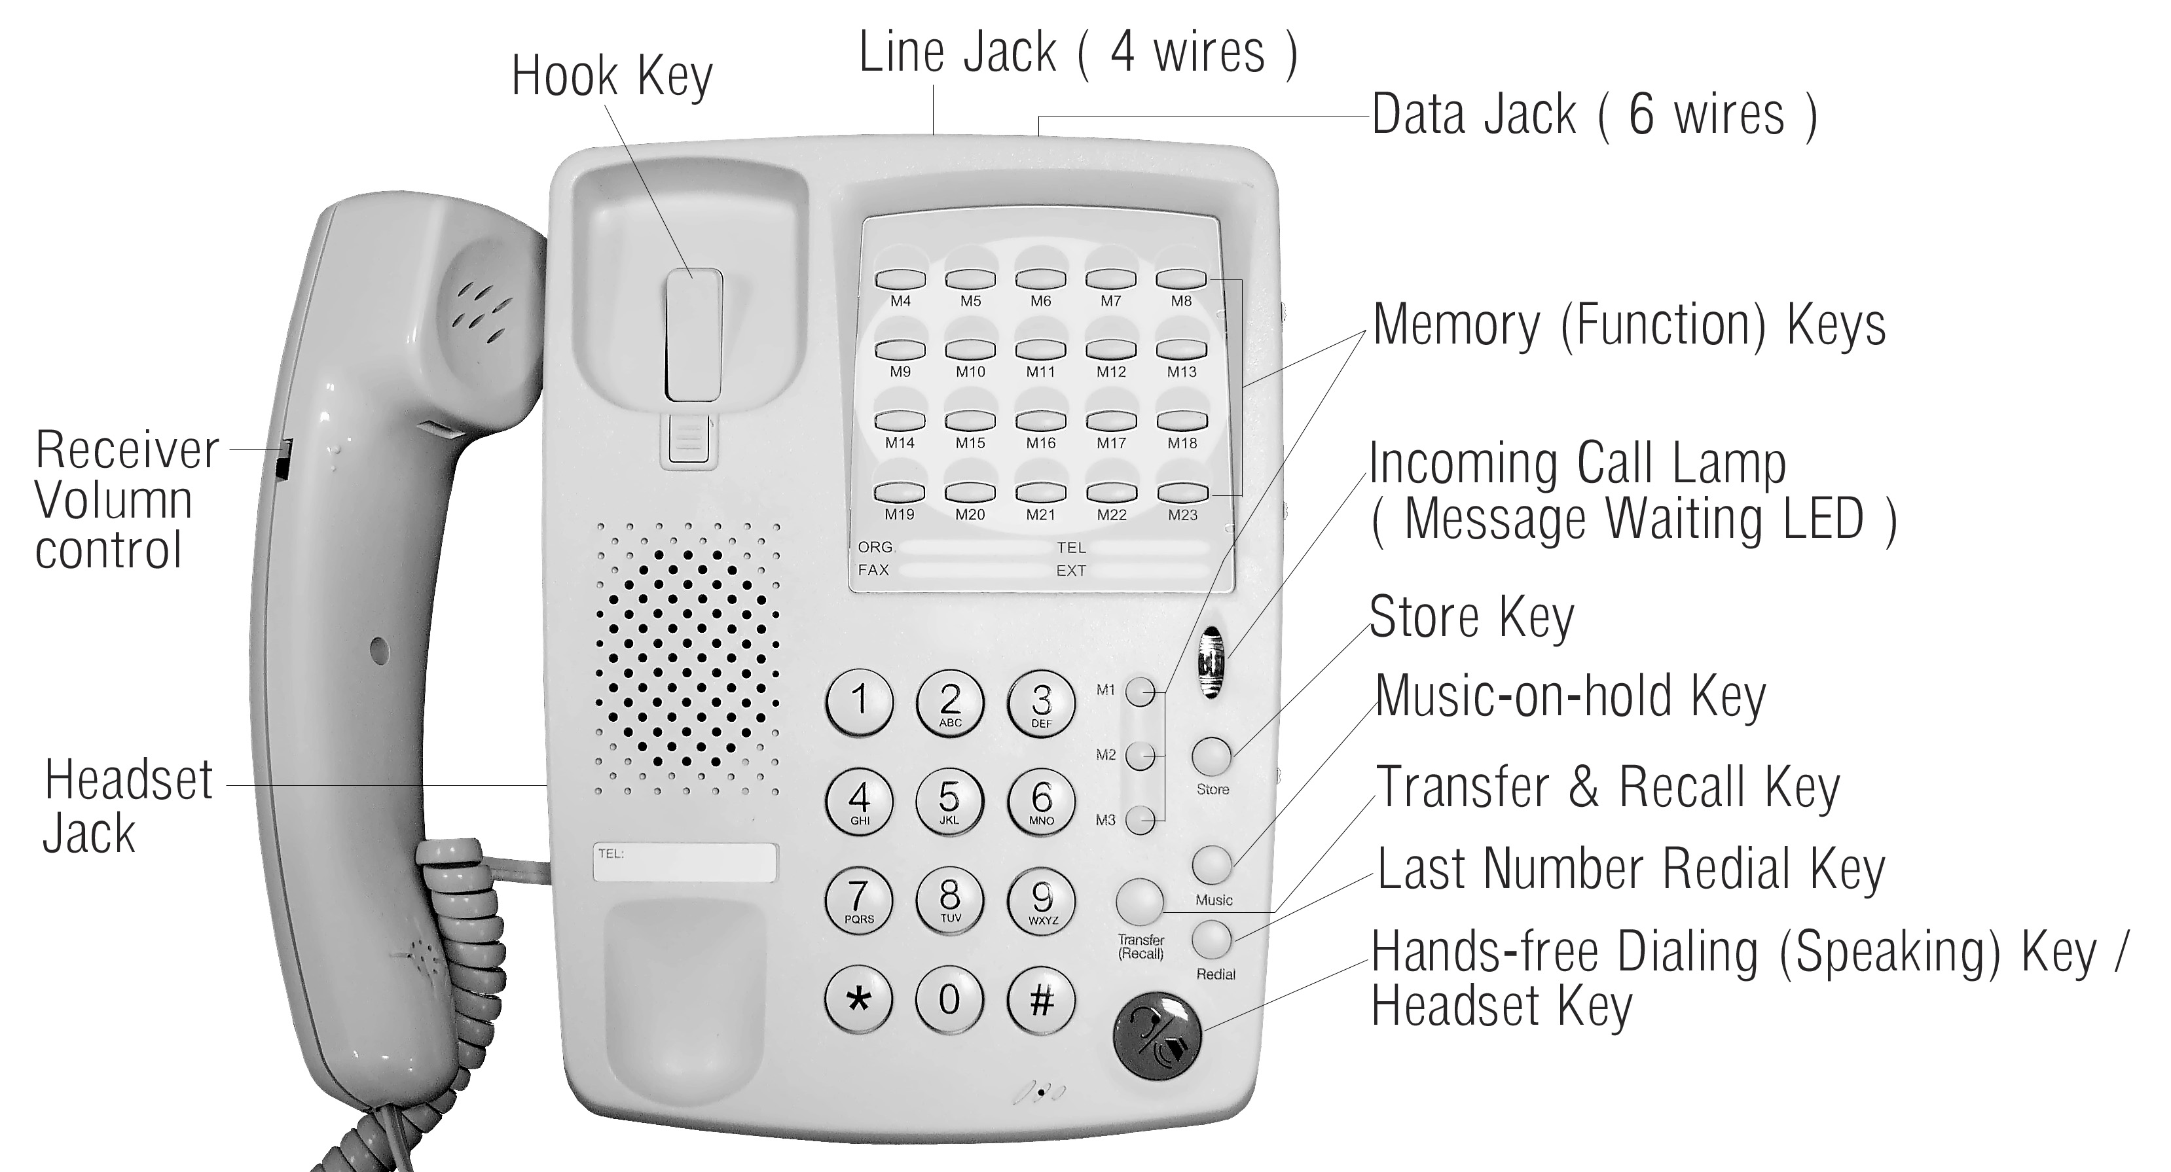

Bottom View  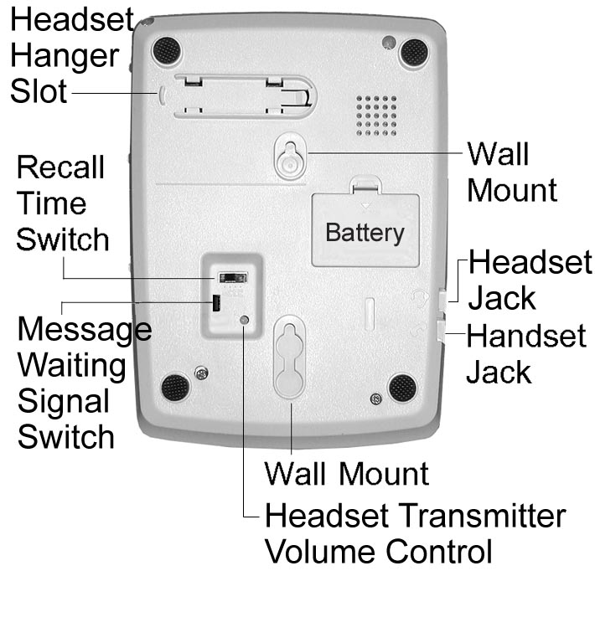 | Side View  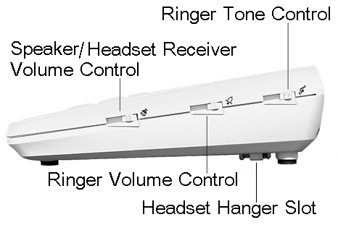
OPERATION INSTRUCTIONS
TO SET THE TRANSFER/RECALL ( FLASH ) TIME
There are three different Transfer/Recall ( Flash ) signals that you can select. Please contact your PBX supplier for the correct setting:
- F1 : 100 m.s. ( Default )
- F2 : 300 m.s.
- F3 : 600 m.s.
Note: By default the switch is set to F1 (100 m.s.)

TO TRANSFER A CALL
This feature is only used when the phone is connected behind a PBX.
While talking to the other party:
- Press the TRANSFER ( Recall ) key.
- Listen for PABX dial tone.
- Dial the extension number of where the call needs to be transferred.
- Replace handset.

BUSY LINE AUTO RELEASE
The phone automatically detects when the called party is busy and reverts back to an on-hook status.
Note: The phone will only detect standard Busy tone & Dial tone. Please contact your local supplier if you require the phone to detect a non-standard tone.

THE MESSAGE WAITING FACILITY
The message LED will flash when a message has been left in the user’s voice mailbox.

OPERATION INSTRUCTIONS
TO PROGRAM THE 23 ONE-TOUCH MEMORY KEYS
- Press the STORE key.
- Enter the telephone number you want to store, including any signal ( i.e. Pause , Recall , On-Hook ).
- Press the relevant memory key to store the numbers ( M1 ---- M23 ) . Each memory key can store up to 32 digits.
- The stored data is not lost in the event of a power failure. Memory is non-volatile and does not require batteries.
Note: Only one number can be stored per memory key. Storing a new number will automatically erase the previous stored number. Any one of memory keys can be locked to be function key. Once it is locked, the number will not be replaced by restoring new number.

TO PROGRAM THE PAUSE SIGNAL
Pressing the REDIAL key will automatically insert a pause signal, but only in the event that another key is pressed prior to the REDIAL key. A pause signal is usually used after the PBX trunk access prefix when programming the one-touch memory keys (M1 - M23).
The pause signal is a maximum of 2 seconds long.
Example:
- To store the number 0 “Pause” 2808888.
- Press the STORE key
- Press 0 REDIAL 2808888.
- Press any memory key to store the number in ( M1 - M23 ).
Note: To insert a 4 second pause, press REDIAL twice, etc . If the phone is programmed with a fixed PBX trunk access prefix then there is no need to program the pause signal.
OPERATION INSTRUCTIONS
DIALLING A SPEED DIAL NUMBER
- Lift up the handset or Press the  key to make the call on headset.
- Wait for dial tone.
- Press the required memory key (M1 - M23).
- The number stored in that specific memory key will be dialed out automatically. Alternatively press the memory key directly to start the dialing process.
TO PLACE A CALL ON MUSIC-ON-HOLD
During a conversation you can place the call on " Music-on-hold ". This will prevent the other party from hearing you (mute).
- Press the MUSIC key ( the other party hears music ).
- Replace the handset.
- You can retrieve the call on hold by just lifting the Handset, or by pressing the key, to talk on headset.
Note: If the phone is connected behind a PABX , DO NOT press the MUSIC key to transfer a call to another extension. To transfer a call to another extension press the “ TRANSFER (Recall) ” key only.

INTELLIGENT AUTO REDIAL
- During the On-Hook status.
- Press the Redial key.
The phone will auto-redial the last number up to 15 times, when a busy tone is detected.
Note: The phone will only detect standard Busy tone & Dial tone. Please contact your local supplier if you require the phone to detect a non-standard tone.

OPERATION INSTRUCTIONS
SPEAKER VOLUME CONTROL
The loudness of the speaker can be adjusted by sliding the Speaker Volume Control (  ) switch located on the right-hand side of the phone.
Note: If there is a headset connected , this switch will automatically change to “ headset receiver ” volume control.
RINGER VOLUME CONTROL
The loudness of the ringer can be adjusted by sliding the Ringer Volume Control ( 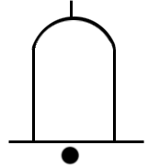 ) switch located on the right-hand side of the phone.
Note: When this switch is set to “low” the phone will not ring, but the incoming call LED will flash.
RINGER TONE CONTROL
The tone of the ringer can be adjusted by sliding the Ringer Tone Control ( ) switch located on the right-hand side of the phone.
HANDSET RECEIVER VOLUME CONTROL
The volume on the handset receiver can be adjusted to either High (  ) or Low () by using the switch on the handset.

DIMENSION & WEIGHT
Dimension: 21 cm ( L ) x 15 cm ( W ) x 8 cm ( H )
Weight: 680 grams

OPERATION INSTRUCTIONS-HEADSET MODEL
HEADSET TRANSMITTER VOLUME CONTROL
You can rotate the switch at the bottom of the phone with a screwdriver to adjust the headset transmitter’s volume level. Rotate clockwise to increase the volume.
Note: Please do not change this setting unless really necessary. By default it should be correct. Adjusting it too high can cause feedback on the headset.
AUTOMATIC HEADSET / HANDSET MODE DETECTION
As soon as a headset is connected, the phone will automatically detect it and set the Key to headset off-hook or on-hook activation (instead of on-hook dialing).
When the headset is disconnected, the Key reverts back to a “on-hook dialing” key.
OPERATION ON HEADSET MODE
- The speaker volume control will automatically changes to headset receiver volume control in Headset Mode.
- The Key will change to be Headset ON / OFF key.
- If there is no headset connected :
The LED will turn RED when you press the key to make a call, and turn OFF when the handset goes off-hook.
- If there is a headset connected :
The LED will turn GREEN when you press the key to make a call using the headset , and turn OFF when you press the key to terminate the call.

OPERATION INSTRUCTIONS-HEADSET MODEL
TO ANSWER A CALL
When the phone rings:
- Lift the Handset or
- Press the key to answer the call on headset.
TO MAKE A CALL
- Lift Handset or
Press the key to make the call on headset.
- Dial the number.
Alternatively, just press the keypad or one of the one-touch memory keys (M1- M23) to activate the intelligent dialing mode.

TO CHANGE BETWEEN HEADSET AND HANDSET MODE
- Change to handset mode when talking on headset:
Simply lift the handset. The LED on key will turn OFF.

- Change to headset mode when talking on handset:
Simply press the key, the LED will turn GREEN.

