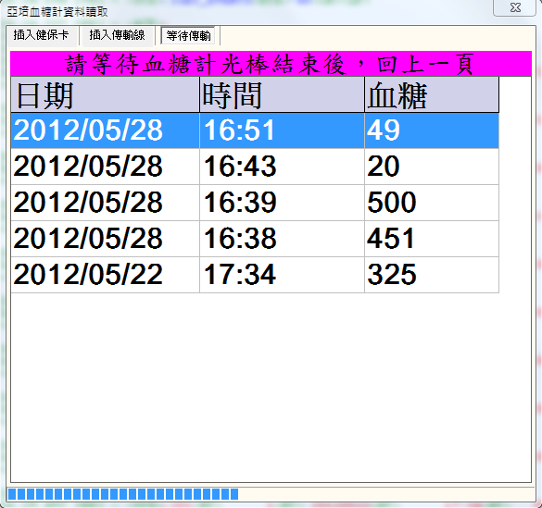

2012/6/6 00:16:24.194 [TX] - <STX>_1GET_EVENTS<ETX>_48<CR><LF>
2012/6/6 00:16:25.890 [RX] - <STX>_106<HT> 1<HT> 20120528<HT> 16:57<HT> 02<HT> 0<CR><ETB>_4C<CR><LF>
2012/6/6 00:16:26.831 [RX] - <STX>_206<HT> 1<HT> 20120528<HT> 16:53<HT> 01<HT> 0<CR><ETB>_48<CR><LF>
2012/6/6 00:16:27.320 [RX] - <STX>_301<HT> 0<HT> 20120528<HT> 16:51<HT> 00049<HT> 0<CR><ETB>_DD<CR><LF>
2012/6/6 00:16:27.696 [RX] - <STX>_408<HT> 0<HT> 20120528<HT> 16:50<HT> 0<HT> 0<CR><ETB>_17<CR><LF>
2012/6/6 00:16:27.978 [RX] - <STX>_501<HT> 1<HT> 20120528<HT> 16:43<HT> 00020<HT> 1<CR><ETB>_D7<CR><LF>
2012/6/6 00:16:28.247 [RX] - <STX>_607<HT> 1<HT> 20120528<HT> 16:42<HT> 00354<HT> 0<CR><ETB>_E6<CR><LF>
2012/6/6 00:16:28.473 [RX] - <STX>_707<HT> 1<HT> 20120528<HT> 16:42<HT> 00354<HT> 0<CR><ETB>_E7<CR><LF>
2012/6/6 00:16:28.777 [RX] - <STX>_001<HT> 1<HT> 20120528<HT> 16:39<HT> 00500<HT> 2<CR><ETB>_DB<CR><LF>
2012/6/6 00:16:29.041 [RX] - <STX>_101<HT> 1<HT> 20120528<HT> 16:38<HT> 00451<HT> 0<CR><ETB>_DE<CR><LF>
2012/6/6 00:16:29.497 [RX] - <STX>_201<HT> 1<HT> 20120522<HT> 17:34<HT> 00325<HT> 0<CR><ETB>_D6<CR><LF>
2012/6/6 00:16:30.058 [RX] - <STX>_310<HT> 1<HT> 20110901<HT> 11:40<HT> 045001<HT> 0<CR><ETB>_FE<CR><LF>
2012/6/6 00:16:30.767 [RX] - <STX>_4END_OF_DATA<ETX>_7B<CR><LF><EOT>_

