- I am still getting that effect of the Incoming Communication page hanging and the bottom left corner showing that it is waiting for an external site. Did you make any progress with this?
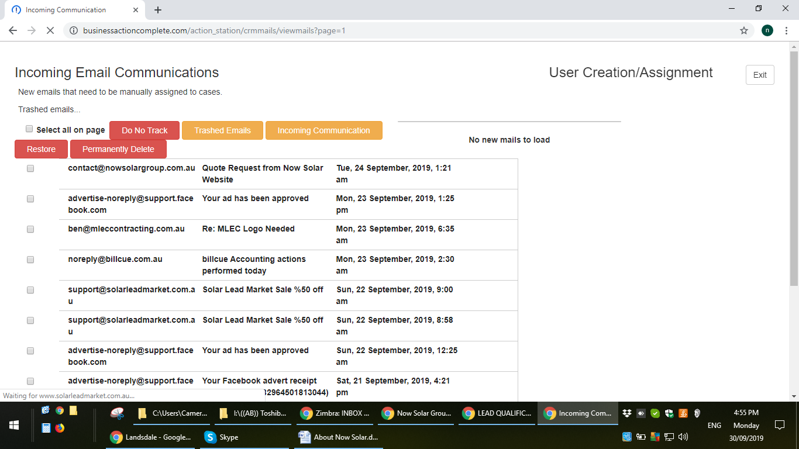

2. Grrrrr.... Confirm Communication Assignment button doesn't work. It just does nothing. Priority 1 problem.
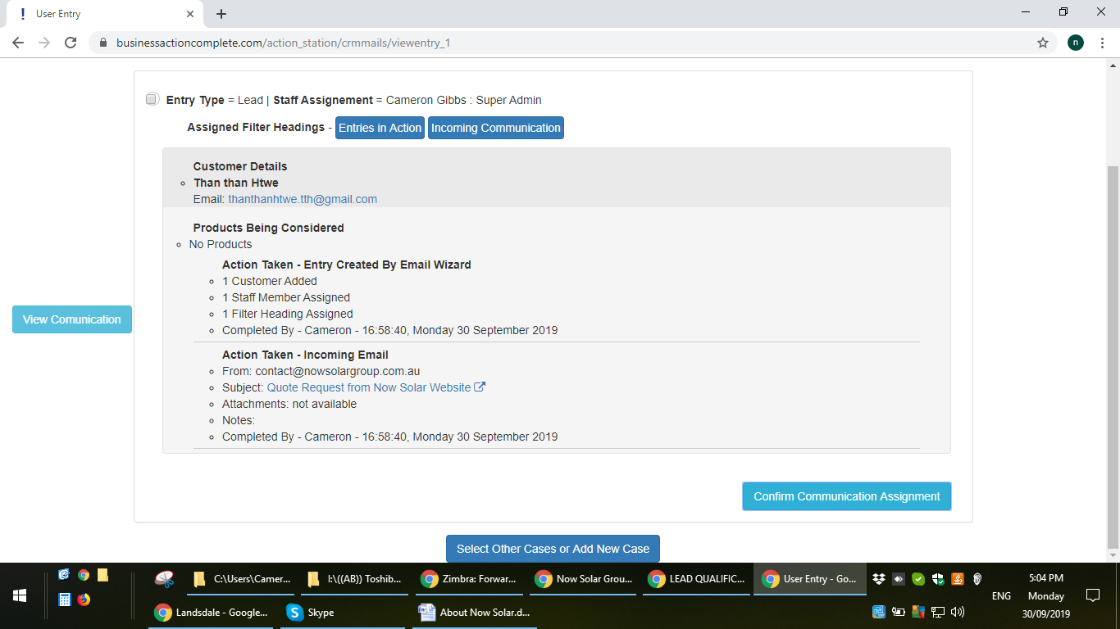

3. Now hanging: "Waiting for eventtracking"

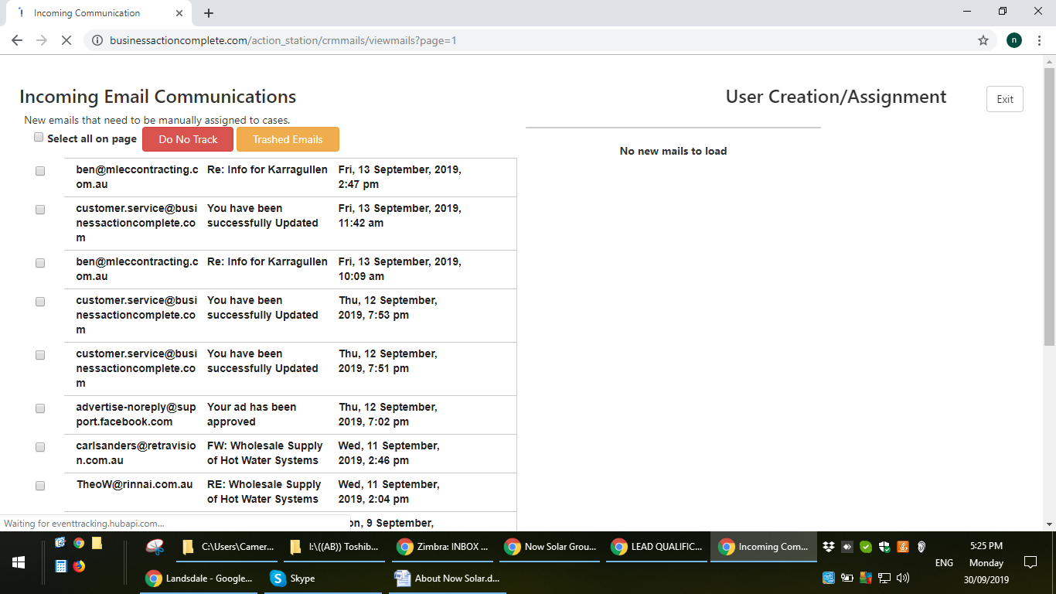

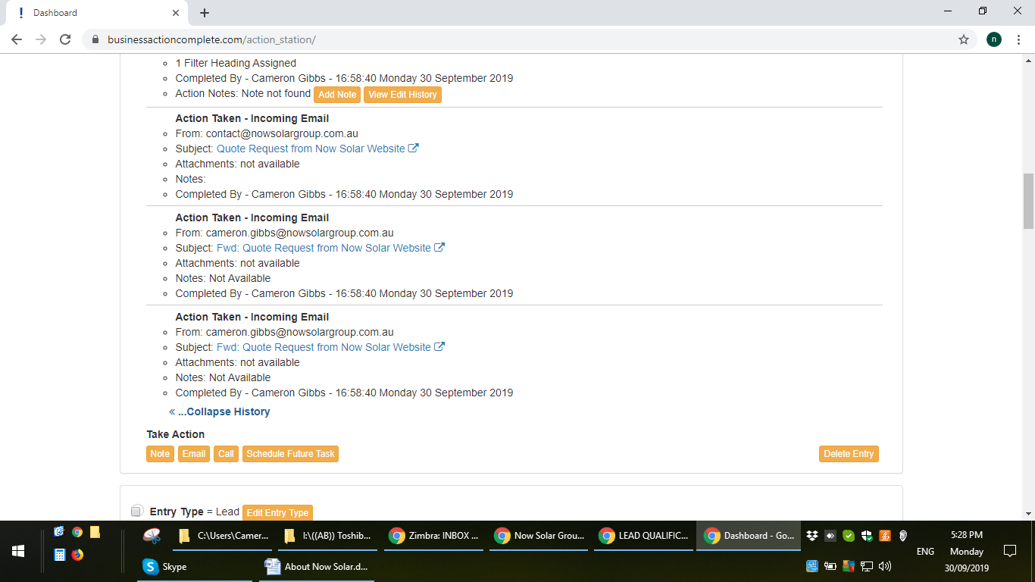
This is a follow on from the "Confirm Communication Assignment" button not working properly. I obviously pressed it twice while on the page and because it gave no indication it was doing anything. As a result, it has created two action logs.
After you have fixed the initial problem, can you please remove one of these action logs from that entry. Make sure you don't affect any other data.
It should also be noted that this wizard pathway gave me no opportunity to add notes but I actually needed to include notes. Please make sure notes are possible along that pathway.
As a new task, we need to create a method to add an action with the title "Action Taken - Email Sent by External Program"
The method would be to forward the sent email onto our gmail account, pick it up in the Incoming Communication page, assign it to an existing user and an existing account but log it as an email sent by an external program.

