|  |  |
| --- | --- |
| **Weekly Report 10-16/10/2014** | |
| Title | Telerik Academy Learning System |
| Testing Modules | Basic Modules |
|  | Certificates |
|  | Software Academy |
| Due date | Nov 24 2014 |
| Type | Weekly Report |
| Status | Version 2 |
| Responsible | Redcurrant Team: |
|  | Kalin Marinov – Team Leader |
|  | Hristo Tsekov |
|  | Milena Gyulmezova |
|  | Violeta Roumenova |
|  | Yordan Tsenkov |
| Project URL | [**www.test.telerikacademy.com**](http://www.test.telerikacademy.com/) |

**Modules in User Part**

|  |  |  |  |  |  |  |  |  |  |  |
| --- | --- | --- | --- | --- | --- | --- | --- | --- | --- | --- |
| Модул | Cases | | | Tests | | | | | | Bugs |
| Priority | | | Testing | | Fail | Pass | No Runned | Runned |
| High | Medium | Low | Automation | Manual |
| Навигация | 2 | 0 | 0 | 2 | 0 | 0 | 2 | 0 | 2 | 0 |
| Кандидатстване | 52 | 25 | 0 | 57 | 20 | 0 | 77 | 0 | 77 | 0 |
| Настройки | 15 | 2 | 0 | 15 | 2 | 2 | 15 | 0 | 17 | 2 |
| Входен Изпит | 4 | 2 | 2 | 5 | 3 | 2 | 6 | 1 | 7 | 0 |

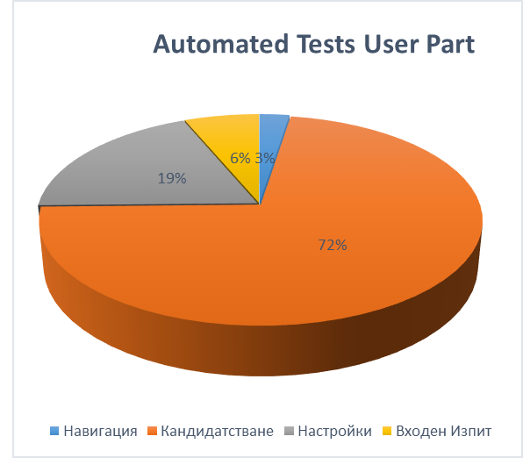

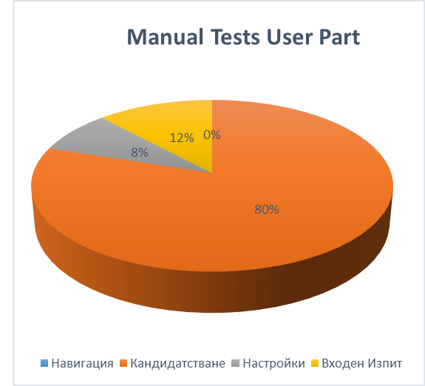

**Modules in Administrator Part**

|  |  |  |  |  |  |  |  |  |  |  |
| --- | --- | --- | --- | --- | --- | --- | --- | --- | --- | --- |
| Модул | Cases | | | Tests | | | | | | Bugs |
| Priority | | | Testing | | Fail | Pass | No Runned | Runned |
| High | Medium | Low | Automation | Manual |
| Настройки | 12 | 0 | 0 | 0 | 12 | 0 | 12 | 0 | 12 | 0 |
| Качени файлове | 34 | 0 | 0 | 2 | 4 | 0 | 6 | 0 | 6 | 0 |
| Входен Изпит | 9 | 5 | 6 | 17 | 3 | 4 | 14 | 0 | 18 | 0 |
| Студенти в академията | 0 | 5 | 0 | 0 | 2 | 2 | 0 | 2 | 2 | 0 |
| Зали | 0 | 2 | 0 | 2 | 0 | 2 | 2 | 0 | 2 | 0 |

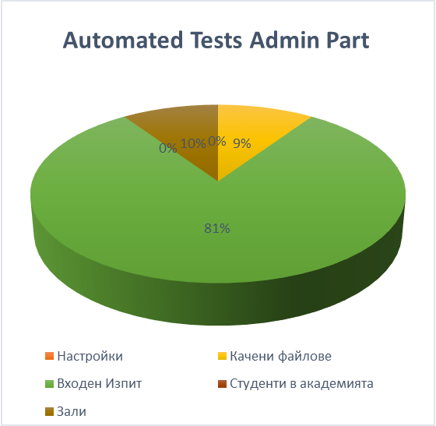

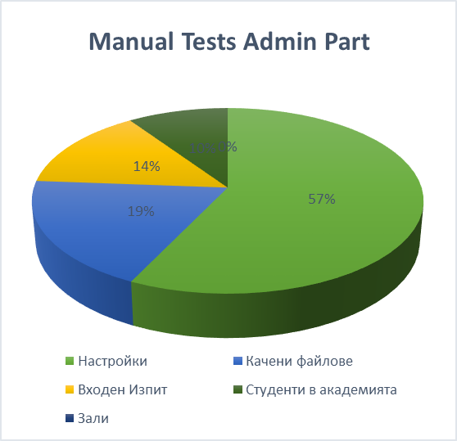

**Summary of All Cases and Tests**

|  |  |  |  |  |  |  |  |  |  |  |
| --- | --- | --- | --- | --- | --- | --- | --- | --- | --- | --- |
|  | Cases Count | | | Tests Count | | | | | | Bugs |
|  | Priority | | | Testing | | Fail | Pass | No Runned | Runned |
|  | High | Medium | Low | Automation | Manual |
| Общо | 128 | 41 | 8 | 100 | 46 | 12 | 134 | 3 | 143 | 2 |

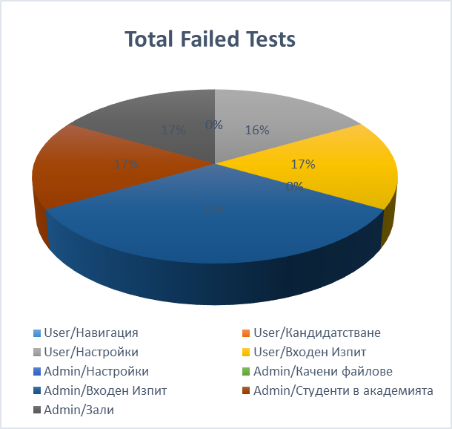

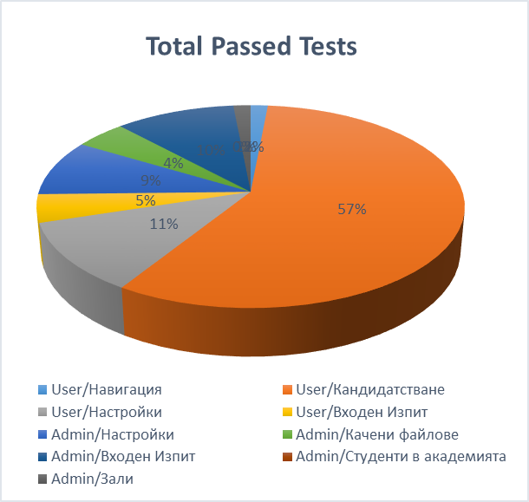

During the testing the team also found bugs in Main Page, Application form, User->Settings and Registration, which are logged in Team Pulse.

**The Result of Week 10-16/10/2014**

|  |  |  |  |
| --- | --- | --- | --- |
|  | Cases | Tests | Bugs |
| Обобщение бр. | 177 | 146 | 2 |