|  |  |
| --- | --- |
| **Weekly Report 14/11/2014** | |
| Title | Telerik Academy Learning System |
| Testing Modules | Basic Modules |
|  | Certificates |
|  | Software Academy |
| Due date | Nov 24 2014 |
| Type | Weekly Report |
| Responsible | Redcurrant Team: |
|  | Milena Gyulmezova – Team Leader |
|  | Kalin Marinov |
|  | Hristo Tsekov |
|  | Violeta Roumenova |
|  | Yordan Tsenkov |
| Project URL | [**www.test.telerikacademy.com**](http://www.test.telerikacademy.com/) |

**Summary of the week**

# Performance (WebTesting)

This kind of testing was executed for module Apply for Academy with 100 and 200 users. The gained collected metrics was Total average Time and Request Time for every test. The results are:

|  |  |  |
| --- | --- | --- |
| **Apply For Academy** | **Total Avg. Time(sec)** | **Request Average Time(sec)** |
| **Web test 100 Users** | 0.5907 | 0.0632 |
| **Web test 200 Users** | 0.9635 | 0.0989 |

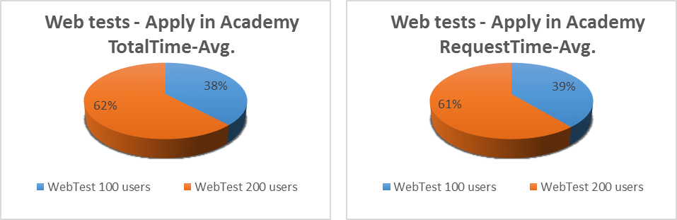

The tests have three steps

Step 1 - http://test.telerikacademy.com/Users/Auth/Login

Step 2 - http://test.telerikacademy.com/Users/Auth/Login

Step 3 - http://test.telerikacademy.com/SoftwareAcademy/Candidate

Step 4 - http://test.telerikacademy.com/SoftwareAcademy/Candidate

Step 5 - http://test.telerikacademy.com/SoftwareAcademy/Candidate/ThankYouForYourCandidature

The time for every one of them is:

|  |  |  |  |  |
| --- | --- | --- | --- | --- |
|  | **100 Users** | | **200 Users** | |
|  | **Total Avg Time(sec)** | **Request Avg Time(sec)** | **Total Avg Time(sec)** | **Request Avg Time(sec)** |
| Step 1 | 0.5164 | 0.0418 | 0.8966 | 0.0283 |
| Step 2 | 0.5479 | 0.0510 | 1.1233 | 0.0491 |
| Step 3 | 0.5865 | 0.1371 | 1.1086 | 0.1727 |
| Step 4 | 0.8268 | 0.0329 | 0.2977 | 0.1897 |
| Step 5 | 0.4698 | 0.0523 | 0.9341 | 0.0793 |

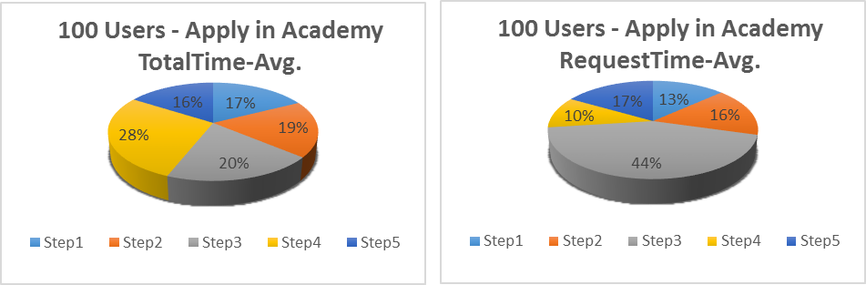

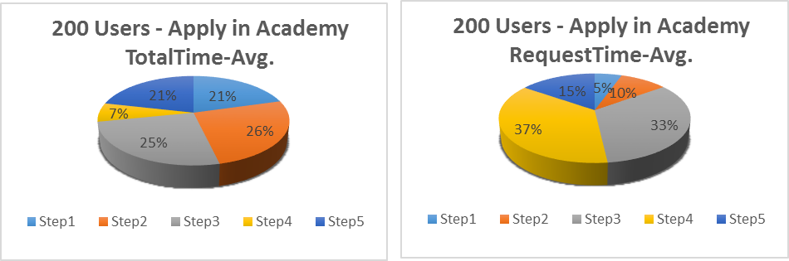

# Load and Stress Tests

Load and Stress testing are performed on Apply for Academy and Search Modules

Load Testing:

|  |  |  |
| --- | --- | --- |
| **Test Run Information** | | |
| Load test name | ApplyForAcademy_Load | WordSearch_Load |
| Start time | 11/14/2014 12:38 | 11/14/2014 10:51 |
| End time | 11/14/2014 12:58 | 11/14/2014 11:11 |
| Warm-up duration | 0:00:00 | 0:00:00 |
| Duration | 0:20:00 | 0:20:00 |
| Controller | Local run | Local run |
| **Overall Results** | | |
| Max User Load | 200 | 200 |
| Tests/Sec | 5.04 | 0.93 |
| ***Tests Failed*** | ***3,075*** | ***287*** |
| Avg. Test Time (sec) | 33.1 | 172 |
| Transactions/Sec | 0 | 0 |
| Avg. Transaction Time (sec) | 0 | 0 |
| Pages/Sec | 12.8 | 2.89 |
| Avg. Page Time (sec) | 13.1 | 57.9 |
| Requests/Sec | 121 | 29.6 |
| ***Requests Failed*** | ***3,344*** | ***344*** |
| Requests Cached Percentage | 38.4 | 13.6 |
| ***Avg. Response Time (sec)*** | ***2.06*** | ***8.27*** |
| Avg. Content Length (bytes) | 9,594 | 70,220 |
| ***Threshold Violations*** | ***2*** | ***2*** |

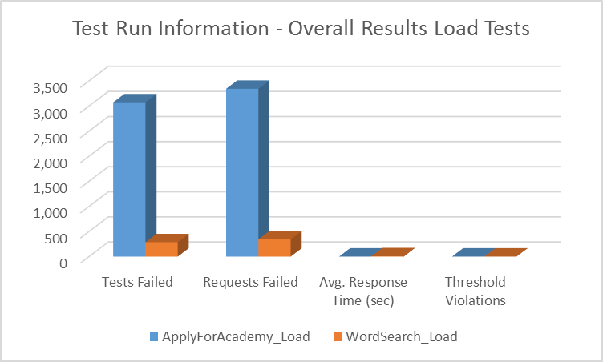

Stress Testing:

|  |  |  |
| --- | --- | --- |
| **Test Run Information** | | |
| Load test name | ApplyForAcademy_Stress | WordSearch_Stress |
| Start time | 11/14/2014 12:07 | 11/14/2014 11:24 |
| End time | 11/14/2014 12:09 | 11/14/2014 11:26 |
| Warm-up duration | 0:00:00 | 0:00:00 |
| Duration | 0:02:00 | 0:02:00 |
| Controller | Local run | Local run |
| **Overall Results** | | |
| Max User Load | 250 | 250 |
| Tests/Sec | 2.31 | 0.033 |
| ***Tests Failed*** | ***1*** | ***0*** |
| Avg. Test Time (sec) | 54.4 | 109 |
| Transactions/Sec | 0 | 0 |
| Avg. Transaction Time (sec) | 0 | 0 |
| Pages/Sec | 6.57 | 0.38 |
| Avg. Page Time (sec) | 24.6 | 50.1 |
| Requests/Sec | 106 | 25.8 |
| ***Requests Failed*** | ***2*** | ***5*** |
| Requests Cached Percentage | 24.8 | 1.59 |
| ***Avg. Response Time (sec)*** | ***3.78*** | ***11.3*** |
| Avg. Content Length (bytes) | 46,840 | 48,026 |
| ***Threshold Violations*** | ***2*** | ***0*** |

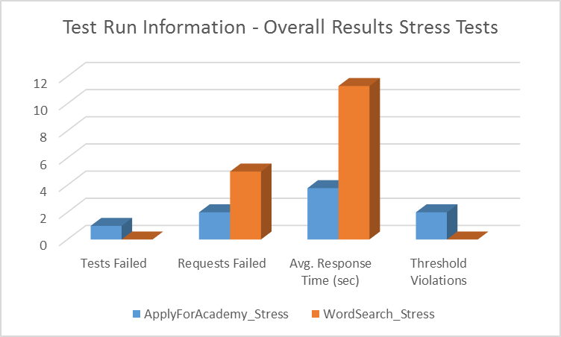

# Endurance Testing

It was execute for Apply for Academy Module .The characteristics are:

|  |  |
| --- | --- |
| **Test Run Information** | |
| Load test name | ApplyForAcademy_Load |
| Start time | 11/14/2014 11:32:45 AM |
| End time | 11/14/2014 12:32:45 PM |
| Warm-up duration | 0:00:00 |
| Duration | 1:00:00 |
| Controller | Local run |
| **Overall Results** |  |
| Max User Load | 25 |
| Tests/Sec | 0.99 |
| ***Tests Failed*** | ***43*** |
| Avg. Test Time (sec) | 25 |
| Transactions/Sec | 0 |
| Avg. Transaction Time (sec) | 0 |
| Pages/Sec | 2.49 |
| Avg. Page Time (sec) | 9.89 |
| Requests/Sec | 29.9 |
| ***Requests Failed*** | ***50*** |
| Requests Cached Percentage | 30.4 |
| ***Avg. Response Time (sec)*** | ***1.78*** |
| Avg. Content Length (bytes) | 44.129 |
| ***Threshold Violations*** | ***2*** |

# Summary of Upper Testing

|  |  |  |  |  |  |
| --- | --- | --- | --- | --- | --- |
| **Overall Results** | | | | | |
|  | **ApplyForAcademy** | | | **WordSearch** | |
|  | Load | Stress | Endurance | Load | Stress |
| Tests Failed | 3,075 | 1 | 43 | 287 | 0 |
| Requests Failed | 3,344 | 2 | 50 | 344 | 5 |
| Avg. Response Time (sec) | 2.06 | 3.78 | 1.78 | 8.27 | 11.3 |
| Threshold Violations | 2 | 2 |  | 2 | 0 |

**Summary for the whole project**

The project contains 264 cases, 313 tests and 29 active bugs. In the table below it is shown the count and coverage of tests and cases by priority, way of run and by zones – user part or administration part

# Cases and Tests metrics

The total distribution of cases and test for the while project

|  |  |  |  |  |  |  |  |  |
| --- | --- | --- | --- | --- | --- | --- | --- | --- |
| **Module** | **Cases** | | | **Tests** | | | | **Bugs  found** |
| **Priority** | | | **Testing** | | **Fail** | **Pass** |
| **High** | **Medium** | **Low** | **Automated** | **Manual** |
| Total | 163 | 78 | 23 | 247 | 66 | 32 | 281 | 29 |

Statistic of cases’ priorities by user and administration part

|  |  |  |  |  |  |  |
| --- | --- | --- | --- | --- | --- | --- |
| **Priority Cases  Statistic** | **High  (count)** | **High %** | **Middle (count)** | **Middle %** | **Low (count)** | **Low %** |
| User | 97 | 59.51 | 33 | 42.31 | 9 | 39.13 |
| Admin | 66 | 40.49 | 45 | 57.69 | 14 | 60.87 |
| All | 163 | 100.00 | 78 | 100.00 | 23 | 100.00 |

Statistic of cases and tests (automated and manual) by user and administration part

|  |  |  |  |  |  |  |
| --- | --- | --- | --- | --- | --- | --- |
| **Auto/Manual  Tests Statistic** | **Cases (count)** | **Cases %** | **Automated (count)** | **Automated %** | **Manual (count)** | **Manual %** |
| User | 139 | 52.65 | 132 | 53.44 | 32 | 48.48 |
| Admin | 125 | 47.35 | 115 | 46.56 | 34 | 51.52 |
| All | 264 | 100.00 | 247 | 100.00 | 66 | 100.00 |

Distribution of cases and tests by **User** part

|  |  |  |  |  |  |  |  |  |
| --- | --- | --- | --- | --- | --- | --- | --- | --- |
| **User part  zone coverage** | **Cases** | | | **Tests** | | | | **Bugs  found** |
| **Priority** | | | **Testing** | | **Fail** | **Pass** |
| **High** | **Medium** | **Low** | **Automated** | **Manual** |
| Basic Modules | 6 | 6 | 7 | 20 | 7 | 6 | 21 | 2 |
| Software Academy | 76 | 27 | 2 | 97 | 23 | 2 | 118 | 0 |
| Specialty and Certificates | 15 | 0 | 0 | 15 | 2 | 2 | 15 | 2 |

Distribution of cases and tests by **Administrator** part

|  |  |  |  |  |  |  |  |  |
| --- | --- | --- | --- | --- | --- | --- | --- | --- |
| **Administrator part  zone coverage** | **Cases** | | | **Tests** | | | | **Bugs  found** |
| **Priority** | | | **Testing** | | **Fail** | **Pass** |
| **High** | **Medium** | **Low** | **Automated** | **Manual** |
| Basic Modules | 47 | 27 | 2 | 82 | 19 | 3 | 98 | 8 |
| Software Academy | 18 | 15 | 12 | 31 | 13 | 18 | 26 | 7 |
| Specialty and Certificates | 1 | 3 | 0 | 2 | 2 | 1 | 3 | 2 |

Here is a detail breakdown of the upper information by modules In **User** part

|  |  |  |  |  |  |  |  |  |
| --- | --- | --- | --- | --- | --- | --- | --- | --- |
| **Module** | **Cases** | | | **Tests** | | | | **Bugs  found** |
| **Priority** | | | **Testing** | | **Fail** | **Pass** |
| **High** | **Medium** | **Low** | **Automated** | **Manual** |
| Навигация | 2 | 0 | 0 | 2 | 1 | 0 | 3 | 0 |
| Кандидатстване | 72 | 25 | 0 | 92 | 20 | 0 | 112 | 0 |
| Входен Изпит | 4 | 2 | 2 | 5 | 3 | 2 | 6 | 0 |
| Настройки | 0 | 6 | 3 | 6 | 3 | 0 | 9 | 1 |
| Cпециалности | 15 | 0 | 0 | 15 | 2 | 2 | 15 | 2 |
| Търсене | 4 | 0 | 2 | 6 | 0 | 1 | 5 | 1 |
| Да получава информация | 0 | 0 | 2 | 6 | 3 | 5 | 4 | 0 |

Here is a detail breakdown of the upper information by modules In **Administrator** part

|  |  |  |  |  |  |  |  |  |
| --- | --- | --- | --- | --- | --- | --- | --- | --- |
| **Module** | **Cases** | | | **Tests** | | | | **Bugs  found** |
| **Priority** | | | **Testing** | | **Fail** | **Pass** |
| **High** | **Medium** | **Low** | **Automated** | **Manual** |
| Настройки | 12 | 0 | 0 | 7 | 12 | 0 | 19 | 1 |
| Качени файлове | 34 | 0 | 0 | 29 | 4 | 2 | 31 | 0 |
| Входен Изпит | 15 | 5 | 7 | 26 | 5 | 13 | 18 | 1 |
| Студенти в академията | 1 | 5 | 0 | 0 | 3 | 0 | 3 | 0 |
| Динамични страници | 0 | 19 | 0 | 36 | 2 | 1 | 37 | 7 |
| Обратна връзка | 0 | 7 | 0 | 7 | 0 | 0 | 7 | 0 |
| Зали | 1 | 1 | 0 | 2 | 0 | 0 | 2 | 0 |
| Професии (тракове) | 0 | 2 | 0 | 0 | 2 | 0 | 2 | 1 |
| Сертификати | 1 | 1 | 0 | 2 | 0 | 1 | 1 | 1 |
| Търсени думи | 0 | 0 | 1 | 0 | 1 | 0 | 1 | 0 |
| Анкети | 0 | 0 | 1 | 1 | 0 | 0 | 1 | 0 |
| Кандидати | 0 | 0 | 3 | 0 | 3 | 0 | 3 | 0 |
| Всички кандидати | 0 | 0 | 1 | 0 | 1 | 0 | 1 | 0 |
| Приети участници | 0 | 0 | 1 | 0 | 1 | 0 | 1 | 0 |
| Сезони | 2 | 5 | 0 | 5 | 0 | 5 | 0 | 6 |

The following modules haven’t been tested: Устройства присъствия, Списък на грешките, Шаблони, Кандидатури за сертификати, Видове сертификати, Допълнителни документи, Статистика кандидати, Статистика въпроси, Корелация входни изпити.

After running regression test the results is 3 tests with Medium priority from Feedback/Post fail, 13 tests – 5 of them with High Priority and 8 with Low Priority – from Entry Exam fail and all tests (count of 5) from module Seasons with Low Priority fail. This information is shown in the table below.

Tests that fails after regression testing

|  |  |  |  |  |
| --- | --- | --- | --- | --- |
| **Modules** | **Priority** | | | **All** |
| **High** | **Medium** | **Low** |
| Да получава информация | 0 | 3 | 0 | 3 |
| Входен Изпит | 5 | 0 | 8 | 13 |
| Сезони | 0 | 0 | 5 | 5 |
| All | 5 | 3 | 13 | 21 |

# Bugs metrics

During testing the team found bugs, some of them blocking. The follow tables show the bugs by zones, by severity.

|  |  |  |
| --- | --- | --- |
| **Bugs by status** | **In Progress** | **Done** |
| User part | 7 | 4 |
| Administrator part | 22 | 3 |

|  |  |  |  |  |  |  |
| --- | --- | --- | --- | --- | --- | --- |
| **Active bugs** | **Blocking** | **Critical** | **High** | **Medium** | **Low** | **All** |
| User part | 2 | 0 | 2 | 1 | 2 | 7 |
| Administrator part | 3 | 1 | 9 | 9 | 0 | 22 |
| All | 5 | 1 | 11 | 10 | 2 | 29 |

|  |  |
| --- | --- |
| **Active bugs by severity** | |
| Blocking | 5 |
| Critical | 1 |
| High | 11 |
| Medium | 10 |
| Low | 2 |

The blocking bugs are in modules Apply for Academy and Settings of User Part. From Administration Part the blocking bugs are in Certificates (tracks) and Seasons.