|  |  |
| --- | --- |
| **Weekly Report 21/11/2014** | |
| Title | Telerik Academy Learning System |
| Testing Modules | Basic Modules |
|  | Certificates |
|  | Software Academy |
| Due date | Nov 24 2014 |
| Type | Weekly Report |
| Responsible | Redcurrant Team: |
|  | Violeta Roumenova – Team Leader |
|  | Kalin Marinov |
|  | Milena Gyulmezova |
|  | Hristo Tsekov |
|  | Yordan Tsenkov |
| Project URL | [**www.test.telerikacademy.com**](http://www.test.telerikacademy.com/) |

**Summary of the week**

# Performance (WebTesting)

This kind of testing was executed for module Apply for Academy with 100 and 200 users. The gained collected metrics was Total average Time and Request Time for every test. The results are:

|  |  |  |
| --- | --- | --- |
| **Apply For Academy** | **Total Avg. Time(sec)** | **Request Average Time(sec)** |
| **Web test 100 Users** | 0.5907 | 0.0632 |
| **Web test 200 Users** | 0.9635 | 0.0989 |

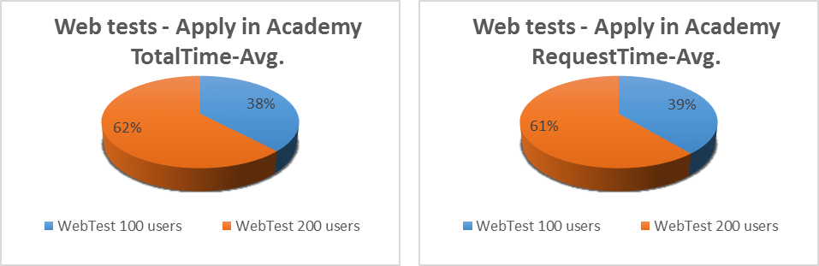

The tests have three steps

Step 1 - http://test.telerikacademy.com/Users/Auth/Login

Step 2 - http://test.telerikacademy.com/Users/Auth/Login

Step 3 - http://test.telerikacademy.com/SoftwareAcademy/Candidate

Step 4 - http://test.telerikacademy.com/SoftwareAcademy/Candidate

Step 5 - http://test.telerikacademy.com/SoftwareAcademy/Candidate/ThankYouForYourCandidature

The time for every one of them is:

|  |  |  |  |  |
| --- | --- | --- | --- | --- |
|  | **100 Users** | | **200 Users** | |
|  | **Total Avg Time(sec)** | **Request Avg Time(sec)** | **Total Avg Time(sec)** | **Request Avg Time(sec)** |
| Step 1 | 0.5164 | 0.0418 | 0.8966 | 0.0283 |
| Step 2 | 0.5479 | 0.0510 | 1.1233 | 0.0491 |
| Step 3 | 0.5865 | 0.1371 | 1.1086 | 0.1727 |
| Step 4 | 0.8268 | 0.0329 | 0.2977 | 0.1897 |
| Step 5 | 0.4698 | 0.0523 | 0.9341 | 0.0793 |

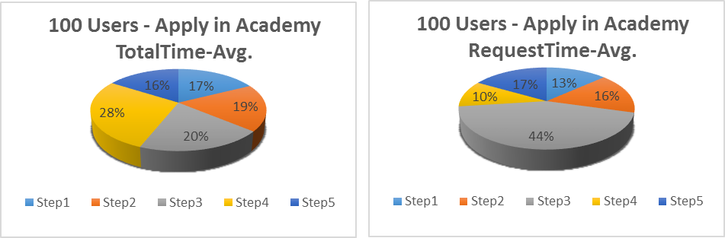

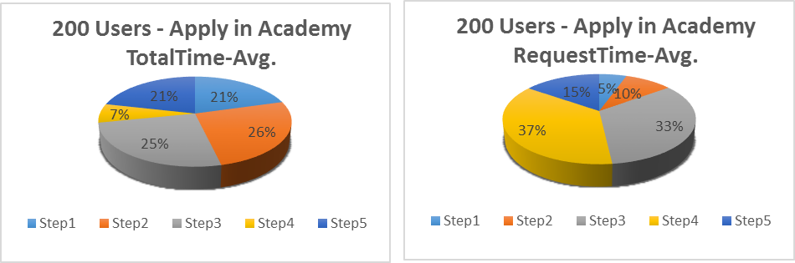

# Load and Stress Tests

Load and Stress testing are performed on Apply for Academy and Search Modules

Load Testing:

|  |  |  |
| --- | --- | --- |
| **Test Run Information** | | |
| Load test name | ApplyForAcademy_Load | WordSearch_Load |
| Start time | 11/14/2014 12:38 | 11/14/2014 10:51 |
| End time | 11/14/2014 12:58 | 11/14/2014 11:11 |
| Warm-up duration | 0:00:00 | 0:00:00 |
| Duration | 0:20:00 | 0:20:00 |
| Controller | Local run | Local run |
| **Overall Results** | | |
| Max User Load | 200 | 200 |
| Tests/Sec | 5.04 | 0.93 |
| ***Tests Failed*** | ***3,075*** | ***287*** |
| Avg. Test Time (sec) | 33.1 | 172 |
| Transactions/Sec | 0 | 0 |
| Avg. Transaction Time (sec) | 0 | 0 |
| Pages/Sec | 12.8 | 2.89 |
| Avg. Page Time (sec) | 13.1 | 57.9 |
| Requests/Sec | 121 | 29.6 |
| ***Requests Failed*** | ***3,344*** | ***344*** |
| Requests Cached Percentage | 38.4 | 13.6 |
| ***Avg. Response Time (sec)*** | ***2.06*** | ***8.27*** |
| Avg. Content Length (bytes) | 9,594 | 70,220 |
| ***Threshold Violations*** | ***2*** | ***2*** |

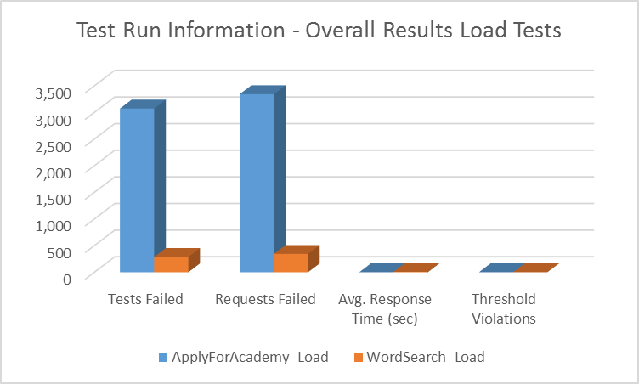

Stress Testing:

|  |  |  |
| --- | --- | --- |
| **Test Run Information** | | |
| Load test name | ApplyForAcademy_Stress | WordSearch_Stress |
| Start time | 11/14/2014 12:07 | 11/14/2014 11:24 |
| End time | 11/14/2014 12:09 | 11/14/2014 11:26 |
| Warm-up duration | 0:00:00 | 0:00:00 |
| Duration | 0:02:00 | 0:02:00 |
| Controller | Local run | Local run |
| **Overall Results** | | |
| Max User Load | 250 | 250 |
| Tests/Sec | 2.31 | 0.033 |
| ***Tests Failed*** | ***1*** | ***0*** |
| Avg. Test Time (sec) | 54.4 | 109 |
| Transactions/Sec | 0 | 0 |
| Avg. Transaction Time (sec) | 0 | 0 |
| Pages/Sec | 6.57 | 0.38 |
| Avg. Page Time (sec) | 24.6 | 50.1 |
| Requests/Sec | 106 | 25.8 |
| ***Requests Failed*** | ***2*** | ***5*** |
| Requests Cached Percentage | 24.8 | 1.59 |
| ***Avg. Response Time (sec)*** | ***3.78*** | ***11.3*** |
| Avg. Content Length (bytes) | 46,840 | 48,026 |
| ***Threshold Violations*** | ***2*** | ***0*** |

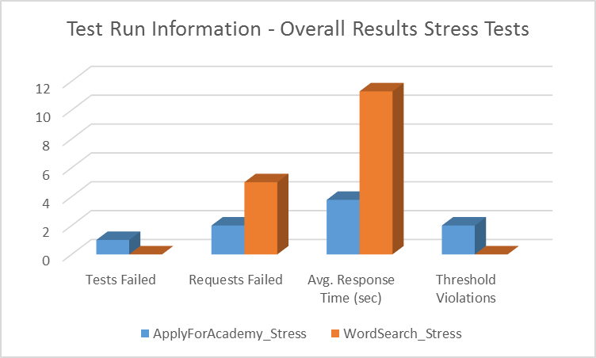

# Endurance Testing

It was execute for Apply for Academy Module .The characteristics are:

|  |  |
| --- | --- |
| **Test Run Information** | |
| Load test name | ApplyForAcademy_Load |
| Start time | 11/14/2014 11:32:45 AM |
| End time | 11/14/2014 12:32:45 PM |
| Warm-up duration | 0:00:00 |
| Duration | 1:00:00 |
| Controller | Local run |
| **Overall Results** |  |
| Max User Load | 25 |
| Tests/Sec | 0.99 |
| ***Tests Failed*** | ***43*** |
| Avg. Test Time (sec) | 25 |
| Transactions/Sec | 0 |
| Avg. Transaction Time (sec) | 0 |
| Pages/Sec | 2.49 |
| Avg. Page Time (sec) | 9.89 |
| Requests/Sec | 29.9 |
| ***Requests Failed*** | ***50*** |
| Requests Cached Percentage | 30.4 |
| ***Avg. Response Time (sec)*** | ***1.78*** |
| Avg. Content Length (bytes) | 44.129 |
| ***Threshold Violations*** | ***2*** |

# Summary of Upper Testing

|  |  |  |  |  |  |
| --- | --- | --- | --- | --- | --- |
| **Overall Results** | | | | | |
|  | **ApplyForAcademy** | | | **WordSearch** | |
|  | Load | Stress | Endurance | Load | Stress |
| Tests Failed | 3,075 | 1 | 43 | 287 | 0 |
| Requests Failed | 3,344 | 2 | 50 | 344 | 5 |
| Avg. Response Time (sec) | 2.06 | 3.78 | 1.78 | 8.27 | 11.3 |
| Threshold Violations | 2 | 2 |  | 2 | 0 |