CEDAR College, Inc.

National Highway Cadiz City, Negros Occidental

**AN INTEGRATED EDUCATIONAL RESOURCES PLATFORM**

Capstone Project Presented to

CEDAR College, Inc.

National Highway

Cadiz City, Negros Occidental

In Partial Fulfillment of the

Requirements for the Degree of

Bachelor of Science in Information Technology

Daphnie M. Dolleno

Allios Kyle M. Miscala

Laurence Marie S. Tigres

March 2025

**APPROVAL SHEET**

This Capstone Project

**AN INTEGRATED EDUCATIONAL RESOURCES PLATFORM**

Prepared and submitted by Daphnie M. Dolleno, Allios Kyle M. Miscala and Laurence Marie S. Tigres is hereby recommended for approval and acceptance as a requirement for the degree:

**Bachelor of Science in Information Technology**

JOHN DAVE A. BARILEA

**Capstone Adviser**

Accepted by the panel of Evaluators with grade of ___________

**PANEL OF EVALUATORS**

WILFREDO C. VILLANUEVA, PhD.

**Lead Panel**

ROMEO D. LOBATON JR. JOHN PAUL B. PALMA

**Panelist Panelist**

Approved as required for the degree of Bachelor of Science in information Technology

WILFREDO C. VILLANUEVA, PhD

**School President**

**ACKNOWLEDGEMENT**

The completion of this project would not have been possible without the support, guidance, and contributions of several individuals. We, the researchers, sincerely express our deepest gratitude to those who played a vital role in the success of this study.

Above all, we thank the Almighty Father for granting us wisdom, perseverance, and strength throughout this journey. His guidance has been our source of motivation, helping us overcome challenges and accomplish this project.

To our families, for their unwavering support, love, and encouragement. Their patience and understanding have been our foundation, pushing us to strive for excellence in our academic pursuits.

To **JOHN DAVE A. BARILEA**, for his invaluable guidance, dedication, and patience. His continuous support, insightful advice, and commitment have been instrumental in shaping this capstone project and ensuring its success.

To **WILLIE D. VILLANUEVA, PhD.** for his guidance, encouragement, and constructive feedback. His insights have greatly contributed to refining our study, providing us with a clearer direction and deeper understanding of our work.

To **ROMEO D. LOBATON**, for his valuable recommendations and technical expertise, which have helped enhance the development of our system. His feedback has played a crucial role in improving the project’s overall quality.

To **JOHN PAUL B. PALMA**, for taking the time to review our work, providing suggestions, and guiding us toward the continuous improvement of this study. His input has been essential in ensuring the success of our capstone project.

Lastly, to our friends, classmates, and everyone who has supported us in one way or another-your encouragement and shared ideas have been invaluable in making this project a reality.

We dedicate this work to all who believe in the power of education and innovation.

**THE RESEARCHERS**

**ABSTRACT**

This Capstone Project focuses on the design and development of an Integrated Educational Resources Platform to improve students' access to academic materials. Many students in the Philippines encounter difficulties in using traditional libraries due to factors such as distance, high costs, and limited operating hours. To address these challenges, a web-based platform was created, offering a centralized digital catalog of educational resources, including e-books, dictionaries, and scholarly articles.  
  
The platform features advanced search capabilities, personalized user accounts, and mobile accessibility, enabling students to efficiently locate and utilize academic materials anytime and anywhere. It simplifies the process of managing resources while encouraging independent learning and research.  
  
To assess the system’s usability and effectiveness, ISO [25010](D:/Documents/Inug%20Print/tel:25010) software quality standards and the Post-Study System Usability Questionnaire (PSSUQ) were applied. Survey findings indicated that 80% of respondents acknowledged the platform's effectiveness in meeting their academic needs, 73% found the advanced search function beneficial, and 67% believed that personalized accounts enhanced resource management.

By ensuring seamless access to digital academic materials, the Integrated Educational Resources Platform supports modern learning environments and promotes an engaging and efficient educational experience.  
  
Keywords: Integrated Educational Resources Platform, Academic Resources, Digital Learning, E-Learning, Information Management

**TABLE OF CONTENTS**

**Title Page**

Title Page i

Approval Sheet ii

Abstract iii

Table Of Contents iv

List of Tables v

List of Figures vi

CHAPTER I : Introduction

Project Context 1

Project Description 1

Objectives 2

Significance of the Study 2

Scope and Limitations 3

Definition of Terms 4

Review Related Literature 7

Conceptual Framework 11

Input 11

Process 11

Output 12

CHAPTER II: Methodology

Research Design 13

Locale of the Study 13

Conceptual & Theoretical Framework 15

Use Case Diagram 18

Requirement Cost 19

Labor Cost 20

Gantt Chart 20

System Prototype 21

Data Flow Diagram 22

ER Diagram 23

System Architecture 24

PERT & CPM 25

Cost Benefit Analysis 26

Return Of Investment 27

CHAPTER III: Presentation of Data

Findings 28

Projections 28

Recommendation 36

CHAPTER IV: Conclusion and Recommendation

Conclusion 37

Recommendation 38

References 40

Appendices 43

**List Of Tables**

**No. Title Page**

1. Conceptual Framework 11
2. Hardware Requirements 19
3. Software Requirements 19
4. Network Requirements 19
5. Integration Requirements 19
6. Labor Cost 20
7. Cost Benefit Analysis 26

**List Of Figures**

**No. Title Page**

1 Map of DVFGMNHS 13

2 Front view of DVFGMNHS 14

3 Theoretical Framework 15

4 Use Case Diagram 18

5 Gantt Chart 20

6 System Prototype 21

7 System Prototype 21

8 System Prototype 21

9 Data Flow Diagram 22

10 Data Flow Diagram Level 0 22

11 ER Diagram 23

12 System Architecture 24

13 Program Evaluation And Review Technique 25

14 Critical Path Method 25

15 Survey responses of Willingness 28

16 Advance Search Functionality 29

17 Survey Responses on The Variety 29

18 Providing Relevant Academic Resources 30

19 Supporting Independent Research 30

20 Being Easy to Access 31

21 Personalize User Account 31

22 System Mobile accessibility 32

23 User Interface Design 32

24 Reducing Challenges 33

25 Response of Effectiveness 33

26 Responses on the expectation 34

27 Real-Time Catalog Updates 34

28 Reliable Performance 35

29 Accessibility From Various Platform 35

**CHAPTER I**

**INTRODUCTION**

**Project Context**

Access to an Integrated Educational Resources Platform was crucial for students’ academic success. In the Philippines, many students faced challenges in utilizing traditional libraries due to distance, high costs, and limited operating hours. These obstacles often hindered their ability to access necessary study materials.

To address these issues, a web-based system was developed, offering students easy access to a wide range of academic resources, including e-books, dictionaries, and articles. This platform aimed to enhance the learning experience by providing a more accessible and convenient way to obtain educational materials.

**Project Description**

The Integrated Educational Resources Platform was designed as a comprehensive solution to improve students’ access to academic materials in the Philippines. This web-based system allowed users to search for and retrieve a variety of resources, such as e-books, dictionaries, and articles, enabling them to focus on their academic needs.

With features such as advanced search functionality, personalized user accounts, and mobile accessibility, the platform ensured that students could obtain the necessary information anytime and anywhere. Users could efficiently locate resources that aligned with their specific academic requirements, enhancing their learning experience and fostering independent research.

**Objectives**

The primary objective of the Integrated Educational Resources Platform was to address the challenges associated with traditional library access and resource management for students in the Philippines. Specifically, the project aimed:

1. To implement a centralized digital catalog that allows users to easily search for and access a diverse range of academic resources, ensuring that essential materials are readily available for their studies;
2. To enhance the user experience by providing advanced search functionalities and personalized accounts, enabling users to efficiently locate resources, save preferences and track history.
3. To create an engaging, interactive, and personalized learning environment that improves users understanding and knowledge retention.

**Significance of the Study**

This study was essential for various stakeholders, as it analyzed the effectiveness of integrated platforms in enhancing the learning experience

The significance extends to:

* **Students:** The platform provided 24/7 access to diverse academic resources, supporting independent research and improving academic performance.
* **Administrative Staff:** The system reduced workload by automating cataloging and resource management, streamlining operations.
* **Researchers:** The platform offered a comprehensive catalog and advanced tools for efficiently locating specialized materials, improving research quality.
* **Educational Institutions:** The system promoted a modern, resource-rich environment that fostered academic growth and competitiveness.

The findings of this study contributed to transforming the Integrated Educational Resources Platform into an accessible, efficient, and innovative resource management tool.

**Scope and Limitation**

The Integrated Educational Resources Platform was designed to improve access to educational resources. It featured a user-friendly interface, allowing students to browse and retrieve digital materials easily. Advanced search tools, like filters by authors and titles, facilitated efficient information retrieval. As a web-based system, it could be accessed from any device with an internet connection, ensuring flexibility and convenience. The responsive design made it compatible across various devices while integrating essential functions into a single online platform.

However, the system had several limitations: Technical Issues – Software compatibility across different devices and scalability concerns as the number of users increased. Internet Dependency – Limited access in some areas could affect system performance. Resource Constraints – Budget and staffing shortages could delay development and limit features. Legal Compliance – Ensuring adherence to copyright and data privacy laws required careful planning. User Adaptation – Training and support were necessary to help students and staff fully utilize the platform.

**Definition of Terms**

1. **Integrated educational resources platform**

It is the Integrated educational resources platform is an online platform that provides students with access to academic resources like e-books and research papers.  
Operationally, it works as a web-based tool that lets students easily search for and access resources anytime, anywhere, through a user-friendly interface with features like advanced search and personalized accounts.

1. **Centralized Digital Catalog**

This refers to a single, organized collection of academic resources in one place.  
Operationally, it allows students to search for resources using filters making it easier to find what they need for their studies.

1. **E-books**  
    E-books are digital versions of books available online.  
   Operationally, they are accessible through the digital library system, allowing students to read them on any device with an internet connection.
2. **Personalized User Accounts**  
   These are individual accounts that offer customized features for each user.  
   Operationally, students can create accounts to save preferences, get tailored recommendations, and keep track.
3. **Advanced Search Functionality**  
   This refers to tools that help users find specific academic materials more efficiently.

Operationally, it allows students to filter results by keywords, authors, or categories to quickly locate the resources they need.

**6**. **Resource Accessibility**

Resource accessibility refers to the ease with which users can reach and utilize academic materials.

Operationally, it involves providing various formats and support features, such as screen readers and adjustable text sizes, to accommodate diverse user needs.

**7. Metadata**

Metadata is structured information that describes and provides context for academic resources. Operationally, it helps students find and organize resources effectively by including details such as the title, author, publication date, and keywords, enhancing search capabilities.

1. **Digital Rights Management (DRM)**

Digital Rights Management (DRM) refers to technologies used to protect copyrighted content from unauthorized use.

Operationally, it ensures that e-books and other digital resources are accessed according to licensing agreements, maintaining the rights of authors and publishers.

**9. Dictionary**

A reference book or online resource containing a list of words in alphabetical order, with definitions, pronunciations, and often additional information such as etymologies, parts of speech, and usage examples.

**10. User Interface (UI)**

User interface (UI) is the visual design and layout of the digital library system that users interact with.

Operationally, it includes elements such as menus, buttons, and search bars, ensuring that students can navigate the platform intuitively and efficiently.

**Review of Related Literature**

In the study by Pankaj Misra et al. (2023), the findings were found to be beneficial to higher learning institutions (HLI), integrated educational resources platform service providers, and government regulatory authorities. HLIs needed to put more effort into procuring subscriptions to reputable publications of e-books, e-research papers, e-magazines, and e-reports to make the integrated educational resources platform more beneficial for students. Efforts were also required to improve students' satisfaction by continuously upgrading software and systems and actively engaging with users. Service provider companies collaborated to customize their digital resources for different academic programs. The government also partnered with private companies to provide integrated educational resources platforms in HLIs. This research was among the first to study the role of students' academic involvement in evaluating their continued use of the integrated educational resources platform in Indian HLIs.

The visibility and accessibility of websites improved when a user-oriented model was adopted during development and implementation. To enhance usability, the navigation structure was designed to support users’ behaviors based on their browsing patterns. The primary responsibility of the management team was to create an integrated platform website that allowed users to complete tasks quickly and efficiently. When the website was initially developed, user patterns were not yet identified. The menu and main page links were selected based on anticipated user needs. To save time and improve navigation, analyzing user behavior helped determine which content was most frequently accessed, enabling further refinement of the site’s structure (Shevchenko, 2020).

The website becomes more visible and accessible when a user-oriented model is adopted in its development and implementation. To make the website use easier, its navigation shall support users’ behaviors based on their navigation patterns. The main task of the management team is to create an integrated platform website that allows users to carry out their tasks quickly and efficiently. When the website Integrated educational resources, platforms were considered among the most complex data systems, involving digital document preservation, distributed database management, hypertext, filtering, information retrieval, and selective dissemination of information. These platforms overcame geographical barriers by offering a wide range of academic, research, and cultural resources with multimedia capabilities, accessible worldwide through distributed networks. The study also examined integrated educational resources platform projects in various countries. This research contributed valuable insights into what had already been discovered about the importance of such platforms and identified potential areas for further exploration. The study also reviewed literature on the emergence of digital resources (Khan, 2021).

Perdana and Prasojo (2019) emphasized the crucial role that integrated educational resources platforms played in improving university education by offering 24/7 access to diverse resources, including e-books and academic journals. This flexibility accommodated students with different learning styles and schedules, ensuring equal educational opportunities regardless of location. Furthermore, integrated educational resources platforms enhanced learning by incorporating various media formats. However, challenges such as digitization, copyright concerns, and the need for strong technological infrastructure had to be addressed to maximize their benefits.

Owusu-Ansah et al. (2019) highlighted the transformative role of integrated educational resources platforms in developing nations, where they enhanced education and improved living standards. These platforms provided access to vast amounts of information, facilitating both traditional and distance education. By digitizing cultural records, integrated educational resources platforms fostered global connectivity and understanding. However, challenges such as inadequate infrastructure, funding constraints, and limited digital literacy needed to be addressed to maximize their impact.

De Leon et al. (2023) conducted a usability assessment of the UST Miguel de Benavides integrated educational resources platform, evaluating how well it met users' needs. The study examined aspects such as navigation, accessibility, search functionality, and overall user satisfaction. The findings revealed that while the platform generally provided a positive user experience, areas for improvement included enhancing search efficiency and optimizing the user interface for ease of access. The researchers emphasized that regular usability assessments were essential for maintaining the platform’s effectiveness, ensuring that it continued to meet evolving user expectations and technological advancements.

Obsanga and Enierga (2021) focused on the automated integrated educational resources platform designed for public libraries in the Philippines, highlighting improvements in operational efficiency. Their research discussed the transition from manual library processes to automated systems, which reduced users' workloads by eliminating repetitive tasks such as manually updating book logs or tracking overdue items. The system also integrated barcoding technology, facilitating faster and more accurate tracking of educational materials, thereby reducing wait times for checkouts and returns.

In addition to operational improvements, the system enabled public libraries to integrate digital resources, such as e-books and online journals, into their collections. This hybrid approach to physical and digital resource management was particularly beneficial for users in remote areas, where access to physical libraries was limited. By providing online access to educational materials, the system ensured that users across the country could benefit from academic resources, regardless of location.

The study conducted by Aloc et al. (2023) aimed to improve students' access to educational resources and streamline library operations through an enhanced integrated educational resources platform. The research assessed how the system influenced students' learning experiences and academic performance, particularly in the subject of Inquiries, Investigation, and Immersion. By integrating user-friendly features and improving resource availability, the system addressed challenges such as resource scarcity, long book request times, and inefficient information retrieval methods.

In a study by Lasig (2024) titled "Students' Awareness and Use of the Online Public Access Catalog (OPAC) at the Central Luzon State University Library in the Philippines," researchers explored how students engaged with the OPAC system, focusing on their awareness and usage patterns. The findings revealed that while most students were generally aware of OPAC, many utilized only basic search functions, such as title or author searches, and were unfamiliar with advanced search features, including filtering by material type, publication year, or subject headings. This underutilization highlighted a gap between the system’s capabilities and students' understanding of how to maximize its potential for research.

Over the past two years, libraries and university libraries prioritized digital transformation, largely driven by the pandemic. Sammy Lagas II and Jonathan D. Isip (2023) analyzed trends in the digitization of Philippine academic libraries and the challenges they faced, including staff shortages, budget constraints, and resource limitations. Their research suggested that inter-library collaboration could support the growth of library services. The study also offered strategies for how libraries could adapt to the increasing demand for distance learning services and technological partnerships, ensuring the continued relevance of academic libraries in the digital age.

**Conceptual Framework (IPO model)**

|  |  |  |
| --- | --- | --- |
| **INPUT** | **PROCESS** | **OUTPUT** |
| * Search queries * User credentials * Resource metadata * Administrative input data | * Search and retrieval * Indexing of search entries * Query processing * Filtering | * Resource listing * Catalog updates * User feedback |

Table 1: Conceptual Framework

**Input**

The inputs for the system included user queries, which were the search terms or phrases entered by users to find relevant resources. User credentials, which consisted of login details for accessing the system, ensured secure access. Resource metadata, such as title, author, subject, and publication date, provided descriptive information about each resource. Administrative inputs consisted of data and commands for system management, including actions like saving, downloading, and tracking history.

**Process**

The system processed user queries by searching for and retrieving relevant resources based on the entered search terms. Indexing organized and categorized the resources for efficient retrieval during searches. Query processing interpreted the user’s query to understand the intent and return the most relevant results. Filtering refined search results, allowing users to view resources based on specific criteria.

**Output**

The output of the system included resource listings, which displayed the relevant resources that matched the user's query. Catalog updates ensured that the system contained accurate and up-to-date information on resources.

User feedback consisted of messages or error notifications that informed the user about the results, success, or failure of their query or actions performed within the system.

**CHAPTER 2**

**Methodology**

**Research Design**

This study utilized qualitative approaches, specifically descriptive research designs. It focused on understanding users' experiences and challenges in accessing educational resources in the Philippines. Researchers employed interviews, focus groups, and usability assessments to collect detailed feedback on features such as advanced search capabilities and personalized accounts. The descriptive nature of the research allowed for a thorough analysis of how students engaged with the Integrated Educational Resources Platform, offering valuable insights into their usage patterns and needs.

**Locale of the Study**

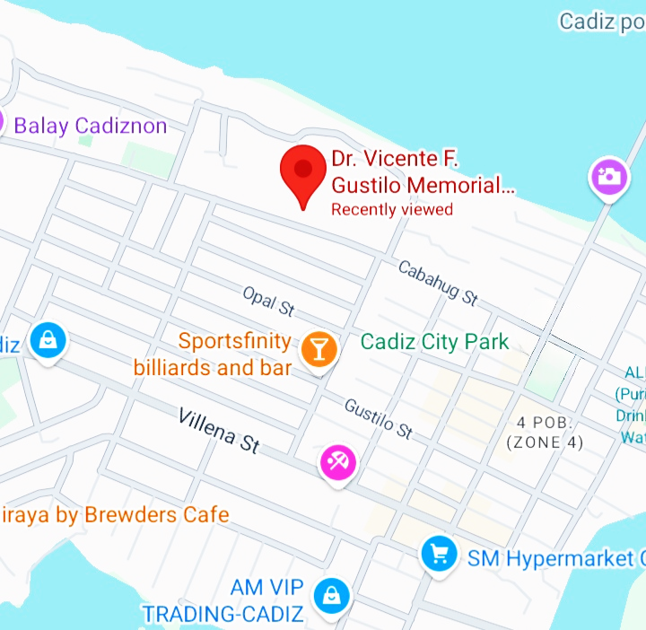The research was conducted at Dr. Vicente F. Gustilo Memorial National High School, located at Cabahug Street in Cadiz City, Negros Occidental, Philippines.

Figure 1: Map of Dr. Vicente F. Gustilo Memorial National High School



Figure 2: Front-view of Dr. Vicente F. Gustilo Memorial National High School

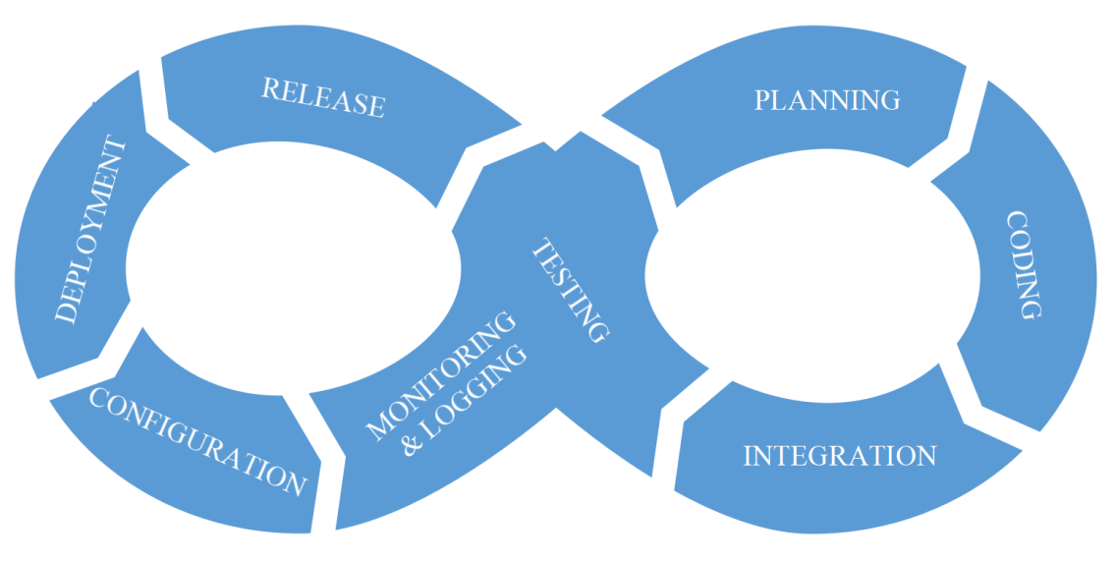**Theoretical Framework**

Figure 3: DevOps of Theoretical Framework

The Integrated Educational Resources Platform adopted the DevOps methodology to optimize system operations and improve user satisfaction. The process began with gathering users' requirements, which guided actions such as searching and managing resources. These requirements triggered continuous development cycles, including design, integration, and testing, ensuring that the system met users' needs. User feedback played a critical role in refining the system, allowing for adjustments and improvements based on real-world usage and technological advancements. By incorporating DevOps, the system rapidly responded to evolving user demands, ensuring a competent and flexible Integrated Educational Resources Platform that remained aligned with both user expectations and technological trends.

**Planning**

The project began with the Planning stage, where the Project Manager gathered requirements, set clear goals, and defined the project scope to ensure the development team aligned with the objectives and delivered the expected outcomes.

**Coding**

In the Coding phase, Front-End Developers focused on designing a user-friendly interface, while Back-End Developers built the server-side components, databases, and application logic to support the library's functionalities.

**Integration**

This was followed by Integration, where Front-End and Back-End Programmers frequently integrated their code into a shared repository, using automated tests to ensure new changes did not disrupt the existing system.

**Testing**

During Testing, Quality Assurance (QA) teams, along with the developers, performed rigorous automated testing to minimize defects and ensure the delivery of high-quality code.

**Release**

The Release phase involved the Project Manager and developers deploying the system to the production environment, ensuring a smooth and disruption-free transition for users.

**Deployment**

Next, Deployment automated the process of pushing updates to the live environment, handled by both Front-End and Back-End Programmers, enabling seamless and rapid deployment cycles.

**Configuration**

In Configuration, Hardware Technicians and Back-End Programmers carefully managed system configurations and infrastructure to prevent errors caused by misconfigurations.

**Monitoring & Logging**

Finally, the Monitoring & Logging stage involved Hardware Technicians and the Project Manager actively monitoring the system’s performance and logging issues to ensure prompt resolution and maintain system stability.

**Use Case Diagram**

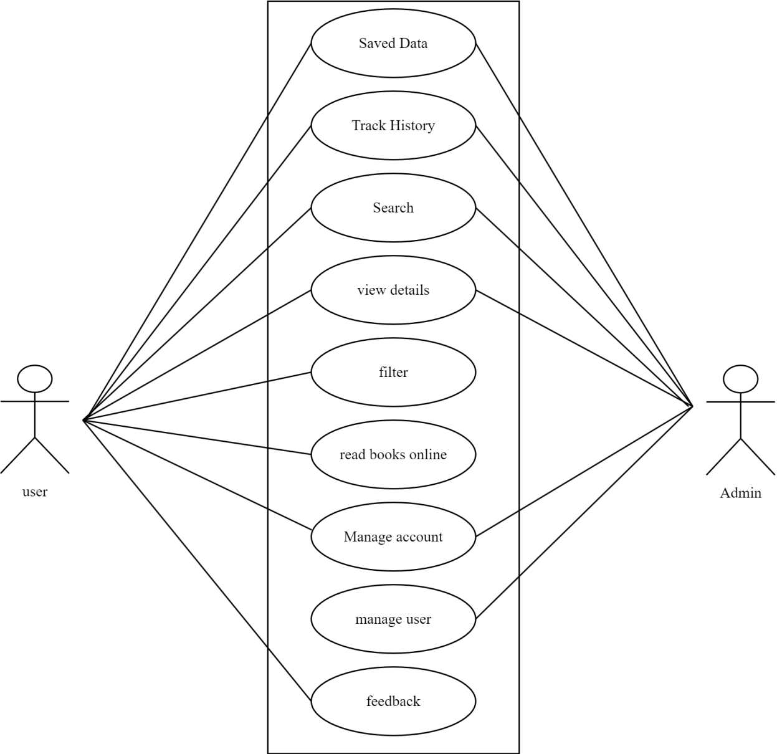

Figure 4: Use Case Diagram of Integrated Educational Resources Platform

**Requirement Costs**

|  |  |  |
| --- | --- | --- |
| **Description** | **Admin** | **User** |
| 1. **HARDWARE REQUIREMENTS** | | |
| * Desktop (Intel i5 11th gen, 8gb RAM, 256 GB SSD/HDD or higher) | ₱ 20,000 |  |
| * Keyboard (A4tech wired keyboard) | ₱ 300 |  |
| * Mouse (A4Tech USB optical mouse) | ₱ 250 |  |

Table 2: Hardware Requirements of Integrated Educational Resources Platform

|  |  |  |
| --- | --- | --- |
| 1. **SOFTWARE REQUIREMENTS** | | |
| * Operating System (Windows 10 Home or higher) | ₱ 10,000 |  |
| * Database Software (MySQL version 8.0.40) |  |  |
| * Version Control System (Github) |  |  |
| * IDE (Visual Studio Code) |  |  |
| * Front-end (React.js with vite) |  |  |
| * Back-end (PHP with laravel) |  |  |

Table 3: Software Requirements of Integrated Educational Resources Platform

|  |  |  |
| --- | --- | --- |
| 1. **NETWORK REQUIREMENTS** | | |
| * High-Speed Internet (25mbps or higher) monthly | ₱ 1,500 |  |
| * LAN Setup (Ethernet cabling and installation Category 6 Ethernet cable (10m), RJ45) | ₱ 1,000 |  |

Table 4: Network Requirements of Integrated Educational Resources Platform

|  |  |  |
| --- | --- | --- |
| 1. **INTEGRATION REQUIREMENTS** | | |
| * APIs (Gutendex) |  |  |
| * APIs (Open Library) |  |  |
| * Cloud Services (AWS S3 for file storage) monthly | ₱ 160 |  |
| **TOTAL** | ₱ 33,210 |  |

Table 5: Integration Requirements of Integrated Educational Resources Platform

|  |
| --- |
|  |

**Labor Cost**

|  |  |
| --- | --- |
| **Peopleware** | **Cost** |
| * Programmer(Full Stack) | ₱40,000 |
| * Maintenance | ₱5,000 |
| * System Analyst | ₱20,000 |

Table 6: Labor Cost of Integrated Educational Resources Platform

**Gantt Chart**

Figure 5: Gantt Chart of Integrated Educational Resources Platform

**System Prototype**

**Figure 6: First page before the user logs in to the system**

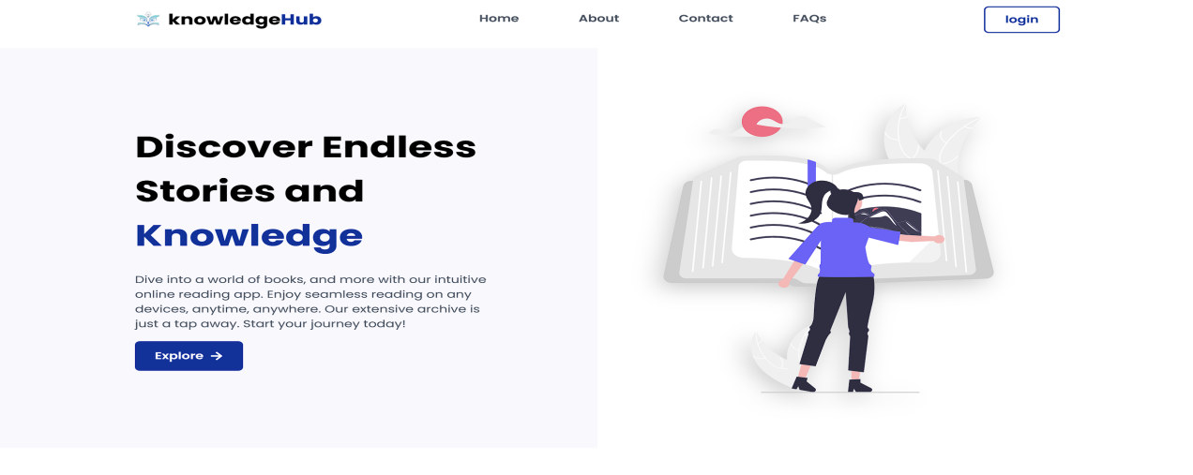

**Figure 7: Log in page with Sign up button at the right pane**

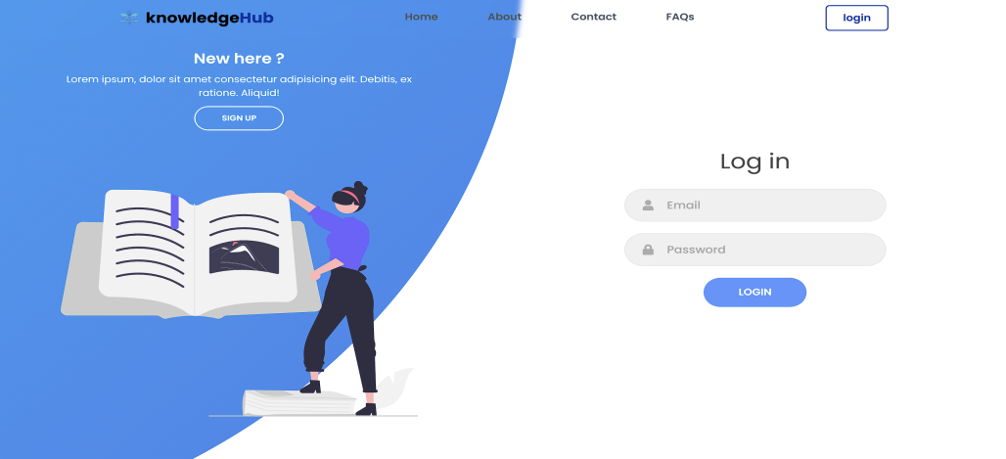

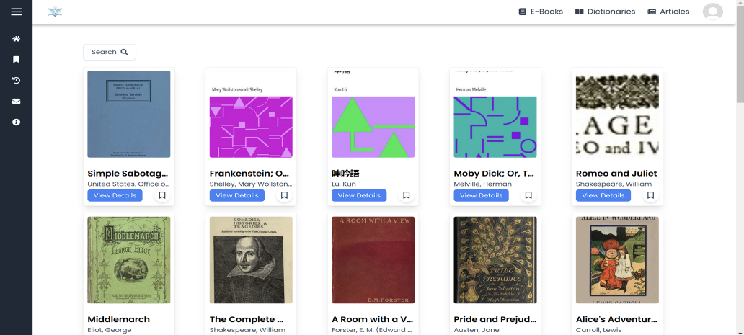**Figure 8: Homepage**

**Data Flow Diagram**

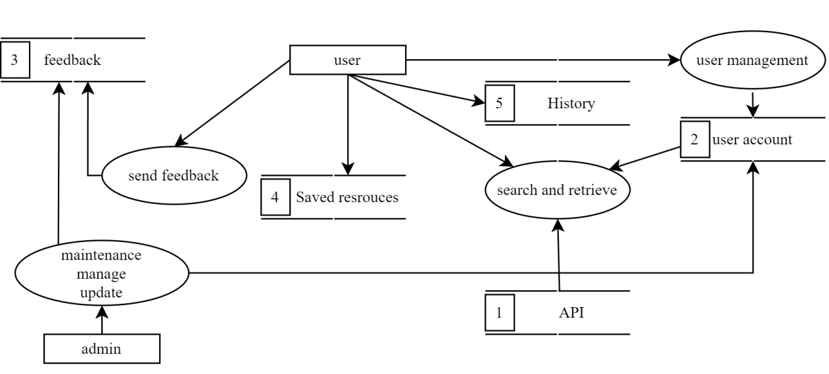

Figure 9: Data Flow Diagram of Integrated Educational Resources Platform

**Data Flow Diagram Level 0**

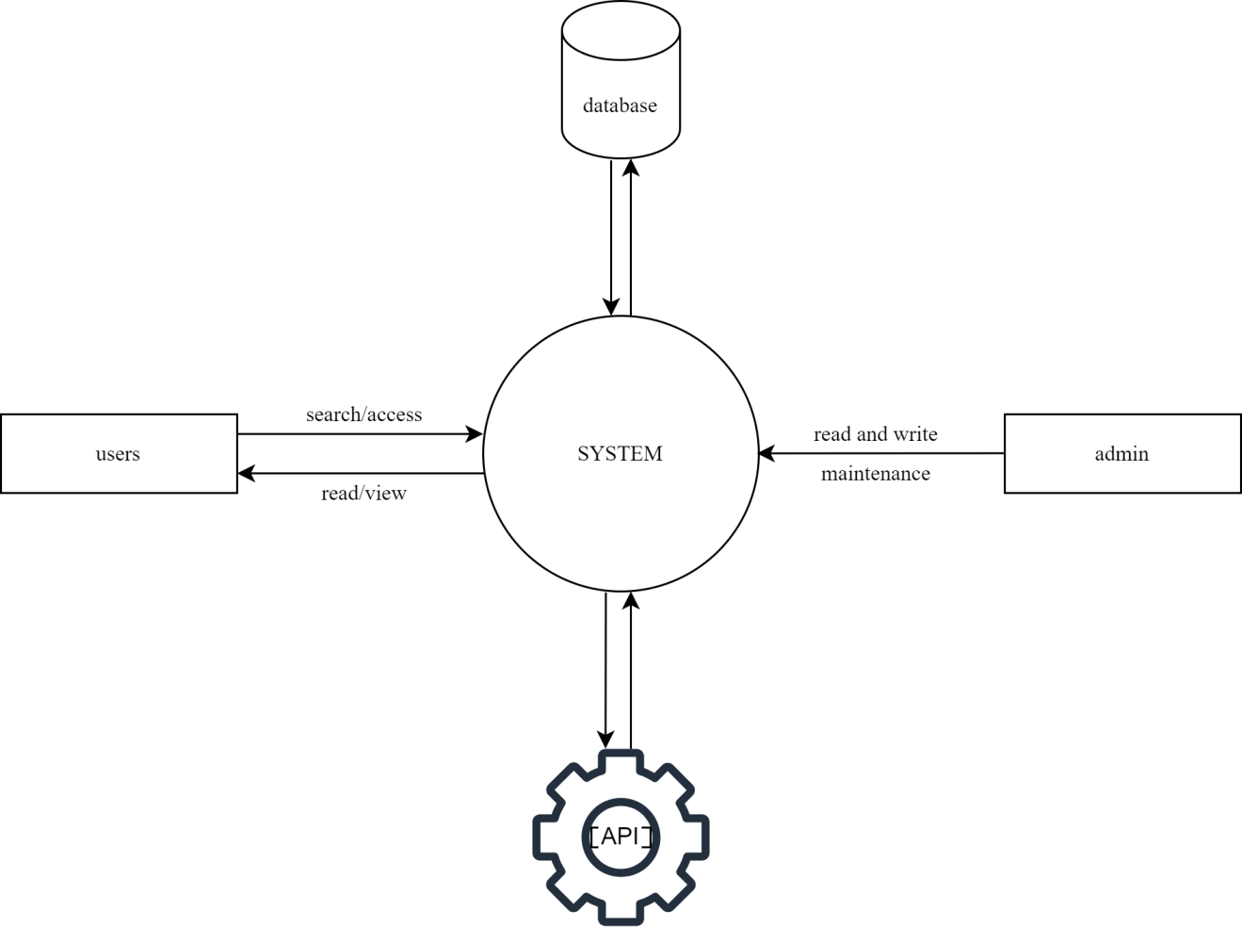

Figure 10: Data Flow Diagram Level 0

**ER Diagram**

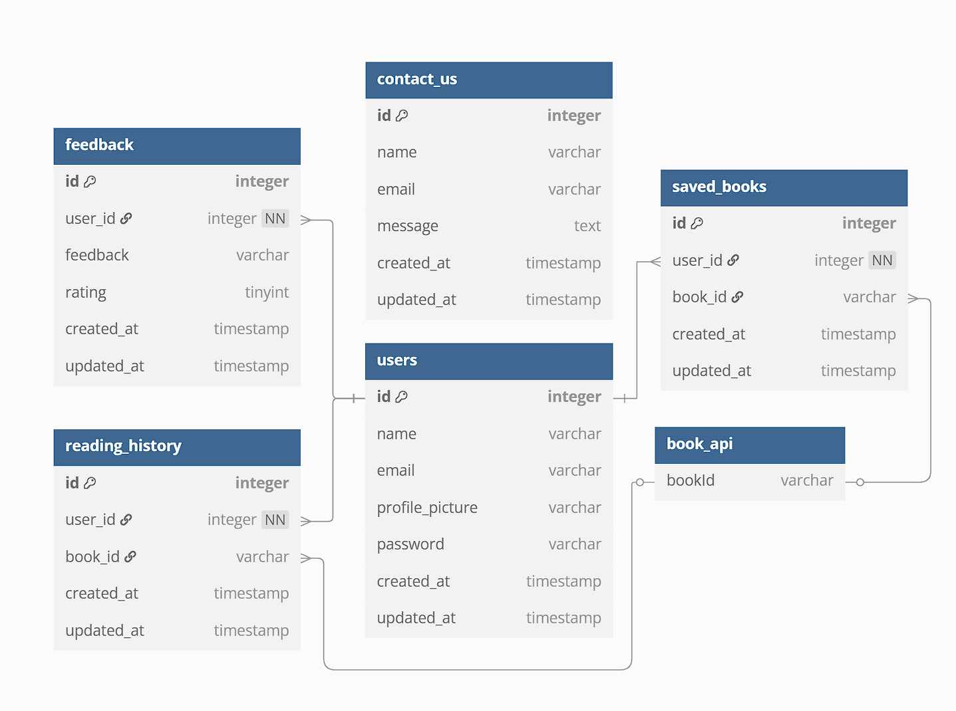

Figure 11: ER Diagram of Integrated Educational Resources Platform

**System Architecture**

The Integrated Educational Resources Platform architecture utilized a layered approach to improve functionality and user experience. It included personalized recommendations based on user behavior, advanced search filtering for efficient navigation, and bookmarking features for easy access to resources. Version control for content updates was also implemented to maintain accurate historical records, ensuring a reliable and engaging user experience.

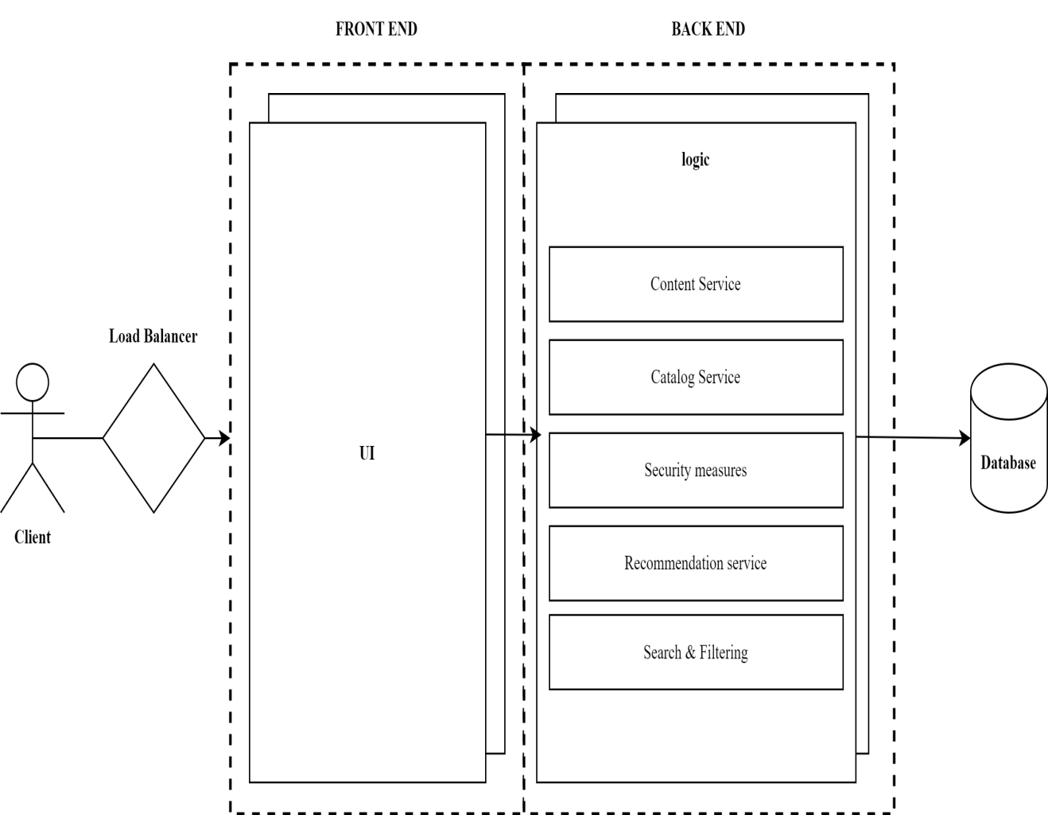

Figure 12: Layered Architecture

**Program Evaluation and Review Technique**

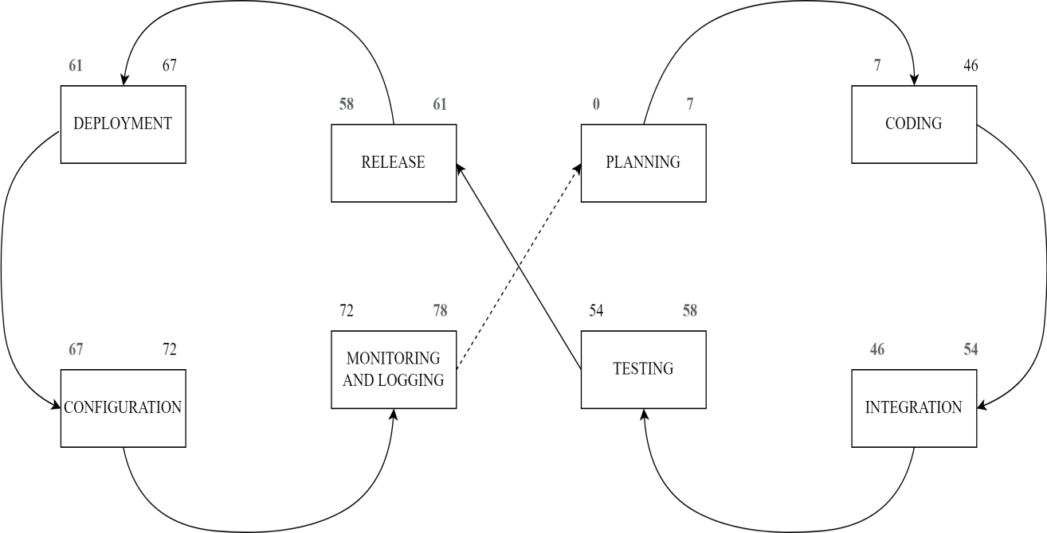  
Figure 13: PERT of Integrated Educational Resources Platform

**Critical Path Method**

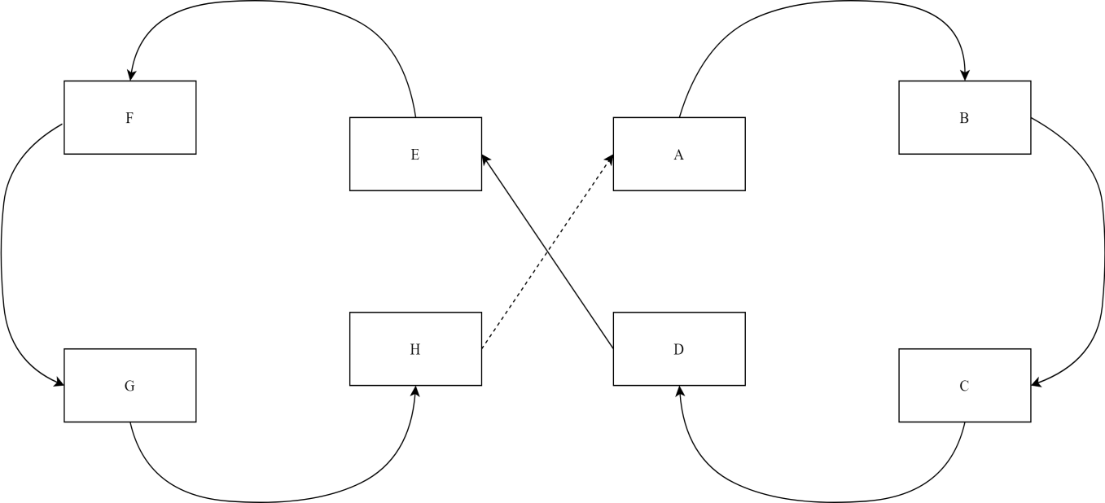

Figure 14: CPM of Integrated Educational Resources Platform

Total No. of Days: 78 days

Critical Path: A, B, C, D, E, F, G, H

**Cost-Benefit Analysis**

|  |  |  |  |  |  |  |  |  |
| --- | --- | --- | --- | --- | --- | --- | --- | --- |
| **Item** | **Year 0** | **Year 1** | **Year 2** | **Year 3** | **Year 4** | **Total Cost** | **Total Benefits** | **Net Benefit/Cost** |
| Development Cost | ₱63,470 | - | - | - |  | ₱63,470 | - |  |
| Operational Cost | - | ₱18,000 | ₱18,000 | ₱18,000 | ₱18,000 | ₱72,000 | - |  |
| Maintenance Cost | - | ₱6,920 | ₱6,920 | ₱6,920 | ₱6,920 | 27,680 | - |  |
| **TOTAL COST** | ₱63,470 | ₱24,920 | ₱24,920 | ₱24,920 | ₱24,920 | ₱163,150 | - |  |
| PV Factor (10%) | 1.000 | 0.909 | 0.826 | 0.751 | 0.683 |  | - | - |
| Present Value | ₱63,470 | ₱22,652 | ₱20,584 | ₱18,715 | ₱17,020 | ₱142,441 | - | - |
| **TOTAL BENEFITS** | - | ₱50,000 | ₱56,000 | ₱62,000 | ₱68,000 | - | ₱236,000 |  |
| PV Factor (10%) | 1.000 | 0.909 | 0.826 | 0.751 | 0.683 | - |  | - |
| Present Value | ₱0.00 | ₱45,450 | ₱46,256 | ₱46,562 | ₱46,444 |  | ₱184,712 |  |
| **Net Cash Flow** | ₱-63,470 | ₱22,798 | ₱25,672 | ₱27,847 | ₱29,424 | - | ₱42,271 | ₱42,271 |
| TOTAL | | | | | | ₱468,741 | ₱462,983 | ₱42,271 |

Table 7: Cost Benefit Analysis of Integrated Educational Resources Platform

**ROI**

Present Value Benefit ₱184,712.00

Present Value Cost ₱142,441.00

Formula for Calculating the ROI:

ROI%= PVb-PVc

X100

PVc

ROI%= Net Return

X100

PVc

ROI= 184,712 -142,441

X100

142,441

ROI= 42,271

X100

142,441

X100

ROI= 0.296761466

29.68%

Return of Investment=

**CHAPTER 3**

**PRESENTATION OF DATA**

A survey was conducted as part of the requirements-gathering phase for developing an Integrated Educational Resources Platform aimed at providing students with seamless access to academic resources such as e-books, articles, and dictionaries through a feature-rich web-based platform with advanced search, personalized accounts, and mobile access.

The survey was distributed to 15 respondents, consisting of 5 males (33.33%) and 10 females (66.67%).

The questions were designed following the ISO/IEC 9126 standard, and the responses were collected using a Likert scale with options: Strongly Agree, Agree, Neutral, Disagree, and Strongly Disagree.

**Figure 15. Survey Responses on Willingness to Use the Integrated Educational Resources Platform Upon Implementation**

As shown in the figure above, 93% of respondents agreed or strongly agreed that they would use the system, while 7% remained neutral. No respondents disagreed, indicating a strong interest in the system.

The projections suggested a strong overall interest in the Integrated Educational Resources Platform, indicating its potential success upon implementation.

**Figure 16. Survey Responses on the Advanced Search Functionality Meeting Research Needs**

**As shown in the figure above, 73% of respondents agreed or strongly agreed that the advanced search functionality would meet their research needs, with 27% neutral. No respondents disagreed, indicating general confidence in this feature.**

**The projections suggest strong potential for the advanced search functionality to meet users' research needs effectively.**

**Figure 17. Survey Responses on the Variety of Resources Meeting Academic Needs**

**As shown in the figure above, 80% of respondents agreed the system's resources will meet their academic needs, while 13% were neutral and 7% strongly disagreed.**

**The projections suggest the system will satisfy most users, though addressing concerns from a small minority could improve acceptance.**

**Figure 18. Survey Responses on the Integrated Educational Resources Platform Providing Relevant Academic Resources**

As shown in the figure above, 87% of respondents agreed or strongly agreed that the system provided relevant academic resources, while 13% remained neutral. No respondents disagreed, indicating strong confidence in the system's relevance to academic needs.

The projections suggested that the system would be well-received, with minimal concerns about its suitability for users' academic needs.

**Figure 19. Survey Responses on the Integrated Educational Resources Platform Supporting Independent Research Effectively**

As shown in the figure above, 74% of respondents agreed or strongly agreed that the system supported independent research, while 27% remained neutral. No respondents disagreed, indicating confidence in its effectiveness.

The projections suggested that the system was effective for research, with minor improvements needed to address uncertainty.

### Figure 20. Survey Responses on the Integrated Educational Resources Platform Being Easy to Access

As shown in the figure above, all respondents (15 out of 15, or 100%) agreed that the Integrated Educational Resources Platform was easy to access. This included 7 respondents (47%) who agreed and 8 respondents (53%) who strongly agreed. No participants selected neutral, disagreed, or strongly disagreed.

The projections suggested that the system's ease of access was widely appreciated, with no concerns raised about its accessibility among the respondents.

**Figure 21. Survey Responses on the Personalized User Account Feature Helping Save and Locate Resources Effectively**

As shown in the figure above, 67% of respondents agreed or strongly agreed that the personalized user account feature helped them save and locate resources effectively, while 27% remained neutral and 7% disagreed.

The projections suggested that most users found this feature useful, but addressing concerns from the neutral or disagreeing respondents could have improved its acceptance.

**Figure 22. Survey Responses on the System's Mobile Accessibility for Convenient Access on the Go**

As shown in the figure above, 73% of respondents agreed or strongly agreed that the system's mobile accessibility allowed convenient access on the go, while 20% remained neutral and 7% disagreed.

The projections suggested that mobile accessibility was valued, though addressing some uncertainty could have enhanced user satisfaction.

**Figure 23. Survey Responses on the User Interface Design Being Clear and Easy to Use**

As shown in the figure above, 100% of respondents expected the system's user interface to be clear and easy to use, with 80% agreeing and 20% strongly agreeing. No respondents disagreed or expressed concerns.

The projections suggested that the system's user interface was highly regarded for its clarity and ease of use, with no concerns raised about its usability.

**Figure 24. Survey Responses on the Integrated Educational Resources Platform Reducing Challenges Associated with Traditional Resources**

As shown in the figure above, 93% of respondents believed that the digital library system reduced challenges associated with resources, with 33% agreeing and 20% strongly agreeing. Meanwhile, 40% remained neutral, and 7% disagreed.

The projections suggested that the system was viewed as an effective solution to these challenges, although addressing the concerns of a few respondents could have enhanced its perceived effectiveness.

**Figure 25. Survey Responses on the Effectiveness of Search Filters in Narrowing Down Resource Results**

As shown in the figure above, 80% of respondents expected the search filters to effectively narrow down resource results, with 47% agreeing and 33% strongly agreeing. Meanwhile, 20% remained neutral, and no one disagreed.

The projections suggested that the filters were effective, though addressing some uncertainty could have improved their perceived usefulness.

**Figure 26. Survey Responses on the Expectation of Fast Speed and Response Times in the Integrated Educational Resources Platform**

As shown in the figure above, 87% of respondents expected the Integrated Educational Resources Platform to have fast speed and response times, with 67% agreeing and 20% strongly agreeing. Meanwhile, 13% remained neutral, and no one disagreed.

The projections suggested that users expected efficient performance, though addressing some uncertainty could have boosted confidence in its speed.

**Figure 27. Survey Responses on the Expectation of Real-Time Catalog Updates for Accessing Latest Educational Materials**

As shown in the figure above, 80% of respondents expected real-time catalog updates to help access the latest educational materials, with 60% agreeing and 20% strongly agreeing. Meanwhile, 20% remained neutral, and no one disagreed.

The projections suggested that real-time updates were seen as a valuable feature, though addressing some uncertainty could have further improved confidence in its effectiveness.

**Figure 28. Survey Responses on the Expectation of Reliable Performance in the Integrated Educational Resources Platform**

As shown in the figure above, 80% of respondents expected the Integrated Educational Resources Platform to perform reliably, with 67% agreeing and 13% strongly agreeing. Meanwhile, 13% remained neutral, and 7% disagreed.

The projections suggested that the system was expected to deliver a stable user experience, though addressing concerns from neutral or disagreeing respondents could have improved its perceived reliability.

**Figure 29. Survey Responses on the Expectation of Integrated Educational Resources Platform Accessibility from Various Devices and Platforms**

As shown in the figure above, 80% of respondents expected the system to be accessible across devices, with 53% strongly agreeing and 27% agreeing.

The projections indicated strong confidence in its cross-platform compatibility, though addressing the uncertainty of a few respondents could have further enhanced this perception.

**Recommendation**

For the Capstone Project entitled Integrated Educational Resources Platform, it was recommended to prioritize a user-friendly platform design that appealed to users by ensuring simplicity and ease of navigation. The platform’s ability to save time and enhance its appeal was highlighted. The search feature needed to include effective filters, enabling users to quickly locate resources. A broad and diverse range of materials had to be provided, with regular updates to meet the evolving needs of users.

Incorporating features such as saving articles, bookmarking, and easy access to saved resources significantly enhanced the research experience. The system supported efficient login processes and was optimized for use across various devices, ensuring accessibility and convenience. Additionally, features like saving search results for future reference contributed to a seamless and efficient user experience.

To improve usability, the system was designed to be fully functional on smartphones and tablets, with intuitive navigation and optimized reading options. A clean and simple interface design was essential to facilitate quick access to resources while emphasizing the advantages of 24/7 availability as a modern solution to traditional library challenges. The search functionality included easy-to-use filters, allowing users to sort by resource type, date, or topic.

Lastly, it was vital to ensure the system operated quickly and smoothly, minimizing loading times or lag while incorporating real-time updates to provide students with fresh and relevant content. Technical stability and compatibility with various devices and platforms were crucial to guaranteeing uninterrupted service, allowing students to access the system from anywhere at any time.

**CHAPTER 4**

**CONCLUSION AND RECOMMENDATIONS**

Access to Integrated Educational Resources Platform is essential for students’ academic success, yet many in the Philippines face challenges such as distance, high costs and limited library hours. To address these issues, the Integrated Educational Resources Platform was developed as a web-based platform to provide students with convenient and accessible academic resources, including e-books, dictionaries, article. This system enhances learning by offering advanced search functionality, personalized user accounts, mobile accessibility, and real-time catalog updates. These features enable users to efficiently locate and access up-to-date materials tailored to their academic needs anytime, anywhere, promoting independent research and a seamless learning experience.

**CONCLUSION**

The Integrated Educational Resources Platform was developed to address challenges in accessing academic materials, particularly in the Philippines. By offering a web-based solution, students were provided with a more convenient and accessible way to retrieve essential learning resources such as e-books, dictionaries, and articles.

The survey results supported the platform’s objectives, with 80% of respondents agreeing that the available resources met their academic needs. Furthermore, 73% of users found the advanced search functionality useful, and 67% believed that personalized accounts improved their ability to manage resources. The inclusion of real-time catalog updates ensured students had access to the latest educational materials, reinforcing the effectiveness of the centralized digital catalog.

These findings confirmed that the project’s emphasis on resource variety, user-friendly features, and continuous updates made the platform a valuable academic tool, supporting students in their learning and research activities.

**RECOMMENDATION**

Based on the study’s findings, several strategic recommendations were proposed to optimize the Integrated Educational Resources Platform for various stakeholders:

* **For Students:** The platform should continue providing seamless access to e-books, dictionaries, and articles, with enhanced search tools, personalized accounts, saved resources, and a 24/7 availability feature. These functionalities improve academic efficiency and research capabilities.
* **For Administrative Staff:** Automating tasks such as user interactions and catalog updates should be prioritized to reduce workloads and enhance operational efficiency.
* **For Researchers:** Advanced search functionalities and a comprehensive catalog should be continuously improved to support specialized research needs.
* **For Educational Institutions:** The adoption of the platform should be promoted as a modern tool for academic advancement, reinforcing the institution’s reputation and competitiveness in the education sector.

To further improve the user experience, the following enhancements should be considered: **User Interface Improvements:** Ensuring a clean, intuitive, and easy-to-navigate design. **Mobile Compatibility:** Optimizing the system for use across smartphones and tablets. **Enhanced Search Features:** Implementing more advanced filters, such as sorting by topic, date, or resource type. **Performance Optimization:** Reducing loading times and lag while incorporating real-time updates for the most current content. **Technical Stability:** Ensuring the platform remains functional across various devices and networks.By addressing these recommendations, the Integrated Educational Resources Platform would continue to evolve as an innovative, reliable, and essential academic tool for students, researchers, and institutions.

**References**

* Aloc, Viela Rose R., Bustamante, Rose-Anne V., Calong, Carl Lorenz I., Remoroza, Juneto Marco P., & Talaman, Eduardo M. (2023). *Enhanced Online Library Management System: Its Impact on Students’ Learning Experience and Academic Performance in Inquires, Investigation, And Immersion.*Galaxy International Interdisciplinary Research Journal, 11(6), 512–525.  
  Retrieved From: <https://giirj.com/index.php/giirj/article/view/5476>  
  Date Accessed: September 12, 2024
* Chanda, A. (2021). *Importance of Digital Library in Academic Institutions*. Journal of Intellectuals, 1(1), 11-20.  
  Retrieved From: <https://www.researchgate.net/profile/Dr-Chanda->2/publication/366500136_Importance_of_Digital_Library_in_Academic_Institutions/links/63a42661c3c99660eb958fa6/Importance-of-Digital-Library-in-Academic-Institutions.pdf  
  Date Accessed: September 10, 2024 (Tuesday)
* De Leon, L. R., Lagao, S., Lobo, M. D., Santiago, G. M. & Sigaya, G. R. (2023). Usability Assessment of the UST Miguel de Benavides Digital Library. PAARL Research Journal, 9(1 - Special Anniversary Issue), 45-62.   
  Retrieved From: https://actamedicaphilippina.upm.edu.ph/index.php/acta/article/view/ 9520

Date Accessed: September 13, 2024(Fri)

* Khan, R. (2021). Importance of educational resources platform. International Journal of Research in Library Science, 7(4), 102-117.  
  Retrieved From: https://scholar.google.com/scholar?hl=en&as_sdt=0%2C5&q=Khan%2C+R.+%282021%29.+Importance+of+digital+library+in+education.+International+Journal+of+Research+in+Library+Science%2C+7%284%29%2C+102117.&btnG=#d=gs_qabs&t=1726712342691&u=%23p%3DMiI5rkYn4DwJ   
  Date Accessed: September 9, 2024 (Mon)
* Lagas, S., & Isip, J. (2023). Challenges to Educational resources in Philippine Academic Libraries. Philippine Journal of Librarianship and Information Studies, 43(1), 27-38.   
  Retrieved From: <https://scholar.google.com/scholar?hl=en&as_sdt=0%2C5&q=digital+library+system+in+the+Philippines+&btnG=#d=gs_qabs&t=1727440936915&u=%23p%3DO4PeAlyXZ-EJ>Date Accessed: September 23,2024(Mon)
* Lasig, C. A. (2024). *Students' Awareness and Use of the Online Public Access Catalog (OPAC) at the Central Luzon State University Library in the Philippines.* International Journal of Information Science & Management, 22(2).  
  Retrieved From: [https://doi**.**org/10.22034/ijism.2024.1977926.0](https://doi.org/10.22034/ijism.2024.1977926.0)  
  Date Accessed: September 23, 2024(Mon)
* **Misra, P., Chopra, G., & Bhaskar, P. (**2023). *Continuous usage intention for Integrated educational resources platform among students at higher learning institutions: Moderating role of academic involvement*. Journal of Applied Research in Higher Education, 15*(5), 1752-1766.*Retrieved From: <https://doi.org/10.1108/JARHE-06-2022-0185>  
  Date Accessed: September 8, 2024 (Sun)
* Obsanga, A.P., & Enierga, R.R. (2021). Automated Library Management System for Public Libraries in the Philippines. Library Hi Tech News, 38(5), 24-29.  
  Retrieved From: https://doi.org/10.1108/LHTN-10-2021-0072   
  Date Accessed: September 22, 2024(Sun)
* Perdana, I. A., & Prasojo, L. D. (2020, February). *Integrated educational resources platform Practice in University: advantages, challenges, and its position.* In International Conference on Educational Research and Innovation (ICERI 2019) (pp. 44-48). Atlantis Press.  
  Retrieved From: <https://www.atlantis-press.com/proceedings/iceri-19/125934015>  
  Date Accessed: September 11, 2024 (Wednesday)
* **Shevchenko, L.** (2020). *Analysis of library website users’ behaviour to optimize virtual information and library services*. Journal of Information Science Theory and Practice, 8*(1), 45-55.*Retrieved From*:* <https://doi.org/10.1633/JISTaP.2020.8.1.4>  
  Date Accessed: September 8, 2024 (Sun)

APPENDICES

APPENDIX A

January 25, 2025

CEDAR College, Inc.

National Highway Cadiz City, Negros Occidental

**PERMISSION LETTER**

Dear Mr. Palma ,

We are Laurence Marie S. Tigres, Allios Kyle M. Miscala, and Daphnie M. Dolleno, a group of Bachelor of Science in Information Technology students from CEDAR College Inc., currently working on Integrated Educational Resources Platform . This system is a web-based platform designed to improve access to academic resources, such as e-books, dictionaries, and articles. It includes features like advanced search functionality, personalized accounts, mobile accessibility, and real-time catalog updates.

We are writing to request your permission to conduct a system testing session with you as a professional in the IT industry. Your expertise and feedback would be invaluable in evaluating the system’s usability, performance, and overall functionality, ensuring it meets industry standards and user expectations.

The testing session is scheduled for January 25, 2025, from 10 am to 12 pm, and will take 30 minute to 1 hour. During the session, our team will guide through the system prototype and gather your insights to enhance its design and features.

We assure you that all feedback and information gathered will be used solely for academic purposes.

Your participation in this activity would significantly contribute to the success of our project. Please let us know if the proposed schedule works for you or if adjustments are needed. You may contact us at [miscalakyle64@gmail.com/](mailto:miscalakyle64@gmail.com/)[daphnie639@gmail.com](mailto:daphnie639@gmail.com)[/laurencemtigres@gmail.com](mailto:/laurencemtigres@gmail.com) for further clarifications or additional information.

Thank you for considering our request we look forward to your positive response.

Sincerely,

THE PROJECT TEAM

|  |  |  |
| --- | --- | --- |
| Daphnie M. Dolleno [daphnie639@gmail.com](mailto:daphnie639@gmail.com)  09515041303 | Allios Kyle M. Miscala [miscalakyle64@gmail.com](mailto:miscalakyle64@gmail.com)  09367377946 | Laurence Marie Tigres [laurencemtigres@gmail.com](mailto:laurencemtigres@gmail.com)  09917578294 |

Rio John C. Palma

Officer

Approved by: JOHN DAVE BARILEA

IT Instructor

\

January 25, 2025

CEDAR College, Inc.

National Highway Cadiz City, Negros Occidental

**PERMISSION LETTER**

Dear Mr. Valdez,

We are Laurence Marie S. Tigres, Allios Kyle M. Miscala, and Daphnie M. Dolleno, a group of Bachelor of Science in Information Technology students from CEDAR College Inc., currently working on Integrated Educational Resources Platform . This system is a web-based platform designed to improve access to academic resources, such as e-books, dictionaries, and articles. It includes features like advanced search functionality, personalized accounts, mobile accessibility, and real-time catalog updates.

We are writing to request your permission to conduct a system testing session with you as a professional in the IT industry. Your expertise and feedback would be invaluable in evaluating the system’s usability, performance, and overall functionality, ensuring it meets industry standards and user expectations.

The testing session is scheduled for January 25, 2025, from 10 am to 12 pm, and will take 30 minute to 1 hour. During the session, our team will guide through the system prototype and gather your insights to enhance its design and features.

We assure you that all feedback and information gathered will be used solely for academic purposes.

Your participation in this activity would significantly contribute to the success of our project. Please let us know if the proposed schedule works for you or if adjustments are needed. You may contact us at [miscalakyle64@gmail.com/](mailto:miscalakyle64@gmail.com/)[daphnie639@gmail.com](mailto:daphnie639@gmail.com)[/laurencemtigres@gmail.com](mailto:/laurencemtigres@gmail.com) for further clarifications or additional information.

Thank you for considering our request we look forward to your positive response.

Sincerely,

THE PROJECT TEAM

|  |  |  |
| --- | --- | --- |
| Daphnie M. Dolleno [daphnie639@gmail.com](mailto:daphnie639@gmail.com)  09515041303 | Allios Kyle M. Miscala [miscalakyle64@gmail.com](mailto:miscalakyle64@gmail.com)  09367377946 | Laurence Marie Tigres [laurencemtigres@gmail.com](mailto:laurencemtigres@gmail.com)  09917578294 |

Billy Ray Q. Valdez

HR Officer

Approved by: JOHN DAVE BARILEA

IT Instructor

January 25, 2025

CEDAR College, Inc.

National Highway Cadiz City, Negros Occidental

**PERMISSION LETTER**

Dear Mr. Bato,

We are Laurence Marie S. Tigres, Allios Kyle M. Miscala, and Daphnie M. Dolleno, a group of Bachelor of Science in Information Technology students from CEDAR College Inc., currently working on Integrated Educational Resources Platform . This system is a web-based platform designed to improve access to academic resources, such as e-books, dictionaries, and articles. It includes features like advanced search functionality, personalized accounts, mobile accessibility, and real-time catalog updates.

We are writing to request your permission to conduct a system testing session with you as a professional in the IT industry. Your expertise and feedback would be invaluable in evaluating the system’s usability, performance, and overall functionality, ensuring it meets industry standards and user expectations.

The testing session is scheduled for January 25, 2025, from 10 am to 12 pm, and will take 30 minute to 1 hour. During the session, our team will guide through the system prototype and gather your insights to enhance its design and features.

We assure you that all feedback and information gathered will be used solely for academic purposes.

Your participation in this activity would significantly contribute to the success of our project. Please let us know if the proposed schedule works for you or if adjustments are needed. You may contact us at [miscalakyle64@gmail.com/](mailto:miscalakyle64@gmail.com/)[daphnie639@gmail.com](mailto:daphnie639@gmail.com)[/laurencemtigres@gmail.com](mailto:/laurencemtigres@gmail.com) for further clarifications or additional information.

Thank you for considering our request we look forward to your positive response.

Sincerely,

THE PROJECT TEAM

|  |  |  |
| --- | --- | --- |
| Daphnie M. Dolleno [daphnie639@gmail.com](mailto:daphnie639@gmail.com)  09515041303 | Allios Kyle M. Miscala [miscalakyle64@gmail.com](mailto:miscalakyle64@gmail.com)  09367377946 | Laurence Marie Tigres [laurencemtigres@gmail.com](mailto:laurencemtigres@gmail.com)  09917578294 |

ARVY JOHN BATO

IT Professor

Approved by: JOHN DAVE BARILEA

IT Instructor

November 19, 2024

Mr. Dindo M. Ampalla

Principal IV

Dr. Vicente F. Gustilo Memorial National High School

Cabahug Street, Cadiz City, Negros Occidental

Dear Mr. Ampalla,

We hope this letter finds you well. As part of our Capstone Project at CEDAR College, Inc., we are conducting a survey to gather insights regarding on integrated educational resources platform that provides students with easy access to academic resources like e-books, dictionaries and articles through a web-based platform. It features advanced search, personalized accounts, and mobile access, ensuring students can find the latest materials anytime, anywhere. Your participation in this survey would be highly valuable, as it will help us assess the usability, functionality, and effectiveness of the system.

The survey is scheduled to take place on November 19, 2024 at 9:30 AM. During this time, we will engage 15 selected respondents from your institution, who have been chosen to provide valuable insights.

Please be assured that all the information you provide will be kept confidential and used solely for the purposes of this research. Your responses will be anonymous and aggregated for analysis.

We kindly request your permission to participate in this survey, which will take approximately 20 minutes to complete. Participation is entirely voluntary, and you may withdraw at any time without consequence.

If you have any questions or concerns regarding the survey, please feel free to contact us at miscalakyle64@gmail.com/daphnie639@gmail.com/laurencemtigres@gmail.com.

We appreciate your time and cooperation. Thank you for helping us improve our project.

Sincerely;

THE PROJECT TEAM

|  |  |  |
| --- | --- | --- |
| Daphnie M. Dolleno [daphnie639@gmail.com](mailto:daphnie639@gmail.com)  09515041303 | Allios Kyle M. Miscala [miscalakyle64@gmail.com](mailto:miscalakyle64@gmail.com)  09367377946 | Laurence Marie Tigres [laurencemtigres@gmail.com](mailto:laurencemtigres@gmail.com)  09917578294 |

Approved by: DINDO M. AMPALLA

Principal IV

Approved by: DR. WILFREDO D. VILLANUEVA

School President

February 27, 2025

Mrs. Dee B. Grave

Education Program Supervisor II

Department of Education

Schools Division Office of Cadiz City

Dear Mrs. Grave,

We hope this letter finds you well. As part of our Capstone Project at CEDAR College, Inc., we are writing this to formally request your permission to review and certify the grammar and composition of our capstone project titled “AN INTEGRATED EDUCATIONAL RESOURCES PLATFORM” developed by Daphnie M. Dolleno, Allios Kyle M. Miscala, & Laurence Marie S. Tigres.

Your expertise in grammar and language structure will be invaluable in ensuring that our project meets the required academic and linguistic standards. We would greatly appreciate your time and effort in reviewing our work and providing certification of its correctness and coherence.

Kindly let us know your availability and any requirements needed for the review process. We truly appreciate your assistance and looking forward to your approval.

Sincerely;

THE PROJECT TEAM

|  |  |  |
| --- | --- | --- |
| Daphnie M. Dolleno [daphnie639@gmail.com](mailto:daphnie639@gmail.com)  09515041303 | Allios Kyle M. Miscala [miscalakyle64@gmail.com](mailto:miscalakyle64@gmail.com)  09367377946 | Laurence Marie Tigres [laurencemtigres@gmail.com](mailto:laurencemtigres@gmail.com)  09917578294 |

APPENDIX B



CEDAR College, Inc.

National Highway Cadiz City, Negros Occidental

**RATING SHEET**

Name of Respondent (Optional): _________________________________________________

Direction:

Read each question carefully and provide your response based on your organizations experiences and perceptions.

Answer each question to the best of your ability. Please indicate your level of agreement with the statement by selecting the corresponding number by placing a check mark on the box provided.

Your responses will be kept confidential and used for research purposes only.

If you have any questions or concerns about the questionnaire. Please free to contact us.

We appreciate your collaboration and insightful comments, which will enable us to better, understand the digital library system.

[Please proceed to answer the questionnaire below.]

|  |  |  |  |  |  |
| --- | --- | --- | --- | --- | --- |
|  | (5)  Excellent | (4)  Very Good | (3)  Good | (2)  Fair | (1)  Poor |
| ***Functionality*** | | | | | |
| 1. Does the system allow you to access e-books, dictionary & articles as intended? |  |  |  |  |  |
| 1. Does the system provide useful features such as bookmarking, save preferences & history? |  |  |  |  |  |
| ***Usability*** | | | | | |
| 1. Is the system user-friendly, with clear navigation and intuitive design? |  |  |  |  |  |
| 1. Can users easily search and filter content based on categories? |  |  |  |  |  |

|  |  |  |  |  |  |
| --- | --- | --- | --- | --- | --- |
| ***Reliability*** | | | | | |
| 1. Is the system stable & free of major bugs or crashes during use? |  |  |  |  |  |
| 1. Does the system recover quickly from failures or errors without losing data? |  |  |  |  |  |
| ***Performance*** | | | | | |
| 1. Does the system respond quickly to user actions, such as searches or loading content? |  |  |  |  |  |
| 1. Can the system handle multiple users accessing content simultaneously without slowdowns? |  |  |  |  |  |
| *Compatibility* | | | | | |
| 1. Does the system work seamlessly on various platforms and devices (e.g., PC, tablet, mobile)? |  |  |  |  |  |
| 1. Does the system maintain a consistent user experience across different browsers and operating systems? |  |  |  |  |  |
| *Security* | | | | | |
| 1. Are there sufficient safeguards in place to protect user data and privacy? |  |  |  |  |  |
| 1. Does the system encrypt sensitive data to prevent unauthorized access? |  |  |  |  |  |

Feedback Section:

* Comments:_________________________________________________________________
* Suggestions:________________________________________________________________

**CAPSTONE PROJECT**

**SURVEY QUESTIONNAIRE RATING SHEET**

Project Title: Survey Date:

Name (leave blank if anonymous):

Please rate each statement based on your level of preference using the scale provided. This feedback will help the development team understand the requirements and expectations for developing their IT Capstone Project.

Encircle

Rating Scale:

1 – Strongly Disagree

2 – Disagree

3 – Neutral

4 – Agree

5 – Strongly Agree

|  |  |  |  |  |  |
| --- | --- | --- | --- | --- | --- |
| **CLARITY / RELEVANCE OF SURVEY QUESTIONS** | | | | | |
| 1. The questions are clear and easy to understand. | **5** | **4** | **3** | **2** | **1** |
| 2. The questions are relevant to the goals of the requirements gathering. | **5** | **4** | **3** | **2** | **1** |
| 3. The questions avoid technical jargon or complex terminology. | **5** | **4** | **3** | **2** | **1** |
| 4. The survey flow is easy to follow. | **5** | **4** | **3** | **2** | **1** |
| 5. Each question directly relates to gathering project requirements. | **5** | **4** | **3** | **2** | **1** |
| **QUESTION VARIETY AND DEPTH** | | | | | |
| 1. The survey includes a good mix of  question types (such as: multiple choices, rating scales, open-ended questions). | **5** | **4** | **3** | **2** | **1** |
| 2. The survey covers all major aspects of the system requirements (such as functional and non-functional requirements). | **5** | **4** | **3** | **2** | **1** |
| 3. The questions explore the needs and  expectations of the users in detail. | **5** | **4** | **3** | **2** | **1** |
| 4. The survey includes questions that encourage useful feedback. | **5** | **4** | **3** | **2** | **1** |
| 5. The length of the survey is appropriate and not too long. | **5** | **4** | **3** | **2** | **1** |

|  |  |  |  |  |  |
| --- | --- | --- | --- | --- | --- |
| **ALIGNMENT WITH PROJECT GOALS** | | | | | |
| 1. The survey is aligned with the overall  objectives of the capstone project. | **5** | **4** | **3** | **2** | **1** |
| 2. The questions help identify the critical system requirements for development. | **5** | **4** | **3** | **2** | **1** |
| 3. The survey is effective in identifying the  needs and pain points of the end-user. | **5** | **4** | **3** | **2** | **1** |
| 4. The survey questions support gathering  non-functional requirements (such as  performance/security of the system) | **5** | **4** | **3** | **2** | **1** |
| 5. The survey facilitates gathering  information about the desired features. | **5** | **4** | **3** | **2** | **1** |
| **USER ENGAGEMENT AND ACCESSIBILITY** | | | | | |
| 1. The survey is user-friendly and engaging for participants. | **5** | **4** | **3** | **2** | **1** |
| 2. The language used in the survey is  understood by the participants. | **5** | **4** | **3** | **2** | **1** |
| 3. The survey encourages honest responses. | **5** | **4** | **3** | **2** | **1** |
| 4. The survey instructions are clear. | **5** | **4** | **3** | **2** | **1** |
| 5. The survey includes sufficient options for respondents to provide feedback. | **5** | **4** | **3** | **2** | **1** |
| **OVERALL EFFECTIVENESS AND SUGGESTIONS** | | | | | |
| 1. The survey, in terms of gathering the necessary requirements, is effective in general. | **5** | **4** | **3** | **2** | **1** |
| 2. The survey will likely yield or produce  good insights for the project team. | **5** | **4** | **3** | **2** | **1** |
| 3. The survey is able to freely obtain  suggestions for the participants. | **5** | **4** | **3** | **2** | **1** |

Average Score:

*(To compute for the* ***Average Score****, add all the values encircled, and then divide the sum by 23.)*

Additional Comments (*thoughts on how to improve the survey questionnaire*): _______________________________________________________________________________________

APPENDIX C



CEDAR College, Inc.

National Highway Cadiz City, Negros Occidental

**RESEARCH INSTRUMENT EVALUATION FORM**

Name of Respondent (Optional): _________________________________________________

Direction:

Read each question carefully and provide your response based on your organizations experiences and perceptions.

Answer each question to the best of your ability. Please indicate your level of agreement with the statement by selecting the corresponding number by placing a check mark on the box provided.

Your responses will be kept confidential and used for research purposes only.

If you have any questions or concerns about the questionnaire. Please free to contact us.

We appreciate your collaboration and insightful comments, which will enable us to better, understand the integrated educational resources platform.

[Please proceed to answer the questionnaire below.]

|  |  |  |  |  |  |
| --- | --- | --- | --- | --- | --- |
|  | (5)  Excellent | (4)  Very Good | (3)  Good | (2)  Fair | (1)  Poor |
| ***Functionality*** | | | | | |
| 1. I will use the integrated educational resources platform once it is implemented. |  |  |  |  |  |
| 1. The advanced search functionality of the integrated educational resources platform will meet my research needs. |  |  |  |  |  |
| 1. The variety of resources (e-books, dictionaries and articles) expected in the system will meet my academic needs. |  |  |  |  |  |
| 1. The integrated educational resources platform will provide resources relevant to my specific academic needs. |  |  |  |  |  |

|  |  |  |  |  |  |
| --- | --- | --- | --- | --- | --- |
| 1. The integrated educational resources platform is expected to support my independent research effectively. |  |  |  |  |  |

|  |  |  |  |  |  |
| --- | --- | --- | --- | --- | --- |
| ***Usability*** | | | | | |
| 1. The integrated educational resources platform is expected to be easy to access and navigate. |  |  |  |  |  |
| 1. The personalized user account feature of the system will help me save and locate resources effectively. |  |  |  |  |  |
| 1. I expect the system’s mobile accessibility will allow me to access resources conveniently on the go. |  |  |  |  |  |
| 1. The user interface design of the integrated educational resources platform is expected to be clear and easy to use. |  |  |  |  |  |
| 1. The integrated educational resources platform is expected to reduce challenges associated with traditional libraries (e.g., distance, limited hours). |  |  |  |  |  |
| 1. I expect the search filters in the system will help narrow down resource results effectively. |  |  |  |  |  |
| ***Reliability*** | | | | | |
| 1. I expect the integrated educational resources platform to have fast speed and response time. |  |  |  |  |  |
| 1. I expect real-time catalog updates will help in accessing the latest educational materials. |  |  |  |  |  |
| 1. I expect the integrated educational resources platform to perform reliably (e.g., uptime, technical stability) |  |  |  |  |  |
| ***Portability*** | | | | | |
| 1. I expect the integrated educational resources platform to be accessible from various devices and platform. |  |  |  |  |  |

**APPENDIX D**

CEDAR College, Inc.

National Highway Cadiz City, Negros Occidental

GRAMMARIAN CERTIFICATE

This is to certify that undersigned has viewed and went through all the pages of the Capstone Project titled **“AN INTEGRATED EDUCATIONAL RESOURCES PLATFORM”** developed by **DAPHNIE M. DOLLENO, ALLIOS KYLE M. MISCALA, LAURENCE MARIE S. TIGRES** aligned with the set of structural rules that govern the composition of sentences, phrases and words in the English Language.

Signed this 27th day of February, 2025 at Cadiz City Negros Occidental

**DEE B. GRAVE**

Grammarian

**APPENDIX E**

**Source Code**

Back-end Source Code

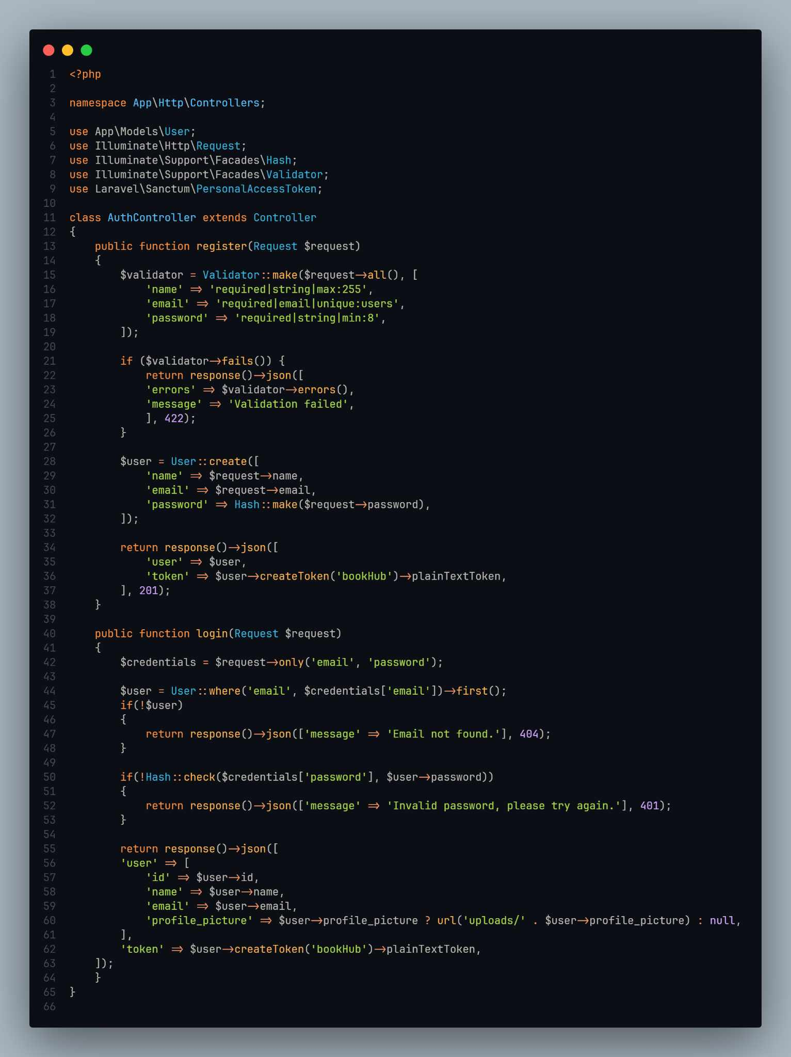

Front-end Source Code

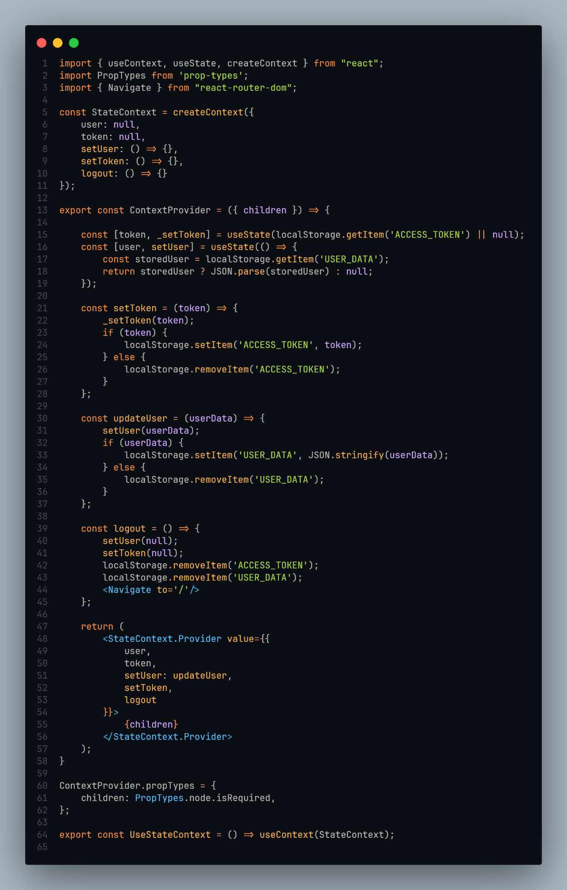

Front-End Source Code

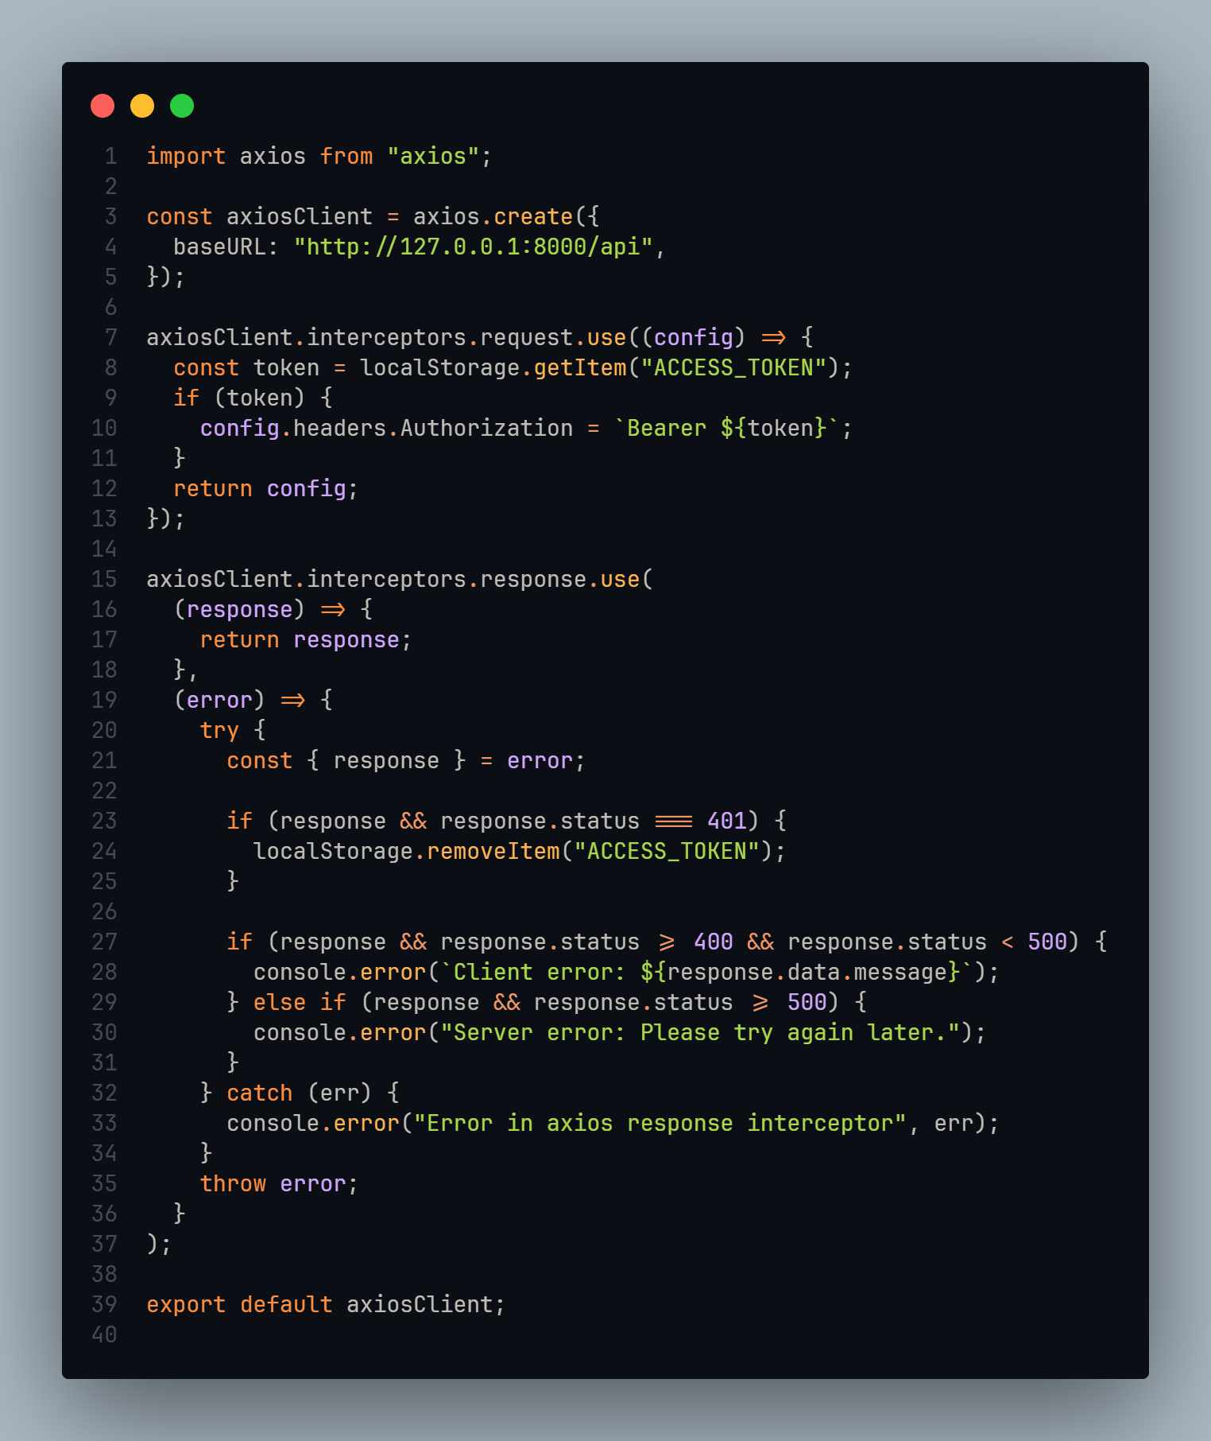

**Appendix F**

**User Manual**

**AN INTEGRATED EDUCATIONAL RESOURCES PLATFORM**

**Version 1.0**



Daphnie M. Dolleno

Allios Kyle M. Miscala

Laurence Marie S. Tigres

March 2025

**KNOWLEDGEHUB SYSTEM USER MANUAL**

**INTRODUCTION**

KnowledgeHub is a web-based application designed to provide easy access to educational resources. It includes features such as search, save, and tracking to help users efficiently find and manage materials through a user-friendly interface.

**SYSTEM REQUIREMENTS**

1. Hardware Requirements

* Minimum 4GB RAM (Recommended: 8GB+)
* Dual-core processor (i3 or equivalent)
* At least 10GB free disk space

1. Software Requirements

* Web browser (Chrome, Firefox, Edge)
* Internet connection
* Operating System: Windows, macOS, Linux

**GETTING STARTED**

Installation & Registration

* Open a web browser and go to [knowledgehub.com]
* Click Sign Up to create an account
* Verify your email and log in

**USER INTERFACE WALKTHROUGH**

* Landing Page – Overview of website and authentication
* Homepage – Displays educational resources
* Navigation Bar – Access E-books, articles, and dictionary
* Saved Items – View and manage bookmarked resources
* Track History – Review previously accessed content

**SYSTEM FEATURES & USAGE**

Common Use Cases

Use Case 1: Searching for an Article

* Log in
* Type keywords in the search bar
* Click on a result to read or save it

Use Case 2: Saving a Resource

* Click the bookmark icon on an article or e-book
* Access saved items later from the Saved Items section

Use Case 3: Tracking History

* Open History to view recently accessed content
* Click any entry to revisit the resource

**TROUBLESHOOTING & FAQs**

Q: I forgot my password. What should I do?

A: Click Forgot Password on the login page and follow the reset instructions.

Q: Why can’t I find a specific resource?

A: Try refining your search terms or adjusting filters.

Q: The system is slow. How can I fix it?

A: Ensure a stable internet connection and clear your browser cache.

**DATA SECURITY & BACKUP**

* Data Storage & Encryption – User data is securely stored and encrypted
* Backup & Restore Procedures – Regular backups ensure data integrity

**CONTACT & SUPPORT INFORMATION**

For assistance, contact miscalakyle64@gmail.com or visit the Help Center on our website.

**APPENDIX G**

**Curriculum Vitae**



Full Name: Dolleno, Daphnie M.

Position/Role: Hardware Technician

Age: 22

Gender: Female

Date of Birth: December 1, 2002

Place of Birth: Manapla, Negros Occidental

Address: Bgry. Sta. Teresa Manapla, Negros Occidental

Contact Number: 09515041303

1. mail: [daphine639@gmail.com](mailto:daphine639@gmail.com)

**Achivements**

* Participated in game development in Holysoft
* Contributed to a symposium on topics including Artificial Intelligence, Android, and Rover.
* Engaged in an interactive quiz and discussions about computing technologies.
* Collaborated with peers to enhance knowledge sharing in IT.

Full Name: Miscala, Allios Kyle M.

Position/Role: Front-end and Back-end Programmer

Age: 21

Gender: Male

Date of Birth: March 26, 2003

Place of Birth: Cadiz City

Address: Hda. Aimee, Brgy. Tinampaan, Cadiz City

Contact Number: 09367377946

1. mail: [m](mailto:marietigres8@gmail.com)iscalakyle64@gmail.com

**Achivements**

* Participated in game development in Holysoft
* Contributed to a symposium on topics including Artificial Intelligence, Android, and Rover.
* Engaged in an interactive quiz and discussions about computing technologies.
* Collaborated with peers to enhance knowledge sharing in IT.

Full Name: Tigres, Laurence Marie S.

Position/Role: Project Manager

Age: 23

Gender: Female

Date of Birth: April 4,2001

Place of Birth: Cadiz City

Address: Purok Bougainvilla, Brgy. Baquerohan, Cadiz City

Contact Number: 09917578294

1. mail: [marietigres8@gmail.com](mailto:marietigres8@gmail.com)

**Achivements**

* Participated in game development in Holysoft
* Contributed to a symposium on topics including Artificial Intelligence, Android, and Rover.
* Engaged in an interactive quiz and discussions about computing technologies.
* Collaborated with peers to enhance knowledge sharing in IT.