 **DIGITAL LIBRARY SYSTEM**

Capstone Project Presented to

CEDAR College, Inc.

National Highway

Cadiz City, Negros Occidental

In Partial Fulfillment of the

Requirements for the Degree of

Bachelor of Science in Information Technology

Daphnie M. Dolleno

Allios Kyle M. Miscala

Laurence Marie S. Tigres

March 2025

**CHAPTER I**

**INTRODUCTION**

**Project Context**

Access to educational resources is crucial for students’ academic success. In the Philippines, many students encounter obstacles when trying to use traditional libraries, such as distance, high costs, and limited operating hours. These challenges often make it difficult for them to find the materials they need for their studies.

The digital library system has been created as a web-based platform that offers students easy access to a wide variety of academic resources, including e-books, research papers, and multimedia content. This system aims to enhance the learning experience by providing a more accessible and convenient way for students to obtain the information they need.

**Project Description**

The digital library system is a comprehensive solution designed to enhance access to educational resources for students in the Philippines. This web-based platform enables users to easily search for and access a wide variety of academic materials, including e-books, research papers, journals, and multimedia content, allowing students to focus on their learning and research needs.

With features like advanced search functionality, personalized user accounts, and mobile accessibility, the platform ensures that students can obtain the information they need anytime, anywhere. Users can efficiently locate resources tailored to their specific academic requirements, enhancing their learning experience and promoting independent research. Moreover, the system supports real-time catalog updates, ensuring that students have access to the latest educational materials.

**Objectives**

The primary objective of the **Digital Library System** is to address the challenges associated with traditional library access and resource management for students in the Philippines. Furthermore, the specific objectives are as follows:

1. To implement a centralized digital catalog that allows students to easily search for and access a diverse range of academic resources, ensuring that essential materials are readily available for their studies;
2. To enhance the user experience by providing advanced search functionalities and personalized accounts, enabling students to efficiently locate resources and receive tailored recommendations based on their academic needs; and
3. To facilitate real-time updates to the digital catalog, ensuring students have access to the latest educational materials and promoting continuous improvement in resource availability and relevance.

**Scope and Limitation**

The digital library system includes key features to improve access to educational resources. It will have a user-friendly interface that allows students to easily browse and find digital materials. Advanced search tools, like keyword searches and filters, will help users quickly find the information they need. The system is web-based, meaning it can be accessed from any device with an internet connection, offering flexibility and convenience. Additionally, the design will be responsive, making it easy to use across different devices while combining all the essential functions into one online platform.

The digital library system faces some limitations, including technical issues like software compatibility across devices and scalability as more users join. Limited internet access in some areas may affect performance. Budget and staffing shortages could delay development or limit features, and time constraints may prevent full implementation. Additionally, ensuring compliance with copyright and data privacy laws, as well as helping students and staff adapt to the system, will require careful planning.

**Definition of Terms**

1. **Digital Library System**

It is the digital library system is an online platform that provides students with access to academic resources like e-books and research papers.  
Operationally, it works as a web-based tool that lets students easily search for and access resources anytime, anywhere, through a user-friendly interface with features like advanced search and personalized accounts.

1. **Centralized Digital Catalog**  
    This refers to a single, organized collection of academic resources in one place.  
   Operationally, it allows students to search for resources using filters and keywords, making it easier to find what they need for their studies.
2. **E-books**  
    E-books are digital versions of books available online.  
   Operationally, they are accessible through the digital library system, allowing students to read them on any device with an internet connection.
3. **Personalized User Accounts**  
   These are individual accounts that offer customized features for each user.  
   Operationally, students can create accounts to save preferences, get tailored recommendations, and keep track.

**5. Advanced Search Functionality**  
This refers to tools that help users find specific academic materials more efficiently.  
Operationally, it allows students to filter results by keywords, authors, or categories to quickly locate the resources they need.

**6**. **Resource Accessibility**

Resource accessibility refers to the ease with which users can reach and utilize academic materials.

Operationally, it involves providing various formats and support features, such as screen readers and adjustable text sizes, to accommodate diverse user needs.

**7. Metadata**

Metadata is structured information that describes and provides context for academic resources. Operationally, it helps students find and organize resources effectively by including details such as the title, author, publication date, and keywords, enhancing search capabilities.

1. **Digital Rights Management (DRM)**

Digital Rights Management (DRM) refers to technologies used to protect copyrighted content from unauthorized use.

Operationally, it ensures that e-books and other digital resources are accessed according to licensing agreements, maintaining the rights of authors and publishers.

**9. Inter library Loan (ILL)**

Inter library loan (ILL) is a service that allows students to borrow resources from other libraries that are not available in their own institution.

Operationally, it enables students to access a wider range of materials by facilitating the sharing of resources among participating libraries.

**10. User Interface (UI)**

User interface (UI) is the visual design and layout of the digital library system that users interact with.

Operationally, it includes elements such as menus, buttons, and search bars, ensuring that students can navigate the platform intuitively and efficiently.

.

**Review of Related Literature**

In the study of *[Pankaj Misra](https://www.emerald.com/insight/search?q=Pankaj%20Misra), et al.* (2023) the findings of the study can be helpful to the HLI, academic librarians, teachers, digital library systems service provider companies and government regulatory authorities. HLI need to put more effort into procuring subscriptions to reputed publications of e-books, e-research papers, e-magazines, e-reports, etc. for making digital library systems more beneficial for the students. Academic librarians need to be effortful towards building students' satisfaction through constantly upgrading software and systems and active interaction with students. Digital library systems service provider companies can also collaborate to customize their digital resources for different types of academic programs. The government can partnership with private companies for providing digital library systems in HLI. Originality/value this research work is the first of its kind in terms of studying the role of academic involvement of students for purpose of evaluating continuous usage intention for digital library systems among students studying in Indian HLI.

The website becomes more visible and accessible when a user-oriented model is adopted in its development and implementation. To make the website use easier, its navigation shall support users’ behaviors based on their navigation patterns. The main task of the management team is to create a customized library website that allows users to carry out their tasks quickly and efficiently. When the website was created, the user patterns were yet unknown. The menu and links on the main page were chosen by the librarians. To save user time and make website browsing easier, it is necessary to explore the user patterns. We can get an idea of user behavior by defining these patterns to understand which content is the most popular, and then improve the navigation through it. (**Shevchenko, 2020).**

Digital libraries are considered as the most complex form of data systems that associate with the digital document preservation, distributed database management, hypertext, filtering, information retrieval, and selective dissemination of information. This has really overcome geographical barrier offering a wide range of academic, research, and cultural resources with multimedia effects which can be accessed around the world over the distributed networks. The study also highlighted the information on the digital library projects undertaken in countries. This article provides information to the audience on the subject matter in terms of what has been already discovered and explored on the importance of Digital Library and what all can be further explored. The literature pertaining to the studies relating to how digital libraries emerged discussed in this article. (Khan, 2021)

Perdana and Prasojo (2019) highlight the crucial role digital libraries play in improving university education by offering 24/7 access to diverse resources like e-books and academic journals. This ensures flexibility for students with different learning styles and schedules, promoting equal educational opportunities regardless of location. Furthermore, digital libraries enhance learning through the inclusion of various media formats. However, challenges such as digitization, copyright concerns, and the need for strong technological infrastructure must be overcome to unlock their full potential.

Owusu-Ansah et al. (2019) highlight the transformative role of digital libraries in developing nations by enhancing education and improving living standards. These libraries provide access to vast information resources, facilitating both learning and distance education, allowing individuals to engage in global matters. By digitizing cultural records, digital libraries also foster global community and understanding. However, challenges like inadequate infrastructure, funding, and digital literacy must be addressed to maximize their impact.

De Leon et. al (2023) conducted a usability assessment of the UST Miguel de Benavides Digital Library, focusing on how well the system meets the needs of its users. The study evaluated various aspects such as navigation, accessibility, search functionality, and overall user satisfaction. Findings revealed that while the digital library generally provided a positive user experience, areas for improvement included enhancing search efficiency and optimizing the user interface for ease of access. The researchers emphasized that regular usability assessments are essential for maintaining the effectiveness of digital library systems, ensuring that they continue to meet evolving user expectations and technological standards.

Obsanga and Enierga (2021) highlight that the Automated Library Management System (ALMS) designed for public libraries in the Philippines focuses on improving the overall efficiency of library operations. They discuss the shift from manual library processes to automated systems, allowing for streamlined cataloging, borrowing, and inventory management. This automation reduces the workload for librarians by eliminating repetitive tasks such as manually updating book logs or tracking overdue items. The system also integrates barcoding technology, enabling faster and more accurate tracking of library materials, which enhances the user experience by reducing wait times for checkouts and returns.

In addition to operational improvements, the researchers argue that the ALMS plays a crucial role in expanding access to library services. The system allows public libraries to integrate digital resources, such as e-books and online journals, into their collections. This hybrid model of physical and digital resource management is especially beneficial for users in remote areas, where physical libraries may be limited. By providing online access to educational materials, the ALMS bridges gaps in resource availability, ensuring that users across the country can benefit from public library services regardless of their location.

The study conducted by Aloc et al. (2023) aimed to improve students' access to educational resources and streamline library operations through an enhanced online library management system. It assessed how the system affects students' learning experiences and academic performance, particularly in the subject of Inquiries, Investigation, and Immersion. By integrating user-friendly features and enhancing resource availability, the system addresses challenges such as resource scarcity, long book request times, and inefficient information retrieval methods.

In the study by Lasig (2024**)**, titled *"Students' Awareness and Use of the Online Public Access Catalog (OPAC) at the Central Luzon State University Library in the Philippines,"* the research explores how students engage with the OPAC system, focusing on their awareness and patterns of use. The findings reveal that while most students are generally aware of OPAC, many are only utilizing basic search functions, such as title or author searches, and are unfamiliar with advanced search features like filtering by material type, publication year, or subject headings. This under utilization highlights a gap between the system’s capabilities and the students' understanding of how to leverage these tools for more effective research.

Over the past two years, the fact that libraries and university libraries have taken the digital turn as a priority, has been caused by the pandemic. Sammy Lagas II & Jonathan D. Isip (2023) track the trends in the digitization of Philippine academic libraries and its challenges including staff and budget deficits, and resources. Their studies indicate that inter-library synergies may promote the growth of libraries. The research seeks to offer strategies on how libraries can cope with the emerging demand for distance learning services and partners, who can bring in diverse skills toward achieving such goals. Certainly, it provides substantial wisdom on the way forward with improving library services in as far as the use of technology is concerned in the Philippines.

**Conceptual Framework**

**(IPO model)**

|  |  |  |
| --- | --- | --- |
| **INPUT** | **PROCESS** | **OUTPUT** |
| * SEARCH QUERIES * USER CREDENTIALS * RESOURCE METADATA * ADMINISTRATIVE INPUT DATA | * SEARCH AND RETRIEVAL OF BOOK ITEMS * INDEXING OF SEARCH ENTRIES * QUERY PROCESSING * ADDITION, UPDATE & REMOVAL OF BOOK ITEMS * FILTERING AND SORTING OF BOOK ITEMS | * RESOURCE LISTING * CATALOG UPDATES AND NOTIFICATIONS * USER FEEDBACK |

**Input**

The inputs for the system include user queries, which are the search terms or phrases entered by users to find relevant resources. User credentials, which are the login details for accessing the system, ensure secure access. Resource metadata, such as title, author, subject, and publication date, provides descriptive information about each resource. Administrative inputs consist of data and commands for system management, including actions like adding, updating, or removing resources from the library database.

**Process**

The system processes user queries by searching and retrieving relevant resources based on the entered search terms. Indexing organizes and categorizes the resources for efficient retrieval during searches. Query processing interprets the user’s query to understand the intent and return the most relevant results. Item addition involves adding new resources to the library's database, while item update modifies existing resource information to keep it current. Item removal ensures the database remains up-to-date by deleting outdated or irrelevant resources. Filtering and sorting refine search results, allowing users to view resources based on specific criteria.

**Output**

The output of the system includes resource listings, which display the relevant resources that match the user's query. Catalog updates are made to ensure the library's database contains accurate and up-to-date information on resources. User feedback consists of messages, notifications, or error messages that inform the user of the results, success, or failure of their query or actions performed in the system.

**CHAPTER 2**

**methodology**

**Research Design**

The digital library system utilizes qualitative approaches, specifically descriptive research designs. This study focuses on understanding users' experiences and challenges in accessing libraries in the Philippines. Researchers employ interviews, focus groups, and usability assessments to collect detailed feedback on features like advanced search capabilities and personalized accounts. The descriptive nature of the research allows for a thorough analysis of how students engage with the digital library, offering valuable insights into their usage patterns and needs.

**Locale of the Study**

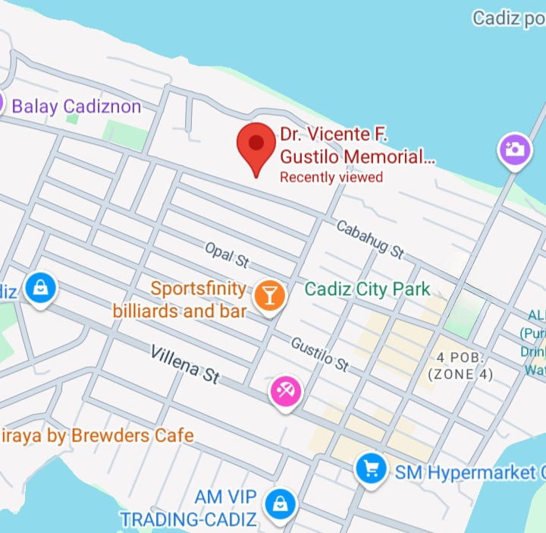The research will be conducted at Dr. Vicente F. Gustilo Memorial National High School, located at Cabahug Street in Cadiz City, Negros Occidental, Philippines.

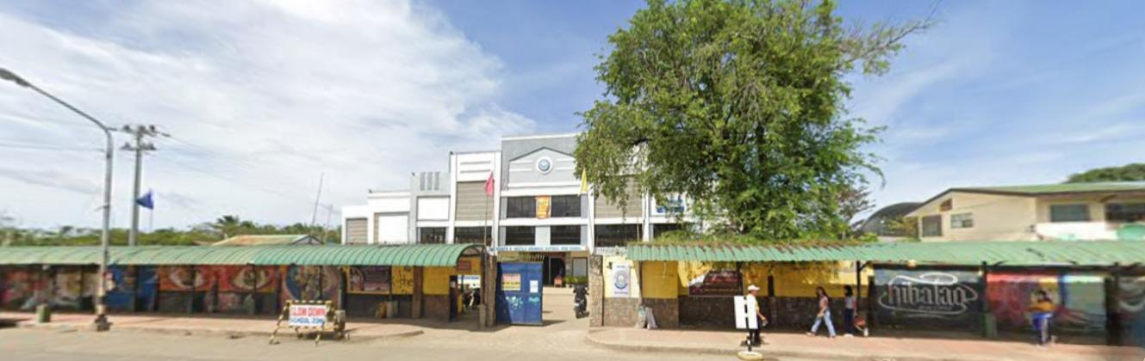

**Theoretical Framework**

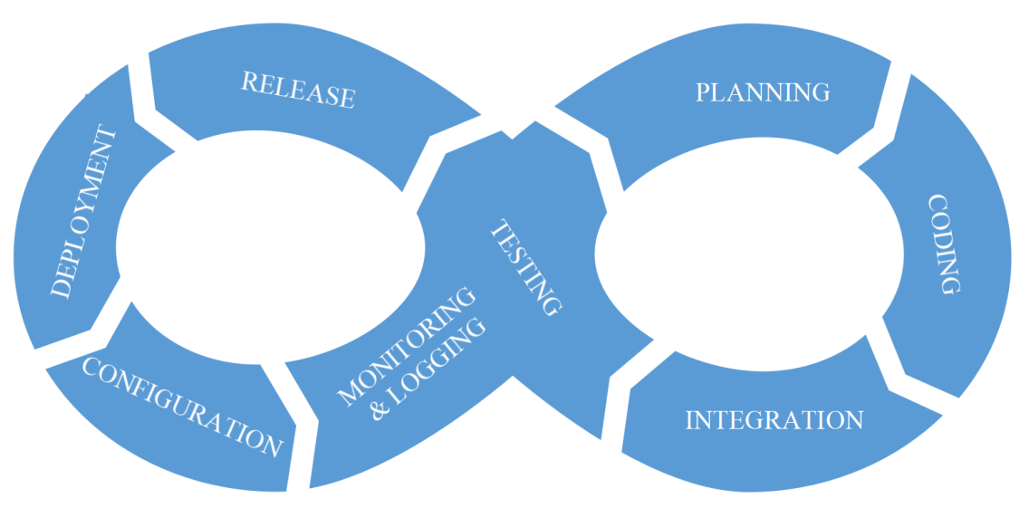

The Digital Library System adopts the DevOps methodology to optimize system operations and improve user satisfaction. The process begins with gathering users' requirements, which guide actions like searching and managing resources. These requirements trigger continuous development cycles, including design, integration, and testing, ensuring that the system meets users' needs. User feedback plays a critical role in refining the system, allowing for adjustments and improvements based on real-world usage and technological advancements. By incorporating DevOps, the system can rapidly respond to evolving user demands, ensuring a competent and flexible Digital Library that stays aligned with both user expectations and technological trends.

**Planning**

The project begins with the Planning stage, where the Project Manager gathers requirements, sets clear goals, and defines the project scope to ensure the development team aligns with the objectives and delivers the expected outcomes.

**Coding**

In the Coding phase, Front-End Developer focus on designing a user-friendly interface, while Back-End Developer build the server-side components, databases, and application logic to support the library's functionalities.

**Integration**

This is followed by Integration, where Front-End and Back-End Programmer frequently integrate their code into a shared repository, using automated tests to ensure new changes do not disrupt the existing system.

**Testing**

During Testing, Quality Assurance (QA), along with the developers, performs rigorous automated testing to minimize defects and ensure the delivery of high-quality code.

**Release**

The Release phase involves the Project Manager and developers deploying the system to the production environment, ensuring a smooth and disruption-free transition for users.

**Deployment**

Next, Deployment automates the process of pushing updates to the live environment, handled by both Front-End and Back-End Programmers, enabling seamless and rapid deployment cycles.

**Configuration**

In Configuration, Hardware Technicians and Back-End Programmers carefully manage system configurations and infrastructure to prevent errors caused by misconfigurations.

**Monitoring & Logging**

Finally, the Monitoring & Logging stage involves Hardware Technicians and the Project Manager actively monitoring the system’s performance and logging issues to ensure prompt resolution and maintain system stability.

**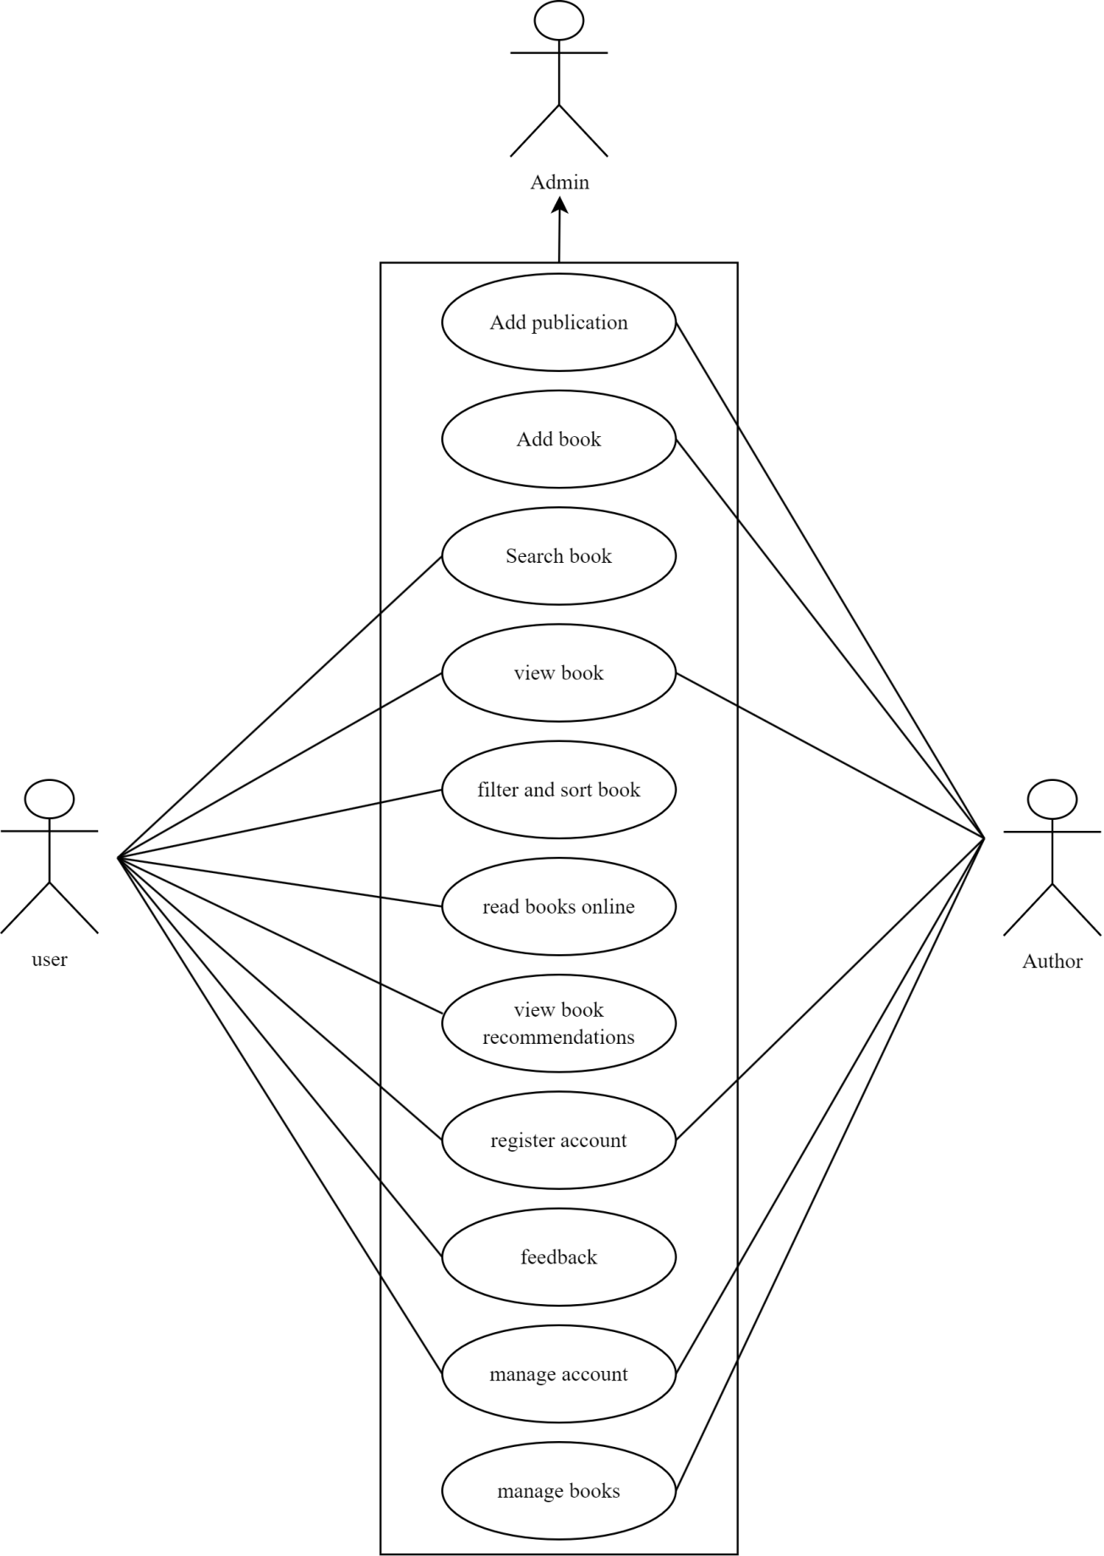Use Case Diagram**

**Requirement Costs**

|  |  |  |
| --- | --- | --- |
| **Description** | **Admin** | **User** |
| 1. **HARDWARE REQUIREMENTS** | | |
| * Laptop (AMD Ryzen 7 7000 series 165hz refresh rate, 16gb RAM, RTX 4050, 512 GB SSD) | ₱ 85,000 | ₱ 0 |
| * Keyboard (AttackShark tri-mode mechanical) | ₱ 2,000 | ₱ 0 |
| * Mouse (A4Tech USB optical mouse) | ₱ 500 | ₱ 0 |
| 1. **SOFTWARE REQUIREMENTS** | | |
| * Operating System (Windows 11 Home, version 23H2) | ₱ 10,000 | ₱ 0 |
| * Database Software (MySQL version 8.0.40) | ₱ 0 | ₱ 0 |
| * Version Control System (Github) | ₱ 0 | ₱ 0 |
| * IDE (Visual Studio Code) | ₱ 0 | ₱ 0 |
| * Front-end (React.js with vite) | ₱ 0 | ₱ 0 |
| * Back-end (PHP with laravel) | ₱ 0 | ₱ 0 |
| 1. **NETWORK REQUIREMENTS** | | |
| * High-Speed Internet (PLDT Fibr 25mbps) monthly | ₱ 1,500 | ₱ 0 |
| * LAN Setup (Ethernet cabling and installation Category 6 Ethernet cable (10m), RJ45) | ₱ 1,000 | ₱ 0 |
| 1. **INTEGRATION REQUIREMENTS** | | |
| * APIs (Gutendex) | ₱ 0 | ₱ 0 |
| * APIs (Open Library) | ₱ 0 | ₱ 0 |
| * Cloud Services (AWS S3 for file storage) monthly | ₱ 160 | ₱ 0 |
| **TOTAL** | ₱ 100,160 | ₱ 0 |

|  |
| --- |
|  |

**Labor Cost**

|  |  |
| --- | --- |
| **Peopleware** | **Cost** |
| * Programmer(Full Stack) | ₱40,000 |
| * Maintenance | ₱5,000 |
| * System Analyst | ₱20,000 |

**Gantt Chart**

**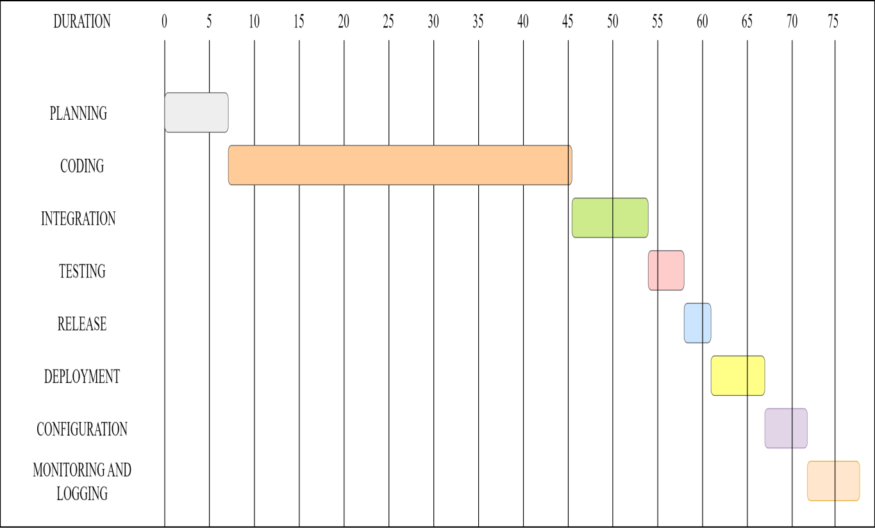**

**System Prototype**

**First page before the user logs in to the system**

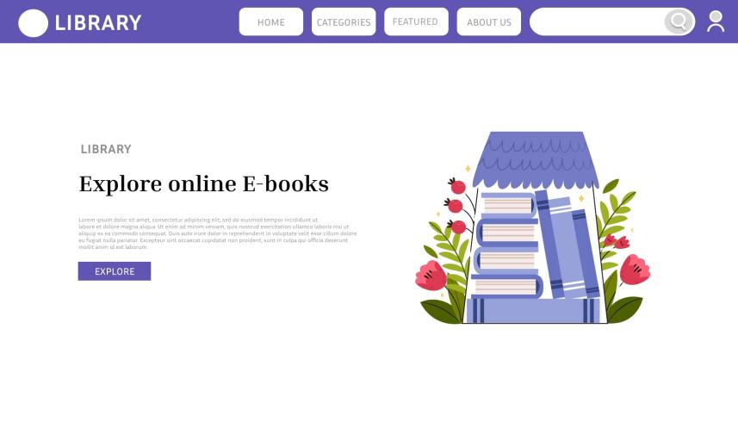**Log in page with Sign up button at the right pane**

**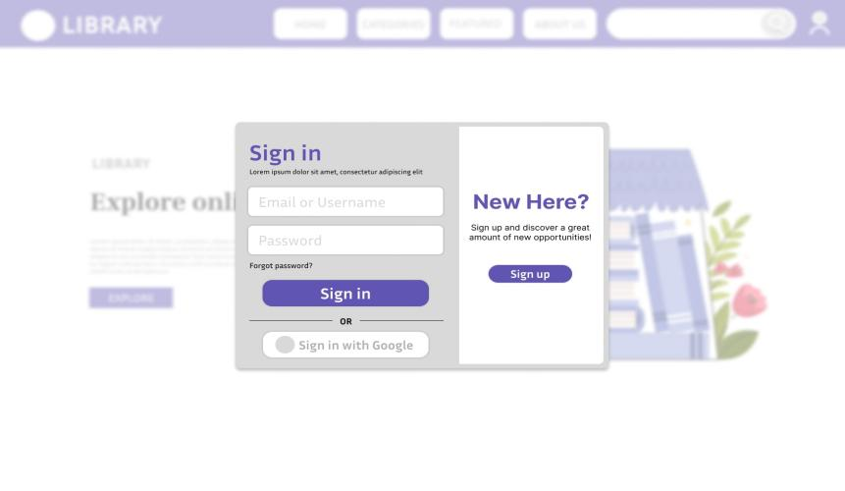Homepage**

**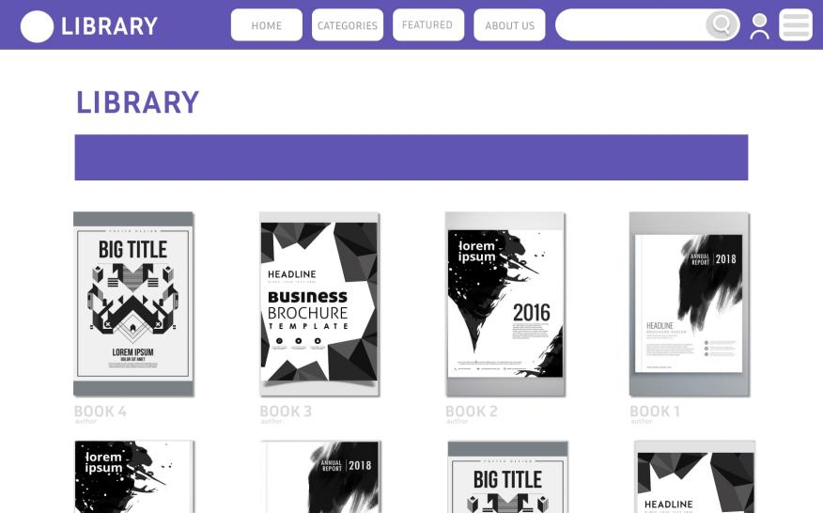**

**Data Flow Diagram**

**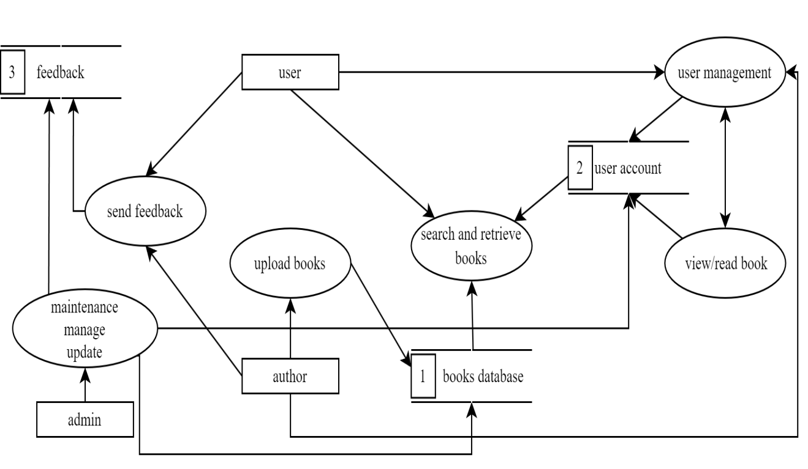**

**Data Flow Diagram Level 0**

**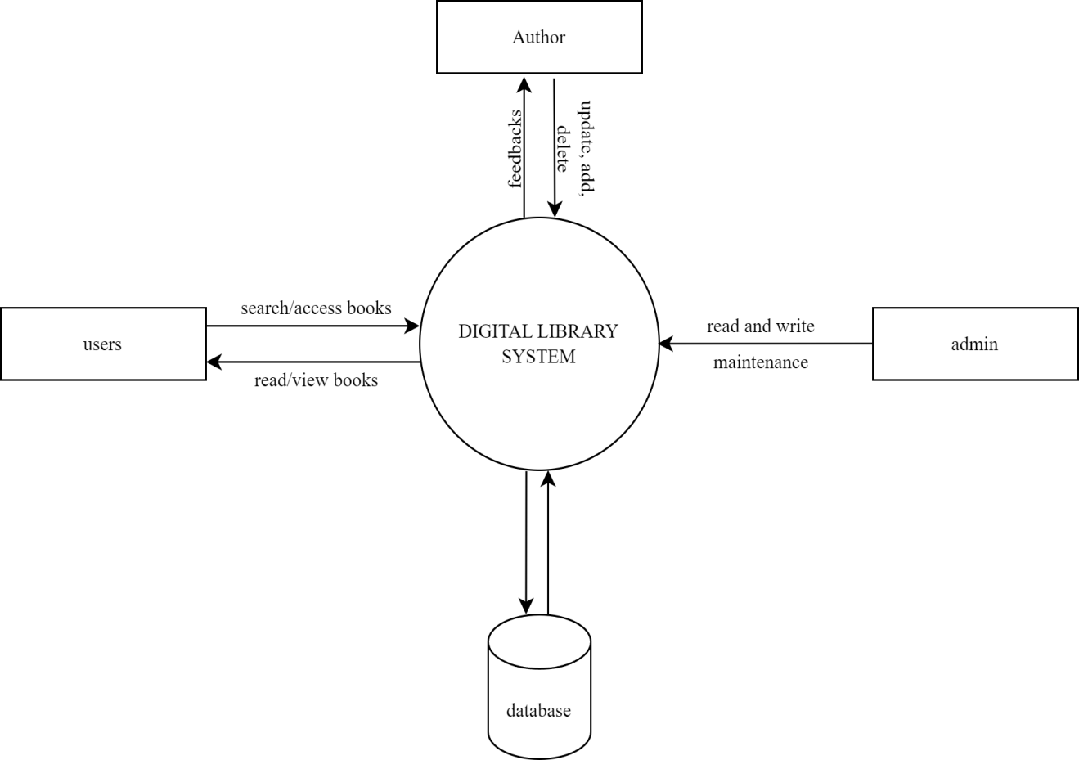**

**ER Diagram**

**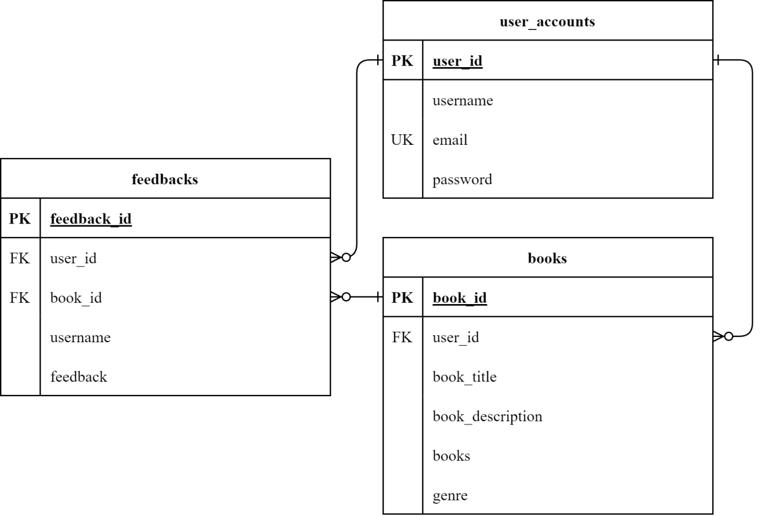**

**System Architecture**

The digital library system architecture that we use is a layered approach to improve functionality and user experience. It includes personalized recommendations based on user behavior, advanced search filtering for efficient navigation, and bookmarking features for easy access to resources. Version control for content updates will also be implemented to maintain accurate historical records, ensuring a reliable and engaging user experience.

**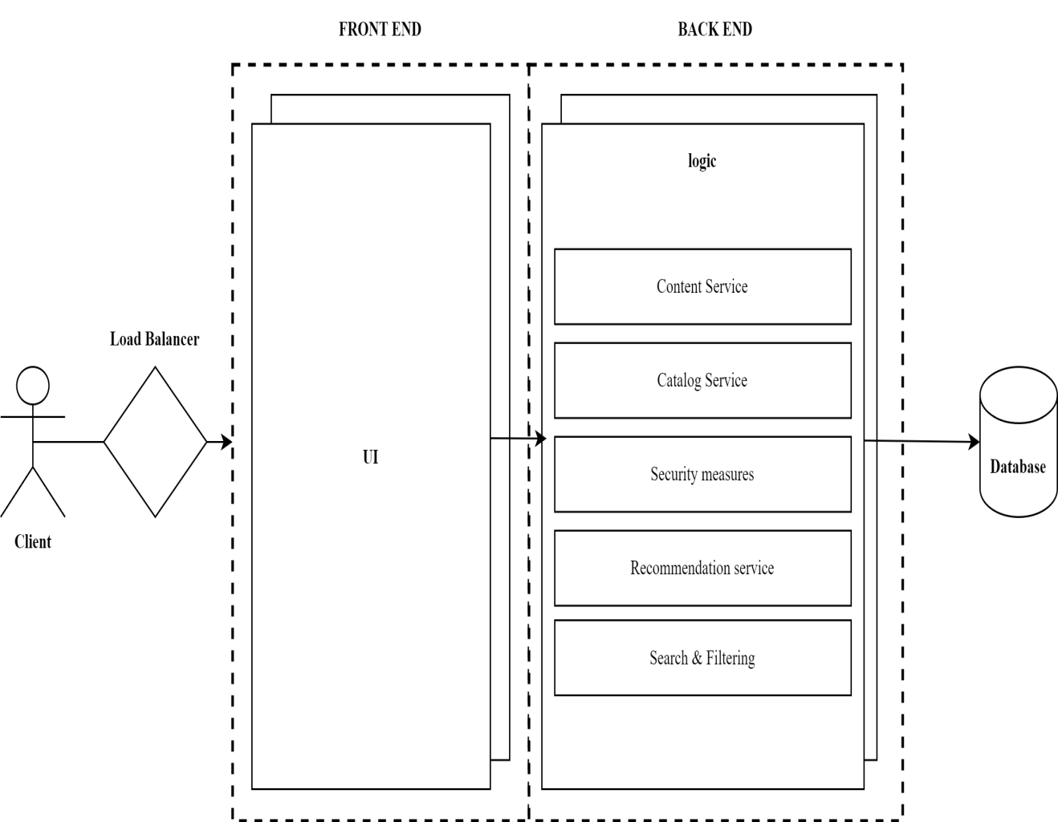**

**Program Evaluation and Review Technique**

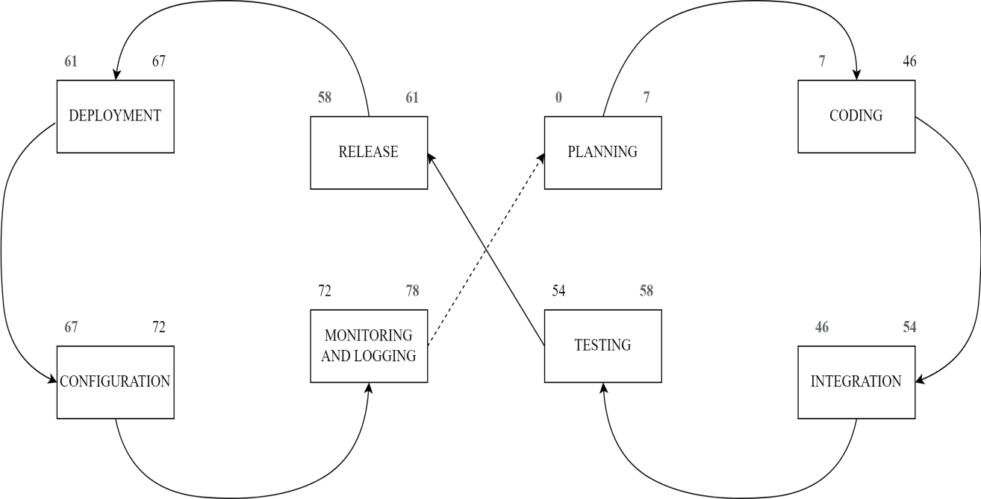

**Critical Path Method**

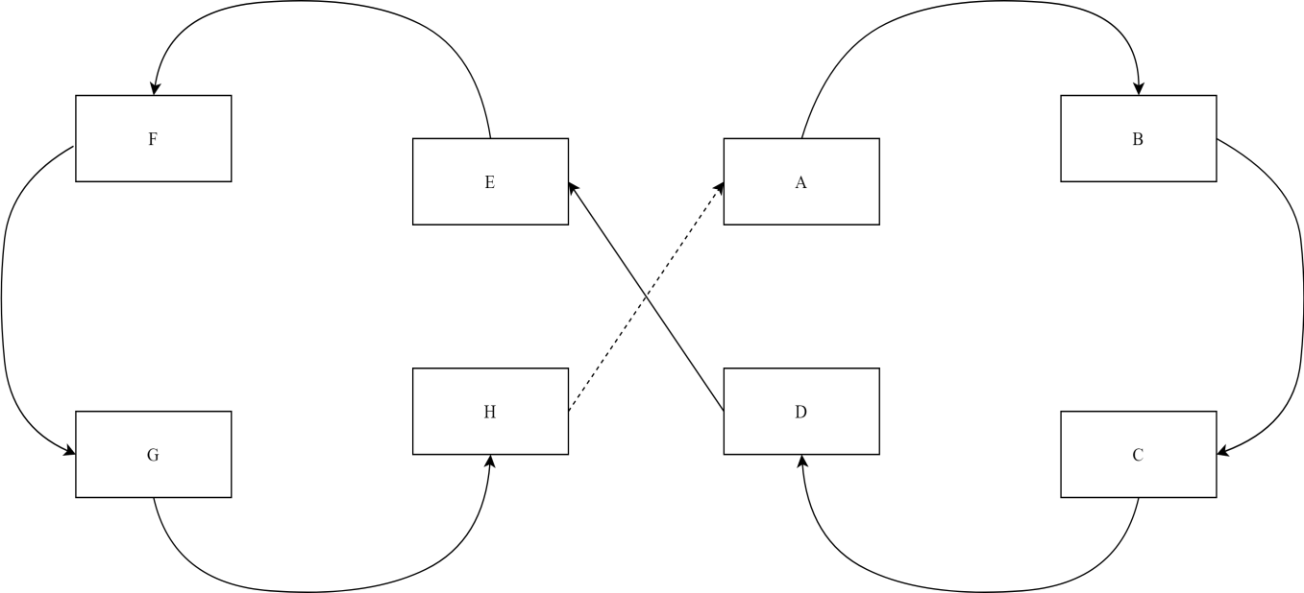

Total No. of Days: 78days

Critical Path: A,B,C,D,E,F,G,H

**Cost-Benefit Analysis**

|  |  |  |  |  |  |  |  |  |
| --- | --- | --- | --- | --- | --- | --- | --- | --- |
| **Item** | **Year 0** | **Year 1** | **Year 2** | **Year 3** | **Year 4** | **Total Cost** | **Total Benefits** | **Net Benefit/Cost** |
| Development Cost | ₱160,420 | - | - | - |  | ₱160,420 | - |  |
| Operational Cost | - | ₱18,000 | ₱18,000 | ₱18,000 | ₱18,000 | ₱72,000 | - |  |
| Maintenance Cost | - | ₱6,920 | ₱6,920 | ₱6,920 | ₱6,920 | 27,680 | - |  |
| **TOTAL COST** | ₱160,420 | ₱24,920 | ₱24,920 | ₱24,920 | ₱24,920 | ₱260,100 | - |  |
| PV Factor (10%) | 1.000 | 0.909 | 0.826 | 0.751 | 0.683 |  | - | - |
| Present Value | ₱160,420 | ₱22,652 | ₱20,584 | ₱18,715 | ₱17,020 | ₱239,391 | - | - |
| **TOTAL BENEFITS** | - | ₱90,000 | ₱96,000 | ₱102,000 | ₱108,000 | - | ₱396,000 |  |
| PV Factor (10%) | 1.000 | 0.909 | 0.826 | 0.751 | 0.683 | - |  | - |
| Present Value | ₱0.00 | ₱81,810 | ₱79,296 | ₱76,602 | ₱73,764 |  | ₱311,472 |  |
| **Net Cash Flow** | ₱-160,420 | ₱59,158 | ₱58,712 | ₱57,887 | ₱56,744 | - | ₱72,081 | ₱72,081 |

**ROI**

Present Value Benefit ₱311,472.00

Present Value Cost ₱239,391.00

Formula for Calculating the ROI:

ROI%= PVb-PVc

X100

PVc

ROI%= Net Return

X100

PVc

ROI= 311,472-239,391

X100

239,391

ROI= 72,081

X100

239,391

X100

ROI= 0.301101545

30.11%

Return of Investment=

**CHAPTER 3**

**PRESENTATION OF DATA**

A survey was conducted as part of the requirements gathering phase for developing a Digital Library System aimed at providing students with seamless access to academic resources like e-books, research papers, and journals through a feature-rich web-based platform with advanced search, personalized accounts, and mobile access.

The survey was distributed to 15 respondents, consisting of 5 males (33.33%) and 10 females (66.67%).

The questions were designed following the ISO/IEC 9126 standard, and the responses were collected using a Likert scale with options: Strongly Agree, Agree, Neutral, Disagree, and Strongly Disagree.

**Figure 1. Survey Responses on Willingness to Use the Digital Library System Upon Implementation**

As shown in the figure above, 93% of respondents agreed or strongly agreed they would use the system, with 7% neutral. No respondents disagreed, indicating strong interest in the system.

The projections indicate a strong overall interest in the digital library system, suggesting its potential success upon implementation.

**Figure 3. Survey Responses on the Variety of Resources Meeting Academic Needs**

**As shown in the figure above, 80% of respondents agreed the system's resources will meet their academic needs, while 13% were neutral and 7% strongly disagreed.**

**The projections suggest the system will satisfy most users, though addressing concerns from a small minority could improve acceptance.**

**Figure 2. Survey Responses on the Advanced Search Functionality Meeting Research Needs**

**As shown in the figure above, 73% of respondents agreed or strongly agreed that the advanced search functionality would meet their research needs, with 27% neutral. No respondents disagreed, indicating general confidence in this feature.**

**The projections suggest strong potential for the advanced search functionality to meet users' research needs effectively.**

**Figure 5. Survey Responses on the Digital Library System Supporting Independent Research Effectively**

As shown in the figure above, 74% of respondents agreed or strongly agreed that the system would support independent research, with 27% neutral. No respondents disagreed, indicating confidence in its effectiveness.

The projections suggest the system will be effective for research, with minor improvements needed to address uncertainty.

**Figure 4. Survey Responses on the Digital Library System Providing Relevant Academic Resources**

**As shown in the figure above, 87% of respondents agreed or strongly agreed that the system would provide relevant academic resources, with 13% neutral. No respondents disagreed, indicating strong confidence in the system's relevance to academic needs.**

**The projections suggest the system will be well-received, with minimal concerns about its suitability for users' academic needs.**

**Figure 7. Survey Responses on the Personalized User Account Feature Helping Save and Locate Resources Effectively**

As shown in the figure above, 67% of respondents agreed or strongly agreed that the personalized user account feature will help them save and locate resources effectively, while 27% were neutral and 7% disagreed.

The projections suggest that most users will find this feature useful, but addressing concerns from the uncertain or disagreeing respondents could improve its acceptance.

### Figure 6. Survey Responses on the Digital Library System Being Easy to Access

As shown in the figure above, all respondents (15 out of 15, or 100%) agreed that the digital library system is expected to be easy to access. This includes 7 respondents (47%) who agreed and 8 respondents (53%) who strongly agreed. No participants selected neutral, disagreed, or strongly disagreed.

The projections suggest that the system's ease of access will be widely appreciated, with no concerns raised about its accessibility among the respondents.

**Figure 8. Survey Responses on the System's Mobile Accessibility for Convenient Access on the Go**

As shown in the figure above, 73% of respondents agreed or strongly agreed that the system's mobile accessibility will allow convenient access on the go, while 20% were neutral and 7% disagreed.

The projections suggest that mobile accessibility will be valued, though addressing some uncertainty could enhance user satisfaction.

**Figure 9. Survey Responses on the User Interface Design Being Clear and Easy to Use**

As shown in the figure above, 100% of respondents expect the system's user interface to be clear and easy to use, with 80% agreeing and 20% strongly agreeing. No respondents disagreed or had concerns.

The projections suggest that the system's user interface will be highly regarded for its clarity and ease of use, with no concerns raised about its usability.

**Figure 10. Survey Responses on the Digital Library System Reducing Challenges Associated with Traditional Libraries**

As shown in the figure above, 93% of respondents believe the digital library system will reduce challenges associated with traditional libraries, with 33% agreeing and 20% strongly agreeing. 40% were neutral, and 7% disagreed.

The projections suggest that the system will be viewed as an effective solution to these challenges, although addressing the concerns of a few respondents could enhance its perceived effectiveness.

**Figure 11. Survey Responses on the Effectiveness of Search Filters in Narrowing Down Resource Results**

As shown in the figure above, 80% of respondents expect the search filters to effectively narrow down resource results, with 47% agreeing and 33% strongly agreeing. 20% were neutral, and no one disagreed.

The projections suggest the filters will be effective, though addressing some uncertainty could improve their perceived usefulness.

**Figure 12. Survey Responses on the Expectation of Fast Speed and Response Times in the Digital Library System**

As shown in the figure above, 87% of respondents expect the digital library system to have fast speed and response times, with 67% agreeing and 20% strongly agreeing. 13% were neutral, and no one disagreed.

The projections suggest users expect efficient performance, though addressing some uncertainty could boost confidence in its speed.

**Figure 13. Survey Responses on the Expectation of Real-Time Catalog Updates for Accessing Latest Educational Materials**

As shown in the figure above, 80% of respondents expect real-time catalog updates to help access the latest educational materials, with 60% agreeing and 20% strongly agreeing. 20% were neutral, and no one disagreed.

The projections suggest that real-time updates are seen as a valuable feature, though addressing some uncertainty could further improve confidence in its effectiveness.

**Figure 14. Survey Responses on the Expectation of Reliable Performance in the Digital Library System**

As shown in the figure above, 80% of respondents expect the digital library system to perform reliably, with 67% agreeing and 13% strongly agreeing. 13% were neutral, and 7% disagreed.

The projections suggest that the system is expected to deliver a stable user experience, though addressing concerns from uncertain or disagreeing respondents could improve its perceived reliability.

**Figure 15. Survey Responses on the Expectation of Digital Library System Accessibility from Various Devices and Platforms**

As shown in the figure above, 80% of respondents expect the system to be accessible across devices, with 53% strongly agreeing and 27% agreeing.

The projections indicate strong confidence in its cross-platform compatibility, though addressing the uncertainty of a few respondents could further enhance this perception.

**Recommendation**

For the Cap

,stone Project entitled Digital Library System, it is recommended to prioritize a user-friendly platform design that appeals to students by ensuring simplicity and ease of navigation. Highlighting the platform's ability to save time compared to traditional libraries can further enhance its appeal. The search feature should include effective filters, such as topic and date, enabling users to quickly locate resources. A broad and diverse range of materials should be provided, with regular updates to meet the evolving needs of users.

Incorporating features such as saving articles, bookmarking, and easy access to saved resources can significantly enhance the research experience. The system should support efficient login processes and be optimized for use across various devices, ensuring accessibility and convenience. Additionally, features like saving search results for future reference can contribute to a seamless and efficient user experience.

To improve usability, the system should be fully functional on smartphones and tablets, with intuitive navigation and optimized reading options. A clean and simple interface design is essential to facilitate quick access to resources while emphasizing the advantages of 24/7 availability as a modern solution to traditional library challenges. The search functionality should include easy-to-use filters, allowing users to sort by resource type, date, or topic.

Lastly, it is vital to ensure the system operates quickly and smoothly, minimizing loading times or lag, while incorporating real-time updates to provide students with fresh and relevant content. Technical stability and compatibility with various devices and platforms are crucial to guaranteeing uninterrupted service, allowing students to access the system from anywhere at any time.

**CHAPTER 4**

**CONCLUSION AND RECOMMENDATIONS**

Access to educational resources is essential for students’ academic success, yet many in the Philippines face challenges such as distance, high costs, and limited library hours. To address these issues, the digital library system was developed as a web-based platform to provide students with convenient and accessible academic resources, including e-books, research papers, journals, and multimedia content. This system enhances learning by offering advanced search functionality, personalized user accounts, mobile accessibility, and real-time catalog updates. These features enable students to efficiently locate and access up-to-date materials tailored to their academic needs anytime, anywhere, promoting independent research and a seamless learning experience.

**CONCLUSION**

In conclusion, the objectives of the centralized digital catalog align closely with the needs of students, as indicated by the survey findings. The goal of providing a diverse range of academic resources is strongly supported, with 80% of respondents agreeing that the catalog’s offerings, including e-books, journals, and multimedia materials, would meet their academic needs. Additionally, the project’s focus on enhancing the user experience through advanced search functionalities and personalized accounts is well-validated, with 73% of respondents recognizing the usefulness of advanced search for research and 67% believing personalized accounts would improve resource management. The inclusion of real-time catalog updates further meets students' expectations for access to the latest educational materials, as emphasized by 80% of participants. These findings confirm that the project’s emphasis on resource variety, user-friendly features, and continuous updates will ensure the centralized digital catalog becomes a valuable academic tool, effectively supporting students’ learning and research.

**RECOMMENDATION**

Based on the findings of this study, several strategic recommendations are proposed to guide the implementation and optimization of the Digital Library System. The following stakeholders will significantly benefit from these recommendations:

The IT staff are responsible for maintaining the system’s stability, security, and updates, ensuring smooth operation, scalability, and optimal performance. They handle troubleshooting, implement technical updates, and keep the system functioning efficiently. Students, as primary users, will benefit from easy access to diverse academic resources, advanced search features, personalized accounts, and real-time updates, enhancing their research and academic success. Administrative staff will experience reduced manual workload through automated cataloging and resource management, leading to increased operational efficiency. Faculty members will enjoy quick access to relevant academic materials for teaching and research, supported by improved search capabilities and personalized tools to manage resources effectively. A technical support team will handle user issues, offering real-time assistance to minimize disruptions and improve user satisfaction. Lastly, a feedback and improvement committee, composed of IT staff, faculty, and students, will regularly collect feedback and propose updates to ensure the system stays aligned with user needs and technological advance

**References**

* Aloc, Viela Rose R., Bustamante, Rose-Anne V., Calong, Carl Lorenz I., Remoroza, Juneto Marco P., & Talaman, Eduardo M. (2023). *Enhanced Online Library Management System: Its Impact on Students’ Learning Experience and Academic Performance in Inquires, Investigation, And Immersion.*Galaxy International Interdisciplinary Research Journal, 11(6), 512–525.  
  Retrieved From: [https://giirj.com/index.php/giirj/article/view/5476](https://giirj.com/index.php/giirj/article/view/5476" \t "_blank)  
  Date Accessed: September 12, 2024
* Chanda, A. (2021). *Importance of Digital Library in Academic Institutions*. Journal of Intellectuals, 1(1), 11-20.  
  Retrieved From: <https://www.researchgate.net/profile/Dr-Chanda->2/publication/366500136\_Importance\_of\_Digital\_Library\_in\_Academic\_Institutions/links/63a42661c3c99660eb958fa6/Importance-of-Digital-Library-in-Academic-Institutions.pdf  
  Date Accessed: September 10, 2024 (Tuesday)

●

* De Leon, L. R., Lagao, S., Lobo, M. D., Santiago, G. M. & Sigaya, G. R. (2023). Usability Assessment of the UST Miguel de Benavides Digital Library. PAARL Research Journal, 9(1 - Special Anniversary Issue), 45-62.   
  Retrieved From: https://actamedicaphilippina.upm.edu.ph/index.php/acta/article/view/ 9520 Date Accessed: September 13, 2024(Fri)
* Khan, R. (2021). Importance of digital library in education. International Journal of Research in Library Science, 7(4), 102-117.  
  Retrieved From: https://scholar.google.com/scholar?hl=en&as\_sdt=0%2C5&q=Khan%2C+R.+%282021%29.+Importance+of+digital+library+in+education.+International+Journal+of+Research+in+Library+Science%2C+7%284%29%2C+102117.&btnG=#d=gs\_qabs&t=1726712342691&u=%23p%3DMiI5rkYn4DwJ   
  Date Accessed: September 9, 2024 (Mon)
* Lagas, S., & Isip, J. (2023). Challenges to Digital Services in Philippine Academic Libraries. Philippine Journal of Librarianship and Information Studies, 43(1), 27-38.   
  Retrieved From: [https://scholar.google.com/scholar?hl=en&as\_sdt=0%2C5&q=digital+library+system+in+the+Philippines+&btnG=#d=gs\_qabs&t=1727440936915&u=%23p%3DO4PeAlyXZ-EJ](https://scholar.google.com/scholar?hl=en&as_sdt=0%2C5&q=digital+library+system+in+the+Philippines+&btnG=" \l "d=gs_qabs&t=1727440936915&u=%23p%3DO4PeAlyXZ-EJ)Date Accessed: September 23,2024(Mon)
* Lasig, C. A. (2024). *Students' Awareness and Use of the Online Public Access Catalog (OPAC) at the Central Luzon State University Library in the Philippines.* International Journal of Information Science & Management, 22(2).  
  Retrieved From: [https://doi](https://doi.org/10.22034/ijism.2024.1977926.0)**[.](https://doi.org/10.22034/ijism.2024.1977926.0)**[org/10.22034/ijism.2024.1977926.0](https://doi.org/10.22034/ijism.2024.1977926.0)  
  Date Accessed: September 23, 2024(Mon)
* **Misra, P., Chopra, G., & Bhaskar, P. (**2023). *Continuous usage intention for digital library systems among students at higher learning institutions: Moderating role of academic involvement*. Journal of Applied Research in Higher Education, 15*(5), 1752-1766.*Retrieved From: [https://doi.org/10.1108/JARHE-06-2022-0185](https://doi.org/10.1108/JARHE-06-2022-0185" \o "DOI: https://doi.org/10.1108/JARHE-06-2022-0185)  
  Date Accessed: September 8, 2024 (Sun)
* Obsanga, A.P., & Enierga, R.R. (2021). Automated Library Management System for Public Libraries in the Philippines. Library Hi Tech News, 38(5), 24-29.  
  Retrieved From: https://doi.org/10.1108/LHTN-10-2021-0072   
  Date Accessed: September 22, 2024(Sun)
* Perdana, I. A., & Prasojo, L. D. (2020, February). *Digital Library Practice in University: advantages, challenges, and its position.* In International Conference on Educational Research and Innovation (ICERI 2019) (pp. 44-48). Atlantis Press.  
  Retrieved From: <https://www.atlantis-press.com/proceedings/iceri-19/125934015>  
  Date Accessed: September 11, 2024 (Wednesday)
* **Shevchenko, L.** (2020). *Analysis of library website users’ behaviour to optimize virtual information and library services*. Journal of Information Science Theory and Practice, 8*(1), 45-55.*Retrieved From*:* <https://doi.org/10.1633/JISTaP.2020.8.1.4>  
  Date Accessed: September 8, 2024 (Sun)