第3章 采样和量化
3-1
答：
输入：syms t w
Xf=fourier(5*cos(6*pi*t)+3*sin(8*pi*t))
输出：Xf=pi*(5*dirac(w+6*pi)+3*i*dirac(w+8*pi)-3*i*dirac(w-8*pi)+5*dirac(w-6*pi))
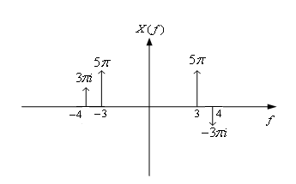
matlab程序： t=0:0.02:8;
L=length(t);
xt=5*cos(6*pi*t)+3*sin(8*pi*t);
f1=fft(xt);
fs=10;Ts=1/fs;
t1=8:-0.02:0;
f=1./t1;
Pt=zeros(1,L);
for i=1:8:L
Pt(i)=1;
end
Xst=xt.*Pt;
f2=fft(Xst);
f3=fs*f1;
f4=ifft(f3);
subplot(2,2,1)
plot(f,f1)
axis([0 10 -1000 3000])
xlabel('f');ylabel('x(f)');
subplot(2,2,2)
plot(f,f2)
axis([0 10 -200 400])
xlabel('f');ylabel('Xs(f)');
subplot(2,2,3)
plot(f,f3)
axis([0 10 -2000 4000])
xlabel('f');ylabel('Xr(f)');
subplot(2,2,4)
plot(t,f4)
xlabel('t');ylabel('Xr(t)');
axis([0 6 -50 50])
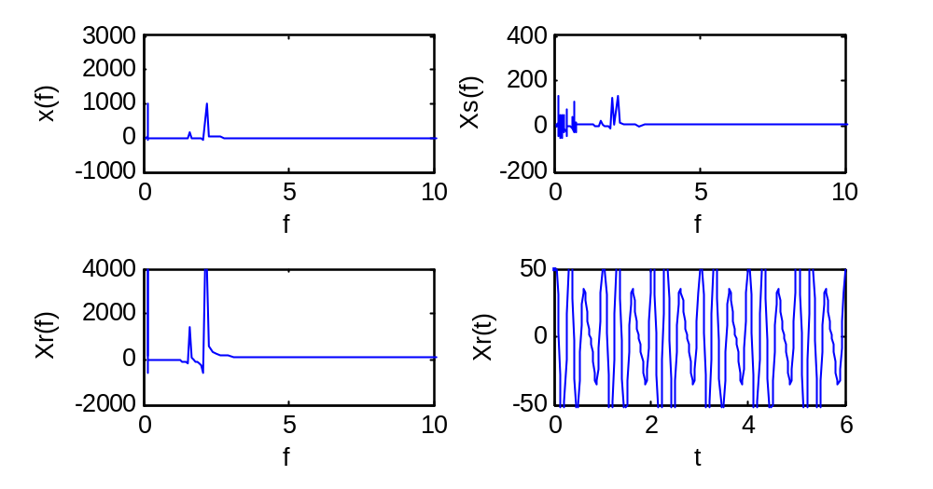
3-2
答：matlab程序： t=0:0.02:8;
L=length(t);
xt=5*cos(6*pi*t)+3*sin(8*pi*t);
f1=fft(xt);
fs=7;Ts=1/fs;
t1=8:-0.02:0;
f=1./t1;
Pt=zeros(1,L);
for i=1:8:L
Pt(i)=1;
end
Xst=xt.*Pt;
f2=fft(Xst);
f3=fs*f1;
f4=ifft(f3);
subplot(2,2,1)
plot(f,f1)
axis([0 10 -1000 3000])
xlabel('f');ylabel('x(f)');
subplot(2,2,2)
plot(f,f2)
axis([0 10 -200 400])
xlabel('f');ylabel('Xs(f)');
subplot(2,2,3)
plot(f,f3)
axis([0 10 -2000 4000])
xlabel('f');ylabel('Xr(f)');
subplot(2,2,4)
plot(t,f4)
xlabel('t');ylabel('Xr(t)');
axis([0 6 -50 50])
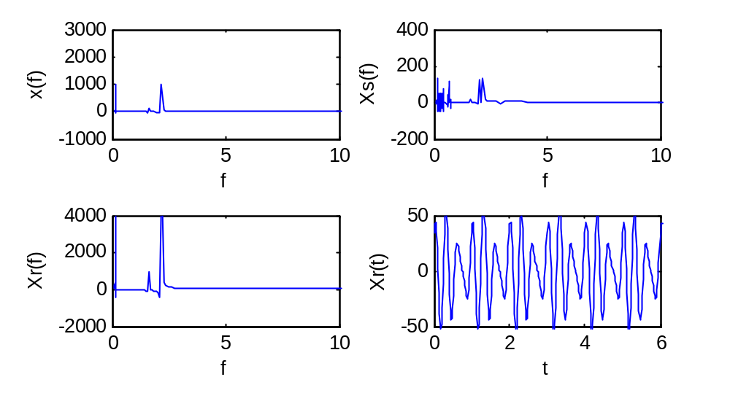

3.5
信号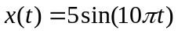，
（a）信号的动态范围为。
（b）信号的波峰因素为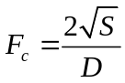。其中，S为信号的功率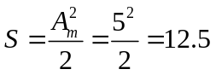，所以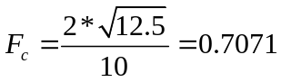。
（c）信噪比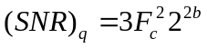，以dB为单位，
当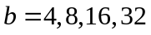比特时，计算得

3.11
k = 50; % samples per lobe
nsamp = 50000; % total frequency samples
snrdb = zeros(1,17); % initialize memory
x = 4:20; % vector for plotting
for m = 4:20
signal = 0; noise = 0; % initialize sum values
f_fold = k*m/2; % folding frequency
for j = 1:f_fold
term = (sin(pi*j/k/2)/(pi*j/k/2))^4;
signal = signal+term;
end
for j = (f_fold+1):nsamp
term = (sin(pi*j/k/2)/(pi*j/k/2))^4;
noise = noise+term;
end
snrdb(m-3) = 10*log10(signal/noise);
end
plot(x,snrdb) % plot results
xlabel('Samples per symbol')
ylabel('Signal-to-aliasing noise ratio')
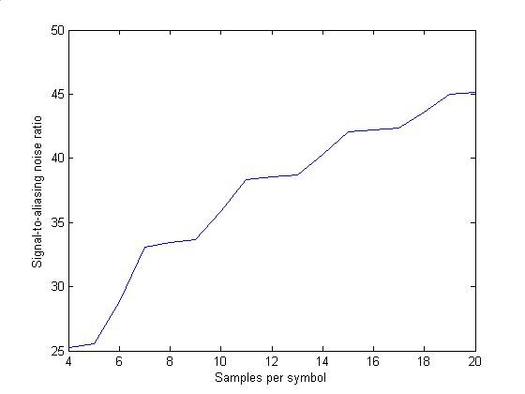
三角脉冲波形的信号混叠信噪比
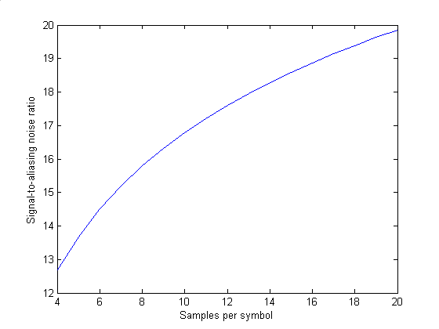
矩形脉冲波形的信号混叠信噪比
3-11
答：matlab程序： k=50;
nsamp=50000;
snrdb=zeros(1,17);
snrdb_triangle=zeros(1,17);
x=4:20;
for m=4:20
signal=0;noise=0;signal_triangle=0;noise_triangle=0;
f_fold=k*m/2;
for j=1:f_fold
term=(sin(pi*j/k)/(pi*j/k))^2;
term_triangle=(sin(pi*j/(2*k))/(pi*j/(2*k)))^4;
signal=signal+term;
signal_triangle=signal_triangle+term_triangle;
end
for j=(f_fold+1):nsamp
term=(sin(pi*j/k)/(pi*j/k))^2;
term_triangle=(sin(pi*j/(2*k))/(pi*j/(2*k)))^4;
noise=noise+term;
noise_triangle= noise_triangle+term_triangle;
end
snrdb(m-3)=10*log10(signal/noise);
snrdb_triangle(m-3)=10*log10(signal_triangle/noise_triangle);
end
plot(x,snrdb,x,snrdb_triangle,'r:');
xlabel('Samples per symbol');
ylabel('signal-to-aliasing noise ratio');
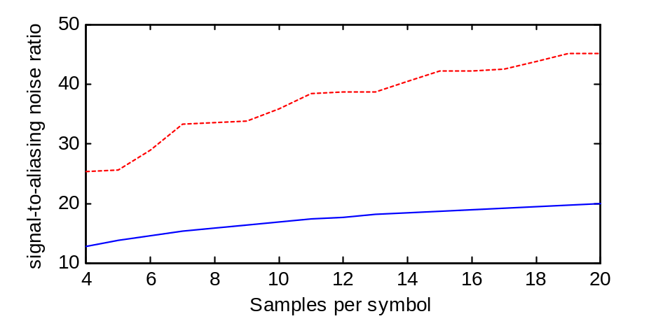
可见成形脉冲为三角脉冲时，效果更好一些。

3.12
k = 50; % samples per lobe
nsamp = 50000; % total frequency samples
snrdb = zeros(1,17); % initialize memory
x = 4:20; % vector for plotting
for m = 4:20
signal = 0; noise = 0; % initialize sum values
f_fold = k*m/2; % folding frequency
for j = 1:f_fold
term = (cos(2*pi*j/k))^2/(pi^2)/((1-(4*j/k)^2))^2;
signal = signal+term;
end
for j = (f_fold+1):nsamp
term = (cos(2*pi*j/k))^2/(pi^2)/((1-(4*j/k)^2))^2;
noise = noise+term;
end
snrdb(m-3) = 10*log10(signal/noise);
end
plot(x,snrdb) % plot results
xlabel('Samples per symbol')
ylabel('Signal-to-aliasing noise ratio')
% End of script file.

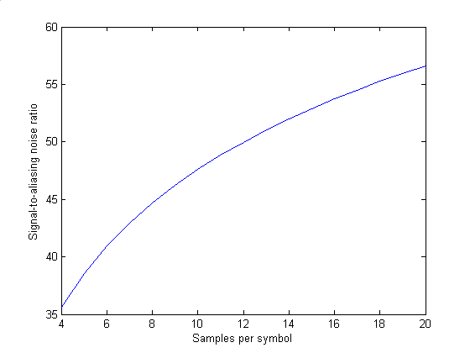
MSK混叠信噪比
矩形脉冲波形的信号混叠信噪比
3-12
答：matlab程序： k=50;
nsamp=50000;
snrdb=zeros(1,17);
snrdb_triangle=zeros(1,17);
x=4:20;
for m=4:20
signal=0;noise=0;signal_triangle=0;noise_triangle=0;
f_fold=k*m/2;
for j=1:f_fold
term=(sin(pi*j/k)/(pi*j/k))^2;
term_triangle=(cos(2*pi*j/k))^2/(pi^2*(1-(4*j/k)^2)^2);;
signal=signal+term;
signal_triangle=signal_triangle+term_triangle;
end
for j=(f_fold+1):nsamp
term=(sin(pi*j/k)/(pi*j/k))^2;
term_triangle=(cos(2*pi*j/k))^2/(pi^2*(1-(4*j/k)^2)^2);;
noise=noise+term;
noise_triangle= noise_triangle+term_triangle;
end
snrdb(m-3)=10*log10(signal/noise);
snrdb_triangle(m-3)=10*log10(signal_triangle/noise_triangle);
end
plot(x,snrdb,x,snrdb_triangle,'r:');
xlabel('Samples per symbol');
ylabel('signal-to-aliasing noise ratio');
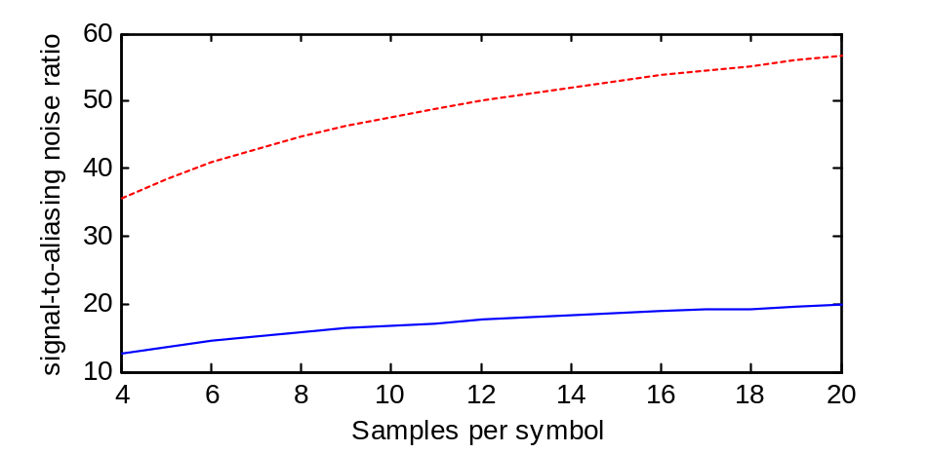

3.13
k = 50; % samples per lobe
nsamp = 50000; % total frequency samples
snrdb = zeros(1,17); % initialize memory
x = 4:20; % vector for plotting
for m = 4:20
signal = 0; noise = 0; % initialize sum values
f_fold = k*m/2; % folding frequency
for j = 1:f_fold
term = (sin(pi*j/k)/(2*pi*j/k))^2;
signal = signal+term;
end
for j = (f_fold+1):nsamp
term = (sin(pi*j/k)/(2*pi*j/k))^2;
noise = noise+term;
end
snrdb(m-3) = 10*log10(signal/noise);
end
plot(x,snrdb) % plot results
xlabel('Samples per symbol')
ylabel('Signal-to-aliasing noise ratio')
QPSK混叠信噪比
矩形脉冲波形的信号混叠信噪比
第4章 带通信号与系统的低通仿真模型
4-3
答：

（a）分析可知：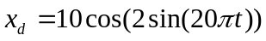 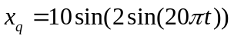
画出同相分量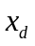：t= 0:0.005:0.7;
xd=10*cos(2*sin(20*pi*t));
plot(t,xd)

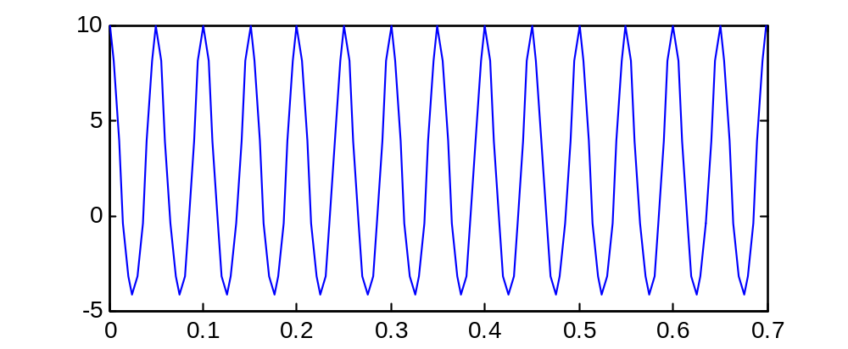

画出正交分量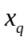：t= 0:0.005:0.7;
xq=10*sin(2*sin(20*pi*t));
plot(t,xq)
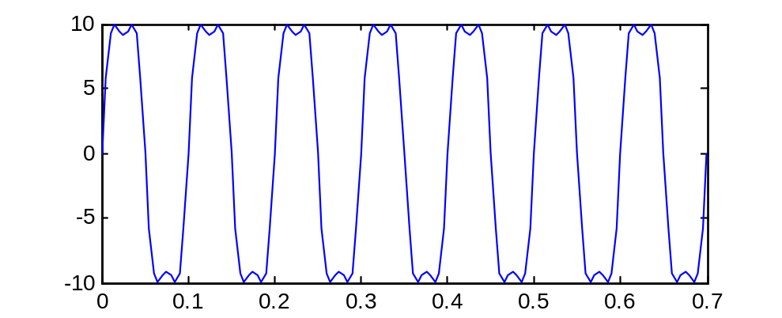
（b） matlab程序： t = 0:0.001:0.5;
x = 10*cos(200*pi*t+2*sin(20*pi*t));
y = fft(x);
m = abs(y); p = angle(y);
f = (0:length(y)-1)*99/length(y);
subplot(2,1,1);
plot(f,m); title('X(f)的幅度');
set(gca,'XTick',[15 40 60 85]);
subplot(2,1,2);
plot(f,p); title('X(f)的相位');
set(gca,'XTick',[15 40 60 85]);
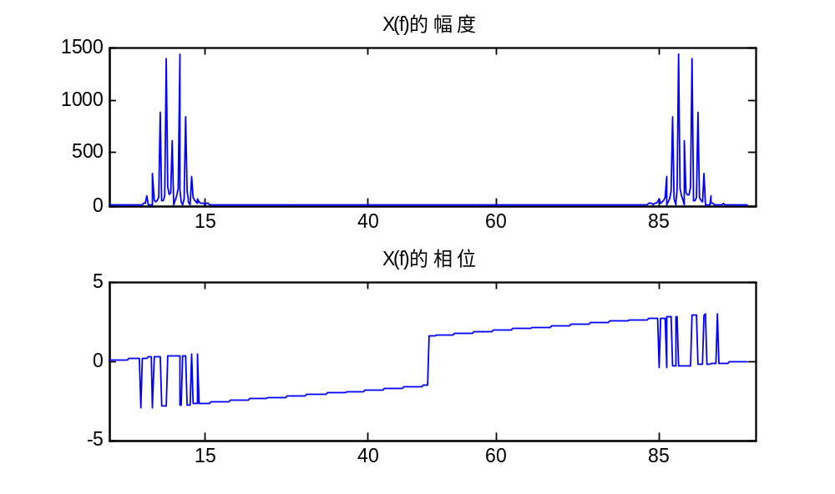

（c）matlab程序： t = 0:0.001:0.6;
x = 10*cos(200*pi*t+2*sin(20*pi*t));
z=hilbert(x);
x1=fft(z.*exp(-j*2*pi*100*t));
m = abs(x1);
f = (0:length(x1)-1)*99/length(x1);
subplot(2,1,1);
plot(f,m);
title(' X~(f)的幅度');
xlabel('频率');
ylabel('幅度');
p =angle(x1);
subplot(2,1,2);
plot(f,p);
title(' X~(f)的相位');
xlabel('频率');
ylabel('相位');
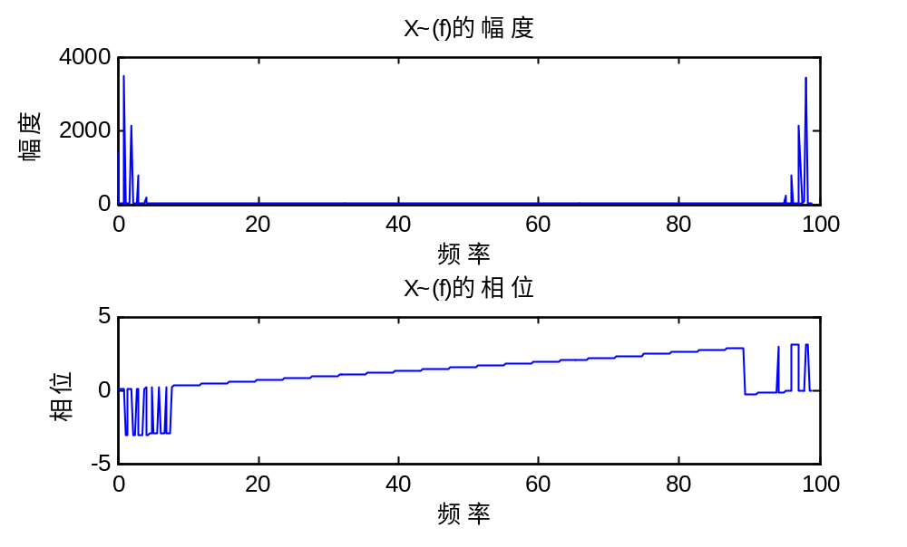
(d) matlab程序： t = 0:0.001:0.7;
x = 10*cos(200*pi*t+2*sin(20*pi*t));
z=hilbert(x);
xl=z.*exp(-j*2*pi*100*t);
xd=real(xl);
xq=-j*(xl-xd);
subplot(2,1,1)
plot(t,xd);
subplot(2,1,2);
plot(t,xq);
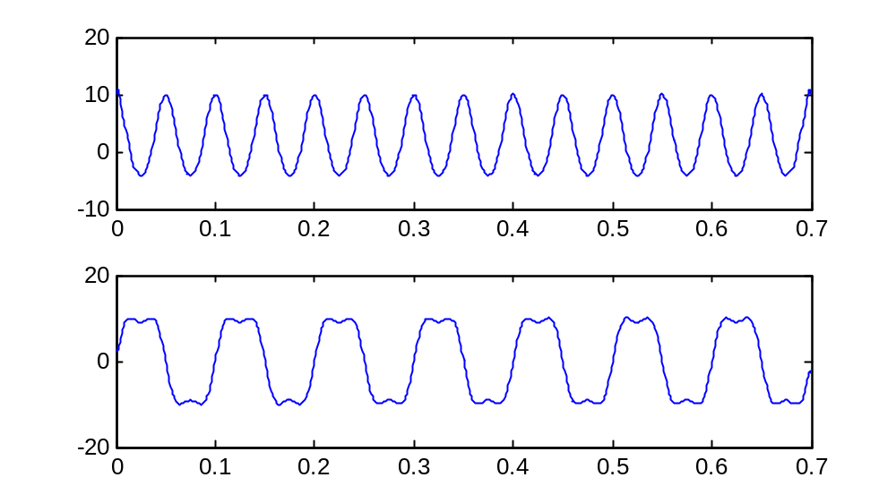
（e）由图可知，该结果与解析结果是一致的。

4.8
由傅立叶反变换：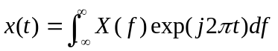可以得：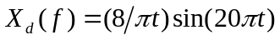
- 当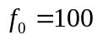，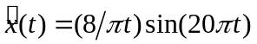，所以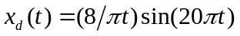，
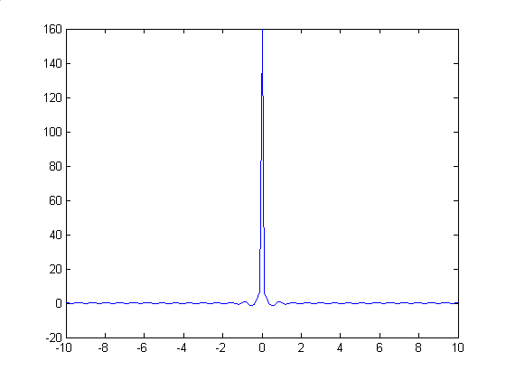
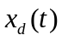的时域图形
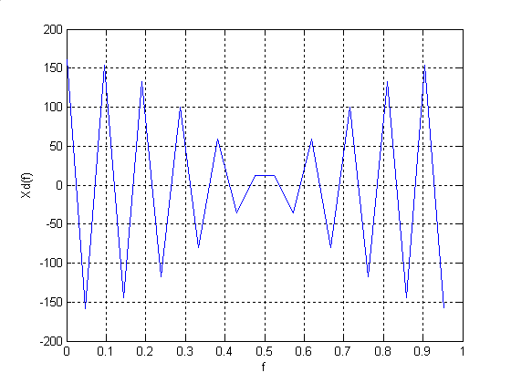
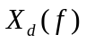的频域图形
- 当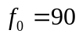，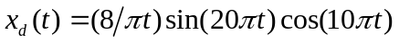，
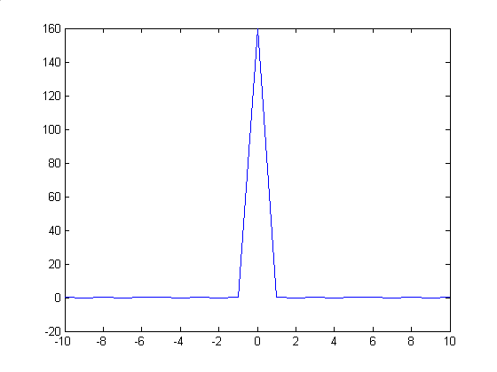
的时域图形
的频域图形

- 当，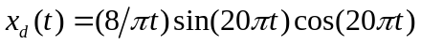
的频域图形
的时域图形

4.11
（a）
（b）当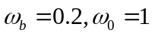时，
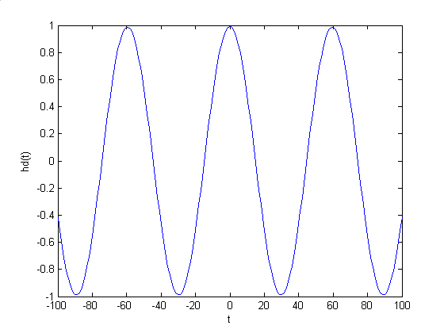
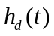的图形
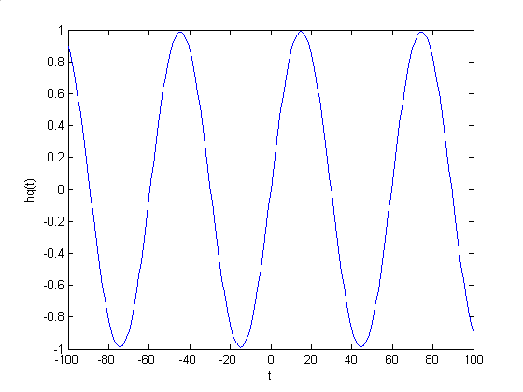
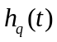的图形
- 当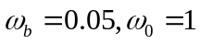时，
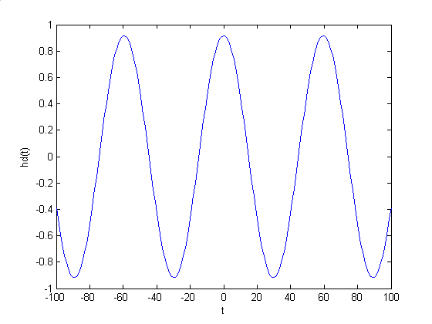
的图形
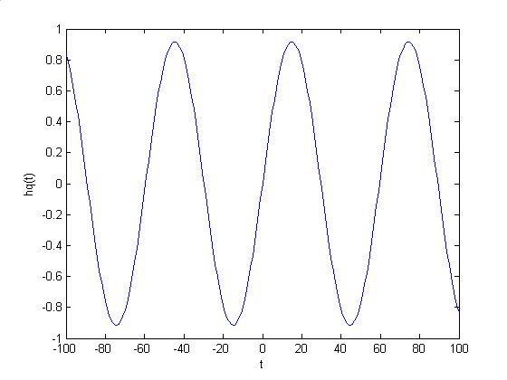
的图形
4-12
答：
（a）matlab程序： t=0:0.001:1;
x=5*(2+sin(2*pi*t)).*cos(20*pi*t+pi/6);
z=hilbert(x);
f0=10;
xl=z.*exp(-j*2*pi*f0*t);
xd=real(xl);
xq=-j*(xl-xd);
subplot(2,1,1)
plot(t,xd); title('xd (t)');
subplot(2,1,2);
plot(t,xq); title('xq (t)');
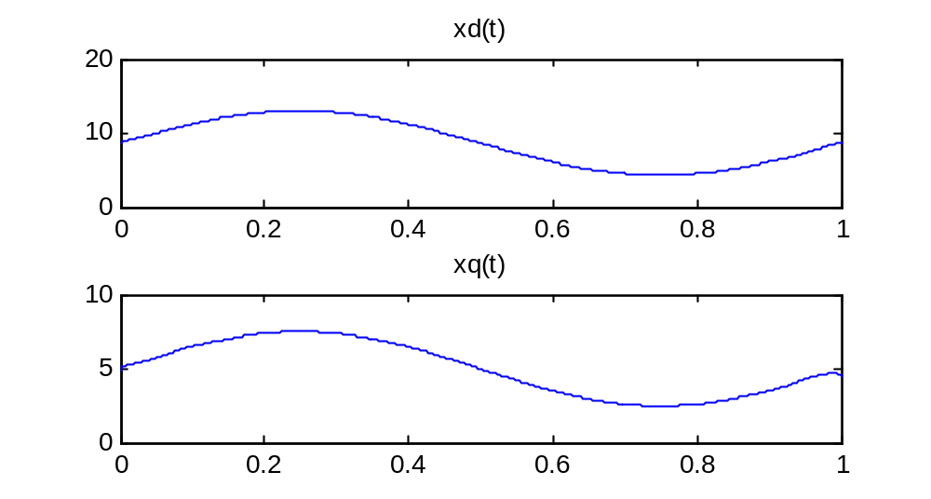
其中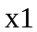即为x(t)的复包络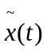。
(b) matlab程序： t=0:0.001:1;
x=5*(2+sin(2*pi*t)).*cos(20*pi*t+pi/6);
z=hilbert(x);
f0=10;
xl=z.*exp(-j*2*pi*f0*t);
xd=real(xl);
xq=-j*(xl-xd);
yd=(7*xd)/sqrt(xd.*xd+xq.*xq);
yq=(7*xq)/(sqrt(xd.*xd+xq.*xq));
yl=yd+j*yq;
z1=exp(j*2*pi*f0*t)*yl;
y=real(z1);
plot(t,y);
title(' 硬限幅器输出y(t)');
xlabel('t');
ylabel(' y(t)');
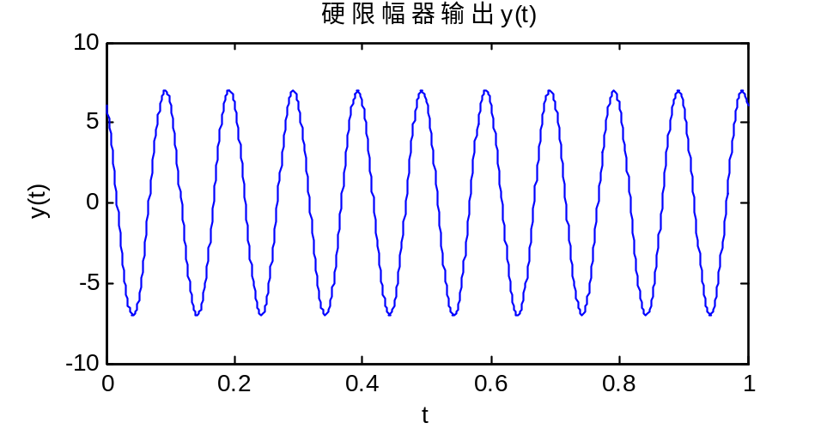
（c）matlab程序： t=0.0001:0.0001:1;
At=5*(2+sin(2*pi*t));f0=10;seta=pi/6;
xt=At.*cos(2*pi*f0*t+seta);
xlt=At.*exp(j*seta);

B=7;
Y2=hilbert(real(xlt));
y=y2.*exp(-j*2*pi*f0*t);
xdty=real(y);xqty=imag(y);
ydt=(B*xdty)./sqrt((xdty.^2)+(xqty.^2));
yqt=(B*xqty)./sqrt((xdty).^2+(xqty).^2);
ylt=ydt+j*yqt;
subplot(3,1,1);plot(ydt); title('yd(t)');
subplot(3,1,2);plot(yqt); title('yq(t)');
subplot(3,1,3);plot(abs(ylt)); title('y(t)复包络的幅值');
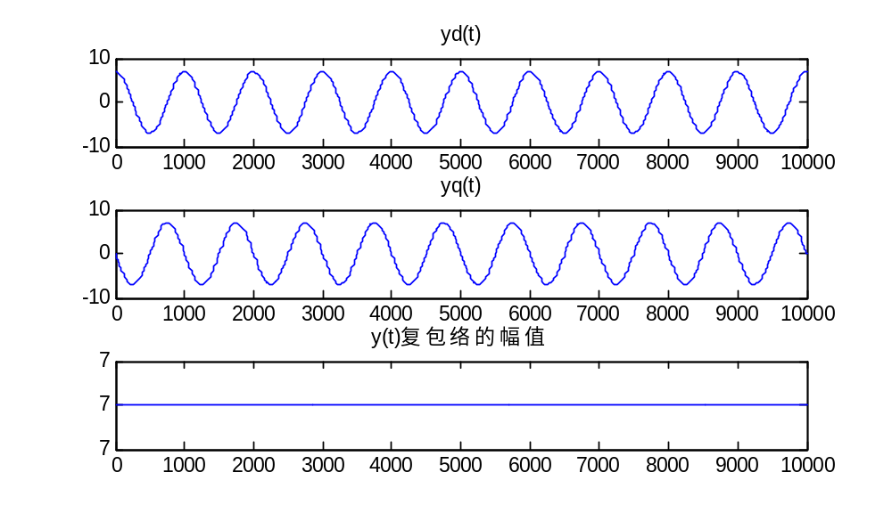
（d）matlab程序： t=0.001:0.001:1;
x=5*(2+sin(2*pi*t)).*cos(20*pi*t+pi/6);
z=hilbert(x);
f0=10;
xl=z.*exp(-j*2*pi*f0*t);
xd=real(xl);
xq=-j*(xl-xd);
yd=(7*xd)/sqrt(xd.*xd+xq.*xq);
yq=(7*xq)/(sqrt(xd.*xd+xq.*xq));
yl=yd+j*yq;
z1=exp(j*2*pi*f0*t)*yl;
y=real(z1);
yt=7*cos(20*pi*t+pi/6);
subplot(2,1,1);plot(t,y);title('仿真结果') ;
subplot(2,1,2);plot(t,yt);title('解析结果') ;
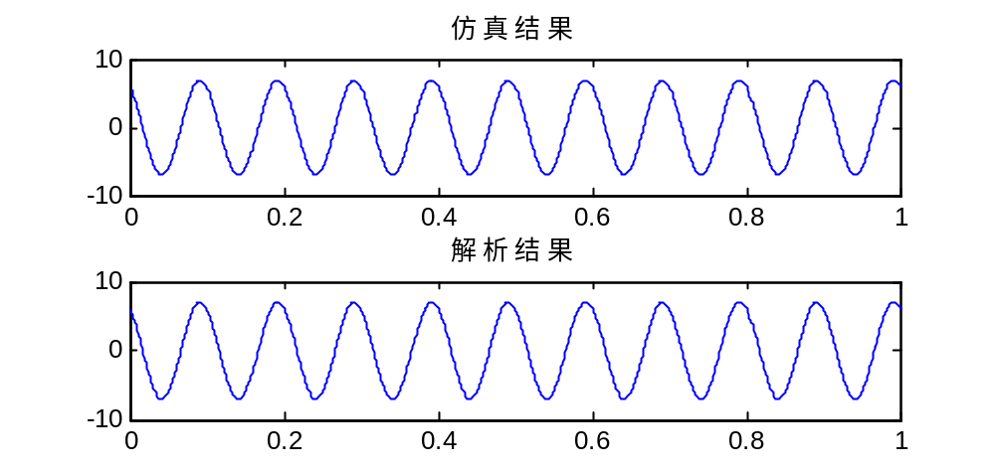
故，由上图分析可知，仿真产生的结果和解析结果是基本一致的。
（e）解析表达式：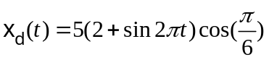，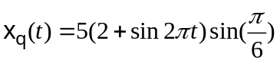，
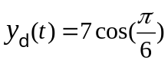， 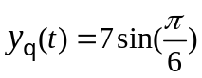
matlab程序： t=0:0.001:1;
xd=5*(2+sin(2*pi*t)*cos(pi/6));
xq=5*(2+sin(2*pi*t)*sin(pi/6));
yd=7*cos(pi/6);
yq=7*sin(pi/6);subplot(2,2,1);plot(t,xd);
subplot(2,2,2);plot(t,xq);
subplot(2,2,3);plot(t,yd);
subplot(2,2,4);plot(t,yq);
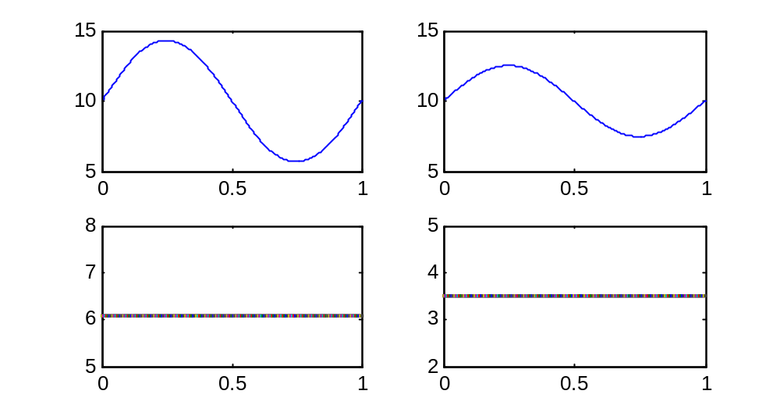
第5章 滤波器模型与仿真方法

5.10

clear all;
T = 0.01;
f = 0:0.1:50;
z = exp(-i*2*pi*f*T); % see (5.4)
a0 = 0.239057; a1 = 0.239057; b1 = 0.521886; % bilinear invariant
num = a0+a1*z;
den = 1-b1*z;
ampx=abs(num./den);
plot(f,ampx);
xlabel('Frequency - Hz')
ylabel('amplitude Response')
% End of script file.

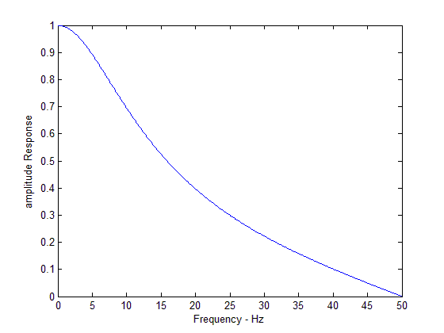
幅度响应
clear all;
T = 0.01;
f = 0:0.1:50;
z = exp(-i*2*pi*f*T); % see (5.4)
a0 = 0.239057; a1 = 0.239057; b1 = 0.521886; % bilinear invariant
num = a0+a1*z;
den = 1-b1*z;
anglex=angle(num./den);
plot(f,anglex);
xlabel('Frequency - Hz')
ylabel('phase Response')
% End of script file.

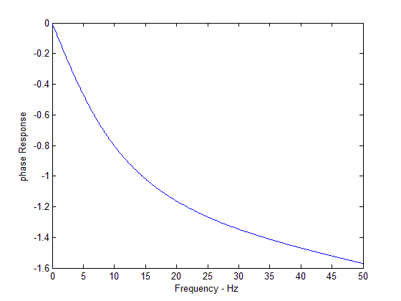
相位响应
5-12
答：matlab程序： T = 1;
k = 10;
m = 4;
beta = 0.2;
n = 0:2*m*k;
z = (n/k)-m+eps;
t1 = cos((1+beta)*pi*z);
t2 = sin((1-beta)*pi*z);
t3 = 1./(4*beta*z);
den = 1-16*beta*beta*z.*z;
num = t1+t2.*t3;
c = 4*beta/(pi*sqrt(T));
h = c*num./den;
in = zeros(1,101); in(11) = 1;
out = conv(in,h);
out1 = conv(out,h);
t = 2:0.1:8;
subplot(2,1,1);
stem(t,out(21:81),'.')
grid;
xlabel('Time');
ylabel('h[n-1]');
subplot(2,1,2);
t = 6:0.1:12;
stem(t,out1(61:121),'.');
grid;
xlabel('Time');
ylabel('conv(h[n-1],h[n])');
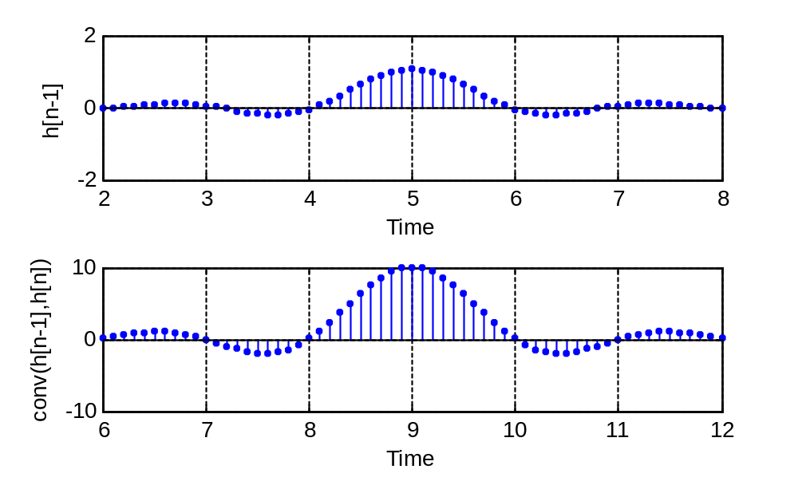
beta = 0.5时：
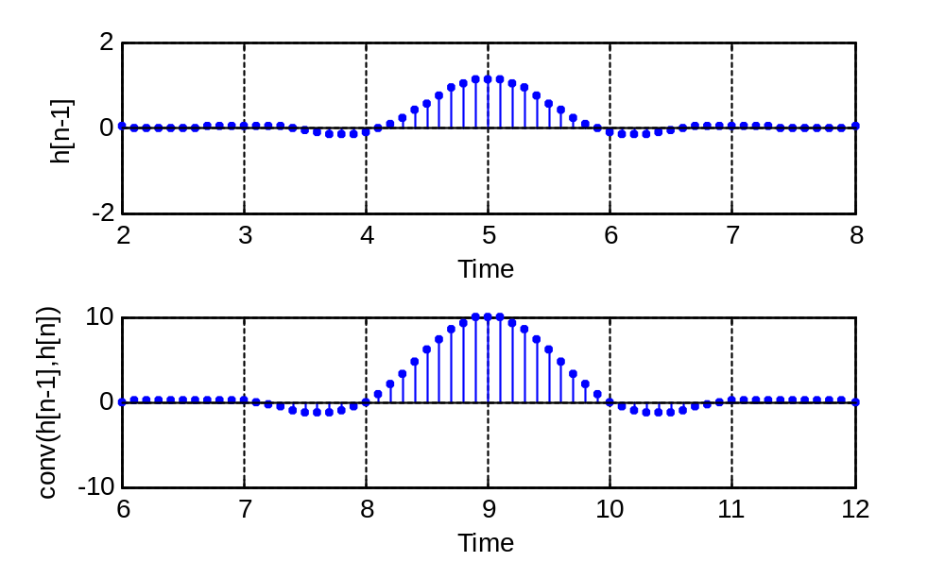
beta = 0.7时：
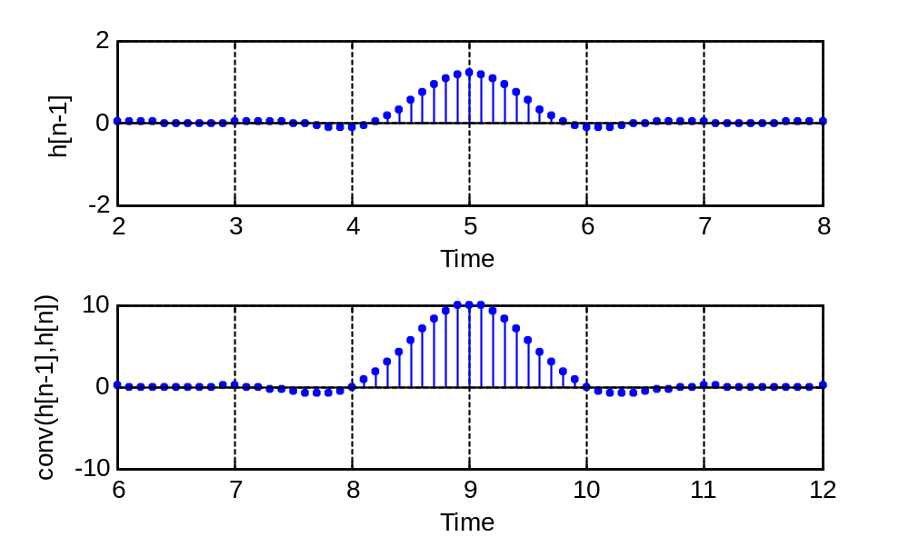
beta = 0.9时：
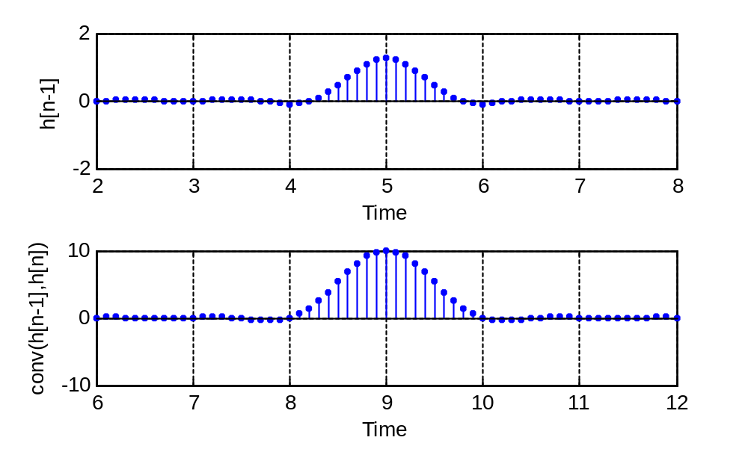
5-13
答：
（a）matlab程序： order=50;
f=[0,0.4,0.44,1];
amp=[1 1 0 0 ];
b=remez(order,f,amp);
stem(b,'.k')
xlabel('采样序数')
ylabel('幅度')
pause
freqz(b,1)
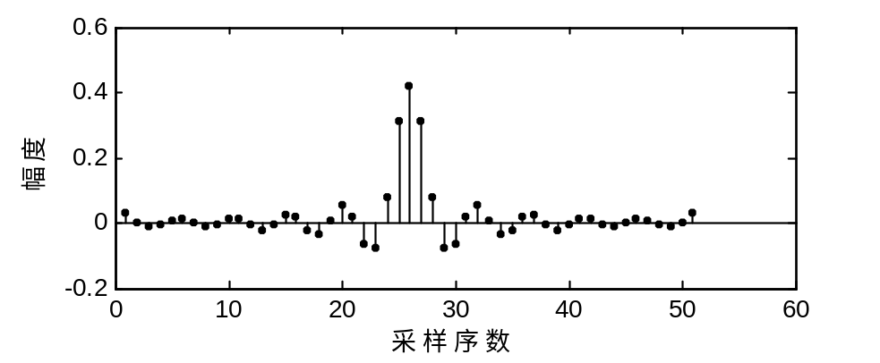
（b）由（a）中程序可知幅度响应和相位响应如下：
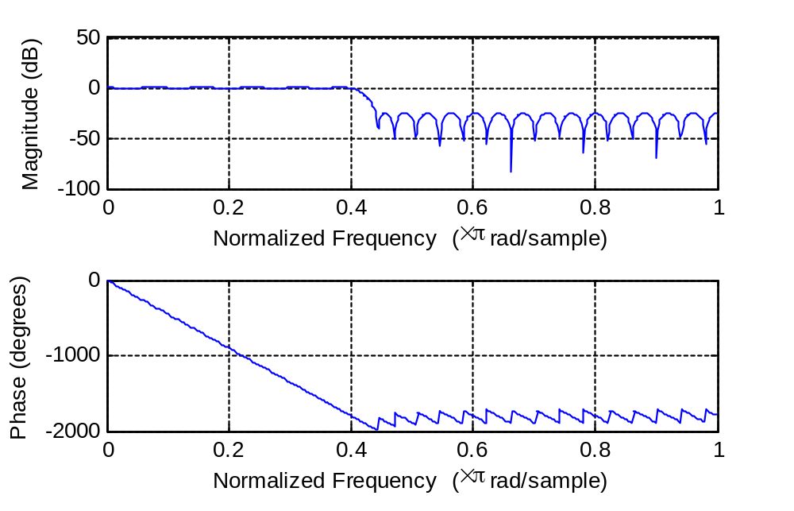
阻带衰减约为25dB.
（c）过渡带为20HZ<|f|<25 HZ时，
order = 50;
f = [0 0.4 0.5 1];
amp = [1 1 0 0];
b = remez(order,f,amp);
stem(b,'.k')
xlabel('采样序数')
ylabel('幅度')
pause
freqz(b,1)
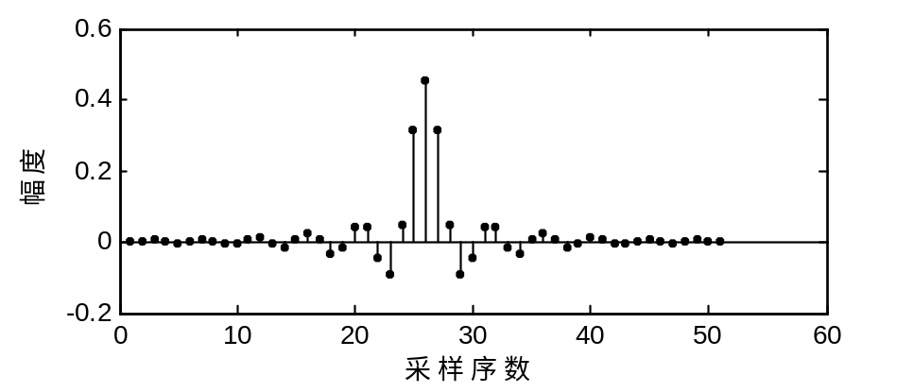
幅度和相位响应如下：
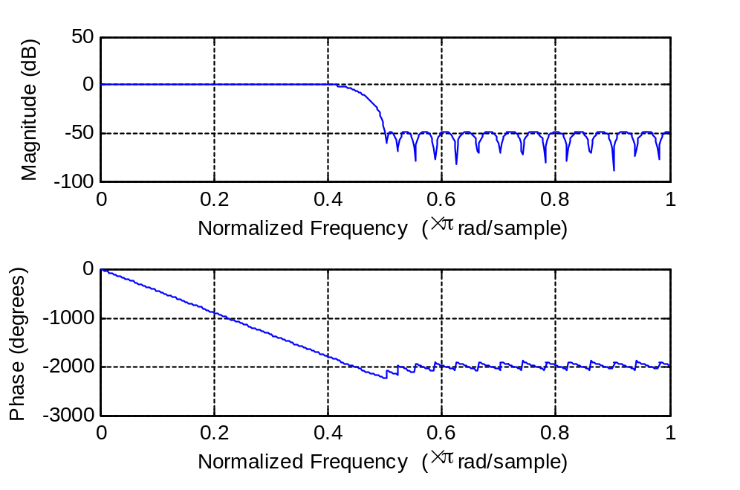
当阶数order为20时，幅度响应与相位响应如下图所示：
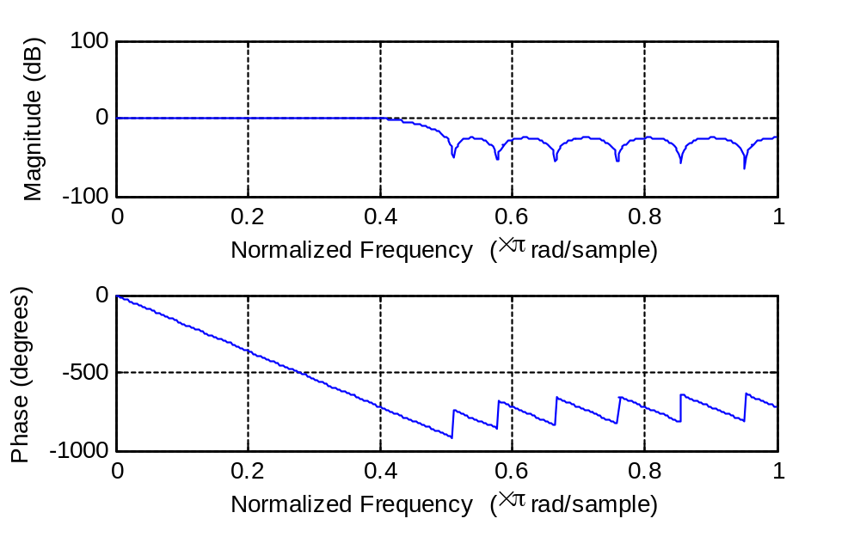
所以，可以通过降低滤波器阶数来降低阻带衰减。
第6章 案例研究：锁相环与微分方程方法
6.3
第一步：
% File: pllpre.m
% Software given here is to accompany the textbook: W.H. Tranter,
% K.S. Shanmugan, T.S. Rappaport, and K.S. Kosbar, Principles of
% Communication Systems Simulation with Wireless Applications,
% Prentice Hall PTR, 2004.
%
clear all % be safe
disp(' ') % insert blank line
fdel = input('Enter the size of the frequency step in Hertz > ');
fn = input('Enter the loop natural frequency in Hertz > ');
lambda = input('Enter lambda, the relative pole offset > ');
disp(' ')
disp('Accept default values:')
disp(' zeta = 1/sqrt(2) = 0.707,')
disp(' fs = 200*fn, and')
disp(' tstop = 1')
dtype = input('Enter y for yes or n for no > ','s');
if dtype == 'y'
zeta = 1/sqrt(2);
fs = 200*fn;
tstop = 1;
else
zeta = input('Enter zeta, the loop damping factor > ');
fs = input('Enter the sampling frequency in Hertz > ');
tstop = input('Enter tstop, the simulation runtime > ');
end
%
npts = fs*tstop+1; % number of simulation points
t = (0:(npts-1))/fs; % default time vector
nsettle = fix(npts/10); % set nsettle time as 0.1*npts
tsettle = nsettle/fs; % set tsettle
%
% The next two lines establish the loop input frequency and phase
% deviations.
%
fin = [zeros(1,nsettle),fdel*ones(1,npts-nsettle)];
phin = [zeros(1,nsettle),2*pi*fdel*t(1:(npts-nsettle))];
%
disp(' ') % insert blank line
% end of script file pllpre.m
在command window中进行一下对话：
Enter the size of the frequency step in Hertz > 40
Enter the loop natural frequency in Hertz > 10
Enter lambda, the relative pole offset > 0

Accept default values:
zeta = 1/sqrt(2) = 0.707,
fs = 200*fn, and
tstop = 1
Enter y for yes or n for no > n
Enter zeta, the loop damping factor > 1/sqrt(2)
Enter the sampling frequency in Hertz > 5000
Enter tstop, the simulation runtime > 0.8

第二步：
%File: c6_PLLsim.m
w2b=0;w2c=0;s5=0;phivco=0; %initialize
twopi=2*pi; %define 2*pi
twofs=2*fs; %define 2*fs
G=2*pi*fn*(zeta+sqrt(zeta*zeta-lambda)); %set loop gain
a=2*pi*fn/(zeta+sqrt(zeta*zeta-lambda)); %set filter parameter
a1=a*(1-lambda);a2=a*lambda; %define constants
phierror=zeros(1,npts); %initialize vector
fvco=zeros(1,npts); %initialize vector

% beginning of simulation loop
for i=1:npts
s1=phin(i)-phivco; %phase error
s2=sin(s1); %sinusoidal phase detector
s3=G*s2;
s4=a1*s3;
s4a=s4-a2*s5; %loop filter integrator input
w1b=s4a+w2b; %filter integrator (step 1)
w2b=s4a+w1b; %filter integrator (step 2)
s5=w1b/twofs; %generate filter output
s6=s3+s5; %VCO integrator input
w1c=s6+w2c; %VCO integrator (step 1)
w2c=s6+w1c; %VCO integrator (step 2)
phivco=w1c/twofs; %generate VCO output
phierror(i)=s1; %build phase error vector
fvco(i)=s6/twopi; %build VCO input vector
end
% end of simulation loop
freqerror=fin-fvco; %build frequency error vector
%End of script file

第三步：
% File: pllpost.m
% Software given here is to accompany the textbook: W.H. Tranter,
% K.S. Shanmugan, T.S. Rappaport, and K.S. Kosbar, Principles of
% Communication Systems Simulation with Wireless Applications,
% Prentice Hall PTR, 2004.
%
kk = 0;
while kk == 0
k = menu('Phase Lock Loop Postprocessor',...
'Input Frequency and VCO Frequency',...
'Input Phase and VCO Phase',...
'Frequency Error','Phase Error','Phase Plane Plot',...
'Phase Plane and Time Domain Plots','Exit Program');
if k == 1
plot(t,fin,'k',t,fvco,'k')
title('Input Frequency and VCO Freqeuncy')
xlabel('Time - Seconds');ylabel('Frequency - Hertz');pause
elseif k ==2
pvco=phin-phierror;plot(t,phin,t,pvco)
title('Input Phase and VCO Phase')
xlabel('Time - Seconds');ylabel('Phase - Radians');pause
elseif k == 3
plot(t,freqerror);title('Frequency Error')
xlabel('Time - Seconds');ylabel('Frequency Error - Hertz');pause
elseif k == 4
plot(t,phierror);title('Phase Error')
xlabel('Time - Seconds');ylabel('Phase Error - Radians');pause
elseif k == 5
ppplot
elseif k == 6
subplot(211);phierrn = phierror/pi;
plot(phierrn,freqerror,'k');grid;
title('Phase Plane Plot');xlabel('Phase Error /Pi');
ylabel('Frequency Error - Hertz');subplot(212)
plot(t,fin,'k',t,fvco,'k');grid
title('Input Frequency and VCO Freqeuncy')
xlabel('Time - Seconds');ylabel('Frequency - Hertz');subplot(111)
elseif k == 7
kk = 1;
end
end
% End of script file.
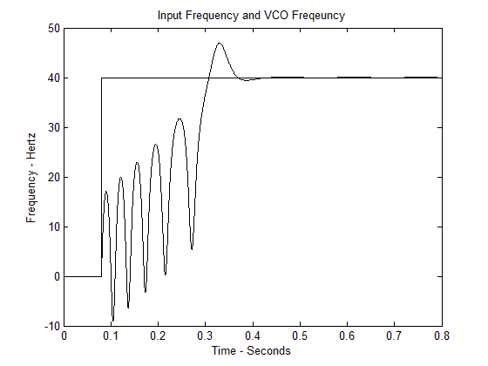
当相对极点偏移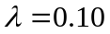时，有6个滑动周期
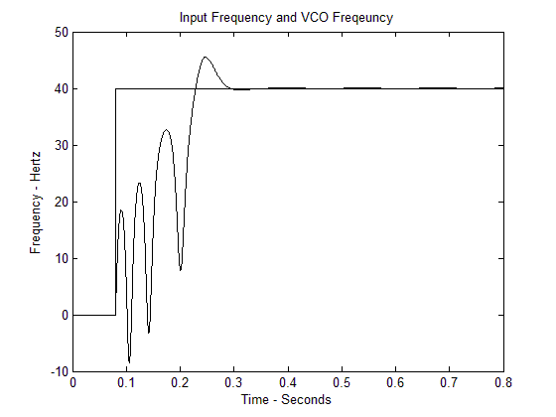
当相对极点偏移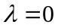时，有4个滑动周期，缩短了2个周期，时间降低了0.1s。
6.4
当相对极点偏移时，相位差随频率差如下图：
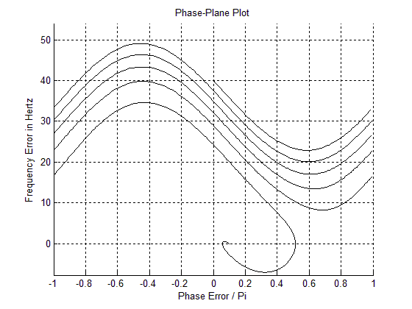
当相对极点偏移时，相位差随频率差如下图：
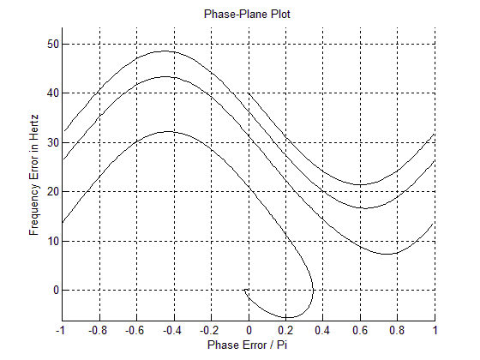
当相对极点偏移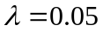时，相位差随频率差如下图：
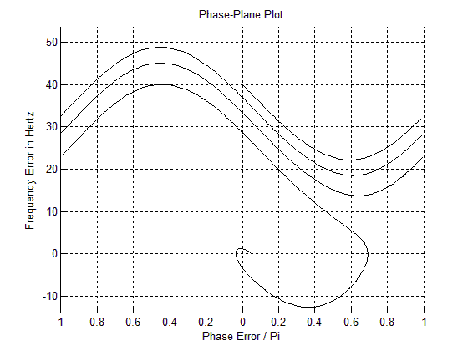
当相对极点偏移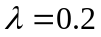时，相位差随频率差如下图：
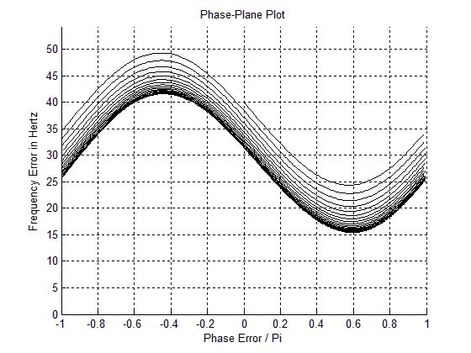
由上面几副图可知：当时，不能捕获，即无法达到稳态误差。

6.5
当采样频率为50Hz时：
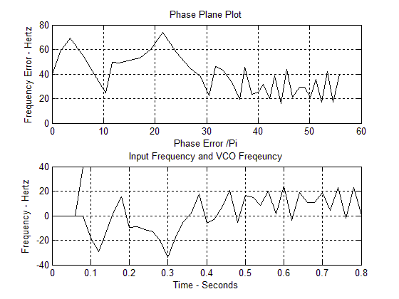
当采样频率为100Hz时：
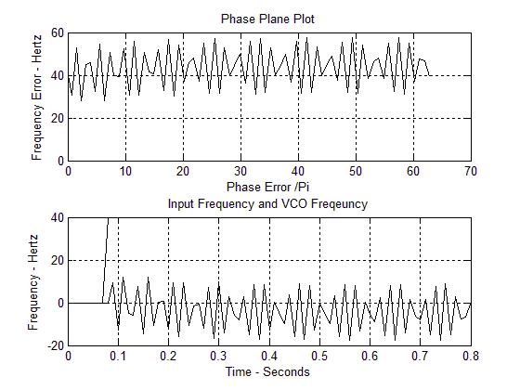
当采样频率为500Hz时：
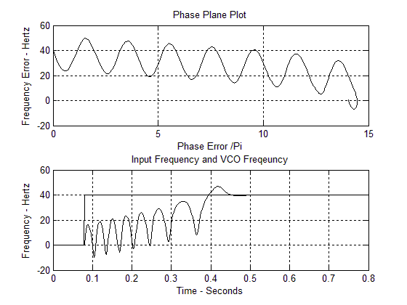
当采样频率为10000Hz时：
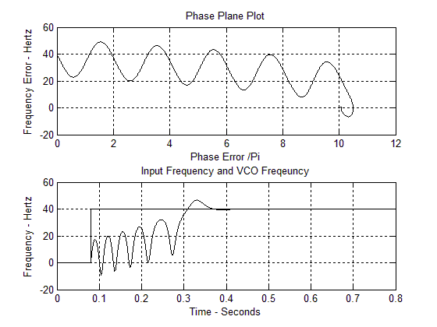
由上面四幅图可知：采样频率越大，结果越精确，收敛时间越快，但是当相位误差能够趋于0时，采样频率即为合适的。
6-11
答：matlab程序： clear all
disp(' ')
fdel=input('Enter the size of the frequency step in Hertz>');
fn=input('Enter the loop natural frequency in Hertz>');
lambda=input('Enter lambda,the relative pole offset>');
disp(' ')
disp('Accept default values:')
disp('zeta=1/sqrt(2)')
disp('tstop=0.8')
dtype=input('Enter y for yes or n for no>','s');
if dtype=='y'
zeta=1/sqrt(2);
fs=200*fn;
tstop=1;
else
zeta=input('Enter zeta,the lop dmping factor>');
fs=input('Enter the sampling frequency in Hertz>');
tstop=input('Enter tstop,the simulation runtime>');
end
npts=fs*tstop+1;
t=(0:(npts-1))/fs;
nsettle=fix(npts/10);
tsettle=nsettle/fs;
fin=[zeros(1,nsettle),fdel*ones(1,npts-nsettle)];
phin=[zeros(1,nsettle),2*exp(t(1:(npts-nsettle)))];
disp(' ')

w2b=0;w2c=0;s5=0;phivco=0; %initialize
twopi=2*pi;
twofs=2*fs;
G=2*pi*fn*(zeta+sqrt(zeta*zeta-lambda));
a=2*pi*fn/(zeta+sqrt(zeta*zeta-lambda));
a1=a*(1-lambda);a2=a*lambda;
%npts=1+fs*tfinal;
phierror=zeros(1,npts);
fvco=zeros(1,npts);
for i=1:npts
s1=phin(i)-phivco;
s2=sin(s1);
s3=G*s2;
s4=a1*s3;
s4a=s4-a2*s5;
w1b=s4a+w2b;
w2b=s4a+w1b;
s5=w1b/twofs;
s6=s3+s5;
w1c=s6+w2c;
w2c=s6+w1c;
phivco=w1c/twofs;
phierror(i)=s1;
fvco(i)=s6/twopi;
end
freqerror=fin-fvco;
kk=0;
while kk==0
k=menu('Phase Lock Loop Postprocessor',...
'Input Frequency and VCO Frequency','Input Phase and VCO Phase',...
'Phase Plane and Time Domain Plots','Exit Program');
if k==1
plot(t,fin,t,fvco)
title('Input Frequency and VCO Frequency')
xlabel('Time-Seconds');ylabel('Frequency-Hertz');
pause
elseif k==2
pvco=phin-phierror;
plot(t,phin,t,pvco)
title('Input Phase and VCO Phase')
xlabel('Time-Seconds');ylabel('Phase-Radians');
pause
elseif k==3
plot(t,freqerror);
title('Frequency Error')
xlabel('Time-Seconds');ylabel('Frequency Error-Hertz');
pause
elseif k==4
plot(t,phierror);
title('Phase Error')
xlabel('Time-Seconds');ylabel('Phase Error-Radians');
pause
elseif k==5
ppplot
elseif k==6
subplot(211);
phierrn=phierr/pi;
plot(phierrn,freqerror);
grid;
title('Phase Plane Plot');
xlabel('Phase Error/pi');ylabel('Frequency Error-Hertz');
subplot(212)
plot(t,fin,t,fvco);grid
title('Input Frequency and VCO Frequency')
xlabel('Time-Seconds');ylabel('Frequency-Hertz');
subplot(111)
elseif k==7
kk=1;
end
end

kz=0;
while kz==0
k=menu('Phase Plane Options',...
'Extend Phase Plane',...
'Phase Plane mod(2pi)',...
'Exit Phase Plane Menu');
if k==1
phierrn=phierror/pi;
plot(phierrn,freqerror,'k')
title('Phase Plane Plot')
xlabel('Phase Error/Pi');ylabel('Frequency Error-Hertz')
grid
pause
elseif k==2
pplane(phierror,freqerror,nsettle+1);
pause
elseif k==3
kz=1;
end
end

function pplane=pplane(x,y,nsettle)
ln=length(x);
maxfreq=max(y);
minfreq=min(y);
close
axis([-1,1,1.1*minfreq 1.1*maxfreq]);
hold on
j=nsettle;
while j<ln
i=1;
while x(j)<pi&j<ln
a(i)=x(j)/pi;
b(i)=y(j);
j=j+1;
i=i+1;
end
plot(a,b,'k')
a=[];
b=[];
x=x-2*pi;
end
hold off
title('Phase-Plane Plot')
xlabel('Phase Error/Pi');ylabel('Frequency Error in Hertz')
grid

Enter the size of the frequency step in Hertz>40
Enter the loop natural frequency in Hertz>10
Enter lambda,the relative pole offset>0.1

Accept default values:
zeta=1/sqrt(2)
tstop=0.8
Enter y for yes or n for no>y
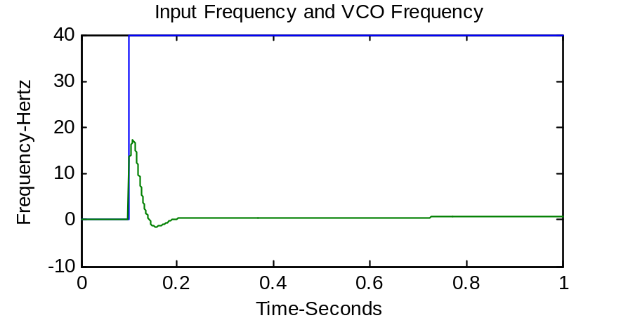
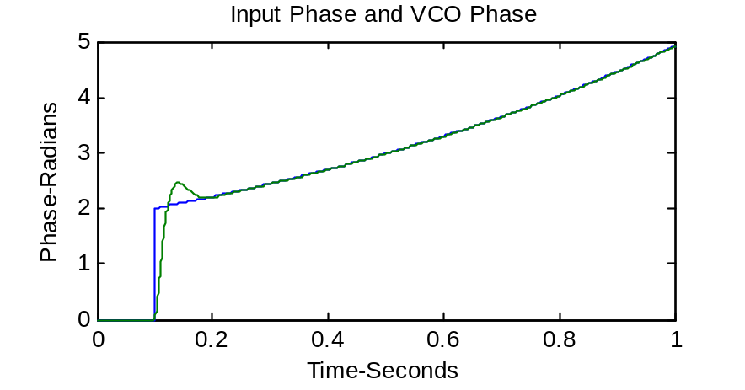
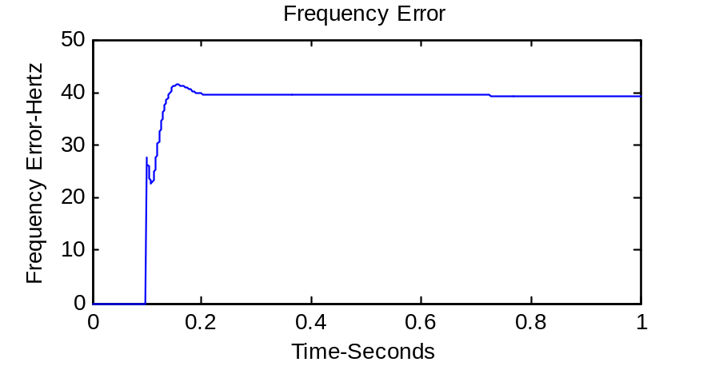
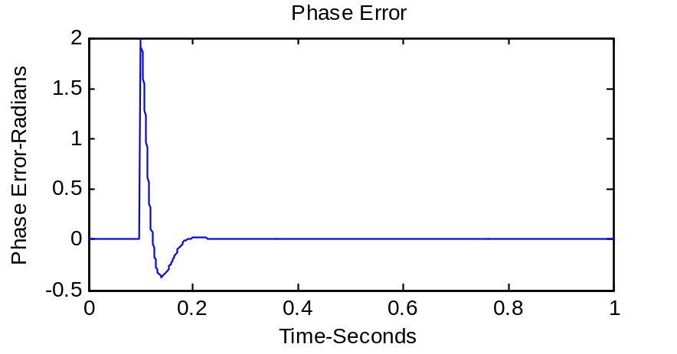
6-14
答：matlab程序： w2b=0;w2c=0;
yd=0;y=0;
tfinal=50;
fs=100;
delt=1/fs;
npts=1+fs*tfinal;
ydv=zeros(1,npts);
yv=zeros(1,npts);
for i=1:npts
t=(i-1)*delt;
ydd1=-y-abs(y)*yd;
w1b=ydd1+w2b;
w2b=ydd1+w1b;
yd=w1b/(2*fs);
w1c=yd+w2c;
w2c=yd+w1c;
y=w1c/(2*fs);
ydv(1,i)=yd;
yv(1,i)=y;
if t==0
y=1;yd=0;
ydd1=0;ydd2=0;
end
end
subplot(2,1,1);
plot(yv,ydv)
xlabel('y(t)1')
ylabel('dy/dt')
for i=1:npts
t=(i-1)*delt;
ydd2=-y-y*abs(yd);
w1b=ydd2+w2b;
w2b=ydd2+w1b;
yd=w1b/(2*fs);
w1c=yd+w2c;
w2c=yd+w1c;
y=w1c/(2*fs);
ydv(1,i)=yd;
yv(1,i)=y;
if t==0
y=1;yd=0;
ydd1=0;ydd2=0;
end
end
subplot(2,1,2);
plot(yv,ydv)
axis([-0.03 0.03 -0.05 0.05])
xlabel('y(t)2')
ylabel('dy/dt')

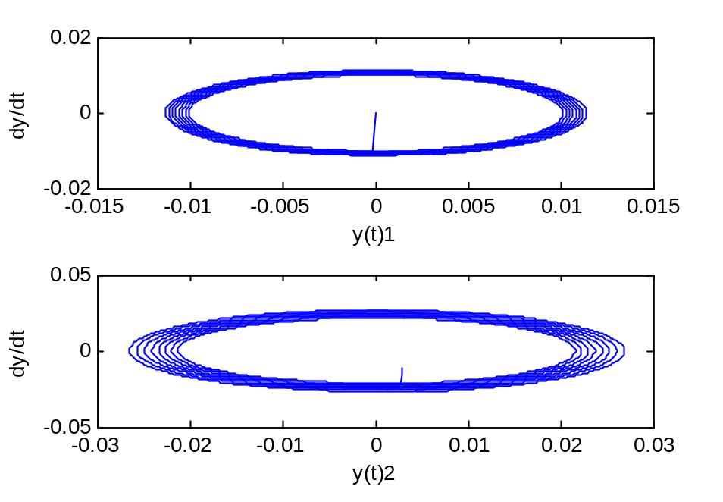
第7章 随机信号的产生与处理
7-19
答：matlab程序： R=7;M=2/pi;
N=input('Input number of points N > ');
fx=zeros(1,N);
u1=rand(1,N);u2=rand(1,N);
v1=R*u1;
v2=(M/R)*rand(1,N);
kpts=0;
for k=1:N
if v2(k)<(M/(R*R))*sqrt(R*R-v1(k)*v1(k));
kpts=kpts+1;
fx(kpts)=v1(k);
end
end
fx=fx(1:kpts);
[N_samp,x]=hist(fx,20);
subplot(2,1,1)
bar(x,N_samp,1)
ylabel('Number of Samples')
xlabel('Independent Variable - x')
yt=(M/R/R)*sqrt(R*R-x.*x);
del_x=x(3)-x(2);
p_hist=N_samp/(kpts*del_x);
subplot(2,1,2)
plot(x,yt,'k',x,p_hist,'ok')
ylabel('Probability Density');
xlabel('Independent Variable -x');
legend('true pdf','samples from histogram',3);
text=['The number of points accepted is',...
num2str(kpts,15),'and N is',num2str(N,15),'.'];
disp(text);
输入数据： Input number of points N > 6000
The number of points accepted is4753and N is6000.
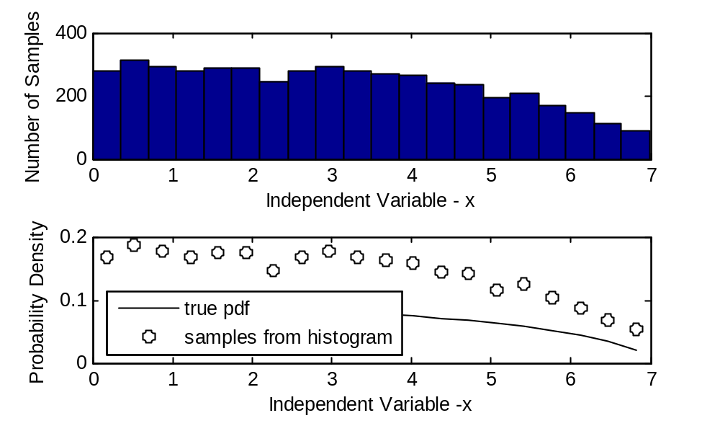
7.20
fd=10;
fs=16*fd;ts=1/fs;
time=1*ts:ts:128*ts;
htt=(pi*fd*time).^(-1/4)/gamma(3/4)*fd.*Bessel(1/4,2*pi*fd*time);
stem(time,htt)
xlabel('time');
ylabel('impulse response');
axis([0 1 -4 8])

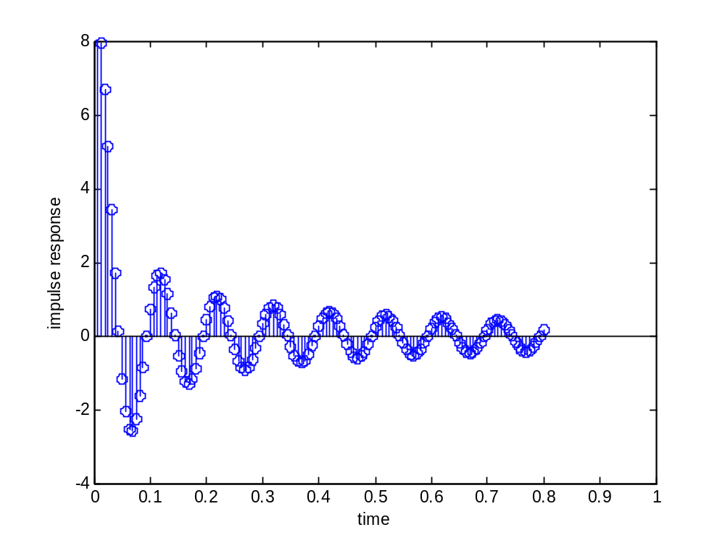
fd = 10;
impw = jakes_filter(fd);
fs = 16*fd; ts = 1/fs;
time = [1*ts:ts:128*ts];
subplot(1,1,1)
stem(time,impw,'.'); grid
xlabel('Time'); ylabel('Impulse Response')
[h f] = linear_fft(impw,128,ts)；
x = randn(1,1024);
y = filter(impw,1,x);
[output_psd ff] = log_psd(y,1024,ts);
figure;
subplot(2,1,1)
plot(ff,output_psd); grid;
axis([-500 500 -50 0])
xlabel('Frequency'); ylabel('PSD')
z = randn(1,1024)+i*randn(1,1024);
zz = filter(impw,1,z);
time = (0.0:ts:1024*ts);
zz = zz/max(max(abs(zz)));
subplot(2,1,2)
plot(time(161:480),10*log10(abs(zz(161:480)))); grid
axis([0.1 0.3 -20 0])
xlabel('Time'); ylabel('Log Amplitude')
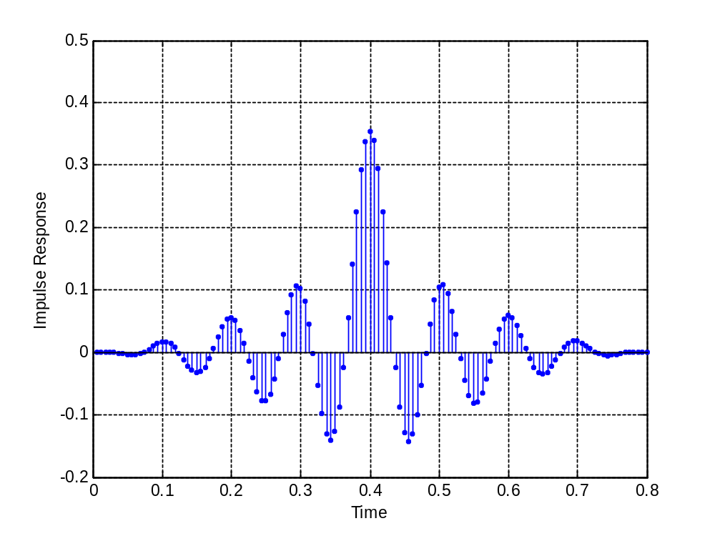

7.20
由matlab程序可以得到h(t)的图：
%c7_20 impulse
t=-1:0.0001:1;
h=(pi*10*t).^(-1/4)./gamma(3/4)*10.*besselj(1/4,20*pi*t);
plot(t,h);
xlabel('t');
ylabel('h(t)');

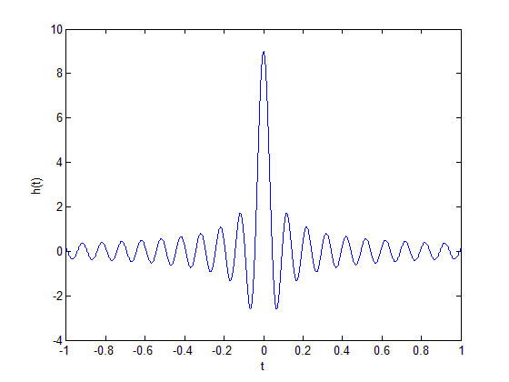

7.21
(a)当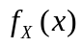，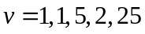时，的图形如下：
clear all
v=[1 1.5 2 2.5];
for i=1:4
subplot(2,2,i)
x=-5:0.0001:5;
f=(v(i)/(sqrt(8)*gamma(1/v(i))))*exp(-(abs(x/sqrt(2))).^v(i));
plot(x,f);
end
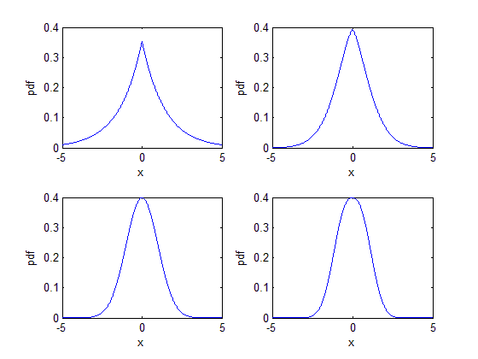
(b)
由上面的几副图可得： 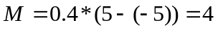
clear all
a = 5; % default value of R
M = 4; % value of M
N = input('Input number of points N > '); % set N
fx = zeros(1,N); % array of output samples
u1 = rand(1,N); u2 = rand(1,N); % generate u1 and u2
v1 = 2*a*u1-5; % generate v1
v2 = M/10*rand(1,N);
kpts = 0; % initialize counter
for k=1:N
if v2(k)<M*(1.5/(sqrt(8)*gamma(1/1.5)))*exp(-(abs(v1(k)/sqrt(2))).^1.5);
kpts=kpts+1; % increment counter
fx(kpts)=v1(k); % save output sample
end
end
fx = fx(1:kpts);
[N_samp,x] = hist(fx,2000); % get histogram parameters
yt =M*(1.5/(sqrt(8)*gamma(1/1.5)))*exp(-(abs(x/sqrt(2))).^1.5); % calculate pdf
plot(x,yt,'k')%,x,p_hist,'ok') % compare
ylabel('Probability Density')
xlabel('Independent Variable - x')
legend('true pdf','samples from histogram',3)
text = ['The number of points accepted is ',...
num2str(kpts,15),' and N is ',num2str(N,15),'.'];
disp(text)
% End of script file.
运行该程序：
Input number of points N > 2000
The number of points accepted is 993 and N is 2000.
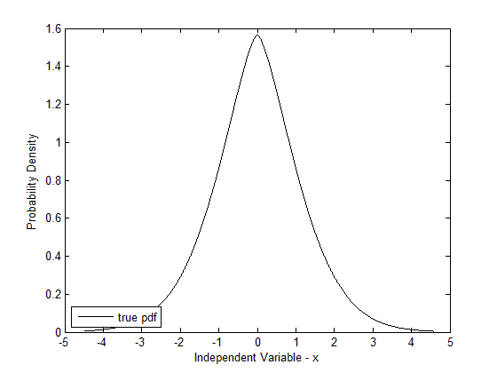
(c)
clear all
a = 5; % default value of R
M = 4; % value of M
N = input('Input number of points N > '); % set N
fx = zeros(1,N); % array of output samples
u1 = rand(1,N); u2 = rand(1,N); % generate u1 and u2
v1 = 2*a*u1-5; % generate v1
v2 = M/10*rand(1,N);
kpts = 0; % initialize counter
for k=1:N
if v2(k)<M*(1.5/(sqrt(8)*gamma(1/1.5)))*exp(-(abs(v1(k)/sqrt(2))).^1.5);
kpts=kpts+1; % increment counter
fx(kpts)=v1(k); % save output sample
end
end
fx = fx(1:kpts);
[N_samp,x] = hist(fx,10000); % get histogram parameters
bar(x,N_samp,1) % plot histogram
ylabel('Number of Samples')
xlabel('Independent Variable - x')
text = ['The number of points accepted is ',...
num2str(kpts,15),' and N is ',num2str(N,15),'.'];
disp(text)
% End of script file.
运行程序：
Input number of points N > 200000
The number of points accepted is 98788 and N is 200000.
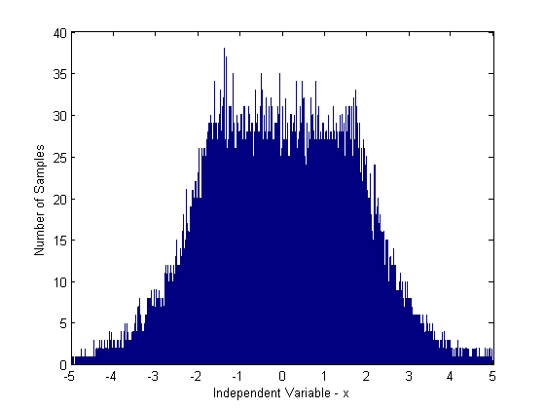
7-23
答：matlab程序： % FIR implementation of the Jakes filter (128 points)
n = 512; nn = 2*n;
fd=10000;
fs = 0:fd/64:fd;
H = zeros(1,n);
for k=1:(n/8+1)
jpsd(k)=(1-cos(pi*fs(k)/fd))^2;
H(k)=jpsd(k)^0.5;
end;
for k=1:n
H(n+k) = H(n+1-k);
end
[inv,time] = linear_fft(H,nn,fd/64);
imp = real(inv(450:577));
impw = imp.*hanning(128)';
energy = sum(impw.^2)
impw = impw/(energy^0.5);
% End of function file.
ts = 1/(16*fd);
time = [1*ts:ts:128*ts];
subplot(3,1,1)
stem(time,impw,'.'); grid
xlabel('Time'); ylabel('Impulse Response')
% Square the fft and check the power transfer function.
[h f] = linear_fft(impw,128,ts);
subplot(3,1,2)
plot(f,abs(h.*h)); grid;
xlabel('Frequency'); ylabel('PSD')
%get the Rxx fuction
Y=ifft(abs(h.*h),512);
Pyy=Y.*conj(Y)/512;
f =(0:256)/512;
subplot(3,1,3)
plot(f,Pyy(1:257));grid;
title('Frequency content of y')
xlabel('frequency (Hz)'); ylabel('Rxx');
% End of file.
其中， File: linear_fft.m如下：
function [fftx,freq] = linear_fft(x,n,ts)
y = zeros(1,n);
for k=1:n
freq(k) =(k-1-(n/2))/(n*ts);
y(k) = x(k)*((-1.0)^(k+1));
end;
fftx = fft(y)/n;
% End of function file.
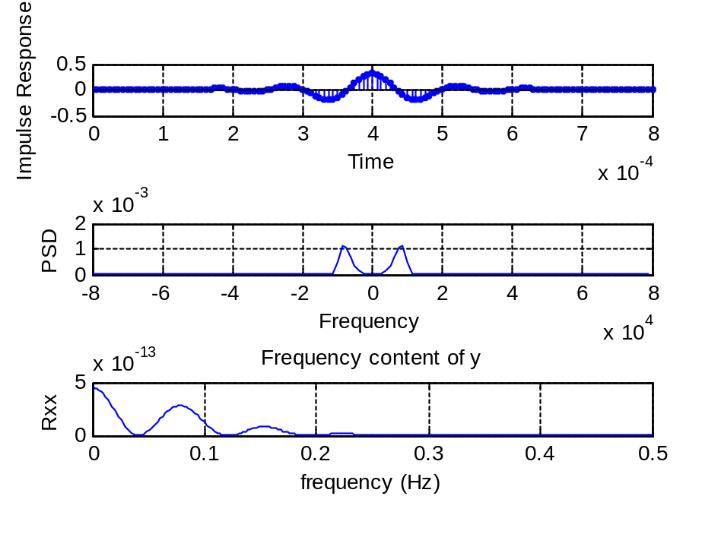
第8章 后处理
8-1
答：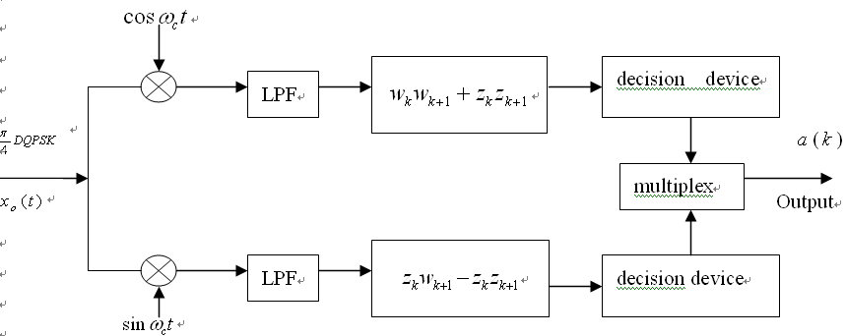
matlab程序： m = 200; bits = 2*m;
sps = 10;
iphase = 0;
order = 5;
bw = 0.2;
data = zeros(1,bits); d = zeros(1,m); q = zeros(1,m);
dd = zeros(1,m); qq = zeros(1,m); theta = zeros(1,m);
thetaout = zeros(1,sps*m);
data = round(rand(1,bits));
dd = data(1:2:bits-1);
qq = data(2:2:bits);
theta(1) = iphase;
thetaout(1:sps) = theta(1)*ones(1,sps);
for k=2:m
if dd(k) == 1
phi_k = (2*qq(k)-1)*pi/4;
else
phi_k = (2*qq(k)-1)*3*pi/4;
end
theta(k) = phi_k + theta(k-1);
for i=1:sps
j = (k-1)*sps+i;
thetaout(j) = theta(k);
end
end
d = cos(thetaout);
q = sin(thetaout);
[b,a] = butter(order,bw);
df = filter(b,a,d);
qf = filter(b,a,q);
kk = 0;
while kk == 0
k = menu('pi/4 QPSK Plot Options',...
'Unfiltered pi/4 QPSK Signal Constellation',...
'Unfiltered pi/4 QPSK Eye Diagram',...
'Filtered pi/4 QPSK Signal Constellation',...
'Filtered pi/4 OQPSK Eye Diagram',...
'Unfiltered Direct and Quadrature Signals',...
'Filtered Direct and Quadrature Signals',...
'Exit Program');
if k == 1
sigcon(d,q)
pause
elseif k ==2
dqeye(d,q,4*sps)
pause
elseif k == 3
sigcon(df,qf)
pause
elseif k == 4
dqeye(df,qf,4*sps)
pause
elseif k == 5
numbsym = 10;
dt = d(1:numbsym*sps);
qt = q(1:numbsym*sps); dqplot(dt,qt)
pause
elseif k == 6
numbsym = 10;
dft=df(1:numbsym*sps);
qft=qf(1:numbsym*sps);
dqplot(dft,qft)
pause
elseif k == 7
kk = 1;
end
end
其中，子程序1： function []=sigcon(x,y)
plot(x,y)
axis('square')
axis('equal')
xlabel('Direct Channel')
ylabel('Quadrature Channel')
% End of function file.
子程序2： function [] = dqeye(xd,xq,m)
lx = length(xd);
kcol = floor(lx/m);
xda = [0,xd]; xqa = [0,xq];
for j = 1:kcol
for i = 1:(m+1)
kk = (j-1)*m+i;
y1(i,j) = xda(kk);
y2(i,j) = xqa(kk);
end
end
subplot(211)
plot(y1);
title('D/Q EYE DIAGRAM');
xlabel('Sample Index');
ylabel('Direct');
subplot(212)
plot(y2);
xlabel('Sample Index');
ylabel('Quadratute');
subplot(111)
% End of function file.
子程序3： function [] = dqplot(xd,xq)
lx = length(xd);
t = 0:lx-1;
nt = t/(lx-1);
nxd = xd(1,1:lx);
nxq = xq(1,1:lx);
subplot(211)
plot(nt,nxd);
a = axis;
axis([a(1) a(2) 1.5*a(3) 1.5*a(4)]);
title('Direct and Quadrature Channel Signals');
xlabel('Normalized Time');
ylabel('Direct');
subplot(212)
plot(nt,nxq);
a = axis;
axis([a(1) a(2) 1.5*a(3) 1.5*a(4)]);
xlabel('Normalized Time');
ylabel('Quadratute');
subplot(111)
% End of function file.
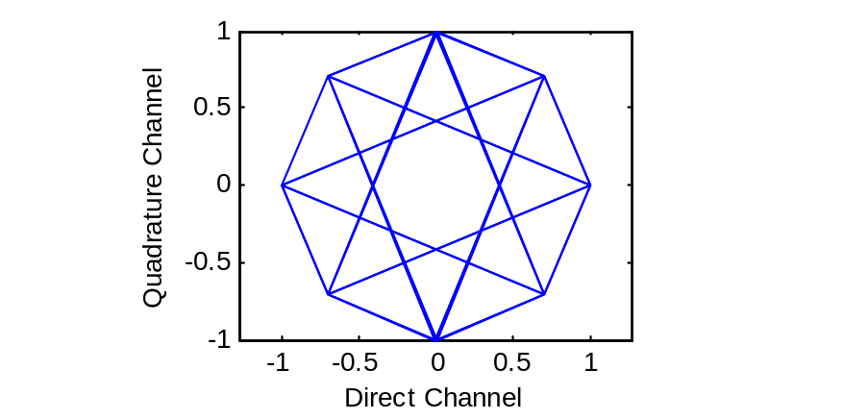
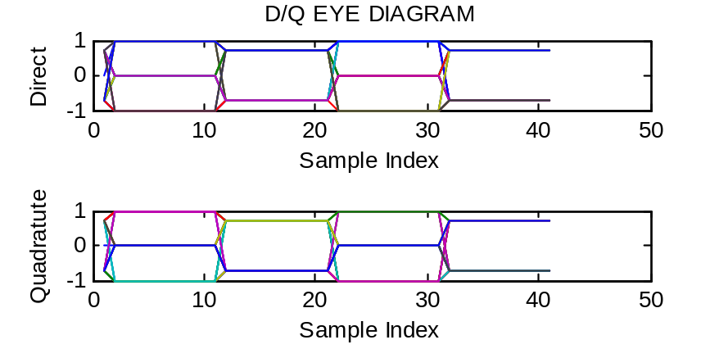
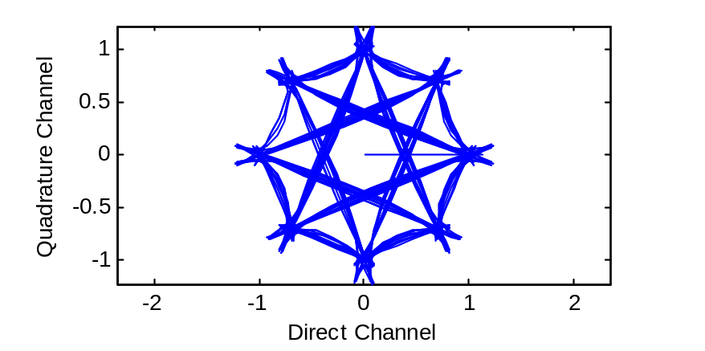
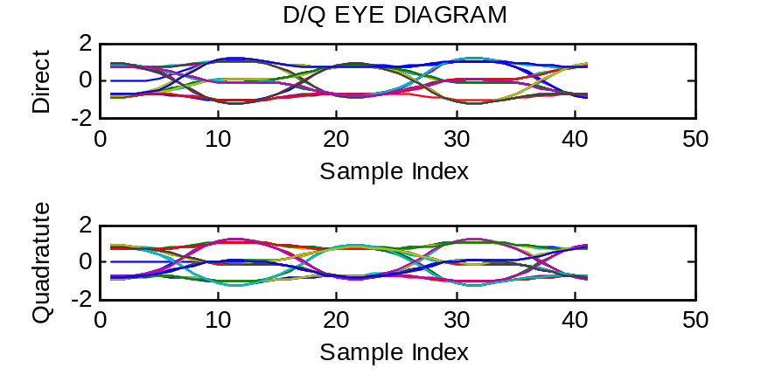
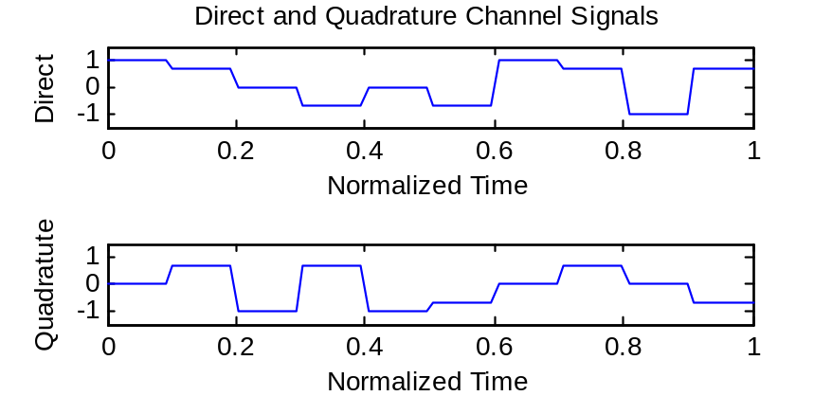

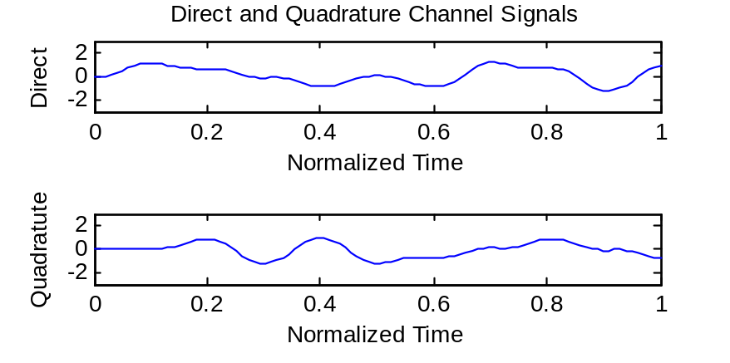

8.5
当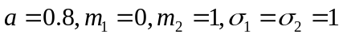时，程序如下：
clear all
x=-5:0.01:5;
a=0.8;m1=0;m2=1;segma1=1;segma2=1;
f=a/sqrt(2*pi)/segma1*exp(-((x-m1).^2/(2*segma1.^2)))+(1-a)/sqrt(2*pi)/segma2*exp(-((x-m2).^2/(2*segma2.^2)));
plot(x,f);

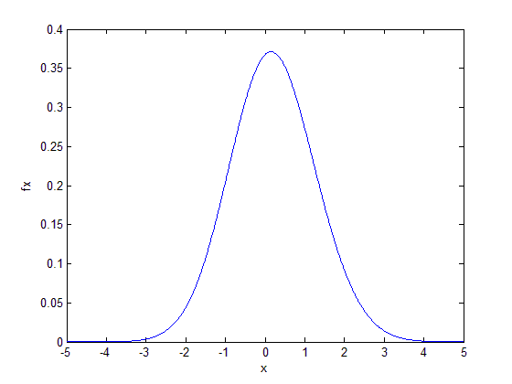
当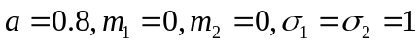时，用高斯混合的pdf，重做例8-2：
clear all
a=0.8;
subplot(2,2,1)
x = a*randn(1,100)+(1-a)*randn(1,100); hist(x,20)
ylabel('N_i'); xlabel('(a)')
subplot(2,2,2)
x = a*randn(1,100)+(1-a)*randn(1,100); hist(x,5)
ylabel('N_i'); xlabel('(b)')
subplot(2,2,3)
x = a*randn(1,1000)+(1-a)*randn(1,1000); hist(x,50)
ylabel('N_i'); xlabel('(c)')
subplot(2,2,4)
x = a*randn(1,100000)+(1-a)*randn(1,100000); hist(x,50)
ylabel('N_i'); xlabel('(d)')

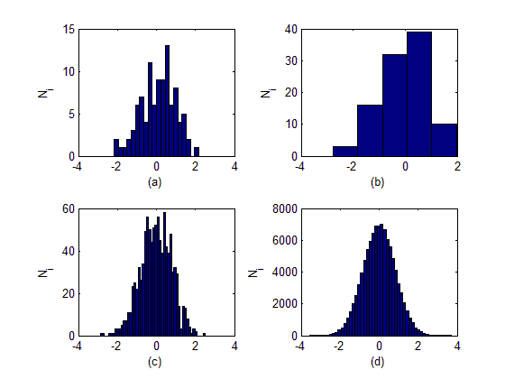
8.11
求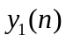利用函数：
% File: snrmse.m
% Software given here is to accompany the textbook: W.H. Tranter,
% K.S. Shanmugan, T.S. Rappaport, and K.S. Kosbar, Principles of
% Communication Systems Simulation with Wireless Applications,
% Prentice Hall PTR, 2004.
%
function [gain,delay,px,py,rxy,rho,snrdb] = snrmse(x,y)
ln = length(x); % Set length of the reference (x) vector
fx = fft(x,ln); % FFT the reference (x) vector
fy = fft(y,ln); % FFT the measurement (y) vector
fxconj = conj(fx); % Conjugate the FFT of the reference vector
sxy = fy .* fxconj; % Determine the cross PSD
rxy = ifft(sxy,ln); % Determine the cross correlation function
rxy = real(rxy)/ln; % Take the real part and scale
px = x*x'/ln; % Determine power in reference vector
py = y*y'/ln; % Determine power in measurement vector
[rxymax,j] = max(rxy); % Find the max of the crosscorrelation
gain = rxymax/px; % Here's the gain
delay = j-1; % Here's the delay
rxy2 = rxymax*rxymax; % Square rxymax for later use
rho = rxymax/sqrt(px*py); % Here's the correlation coefficient
snr = rxy2/(px*py-rxy2); % Here's the snr
snrdb = 10*log10(snr); % Here's the snr in db
% End of script file.
再自己编写程序：
kpts = 1024; % FFT Block size
k = 1:kpts; % sample index vector
fd = 2; % desired signal frequency
Ax = 1; Ayd = 5; % amplitudes
theta = 2*pi*k/kpts; % phase vector
x = Ax*sin(fd*theta); % desired signal
yd = Ayd*sin(fd*theta); % desired signal at receiver input
yy = yd; % receiver input
[gain,delay,px,py,rxy,rho,snrdb] = snrmse(x,yy);
cpx = ['The value of Px is ',num2str(px),'.'];
cpy = ['The value of Py is ',num2str(py),'.'];
cgain = ['The value gain is ',num2str(gain),'.'];
cdel = ['The value of delay is ',num2str(delay),'.'];
csnrdb = ['The value of SNR is ',num2str(snrdb),' dB.'];
disp(' ') % insert blank line
disp(cpx)
disp(cpy)
disp(cgain)
disp(cdel)
disp(csnrdb)
% End of script file.
运行结果：
The value of Px is 0.5.
The value of Py is 12.5.
The value gain is 5.
The value of delay is 0.
The value of SNR is 155.4635+13.64376i dB.
同理，求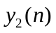自己再编写程序：
kpts = 1024; % FFT Block size
k = 1:kpts; % sample index vector
fd = 2; % desired signal frequency
Ax = 1; Ayd = 5;% Ayi =4; % amplitudes
phase = pi/2-pi/512; % phase shift
theta = 2*pi*k/kpts; % phase vector
x = Ax*sin(fd*theta); % desired signal
yd = Ayd*sin(fd*theta-phase); % desired signal at receiver input
yy = yd; % receiver input
[gain,delay,px,py,rxy,rho,snrdb] = snrmse(x,yy);
cpx = ['The value of Px is ',num2str(px),'.'];
cpy = ['The value of Py is ',num2str(py),'.'];
cgain = ['The value gain is ',num2str(gain),'.'];
cdel = ['The value of delay is ',num2str(delay),'.'];
csnrdb = ['The value of SNR is ',num2str(snrdb),' dB.'];
disp(' ') % insert blank line
disp(cpx)
disp(cpy)
disp(cgain)
disp(cdel)
disp(csnrdb)
% End of script file.
运行结果：
The value of Px is 0.5.
The value of Py is 12.5.
The value gain is 4.9999.
The value of delay is 127.
The value of SNR is 44.2423 dB.
8-12
答：
（a） %M文件：snrmse(x,y)
function [gain,delay,px,py,rxy,rho,snrdb] = snrmse(x,y)
ln = length(x);
fx = fft(x,ln);
fy = fft(y,ln);
fxconj = conj(fx);
sxy = fy .* fxconj;
rxy = ifft(sxy,ln);
rxy = real(rxy)/ln;
px = x*x'/ln;
py = y*y'/ln;
[rxymax,j] = max(rxy);
gain = rxymax/px;
delay = j-1;
rxy2 = rxymax*rxymax;
rho = rxymax/sqrt(px*py);
snr = rxy2/(px*py-rxy2);
snrdb = 10*log10(snr);
% End of script file.
%设置频率和样本数
kpts = 1024;
k = 1:kpts;
fd = 5;
% desired signal frequency
fi =10;
Ax = 2; Ayd = 5; Ayi =5;
phase = pi/2;
% phase shift
nstd = 5;
theta = 2*pi*k/kpts;
% phase vector
x = Ax*sin(fd*theta);
yd = Ayd*sin(fd*theta-pi/2);
yi = Ayi*sin(fi*theta-3*pi/4);
noise = nstd*sin(15*theta-pi);
yy = yd+yi+noise;
[gain,delay,px,py,rxy,rho,snrdb] = snrmse(x,yy);
cpx = ['The value of Px is ',num2str(px),'.'];
cpy = ['The value of Py is ',num2str(py),'.'];
cgain = ['The value gain is ',num2str(gain),'.'];
cdel = ['The value of delay is ',num2str(delay),'.'];
csnrdb = ['The value of SNR is ',num2str(snrdb),' dB.'];
disp(' ')
disp(cpx)
disp(cpy)
disp(cgain)
disp(cdel)
disp(csnrdb)
% End of script file.
结果： The value of Px is 2.
The value of Py is 37.5.
The value gain is 2.5.
The value of delay is 256.
The value of SNR is -3.0103 dB.
（b） 从（a）中的显示结果可以看到，增益，延迟，信噪比等数据，得到这些差错源并不是很严重的。
（c） 系统幅度失真，相位失真。
（d） 参数A=B=1，a=b=0时，系统无失真，下面对这些参数进行实验,并通过和真实值比较证明结论正确。
kpts = 1024;
k = 1:kpts;
fd = 5;
fi =10;
Ax = 2; Ayd = 5; Ayi =1;
phase = pi/2;
nstd = 1;
theta = 2*pi*k/kpts;
x = Ax*sin(fd*theta);
yd = Ayd*sin(fd*theta-pi/2);
yi = Ayi*sin(fi*theta);
noise = nstd*sin(15*theta);
yy = yd+yi+noise;
[gain,delay,px,py,rxy,rho,snrdb] = snrmse(x,yy);
cpx = ['The value of Px is ',num2str(px),'.'];
cpy = ['The value of Py is ',num2str(py),'.'];
cgain = ['The value gain is',num2str(gain),'.'];
cdel = ['The value of delay is ',num2str(delay),'.'];
csnrdb = ['The value of SNR is ',num2str(snrdb),' dB.'];
disp(' ')
disp(cpx)
disp(cpy)
disp(cgain)
disp(cdel)
disp(csnrdb)
% End of script file.
结果： The value of Px is 2.
The value of Py is 13.5.
The value gain is 2.5.
The value of delay is 256.
The value of SNR is 10.9691 dB
第9章 蒙特卡罗方法导论

9.10
先利用q函数：q.m
function y=q(x)
y = 0.5*erfc(x/sqrt(2));
再编写程序：
clear all
snrdB_min = 0; snrdB_max = 10; % SNR (in dB)limits
snrdB = snrdB_min:1:snrdB_max;
Nsymbols = input('Enter number of symbols > ');
snr = 10.^(snrdB/10); % convert from dB
h = waitbar(0,'SNR Iteration');
len_snr = length(snrdB);
for j=1:len_snr % increment SNR
waitbar(j/len_snr)
sigma = sqrt(1/(2*snr(j))); % noise standard deviation
error_count = 0;
for k=1:Nsymbols % simulation loop begins
d = round(rand(1)); % data
if d ==0
x_d = sqrt(3)/2; % direct transmitter output
x_q = 0; % quadrature transmitter output
else
x_d = 0; % direct transmitter output
x_q = 1/2; % quadrature transmitter output
end
n_d = sigma*randn(1); % direct noise component
n_q = sigma*randn(1); % quadrature noise component
y_d = x_d + n_d; % direct receiver input
y_q = x_q + n_q; % quadrature receiver input
if y_d > y_q % test condition
d_est = 0; % conditional data estimate
else
d_est = 1; % conditional data estimate
end
if (d_est ~= d)
error_count = error_count + 1; % error counter
end
end % simulation loop ends
errors(j) = error_count; % store error count for plot
end
close(h)
ber_sim = errors/Nsymbols; % BER estimate
ber_theor = q(sqrt(snr)); % theoretical BER
semilogy(snrdB,ber_theor,snrdB,ber_sim,'o')
axis([snrdB_min snrdB_max 0.0001 1])
xlabel('SNR in dB')
ylabel('BER')
legend('Theoretical','Simulation')

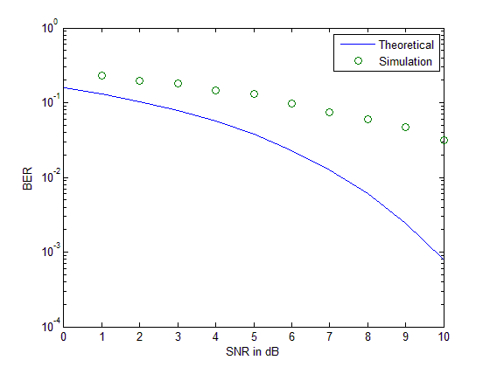
9-13
答：matlab程序： iter=input('the parameter N iter:=');
high=4;low=1.5;
x=1.5+2.5*rand(iter,1);
y=2*rand(iter,1);
s=2.5*2*sum(4*exp(-x(:,1)/2)-y(:,1)>=0)/iter;
s1=quad('4*exp(-x/2)',1.5,4);
disp(s);
disp(s1);
the parameter N iter:=100
2.7500

2.6963
the parameter N iter:=500
2.6900

2.6963
the parameter N iter:=1000
2.6450

2.6963
其中，s: 蒙特卡罗积分值
s1:真实积分值
由此可知，N越大，蒙特卡罗积分结果就越接近真实的积分值。

9.14
clear all
N=input('the parameter N iter:=') % Number of experiments % Trials per experiment
u = rand(N,1); % Generate random numbers
uu =sqrt(1-u.*u);% Define function
data = zeros(N,1); % Initialize array
% The following four lines of code determine
% M estimates as a function of j, 0<j<=N.
data(1,:)=uu(1,:);
for j=2:N
data(j,:)=sum(uu(1:j,:))/j;
end
est = data(N,:) % M estimates of pi
s1=quad('sqrt(1-u.*u)',0,1)
plot(data,'k') % Plot results
xlabel('Number of Trials')
ylabel('integral value')

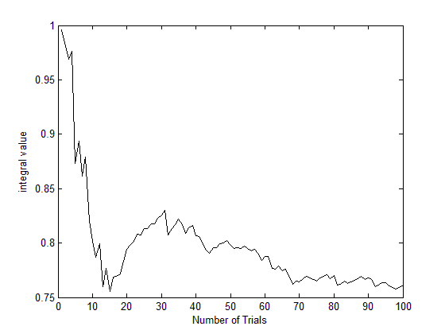
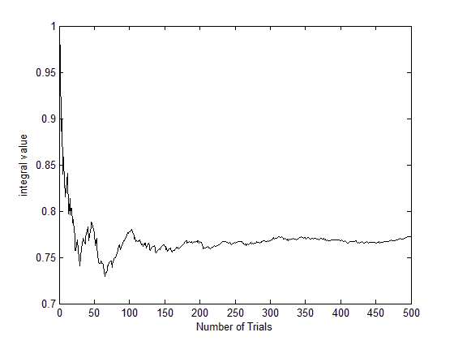
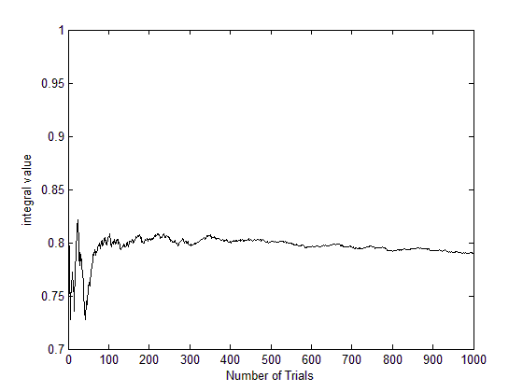
9-16
答：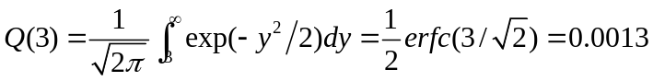
Matlab程序基本同前：
gx=exp(-9/(2*sin(pi*x*0.5).^2));
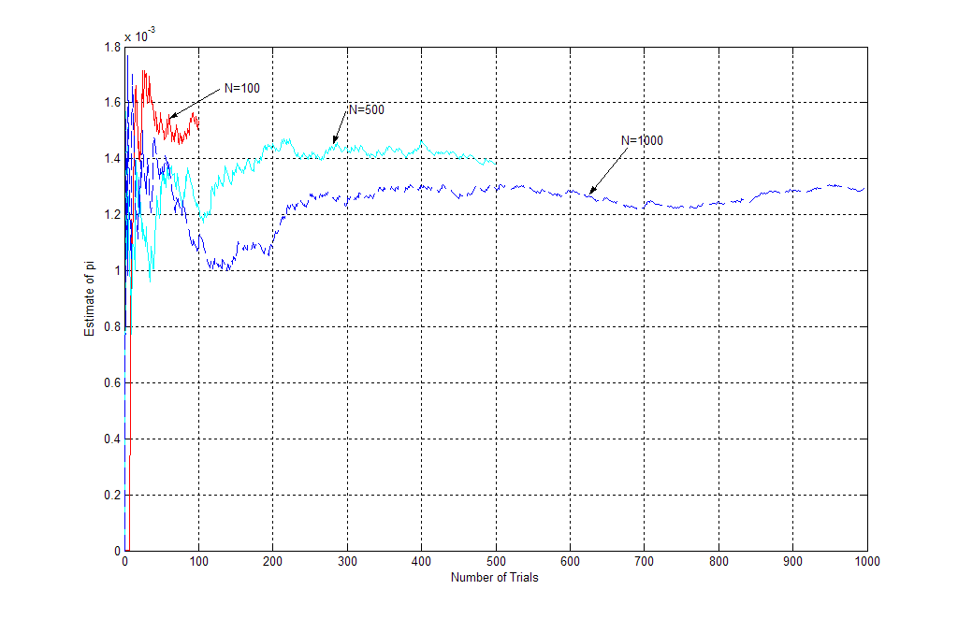
第10章 通信系统的蒙特卡罗仿真

10.3
首先要修改采样次数：
% File: c10_MCBPSKrun.m
% Software given here is to accompany the textbook: W.H. Tranter,
% K.S. Shanmugan, T.S. Rappaport, and K.S. Kosbar, Principles of
% Communication Systems Simulation with Wireless Applications,
% Prentice Hall PTR, 2004.
%
function [BER,Errors]=MCBPSKrun(N,EbNo,delay,FilterSwitch)
SamplesPerSymbol = 20; % samples per symbol
BlockSize = 1000; % block size
NoiseSigma = sqrt(SamplesPerSymbol/(2*EbNo)); % scale noise level
DetectedSymbols = zeros(1,BlockSize); % initialize vector
NumberOfBlocks = floor(N/BlockSize); % number of blocks processed
[BTx,ATx] = butter(5,2/SamplesPerSymbol); % compute filter parameters
[TxOutput,TxFilterState] = filter(BTx,ATx,0); % initialize state vector
BRx = ones(1,SamplesPerSymbol); ARx=1; % matched filter parameters
Errors = 0; % initialize error counter
%
% Simulation loop begine here.
%
for Block=1:NumberOfBlocks
%
% Generate transmitted symbols.
%
[SymbolSamples,TxSymbols] = random_binary(BlockSize,SamplesPerSymbol);
%
% Transmitter filter if desired.
%
if FilterSwitch==0
TxOutput = SymbolSamples;
else
[TxOutput,TxFilterState] = filter(BTx,ATx,SymbolSamples,TxFilterState);
end
%
% Generate channel noise.
%
NoiseSamples = NoiseSigma*randn(size(TxOutput));
%
% Add signal and noise.
%
RxInput = TxOutput + NoiseSamples;
%
% Pass Received signal through matched filter.
%
IntegratorOutput = filter(BRx,ARx,RxInput);
%
% Sample matched filter output every SamplesPerSymbol samples,
% compare to transmitted bit, and count errors.
%
for k=1:BlockSize,
m = k*SamplesPerSymbol+delay;
if (m < length(IntegratorOutput))
DetectedSymbols(k) = (1-sign(IntegratorOutput(m)))/2;
if (DetectedSymbols(k) ~= TxSymbols(k))
Errors = Errors + 1;
end
end
end
end
BER = Errors/(BlockSize*NumberOfBlocks); % calculate BER
% End of function file.

Delay仿真估计：
% File: c10_MCBPSKdelay.m
% Software given here is to accompany the textbook: W.H. Tranter,
% K.S. Shanmugan, T.S. Rappaport, and K.S. Kosbar, Principles of
% Communication Systems Simulation with Wireless Applications,
% Prentice Hall PTR, 2004.
%
EbNodB = 6; % Eb/No (dB) value
z = 10.^(EbNodB/10); % convert to linear scale
delay = 0:8; % delay vector
BER = zeros(1,length(delay)); % initialize BER vector
Errors = zeros(1,length(delay)); % initialize Errors vector
BER_T = q(sqrt(2*z))*ones(1,length(delay)); % theoretical BER vector
N = round(100./BER_T); % 100 errors for ideal (zero ISI) system
FilterSwitch = 1; % set filter switch (in=1 or out=0)
for k=1:length(delay)
[BER(k),Errors(k)] = c10_MCBPSKrun(N(k),z,delay(k),FilterSwitch)
end
semilogy(delay,BER,'o',delay,BER_T,'-'); grid;
xlabel('Delay'); ylabel('Bit Error Rate');
% End of script file.
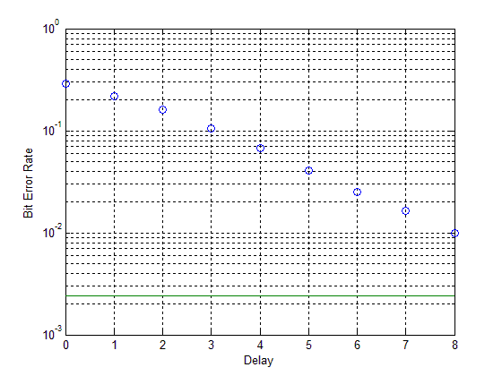

BER仿真估计：
% File: c10_MCBPSKber.m
% Software given here is to accompany the textbook: W.H. Tranter,
% K.S. Shanmugan, T.S. Rappaport, and K.S. Kosbar, Principles of
% Communication Systems Simulation with Wireless Applications,
% Prentice Hall PTR, 2004.
%
EbNodB = 0:8; % vector of Eb/No (dB) values
z = 10.^(EbNodB/10); % convert to linear scale
delay = 5; % enter delay value (samples)
BER = zeros(1,length(z)); % initialize BER vector
Errors = zeros(1,length(z)); % initialize Errors vector
BER_T = q(sqrt(2*z)); % theoretical (AWGN) BER vector
N = round(20./BER_T); % 20 errors for ideal (zero ISI) system
FilterSwitch = 1; % Tx filter out (0) or in (1)
for k=1:length(z)
N(k) = max(1000,N(k)); % ensure at least one block processed
[BER(k),Errors(k)] = c10_MCBPSKrun(N(k),z(k),delay,FilterSwitch)
end
semilogy(EbNodB,BER,'o',EbNodB,BER_T)
xlabel('E_b/N_0 - dB'); ylabel('Bit Error Rate'); grid
legend('System Under Study','AWGN Reference',0)
% End of script file.
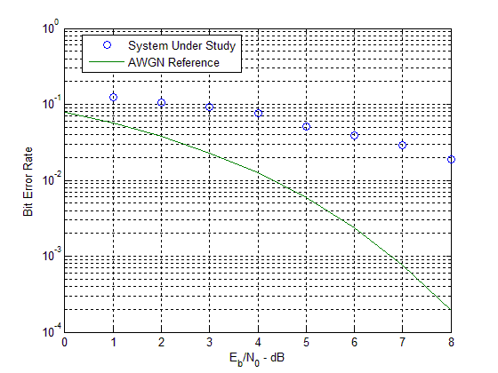
10-1中的图形为：
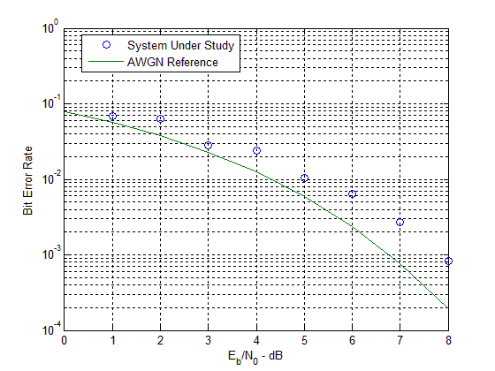

10.4
蒙特卡罗方法：
tic
EbNodB = 0:8; % vector of Eb/No (dB) values
z = 10.^(EbNodB/10); % convert to linear scale
delay = 5; % enter delay value (samples)
BER = zeros(1,length(z)); % initialize BER vector
Errors = zeros(1,length(z)); % initialize Errors vector
BER_T = q(sqrt(2*z)); % theoretical (AWGN) BER vector
N = round(20./BER_T); % 20 errors for ideal (zero ISI) system
FilterSwitch = 1; % Tx filter out (0) or in (1)
for k=1:length(z)
N(k) = max(1000,N(k)); % ensure at least one block processed
[BER(k),Errors(k)] = c10_MCBPSKrun(N(k),z(k),delay,FilterSwitch)
end
semilogy(EbNodB,BER,'o',EbNodB,BER_T)
xlabel('E_b/N_0 - dB'); ylabel('Bit Error Rate'); grid
legend('System Under Study','AWGN Reference',0)
toc
% End of script file.
Elapsed time is 0.484517 seconds.

半解析估计法：
tic
NN = 256; % number of symbols
tb = 1; % bit file
p0 = 1; % power
fs = 16; % samples/symbol
ebn0db = [0:1:8]; % Eb/No vector in dB
[bt,at] = butter(5,2/fs); % transmitter filter parameters
x = random_binary(NN,fs); % establish PSK signal
y1 = x; % save signal
y2a = y1*sqrt(p0); % scale amplitude
y2 = filter(bt,at,y2a); % transmitter output
br = ones(1,fs); br = br/fs; ar = 1; % matched filter parameters
y = filter(br,ar,y2); % matched filter output
%
% End of simulation.
%
% The following code sets up the semianalytic estimator. Find the
% maximum magnitude of the cross correlation and the corresponding lag.
%
[cor lags] = vxcorr(x,y); % compute crosscorrelation
[cmax nmax] = max(abs(cor)); % maximum of crosscorrelation
timelag = lags(nmax); % lag at max crosscorrelation
theta = angle(cor(nmax)); % determine angle
y = y*exp(-i*theta); % derotate
%
% Noise BW calibration.
%
hh = impz(br,ar); % receiver impulse response
nbw = (fs/2)*sum(hh.^2); % noise bandwidth
%
% Delay the input and do BER estimation on the NN-20+1 128 bits.
% Use middle sample. Make sure the index does not exceed number
% of input points. Eb should be computed at the receiver input.
%
index = (10*fs+8:fs:(NN-10)*fs+8);
xx = x(index);
yy = y(index-timelag+1);
eb = tb*sum(abs(y2).^2)/length(y2);
eb = eb/2;
[peideal,pesystem] = psk_berest(xx,yy,ebn0db,eb,tb,nbw);
semilogy(ebn0db,pesystem,'ro-',ebn0db,peideal); grid;
xlabel('E_b/N_0 (dB)'); ylabel('Bit Error Rate')
legend('System Under Study','AWGN Reference',0)
toc
% End of script file.
Elapsed time is 0.171073 seconds.
10-6
答：matlab程序： EbNodB = 0:10;
z = 10.^(EbNodB/10);
delay = 5;
BER = zeros(1,length(z));
Errors = zeros(1,length(z));
BER_T = q(sqrt(2*z));
N = round(20./BER_T);
FilterSwitch = 1;
for k=1:length(z)
N(k) = max(1000,N(k));
[BER(k),Errors(k)] = c10_MCBPSKrun(N(k),z(k),delay,FilterSwitch) ;
end
semilogy(EbNodB,BER,'o',EbNodB,BER_T) ;
xlabel('E_b/N_0 - dB'); ylabel('Bit Error Rate');
grid
legend('System Under Study','AWGN Reference',0) ;
% End of script file.
其中，子程序1：function [BER,Errors]=MCBPSKrun(N,EbNo,delay,FilterSwitch)
SamplesPerSymbol = 10;
BlockSize = 1000;
NoiseSigma = sqrt(SamplesPerSymbol/(2*EbNo));
DetectedSymbols = zeros(1,BlockSize);
NumberOfBlocks = floor(N/BlockSize);
[BTx,ATx] = butter(5,2/SamplesPerSymbol);
[TxOutput,TxFilterState] = filter(BTx,ATx,0);
BRx = ones(1,SamplesPerSymbol); ARx=1;
Errors = 0;
for Block=1:NumberOfBlocks
[SymbolSamples,TxSymbols] =random_binary(BlockSize,SamplesPerSymbol);
if FilterSwitch==0
TxOutput = SymbolSamples;
else
[TxOutput,TxFilterState] =filter(BTx,ATx,SymbolSamples,TxFilterState);
end
NoiseSamples = NoiseSigma*randn(size(TxOutput));
RxInput = TxOutput + NoiseSamples;
IntegratorOutput = filter(BRx,ARx,RxInput);
for k=1:BlockSize,
m = k*SamplesPerSymbol+delay;
if (m < length(IntegratorOutput))
DetectedSymbols(k) = (1-sign(IntegratorOutput(m)))/2;
if (DetectedSymbols(k) ~= TxSymbols(k))
Errors = Errors + 1;
end
end
end
end
BER = Errors/(BlockSize*NumberOfBlocks);
% End of function file.
子程序2：function y=q(x)
y = 0.5*erfc(x/sqrt(2));
% End function file.
子程序3：function [x, bits] = random_binary(nbits,nsamples)
x = zeros(1,nbits*nsamples);
bits = round(rand(1,nbits));
for m=1:nbits
for n=1:nsamples
index = (m-1)*nsamples + n;
x(1,index) = (-1)^bits(m);
end
end
% End of function file.
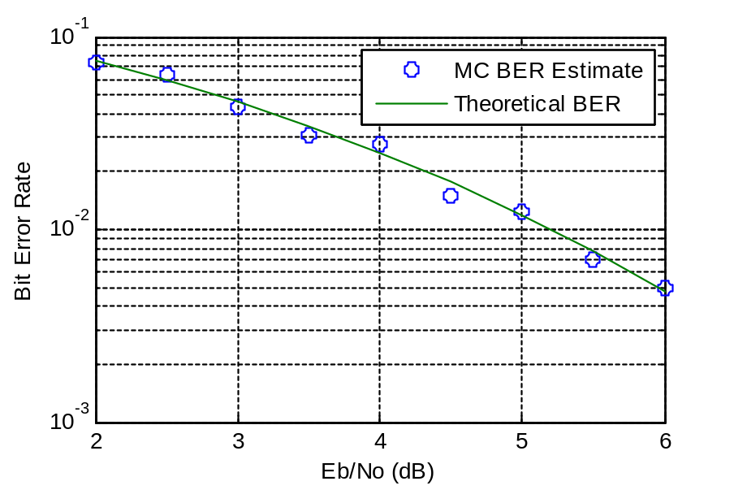

10-7
答：matlab程序： NN = 256;
tb = 0.5;
p0 = 1;
fs = 16;
ebn0db = [0:1:10];
[b,a] = butter(5,1/16);
x = random_binary(NN,fs)+i*random_binary(NN,fs);
y1 = x;
y2a = y1*sqrt(p0);
y2 = filter(b,a,y2a);
b = ones(1,fs); b = b/fs; a = 1;
y = filter(b,a,y2);
[cor lags] = vxcorr(x,y);
cmax = max(abs(cor));
nmax = find(abs(cor)==cmax);
timelag = lags(nmax);
theta = angle(cor(nmax));
y = y*exp(-i*theta);
hh = impz(b,a);
nbw = (fs/2)*sum(hh.^2);
index = (10*fs+8:fs:(NN-10)*fs+8);
xx = x(index);
yy = y(index-timelag+1);
[n1 n2] = size(y2); ny2=n1*n2;
eb = tb*sum(sum(abs(y2).^2))/ny2;
eb = eb/2;
[peideal,pesystem]= qpsk_berest(xx,yy,ebn0db,eb,tb,nbw);
subplot(1,2,1)
yscale = 1.5*max(real(yy));
plot(yy,'+')
xlabel('Direct Sample'); ylabel('Quadrature Sample'); grid;
axis([-yscale yscale -yscale yscale])
subplot(1,2,2)
semilogy(ebn0db,peideal,ebn0db,pesystem,'ro-'); grid;
xlabel('E_b/N_0 (dB)'); ylabel('Bit Error Rate')
legend('AWGN Reference','System Under Study')
% End of script file.
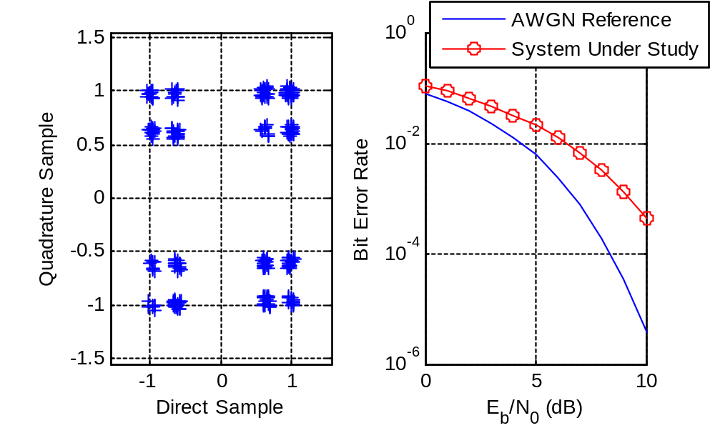

第11章 无线系统仿真的方法论
11-1
答：
- 因为Ak=+1或-1，所以从j=1到j=5相对应的Ak值共有32种组合。当全1时，Dkmax=0.5；当全-1时，Dkmin=-0.5.得出ISI的分布范围是（-0.5，0.5）。
（b） Aj的奇数阶距是零，偶数阶距是1。由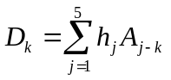，可得出奇数阶距D=0（k=1，3，5，7，9）；偶数阶距D=0.5（k=2，4，6，8，10）
（c） 由Dk的各阶矩，可以获得Dk分布的一个离散近似。在该近似中，Dk被当作一个可取J值的离散随机变量，这个J值为d1,……dj，对应的概率为p1,……，pj。
选择横坐标x1,……,xj和纵坐标p1,……,pj，使得连续分布和离散分布具有相同的矩
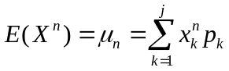
已知X的前3阶距，就可以求出xk和pk，k=1，2，3.
（d） 使用ISI分布的离散近似，按下式就可以计算两种情况的差错概率：
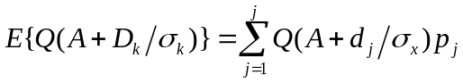
11-2
答：
（a） 因为Ak，Bk=+1或-1，所以5相对应的Sk值为2，-2，0三种。用下面表达式来表示确切分布：
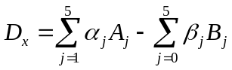
其中，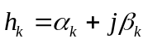
（b）Dx的矩可通过下式进行计算：
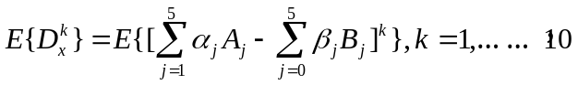
这样就可以得到其前10阶距。
（c）同样道理，已知X的前3阶距，就可以求出xk和pk，k=1，2，3.计算出ISI分布的一阶距匹配近似。
（d）使用ISI分布的离散近似，按下式就可以计算两种情况的差错概率：

15.6
N = 200;
pie = zeros(N,3);
A = [0.8 0.15 0.05;0.2 0.7 0.1;0 0.1 0.9];
pie(1,:) = [1 0 0];
S=zeros(1,N);
S(1)=1;
for k=2:N
pie(k,:) = pie(k-1,:)*A;
R=rand(1);
if R>0&R<=pie(k,1)
S(k)=1;
elseif R>pie(k,1)&R<=(pie(k,2)+pie(k,1))
S(k)=2;
else R>(pie(k,2)+pie(k,1))&R<=1
S(k)=3;
end
end
disp('The value of A^N is');A^N
disp('状态S各个时刻为：');S
t=1:200;
plot(t,S,'*')
% End of script file.
运行结果：
The value of A^N is

ans =

0.2857 0.2857 0.4286
0.2857 0.2857 0.4286
0.2857 0.2857 0.4286

状态S各个时刻为：

S =

Columns 1 through 13

1 3 1 2 1 3 3 2 1 3 2 2 3

Columns 14 through 26

3 3 1 2 3 3 2 3 1 2 3 1 1

Columns 27 through 39

1 1 3 1 1 1 3 2 3 2 2 3 2

Columns 40 through 52

1 3 3 1 3 2 3 2 3 2 2 1 1

Columns 53 through 65

3 2 2 1 3 2 3 3 3 2 3 3 3

Columns 66 through 78

3 3 2 2 2 2 3 2 3 2 2 3 2

Columns 79 through 91

2 3 3 3 3 2 3 1 3 1 1 3 3

Columns 92 through 104

1 1 3 1 2 3 1 2 1 3 3 2 2

Columns 105 through 117

2 2 1 3 3 2 3 1 2 3 3 2 2

Columns 118 through 130

3 1 3 1 2 2 3 1 3 3 3 3 2

Columns 131 through 143

2 1 3 2 3 3 2 3 1 2 3 3 1

Columns 144 through 156

3 3 1 1 3 3 2 3 2 1 1 2 1

Columns 157 through 169

2 3 1 1 3 3 1 1 1 3 1 2 3

Columns 170 through 182

3 3 1 2 2 2 1 3 3 3 2 2 1

Columns 183 through 195

2 3 3 1 1 3 1 3 3 1 1 1 1

Columns 196 through 200

3 1 3 1 1
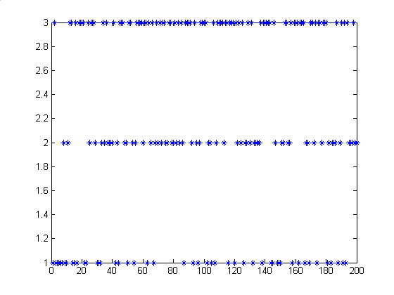
- 表示状态1
- 表示状态2
- 表示状态3

当N=40000；
先运行：
% File: c15_errvector.m
% Software given here is to accompany the textbook: W.H. Tranter,
% K.S. Shanmugan, T.S. Rappaport, and K.S. Kosbar, Principles of
% Communication Systems Simulation with Wireless Applications,
% Prentice Hall PTR, 2004.
%
disp(' ')
disp('Default values are:')
N = 20000 % default N
A = [0.8 0.1 0.1; 0.2 0.6 0.2; 0.02 0.08 0.90] % default A
B = [0.999 0.95 0.99; 0.001 0.05 0.01] % default B
disp(' ')
disp('Accept default values?')
dtype = input('Enter y for yes or n for no > ','s');
if dtype == 'n'
N = input(' Enter N, the number of points to be generated > ');
A = input(' Enter A, the state transition matrix > ');
B = input(' Enter B, the error distribution matrx > ');
end
state = 1; % initial state
total_states = size(A,1);
out = zeros(1,N); % initialize error vector
state_seq = zeros(1,N); % initialize state sequence
h = waitbar(0,'Calculating Error Vector');
%
u2 = rand(1); % get random number
if u2>B(1,state) % test for error
out(1) = 1; % record error
end
state_seq(1) = state; % record state
for t=2:N
u1 = rand(1); % get random number
cum_sum = [0 cumsum(A(state,:))];
for i=1:total_states % loop to determine new state
if u1>=cum_sum(i) & u1<cum_sum(i+1);
state = i; % assign new state
end
end
state_seq(t) = state; % new record state
u2 = rand(1); % get random number
if u2>B(1,state)
out(t) = 1; % record error
end
waitbar(t/N)
end
close(h)
% End of script file.
在对话框输入：
Accept default values?
Enter y for yes or n for no > n
Enter N, the number of points to be generated > 40000
Enter A, the state transition matrix > [0.8 0.15 0.05;0.2 0.7 0.1;0 0.1 0.9]
Enter B, the error distribution matrx > [0.9990 0.9500 0.9900;0.0010 0.0500 0.0100]
再运行以下程序：
% File: c15_hmmtest.m
% Software given here is to accompany the textbook: W.H. Tranter,
% K.S. Shanmugan, T.S. Rappaport, and K.S. Kosbar, Principles of
% Communication Systems Simulation with Wireless Applications,
% Prentice Hall PTR, 2004.
%
pe = sum(out)/N;
state_sum = zeros(1,total_states);
for k=1:N
if state_seq(k)==1
state_sum(1)=state_sum(1)+1;
end
if state_seq(k)==2
state_sum(2)=state_sum(2)+1;
end
if state_seq(k)==3
state_sum(3)=state_sum(3)+1;
end
end
a = ['The probability of State 1 is ',num2str(state_sum(1)/N),'.'];
b = ['The probability of State 2 is ',num2str(state_sum(2)/N),'.'];
c = ['The probability of State 3 is ',num2str(state_sum(3)/N),'.'];
d = ['The error probability is ',num2str(pe),'.'];
disp('Simulation results:')
disp(a) % display probability of state 1
disp(b) % display probability of state 2
disp(c) % display probability of state 3
disp(d) % display error probability
% End script file.
Simulation results:
The probability of State 1 is 0.28092.
The probability of State 2 is 0.28405.
The probability of State 3 is 0.43503.
The error probability is 0.018.
>> A^N

ans =

0.2857 0.2857 0.4286
0.2857 0.2857 0.4286
0.2857 0.2857 0.4286

