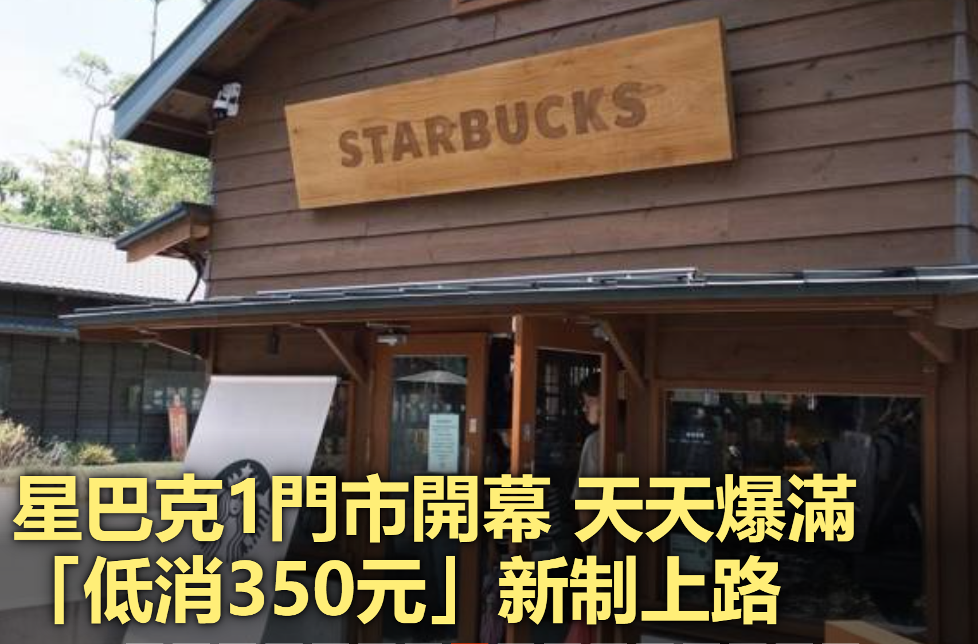
https://www.chinatimes.com/realtimenews/20260902001131-260405?ctrack=pc_main_headl_p08&chdtv

宜蘭羅東林場星巴克

\

