1. Go to <https://github.com/> and register new account.
2. If you don’t have skype, please install it: <https://www.skype.com/en/download-skype/skype-for-computer/>
3. Create skype account. It’s better to avoid skype names like “Nagibator99”, “SuperStar_97”, etc. Just use your name and surname as your login. In future you can use it as your work skype. For example, henadzi_baranau.
4. Join conversation: <https://join.skype.com/mBzmQcbSh1uK> . Feel free to ask there any questions you have.
5. Please write a message in this conversation with your name, surname, nickname used in GIT and your email used during registration in GIT. I will add you to the repository. You need to commit completed tasks to this repository to your own folder.
6. Use the following link to find the Quick start for GIT.

<https://drive.google.com/drive/folders/0BzILpTtz2boUaHRJRWV3bDBYdFE?usp=sharing>

1. In the same shared folder(link above) you can find Task with HTML and CSS(select any from 11.psd, 13.psd or 1.psd – whatever you like).
2. You may use the following tutorials <http://www.w3schools.com/html/default.asp> , <http://www.html5andcss3.org/> for HTML5 + CSS3 and PDF book from shared folder.
3. Use separate css file for styles.
4. Use separate folder for images.
5. Try to use semantic tags.
6. Don’t use tables. (<table>, <tr>, <td>).
7. Don’t use javascript.
8. Use any content you want – images, text, etc. Just make you page look similar to psd.

If you don’t know, how to to this – just google it. ☺ If google don’t know, ask me and I will google it for you. ☺

For example, basic index.html page:

<!DOCTYPE html>  
<html>  
<head>  
<title>Page Title</title>  
</head>  
<body>  
  
<h1>This is a Heading</h1>  
<p>This is a paragraph.</p>  
  
</body>  
</html>

And you need to setup some dark backround for you page.

Google it!

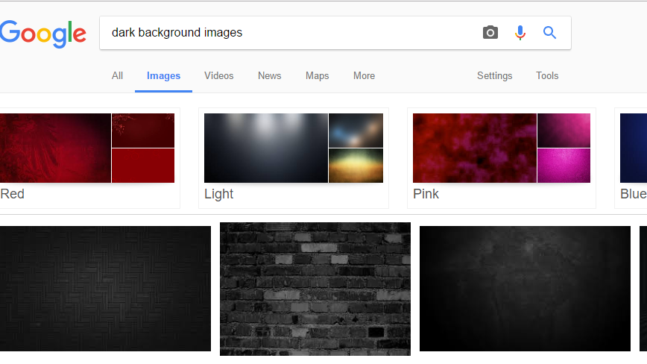

Download image.

Google how to setup page background:

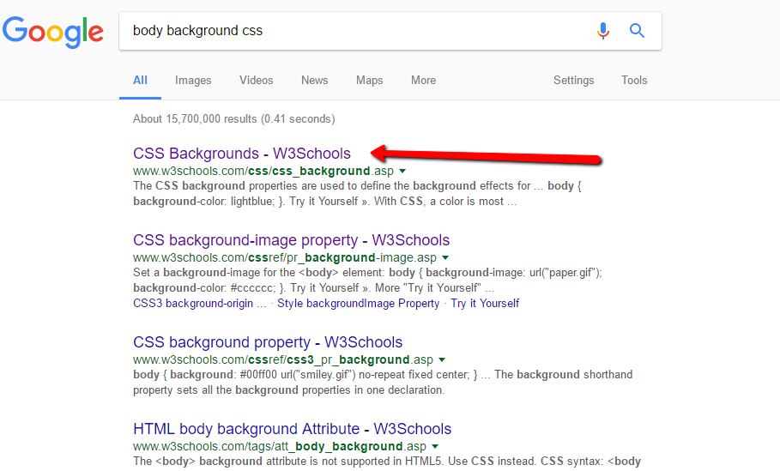

Specify the following style in css (sample in folder gennadybaranov in GIT repository):

body {

background: url(../images/background.jpg) repeat;

padding-top: 50px;

padding-bottom: 50px;

}