1. Add 2 pages to the site from Task1:
   1. 1 page – simple static html page that should be opened by click on menu item(like contacts, about, etc.)
   2. 2 page – search page that can be opened from main page and allow user to search through the list of items. By default all items are shown. When user types any symbol, the list shows only items that contain this symbol in name/description. The list item contains the following fields: id, name, description, imageUrl and looks similar to mockup below:

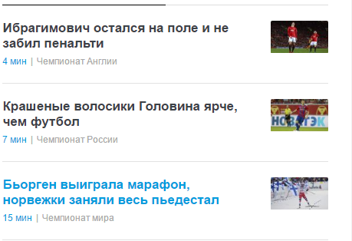

1. Try to keep existing design.

**To complete 1b use the following tips:**

* Create html page. Create empty div which will be container for the all shown items:

*<div id=”itemsWrapper”></div>*

Also define input that will be used for search:

*<input id=”search”>*

* Read about JSON: <https://www.w3schools.com/js/js_json_intro.asp>
* Add js file and include it in head of your search page. Define the JSON string like it was done in Task3(5-7 items). For example:

*window.poc = {};*

*window.poc.jsonData =' [ *

*{ *

*"id": "58bac7ca9bad60c729fdc62f", *

*"imageUrl": "xxx", *

*"name": "Ибрагимович остался на поле и не забил пенальти", *

*"description": "Чемпионат Англии " *

*}, /*

*{*

*... // the same object*

*}';*

* To parse your JSON into the array of objects use the folllowing:

*var data = JSON.parse(window.poc.jsonData);*

After that you will be able to get id, imageUrl, name, description using:

*data[0].id, data[0].imageUrl, etc.*

* Use ***ul, li*** do show the entire list of items. All styles can be defines in css, ul and li will be appended dynamically:

*var wrapper = document.getElementById(‘itemsWrapper);*

*var list = document.createElement(‘ul’);*

*list.setAttribute(‘id’, ‘list’);*

*list.classList.add("myListClassStyleFromCSSfile");*

*var listItem = document.createElement("li");*

*var textnode = document.createTextNode(data[0].name);*

*listItem.appendChild(textnode);*

*list.appendChild(listItem);*

*wrapper.appendChild(list);*

* Subscribe to keypress event for the search input field:

*var search = document.getElementById(‘search’);*

*search.addEventListener(‘keydown’, function (e){*

*var currentInput = search.value;*

*for (var i =0; i < data.length; i++) {*

*if (data[i].name.indexOf(currentInput) >= 0){*

*// leave list item shown*

*} else {*

*// hide list item*

*}*

*}*

*});*

* Manage the visibility of list items using:

*document.getElementById(‘list’).children[0].style.display = ‘none’;*

* **Note**: As alternative you could also harcode your object in JS:

var data = [

{

*id: "58bac7ca9bad60c729fdc62f",*

*imageUrl: "xxx",*

*name: "Ибрагимович остался на поле и не забил пенальти",*

*description: "Чемпионат Англии "*

},

{

id: “23452352”,

imageUrl: “xxx”,

///

}

];