Gennaro Finelli (2268017)

Assignment‐02: Object Oriented Programming ‐ Inheritance

**Problem: Account Inheritance Hierarchy**

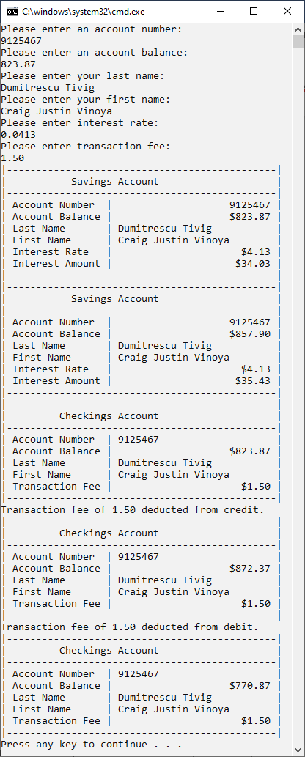

**Problem 2: LINQ to Objects querying an array of Employee**

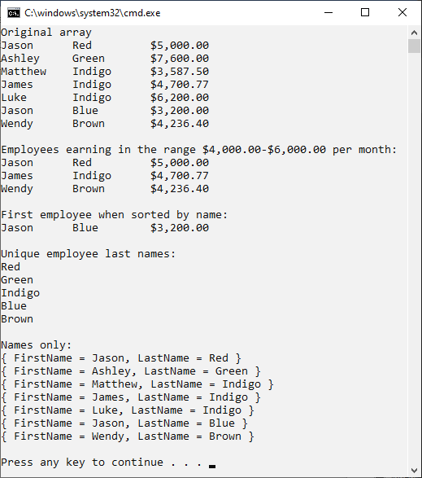

**Problem 3: Generic LIST<T> collection demonstration**

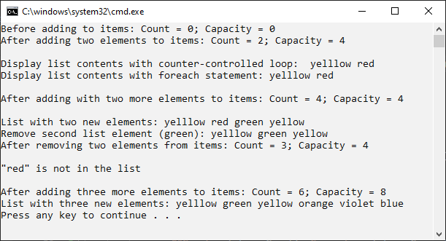

**Problem 4: LINQ to Objects using a List<string>**

