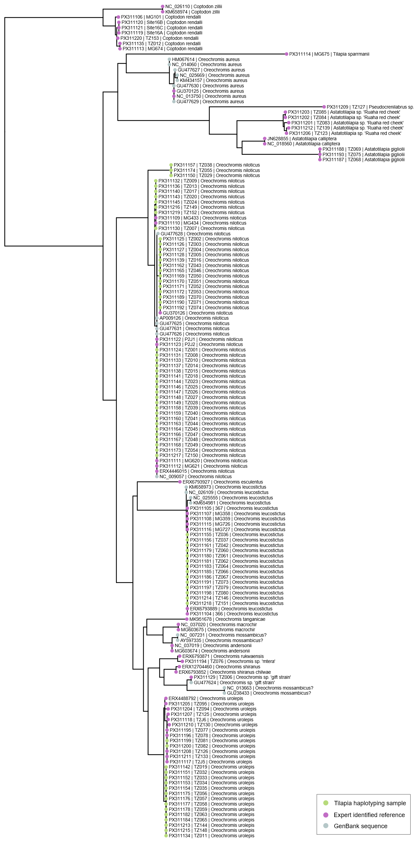
Figure S1. Maximum likelihood phylogenetic tree of Oreochromis and related cichlids constructed using R package Phangorn (Schliep, 2011) from complete coding sequences of the mitochondrial ND1 (NADH dehydrogenase subunit 1) gene.
Sequences generated as part of this study comprise tip labels in the three-part format of "GenBank accession code | Tissue sample code | Species scientific name", while sequence data obtained directly from NCBI Sequence Read Archive or NCBI GenBank do not include the tissue sample code.
Coloured tip dots indicate: tissue samples of tilapias obtained from aquaculture ponds for species identification from their ND1 haplotype (green); expert identified reference sequences (purple); and additional GenBank sequence data (grey).

