***Travon***

**Project**

Mobile Computing CSCI 5708 Fall 2018

**GROUP 15**

|  |  |  |
| --- | --- | --- |
| **Name** | **B00** | **Email** |
| Genny Andrea Centeno Metri | B00786201 | gn936133@dal.ca |
| Richa Khatri | B00792218 | [rc801868@dal.ca](mailto:rc801868@dal.ca) |
| Jamuna Loganath | B00811590 | [jm284791@dal.ca](mailto:jm284791@dal.ca) |
| Nikhil Tyagi | B00809791 | [nikhil.tyagi@dal.ca](mailto:nikhil.tyagi@dal.ca) |
| Dheeraj Varshney | [B00808467](mailto:B00808467,dh301823@dal.ca) | [dh301823@dal.ca](mailto:B00808467,dh301823@dal.ca) |
| Charley LeBlanc | B00727183 | ch875607@dal.ca |

   
*Instructor:* Tami Meredith

Contents

Abstract 3

Introduction 3

Users 4

Purpose and Benefits 4

Sitemap 5

User cases 5

Design 6

Project architecture 6

Prototyping 8

Low fidelity prototype 8

High fidelity prototype 11

Clickstreams 13

Weather 13

Events 14

News 15

Immigration 15

Services 16

Finding rooms 16

Services 17

Testing 17

Automated tests 17

Test cases 17

Project management 18

Task Assignment 18

Version control 18

Timeline 19

References 21

# Abstract

The mobile application “Travon” will help users to ease their difficulties, problems or issues they may face while moving to a new city. Travel Companion will also help them to figure out the basic issues and worries people may face during their initial days in the new city.

Users will be able to know the place better with anticipation and can prepare accordingly.  They can also use the application during their stay in the new city. The application also provides users the ability to find other matters such as weather, places to visit, and much more. Features like GPS and Voice Recognition are incorporated in this app.

# Introduction

Most of the time, moving to a new city is considered as a big change and it is challenging to adjust to. People generally move to a new city for job or academic purposes, totally unacquainted and unknown to them, they usually have a lot of questions about that place.

Whenever we move to a new place, it would be useful if they could figure out all the important matters before even arriving. This is the central idea of our mobile application, “*Travon*”, to ease the process and help people adjusting and settling in a new city.

Travon will provide all the information under a single application; so it becomes easy for the user to sort out these things with anticipation. Travon will be a location based and informative app with features such as receiving news and events of that area, interesting facts about that place, and recommended places to visit such as hotels, hospitals, universities, and stores. Other features include finding rooms using GPS, performing search using voice recognition or typing, and getting important information regarding immigration policies.

**Scope**

Users will be able to use most of the functionalities in any city of the world, except for Services and Immigration Information functionalities which will only be available for Halifax at the moment. Further in the future, the API will be extended so it covers other cities apart from Halifax.

Immigration Information is something which varies for different countries. Every country has different policies and immigration requirements. For this project, we have considered Canada and will be considering other countries for future scope. Another reason for choosing Canada for this project is that we didn’t find any API which can be used for that. So, we have to use mock APIs for that.

# Users

The proposed application will attract people who are planning to move or travel for a long time to a city different to where they reside. Most importantly, our app will assist the inhabitants of any city including landed immigrants, temporary residents, work permit holders, students, and tourist visa holders to know more about the city in their daily lives.

# Purpose and Benefits

The purpose of our proposed application is to provide users with all the essential information that one should know before and after they arrive at the new city for them, all within the same application.

Relocation and travelling are always challenging. Usually, when people plan to come to a new city, they will have various questions/doubts concerning their preparations, weather, things to know, things to do, finding accommodations, understanding culture & geography of the city, attractions, entertainment, bus connectivity, as well as immigration rules, regulations, and guidelines.

To find out the answers for these, they will have to visit various websites and collect information from all those sites separately. Working on various sites could be overwhelming and baffling for users. All information in one application indorses simplicity and could possibly save a lot of time.

As our app will have all information for a visitor/traveler, by using our app people can plan every activity such as finding a place to stay, selecting a place according to preferred neighborhood & bus connectivity, relish their favorite cuisine at the nearest restaurant, getting involved with their community events, plan for their favorite sports games, etc.

# Sitemap

At the moment of planning a mobile application, creating a sitemap will help ensure the team has included all the screens needed to cover the proposed functionalities. The following sitemap shows the navigation the user can go through within the application. It shows the hierarchy of screens and functionalities available for each feature.

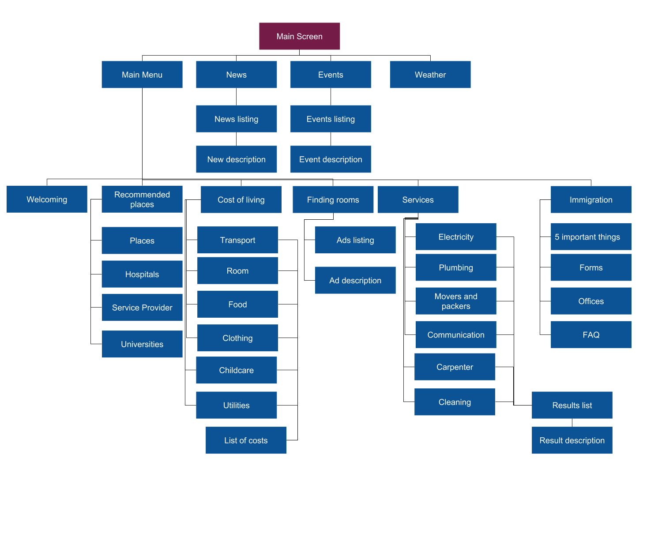

# User cases

## Travon Test Cases

### Home page Test Cases

|  |  |  |  |
| --- | --- | --- | --- |
| **Test Condition** | **Expected Result** | **Passed** | **Failed** |
| When user launches the application, user should be able to see the home page | User should be presented with the home page with the default city name and Weather, News and Events option |  |  |
| User clicks Weather | User should be navigated to weather page |  |  |
| User clicks News | User should be navigated to News page |  |  |
| User clicks on Events | User should be navigated to Events page. |  |  |

### News,Weather,Immigration Page Test Cases

|  |  |  |  |
| --- | --- | --- | --- |
| User clicks on News Card | User should be navigated to that particular news article |  |  |
| User clicks back button on news article | User should be navigated back to news page |  |  |
| User clicks on Weather button | User should be navigated to Weather page where user can view the weather of the particular city and when user clicks on back button, should be navigated back to Home page |  |  |
| User clicks on Immigration button | User should be navigated to Immigration where all other options are displayed and user should be able to navigate through those options |  |  |

**Voice Recognition Functionality**

|  |  |  |  |
| --- | --- | --- | --- |
| **Test Condition** | **Expected Result** | **Passed** | **Failed** |
| Validate that when user launches the application, user is able to see the voice icon. | User should be able to view the voice icon at the top right corner of the screen | Yes |  |
| Validate that when user clicks on voice icon, user is able to  provide his input through voice | User should be able to  provide his input through voice | Yes |  |
| Validate that the user input is displayed in the search box | User input should be displayed in the search box. | Yes |  |
|  |  |  |  |

# Design

## Project architecture

### Model-View-Controller (MVC)

The Model-View-Controller (MVC) is an architectural pattern that separates an application into three main logical components: the model, the view, and the controller. Each of these components are built to handle specific development aspects of an application. MVC is one of the most frequently used industry-standard web development framework to create scalable and extensible projects.[2].

#### Mvc

Following are the components of MVC −

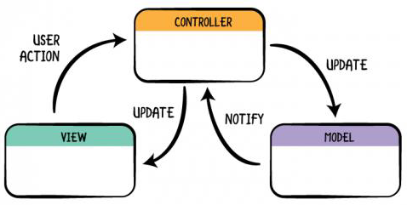

##### Model

The Model component corresponds to all the data-related logic that the user works with. This can represent either the data that is being transferred between the View and Controller components or any other business logic-related data.

For our project, we have included News Article and Recommended Place.

##### View

The View component is used for all the UI logic of the application. For example, the Customer view will include all the UI components such as text boxes, dropdowns, etc. that the final user interacts with.

For our Project we have different screens for e.g. We have Main menu screen where user will be presented with the options like News.5 Things to Do,Cost Of Living. Services and Immigration Info. so as to navigate to that particular section. Similarly, we have designed screen for other sections as well like if user navigates to Immigration Info section, he will be able to view other options pertaining to that.

##### Controller

Controllers act as an interface between Model and View components to process all the business logic and incoming requests, manipulate data using the Model component and interact with the Views to render the final output.

For Travon, we have used different activities like MainScreen, MenuScreen, NewsScreen, Recommended Places Screen, Recommended Places Activity

##### API Handlers and Adapters

For now we have used News Handler and Recommended Places Handler.Adapters used are News Card Adapter and Recommended Places Adapter.

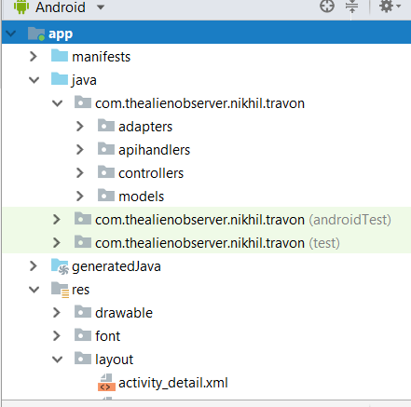

Figure n. MVC Architecture of Project

# Prototyping

## Low fidelity prototype

Low fidelity prototype was helpful to get a better idea of how the application would look once implemented and how the information and functionalities could be organized and displayed throughout the application.

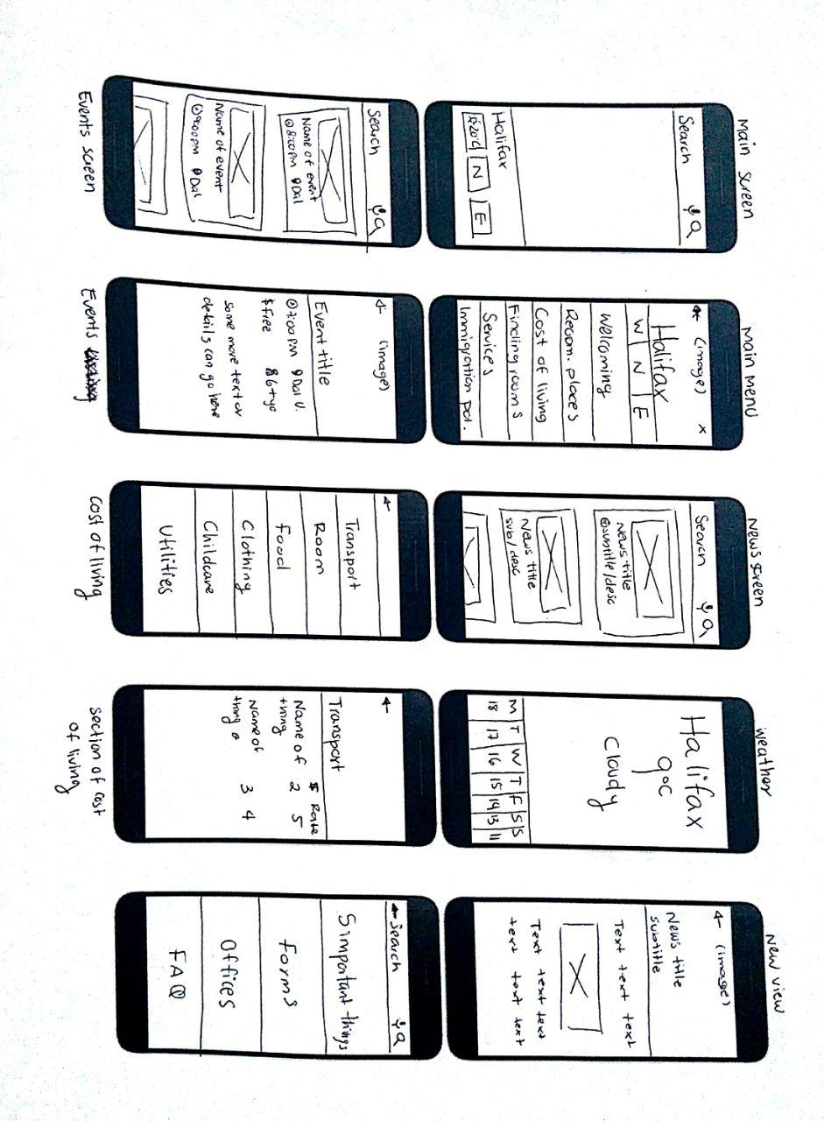

Figure n. Low fidelity prototype part 1

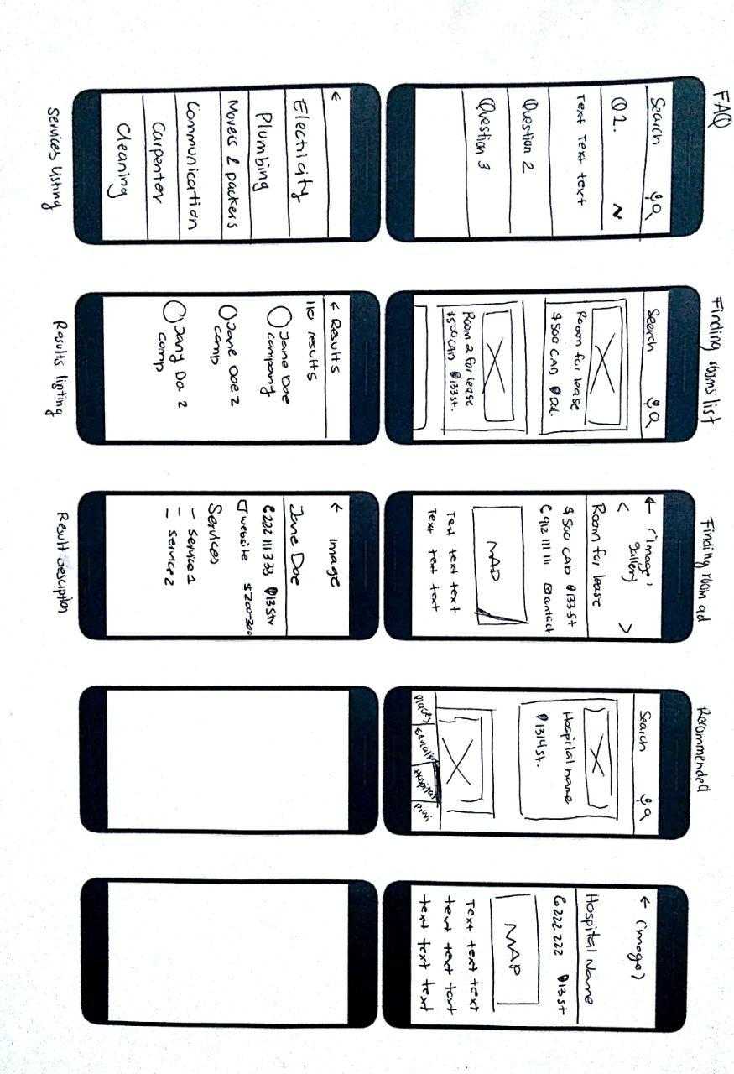

Figure n. Low fidelity prototype part 2

## High fidelity prototype

As part of the design project, the high fidelity prototype was created from the low fidelity prototype.

|  |  |  |
| --- | --- | --- |
|  |  |  |
| Figure n. Main Screen | Figure n. Main Menu | Figure n. Weather screen |

|  |  |  |  |
| --- | --- | --- | --- |
|  | |  | |
| Figure n. Events listing | Figure n. Event description | Figure Immigration listing | Figure n. Immigration description |

|  |  |  |  |
| --- | --- | --- | --- |
|  | |  | |
| Figure n. News listing | Figure n. News description | Figure n. Cost of living listing | Figure n. Cost of living description |

|  |  |  |  |
| --- | --- | --- | --- |
|  |  |  |  |
| Figure n. Finding room listing | Figure n. Finding room description | Figure n. Recommended hospital listing | Figure n. Recommended hospital description |

|  |  |  |
| --- | --- | --- |
|  | | |
| Figure n. Additional services listing | Figure n. Additional services results listing | Figure n. Additional services result description |

# Clickstreams

Click stream can be seen as a roadmap of a user’s activity. The following click streams show the screens sequences the user might follow while using the mobile application.

## Weather

There are two possible ways to access to the weather screen. You can directly access from main screen or from the main menu screen.

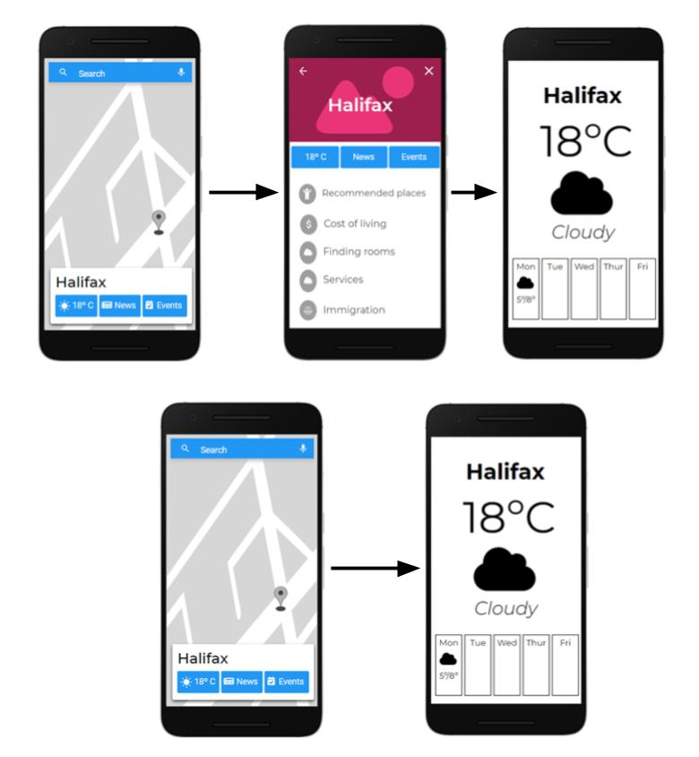

Figure n. First weather clickstream



Figure n. Second weather clickstream

## Events

There are two possible ways to access to the events screen. You can directly access from main screen or from the main menu screen.

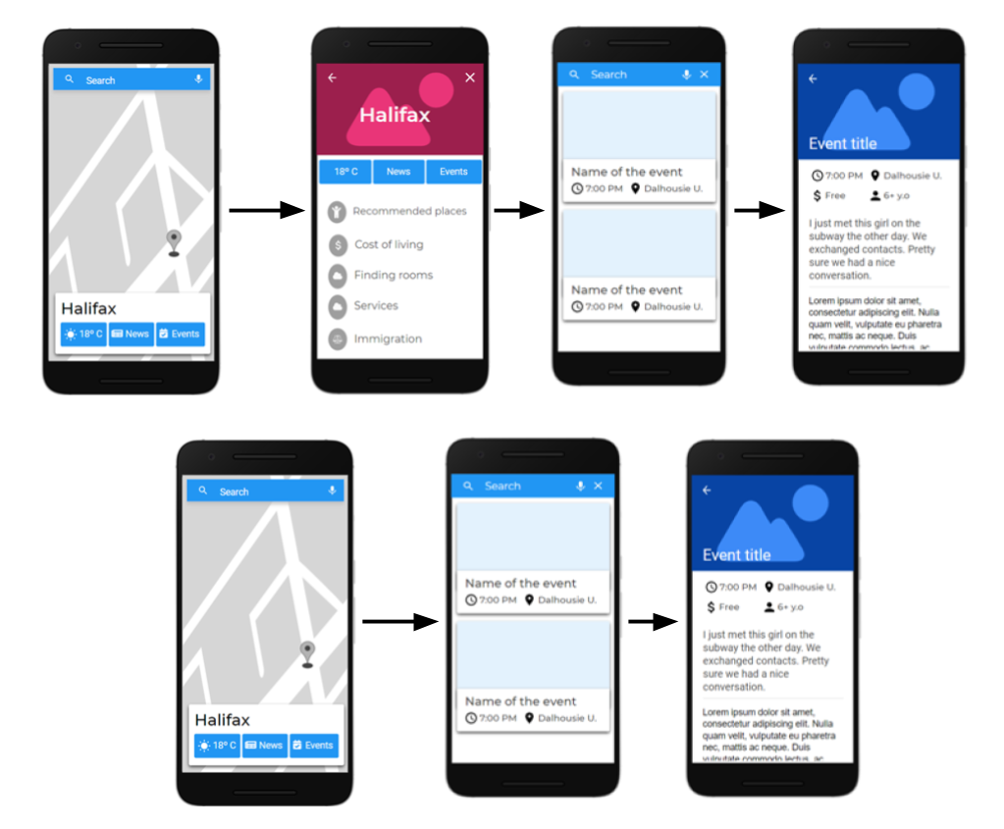

Figure n. Events possible clickstreams

## News

There are two possible ways to access to the news screen. You can directly access from main screen or from the main menu screen.

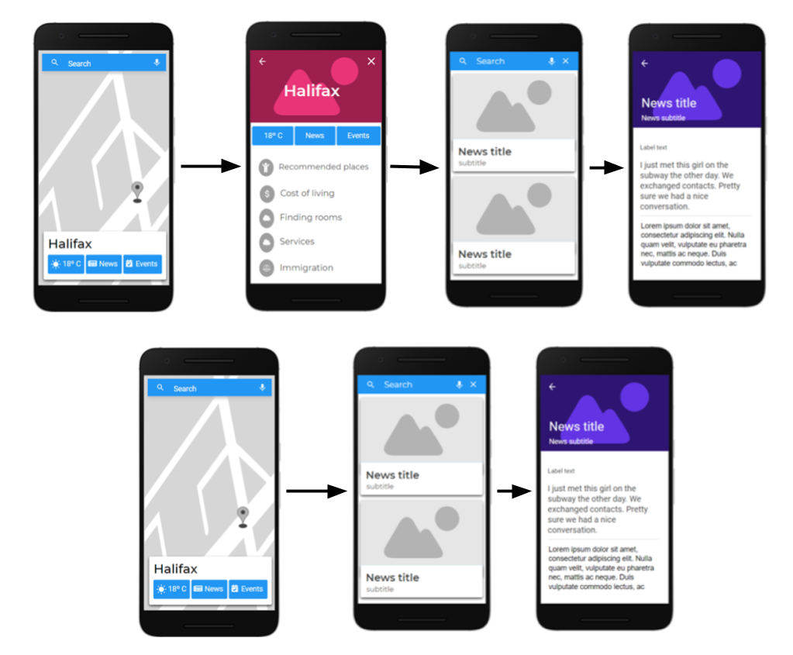

Figure n. News possible clickstreams

## Immigration

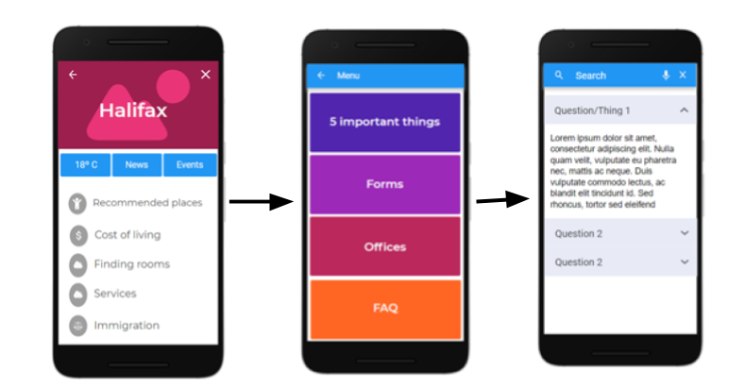

Figure n. Immigration clickstream

## Services

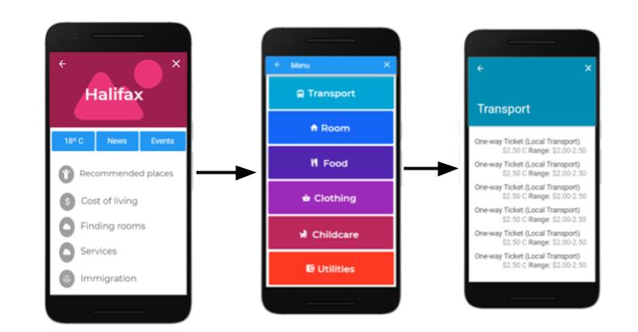

Figure n. Services clickstream

## Finding rooms

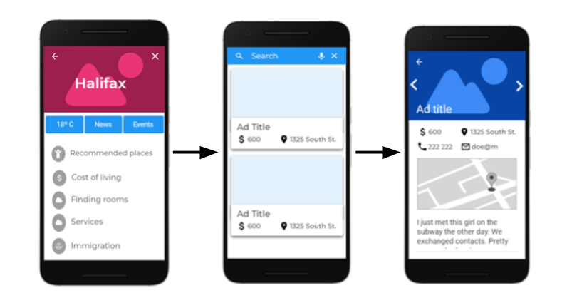

Figure n. Finding rooms clickstream

Recommended places

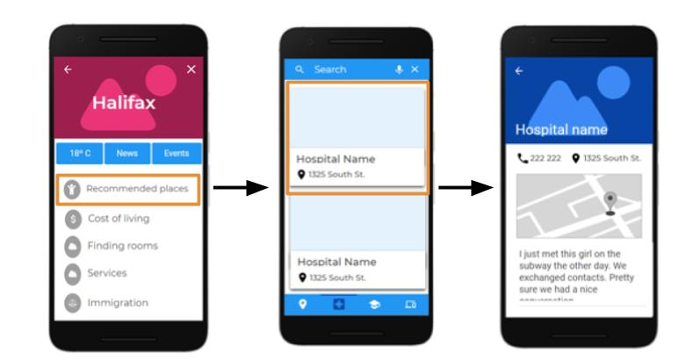

## Services

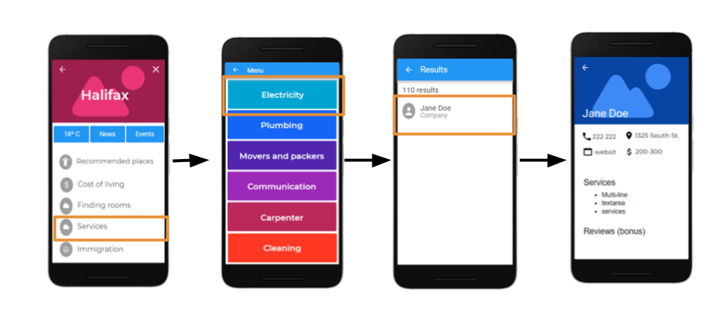

# Testing

## Automated tests

//to do

# Project management

## Task Assignment

In order to be able to carry the project progress more accurately, *Trello* was chosen as a tool for distributing tasks and responsibilities,. Trello is a project management software with web interface, client for iOS and android to organize projects [1].

Trello’s UI makes it easy to create and assign tasks; and keep track of its status. Cards are added at the beginning of each update section. In case there was a previous section, the pending tasks are evaluated in order to be able to include them in the next section planning. See Figure n for an example of the team’s trello board.

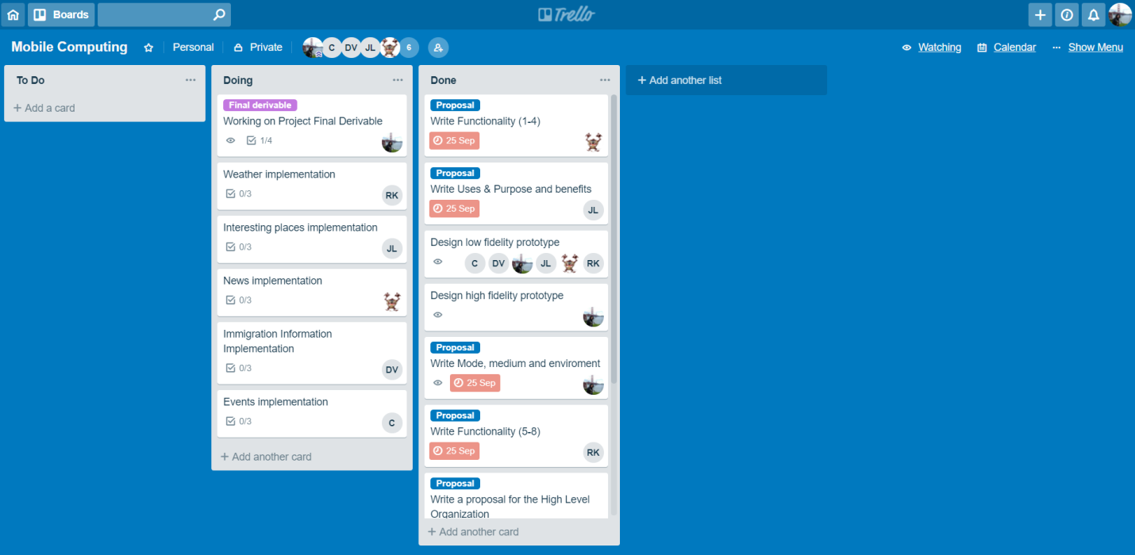

Figure n. Travon’s trello board

## Version control

Code is being submitted to a repository on Git Lab. There are 6 members, where the team leader is a Maintainer and the rest of team are as developers. The url of the repository is: <https://git.cs.dal.ca/metri/mobile-comp-project> .

In order to push new changes to the repository, a merge request has to be created. After, 3 members have to check the request and if the three approve, then the code can be pushed.

# Timeline

|  |  |  |  |
| --- | --- | --- | --- |
| **Milestones** | **Group Members\*** | **Timeline** | **Duration** |
| **Project Update 1 (October 31st)** | | | |
| Map integration along with marker interface | Nikhil | October 1st - October 4th | 3 days |
| Design low fidelity prototype | All team | October 16th | 1 day |
| Design high fidelity prototype | Genny | October 17th - October 19th | 3 days |
| Main menu | Genny | October 25th -October 27th | 3 days |
| Weather | Richa | October 17th - October 29th | 2 weeks |
| Recommended places > places to visit | Jamuna |
| News | Nikhil |
| Immigration Info (first part) | Dheeraj |
| Events | Charley |
| Project documentation | Genny, Dheeraj | October 22th - October 29th | 5 days |
| **Project Update 2 (November 14th)** | | | |
| Cost of living | Genny | November 1st - November 7th | 2 weeks |
| Recommended places > hospitals, universities, providers | Jamuna | November 1st - November 7th | 1 week |
| Immigration Info (Android second part) | Dheeraj, Jamuna | November 4th - November 14th | 2 weeks |
| API to get Immigration Info | Nihkil, Genny | November 1st - November 7th | 1 week |
| Welcoming | Dheeraj | October 1st –October 3th | 3 days |
| API to get Services Info | Nihkil, Charley | November 1st - November 14th | 2 weeks |
| Notifications | Richa | November 1st - November 14th | 2 weeks |
| Testing | All team | November 1st - November 14th | 2 weeks |
| **Project Demonstrations (November 27/29th)** | | | |
| Finding Rooms | Richa | November 15th - November 23rd | Time Left |
| Voice recognition | Nihkil | November 15nd – November 22th | 1 week |
| Search functionality (text input) | Charley, Dheeraj | November 15nd – November 22th | 1 week |
| Additional GPS Services (plumber, electrician, etc.) | Genny, Jamuna | November 9th - November 23rd | Time Left |
| Testing | team |  |  |
| **Others** | | | |
| Documentation and Comments | All members | September 23rd - November 23rd | 2 months |
| Bus Stops (bonus) |  | November 9th - November 23rd | Time Left |

**\* Group Members are the main programmers working on features; other members will be assisting as and when required.**

# References

[1]"Trello", *Es.wikipedia.org*, 2018. [Online]. Available: <https://es.wikipedia.org/wiki/Trello>. [Accessed: 31- Oct- 2018]

[2]"MVC Framework Introduction", [*www.tutorialspoint.com*](http://www.tutorialspoint.com/), 2018. [Online]. Available: <https://www.tutorialspoint.com/mvc_framework/mvc_framework_introduction.htm>. [Accessed: 28- Oct- 2018]