***Travon***

**Project**

Mobile Computing CSCI 5708 Fall 2018

**GROUP 15**

|  |  |  |
| --- | --- | --- |
| **Name** | **B00** | **Email** |
| Genny Andrea Centeno Metri | B00786201 | gn936133@dal.ca |
| Richa Khatri | B00792218 | [rc801868@dal.ca](mailto:rc801868@dal.ca) |
| Jamuna Loganath | B00811590 | [jm284791@dal.ca](mailto:jm284791@dal.ca) |
| Nikhil Tyagi | B00809791 | [nikhil.tyagi@dal.ca](mailto:nikhil.tyagi@dal.ca) |
| Dheeraj Varshney | [B00808467](mailto:B00808467,dh301823@dal.ca) | [dh301823@dal.ca](mailto:B00808467,dh301823@dal.ca) |
| Charley LeBlanc | B00727183 | ch875607@dal.ca |

   
*Instructor:* Tami Meredith

Contents

Abstract 3

Introduction 3

Timeline 3

# Abstract

The mobile application “Travon” will help users to ease their difficulties, problems or issues they may face while moving to a new city. Travel Companion will also help them to figure out the basic issues and worries people may face during their initial days in the new city.

Users will be able to know the place better with anticipation and can prepare accordingly.  They can also use the application during their stay in the new city. The application also provides users the ability to find other matters such as weather, places to visit, and much more. Features like GPS and Voice Recognition are incorporated in this app.

# Introduction

Most of the time, moving to a new city is considered as a big change and it is challenging to adjust to. People generally move to a new city for job or academic purposes, totally unacquainted and unknown to them, they usually have a lot of questions about that place.

Whenever we move to a new place, it would be useful if they could figure out all the important matters before even arriving. This is the central idea of our mobile application, “*Travon*”, to ease the process and help people adjusting and settling in a new city.

Travon will provide all the information under a single application; so it becomes easy for the user to sort out these things with anticipation. Travon will be a location based and informative app with features such as receiving news and events of that area, interesting facts about that place, and recommended places to visit such as hotels, hospitals, universities, and stores. Other features include finding rooms using GPS, performing search using voice recognition or typing, and getting important information regarding immigration policies.

**Scope**

Users will be able to use most of the functionalities in any city of the world, except for Services and Immigration Information functionalities which will only be available for Halifax at the moment. Further in the future, the API will be extended so it covers other cities apart from Halifax.

# Users

The proposed application will attract people who are planning to move or travel for a long time to a city different to where they reside. Most importantly, our app will assist the inhabitants of any city including landed immigrants, temporary residents, work permit holders, students, and tourist visa holders to know more about the city in their daily lives.

# Purpose and Benefits

The purpose of our proposed application is to provide users with all the essential information that one should know before and after they arrive at the new city for them, all within the same application.

Relocation and travelling are always challenging. Usually, when people plan to come to a new city, they will have various questions/doubts concerning their preparations, weather, things to know, things to do, finding accommodations, understanding culture & geography of the city, attractions, entertainment, bus connectivity, as well as immigration rules, regulations, and guidelines.

To find out the answers for these, they will have to visit various websites and collect information from all those sites separately. Working on various sites could be overwhelming and baffling for users. All information in one application indorses simplicity and could possibly save a lot of time.

As our app will have all information for a visitor/traveler, by using our app people can plan every activity such as finding a place to stay, selecting a place according to preferred neighborhood & bus connectivity, relish their favorite cuisine at the nearest restaurant, getting involved with their community events, plan for their favorite sports games, etc.

# Sitemap

At the moment of planning a mobile application, creating a sitemap will help ensure the team has included all the screens needed to cover the proposed functionalities. The following sitemap shows the navigation the user can go through within the application. It shows the hierarchy of screens and functionalities available for each feature.

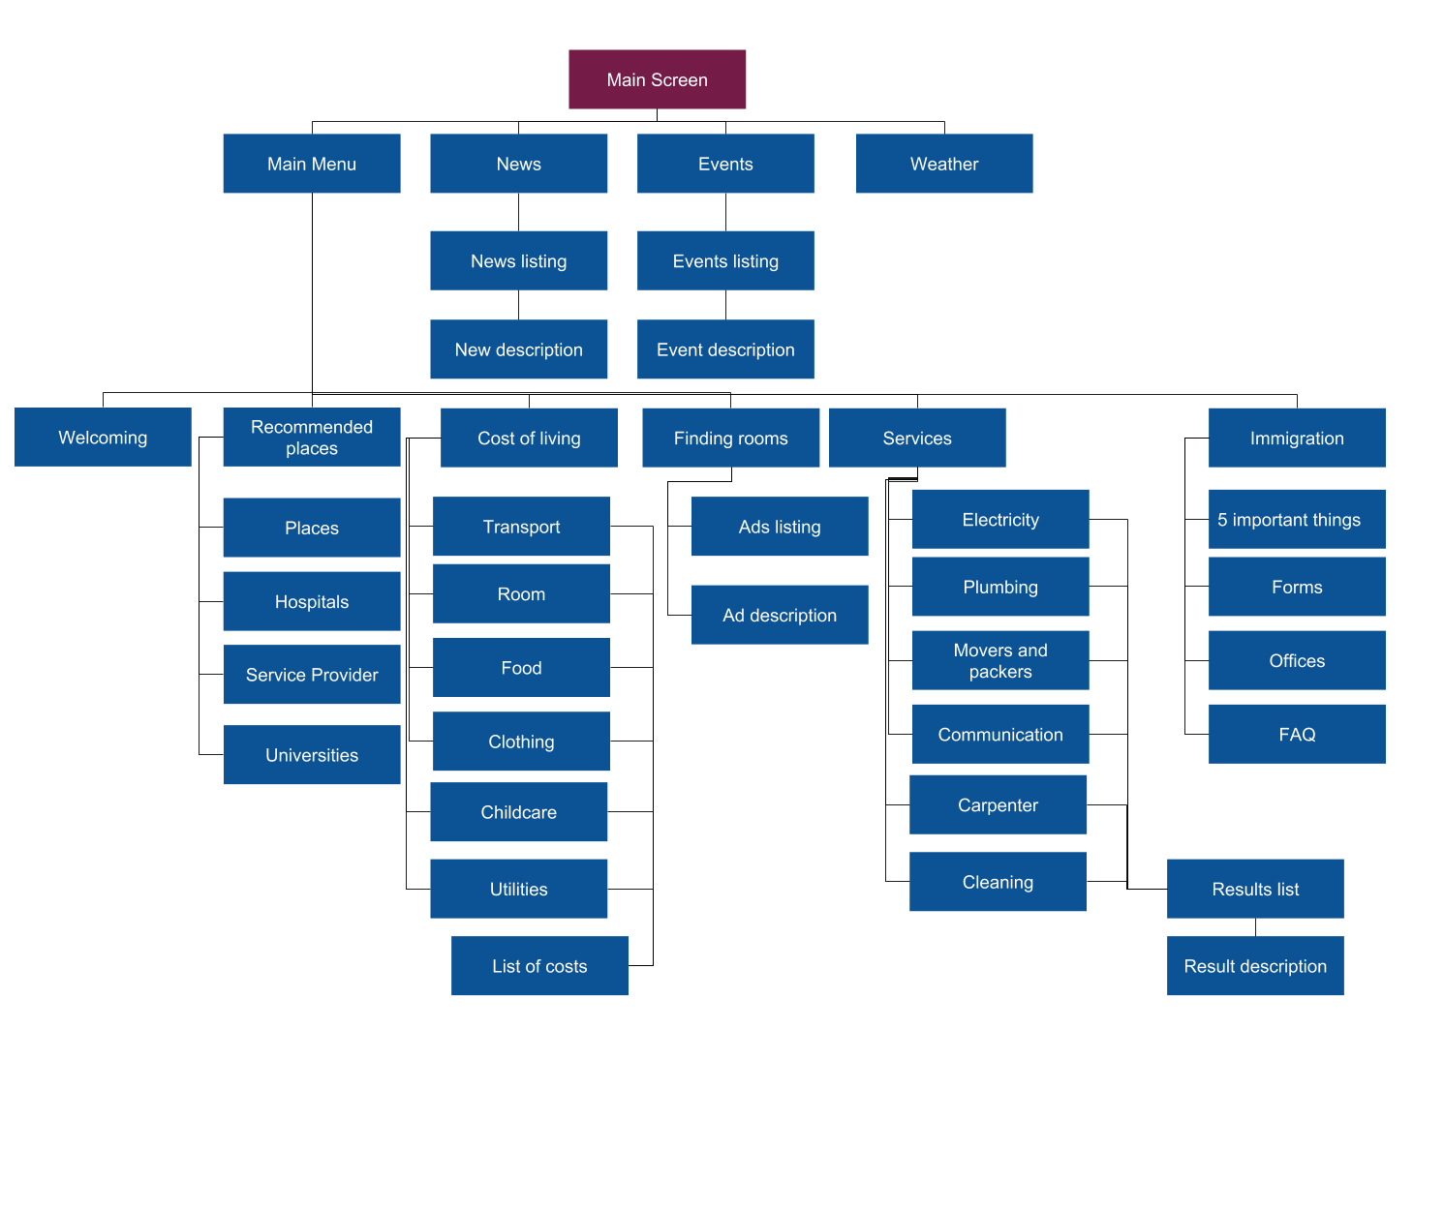

# User cases

# Design

## Project architecture

Mvc

* Talk about mvc
* Provide a diagram of the architecture used in the mobile app (Check the project on Android Studio_
  + Model
  + View(layouts)
  + Controllers
  + Apihandlers
  + adapters

# Prototyping

## Low fidelity prototype

Low fidelity prototype was helpful to get a better idea of how the application would look once implemented and how the information and functionalities could be organized and displayed throughout the application.

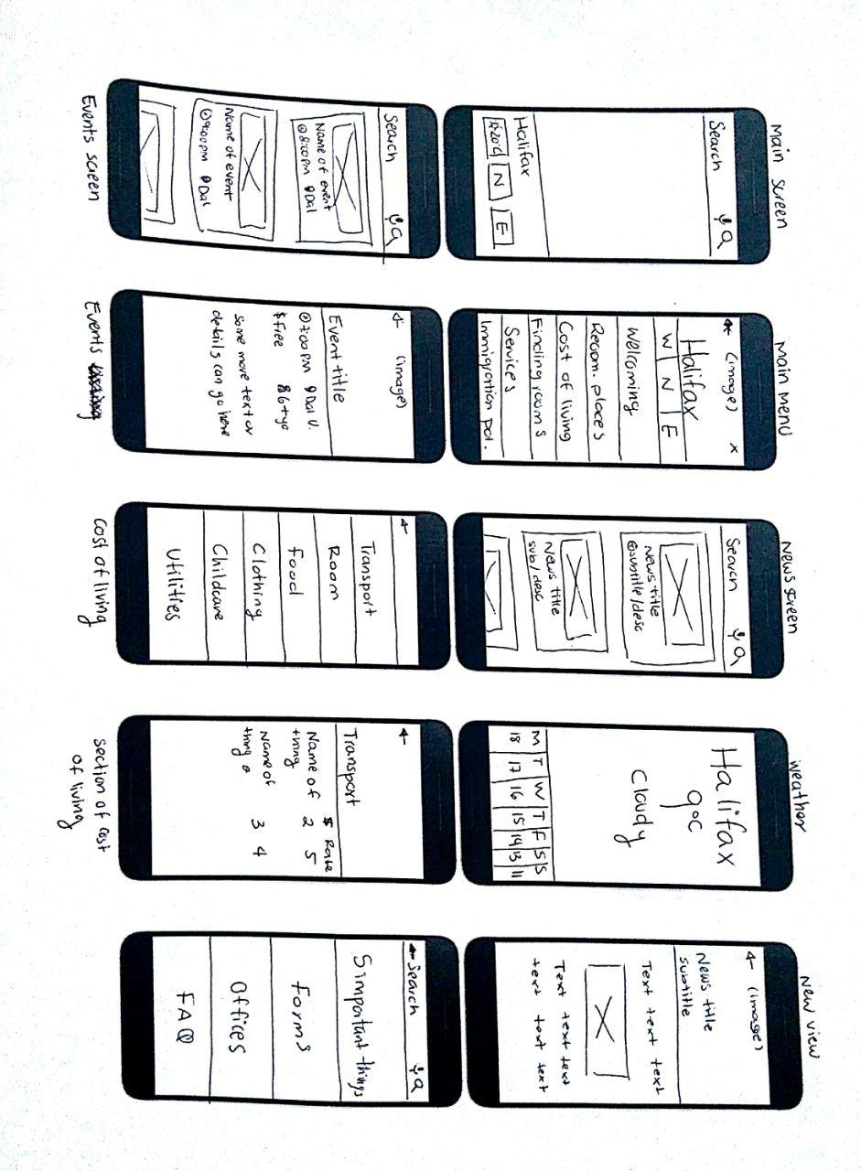

Figure n. Low fidelity prototype part 1

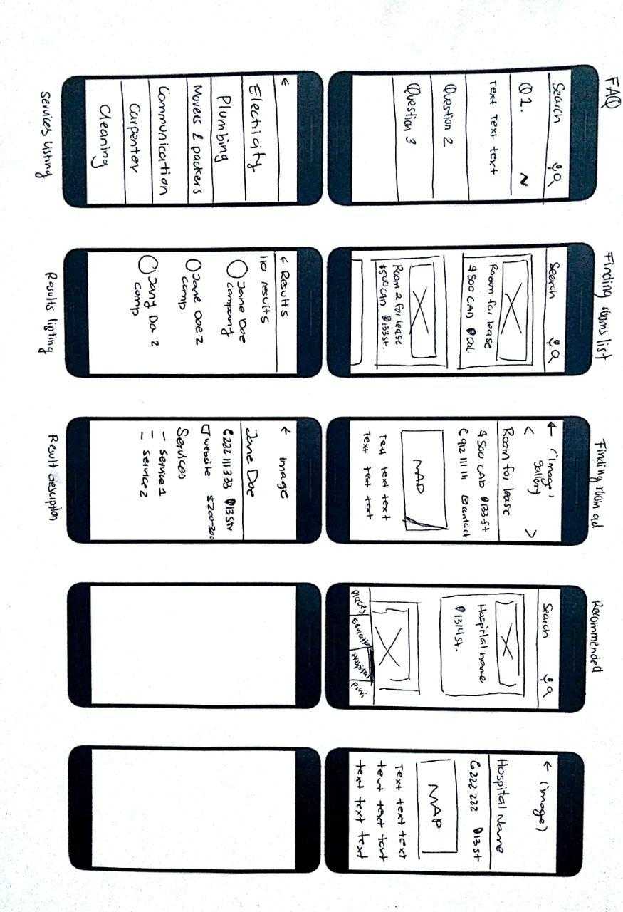

Figure n. Low fidelity prototype part 2

## High fidelity prototype

As part of the design project, the high fidelity prototype was created from the low fidelity prototype.

|  |  |  |
| --- | --- | --- |
|  |  |  |
| Figure n. Main Screen | Figure n. Main Menu | Figure n. Weather screen |

|  |  |  |  |
| --- | --- | --- | --- |
|  | |  | |
| Figure n. Events listing | Figure n. Event description | Figure Immigration listing | Figure n. Immigration description |

|  |  |  |  |
| --- | --- | --- | --- |
|  | |  | |
| Figure n. News listing | Figure n. News description | Figure n. Cost of living listing | Figure n. Cost of living description |

|  |  |  |  |
| --- | --- | --- | --- |
|  |  |  |  |
| Figure n. Finding room listing | Figure n. Finding room description | Figure n. Recommended hospital listing | Figure n. Recommended hospital description |

|  |  |  |
| --- | --- | --- |
|  | | |
| Figure n. Additional services listing | Figure n. Additional services results listing | Figure n. Additional services result description |

# Clickstreams

Click stream can be seen as a roadmap of a user’s activity. The following click streams show the screens sequences the user might follow while using the mobile application.

## Weather

There are two possible ways to access to the weather screen. You can directly access from main screen or from the main menu screen.

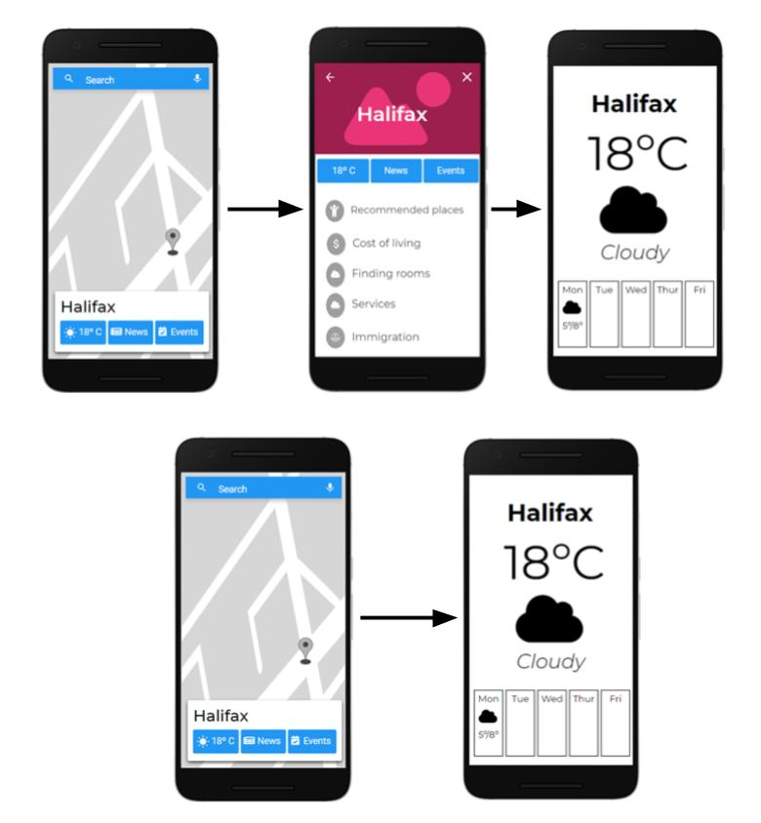

Figure n. First weather clickstream



Figure n. Second weather clickstream

## Events

There are two possible ways to access to the events screen. You can directly access from main screen or from the main menu screen.

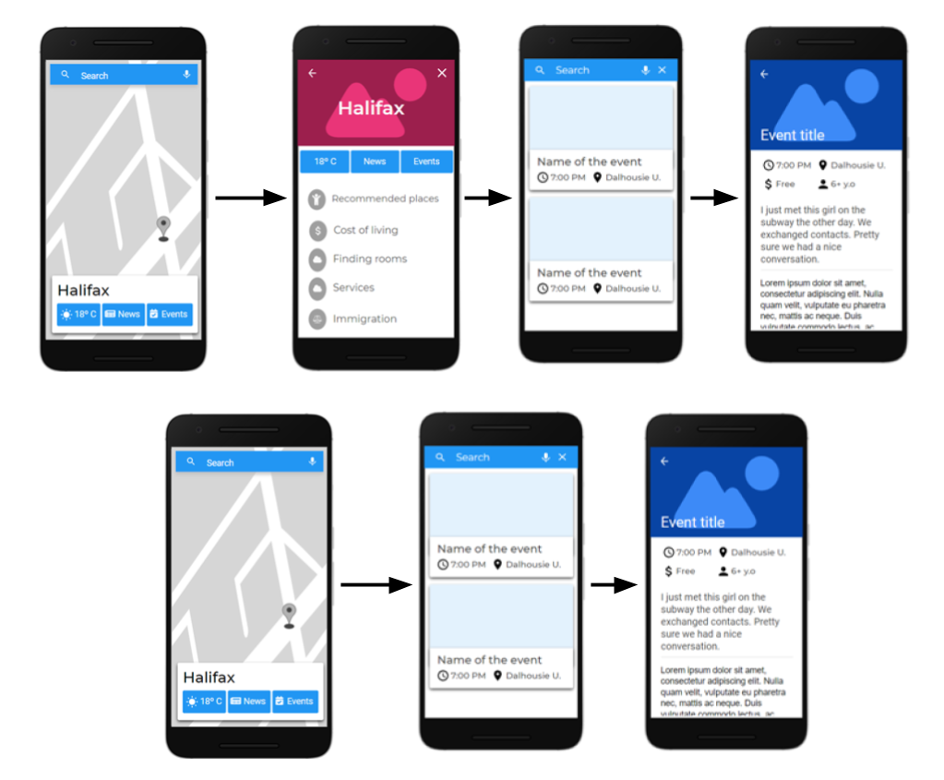

Figure n. Events possible clickstreams

## News

There are two possible ways to access to the news screen. You can directly access from main screen or from the main menu screen.

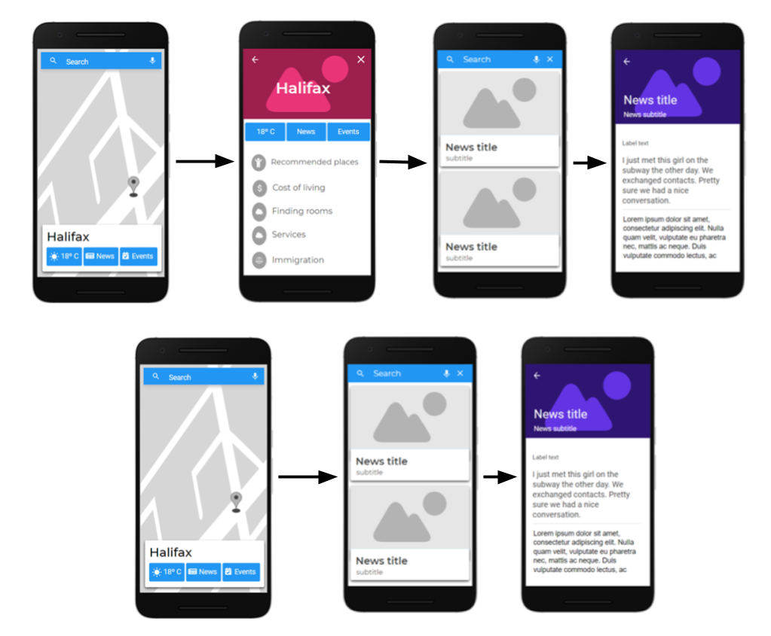

Figure n. News possible clickstreams

## Immigration

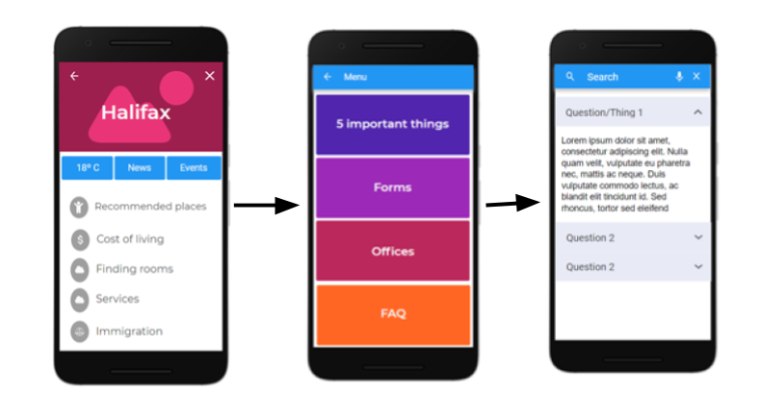

Figure n. Immigration clickstream

## Services

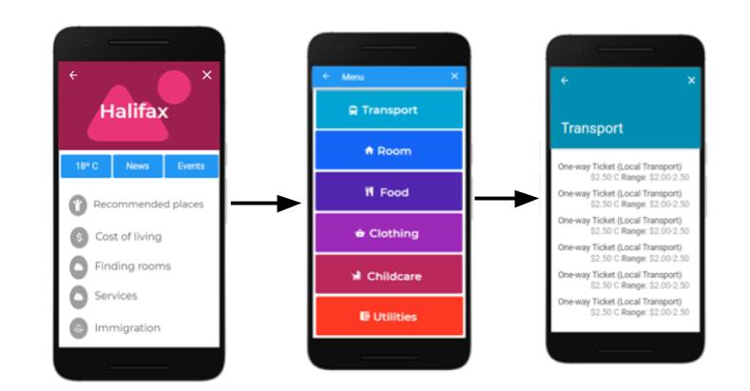

Figure n. Services clickstream

## Finding rooms

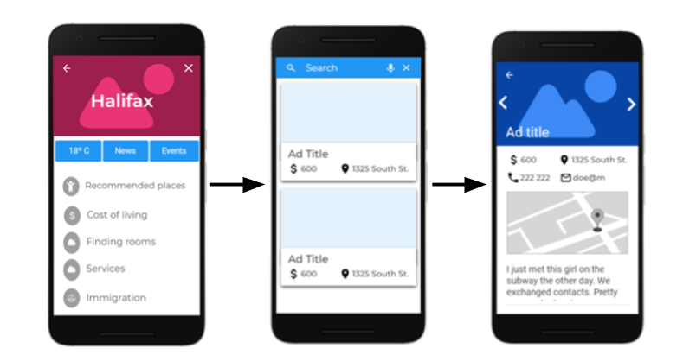

Figure n. Finding rooms clickstream

## Recommended places

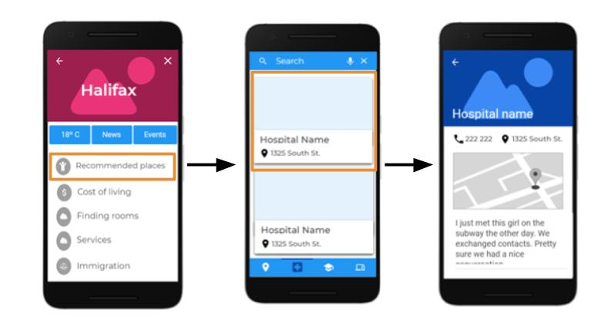

## Services

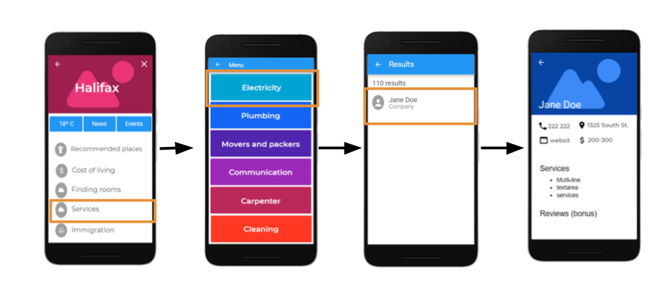

# Testing

## Automated tests

//Nihkil will explain

## Test cases

# Project management

In order to be able to carry the project progress more accurately, *Trello* was chosen as a tool for distributing tasks and responsibilities,. Trello is a project management software with web interface, client for iOS and android to organize projects [1].

Trello’s UI makes it easy to create and assign tasks; and keep track of its status. Cards are added at the beginning of each update section. In case there was a previous section, the pending tasks are evaluated in order to be able to include them in the next section planning. See Figure n for an example of the team’s trello board.

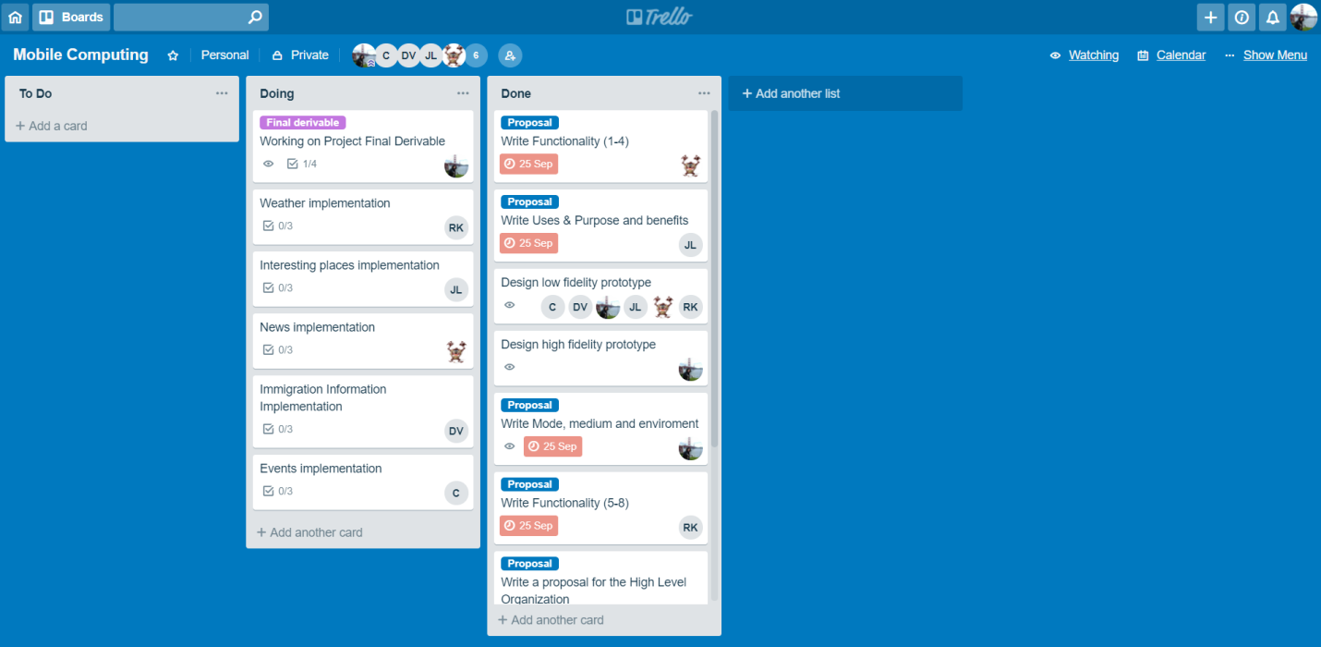

Figure n. Travon’s trello board

# Timeline

|  |  |  |  |
| --- | --- | --- | --- |
| **Milestones** | **Group Members\*** | **Timeline** | **Duration** |
| **Project Update 1 (October 1st)** | | | |
| Map integration along with marker interface | Nikhil | October 1st - October 4th | 3 days |
| Design low fidelity prototype | All team | October 16th | 1 day |
| Design high fidelity prototype | Genny | October 17th - October 19th | 3 days |
| Main menu | Genny | October 25th -October 27th | 3 days |
| Weather | Richa | October 17th - October 29th | 2 weeks |
| Interesting places | Jamuna |
| News | Nikhil |
| Immigration Info (first part) | Dheeraj |
| Events | Charley |
| Project documentation: TODO: specify which parts | Genny | October 22th - October 29th | 5 days |
| **Project Update 2 (November 8th)** | | | |
| Cost of living | Genny | October 25th - November 7th | 2 weeks |
| Immigration Info (Android second part) | Dheeraj |  |  |
| API to get Immigration Info |  |  |  |
| Welcoming | Dheeraj | October 28th –October 29th | 2 days |
| Search functionality (text input) | Dheeraj, Charley | October 25th - November 7th | 2 weeks |
| Notifications | Richa | October 25th - November 7th | 2 weeks |
| Testing | All team |  |  |
| **Project Demonstrations (November 27/29th)** | | | |
| Finding Rooms | Richa | November 9th - November 23rd | Time Left |
| Recommended places | Charley, Dheeraj |  |  |
| Voice recognition | Nihkil | November 2nd – November 9th | 1 week |
| API to get Services Info |  |  |  |
| Additional GPS Services (plumber, electrician, etc.) | Genny, Jamuna | November 9th - November 23rd | Time Left |
| Testing |  |  |  |
| **Others** | | | |
| Documentation and Comments | All members | September 23rd - November 23rd | 2 months |
| Bus Stops (bonus) | Charley, Dheeraj | November 9th - November 23rd | Time Left |

**\* Group Members are the main programmers working on features; other members will be assisting as and when required.**

# References

[1] https://es.wikipedia.org/wiki/Trello