Hwk 3 Genoa Sullaway
Table of Contents

TO DO – FIGUURE OUT FIGURE SIZES IN RMD, NEED TO BE BIGGER

HYPOTHESES COULD BE BETTER?

FIGURE LABEL #S AND REFERENCE THEM IN TEXT

MAKE SURE REFERENCES ARE SET UP RIGHT

ANY OTHER PLOTS?

Preliminary Title:
Evaluating Spatial Variance in Calanus marshallae distribution during the 2014-2106 Marine Heatwave in the Eastern Bering Sea

Introduction/Background
Marine heatwaves (MHW) have become more prevalent as anthropogenic climate change impacts progress (Frolicher et al 2018). In the Northeast Pacific Ocean, the most recent MHW (2014-2016) resulted in mass mortalities and marine mammal strandings, species distribution shifts, fishery closures and social-ecological network shifts (Cheng and Frolicher 2020, Fisher et al 2021).
Primary and secondary production are tightly linked to oceanographic conditions. In the E. Bering Sea, copepods such as Calanus spp, underpin the health of the entire ecosystem. As high nutrient prey items, Calanus support marine mammals, numerous subsistence fisheries and a billion-dollar Pollock fishery. However, copepod abundance and community composition are heavily regulated by environmental factors. During cold years, large nutritious copepods are abundant and persist throughout the season to feed age-0 pollock in Fall. However, during warm years, the zooplankton community composition transitions to smaller less nutritious species and large copepods are often absent on the inner shelf in Fall when pollock are preparing to overwinter (Kimmel et al 2018). This disruption in lipid-rich prey in warm years has negative cascading effects throughout the EBS food web and social ecological networks.
If Calanus spatial heterogeneity exists within warm years, this could provide spatial refuges for predators where they still have access to high quality prey items. On the other hand, large scale climate events can lead to increases in spatial synchrony across increasingly large distances. A large spread marine heatwave may increase synchrony in Calanus abundance across the EBS, and this can have cascading negative effects through the ecosystem. Moreover, changes to spatial variability in Calanus within warm years can have implications for future predator-prey overlap (Siddon et al 2013).

Goals and Objectives
The research question I would like to address is: Is there spatial variation in Calanus abundance during the 2014-2016 Marine Heatwave in the Eastern Bering Sea?
Warm stanzas and marine heatwaves are predicted to become more common in the EBS. I want to understand the spatial variability for Calanus among warm years, to ultimately inform the spatial availability of Calanus prey for higher trophic levels. Does the EBS become a “food desert” for higher trophic levels or are there certain spatial refuges during warm years?
Generally, copepod abundance and phenology are tightly linked to oceanographic conditions. Thus, I expect variation in temperature to be a strong predictor in C. marshallae CPUE. With greater temperatures resulting in less Calanus. I expect there may be effects related to years since the onset of the marine heatwave, ie I expect 2014 to be different than 2016 because of cumulative impacts of warm years. I expect Calanus to be more abundance in the northern inner shelves compared to the southern and outer shelves because of past Calanus research demonstrating higher abudnance on inner shelves, additionally, temperatures in the Norther regions were slightly cooler than the south and I expect this to contribute to Calanus spatial variation.
I will need to test for colinearity across covariates, I may not need all the covariates I propose. For example, depth, temperature and Ortiz region may be confounded since Ortiz regions were delineated based on oceanographic bounds and shelf breaks that differ by depth and temperature.
-wind? salinity? talk about mutlicoollinearity

Data Description
Data were collected by NOAA AFSC ECOFOCI during at-sea oceanographic cruises in the Eastern Bering Sea (Figuure XX) and zooplankton data were provided to GS by Dr. Dave Kimmel. These data are part of a larger zooplankton community dataset from the eastern Bering Sea. The response variable is Calanus marshallae catch per unit effort (CPUE) (individuals m^3) for each station (each point in figure XX) sampled in each year.
Zooplankton data are collected annually on NOAA oceanographic cruises from April-September, however the spatial and temporal schedule is unbalanced from year to year (Figure XX). Copepods are collected using paired bongo nets (20cm frame, 150um mesh and a 60cm frame, 333 um mesh) on oblique tows. The tow depth varies by station and is not necessarily related to bottom depth. If bottom depth is less than 100m, max tow depth is 5-10m above the bottom. However, if max bottom depth is deeper than 100m the max gear depth can vary depending on the sea state, most tows are not deeper than 300m. The samples are identified to lowest taxonomic level and sorted into different stages (C-1 to C-6), however at this point, I summed Calanus CPUE across lifestages.
Some covariate data is collected onboard the ship, for example maximum bottom depth and gear depth are recorded on the zooplankton gear deployment. Salinity and temperature covariates were collected from CTD casts done in parallel to zooplankton net casts. Covariates such as wind stress and cold pool extent were downloaded from publicly available climate dataset provided by Dr. Mike Litzlow (NOAA AFSC, https://github.com/mikelitzow/bold-new-pollock/tree/master/data).
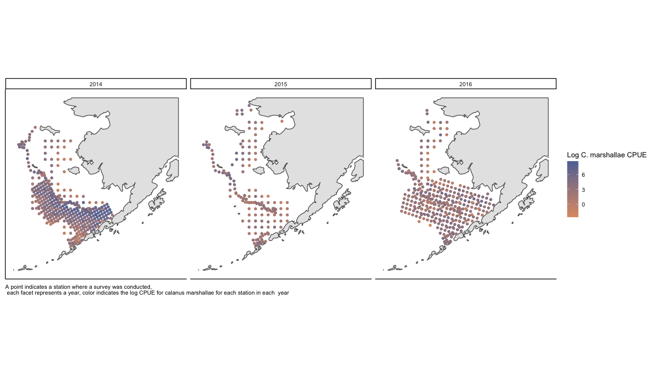
Exploratory data analysis demonstrate that there is unbalanced sampling of stations across years (Figure XX). A coplot of select covariates indicate possible relationships between depth salinity and temperature. We see that there is more variation in temperature and salinity at shallower depths across years. Additionally, there is generally less variation in temperature at depth, which is expected based on the differences in water mixing. Interestingly, it appears that temperatures at depth get warmer and have less variability from 2014 to 2016 (Figure XX).

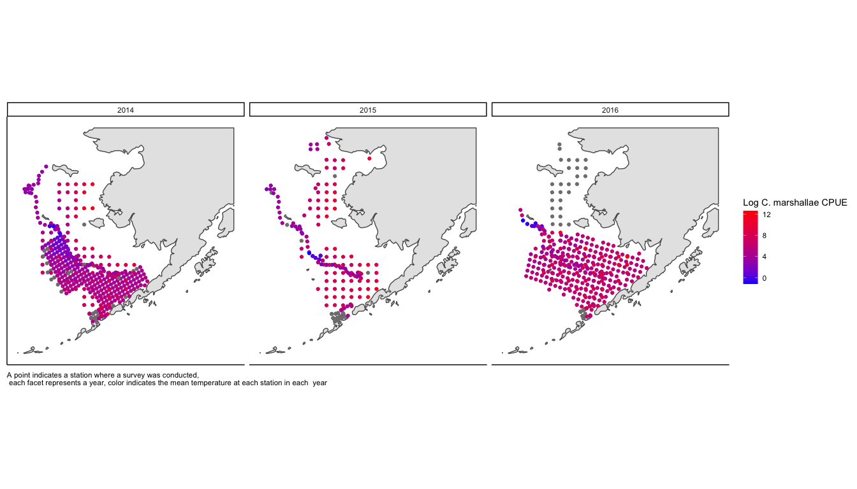
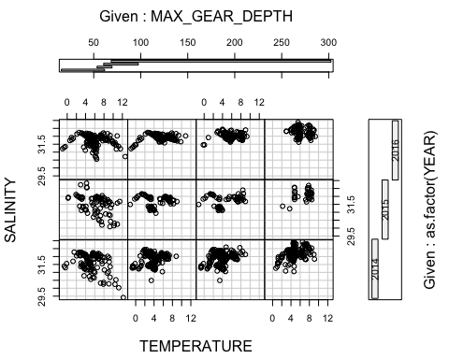
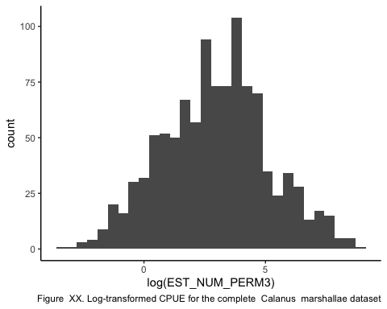

Methods
- These data may have spatial autocorrelation and they may have a slight right skew. However, with a log transformation (Figure XX) data appear normal, so I will use a log normal distribution with a log link for the model.
- The random variable we want to predict is Calanus CPUE where $γ_{i}$ = Calanus m-3
$$log(γ_{i,s,y})∼LogNormal(μ_{i,s,y},σ^{2})$$
$$log(μ_{s,y})=B_{0s}+B_{1}Depth_{s,y}+B_{2}Temp_{s,y}+B_{3}SAL_{s,y}+B_{4}Wind_{n,y}+B_{5}CP_{y}+B_{6}Domain_{s}+B_{7}SAL_{s,y}+ε$$
$$ε=MVN(0,σ)$$
Where $B_{0i}$ is the random effect of year (note I am interested in looking at temporal autocorrelation, I think the order of the year matters as the heatwave progresses), $Depth_{s,y}$ is the survey depth, $Temp_{s,y}$ is the mean temperature at each station for each year, $SAL_{s,y}$ is the mean salinity at each station for each year, $Wind_{n,y}$ is the wind stress for each direction (north or south) for each year, $CP_{y}$ is the cold pool extent for that year, $Domain_{s}$ is the station domain related to the Ortiz regions delineated by oceanographic bounds. The error term, $ε_{i}$, is assumed to be multivariate normally distributed and $σ$ will be composed of a variance-covariance matrix that accounts for spatial autocorrelation.
Back-transformed results will under go a bias correction.
- W = wind (north and south) for each year (y) DECIDE WHICH WIND METRIC TO USE

References
- Cheung, W.W.L., Frölicher, T.L. Marine heatwaves exacerbate climate change impacts for fisheries in the northeast Pacific. Sci Rep 10, 6678 (2020). https://doi.org/10.1038/s41598-020-63650-z
- Frölicher, Thomas L., Erich M. Fischer, and Nicolas Gruber. “Marine heatwaves under global warming.” Nature 560.7718 (2018): 360-364.
- Fisher, Mary C., Stephanie K. Moore, Sunny L. Jardine, James R. Watson, and Jameal F. Samhouri. “Climate shock effects and mediation in fisheries.” Proceedings of the National Academy of Sciences 118, no. 2 (2021).
- Siddon, Elizabeth Calvert, Trond Kristiansen, Franz J. Mueter, Kirstin K. Holsman, Ron A. Heintz, and Edward V. Farley. “Spatial match-mismatch between juvenile fish and prey provides a mechanism for recruitment variability across contrasting climate conditions in the eastern Bering Sea.” PLoS One 8, no. 12 (2013): e84526.

