Ashley Stanek
Fish 604 – Homework 2
September 23, 20214

Problem 1 Explore length distribution by plotting histograms or density plots of the length of sablefish overall and by sex. Are there obvious differences in the length distribution between males and females?

Gray bars in the histogram show the distribution when sexes are combined while the colored bars separate out the sexes. There are differences in the length distributions of the sexes, males are smaller than females, overall.

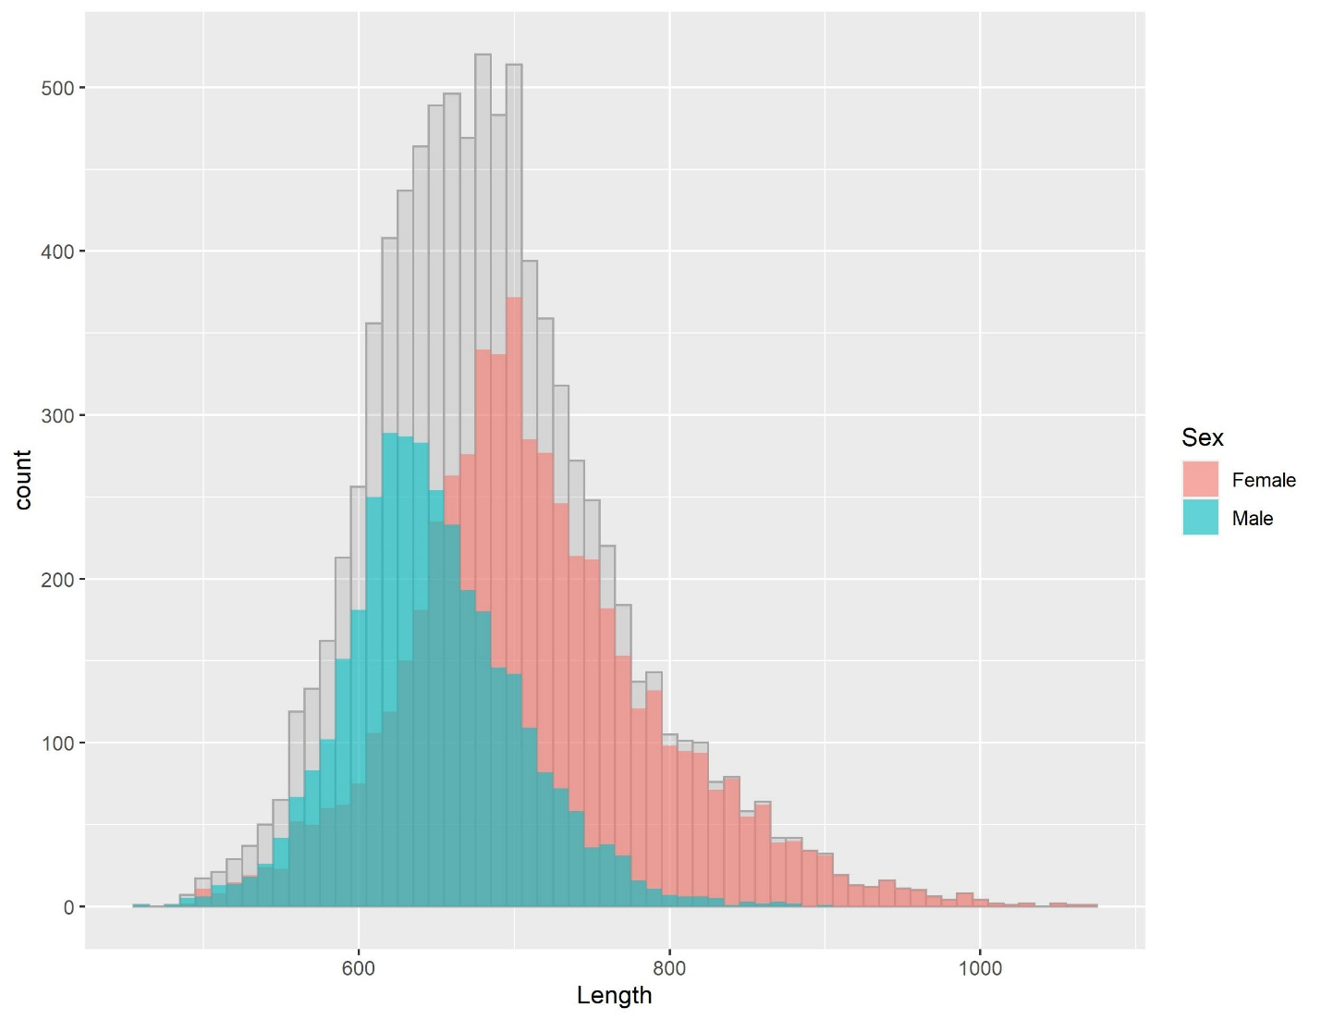

Problem 2 Show a few illustrative plots by saving graphical output or copying and pasting them into your results file. To paste into Word, the Windows metafile format usually works well! Add a figure caption that clearly states what the figures show. Questions: Does there appear to be an asymptotic length and/or weight for males and females? Does there appear to be a difference in growth between males and females? Are there apparent differences in the length-weight relationship among years?

There does appear to be an asymptotic length and weight in most years, though it does differ by sex. This is most notable in 2002, 2003, and 2005. It is clear though that the rate at which weight and length increases as fish age, slows. While the length-weight relationship appears very similar for males and females and between years, there is a potential difference in 2006.

Figure 2. Growth relationships of Chatham Strait sablefish by sex (pink: females, teal: males) from 2002 to 2006. Circles identify individual fish while lines reflect the smoothed (lowess) relationship with 95% confidence intervals shown by shading. A) Length in mm by age in years, B) weight in kg by age in years, and C) length in mm by weight in kg.

A)
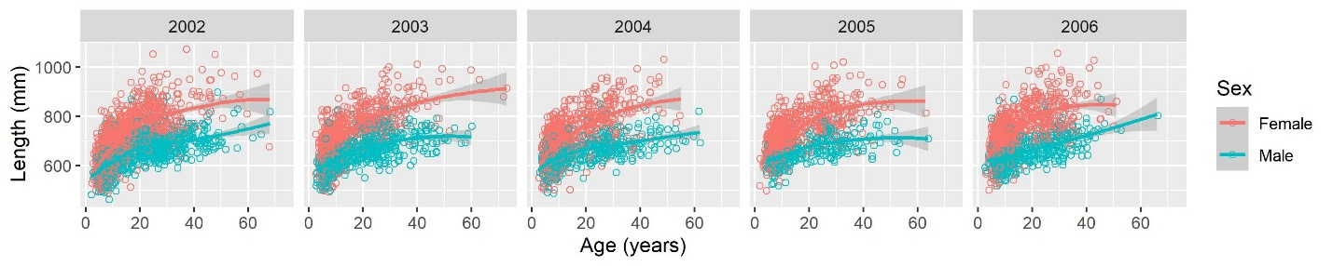
B)
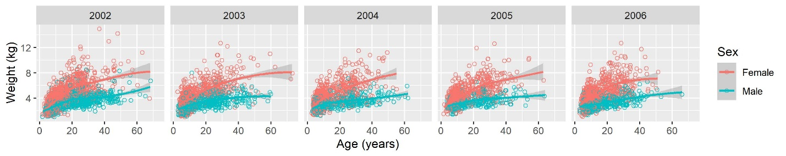
C)
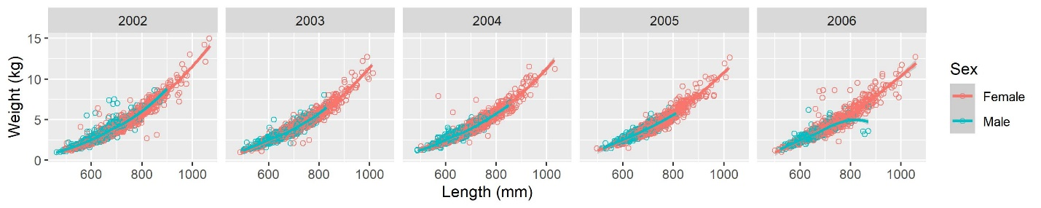

Problem 3 Based on the previous graphical analyses (disregarding sexes, i.e. we fit the model to both sexes combined) and the interpretation of the parameters in the model, choose reasonable starting values for L∞ and a0 and justify your choice! Use 0.05 for the growth parameter k. Construct a 95% confidence interval for the overall growth parameter and for the estimated
mean length at infinity.

Starting values: L_{inf} = 850, a₀ = -20

Table with coefficients and 95% confidence intervals:
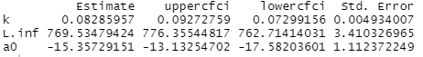

Solid line reflects fitted model, dotted lines represent ± 95% confidence intervals.

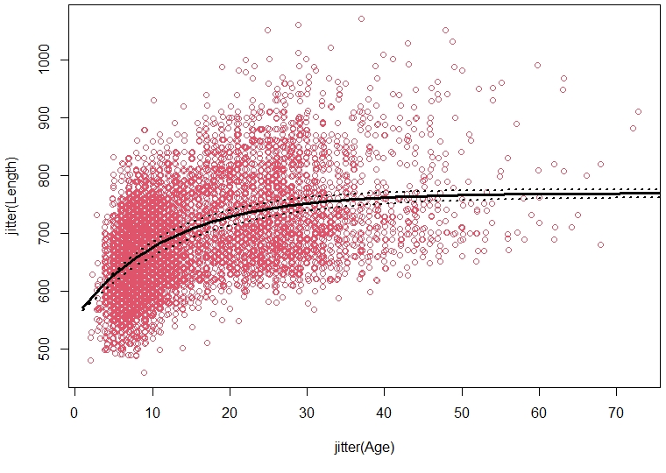

Problem 4 Plot the distribution of the residuals as histograms and boxplots (overall, by year, by sex). See below.

Examine these plots and based on a graphical examination only, briefly discuss the assumptions that residuals (for the combined model) are normally distributed and that they are identically distributed (with age, across years and between sexes)!

The distribution of the residuals of all fish are relatively normally distributed, but there is a slight right skew. However, there are some differences by year and sex. All years have overlapping distributions except for 2002 which stands out most in the histogram. Thus, we should probably account for year, but because it is only one of five years, it may not be that influential. It is notable that the residuals appear to slightly increase over time (i.e. fish were typically smaller than the predicted values in 2002 and 2003, and larger than the predicted values in 2005 and 2006).

Histogram (left) and boxplot (right) of the residuals for the entire population.
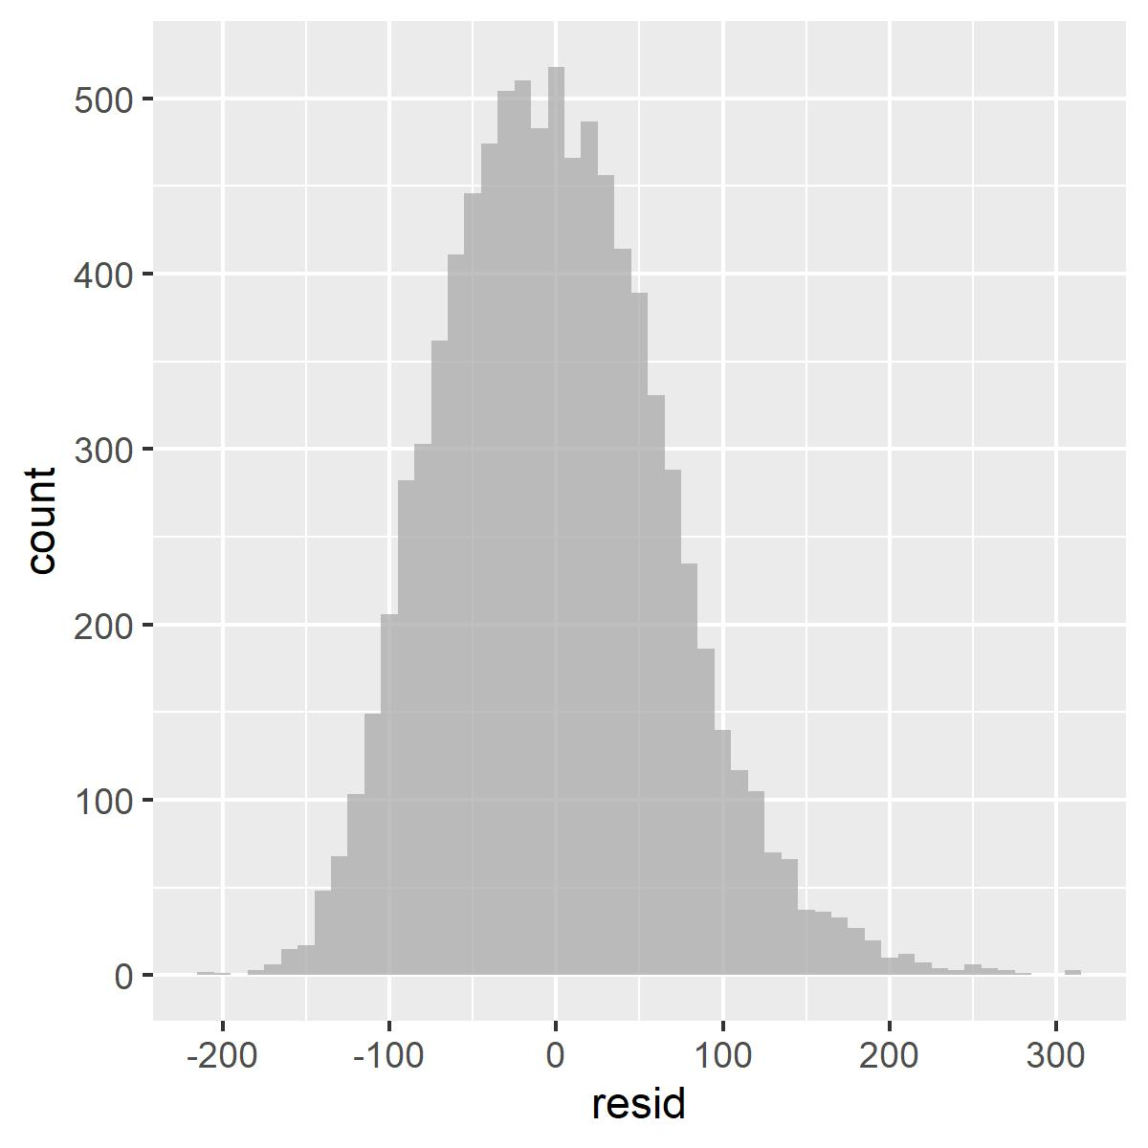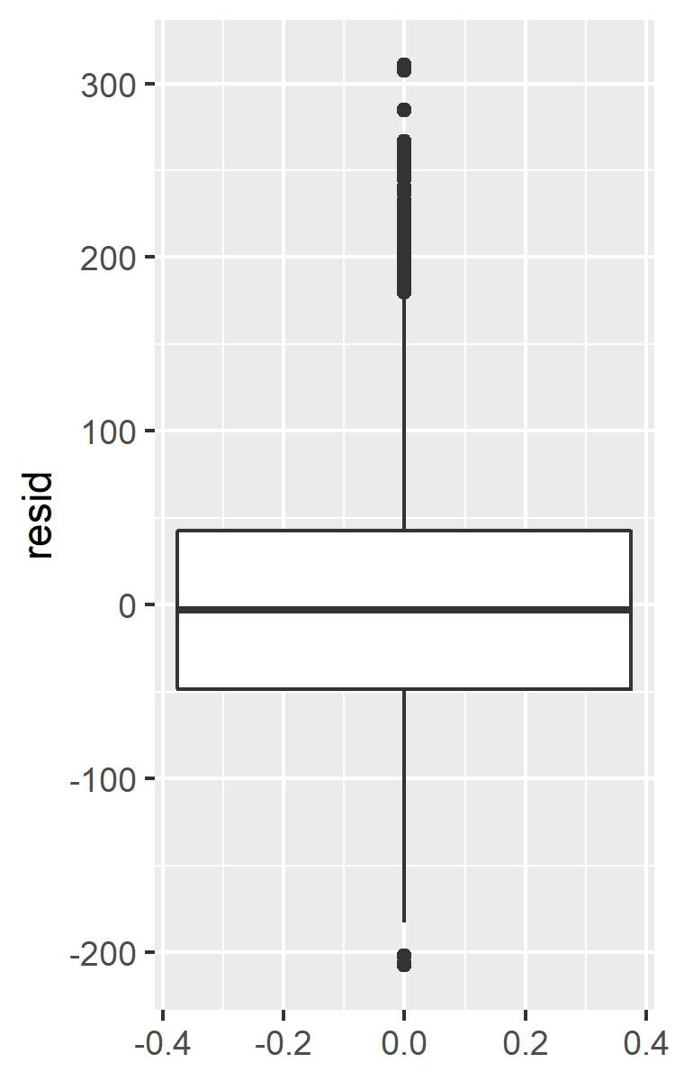

Histograms (top row) and boxplots (bottom row) of the residuals separated by year (left column) and sex (right column).
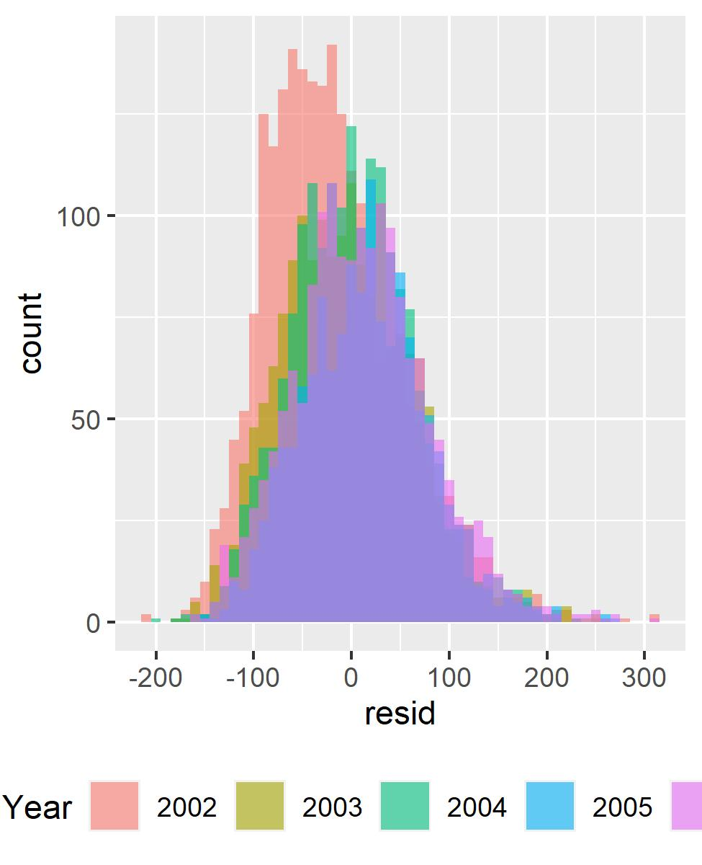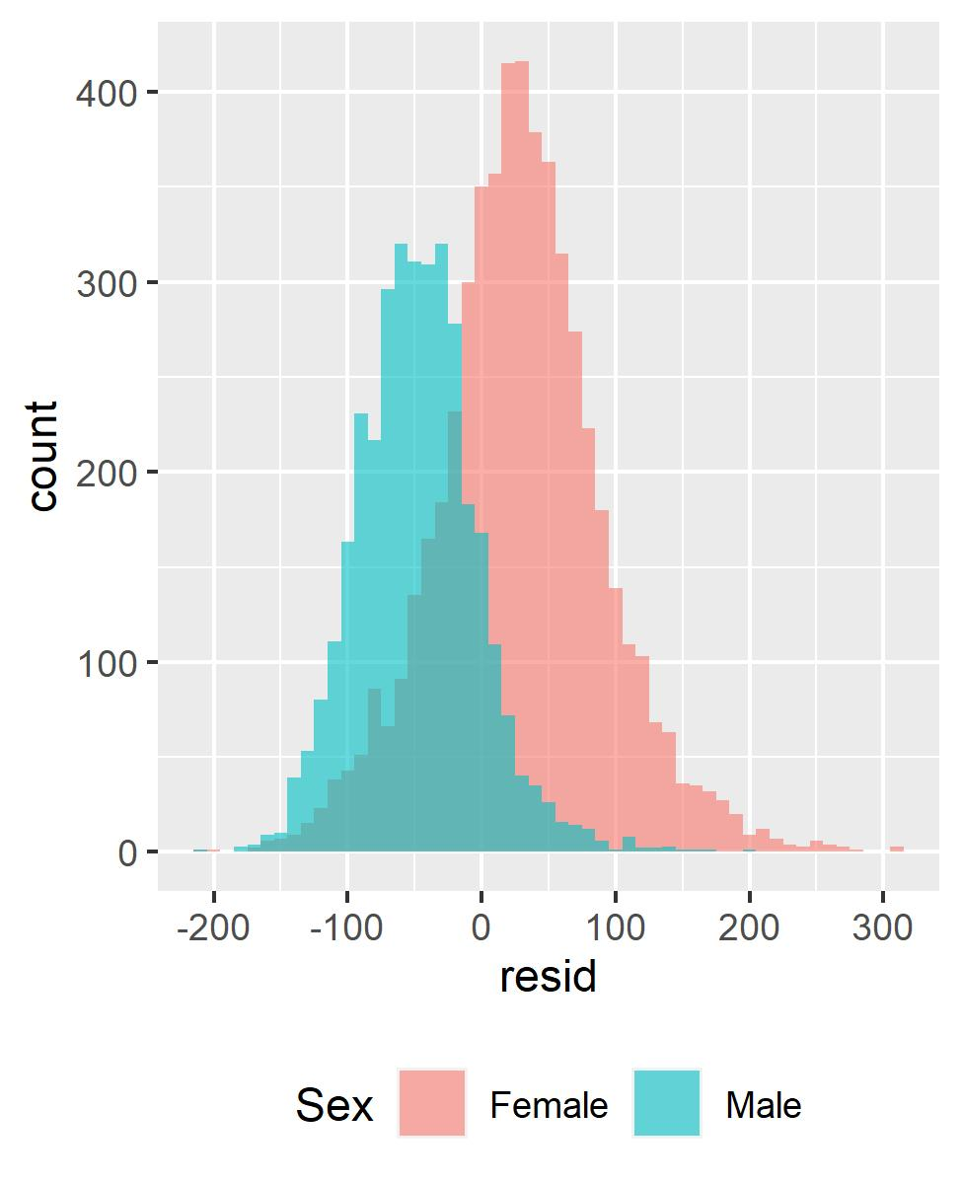

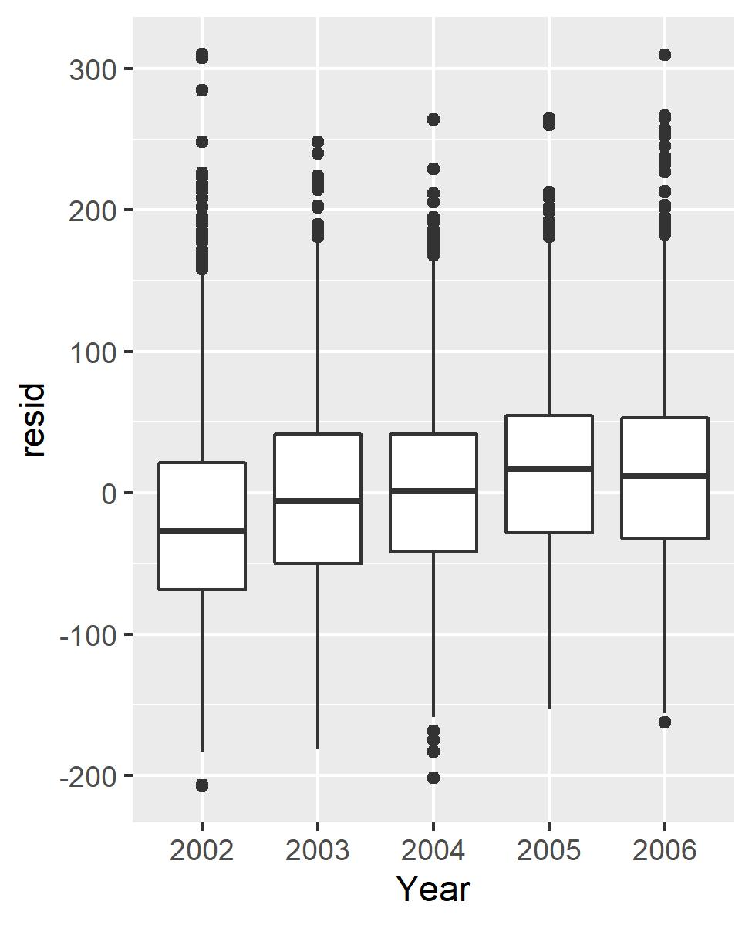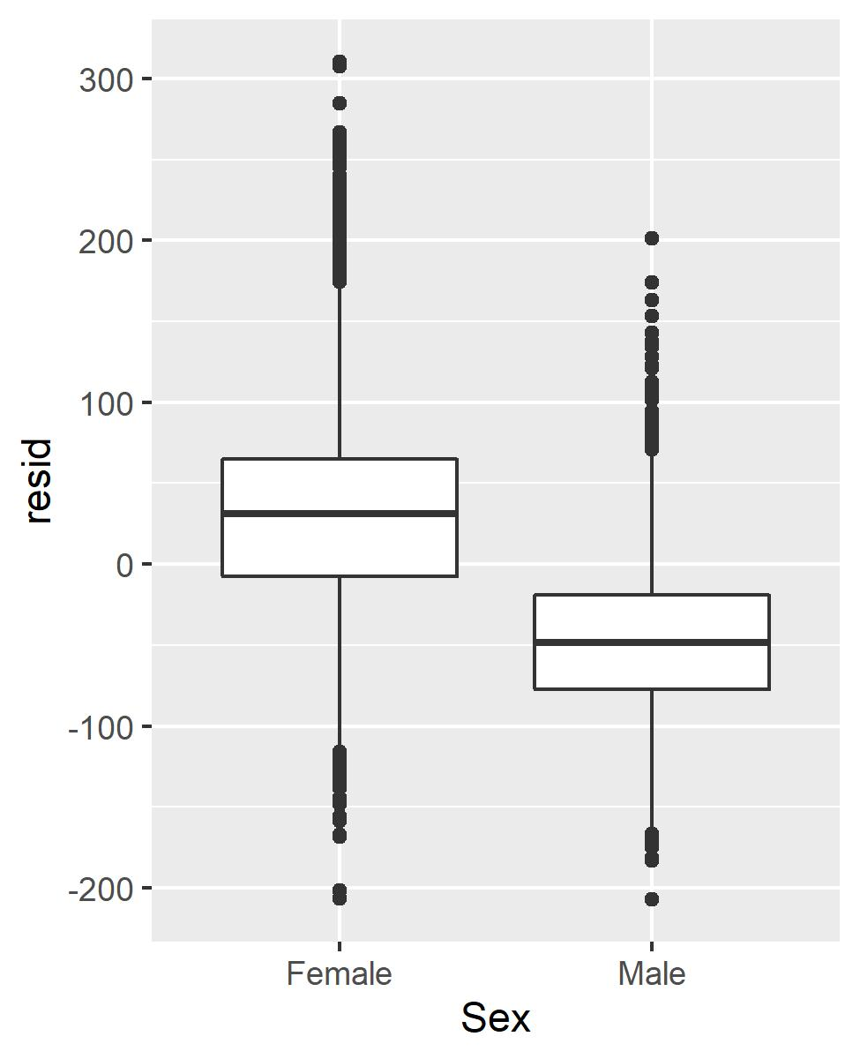
Show one or two representative plots to illustrate your conclusion(s). If you find that any of the regression assumptions are violated, what might be a good approach to dealing with it in this case?

The curved shape of the residuals relative to normal (line) in the qq plot (see below) are indicative of a right skew. This is one indicator that we haven’t included the appropriate variables in the model. In our histograms of the data above, we see that there are differences in the distribution of sexes and maybe slight differences by year also. The first step would be to incorporate year and/or sex in the model.

Normal QQ plot showing of the residuals with all fish included in a single model.
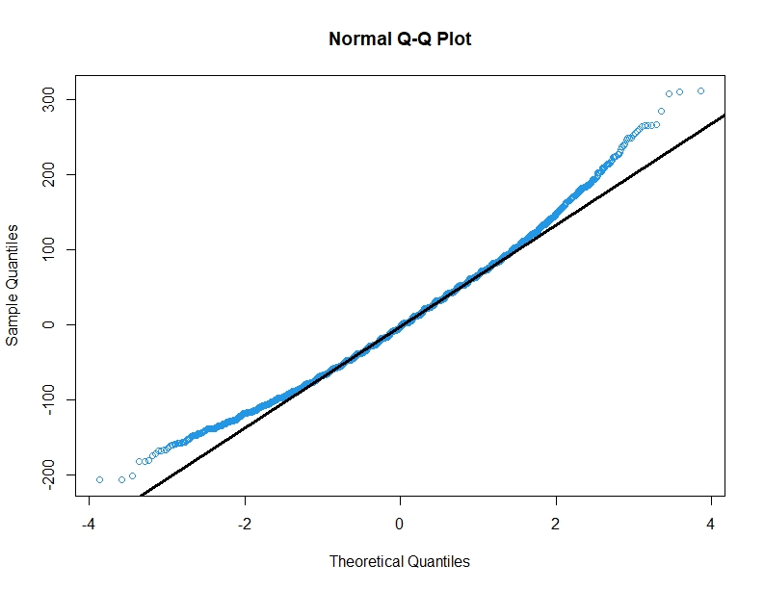

Problem 5 Show plots of male and female length-at-age with the fitted lines (you can plot them
separately or in a single panel using any tools in your toolkit).

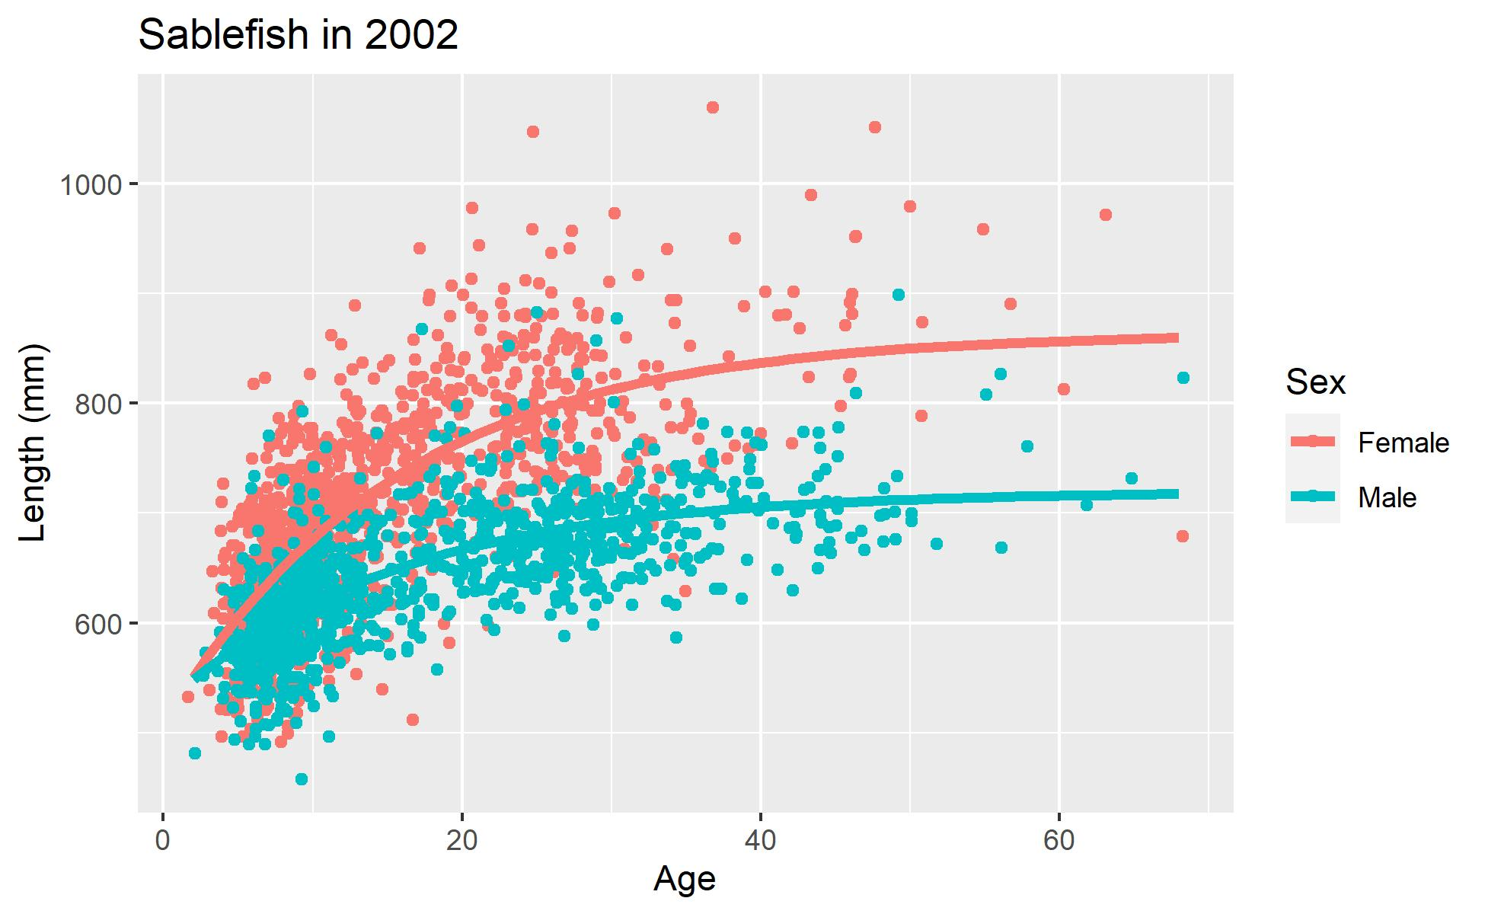

Summarize the parameter estimates and their standard errors for males and females and
compute approximate 95% confidence intervals for the growth parameters by sex.

Coefficient estimates with 95% confidence intervals and standard error by sex. Parameter k reflects growth rate where L.inf reflects the asymptotic length. (See plot with these values below).

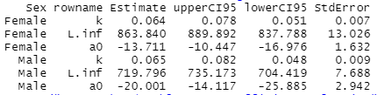

Statistically test for a difference in the growth parameter k between males (km) and females
(kf) using a Wald test by computing the Wald statistic for the difference (kf – km) and test whether it is larger than expected by chance under the null hypothesis that the difference is zero. Repeat the test to compare the Linf parameter between male and female sablefish estimated
from a single year.
Briefly summarize your conclusions about growth of male and female sablefish.

After calculating W and using pchsq(W, 1), results showed that k and a0 had p values greater than 0.05 (0.9 and 0.6, respectively) and thus indicated there were not significant different between sexes the growth rate and intercept between the sexes, while Linf was significantly different. We can see these differences also in the plot below with estimates for each parameter and the 95% CI.

