Evaluating zooplankton spatial variability during the 2014-2016 Marine Heatwave in the Eastern Bering Sea

Genoa Sullaway
Fish 604 – Fall 2021

Abstract:
Understanding how marine heatwaves (MHW) impact ecosystems can provide a window into the future of a warming ocean. I model abundance for two species of zooplankton, Pseudcalanus spp. and Calanus marshallae, in the Eastern Bering Sea to understand the spatial distribution of this important prey-source during a MHW. I found that temperature is an important predictor in zooplankton CPUE and that the two species differed in their response to temperature and in their spatial variability. Pseudocalanus abundance increased during the MHW and the greatest abundance was centered in the southern inner and middle shelfs. On the contrary, the lipid-rich zooplankton, C. marshallae, decreased throughout the MHW and had low overall abundance after 2014. Zooplankton are a prey source for many components of the EBS ecosystem, so understanding zooplankton MHW response is crucial to being able to predict regime and ecosystem shifts as climate change progresses.

Introduction/Background:
Marine heatwaves (MHW) have increased in prevalence as anthropogenic climate change progresses (Frolicher et al. 2018). In the Northeast Pacific Ocean, the most recent MHW (2014-2016) resulted in mass mortalities and marine mammal stranding’s, species distribution shifts, fishery closures, and social-ecological network shifts (Cheng and Frolicher 2020, Fisher et al. 2021). Climate-ready fisheries management necessitates an ecosystem-wide understanding of how ecosystem components are impacted and respond to MHW’s.

Primary and secondary production are tightly linked to oceanographic conditions and are thus heavily influenced by MHW's. In the Eastern Bering Sea (EBS), copepods such as Calanus marshallae underpin the structure of the entire ecosystem. As high nutrient prey items for higher trophic levels, C. marshallae support marine mammals, numerous subsistence fisheries and a billion-dollar Pollock fishery. The EBS has become dominated by warm and cold temperature stanzas, where warm stanzas have become more frequent as MHW’s continue to form. Generally, zooplankton abundance increases in the spring as they feed on phytoplankton and microzooplankton as sea-ice melts. Sea ice melt can vary substantially between warm and cold years and create a cascade of ecosystem-wide effects leading the zooplankton community composition to differ between warm and cold stanzas. During cold years, large nutritious copepods are abundant into the Fall and are key prey items for pollock (Siddon et al 2013), seabirds (Springer et al 1986) and marine mammals (Baumgartner et al. 2013). C. marshallae abundance is tightly linked with pollock recruitment through the Oscillating Control Hypothesis (Kimmel et al. 2018). However, during warm stanzas, the zooplankton community is dominated by smaller species, such as Pseudocalanus spp, which have lower lipid content (Kimmel et al 2018). Pseudocalanus spp prevalence have been linked to poor fish recruitment and a general ecosystem shift. This disruption in lipid-rich prey during warm years has negative effects that cascade throughout the EBS food webs and social-ecological networks.

Warm stanzas and marine heatwaves are predicted to become more common in the EBS. I want to understand drivers of C. marshallae and Pseudocalanus spp spatial variability within a MHW to ultimately inform spatial prey availability for higher trophic levels. Changes to spatial variability in C. marshallae within warm years can have implications for future predator-prey overlap and energy content availability (Siddon et al 2013). I expect temperature to be a strong predictor of zooplankton CPUE. Specifically, I expect a decreasing non-linear relationship between temperature and C. marshallae abundance, and a negligible or increasing nonlinear relationship between temperature and Pseudocalanus spp CPUE. Additionally, I expect an effect of year as the MHW progresses, ie. I expect 2014 to be different than 2016 because of cumulative impacts of warm years. I expect C. marshallae to be generally more abundant in the northern inner shelves compared to the southern and outer shelves (Kimmel et al 2018). I utilize a generalized additive modeling (GAM) framework to address this research question.

Methods
The data I am using for this analysis were collected by NOAA AFSC ECOFOCI during oceanographic cruises in the Eastern Bering Sea (Figure 1). Zooplankton data were provided by Dr. Dave Kimmel. The response variable is C. marshallae and Pseudocalanus spp catch per unit effort (CPUE) (individuals m^3) for each station (each point in Figure 1) sampled in each year of the recent MHW (2014-2016 and 2018, 2017 was excluded because of small sample size). Zooplankton data are collected annually on NOAA oceanographic cruises from April-October, however the spatial and temporal schedule is unbalanced from year to year (Figure 1, Table 1). There is also variation in survey month among years. Survey timing is important because missing the peak spring dates can lead to underestimating CPUE, I include day of year in my modeling efforts to account for this variation.

Zooplankton are collected using paired bongo nets (20cm frame, 150um mesh and a 60cm frame, 333 um mesh) on oblique tows. The tow depth varies by station and is not necessarily related to bottom depth. If bottom depth is less than 100m, max tow depth is 5-10m above the bottom. However, if max bottom depth is deeper than 100m the max gear depth can vary depending on the sea state, most tows are not deeper than 300m. The samples are identified to lowest taxonomic level and sorted into different stages (C-1 to Adult), however for this analysis I have summed CPUE across life stages. Temperature covariates were collected from CTD casts done in parallel to zooplankton net casts. I used mean temperature to 100m (C), or max gear depth if survey location was shallower than 100m.

Statistical Analysis
To evaluate factors associated with zooplankton CPUE spatial variability, I fit general additive models (GAM) using a Tweedie distribution and a log-link function. Initial data exploration indicated potential for non-linear relationships between CPUE and temperature, additionally a GAM framework allowed a geospatial modeling approach which was most appropriate for the modeling goals and problem. I modeled zooplankton CPUE for each year as a function of multiple covariates for each species separately. I used AIC to compare model fit across six different models (Table 2). Goodness of fit was checked using diagnostic plots (Appendix). I also checked the residuals specifically for each predictor and I examined the residuals across space. There are some instances of high residuals on the fringes of the spatial smooth and I removed most of those from the model to minimize extrapolation. I estimated model using Maximum Likelihood for model comparison but the parameters in the best models were estimated using Restricted Maximum Likelihood (REML). Models presented in Table 2 were selected based on a hypothesis testing structure rather than a global model approach to ensure that the relationships being estimated in GAM were biologically realistic.

I chose a tensor spline to estimate a smooth spatial surface in the model to allow for anisotropy, or variability in the degree of smoothing between latitude and longitude, in the smooth surface. To avoid errors estimating the Tweedie-specific parameter, p, in more complex models, I estimated p in a separate simpler model. In the following modeling efforts p is fixed to 1.84. Residuals and goodness of fit were examined for each predictor including spatial predictors and interactions to ensure appropriate model fit.

The best performing model for each species was Model 6 (Table 2).

$$\log\left(μ_{i,y}\right)=α+β{∙Year}_{y}+ f_{1}\left(Day\right)+f_{2}\left(Temperature\right)+ f_{3}\left(ρ_{1}, ρ_{2}\right)+ ε_{i,y}$$

$$σ^{2}= ϕ{μ_{s,y}}^{p}$$

$$ε_{i,y} \sim N(0,σ^{2})$$

where $μ_{i,y}$ is the mean CPUE (individuals m⁻³) of zooplankton at each station i in each year y, $Year$ is categorical here, representing the year the zooplankton were sampled (2014, 2015, 2016, 2018), $Day$ is day of year the zooplankton were sampled, $Temperature$ is the mean survey temperature (C) for the top 100m or survey depth if shallower than 100m, $f_{1}$ and $f_{2}$ are non-parametric smooth functions. Finally, $f_{3}$ represents a non-parametric spatial smooth function. Here I use a tensor smooth spline for x distance, $ρ_{1}$ (equal distance conversion of latitude) and y distance, $ρ_{2}$ (equal distance conversion for longitude) by year and I allowed anisotropy in the smoothing process. The residuals are assumed to be independent, normally distributed with mean 0 and standard deviation $σ^{2}$.

Results
The best models for C. marshallae and Pseudocalanus explained 75% and 52.6% of the deviance, respectively (Table 2). The modeling fitting process indicated that there is spatial autocorrelation in the dataset and the spatial patterns vary by year, as model fit improved significantly when the geospatial component was included. Day of year accounts for intra-annual variation in survey timing and was also an important predictor in the model.

Overall, Psuedocalanus spp was more abundant than C. marshallae during marine heatwave conditions. However, abundance patterns varied among years and changed as the MHW progressed. The largest decrease in average C. marshallae CPUE occurred at the onset of the MHW, from 2014 to 2015 (Figure 2). Conversely, average Pseudocalanus CPUE was relatively constant throughout the MHW and increased significantly in 2018, when the annual cold pool extent was the smallest (Figure 2).

The nature of the temperature relationship varied between the two species (Figure 2). C. marshallae abundance decreases nonlinearly as temperature increases, while Pseudocalanus has a slight nonlinear increase in abundance as temperature increases (Figure 2). Generally, CPUE for both species decreased as day of year increased (Figure 2). However, patterns between the two species differ during the latter half of the year. Pseudocalanus abundance is greater and has an increasing pattern in Fall while C. marshallae abundance is lower and decreases during Fall (Figure 2).

CPUE spatial variability for both species across the EBS vary by year and day (Figure 3). Both species have higher CPUE on the northern regions in 2015, this northward movement has been shown in other studies to result in a predator-prey spatial mismatch (Siddon et al 2013). It is difficult to compare spatial variability across the full spatial extent of the EBS because of uneven spatial survey coverage, however the high density of Pseudocalanus across the southern middle and inner shelf is relatively consistent throughout the MHW. Compared to Pseudocalanus spp, C. marshallae concentrations through the MHW decrease and are not concentrated on the southern middle and inner shelves. They have a lower abundance and patchier distribution. The southern inner and middle shelves are a highly productive region and an area where young of year fish prepare to overwinter. However, the lack of C. marshallae in this region may indicate that species preparing to overwinter do not have access to the lipid rich prey that can increase survival.

Discussion
I modeled CPUE for two zooplankton species, C. marshallae and Psuedocalanus spp, in the Eastern Bering Sea. I found that temperature was an important component in determining CPUE across the EBS. Zooplankton species modeled in this study had differing responses to increased temperature resulting in spatial variability across the EBS (Figure 3). These results generally align with my hypotheses; however, the increase in Psuedocalanus spp CPUE with temperature (Figure 2) is especially interesting, the degree of increase is greater than I expected.

It is difficult to tease apart the effects of day and temperature in this modeling approach as they both can co-vary with each other and the addition of both did not cause a very large change in the AIC. However, the research question is driven by wanting to understand temperature, and it seems important to account for differences in survey day within a year, so I did not feel comfortable choosing a final model without both terms. However, the model fit improved, albeit a very small amount, when both were included in the model and during the MHW there were not as large of temperature swings across the sampling time period as we may see in cold years.
Estimated abundance across day of year produced an interesting pattern that may deserve more attention. The decrease in C. marshallae and concomitant increase in Pseudocalanus spp was unexpected. This pattern could represent C. marshallae entering diapause while Pseudocalanus spp experiences a trophic release and increases in abundance. This pattern is observed spatially as well, where C. marshallae decreases on the middle shelf and Pseudocalanus spp increases, especially around day 250. The ability to glean information from the data is somewhat limited by the spatial extent of sampling. As mentioned, there is temporal and spatial unbalanced sampling, this is partially accounted for by a spatial smooth and including year and day in the model. While I don’t necessarily think this violates analysis assumptions, I think understanding how the unbalanced sampling impacts the model output will be important going forward.

The estimated temperature response and spatial variability has implications for zooplankton availability to predators during a marine heatwave. Due to the direct links between oceanographic conditions and zooplankton community, zooplankton can be an early indicator for regime shifts in the EBS. However, more research is needed to understand differences in zooplankton spatial variability between warm and cold stanzas and how these patterns link to fish recruitment and productivity.

References
Baumgartner, M. F., Lysiak, N. S., Esch, H. C., Zerbini, A. N., Berchok, C. L., & Clapham, P. J. (2013). Associations between North Pacific right whales and their zooplanktonic prey in the southeastern Bering Sea. Marine Ecology Progress Series, 490, 267-284.
Cheung, W.W.L., T.L. Frölicher (2020) Marine heatwaves exacerbate climate change impacts for fisheries in the northeast Pacific. Sci Rep 10, 6678 https://doi.org/10.1038/s41598-020-63650-z
Fisher, M.C., S.K. Moore, S.L. Jardine, J.R. Watson, & J.F. Samhouri (2021) Climate shock effects and mediation in fisheries. Proceedings of the National Academy of Sciences 118, no. 2.
Frölicher, T.L., E.M. Fischer, & N Gruber. (2020) Marine heatwaves under global warming." Nature 560.7718 (2018): 360-364.
Kimmel, D. G., Eisner, L. B., Wilson, M. T., & Duffy‐Anderson, J. T. Copepod dynamics across warm and cold periods in the eastern Bering Sea: Implications for walleye pollock (Gadus chalcogrammus) and the Oscillating Control Hypothesis. Fisheries Oceanography 27.2 (2018): 143-158.
Siddon, E.C., T. Kristiansen, F.J. Mueter, K.K. Holsman, R.A. Heintz, and E.V. Farley. (2013) Spatial match-mismatch between juvenile fish and prey provides a mechanism for recruitment variability across contrasting climate conditions in the eastern Bering Sea. PLoS One 8, no. 12 (2013): e84526.
Springer, A. M., Roseneau, D. G., Lloyd, D. S., McRoy, C. P., & Murphy, E. C. (1986). Seabird responses to fluctuating prey availability in the eastern Bering Sea. Marine Ecology Progress Series, 1-12.

Figures and Tables

Table 1: Brief summary of survey data and temperature covariate.
Survey Year: | 2014 | 2015 | 2016 | 2018
Stations surveyed | 230 | 89 | 210 | 159
Survey Months | 5,6,8,9,10 | 4,5,9,10 | 5,6,8,9,10 | 5,6,8,10
Mean Temp (C) first 100m or deepest point (min, max) | 4.9 (0, 13) | 5.9 (0, 11) | 6.05 (0, 13) | 4.3 (3, 7)

Table 2: Table of models tested and relative percent change in AIC compared to the best ranking model (lowest AIC model). Calanus values in green, Pseudocalanus in blue.
Model number | Formula | Percent change in AIC compared to best ranking model & deviance explained.
1 | $$\log\left(μ_{i,y}\right)=α+ f_{1}\left(Day\right)+ ε_{i,y}$$ | -13%, 18%  -7%, 3%
2 | $$\log\left(μ_{i,y}\right)=α+ f_{1}\left(Temperature\right)+ ε_{i,y}$$ | -12.6%, 22.5%  5%, 3.4%
3 | $$\log\left(μ_{i,y}\right)=α+β{∙Year}_{y}+ f_{1}\left(Temperature\right)+f_{3}\left(ρ_{1}, ρ_{2}\right)+ ε_{i,y}$$ | -12%, 45.6%  -3.1%, 31.8%
4 | $$\log\left(μ_{i,y}\right)=α+β{∙Year}_{y}+ f_{1}\left(Temperature\right)+f_{3}\left(ρ_{1,y}, ρ_{2,y}\right)+ ε_{i,y}$$ | -4.6%, 74%  -2%, 47.2%
5 | $$\log\left(μ_{i,y}\right)=α+β{∙Year}_{y}+ f_{1}\left(Day\right)+f_{3}\left(ρ_{1,y}, ρ_{2,y}\right)+ ε_{i,y}$$ | -0.6%, 74.5%  -0.2%, 48.3%
6 | $$\log\left(μ_{i,y}\right)=α+β{∙Year}_{y}+ f_{1}\left(Day\right)+f_{2}\left(Temperature\right)+ f_{3}\left(ρ_{1,y}, ρ_{2,y}\right)+ ε_{i,y}$$ | 0%, 75%  0%, 52.6%

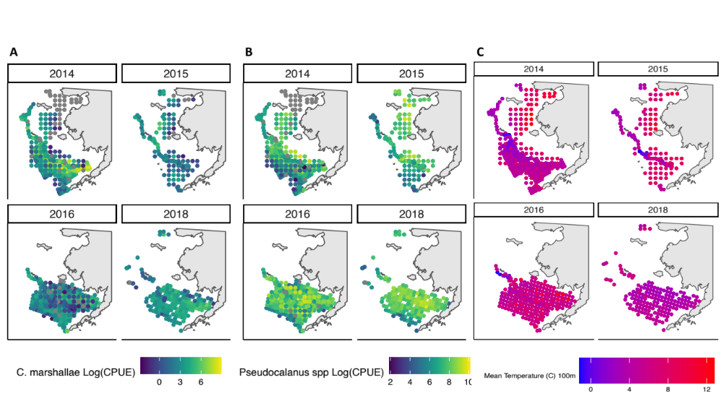
Figure 1: CPUE (number per m3) of A) C. marshallae and B) Pseudocalanus for each survey year. C) Mean temperature from first 100m of survey depth or to deepest point less than 100m.

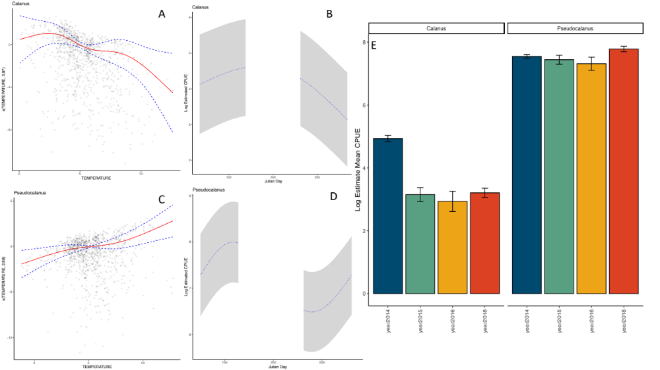
Figure 2: Estimate of nonlinear relationship between Temperature and A) C. marshallae and C) Pseudocalanus CPUE. Estimate of nonlinear relationship between day and B) C. marshallae and D) Pseudocalanus CPUE. Lines are means and bands represent 95% CI's. Points (A and C) are observations in model. E) Model estimate for Log Mean CPUE per year for each zooplankton species. Bar are means and error bars are +/- 1 SE.

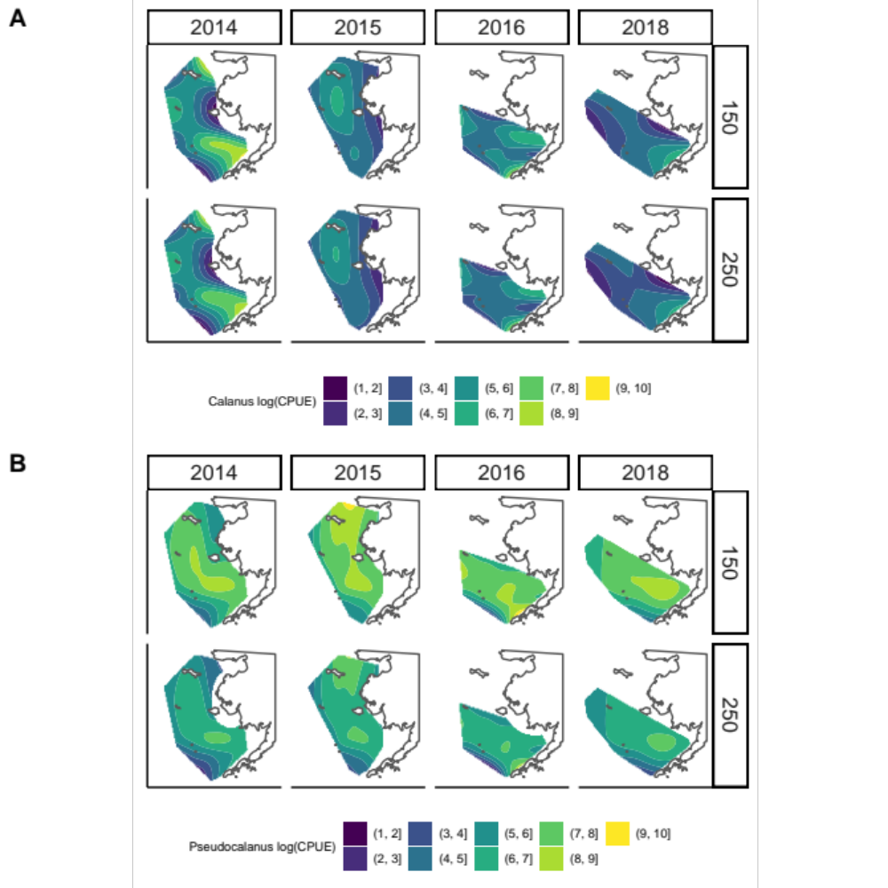
Figure 3: Predicted log CPUE for A) C. marshallae and B) Pseudocalanus for 2016-2016 and 2016 during day 150 (early) and 250 (late). Results were predicted from a GAM model (Table 2, model 6).

Appendix:

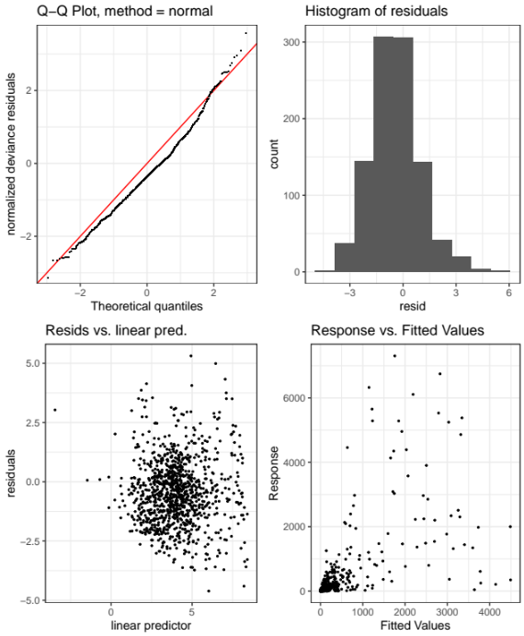
Figure Appendix 1: Goodness of fit results for Calanus, model 6 in Table 2.

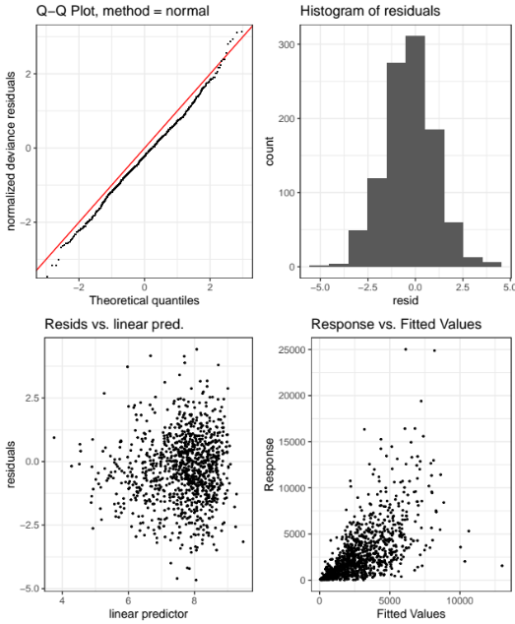
Figure Appendix 2: Goodness of fit Pseudocalanus, model 6 in Table 2.

