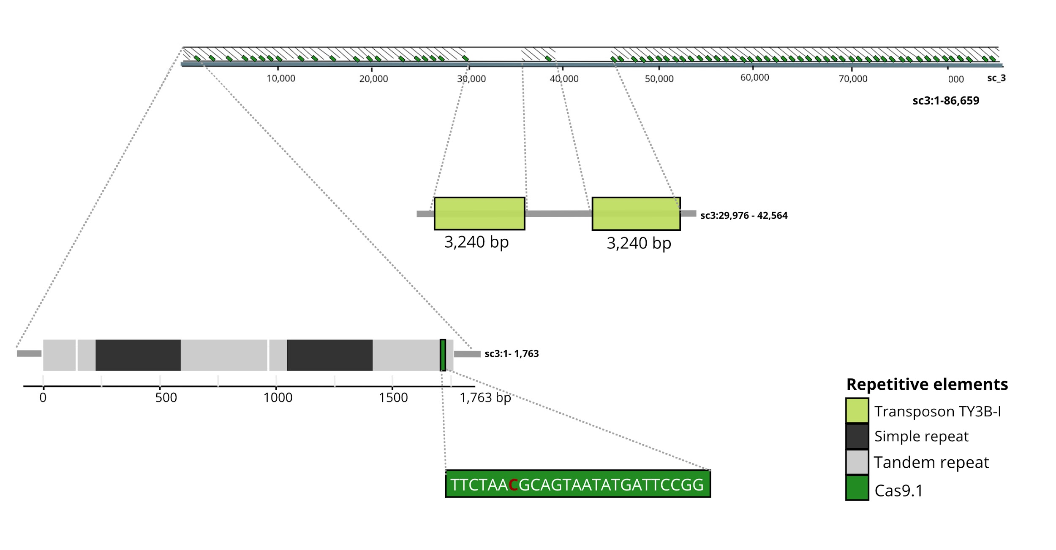

Figure 1. Kmer-1

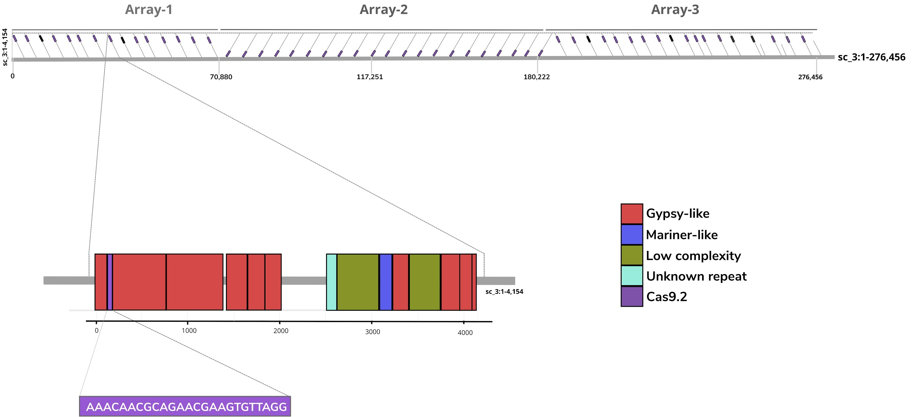

Figure 2. Kmer-1

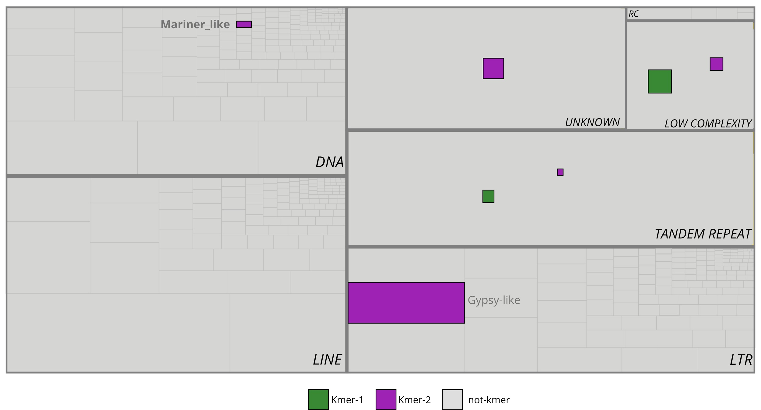

Figure 3. Kmers sequences associated with the repeats landscape.

Figure 5. Kmer-2