student

Comparative Analysis Exercises:
Accessing files for MUMmer alignments

On the Desktop, double-click on the icon “xterm@solaris”
(or “dtterm@solaris”).

This will open up a terminal. Your prompt will look like this
lserver1:~>

Each of you will be doing the MUMmer exercises in your own directory.

To get to your directory, type (at the prompt)
cd eukaryotic_course/student#/comparative_analysis
Hit Enter

To ensure that you are in the right directory, type (at the prompt)
pwd
Hit Enter

You should see
/home/training/eukaryotic_course/student#/comparative_analysis
followed by your prompt
lserver1:~/eukaryotic_course/student#/comparative_analysis>

For the exercises, the prompt is shown as %
Type only the text that follows the percent sign.
Do not type “%”!

Comparative Analysis Exercises

# notes
* to be used for the exercise
% this represents the prompt.
On the command line, type the text that follows %
DO NOT TYPE the percentage symbol!

I. NUCmer (alignment at the nucleotide level)

# This exercise should be done in the following directory:
/home/training/euk﻿aryotic_course/student#/comparative_analysis

1. align single chromosomes (same example as in this morning’s presentation)

Organisms: Cryptococcus neoformans var. neoformans JEC21 (reference)
Cryptococcus neoformans var. neoformans B-3501A (query)

Align chromosome 1 from each of these organisms

Input files:
﻿* ref1.fasta
﻿* qry1.fasta

* usage:
% nucmer --prefix ex1 ref1.fasta qry1.fasta

# default prefix is ‘out’
# there are 2 dashes (or minus signs) preceding ‘prefix’
# --prefix can also be written as –p (single dash)

Output files that will be generated:
ex1.delta
ex1.cluster

Utilities:
show-coords (generates human-readable file showing coordinates of alignment)

* usage:
% show-coords –T ex1.delta > ex1.coords

# remember to include ‘-T’ option to get output in tab-delimited format.

* To view the .coords file
% more ex1.coords
# press spacebar to scroll down.

mummerplot (plot alignment)
* usage:
% mummerplot ex1.delta

# reference sequence is on the x-axis and query sequence is on the y-axis.
* to zoom in: right-click and drag to define area to be enlarged. Then left-click.
# to go back to original plot type p (for previous)
[Close mummerplot window by clicking X at the top right corner of the window and then press Enter]

2. align multiple chromosomes (same example as in this morning’s presentation)

Organisms: Cryptococcus neoformans var. neoformans JEC21 (reference)
Cryptococcus neoformans var. neoformans B-3501A (query)

Align all 14 chromosomes from each of these organisms.

Input files:
﻿* ref2.fasta
﻿* qry2.fasta

* usage:
% nucmer –prefix ex2 ref2.fasta qry2.fasta

# this will take longer than the previous alignment because there is more sequence to align.

Output files that will be generated:
ex2.delta
ex2.cluster

Utilities:
mummerplot

# Files provided (text files containing contig name, length and orientation):
* ref2.txt
* qry2.txt

* usage:
% mummerplot –R ref2.txt –Q qry2.txt ex2.delta (initial plot)

# the text files for the reference and query contain 3 columns: contig name, contig length and contig orientation (+ or -). These files may be modified to make the plot “pretty”. The modified files for this exercise are provided.
* ref2a.txt
* qry2a.txt

% mummerplot –R ref2a.txt –Q qry2a.txt ex2.delta (reoriented plot)

[Close mummerplot window by clicking X at the top right corner of the window and then press Enter]
II. PROmer (alignment at the protein level)

# This exercise should be done in the following directory:
/home/training/euk﻿aryotic_course/student#/comparative_analysis

Align supercontigs to chromosomes (same example as in this morning’s presentation)

# This exercise is similar to the one in the previous example (alignment of multiple chromosomes) except that the PROmer program translates the input sequence in all the reading frames. Due to limitations of space this alignment has been done for you and the output files have been provided. You will plot the alignment.

Organisms: Aspergillus fumigatus Af293 (8 chromosomes; reference)
Neosartorya fischeri (13 supercontigs; query)

Input files (not provided!):
﻿ref3.fasta
qry3.fasta

usage: NOT TO BE DONE TODAY
% promer --prefix ex3 ref3.fasta qry3.fasta

example: This example has been done and the output files are provided.

vinita@vinita-lx % promer --prefix ex3 ref3.fasta qry3.fasta
1: PREPARING DATA
2,3: RUNNING mummer AND CREATING CLUSTERS
# reading input file "ex3.aaref" of length 58769932
# construct suffix tree for sequence of length 58769932
# (maximum input length is 536870908)
# process 587699 characters per dot
#....................................................................................................
# CONSTRUCTIONTIME /usr/local/packages/MUMmer/mummer out.aaref 209.35
# reading input file "ex3.aaqry" of length 62209443
# matching query-file "ex3.aaqry"
# against subject-file "ex3.aaref"
# COMPLETETIME /usr/local/packages/MUMmer/mummer ex3.aaref 463.25
# SPACE /usr/local/packages/MUMmer/mummer ex3.aaref 117.30
4: FINISHING DATA
vinita@vinita-lx %

Out put files that will be generated:
* ex3.delta (provided)
ex3.cluster (not provided)

Utilities:
show-coords

* usage:
% show-coords -T ex3.delta > ex3.coords

mummerplot

# Files provided (text files containing contig name, length and orientation):
* ref3.txt
* qry3.txt

* usage:
% mummerplot –R ref3.txt –Q qry3.txt ex3.delta

* Zoom in to examine the alignments for chromosome 4 in the reference sequence.
* Zoom in to examine the alignments for the first assembly in the query sequence.

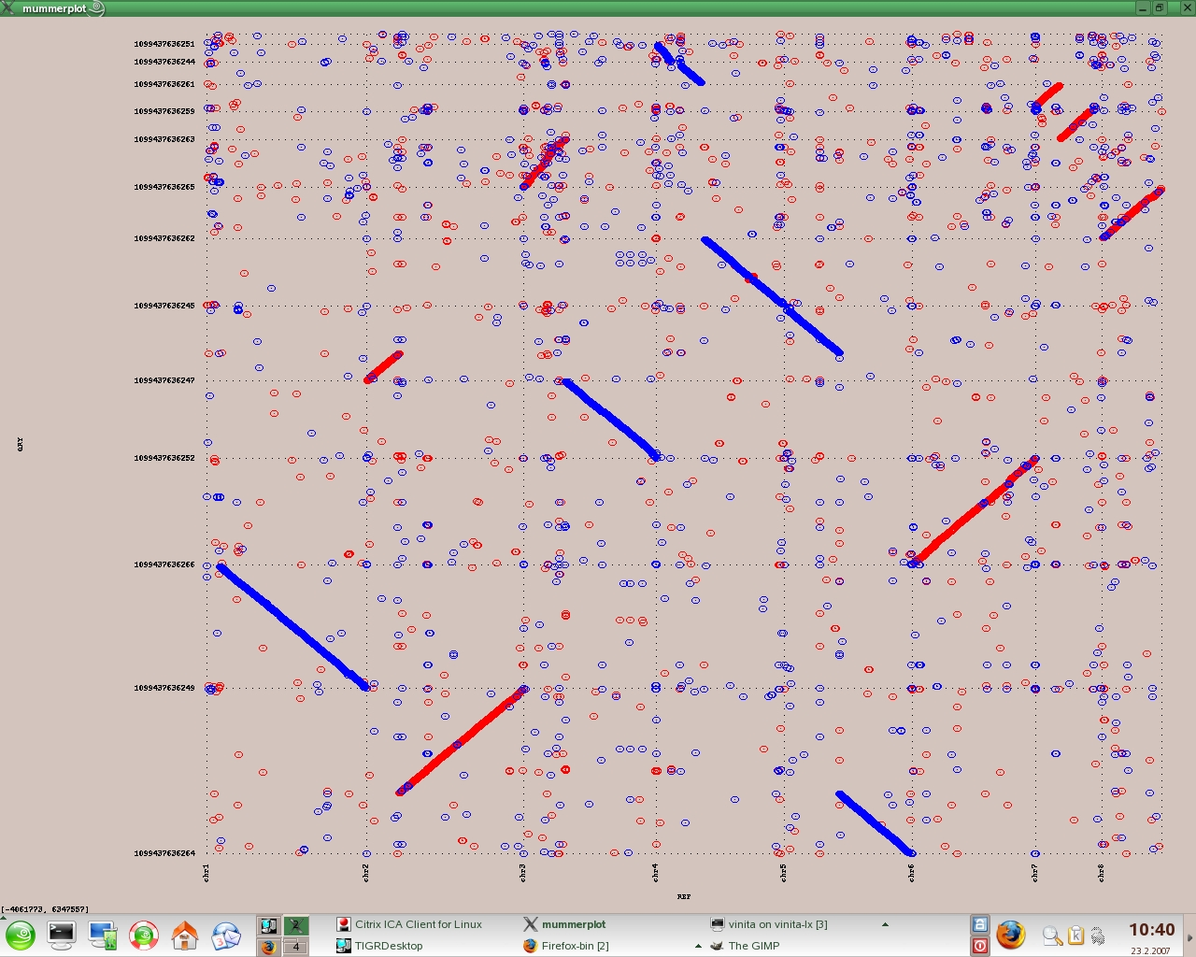
reference
query

* Any other regions of the reference/query that merit further investigation?

III. Artemis Comparative Tool
(upload files; view and customize interface)

# This is a web-based exercise.
Website: http://www.sanger.ac.uk/Software/ACT/

Comparing single chromosomes:

Cryptococcus neoformans var. neoformans JEC21 (chromosome 9; reference)
Cryptococcus neoformans var. neoformans B-3501A (chromosome 8; query)

# The sequences and annotation files were downloaded from GenBank. The homologous regions were identified using TBLASTX (NCBI BLAST).

Files used:
Sequence files (downloaded from GenBank):
﻿ ref4.fasta (reference)
﻿ qry4.fasta (query)

Annotation files (downloaded from GenBank; provided):
﻿ * ref4.txt
﻿ * qry4.txt

# The download option for the annotation files is ‘GenBank(Full)’. Note that the ‘Hide’ options (i.e ‘sequence’ and ‘all but gene, CDS and mRNA features’) should be UNCHECKED before downloading.

Comparison file identifying homologous regions:
* tblastx.tab

The comparison file has been provided for you. This file contains the output of a BLAST search (tblastx = translated reference vs. translated query). If you would like to know how to generate the file yourself, the directions are given below. To continue with the exercise using the provided tblastx.tab file, skip to the ‘Launch ACT and upload files’ section.

- Format the reference file (the one that will be used as the database):
% formatdb –i ref4.fasta –p F (NOT TO BE DONE TODAY)

﻿-i input files for formatting (reference file)

-p type of file
T - protein
F - nucleotide
default = T

If your input reference file has been formatted correctly, there will be 3 files generated (ref4.nhr, ref4.nin and ref4.nsq)

- BLAST (NOT TO BE DONE TODAY)
% blastall –p tblastx –d ref4.fasta –i qry4.fasta –m 8 > tblastx.tab

﻿-p program Name [BLAST program]
-d database [reference file]
default = nr
-i query file [File In]
default = stdin
-m alignment view options:
0 = pairwise,
1 = query-anchored showing identities,
2 = query-anchored no identities,
3 = flat query-anchored, show identities,
4 = flat query-anchored, no identities,
5 = query-anchored no identities and blunt ends,
6 = flat query-anchored, no identities and blunt ends,
7 = XML Blast output,
8 = tabular,
9 tabular with comment lines
10 ASN, text
11 ASN, binary [Integer]
default = 0
range from 0 to 11

output file = tblastx.tab

Launch ACT and upload files

* Website: http://www.sanger.ac.uk/Software/ACT/
Or Artemis Comparative Tool download (or launch) on course links site

* Left-click the ‘LAUNCH ACT’ button.

This brings up the ‘OpeningACT.jnlp’ window.
* Select ‘Open with /usr/bin/javaws (default)’.
* Click ‘OK’.

This brings up a ‘Warning-Security’ window.
* Click ‘Run’ (we trust this site).

This brings up the ‘ACT Release 5’ window.
* Left-click on ‘File’.
* In the drop-down box, left-click on ‘Open’.
* For sequence file 1, click on ‘Choose’ and select file from flash drive
Annotation_course → Sept_25 → Data → ref4.txt
* For Comparison file 1, click on ‘Choose’ and select
Annotation_course → Sept_25 → Data → tblastx.tab
* For Sequence file 2, click on ‘Choose’ and select
Annotation_course → Sept_25 → Data → ﻿qry4.txt

* Click ‘Apply’. This brings up the ACT interface.
# The reference (or target) sequence is at the top and the query sequence is at the bottom. Exons are represented by rectangles (turquoise) connected by introns (lines). For each genome, the top three frames show the forward orientation and bottom three frames show the reverse orientation. The black vertical lines in the each frame represent stop codons.
* Right-click on a gene/exon → View → View Selected features
to get information about that gene.
* Use the horizontal scroll bar to view the genes along the chromosomes.
* Use the vertical scroll bars to zoom out (down) or in (up).
* The sequences are “Locked” i.e. they will scroll together. At the bottom left corner you will see the word ‘LOCKED’. To allow the sequences to scroll independently of each other, they need to be “unlocked”. To unlock, right-click anywhere on the screen and uncheck “Lock Sequence”.
# If red connecting lines are at angles that do not connect homologs on screen: Unlock sequences, align the coordinates on reference and query, lock sequences. This may happen a lot as you browse/zoom!

The regions of homology identified in the tblastx comparison are show in red (reference and query in the same orientation) or blue (reverse orientation).
* Click in any red area to highlight (color changes from red to yellow) that region of homology. A small window (on the left hand side) gives information about the coordinates and the percent identity associated with the highlighted tblastx hit.

Customizing the interface:

- Set percent identity cutoff. Default is 0%.
* Right-click and choose ‘Set Percent ID Cutoffs…’. Change ‘Minimum cutoff’ to 100%. Minimise (do not close) the window.
* To change percent identity cutoff again, maximize the window and change ‘Minimum Cutoff’ to 95% (or any other number)

- Set score cutoff.
* Right-click and choose ‘Set Score Cutoffs…’. Try different values.

- Change color of tblastx hits and adjust gradation of color
* Right-click and choose ‘Color matches’. Choose color. You can also change the gradation of color in this window using the tab.

- Flip reference (subject) sequence.
* Right-click and choose ‘Flip Subject Sequence’. Similarly, flip query sequence.

- Hide frame lines
* In the ‘Display’ menu at the top, choose ‘Hide Frame Lines’.

Some features to look for:

* Find gap in query sequence (approx. 340,000 to 366,000). Hint: zoom out to look for it visually.
* Find “missing gene” region in reference sequence (approx. 249,000 to 250,200).

IV. Sybil (web interface for comparative database)

# This is a web-based exercise. Please be patient! Some of the pages take a while to load.

Website: http://www.tigr.org/sybil/asp

Aspergillus Comparative Database (April-27-2007 build)
There are 7 genomes in this database.

There are 5 links in the ‘Comparative Tools’ section of this page.
sybil home page
protein cluster/COG summary
genome sequence overview
comparative sequence display tool
match table display

sybil home page

On this page you will see
- the names of the species included in this comparison and the number of genes in these genomes.
- details about the computes (analyses) run on the genomes.
- links to the assemblies (contigs) and supercontigs
- links to the details of the different protein clustering analyses
- search boxes (by keyword or by protein/cluster id)

Search by keyword: glucose transporter

The search boxes are at the bottom of the page.
* Type in ‘glucose transporter’ in the ‘protein keyword search’ box and click ‘run search’.

* Find the protein ‘MFS glucose transporter, putative’ in N. fischeri (NFIA_063120) and click on the protein link in the second column (nfa1.polypeptide.368418.0). This takes you to the protein page for this reference gene. Here you will find information about the gene (length, coordinates, location on supercontig, sequence).

Genomic Context: This shows the position of the gene on the supercontig. Also shown are the genes that are in the immediate vicinity of the reference gene.
* To expand the range on either side of the query gene, click on ‘25kb’
* To view the protein pages for any of the genes adjacent to the reference gene, click on the gene.

Protein Cluster/COGs: This lists membership of the reference protein in clusters.
* Click on ‘asp.match.9016.1’ to see the protein cluster (Jaccard Ortholog Cluster, JOC, all organisms)

In this cluster there are protein members from all genomes except A. niger (connected by pink lines). However, gene synteny can be seen only in the 3 closely related genomes. BLASTP hits and ClustalW Alignment of the proteins in the cluster are also shown on this page.
* To redraw the clusters showing only the 3 closely related genomes,
Choose ‘Hidden’ from the drop-down box for A. oryzae (pink), A. nidulans (brown) and A. terreus (red). Choose ‘1 (reference)’ for A. fumigatus (purple). Choose ‘2’ for N. fischeri (green) and ‘3’ for A. clavatus (yellow). Click ‘redraw’.

* To expand the range on either side of the reference cluster, click on ‘25kb’.
* To view the list of protein in a cluster mouse-over the grey region connecting the members of the cluster.
* To change the reference protein click on the protein ‘afu1.polypeptide.321304.0’ (purple; A. fumigatus). [If a ‘Preferences’ window opens up, close it.] Follow the link in the window to change the reference protein (F-box domain protein).

protein cluster/COG summary
This page has information on the number of proteins and clusters.

Protein cluster reports
This is the third section on the page. Protein clusters can be accessed from this section. Here you will see a number of cluster reports from the various clustering analyses.

There are 2 different clustering algorithms used here.
Jaccard clusters – paralogs within a single genome
Jaccard Ortholog Clusters [JOCs] - reciprocal best hits (orthologs) between genomes (taking Jaccard clusters into account)

There are 3 different comparisons
All 7 genomes
Only the three most closely related genomes (A. fumigatus, N. fischeri and
A. clavatus)
Custom group (A. fumigatus, A. nidulans, A. niger)

* To look at the clickable list of all JOCs in the 7-way comparison (first line in the section:
Click on the ‘HTML’ link (the tabbed version is also available)

For each cluster there is information on the number of proteins in the cluster, average BLASTP percent identity, average BLASTP sequence coverage and a list of the proteins in that cluster.

* Scroll down to cluster number 2404 (= CLUSTER: asp.match.2961.1) (aminopeptidase)
number of proteins: 7

* Click on the link for this cluster
This cluster has one protein from each genome. In all of the genomes, synteny extends on either side of the reference cluster (pink). All proteins are approximately 880 amino acids in length except in A. fumigatus (968 aa).

* Try the different links available on this cluster page.
Change reference protein; extend display on either side of reference protein; redraw, etc.

genome sequence overview
This page has information on the contigs and supercontigs in the genomes (e.g. number of contigs/supercontigs, contig name, length, etc.)

comparative sequence display tool
On this page, the graphical representation of the comparative data can be customized by the user. A single reference molecule is selected (whole contig or a part of it) and compared to one or more of the other genomes in the database.

Example: N. fischeri nfa1.assembly.2882.0 (6.29 Mb) – 1.0 Mb to 1.2 Mb

- Select reference sequence
* From the drop-down menu for ‘sequence’, select ‘nfa1.assembly.2882.0 (6.29 Mb) [N. fischeri]’
* In the ‘start’ box enter ‘1000000’ (i.e. 1.0 Mb)
* In the ‘end’ box enter ‘1250000’ (i.e. 1.25 Mb)

- Select target organism(s)
* Check A. fumigatus and A. clavatus
* From the drop-down menu for ‘target sequence type’, select ‘assembly’

- Select method(s) for retrieving linked sequences (check at least one)
* Check ‘3a. retrieve linked sequences using cluster/COG analyses:’
* From the drop-down menu for ‘cluster/COG analysis’, select ‘JOCs (all organisms)

- Layout options:
* From the drop-down menu for ‘rule to use in aligning linked sequences’, select ‘average’ (default setting)
* Check ‘fragment sequences; remove non-matching regions:’ and uncheck all other options.
* Leave other options at default settings.

- Display options
* Check only the following options (these are the default settings):
highlight genes without onscreen matches
only display matches to the ref seq
filter COG matches
show TEs

- Display the image
* From the drop-down menu for ‘output format’, select ‘HTML’

Click ‘display image’.

V. VISTA (web-based tool for comparative genomics)

# This is a web-based exercise
GenomeVISTA: http://pipeline.lbl.gov/cgi-bin/GenomeVista

Alignment of user-specified sequence to base genome(s) in VISTA database to identify orthologous regions.

The query sequence can be entered as follows:
- paste into window in FASTA format
- upload as FASTA file
- * provide GenBank accession number

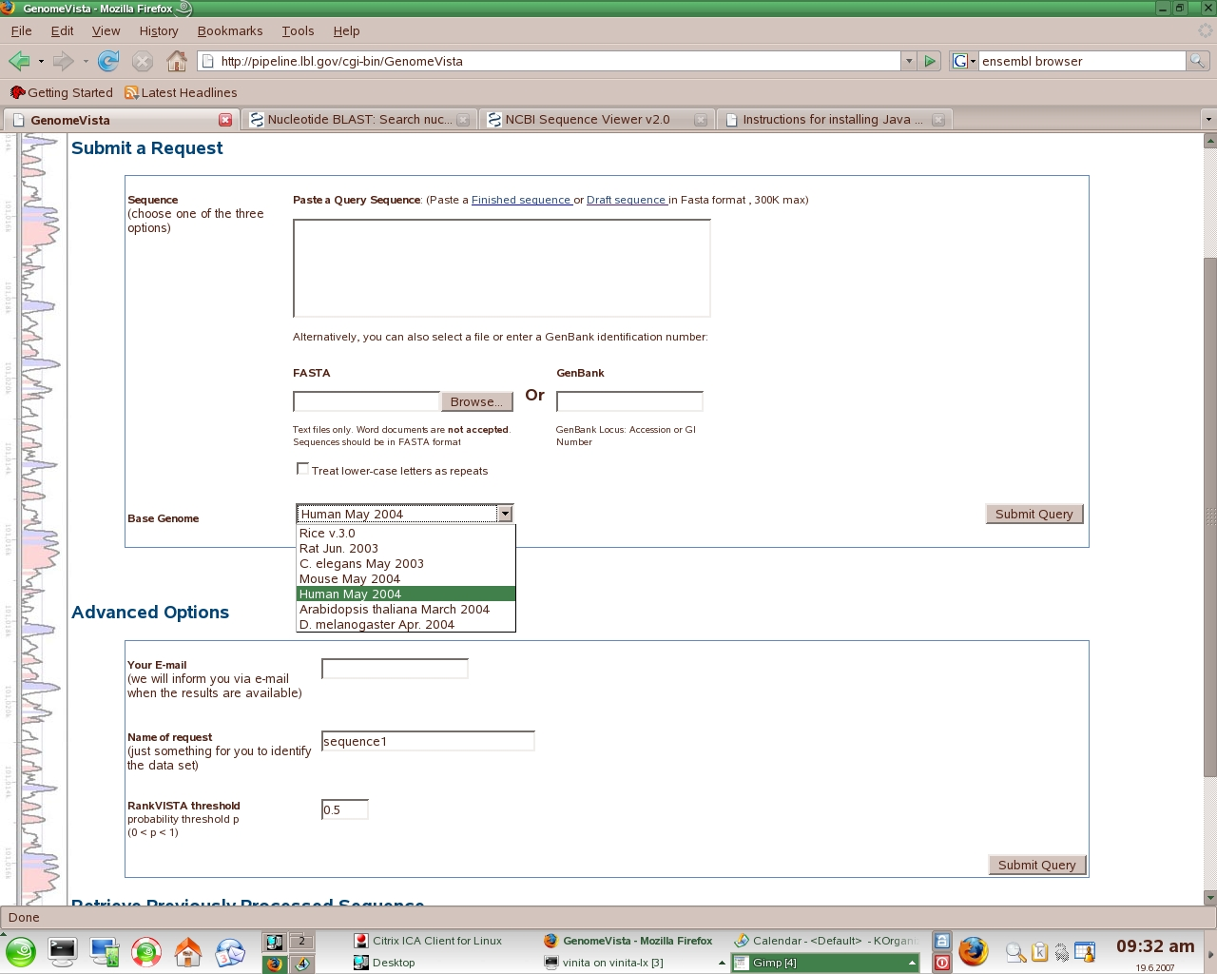

* GenBank accession number: 21068651
Homo sapiens mRNA for apoA-I binding protein (AIBP gene)
Length: 1,109 bp

* Name of request: example
* Enter email address for the results.

* Follow link in email for GenomeVISTA results.
For this exercise, the results are already available via email.
# The email will look like the one provided below for this exercise:
Run 91-xG5WCDdm.
The GenomeVISTA server has processed your request.
The results are available at
http://pipeline.lbl.gov/cgi-bin/textBrowser2?act=summary&run=u91-xG5WCDdm&base=hg18&showdefaults=1
They will be stored on the server for 7 days.
* To access the results: Copy and paste the link provided in the file GenomeVISTA1.doc into your browser.
flash drive: Annotation_course → Sept_25 → Data → GenomeVISTA1.doc. This will bring up a page that looks like the one below:

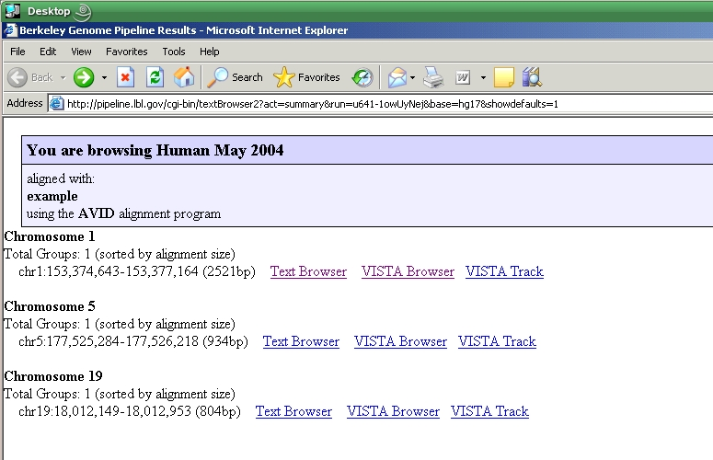

VISTA Browser interface
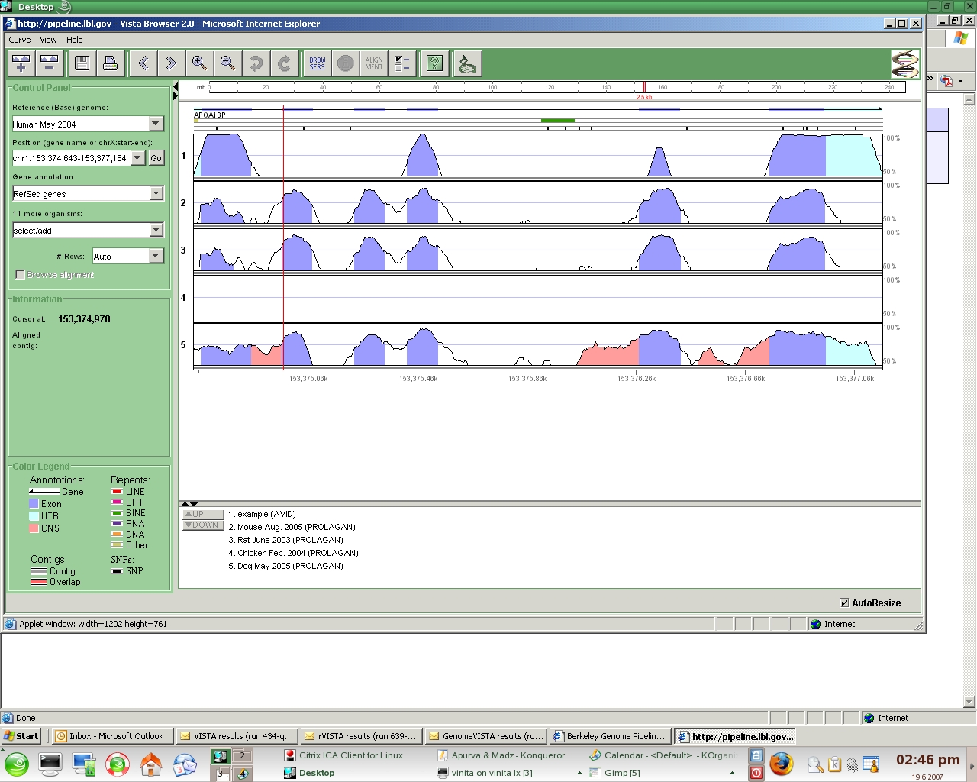

* Add more genomes to alignment
For example, Cow and/or Fugu

If you have time (and the inclination!) check out the other links in the results:

# To see the alignments follow the ‘Text Browser’ link

# The change the window size follow the ‘VISTA Track’ link

* example2: FASTA sequence of GenBank accession number 32981584
Length: 1,568 bp

>gi|32981584|dbj|AK071561.1| Oryza sativa Japonica Group cDNA clone:J023099O18, full insert sequence
GGTGAGAAGAGCTCAAATCCTCCAAACTTTTTTTCCTCCTCCATATCCATCGATCGATCTCGCCATCGTC
CTCGAGCGAGCGGGCGGCTGCGGCGAGCTCGATCCGATCCCCGCCGGCGGAGATGGGGAGCTTGGCAGGC
GGCGGCGGAGGCGGCAAGGTGGGGCTGCCGGCGTTGGACGTCGCGCTCGCGTTCCCGCAGGCCACGACGG
CGTCCCAGTTCCCACCCGCCGTATCGGATTACTACCAGTTTGATGATTTGCTTACTGATGAAGAGAAGAC
ACTTAGGAAGAAAGTCCGTGGTATTATGGAGAGAGAAATTGCACCCATTATGACAGAGTACTGGGAGAAA
GCAGAATTTCCCTTCCATGCCATTCCCAAACTTGCAACTCTTGGCTTGGCAGGAGGGACAACAAAGGGAT
ATGGTTGCCCAGGACTCTCACTTACAGCTAGTGCTATTTCTGTTGCAGAAGTTGCACGGGTGGATGCCAG
CTGCTCCACATTTATTTTAGTACATTCCTCTTTGGCAATGAGCACAATTGCACTTTGTGGATCAGAGGCT
CAAAAGCAGAAGTACTTACCATCATTAACGCAGTTTAGAACAATTGGTTGCTGGGCATTGACAGAGCCAG
ATTATGGAAGTGATGCAAGTTCATTAAGGACTGCAGCGACCAAGGTGCCTGGCGGTTGGCATTTGGATGG
CCAAAAGCGTTGGATAGGCAACGGCACTTTTGCAGATGTGCTCATCATCTTAGCTAGAAATTCAGATACA
AATCAACTAAATGGATTTATTGTCAAGAAAGGAGCTCCTGGTTTGAAATGTACAAAAATTGAAAATAAAA
TTGGACTCAGAATGGTTCAGAATGCCGACATTGTTCTGAATAAAGTATTTGTCCCTGACGAAGATAGATT
AACTGGAATCAATTCATTTCAAGACATAAACAAGGTCCTTGCTATGTCGCGCATTATGGTGGCATGGCAG
CCAATTGGGATATCCATGGGGGTCTTCGACATGTGTCATCGGTATTTGAAAGAAAGAAAGCAATTTGGAG
TTCCGTTGGCAGCTTTTCAGCTCAACCAAGAAAAGCTTGTTCGCATGCTAGGAAACATCCAAGCCATGCT
TCTTGTCGGCTGGCGCCTGTGCAAGCTGTATGAATCAGGCAAAATGACACCAGGCCATGCTAGTTTAGGC
AAGGCATGGACATCCAAGAAGGCTAGGGAGGTGGTTTCTCTTGGCCGTGAGCTACTGGGTGGAAACGGAA
TTTTGGCTGACTTTCTGGTAGCAAAGGCGTTCTGTGATCTGGAGCCAATCTTCTCGTACGAAGGCACCTA
TGACATCAACAGCTTGGTGACCGGAAGAGAGATCACCGGAATCGCCAGCTTCAAACCTGCTGCATTGACA
AAATCTCGTCTTTAATTTTTTTTCCTTTCAAATGTATATAGCTGCAATAGACAAAATAATATACGTCCAC
CCTATATTTTGATGAAAGCAAATGGGCAATAAAAGGAATAGAAAAACCATATTTGTTCTTGAAAAGAAAA
TAAAAGCTCTGATATGCTTCGTTTTGCT

* To access the results: Copy and paste the link provided in the file GenomeVISTA2 into your browser.
flash drive: Annotation_course → Sept_25 → Data → GenomeVISTA2.doc.

