Standard File Format for the Electronic Transfer of Photometric Data

1.0 INTRODUCTION

This is the fourth revision of this standard. Since its introduction in 1986 (IESNA LM-63-1986), this stan- dard has proved to be very useful and powerful. This revision further clarifies the standard to make its use as simple as possible.

2.0 LIMITS OF SCOPE

This document describes the ANSI/IESNA LM-63- 2002 data system and how to build a file using this system. This recommended standard addresses pho- tometric data file formats specifically for data transfer, however, it is recognized that this standard is often used for data storage and retrieval.

3.0 KEY DEFINITIONS

Absolute (or direct) photometry - Consists of the simultaneous comparison of a standard lamp and an unknown light source.

Delimiter- Used to delineate data in a file. Acceptable delimiters are: a comma, a space, multiple spaces, or a carriage-return and line-feed character sequence.
Goniophotometer - A photometer for measuring the directional light distribution characteristics of sources, luminaires, media and surfaces.
Horizontal angles - Measurements in degrees of angular displacement measured counterclockwise in a horizontal plane for Type C photometry and clock- wise for Type A and B photometry.

Keyword - Square bracketed words used in IESNA LM-63-2002 to label data.
Photometric horizontal - Refers to a horizontal direc- tion from photometric center that is coincident with horizontal angle 0° and vertical angle 90° for Types B and C photometry. For Type A, the direction is coinci- dent with horizontal angle 0° and vertical angle 0°.
Photometric plane - A plane, not a cone, upon which photometric data is measured. In Types A and C pho- tometry, the planes are all vertical and share a com- mon vertical axis. In Type B photometry, the planes share a common horizontal axis.
Photometric zero - Refers to a vertical direction from photometric center that is coincident with horizontal angle 0° and vertical angle 0° for Types B and C pho- tometry. For Type A, the direction is coincident with horizontal angle 0° and vertical angle -90°.

Relative photometry - Consists of the evaluation of the photometric characteristic of a lamp by compari- son with the assumed lumen or spectral output of a test lamp.

Search string - A group of characters created by the user of the photometric file located to the right of the keyword [SEARCH]. These strings may be used by software to locate photometric files based on encod- ed characteristics.

Vertical angles -The angular displacement in degrees from straight down (referred to as nadir in the IESNA Lighting Handbook).
Zero degree photometric plane - A vertical plane passing through photometric center containing photo- metric zero and photometric horizontal.

4.0 SUMMARY OF MODIFICATIONS FROM IESNA LM-63-1995

The following is a summary of the major changes from LM-63-1995 to LM-63-2002:

- The first line in the file is now IESNA:LM-63-2002 (see Section 5.1).
- All lines can now be 256 characters in length (see Section 6).
- All IESNA LM-63-2002 filenames shall now have the file extension ies or IES.
- The following keywords are now required: [TEST], [TESTLAB], [MANUFAC], and [ISSUEDATE]
(see Section 5.2).
- [DATE] keyword replaced with [ISSUEDATE] (see Annex B).
- [BLOCK] and [ENDBLOCK] keywords have been removed.
- All tilt filenames (TILT=<filename>) shall now have the file extension tlt or TLT (tilt format moved to Annex G).
- Definitions of the Luminous Opening have been expanded and, in some cases, modified. The fol-

lowing shapes are directly affected: Circular, Sphere, Vertical Cylinder, Horizontal Cylinder, Ellipse, and Ellipsoid (see Table 1 and Annex D).
- The allowance for horizontal angles starting at 90 degrees and ending at 270 degrees for Type C photometry has been removed.
- [LAMPPOSITION] keyword has been added (see
Annex E).

5.0 DETAILED DESCRIPTION OF DATA

The following is a file format specification. All ANSI/IESNA LM-63-2002 filenames shall end with the file extension ies or IES (the file extension is not case-specific); e.g., SAMPLE.IES.
Each of the items listed in the format are described in the sections below. Each line marked with a bullet (•) shall begin a new line in the file. Unmarked fields, such as <lumens per lamp>, may either be placed on the same line as the field before it or may be used to start a new line of data.

IESNA:LM-63-2002
- [Keyword 1] Keyword data
- [Keyword 2] Keyword data
- [Keyword 3] Keyword data
- :
- [Keyword n] Keyword data

TILT=<filename> or INCLUDE or NONE
  - [Keywords]
Following IESNA:LM-63-2002, and prior to TILT= any number of defined IES keywords may be used (see Annex A and B). Each keyword line shall begin with an appropriate keyword.
All files shall contain the following keywords:

[TEST] Test report number [TESTLAB] Photometric testing laboratory
[ISSUEDATE] Date that the manufacturer issued
the IESNA:LM-63-2002 file [MANUFAC] Manufacturer of luminaire

All other keywords are optional. In addition to the required keywords, the following are a suggested minimum:
[LUMCAT] Luminaire catalog number [LUMINAIRE] Luminaire description [LAMPCAT] Lamp catalog number [LAMP] Lamp description (i.e., type,
wattage, size, etc.)

TILT=NONE or TILT=INCLUDE or TILT=
<filename>

This line indicates whether the lamp output varies as a function of the luminaire tilt angle, and if so, the location of the tilt multiplier information.

    - <lamp to luminaire geometry>
    - <number of tilt angles>
    - <angles>
    - <multiplying factors>

These four lines shall be present if and only if TILT=INCLUDE
If the output of the lamp does not vary as a function of the tilt angle, TILT=NONE shall appear on this line (skip to Section 5.4).
If the output of the lamp does vary as a function of

    - <number of lamps> <lumens per lamp> <candela multiplier> <number of vertical angles> <number of horizontal angles> <photometric type> <units type> <width> <length> <height>
    - <ballast factor> <future use> <input watts>
    - <vertical angles>
    - <horizontal angles>
    - <candela values for all vertical angles at 1st hori- zontal angle>
    - <candela values for all vertical angles as 2nd horizontal angle>
    - <candela values for all vertical angles at last hori- zontal angle>

5.1 IESNA:LM-63-2002
The first line of any photometric file shall be IESNA:LM-63-2002. This character string distinguishes it from files using other formats and marks the beginning of the file.
the tilt angle, TILT=INCLUDE or TILT=<filename> shall appear on this line. TILT=INCLUDE indicates that the tilt information is included as part of the photometric file. TILT=<filename> indicates that the tilt information is in a separate file. The filename shall end with the file extension tlt or TLT (the file extension is not case-specific); e.g., MH100V.TLT. The format for tilt information is the same whether it is in a separate file or included as part of the photometric file and is discussed in Annex F.

- NOTE: The phrase TILT= shall be exactly as shown and begin in column 1. This is important since this phrase is used to signify the end of the keyword information.

<number of lamps>
This field shall contain a number indicating the total number of lamps in the luminaire.

<lumens per lamp>
This field shall contain a number indicating the lumens per lamp on which the photometric test is based. In the case of absolute photometry, where the lumens per lamp are not the basis for the photometric data, enter negative one (-1).

    - NOTE: For most luminaires with more than one lamp, the lamps will all be of the same type with the same lumen output.

    - For those luminaires with two or more lamps with different lumen output, this value shall be treated as the average lumens per lamp. The product:
<lumens per lamp> x <number of lamps> shall be the total lumen output by all lamps operating in the luminaire.
    - When creating reports with absolute photometry
«lumens per lamp> = -1), it is suggested to include the keyword [OTHER] indicating the can- dela values are absolute and should not be fac- tored for different lamp ratings.

<multiplier>

This field shall contain a number indicating the multi- plying factor that shall be applied to all candela values in the file. This is often 1.0, but may be a value other than 1.0.

<number of vertical angles>

This field shall contain a number indicating the total number of vertical angles in the photometric report.

<number of horizontal angles>

This field shall contain a number indicating the total number of horizontal angles in the photometric report.

<photometric type>
This is an integer indicating the type of photometry that exists for the luminaire being described, and shall be the value 1, 2, or 3, according to the following schedule:

- Type C
- Type B
- Type A
Refer to IESNA LM-75-012 for a detailed explanation of goniophotometer types.

Luminous Dimensions
The following dimensions refer to the luminous (that is, light emitting) opening of the luminaire, not its physical dimensions. They are meant to approximate the luminous opening (either as a luminous area or volume) for lighting calculations. They are not intended for computer-generated renderings of the luminaire. It is assumed that there is only one luminous opening in each IESNA LM-63-2002 data file.
The luminous dimensions apply to a luminaire aimed at "photometric zero" (0° horizontal, 0° vertical,). "Photometric horizontal" would be (0° horizontal, 90° vertical).
"Length" and "Width" measurements refer only to their orientation with respect to the zero-degree photometric plane; they do not refer to the luminaire dimensions or lamp orientation. In particular, the "length" measurement may be less than the "width" measurement.

<units type>
This is an integer indicating the type of units used for the luminous dimensions of the luminaire, and shall be the value 1 or 2, according to the following schedule:
- Luminous dimensions are given in feet
- Luminous dimensions are given in meters

<width>
This field shall contain a number indicating the dis- tance across the luminous opening when measured perpendicular to the 0° photometric plane (perpen- dicular to "photometric horizontal" - see Figure 1, Table 1 and Annex D for additional details).

<length>
This field shall contain a number indicating the dis- tance across the luminous opening when measured parallel to the 0° photometric plane (along "photomet- ric horizontal" - see Figure 1, Table 1 and Annex D for additional details).

<height>
This field shall contain a number indicating the overall height of the luminous opening, measured parallel to "photometric zero" (see Figure 1, Table 1 and Annex D for additional details).

Luminous Shape

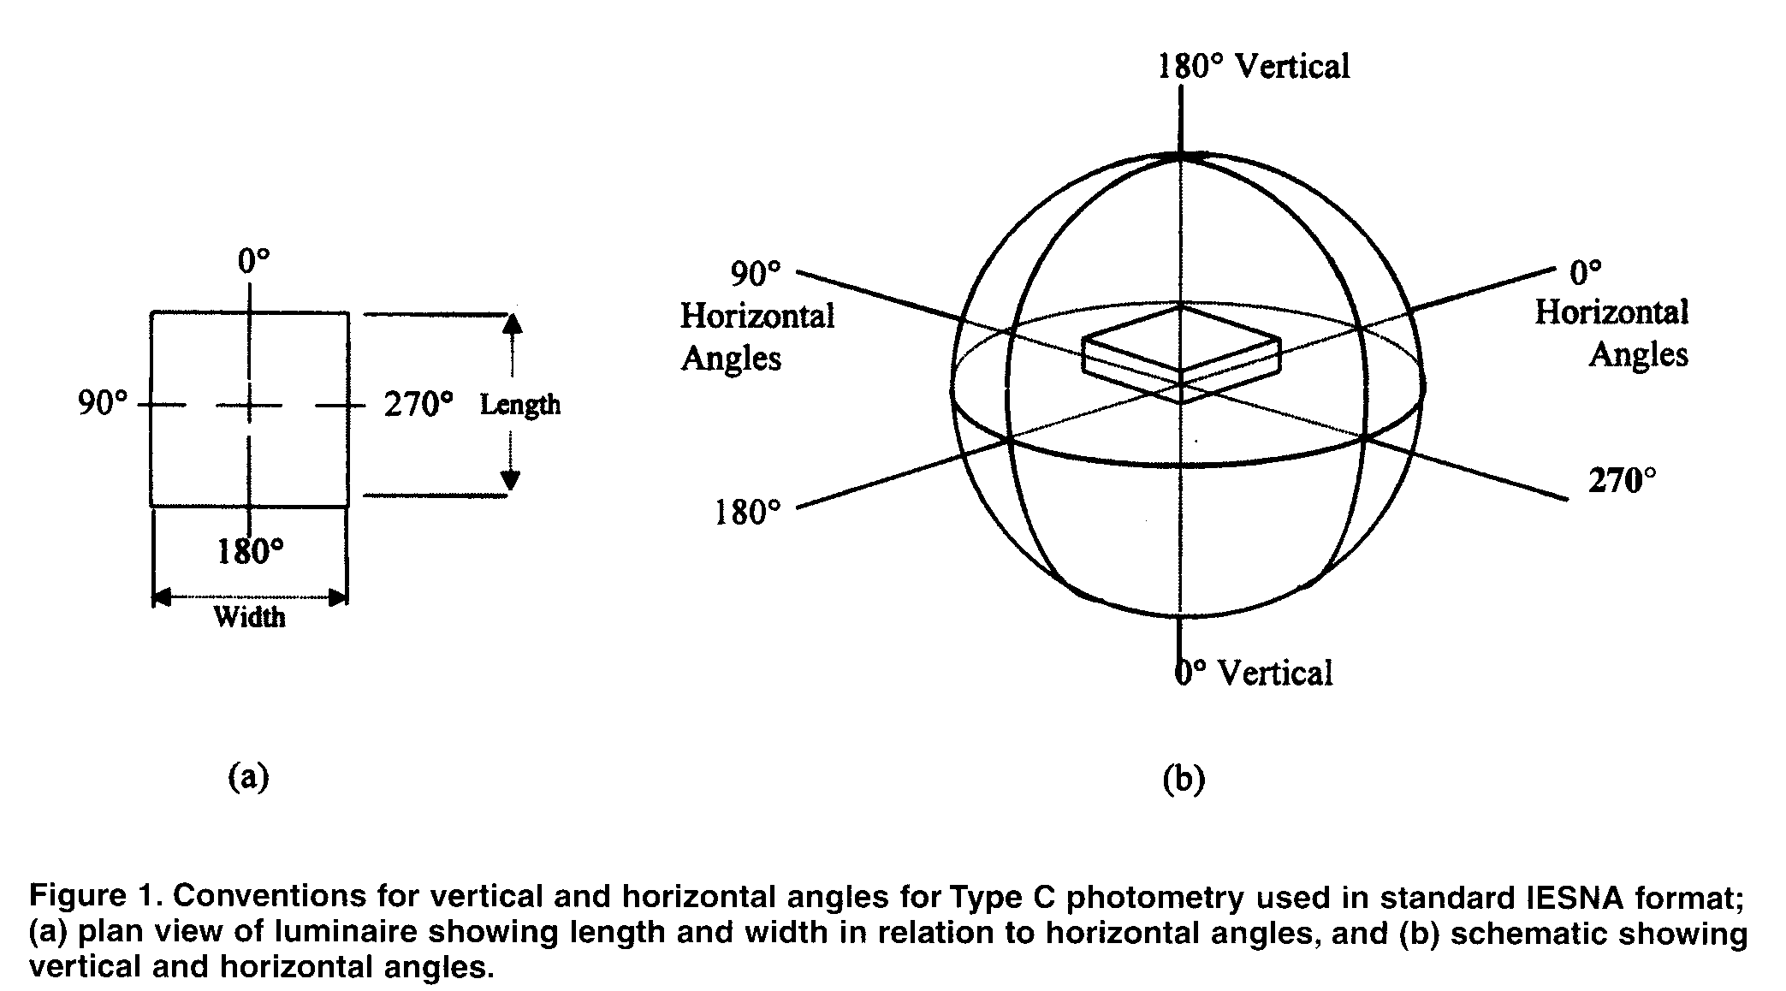
As defined in the previous paragraphs, the luminous opening is assumed to be rectangular. To describe luminous openings of other shapes (including 3D), see Table 1. This table is based on a simple principle: if the dimension is positive, it represents a squared off shape. If two dimensions are negative, the luminous opening is rounded when viewing the plane containing those two dimensions.
This document acknowledges that not all luminous openings can be specified using the indicated width, length, and height values. It is the responsibility of the supplier to select the shape that best describes the luminous opening.

    - NOTE: Some changes have been made from IESNA LM-63-1995. Circular, Sphere, Vertical Cylinder, Horizontal Cylinder, Ellipse and Ellipsoid have a different form in this standard.
    - See Annex D for drawings of these and other shapes.

<ballast factor>
This field shall contain a number indicating the ballast factor of the luminaire. The ballast factor describes the application characteristics of the luminaire. It represents the fractional lumens of a lamp(s) operated on a commercial ballast compared to the lumens when operated on a standard (reference) ballast used for rating lamp lumens. If ballast factor is not known, default value shall be 1.0.

For application purposes, this factor is used to adjust
luminaire performance data from laboratory test con- ditions to actual field conditions. Values in the file do not include ballast factor. This factor shall be applied to all candela values in the file at application time.

<future use>
This element is reserved for future use. Set equal to one (1) to remain compatible with previous versions of LM-63.

<input watts>
This field shall contain a number indicating the total watts input to the luminaire including ballast watts.

<vertical angles>

The vertical angles for which data are present in the photometric report shall be listed in ascending order.
    - For Type C photometry, the first value shall be either 0 or 90 degrees, and the last angle value shall be either 90 or 180 degrees.
    - For Type A or B photometry, the first vertical angle shall be -90 or 0 degrees, and the last angle value shall be 90 degrees.

<horizontal angles>

The horizontal angles for which data are present in the photometric report shall be listed in ascending order.
For Type C photometry, the first value shall always be

Luminous Opening | <width> | <length> | <height>
Point | 0 (zero) | 0 (zero) | 0 (zero)
Rectangular | Width | Length | 0 (zero)
Rectangular with Luminous Sides | Width | Length | Height
Circular | -Diameter | -Diameter | 0 (zero)
Ellipse | -Width | -Length | 0 (zero)
Vertical Cylinder | -Diameter | -Diameter | Height
Vertical Ellipsoidal Cylinder | -Width | -Length | Height
Sphere | -Diameter | -Diameter | -Diameter
Ellipsoidal Spheroid | -Width | -Length | -Height
Horizontal Cylinder along Photometric Horizontal | -Diameter | Length | -Diameter
Horizontal Ellipsoidal Cylinder Along Photometric Horizontal | -Width | Length | -Height
Horizontal Cylinder  Perpendicular to Photometric Horizontal | Width | -Diameter | -Diameter
Horizontal Ellipsoidal Cylinder Perpendicular to Photometric  Horizontal | Width | -Length | -Height
Vertical Circle Facing Photometric Horizontal | -Diameter | 0 (zero) | -Diameter
Vertical Ellipse Facing Photometric Horizontal | -Width | 0 (zero) | -Height

Table 1: Shapes of Luminous Areas and Solids
For Type C photometry, the first value shall always be 0 degrees, and the last value shall be one of the following:
- 0 - in this case, there is only one horizontal angle, and the luminaire is assumed to be laterally symmetric in all planes.
- 90 - the luminaire is assumed to be symmetric in each quadrant.
- 180 - the luminaire is assumed to be symmetric about the 0 to 180 degree plane.
- 360 - in this case, the luminaire is assumed to exhibit no lateral symmetry.
For Type A or B photometry, there are two possibilities:
- The luminaire is laterally symmetric about a verti- cal reference plane. In this case, the first horizontal angle shall be zero, and the last horizontal angle shall be 90 degrees.
- The luminaire is not laterally symmetric about a vertical reference plane. In this case, the first horizontal angle shall be -90 degrees, and the last horizontal angle shall be 90 degrees.

<candela values>
    - <candela values for all vertical angles at the 1 st horizontal angle>
    - <candela values for all vertical angles at the 2nd horizontal angles>
    - :
    - <candela values for all vertical angles at the last horizontal angle>
List of candela values corresponding to each vertical angle of photometry. The order of the candela values shall exactly correspond to the list of vertical angles. Successive planes are listed in a sequence corre- sponding to the list of horizontal angles, and the first candela value for each horizontal angle shall begin a new line. Any of the values may be continued on a second and subsequent lines if necessary.

6.0 PROGRAMMING AND FILE CONVENTIONS

There are several conventions that shall be used in constructing and using IESNA standard photometric files. They are as follows:
- All lines shall end with a carriage-return and line- feed character sequence.
- The maximum line length for all lines shall be 256 characters per line including carriage-return and line-feed character sequence.
- All lines from the first through the TILT= line are read using text-mode.
- It is the responsibility of the programmer to allow for trailing blanks on lines IESNA:LM-63-2002 through TILT=.
- Keywords may be presented in any order (prior to the TILT= line).
- Only keywords and user defined keywords shall be enclosed in brackets.
- Refer to Annex F for TILT=<filename> or INCLUDE data types.
- All remaining data are real values except: <# of lamps>,<# of vertical angles>,<# of horizontal angles>, <photometric type>, and <units type>, which are integer values (exponential notation is not allowed).
- The individual values on anyone line shall be separated by a delimiter.
- Any of the specified data lines may be continued on an additional line (or lines), if necessary.
- A "Null" file may be created by having a minimum of one horizontal angle and two vertical angles. In this case, two corresponding candela values would be required, and they should be shown as zeroes. Such a file shall also have all of the correct numeric items as outlined in the above requirements.
- It is the responsibility of the programmer to display and report all factors applied to the photometric file.
- Photometric center, used for luminaire placement, is beyond the scope of this document. It is described in various IESNA Testing Procedures documents (LM-10-96: Photometric Testing of Outdoor Fluorescent
Luminaires, LM-31-95: Photometric Testing of Roadway Luminaires Using Incandescent Filament and High Intensity Discharge Lamps, LM-35-89: Photometric Testing of Floodlights Using High Intensity Discharge or Incandescent Filament Lamps, LM-41-98: Photometric Testing of Indoor Fluorescent Luminaires, LM-46-98: Photometric Testing of Indoor Luminaires Using High Intensity Discharge or Incandescent Filament Lamps).

References
- The IESNA Lighting Handbook, 9th Edition, Reference & Application. New York: Illuminating Engineering Society of North America, 2000: Chapters 2 and 9.

- Photometry of Luminaires for Street Lighting, CIE Report No.27-1973. Vienna: International Commission on Illumination (CIE). 1973.

- Photometry of Floodlights, CIE Report No. 43- 1979. Vienna: International Commission on Illumination (CIE), 1979. (For CIE publications in the US contact TLA-Lighting Consultants, Inc., 7 Pond Street, Sales, MA 091970-4819; in Canada, contact the National Research Council, Attn: Alan Robertson, Insitute for National Measurements, Montreal Road, Ottawa, Ontario KIA OR6.)
- McCulloch, J. H., and H. McCulloch. 1967. "Floodlight Photometry Without Special Photometer And Without Tipping Luminaire - A Computer Application", Illuminating Engineering 42(4):243-245.

- IESNA Testing Procedures Committee, Goniophotometers and Photometric Coordinates, IESNA LM-75-01. New York: Illuminating Engineering Society of North America. 2001.

Annex A - General rules for keywords
The keyword:

  - Shall be the first non-blank character in a new line.
  - Shall be in upper case.
  - Shall occur prior to TILT=.
  - Shall not contain any characters (including spaces and/or non-printing characters) that are not specif- ically listed as part of the keyword.
  - Shall be contained in square brackets.
  - Shall occur only once except for the keywords [MORE] and [OTHER].
  - Shall be 20 characters or less counting the brackets.
  - User defined keywords may be included. User defined keywords shall have an underscore char- acter immediately following the first bracket and preceding the actual keyword (e.g., [_USERKEY- WORD]). The underscore character distinguishes user-defined keywords from those defined in Annex B.
  - Shall be read as descriptive text if not listed in

Annex B.
The keyword data:

  - Shall be preceded with a keyword.
  - Shall conform to the official IESNA LM-63-2002 format for that keyword.
  - Shall end with a carriage-return and line-feed character sequence.
  - Shall begin with the keyword [MORE], if additional lines of data are required.

Annex B - Valid keywords
REQUIRED (*) KEYWORD PURPOSE

Test Related items:
- [TEST] Test report number
- [TESTLAB] Photometric testing laboratory
[TESTDATE] Date that the photometric report was generated [NEARFIELD]D1,D2,D3 This indicates that the report was tested using near
field photometry.
D1 = Distance from photometric center to horizontal surface to which luminaire is mounted.
D2 = Distance from photometric center to vertical surface along the 0 degree plane.
D3 = Distance from photometric center to vertical surface along the 90 degree plane.
Luminaire product information:

- [MANUFAC] Manufacturer of luminaire
[LUMCAT] Luminaire catalog number
[LUMINAIRE] Luminaire catalog description
[LAMPCAT] Lamp catalog number
[LAMP] Lamp description (for example: type, wattage, size, etc.)
[BALLAST] Ballast description (for example: watts, volts, magnetic or electronic, etc.)
[BALLASTCAT] Ballast catalog number Luminaire characteristics:

Miscellaneous:
[MAINTCAT] A digit (1-6) indicating the IES maintenance category (see reference 1)
[DISTRIBUTION] General description of the photometric distribution
(e.g, Type II, Medium, Direct, SC=1.5)
[FLASHAREA] Light emitting area of the luminaire projected under 76 degrees in square meters. Used in calculation of CIE Discomfort Glare Mark.
[COLORCONSTANT] Used in calculation of CIE glare control [LAMPPOSITION] Two angles, separated by a space or comma
delimiter, that determine lamp position within the luminaire with respect to the photometric angles (see Annex E).

- [ISSUEDATE] Date that the manufactuer issued the IESNA LM- 63-2002 file
[OTHER] Other information about this file
[SEARCH] User created search string
[MORE] More information tied to previous keyword

Annex C -Example
The following is an example of an IESNA LM-63-2002 photometric file using Type C photometry.

IESNA: LM-63-2002 [TEST] ABC1234
[TESTLAB] ABC Laboratories [ISSUEDATE] 18-FEB-2001
[MANUFAC] Aardvark lighting Inc. [LUMCAT] SKYVIEW 123-XYZ-abs-400
[LUMINAIRE] Wide beam flood to be used without tilt
[LAMPCAT] MH-400-CLEAR
[LAMP] 400 Watt Metal Halide [BALLASTCAT] Global 16G6031-17R [BALLAST] 400W 277V MH Magnetic [MAINTCAT] 4
[OTHER] This luminaire is useful as an indirect flood
[MORE] and to reduce light pollution in down light applications. [LAMPPOSITION] 0,0
[SEARCH] POLLUTION SPORTS INDIRECT [_NEMATYPE] 4h x 6v
[_PRICE] Make us an offer TILT=INCLUDE
1
13
0 15 30 45 60 75 90 105 120 135 150 165 180
1.0 .95 .94 .90 .88 .87 .98 .87 .88 .90 .94 .95 1.0
1 50000 1 5 3 1 1 .5 .6 0
1.0 1.0 495
0 22.5 45 67.5 90
0 45 90
100000 50000 25000 10000 5000
100000 35000 16000 8000 3000
100000 20000 10000 5000 1000

Annex D - Describing luminous openings

With the use of <width>, <length>, and <height> it is possible to describe various luminous openings as shown in the following figures.
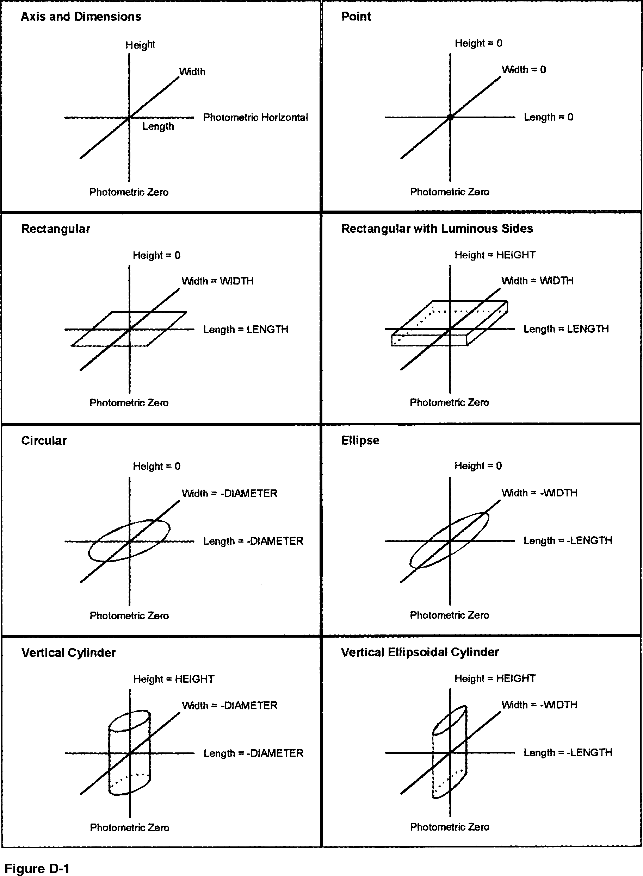

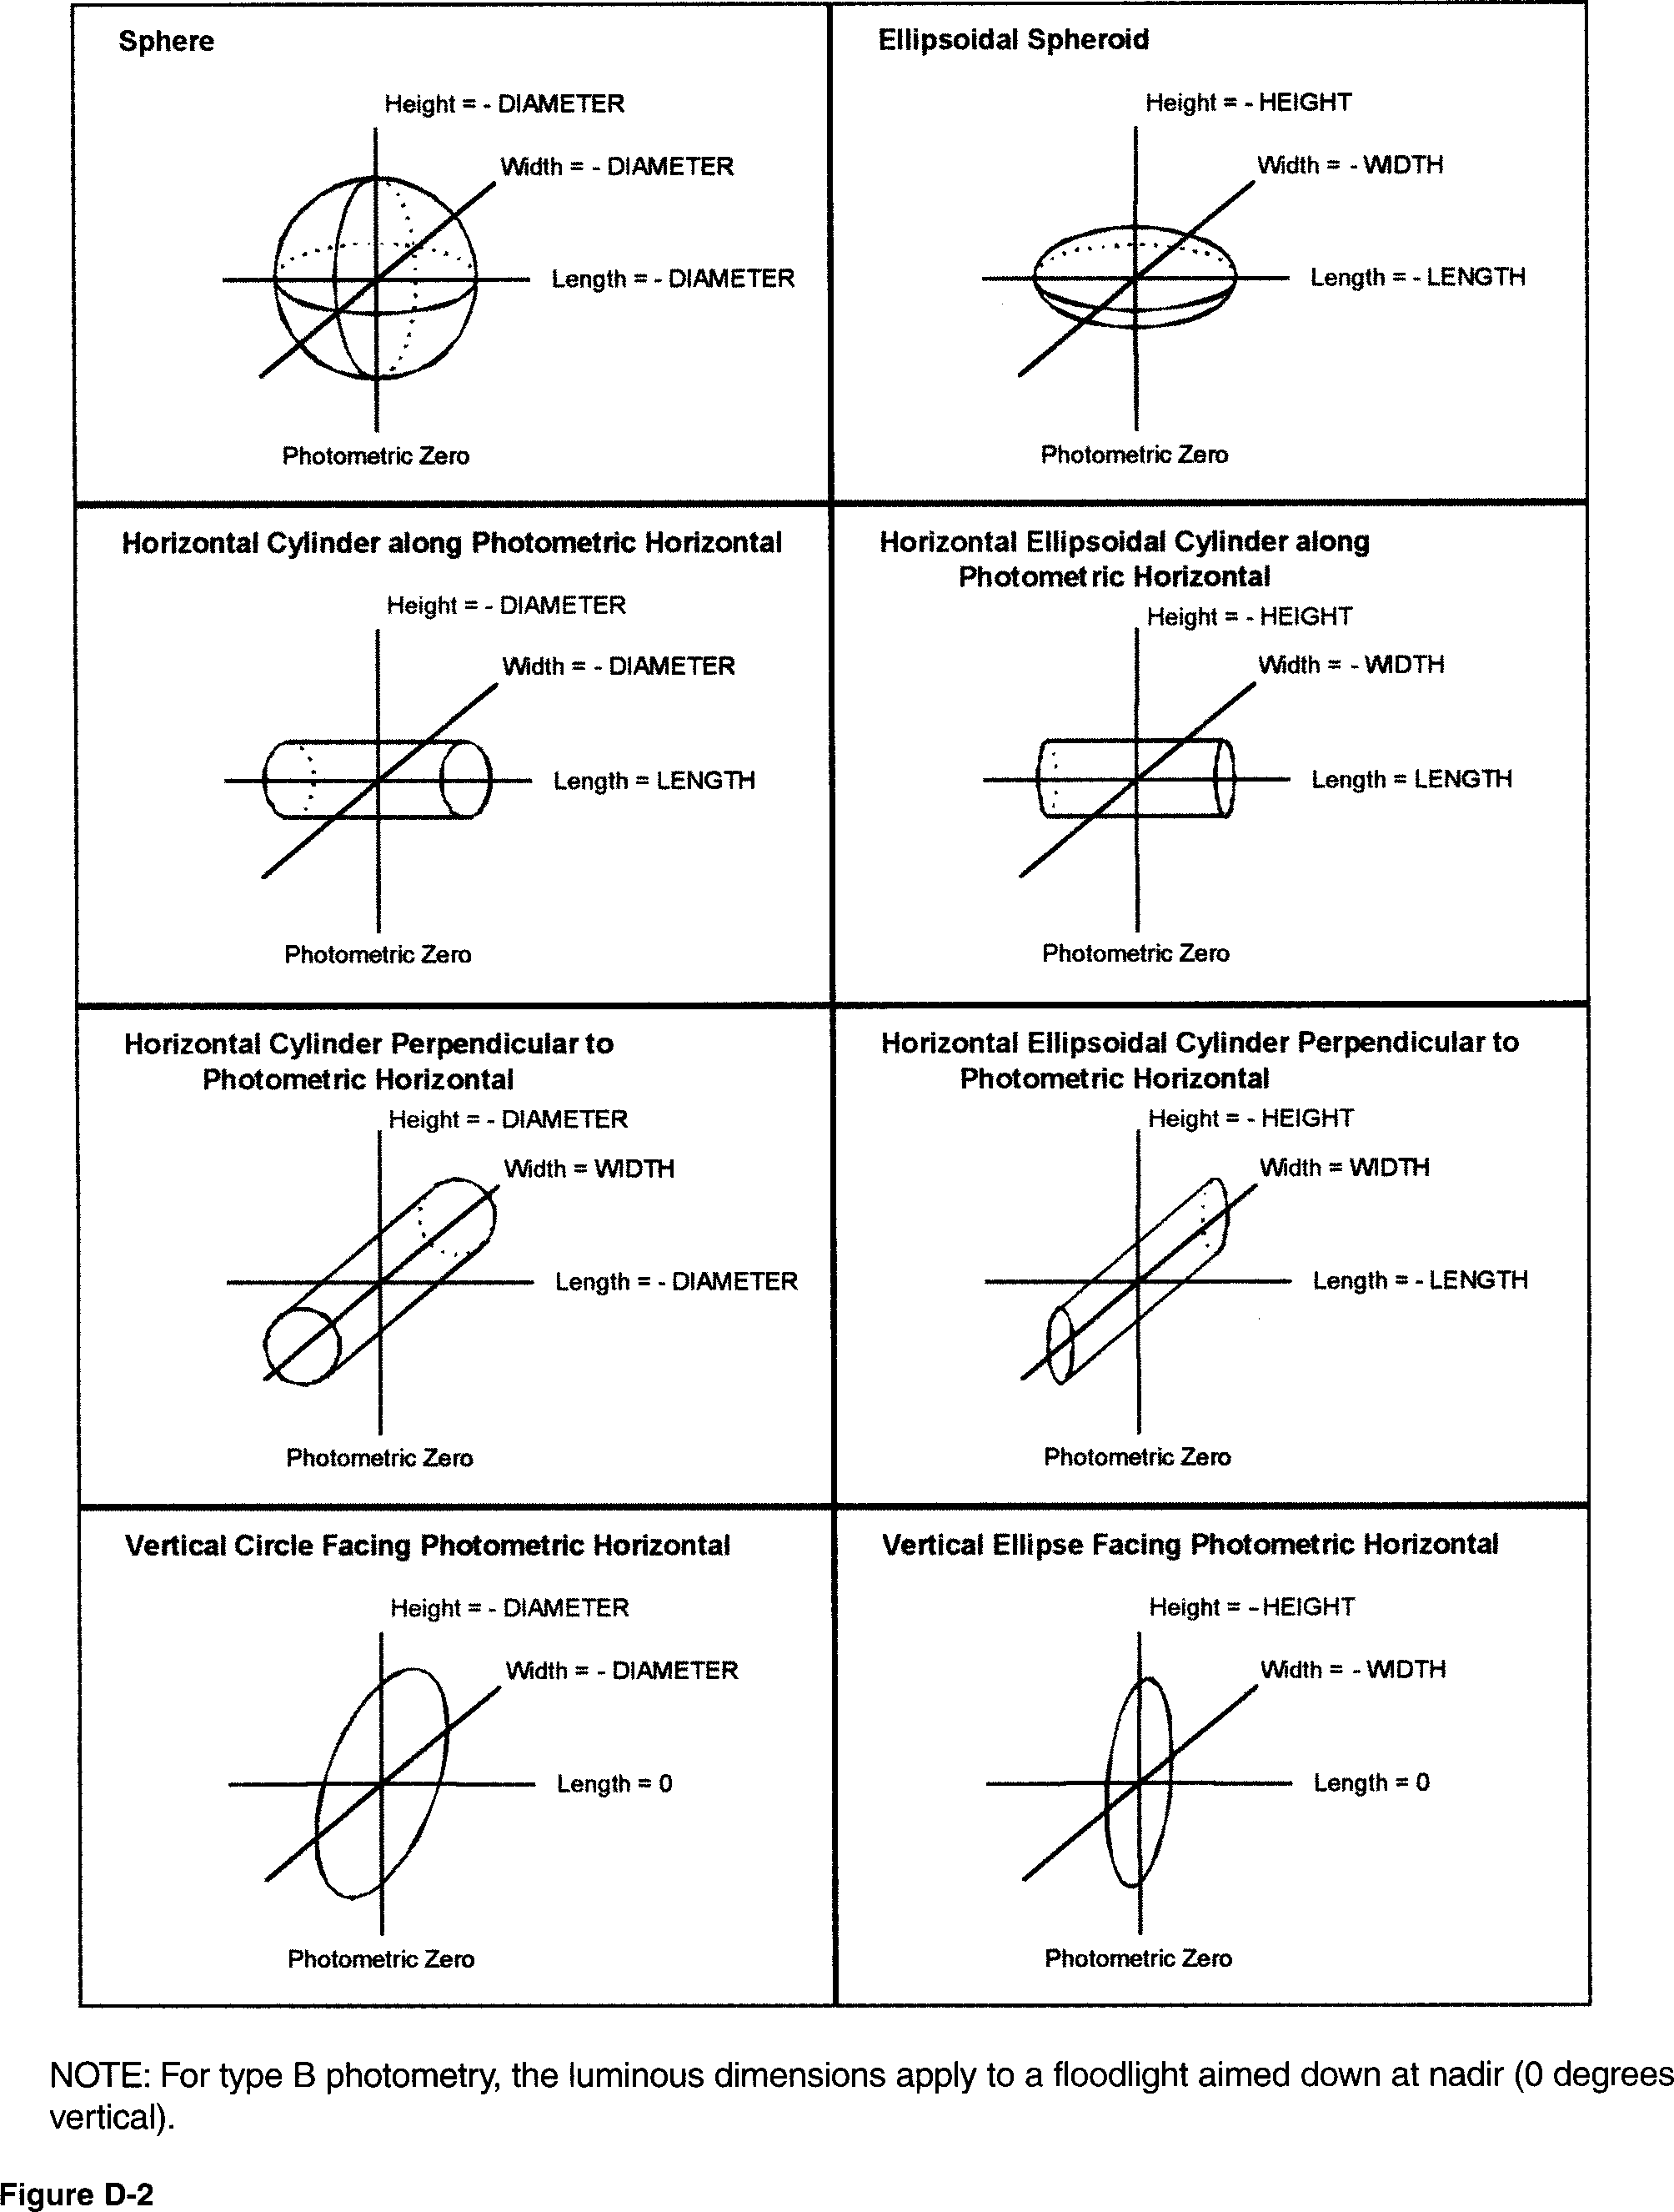

Annex E - Lamp position
The keyword [LAMPPOSITION], if present, shall be followed by two numbers separated by a space or comma delimiter, as follows:
Lamp position within a luminaire shall be expressed as two angles (horizontal and vertical), which describe the direction of the lamp's vector with respect to the luminaire photometrics. The lamp's vector is defined as a line from the lamp's base through the opposite end of the lamp. For lamps with bases on either end (double ended lamps) the vector may run in either direction.

The first angle, the horizontal position angle, ranges from 0.00 to 359.99 degrees. This angle shall be measured counter-clockwise looking down on a horizontal plane from "photometric horizontal" to the lamp's vector projected onto that horizontal plane. For a lamp mounted vertically, this will be 0° (default). For a lamp mounted horizontally with the lamp vector pointing along "photometric horizontal," this will be 0°. If the lamp vector points "West" when "photometric horizontal" is considered "North," this will be 90°.
The second angle, the vertical position angle, ranges from 0.00 to 180.00 degrees. This angle shall be measured from photometric zero to the lamp's vector. When the luminaire is aimed straight down (nadir), this angle will be zero degrees for a vertical base up lamp, ninety degrees for a horizontal lamp and 180 degrees for a vertical, base down lamp.

Note that if [LAMPPOSITION] is specified, the tilt of the lamp can be determined no matter how the Iumi- naire photometrics are oriented (aimed).
[LAMPPOSITION] supersedes the <lamp to luminaire geometry> specification when TILT=<filename> or TILT=INCLUDE (see Annex E).
See Figures E-1 through E-8 for drawings of many typical lamp positions. Photometric zero is shown in those drawings as V=0°. Photometric horizontal is shown as H=0°.

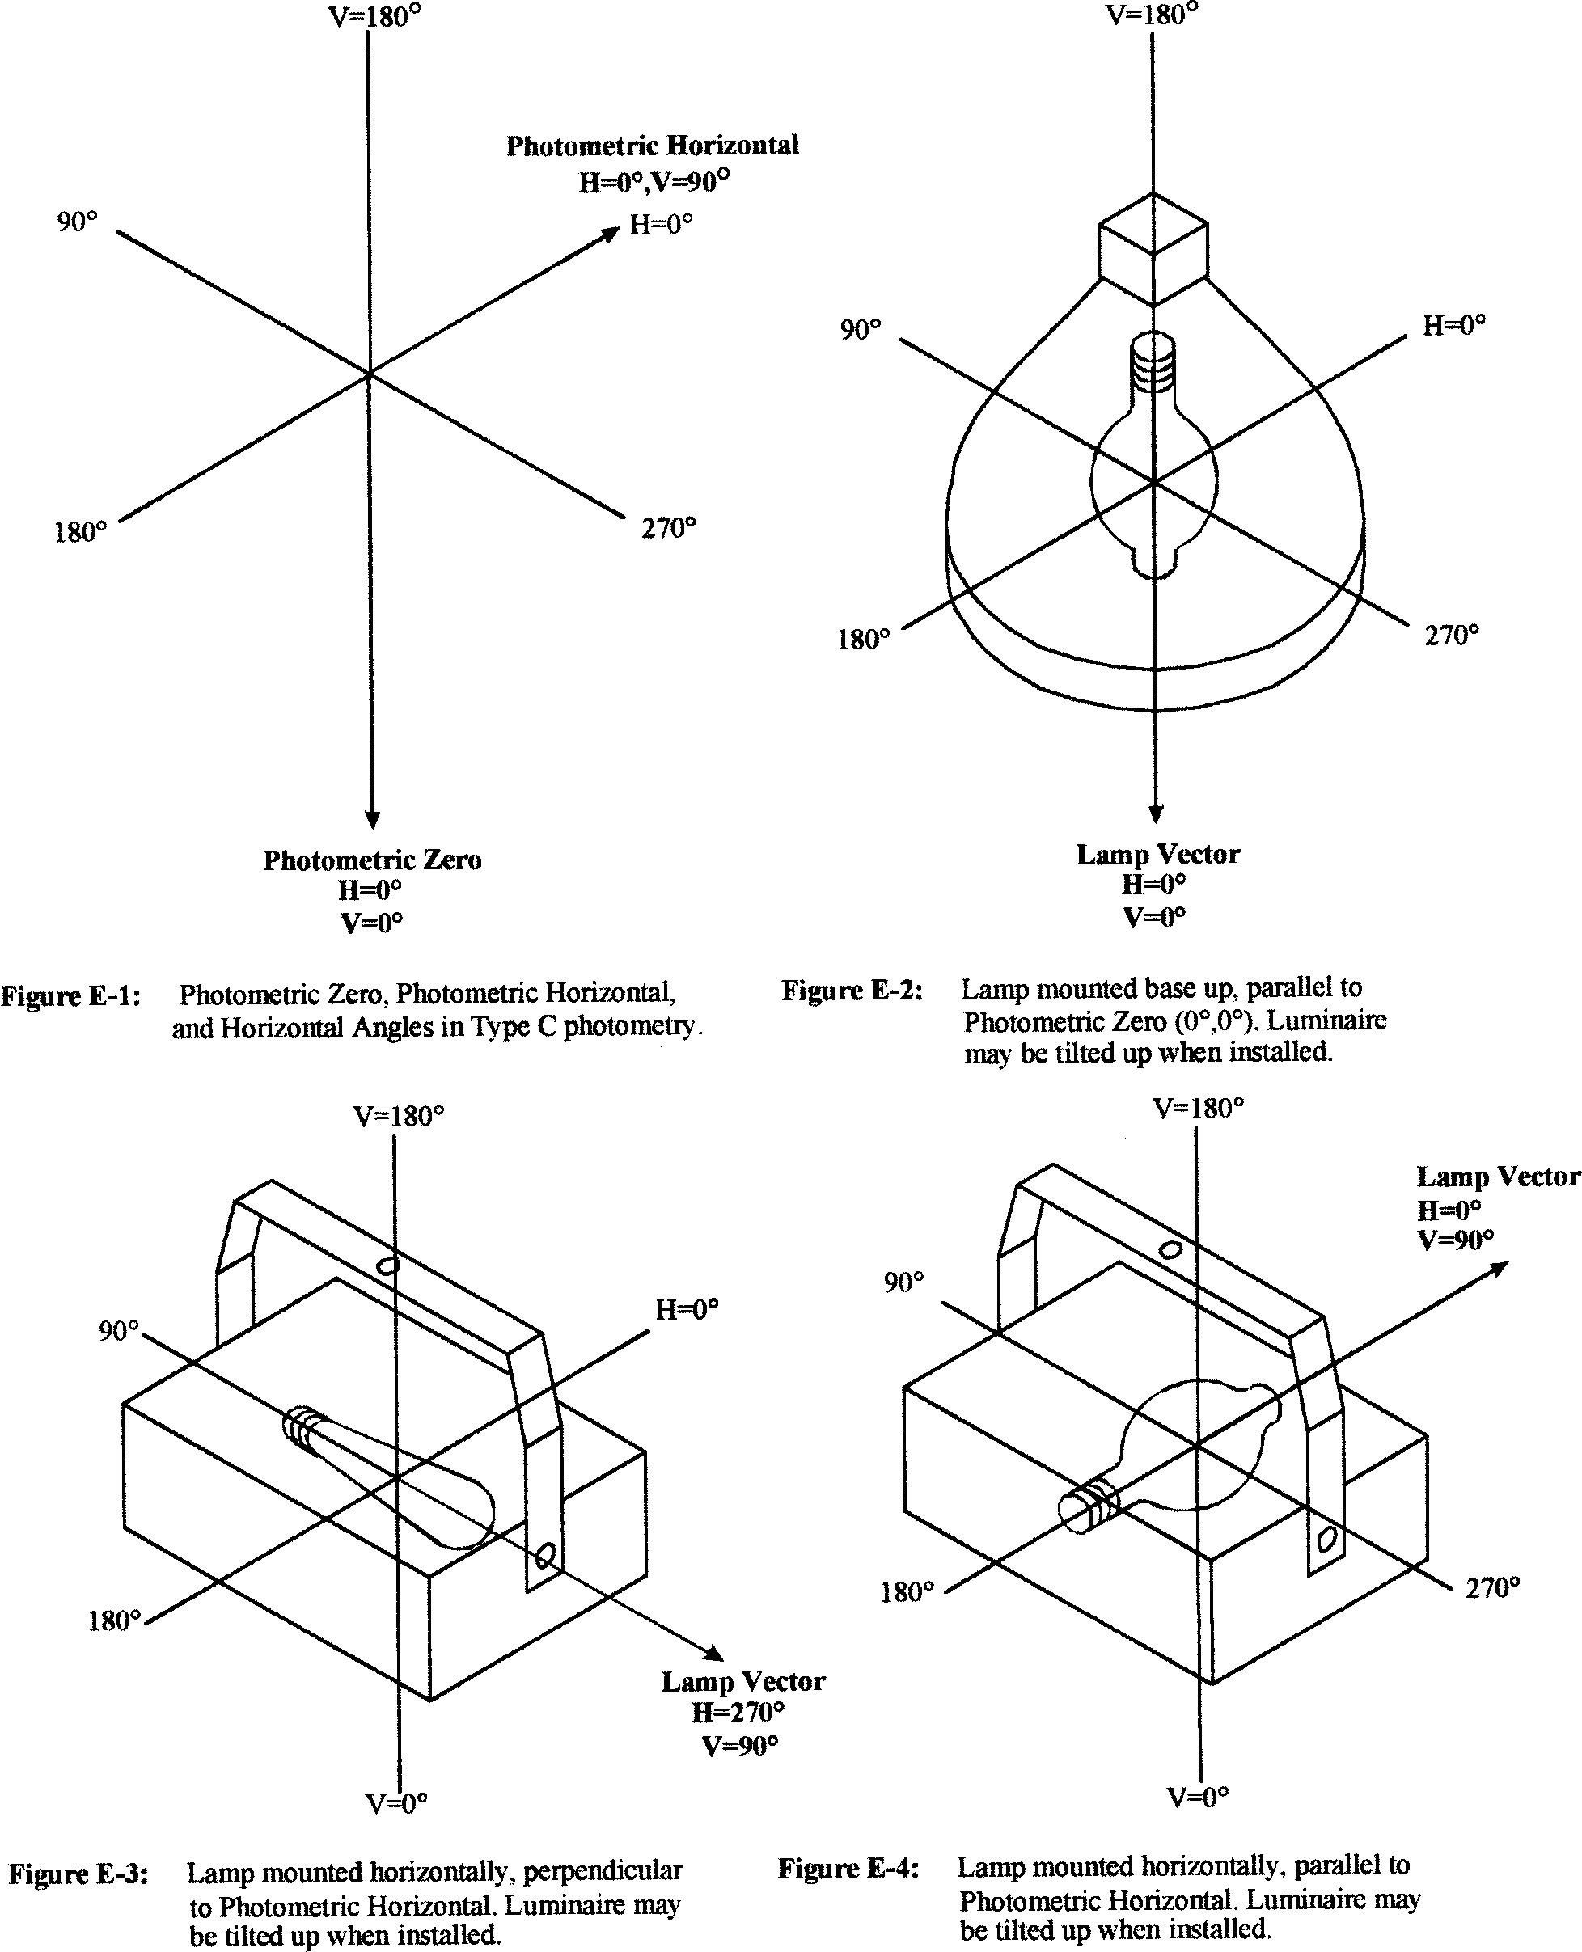

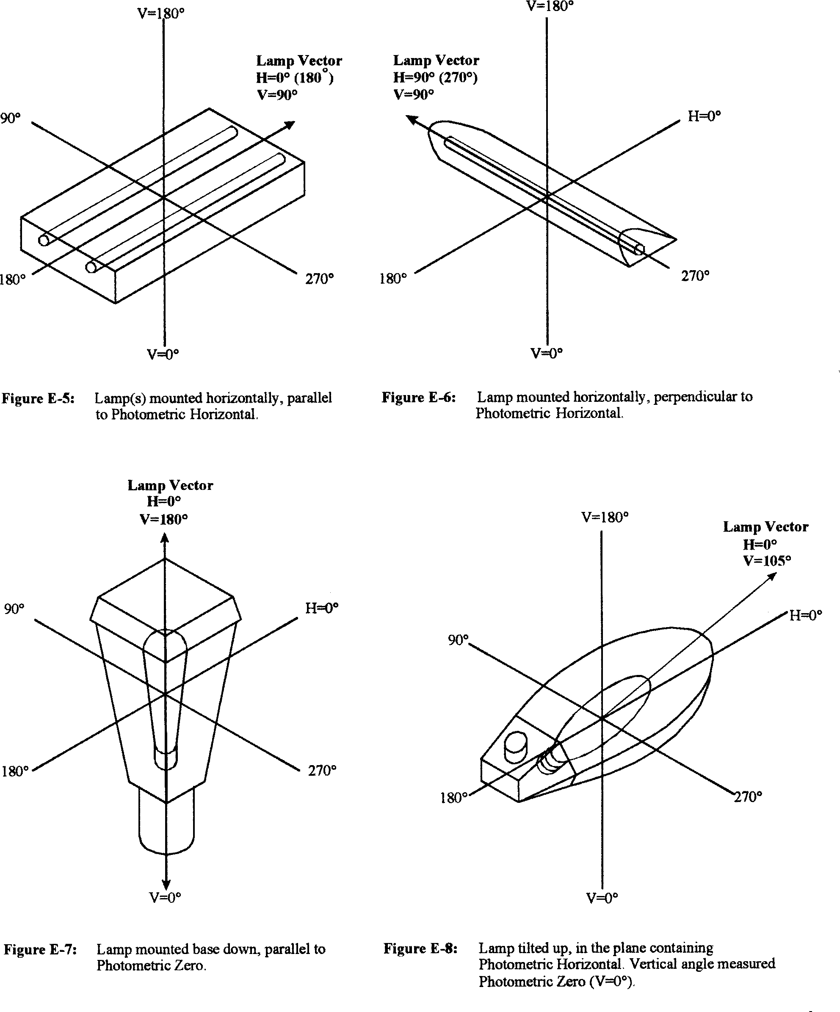

Annex F- Format for TILT=<filename> or INCLUDE
The format for tilt information is the same whether it is in a separate file or included as part of the photometric file. Each of the items listed in the format are described in the sections below. Each line shall begin a new line in the file. Note: The tilt data are real values except: <lamp to luminaire geometry> and
<number of tilt angles>, which are integer values (exponential notation is not allowed).
- <lamp to luminaire geometry>
- <number of tilt angles>
- <angles>
- <multiplying factors>

<lamp to luminaire geometry>

This indicates the orientation of the lamp within the luminaire, and shall be the value l, 2, or 3, according to the following schedule (see Figure F-1).

- When the luminaire is aimed straight down, the lamp is either vertical base up or vertical base down.
- When the luminaire is aimed straight down, the lamp is horizontal. The lamp remains horizontal when the luminaire is tilted up in the 0 degree horizontal plane.
- When the luminaire is aimed straight down, the lamp is horizontal. When the luminaire is tilted in the 0 degree horizontal plane, the lamp tends to a base up or base down condition as a result of the luminaire tilt.
  - NOTE: If a [LAMPPOSITION] keyword is specified, it should be considered to supersede the <lamp to luminaire geometry> specification (see Annex E).

<Number of tilt angles>
This field shall contain a number indicating the total number of pairs of angles and corresponding multi- plying factors.

<angles>

The angles shall be listed in increasing order, and shall go from 0 to 90 degrees or from 0 to 180 degrees, inclusive.

<multiplying factors>

The multiplying factors shall be listed in order corre- sponding with the angles given in the line above.

Examples

The following is an example of including the tilt infor- mation in the photometric file.

TILT=INCLUDE
1
7
0 15 30 45 60 75 90
1.0.95.94.90.88.87.94

The following is an example of including the tilt infor- mation in an external file.

TILT =ExampleTiltFile. TLT

ExampleTiltFile.TLT would be an ASCII text file con- taining the following four lines:
1
7
0 15 30 45 60 75 90
1.0 .95 .94 .90 .88 .87 .94

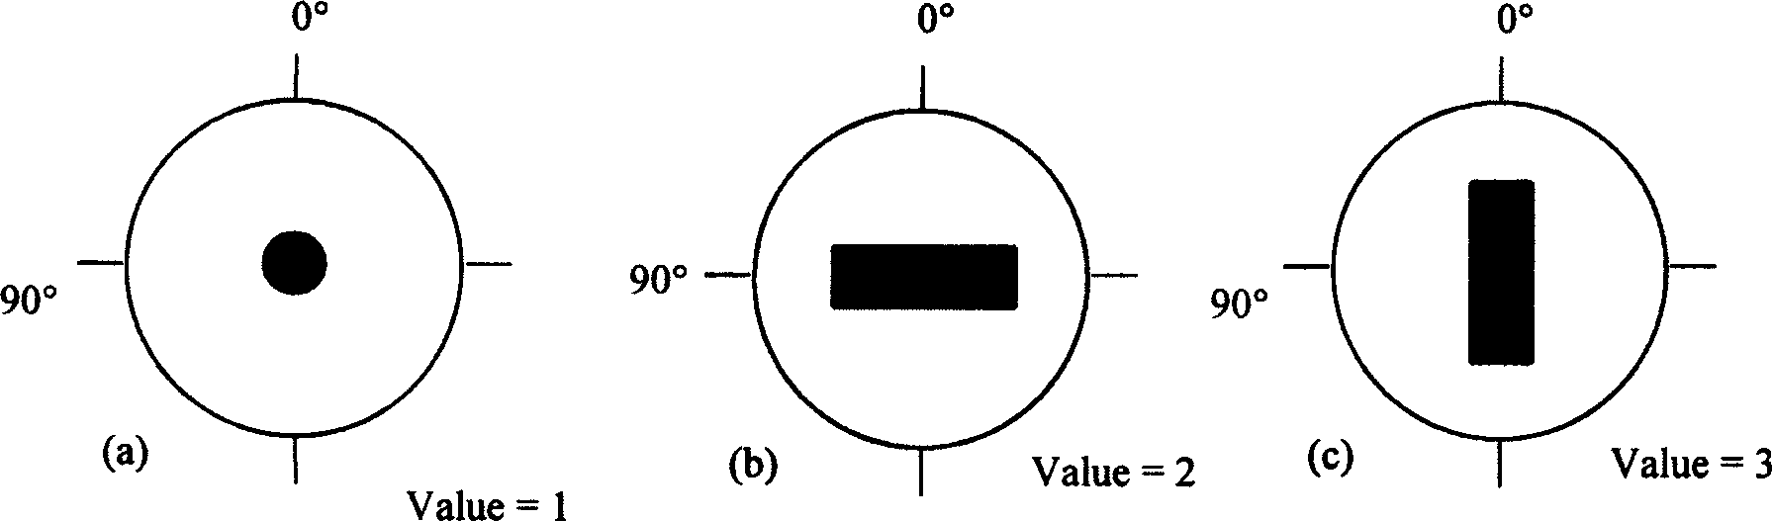

Figure F-1. Plan view of lamp to luminaire geometry when luminaire tilt information is included using the TILT=INCLUDE or TILT=<filename> options. Labeled angles are horizontal angles. The lamps are; (a) vertical base down, (b) horizontal along the 90 degree plane, and (c) horizontal along the 0 degree plane.

Annex G -Use of Shall, Should, May, and Can
The following terms are used throughout this docu- ment. The use of these terms is based on the follow- ing IESNA descriptions:
- Shall - Used to convey a strict requirement, from which the reader/user may not deviate in order to be considered in conformance with the publication.

- Should - Used to convey a recommendation.
- May - Used to show that the publication is giving the reader/user permission to follow a certain course of action.

- Can - Used to convey possibility or capability, whether material, physical, or casual.
The negative forms of these verbs (shall not, should not, may not, and cannot) carry equal weight and meaning as the positive forms just listed.

