INTERNSHIP PROJECT REPORT
UNIGATEWAY
Unified API Gateway & Health Monitoring System
Technical Project Report | October 2026
Backend Monitoring • Real-Time Analytics • Alert Management
Github link : https://github.com/gensine/Unigateway
SUBMITTED BY  Vaishnavi Mishra  B. Tech in Computer Science & Engineering  Specialization in Blockchain Technology  Department of Data Science and Business Systems  SRM Institute of Science and Technology | ORGANIZATION  Sopra Steria  Mentor: Debdeep Dutta
INTERNSHIP PERIOD
19 July – 15 October 2026

Acknowledgement
I am thankful to Sopra Steria for giving me the chance to work on a real project during my internship. Building something that is actually meant to be used taught me far more than a classroom exercise would have.
My sincere thanks go to my mentor, Mr. Debdeep Dutta. He reviewed my work regularly, questioned my design choices when they needed questioning, and gave feedback that made the final system better than my first version.
I also thank the faculty of the Department of Data Science and Business Systems at SRM Institute of Science and Technology for the foundation that made this internship possible, and the department and university for supporting internships as part of the programme.
Working in a professional setting showed me that planning, documentation and clear communication matter as much as the code itself. Finally, I thank my family and friends for their patience and encouragement throughout these three months.
Vaishnavi Mishra

Abstract
Most applications today depend on several smaller services, and when one of them slows down or stops, the whole product suffers. During my internship I built Unigateway, a self-hosted tool that watches the health of such services, records how they behave over time and tells the team when something is wrong.
The backend is written in FastAPI. APScheduler and httpx check each registered service at its own interval, and every result is stored in SQLite running in WAL mode. A check is marked healthy, degraded or down depending on the HTTP response and on the SLA latency limit set for that service. A small rule engine watches the stored results for downtime, slow responses and high error rates, and sends alerts through Slack or email. The React frontend shows all of this on a live dashboard that updates through WebSockets, with latency charts, uptime, p95 latency, SLA compliance and incident history.
Some design decisions are worth mentioning. Services are deactivated instead of deleted, so their history is never lost. An incident raises only one alert however long it lasts. The dashboard reconnects on its own if the connection drops. The main logic is covered by pytest tests, and the whole application can be started locally or with Docker Compose and Nginx.
This report describes the requirements, design, implementation, deployment, testing and results of the project, along with its limitations and the improvements I would make next.

Table of Contents
Acknowledgement 2
Abstract 3
List of Figures and Tables 6
1. Introduction 7
1.1 Background and Motivation 7
1.2 Problem Statement 7
1.3 Objectives and Scope 7
2. Literature Survey 9
2.1 Existing Monitoring Tools 9
2.2 Gaps in Existing Solutions 9
2.3 Proposed Solution: Unigateway 9
3. Requirements Analysis 11
3.1 Functional Requirements 11
3.2 Non-Functional Requirements 11
3.3 Software Requirements 12
4. Technology Stack 14
5. System Architecture and Design 16
5.1 Overall Architecture 16
5.2 Data Flow and Real-Time Update Mechanism 16
5.3 Database Schema 17
5.4 Use Case Diagram 17
5.5 Sequence Diagrams 18
6. Implementation 19
6.1 Backend 19
6.2 Frontend 21
7. Deployment and Usage 23
7.1 Running Locally 23
7.2 Running with Docker 23
7.3 Configuration (Environment Variables) 24
7.4 Using the Application 25
8. Testing and Results 26
8.1 Unit Tests 26
8.2 Functional Test Scenarios 26
8.3 Application Screenshots 27
8.4 Observations 28
9. Conclusion and Future Scope 29
9.1 Conclusion 29
9.2 Limitations 29
9.3 Future Scope 29
10. References 30
Appendix A: API Endpoint Reference 31
Appendix B: Project Directory Structure 32
Appendix C: WebSocket Message Formats 32

List of Figures and Tables
List of Figures
Figure 5.1 Overall system architecture
Figure 5.2 Backend and WebSocket interaction flow
Figure 5.3 Entity relationship diagram
Figure 5.4 Use case diagram
Figure 5.5 Health check and alerting flowchart
Figure 5.6 Component interaction sequence
Figure 6.1 Service health status state diagram
Figure 6.2 Slack alert and recovery notification
Figure 6.3 FastAPI Swagger documentation
Figure 7.1 Application launch using run.ps1
Figure 7.2 Docker deployment architecture
Figure 7.3 Docker Desktop container stack
Figure 8.1 Automated test execution
Figure 8.2 Dashboard
Figure 8.3 Service Registry
Figure 8.4 Service Detail and latency chart
Figure 8.5 Alerts and incident history

List of Tables
Table 2.1 Comparison of existing monitoring tools
Table 3.1 Software requirements
Table 4.1 Technology stack
Table 5.1 Database tables
Table 6.1 Backend modules and responsibilities
Table 6.2 Status classification rules
Table 6.3 Alert conditions
Table 7.1 Backend configuration settings
Table 8.1 Unit test cases and results
Table 8.2 Functional test scenarios
Table A.1 API endpoint reference
Table C.1 WebSocket message types

1. Introduction

1.1 Background and Motivation
Applications are rarely a single program any more. A typical product uses separate services for login, payments, data and notifications, and these talk to each other over HTTP. If one of them becomes slow or stops responding, users feel it at once, even when the main application is still running.
Checking every endpoint by hand stops being practical once the number of services grows. Large commercial monitoring suites solve the problem, but they are often costly and complicated for a small team. I wanted to build something simpler that a team could host on its own and understand completely.
Teams also work with Service Level Agreements (SLAs), which say how fast and how available a service must be. One manual check cannot show whether an SLA is being met. It needs continuous measurement, saved history and a quick warning when the agreed limits are crossed, and Unigateway is built around exactly that.

1.2 Problem Statement
The task was to build a self-hosted system that automatically checks several HTTP services, compares their response times with SLA limits, keeps a history of the results, alerts the team when something goes wrong and shows everything on one live dashboard.
Doing this manually has clear drawbacks. Problems are noticed late, often after users complain. Nothing is stored, so uptime and latency trends cannot be measured. A slow service looks the same as a failed one, there is no single place to see all services together, and alerts depend on someone remembering to look.

1.3 Objectives and Scope

Objectives
The project set out to achieve the following:
- Register and manage services, each with its own polling interval and SLA threshold.
- Poll services automatically in the background and store every result.
- Classify each service as healthy, degraded or down.
- Calculate uptime, latency percentiles, SLA compliance and error rate.
- Raise and resolve alerts through Slack and email using configurable rules.
- Show live status on a dashboard without refreshing the page.
- Make deployment easy, both locally and with Docker.
- Keep the code modular, documented and covered by automated tests.

Scope
The project covers monitoring of HTTP and HTTPS health endpoints, with settings for interval, SLA threshold, owner team and environment. It stores the check history, calculates the metrics above, supports rule-based alerts with Slack and email, and provides a live dashboard with filters and a detail page for each service. It can be run locally or in Docker.
Some things were deliberately left out: distributed tracing, log analysis, protocols other than HTTP, user login with role-based access, and automatic archiving of old records. These are listed again under future scope.
Unigateway is meant for development and operations teams, small organisations and student teams that run several APIs and want clear visibility without setting up a large monitoring stack. By the end of the internship the goal was a working, tested and documented application that starts with a single command.

2. Literature Survey

2.1 Existing Monitoring Tools
Before designing Unigateway I looked at the tools teams commonly use for monitoring. Table 2.1 summarises what each one does well and where it falls short for a small team.
Table 2.1: Comparison of existing monitoring tools
Tool | Strengths | Limitations
Prometheus + Grafana | Powerful metrics collection and dashboards; large ecosystem | Needs several components, exporters and query-language knowledge
Uptime Kuma | Simple self-hosted uptime monitor with a friendly UI | No SLA-based degraded state or per-team ownership model
Datadog / New Relic | Full observability platform with APM and alerting | Paid, hosted by a third party, heavy for small teams
UptimeRobot / Pingdom | Easy external uptime checks | Limited customisation, external dependency, cost for short intervals

2.2 Gaps in Existing Solutions
Full observability stacks such as Prometheus with Grafana are far more than a team needs just to know whether its services are up and fast enough. Simple uptime monitors are easy to set up but usually report only up or down, with no way to say that a service is reachable yet too slow for its SLA.
Hosted tools add recurring cost and keep the monitoring data outside the organisation. I found very few lightweight options that combine live updates, a separate SLA limit for each service, team and environment tags and configurable alert rules in one place.

2.3 Proposed Solution: Unigateway
Unigateway tries to fill that gap. It keeps the stack small, with FastAPI, SQLite and React, and adds a degraded state based on the SLA threshold of each service. Services carry team and environment tags, updates reach the browser through WebSockets, and alerts follow rules that the user defines, with notifications going to Slack or email.
Each service has its own polling interval and SLA limit, so a payment API can be checked more often and more strictly than an internal tool. The three states (healthy, degraded and down) say more than a plain up or down. An alert fires only after a chosen number of failures in a row, which cuts down false alarms, and it closes by itself once the service recovers. Every check is stored, which makes uptime, SLA compliance, error rate and latency percentiles possible.
Compared with the tools in Table 2.1, Unigateway has fewer moving parts than Prometheus and Grafana, because one backend, one database file and one frontend are enough to start. It gives more detail than a basic uptime monitor, and it has no licence cost or third-party hosting. The codebase is also small enough for a student or small team to read and extend. It does not try to replace full observability platforms; it covers the common need of knowing quickly whether services are up, fast enough and being looked after.

3. Requirements Analysis

3.1 Functional Requirements

Service Registration and Management
- Add, view, edit and deactivate services.
- Store name, base URL, health path, polling interval, SLA threshold, owner team and environment.

Health Polling and Status Classification
- Poll each active service at its own interval.
- Classify every check as healthy, degraded or down and store it with latency and error details.

Metrics, SLA Tracking and Analytics
- Show uptime, SLA compliance and error rate over selectable periods.
- Show latency trend and p50, p95 and p99 percentiles per service.

Alert Rules and Incident Management
- Create, update and disable rules for downtime, latency threshold and error rate.
- Open an incident when a rule fires and resolve it automatically on recovery; keep incident history.

Notifications
- Send alerts and recovery messages through Slack, email or both.

Real-Time Dashboard and Filtering
- Update service status and raise alert notices live through WebSockets.
- Filter services by environment and owner team.

3.2 Non-Functional Requirements

Performance and Responsiveness
- Non-blocking polling so slow services do not delay others.
- Dashboard updates appear without manual refresh.

Reliability and Fault Tolerance
- Timeouts and connection errors are recorded as failed checks, not crashes.
- Polling jobs persist across restarts; the frontend reconnects automatically if the WebSocket drops.

Scalability and Portability
- Each service has an independent job, so more services can be added easily.
- Runs on Windows, Linux and macOS, locally or with Docker.

Security
- Inputs validated with Pydantic; CORS limited to the frontend origin.
- Slack and SMTP secrets kept in environment variables, not in code.

Usability and Maintainability
- Clear dashboard with colour-coded status and simple forms.
- Modular code (routers, scheduler, alerting, WebSocket manager) with automatic API documentation.

3.3 Software Requirements
The project needs only common, free software. No separate database server is required because SQLite is built into Python.
Table 3.1: Software requirements
Category | Requirement
Operating system | Windows 10/11, Linux or macOS
Backend runtime | Python 3.10 or higher (Python 3.12 is used in the Docker image) with pip
Backend libraries | FastAPI, Uvicorn, SQLAlchemy, APScheduler, httpx, Pydantic, python-dotenv, pytest
Frontend runtime | Node.js 18 or higher with npm
Frontend libraries | React, Vite, React Router, Recharts, Axios, dayjs
Database | SQLite (included with Python, no installation needed)
Containerisation (optional) | Docker and Docker Compose
Browser | Any modern browser such as Chrome, Edge or Firefox
Development tools | VS Code or any editor, Git, PowerShell (for the Windows launcher)

A few points about these requirements:
- The same code runs on all three operating systems; only the virtual environment activation command differs.
- Docker is optional. It is useful when the application must run in the same way on any machine or on a server.
- Internet access is needed only to reach the monitored service URLs and, if enabled, Slack or an SMTP server.
- Python libraries are installed from requirements.txt and frontend packages from package.json, so no manual installation of individual packages is needed.

4. Technology Stack
I chose technologies that keep the system asynchronous, light and easy to deploy. Python suited the backend because of its strong ecosystem for web APIs, and React suited the frontend because of its component model and large community.
Table 4.1: Technology stack
Layer | Technology | Purpose
Backend framework | FastAPI, Uvicorn (Python) | REST APIs, WebSocket endpoint, async runtime
Scheduling | APScheduler (AsyncIOScheduler, SQLAlchemy job store) | Per-service recurring polling jobs
HTTP client | httpx | Async health requests with timeout
Database | SQLite (WAL mode), SQLAlchemy 2.0 | Persistence of services, checks, rules, events
Validation | Pydantic v2 | Request and response schemas
Real-time | WebSockets (Starlette / FastAPI) | Live push of status and alerts
Notifications | Slack webhooks, smtplib (SMTP) | Alert delivery
Frontend | React, Vite, React Router | Single-page application
Charts and HTTP | Recharts, Axios, dayjs | Latency graphs, API calls, time formatting
Deployment | Docker, Docker Compose, Nginx (Alpine) | Containerised build; static serving and reverse proxy
Testing and tooling | pytest, oxlint, PowerShell script | Unit tests, linting, one-click local launch

FastAPI was the main reason the backend stayed simple. It is fully asynchronous, supports WebSockets out of the box and produces interactive API documentation automatically. httpx fits well with it, since many services can be checked at once without one slow response holding up the rest. APScheduler runs the recurring jobs inside the same process, and because its job store lives in the database, the schedule survives a restart.
SQLite needs no separate server, and its write-ahead logging mode lets the dashboard read data while the poller is writing. SQLAlchemy and Pydantic handle the data layer and input validation with very little extra code. On the frontend, Vite gives fast builds and Recharts provides responsive charts without much setup. WebSockets were preferred over repeated polling from the browser because they deliver changes the moment they happen, and Docker with Nginx makes the same build run the same way on any machine.

5. System Architecture and Design

5.1 Overall Architecture
Unigateway has three cooperating parts: a background monitoring engine, a FastAPI service layer and a React frontend. APScheduler polls the monitored services and saves each result to SQLite. The alerting engine then checks the result against the active rules, and the WebSocket manager pushes the update to every connected browser. The FastAPI routers expose services, metrics and alerts to the frontend through REST.
Seen as layers, the monitored services sit at the bottom, and the monitoring engine (APScheduler and httpx) polls them. Above that, the alerting engine and WebSocket manager act on every result, while SQLite and the FastAPI routers handle storage and the API. The React frontend forms the top layer, and Slack and SMTP carry notifications out to the team.
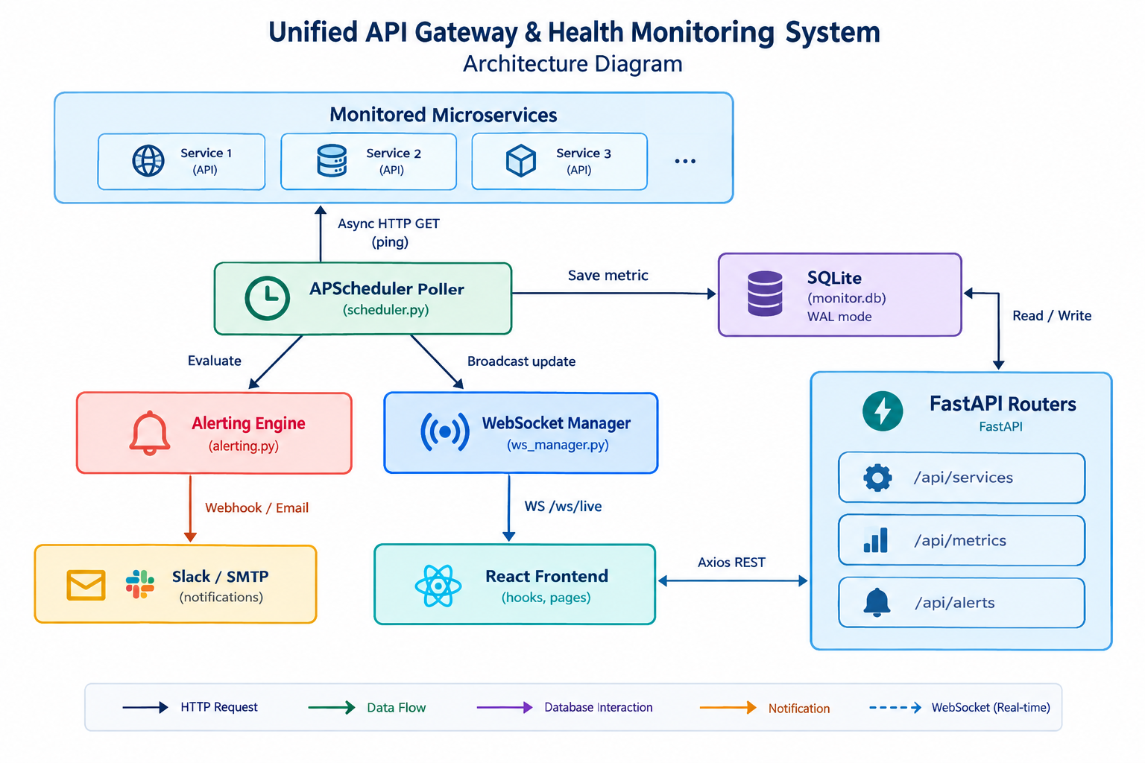
Figure 5.1: Overall system architecture
In the diagram the scheduler is the central component. It writes each metric to the database, passes the result to the alerting engine and gives the WebSocket manager the update to broadcast. Because monitoring runs separately from user requests, the dashboard stays fast and the checks carry on even when nobody has the page open.
The parts talk to each other in different ways. The poller sends asynchronous HTTP GET requests with a timeout to the services. Inside the backend, the scheduler, alerting engine and WebSocket manager call each other directly. The frontend uses REST calls through Axios for configuration, history and metrics, and receives live status and alerts over a WebSocket. Notifications leave the system through a Slack webhook or SMTP.
Several principles guided the design. Checks run asynchronously so they never block each other or the API. Each module has a single responsibility and can be changed on its own. Results and scheduled jobs are kept in the database and survive a restart. The browser is told about changes instead of asking for them, and a failing service or a failed notification does not stop the rest of the system.

5.2 Data Flow and Real-Time Update Mechanism
One monitoring cycle runs in these steps:
- APScheduler triggers the job of an active service at its interval.
- httpx sends an asynchronous GET request to the health URL of the service with a 10-second timeout and measures the latency.
- The result is classified as healthy, degraded or down and saved in the health_checks table.
- The alerting engine evaluates the active rules and opens or resolves incidents.
- The WebSocket manager broadcasts a STATUS_UPDATE, and an ALERT when a rule fires, to all connected clients.
- The React hook receives the message, updates its state, and the dashboard refreshes instantly.
So the frontend relies on WebSockets for live status and on REST calls for history and aggregated metrics.
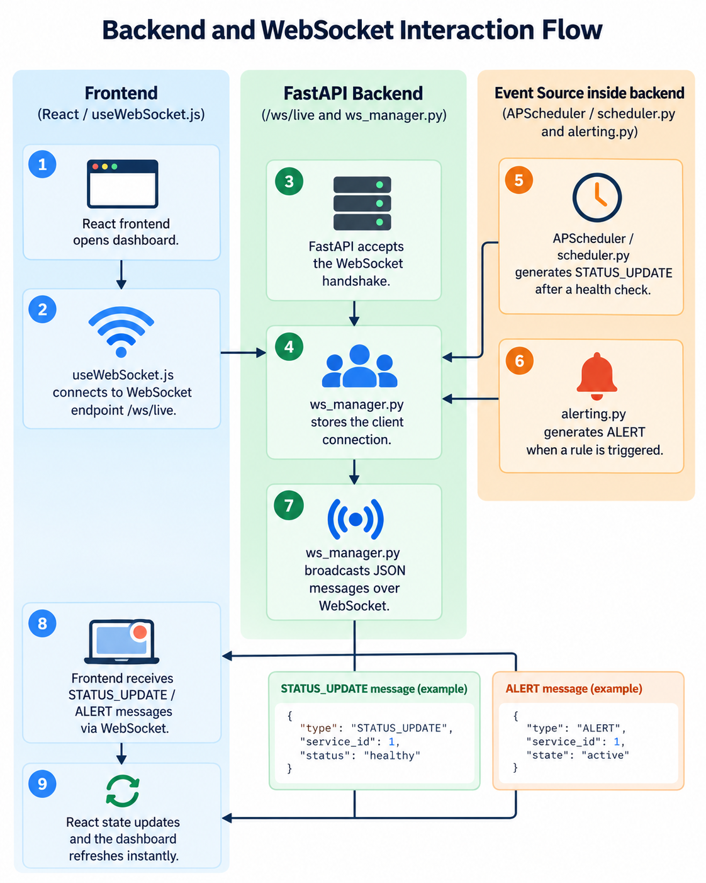
Figure 5.2: Backend and WebSocket interaction flow

5.3 Database Schema
The database has four tables linked by foreign keys. One service has many health checks and many alert rules, and one alert rule has many alert events.
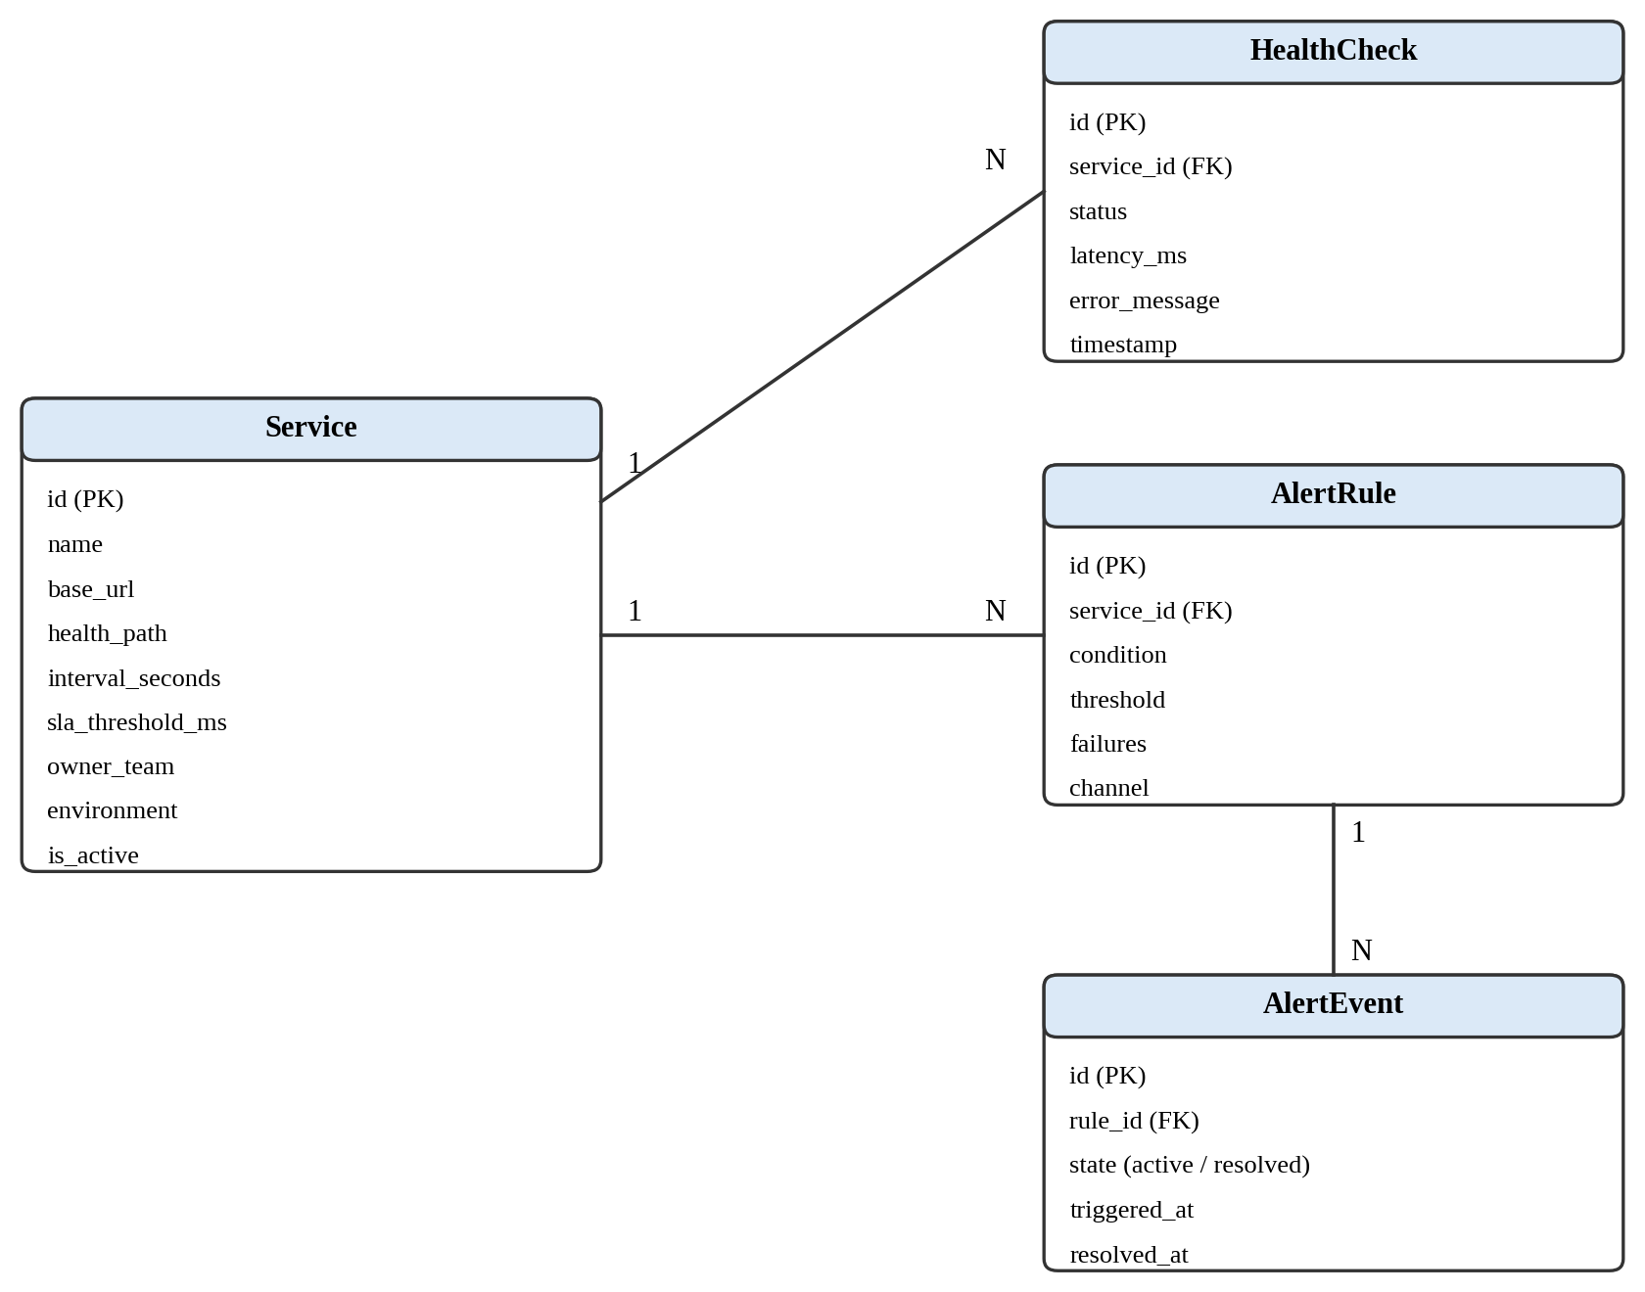
Figure 5.3: Entity relationship diagram

Table 5.1: Database tables

Table | Description
services | Name, base_url, health_path, interval_seconds, sla_threshold_ms, owner_team, environment, is_active, created_at
health_checks | One row per poll: service_id, timestamp (indexed), status, latency_ms (null if down), error_message
alert_rules | service_id, condition (downtime / latency_threshold / error_rate), threshold, failures, channel, is_active
alert_events | rule_id, triggered_at, resolved_at, status (active / resolved), details

SQLite runs in WAL mode with synchronous set to NORMAL, so the frequent writes from background polling do not block reads from the dashboard.

5.4 Use Case Diagram
The use case diagram shows who interacts with the system and for what. The user registers and edits services, filters and watches the live dashboard, studies latency and SLA metrics, and creates alert rules and reviews incidents. The scheduler works on its own: it polls services, stores each result, evaluates the rules and broadcasts updates. When a rule fires, the Slack and SMTP services receive the alert.
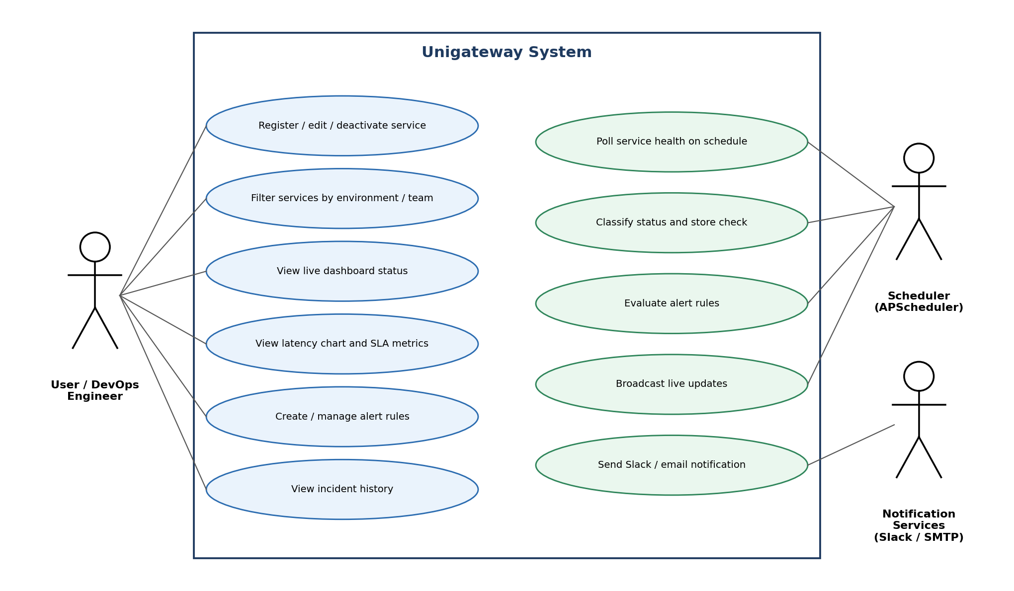
Figure 5.4: Use case diagram

5.5 Sequence Diagrams

Health Check Cycle
The flowchart below follows a registered service through polling, classification, storage and alert evaluation.
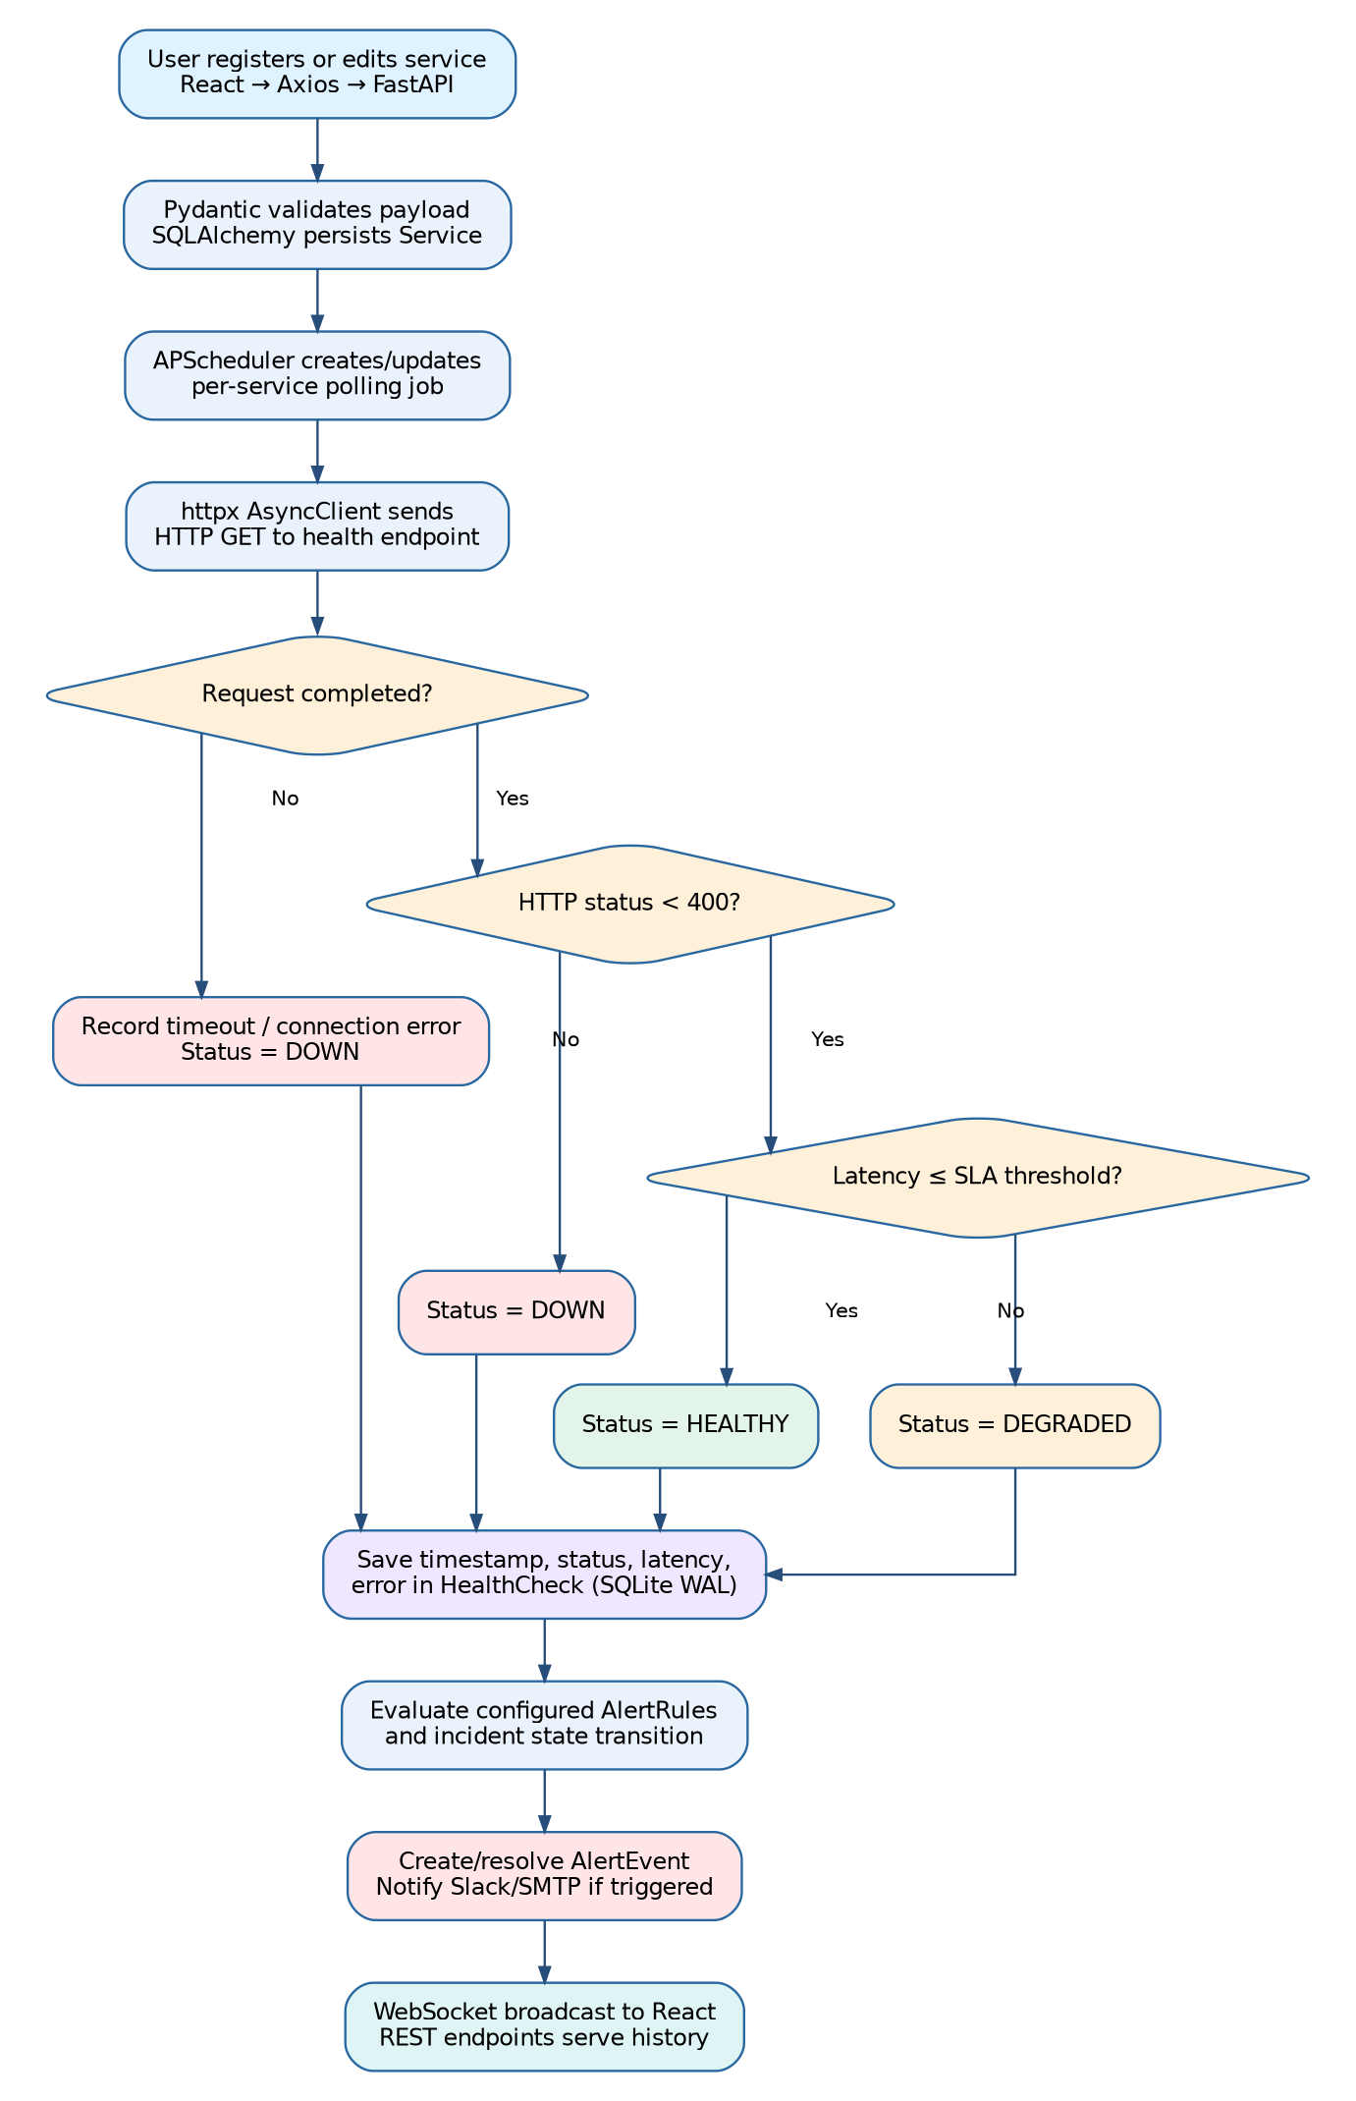
Figure 5.5: Health check and alerting flowchart

Alert Trigger and Resolution
When the last N checks (the failure count set in the rule) match the rule condition and no incident is open, a new alert event is created, an ALERT message is broadcast and the notification goes out. When later checks are healthy again, the open event is marked resolved and a recovery notification is sent. The overall interaction between the components is shown in Figure 5.6.
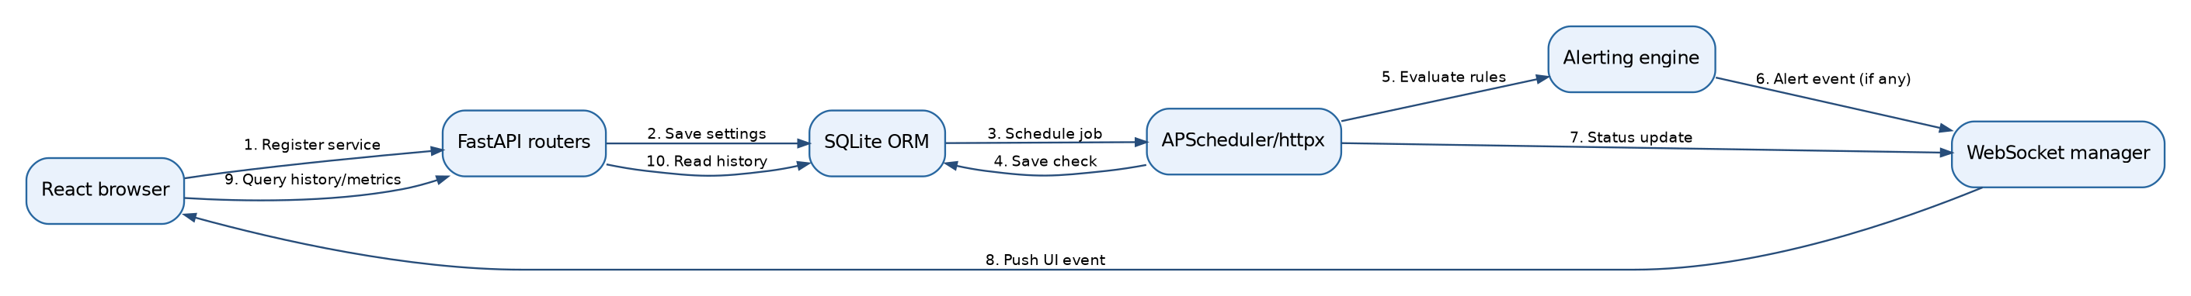
Figure 5.6: Component interaction sequence
The sequence has two parts. When the user registers a service (steps 1 to 3), the FastAPI router saves the settings through the ORM and the scheduler creates a polling job. At each interval (steps 4 to 8), the poller saves the check, the alerting engine evaluates the rules and the WebSocket manager pushes the update to the browser. Steps 9 and 10 show the browser reading history and metrics through the API.

6. Implementation
I split the project into a backend and a frontend, and divided each into small modules with one job each. That made the code easier to read, test and extend while I was building it.

6.1 Backend
Table 6.1: Backend modules and responsibilities
Module | Responsibility
main.py | Application entry point, lifespan, CORS, routers and WebSocket endpoint
database.py | SQLAlchemy engine, WAL settings and session provider
models.py / schemas.py | ORM models and Pydantic request/response schemas
scheduler.py | Polling jobs, status classification and uptime calculation
alerting.py | Rule evaluation, incident open/resolve and notification dispatch
ws_manager.py | WebSocket connection registry and broadcasting
routers/ | REST endpoints for services, metrics and alerts
test_unigateway.py | Automated unit tests

Application Lifecycle and Database Layer
main.py creates the tables at startup, starts the scheduler through a lifespan handler and stops it on shutdown. It also enables CORS for the frontend, registers the three routers and exposes the /ws/live WebSocket and a /health self-check. database.py creates the SQLAlchemy engine, applies the WAL settings on each connection and provides the get_db dependency, while models.py and schemas.py hold the ORM models and the Pydantic schemas.

Scheduler and Polling Engine
scheduler.py runs an AsyncIOScheduler with a SQLAlchemy job store, so the jobs survive a restart. At startup every active service gets a job named poll_<id>, and creating, updating or deactivating a service adds, reschedules or removes that job. The poll function sends the request, measures latency with a monotonic clock, classifies the result, saves it, calculates uptime, broadcasts the update and calls the alert evaluator. Timeouts and connection errors are caught and stored as failed checks, so one unreachable service never stops the monitoring of the others.
Table 6.2: Status classification rules
Status | Condition | Meaning
Healthy | HTTP status below 400 and latency within SLA | Service working normally
Degraded | HTTP status below 400 but latency above SLA | Service reachable but slow
Down | HTTP status 400 or above, timeout or connection error | Service failing

Figure 6.1 shows how a service moves between the three states. It can go from healthy straight to down when an error or timeout occurs, and after recovery it returns to healthy or degraded depending on whether the latency is within the SLA threshold.
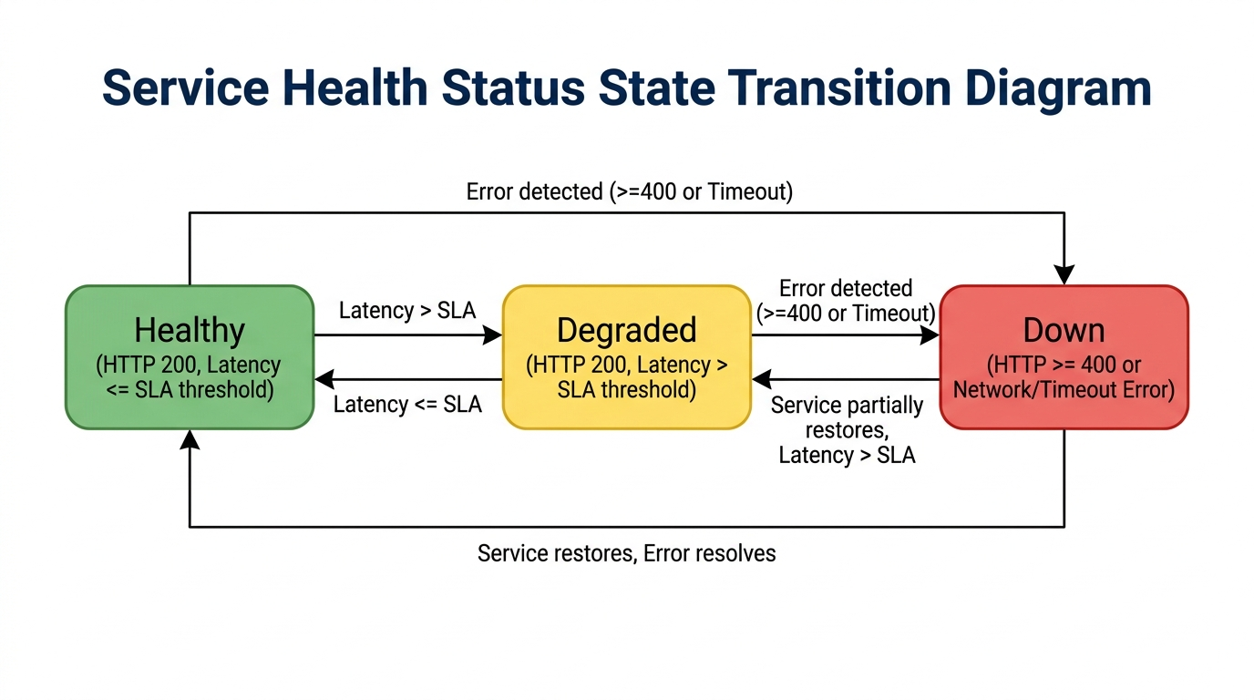
Figure 6.1: Service health status state transition diagram

Alerting Engine
alerting.py reads the active rules of a service and checks the most recent results against each one. If a rule is satisfied and no incident is open, it creates an alert event, broadcasts an ALERT message and sends the notifications. If the condition clears, it resolves the open event. Since a new event is created only when none is already open, the team is not flooded with repeated alerts during a long outage.
Table 6.3: Alert conditions
Condition | Fires when
downtime | The last N consecutive checks are all down
latency_threshold | The last N consecutive checks exceed the threshold in milliseconds
error_rate | The percentage of failed checks in the window exceeds the threshold

Slack messages are sent as JSON to a webhook URL, and emails go out over SMTP with TLS. When the credentials are not configured, the notification is only written to the log, so the system can be tested locally without any external account.
Figure 6.2 shows the Slack notifications. An alert is posted when a rule fires, and a green recovery message follows when the service is healthy again.
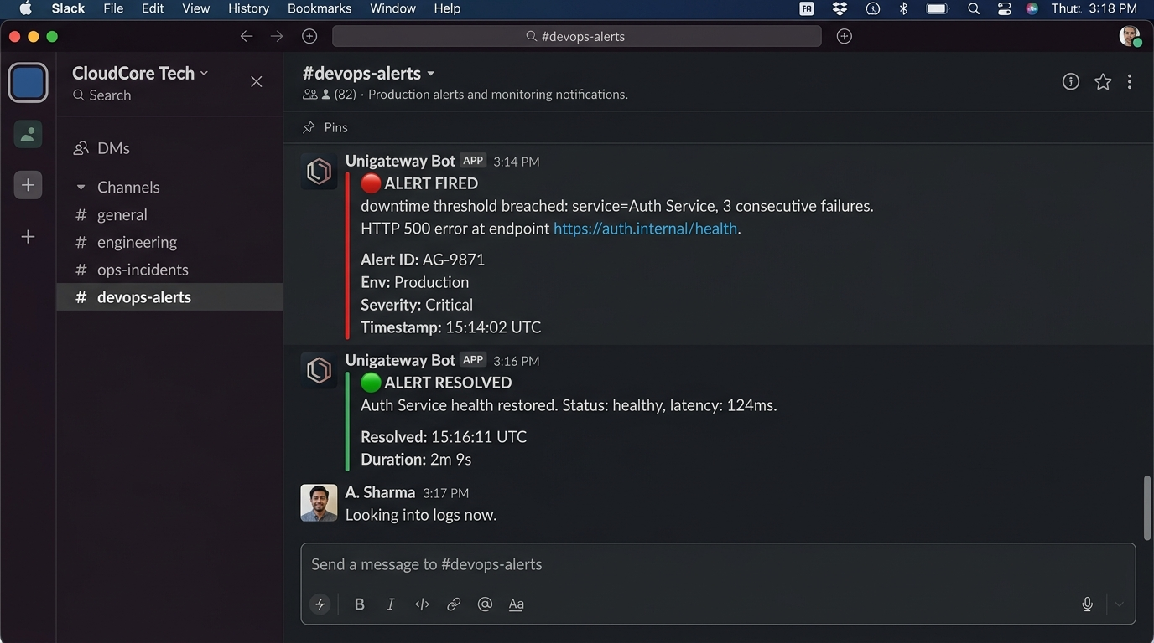
Figure 6.2: Slack incident alert and recovery notification

WebSocket Broadcasting
ws_manager.py keeps the list of connected clients, accepts and removes connections and broadcasts JSON messages to all of them. Clients whose connection has closed are dropped automatically.

REST API Design
Three routers make up the API. The services router handles creation, listing with environment and team filters, updates and soft delete, where is_active is set to false so that the history is preserved. The metrics router returns summary statistics, time-series data and percentiles for the 1h, 6h, 24h and 7d ranges. The alerts router manages rules and lists incident events. The full list is in Appendix A, and FastAPI generates interactive documentation for it automatically.
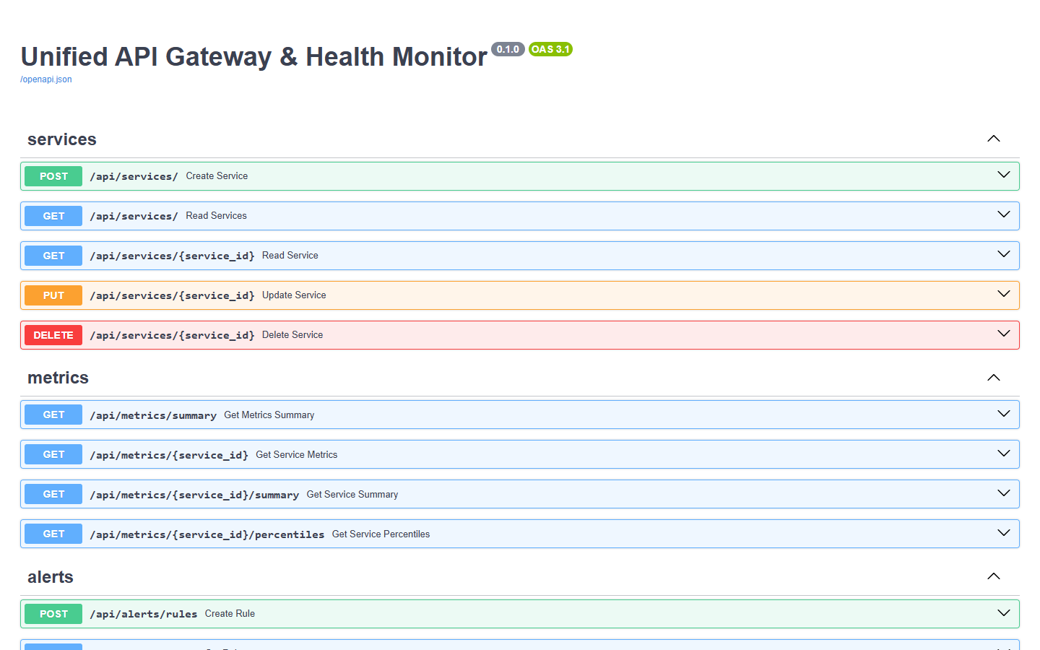
Figure 6.3: FastAPI Swagger documentation

6.2 Frontend

Routing and API Layer
The frontend is a single-page application with four routes: the dashboard (/), the service registry (/registry), alerts (/alerts) and the service detail page (/service/:id). A shared Axios instance with the base path /api is wrapped by small modules for services, metrics and alerts.

Real-Time Updates with WebSocket Reconnection
The useWebSocket hook connects to /ws/live and passes incoming messages to the pages. If the connection closes, it retries with exponential backoff (1s, 2s, 4s and so on, up to 30s) and goes back to 1s after a successful connection. The socket is closed when the component unmounts, which avoids leaks.

Components and Pages
The dashboard shows a card for each service with its status, latency, uptime and last-checked time, together with filters, and it changes in place when a WebSocket message arrives. The service registry has the form for registering or editing a service and a table of active services with edit and deactivate actions. The detail page shows uptime, p95 latency, SLA compliance and error rate cards above a Recharts latency chart with an SLA reference line. The alerts page has the form for creating rules, the list of active rules and the incident history, and the bell icon in the navigation bar shows active alerts. StatusCard, UptimeBadge, FilterBar, LatencyChart and NavBar are the shared components behind these pages.

UI Design System
The interface uses plain CSS with a small set of design tokens, which keeps colours and spacing consistent on every page. It has a dark theme with a deep navy background, lighter card surfaces and high-contrast text, which suits a screen that is often left open for long periods.
Status colours mean the same thing everywhere: green for healthy, amber for degraded and red for down, whether on a card, a badge, a chart or an alert. The uptime badge is green at 99% or above, yellow at 95% or above and red below that. Cards sit on a responsive grid that adjusts to the screen width, live status changes are animated lightly, and pages show clear messages when there is no data yet or a service is down.

7. Deployment and Usage

7.1 Running Locally
You need Python 3.10 or higher, Node.js 18 or higher and npm. Before starting, copy backend/.env.example to backend/.env (see Section 7.3).
Backend:
- cd backend
- python -m venv venv, then activate it (venv\Scripts\activate on Windows, source venv/bin/activate on Linux or macOS)
- pip install -r requirements.txt
- uvicorn main:app --reload --port 8000
Frontend:
- cd frontend
- npm install
- npm run dev (opens at http://localhost:5173)
On Windows, running .\run.ps1 from the project root starts both servers together.
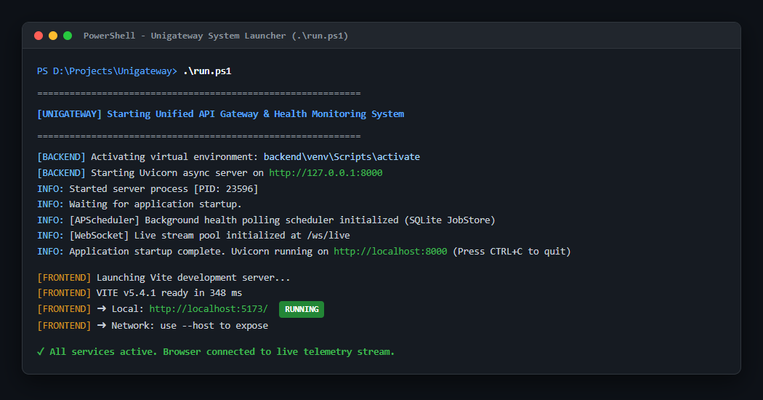
Figure 7.1: Application launch using run.ps1

7.2 Running with Docker
From the project root, run docker-compose up --build -d. The backend container runs Uvicorn on port 8000 and keeps its database in a mounted data folder. The frontend container builds the Vite app and serves it with Nginx on port 3000, and Nginx also forwards /api/ and /ws/ requests to the backend. The web application is then available at http://localhost:3000 and the Swagger documentation at http://localhost:8000/docs.
Figure 7.2 shows the deployment layout. The browser talks only to the frontend container, which serves the React build and passes API and WebSocket requests on to the backend. The backend stores its data in the SQLite database on a persistent volume, so nothing is lost when a container restarts.
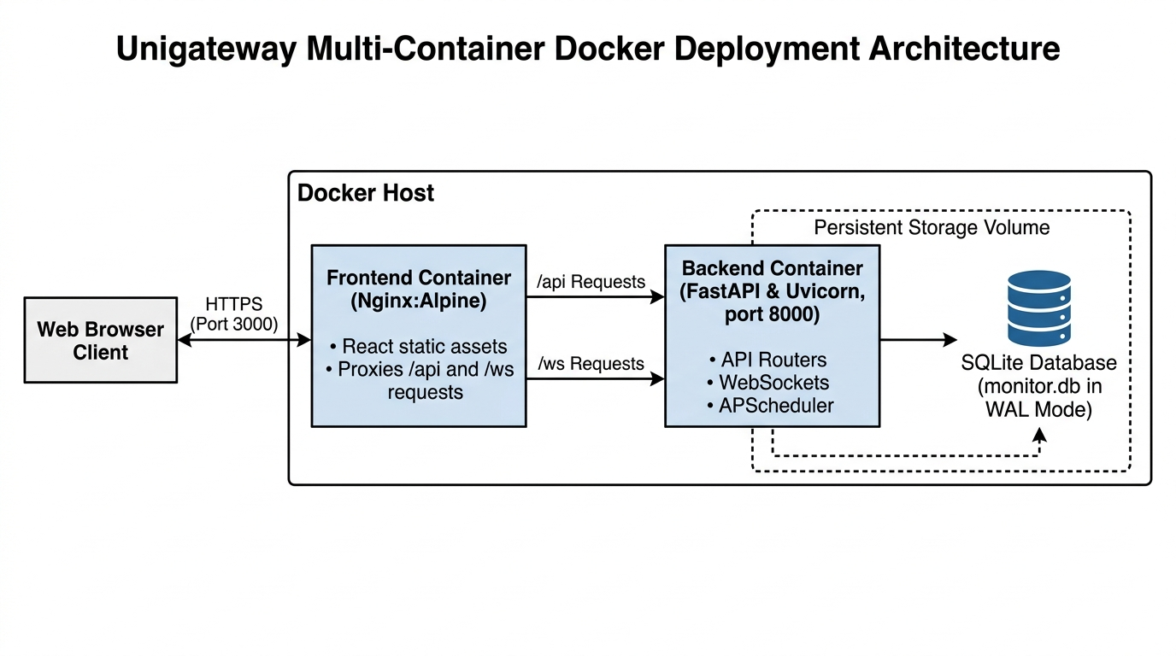
Figure 7.2: Multi-container Docker deployment architecture
Figure 7.3 shows both containers, unigateway-frontend on port 3000 and unigateway-backend on port 8000, running in Docker Desktop.
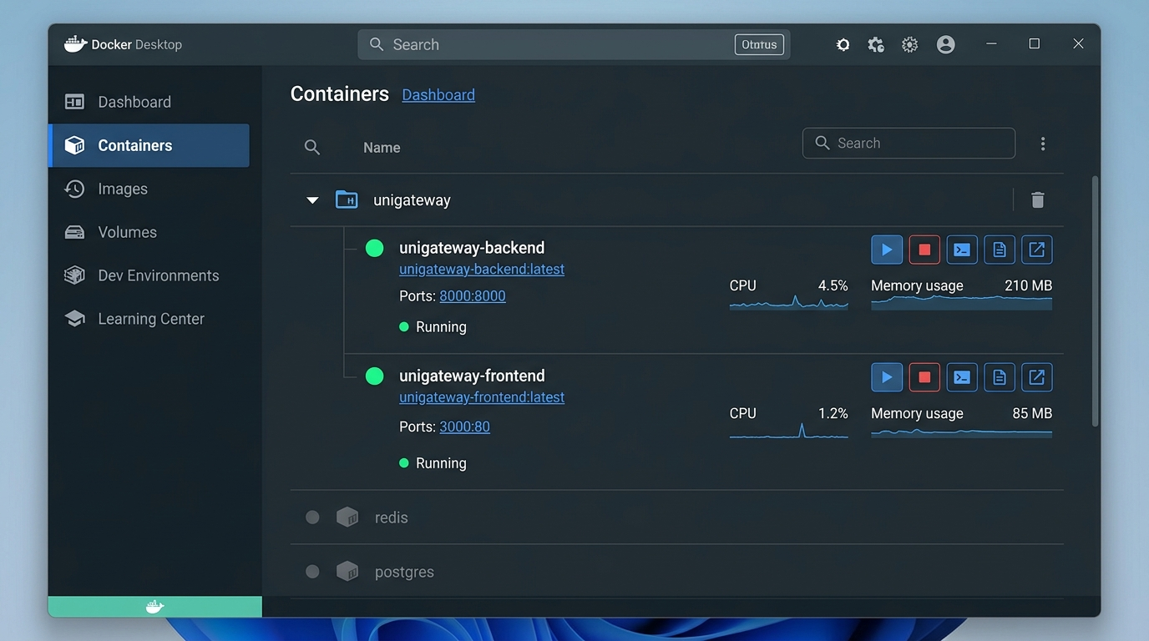
Figure 7.3: Docker Desktop showing the running container stack

7.3 Configuration (Environment Variables)
The backend reads its settings from backend/.env, which is created by copying backend/.env.example. Keeping the settings outside the code lets the same build run in development and production, and keeps secrets out of version control.
Table 7.1: Backend configuration settings
Variable | Purpose | Example value
DATABASE_URL | Location of the SQLite database file | sqlite:///./monitor.db
JWT_SECRET | Secret key for signing tokens (authentication is planned as future work) | your-secret-here
SLACK_WEBHOOK_URL | Incoming webhook used to post alert and recovery messages to Slack | https://hooks.slack.com/services/...
SMTP_HOST | Email server used to send alert emails | smtp.gmail.com
SMTP_PORT | Port of the email server (TLS) | 587
SMTP_USER | Username (sender address) for the email server | alerts@yourcompany.com
SMTP_PASS | Password for the email account | your email password
CORS_ORIGIN | Frontend address allowed to call the API | http://localhost:3000

The example values in .env should be replaced with your own Slack webhook and SMTP account details. If they are left unset, alerts are written to the log instead of being sent, so the system can still be tested without any external account. The .env file contains secrets and should never be committed to a repository or shared, and the backend must be restarted after the file is changed.

7.4 Using the Application
A typical first session goes like this:
- Open Service Registry and fill in the form: service name, base URL, health path (default /health), polling interval, SLA threshold, owner team and environment. Then click Register Service.
- Open the Dashboard. The new service appears as a card, and its status, latency and uptime update live as checks run.
- Use the environment and team filters to narrow the dashboard when many services are registered.
- Click a service card to open its detail page. Choose 1h, 6h or 24h to change the chart range, and read the uptime, p95 latency, SLA compliance and error rate cards.
- Open Alerts, choose a service, a condition (downtime, latency threshold or error rate), the number of failures before firing and a channel, and create the rule.
- When a rule fires, the bell icon in the navigation bar shows the alert, and the incident stays in the history until it resolves.
- To stop monitoring a service, deactivate it in the registry. Its earlier results are kept.
To try the system quickly, register a public test endpoint such as httpbin, which gives a healthy or failing service without setting up your own API. A very low SLA threshold will push a service into the degraded state, and a downtime rule with a small failure count lets you watch an alert open and then resolve. You can also open http://localhost:8000/docs to try every API endpoint from the browser.

8. Testing and Results
I tested the system at two levels. Unit tests check the core logic in isolation, and functional scenarios check the whole flow from a service check to the dashboard and the alert. The aim was to confirm that health is classified correctly, that alerts open and resolve at the right time and that the interface updates live.

8.1 Unit Tests
The unit tests are written with pytest and cover status classification, uptime calculation and the alert state transition. All five passed.
Table 8.1: Unit test cases and results
Test | Checks | Result
test_service_healthy_classification | HTTP 200 within SLA gives healthy | Passed
test_service_degraded_latency_breach | HTTP 200 above SLA gives degraded | Passed
test_service_down_on_http_error | HTTP 500 gives down | Passed
test_uptime_calculation | Uptime percentage from stored checks | Passed
test_alert_state_machine_transition | Alert opens on failure and resolves on recovery | Passed

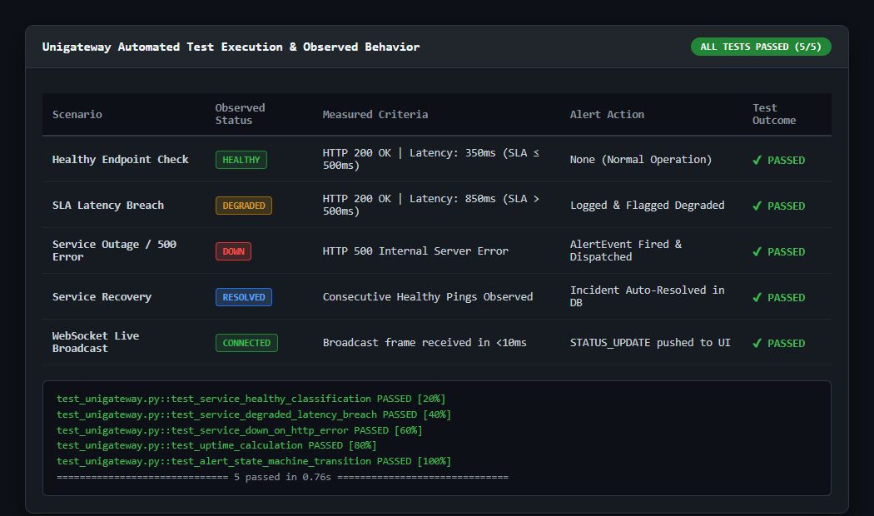
Figure 8.1: Automated test execution

8.2 Functional Test Scenarios
The scenarios in Table 8.2 were run against registered test services with an SLA threshold of 500 ms, and each produced the expected outcome.
Table 8.2: Functional test scenarios
Scenario | Condition | Status | Outcome
Healthy endpoint | HTTP 200, latency 350 ms | Healthy | No alert; normal operation
SLA latency breach | HTTP 200, latency 850 ms | Degraded | Logged and flagged
Service outage | HTTP 500 error | Down | Alert event fired and dispatched
Service recovery | Consecutive healthy checks | Healthy | Incident auto-resolved
Live broadcast | New check completed | Connected | STATUS_UPDATE pushed to the UI

8.3 Application Screenshots

Dashboard
The dashboard shows live service cards with status, latency and uptime, updated through WebSockets.
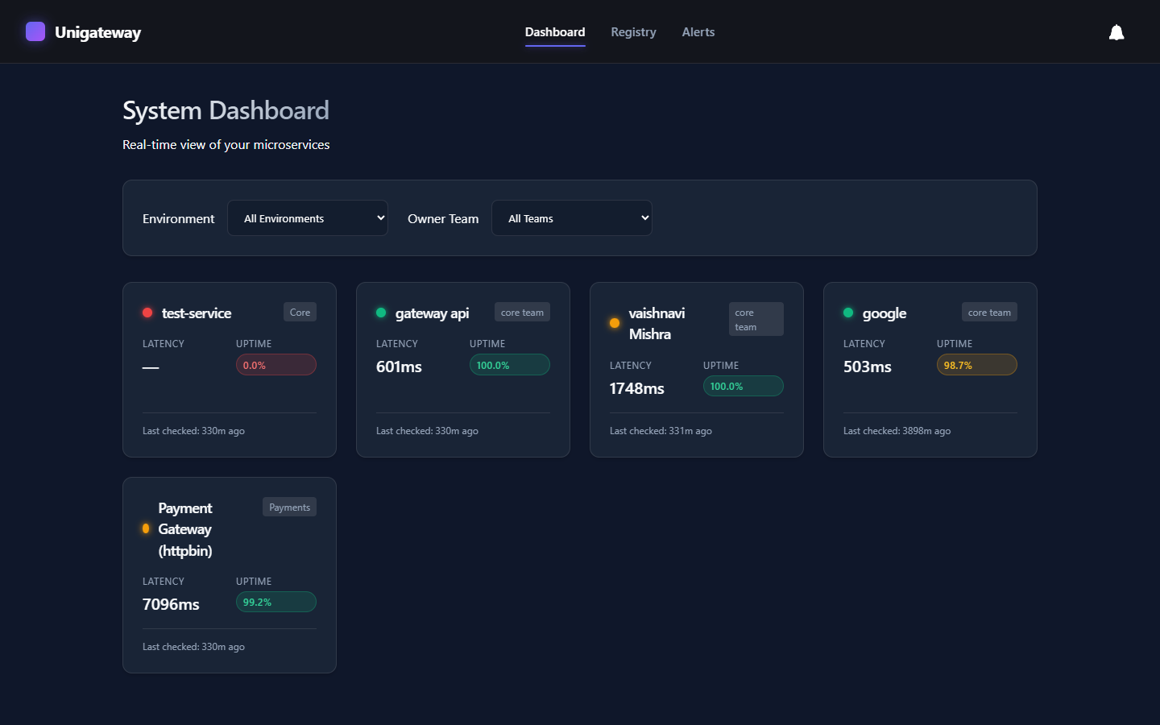
Figure 8.2: Dashboard

Service Registry
Services are registered and managed here, with filters for environment and team.
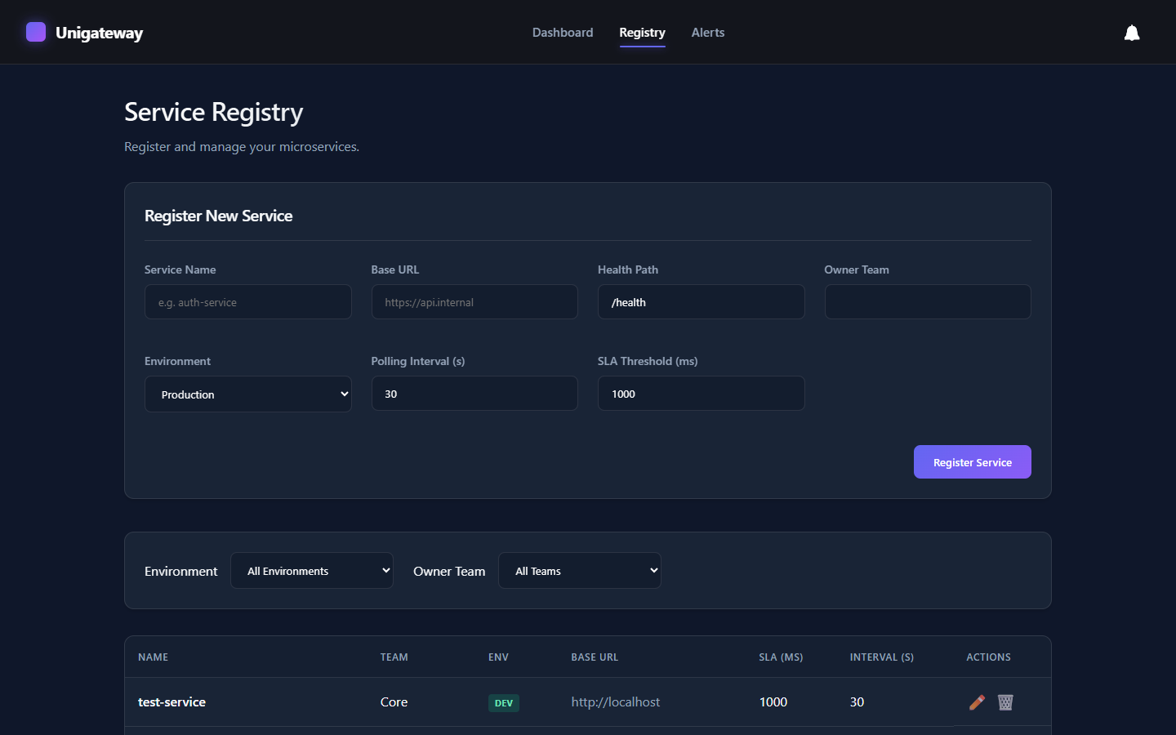
Figure 8.3: Service Registry

Service Detail and Latency Chart
The detail page shows the latency trend with the SLA reference line, along with uptime, p95 latency, SLA compliance and error rate.
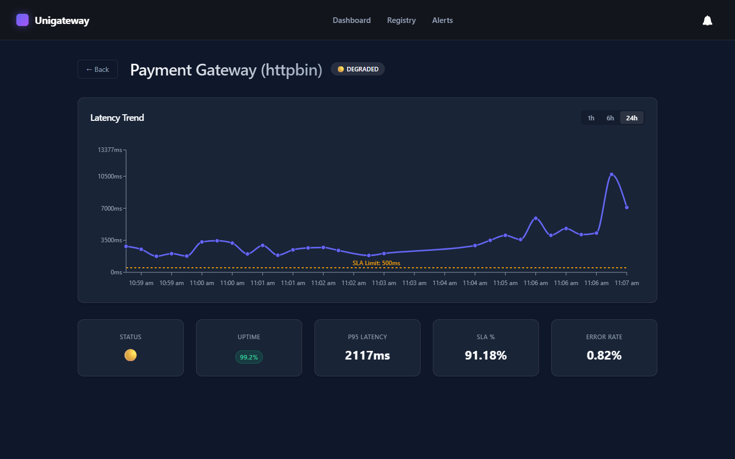
Figure 8.4: Service Detail and latency chart

Alerts and Incident History
Alert rules are created and managed here, and incidents appear in the history with their state.
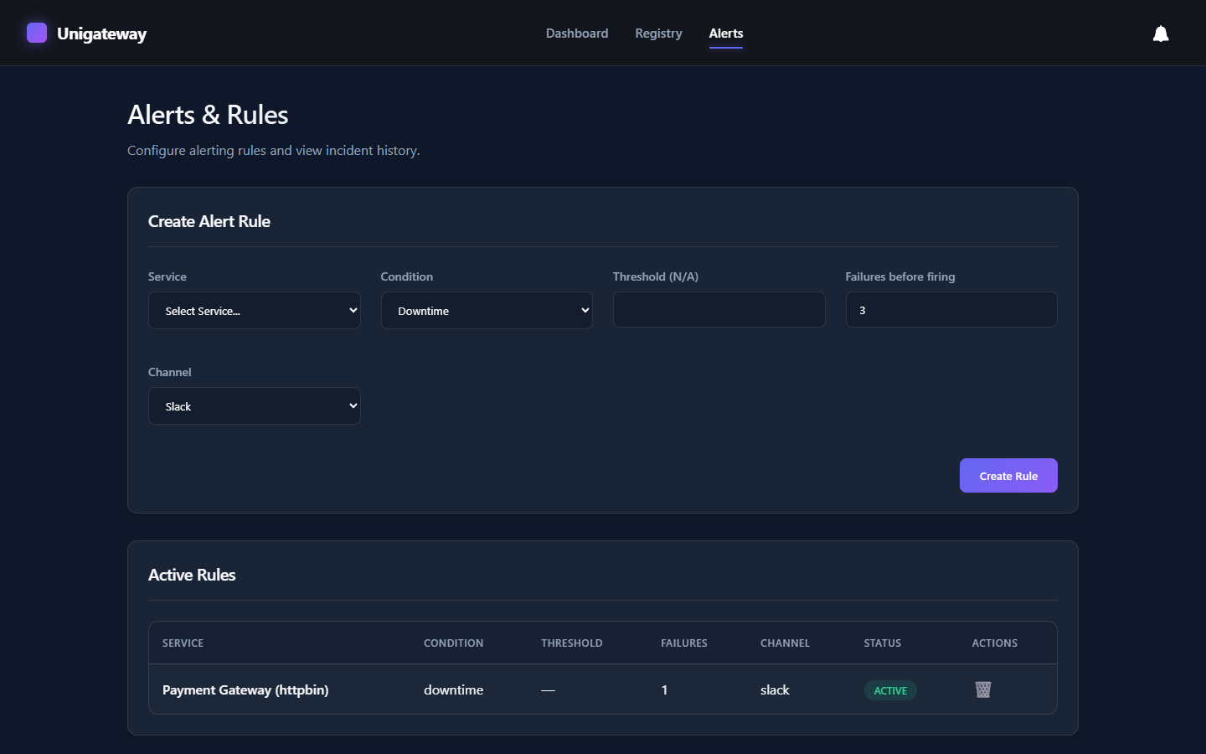
Figure 8.5: Alerts and incident history

8.4 Observations
All five unit tests passed, and in the functional scenarios the status followed the SLA threshold, while an outage produced an alert that resolved automatically on recovery. Live updates reached the dashboard through WebSockets without a page refresh. Failed checks are recorded instead of stopping the poller, so one unreachable service does not block the checks of the others, and the latency charts and metric cards gave a clear picture of how a service behaved over time.

9. Conclusion and Future Scope

9.1 Conclusion
Unigateway meets the objectives I set at the start. It polls services asynchronously, classifies their health against SLA thresholds, stores a history that can be analysed, raises and resolves alerts through Slack and email, and shows everything on a live dashboard. It was tested with automated unit tests and can be run locally or with Docker.
The internship gave me hands-on practice with asynchronous Python and FastAPI, background scheduling with APScheduler, database design and SQLite tuning, and building a responsive React interface with live data and charts. I also learned how to write unit tests, package an application with Docker, document a project and work through feedback from a mentor while delivering in stages.

9.2 Limitations
The application has no user login or role-based access yet. SQLite allows only one writer at a time, so a very large deployment would need a different database. Only HTTP and HTTPS endpoints are supported, and old health-check records are not archived, so the database keeps growing over time.

9.3 Future Scope
If I continued the project, these are the improvements I would make:
- User authentication with role-based access (JWT).
- PostgreSQL for larger deployments and multiple backend instances.
- Data retention rules and archiving of old health checks.
- More notification channels such as Microsoft Teams and SMS, plus alert acknowledgement and escalation.
- Anomaly detection on latency trends and checks for protocols such as TCP and gRPC.
- Exportable uptime and SLA reports in PDF or CSV.
- Kubernetes deployment manifests and a public status page.

10. References
- FastAPI Documentation. https://fastapi.tiangolo.com
- APScheduler Documentation. https://apscheduler.readthedocs.io
- SQLAlchemy 2.0 Documentation. https://docs.sqlalchemy.org
- SQLite Write-Ahead Logging. https://www.sqlite.org/wal.html
- HTTPX Documentation. https://www.python-httpx.org
- Pydantic Documentation. https://docs.pydantic.dev
- React Documentation. https://react.dev
- Recharts Documentation. https://recharts.org
- Vite Documentation. https://vitejs.dev
- Docker Documentation. https://docs.docker.com
- Slack Incoming Webhooks. https://api.slack.com/messaging/webhooks
- The WebSocket Protocol, RFC 6455. https://www.rfc-editor.org/rfc/rfc6455

Appendix A: API Endpoint Reference
Table A.1: API endpoint reference
Method | Endpoint | Description
POST | /api/services/ | Create a service and schedule its polling job
GET | /api/services/ | List services (filters: environment, team, skip, limit)
GET | /api/services/{id} | Get one service with latest status, latency and uptime
PUT | /api/services/{id} | Update a service and reschedule its job
DELETE | /api/services/{id} | Soft delete (deactivate) a service
GET | /api/metrics/summary | Overall uptime, SLA compliance and error rate
GET | /api/metrics/{service_id} | Latency and status time series for charts
GET | /api/metrics/{service_id}/summary | Service uptime, SLA compliance, error rate and p95
GET | /api/metrics/{service_id}/percentiles | Latency p50, p95 and p99
POST | /api/alerts/rules | Create an alert rule
GET | /api/alerts/rules | List active rules (optional service_id)
PUT | /api/alerts/rules/{id} | Update a rule
DELETE | /api/alerts/rules/{id} | Disable a rule
GET | /api/alerts/events | List incidents (filters: service_id, is_resolved)
WS | /ws/live | Live STATUS_UPDATE and ALERT messages
GET | /health | Gateway self-health check

Appendix B: Project Directory Structure
Unigateway/
docker-compose.yml
run.ps1
backend/
main.py, database.py, models.py, schemas.py
scheduler.py, alerting.py, ws_manager.py
routers/ (services.py, metrics.py, alerts.py)
test_unigateway.py
requirements.txt, .env.example, Dockerfile
frontend/
package.json, vite.config.js, nginx.conf, Dockerfile
src/
main.jsx, App.jsx, index.css
api/ (client.js, services.js, metrics.js, alerts.js)
hooks/ (useWebSocket.js)
components/ (NavBar, StatusCard, UptimeBadge, FilterBar, LatencyChart)
pages/ (Dashboard, ServiceRegistry, ServiceDetail, AlertsPage)

Appendix C: WebSocket Message Formats
The backend sends two types of JSON messages over /ws/live. Examples:
{ "type": "STATUS_UPDATE", "service_id": 1, "status": "healthy" }
{ "type": "ALERT", "service_id": 1, "state": "active" }
Table C.1: WebSocket message types
Type | Meaning
STATUS_UPDATE | Sent after every health check so the dashboard can update a service card
ALERT | Sent when an alert rule fires or resolves so the bell and incident list update

