**Submission of my class Assignment**

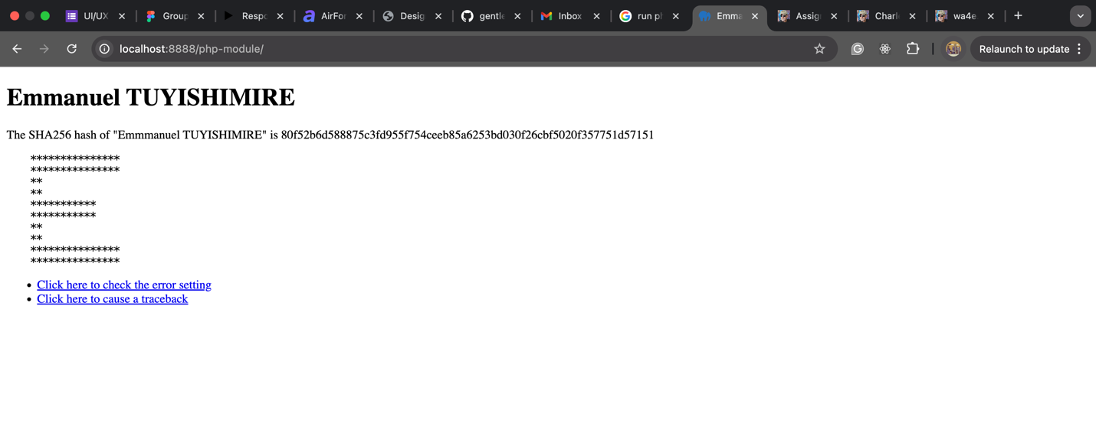

**Url to: check.php**

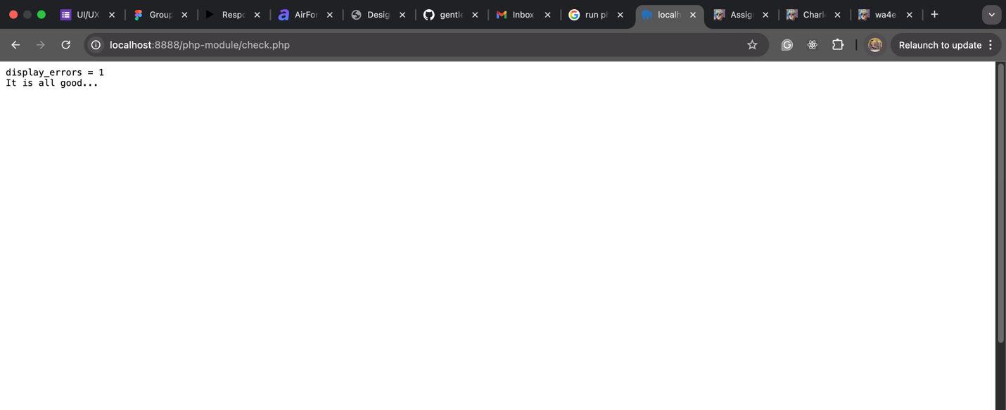

**Url to: fail.php**

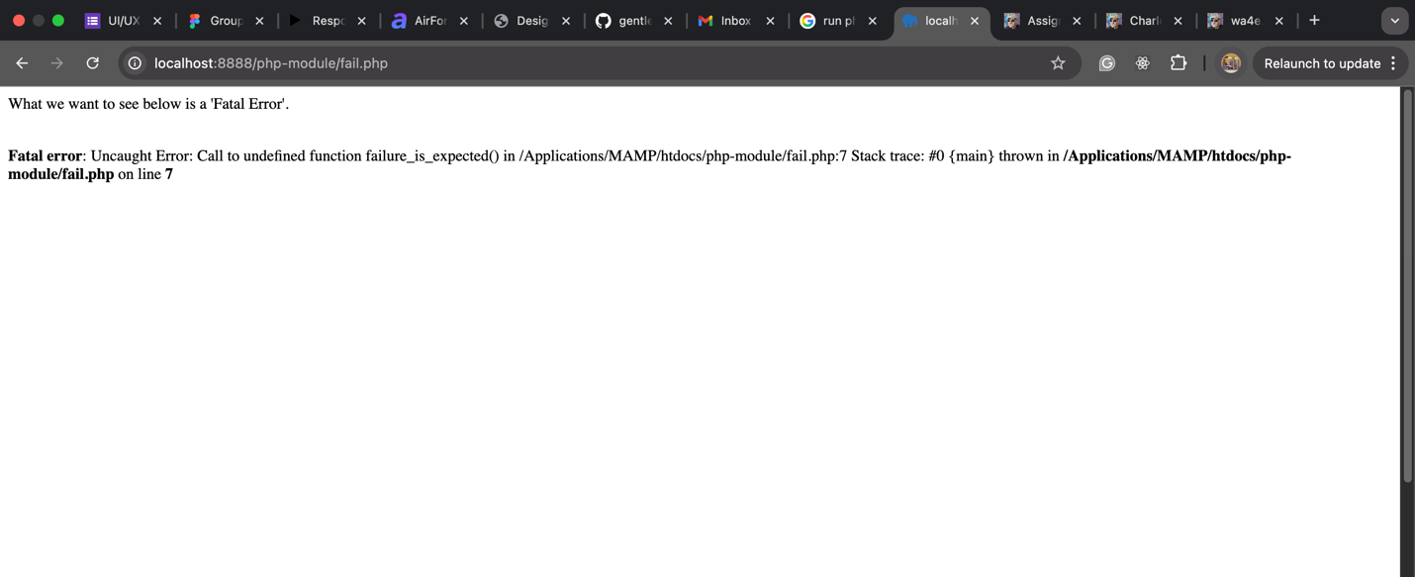

**Code for my index.php**

<!DOCTYPE html>

<html lang="en">

<head>

<meta charset="UTF-8">

<meta name="viewport" content="width=device-width, initial-scale=1.0">

<title>Emmanuel TUYISHIMIRE</title>

</head>

<body>

<h1>Emmanuel TUYISHIMIRE</h1>

<?php

print ('The SHA256 hash of "Emmmanuel TUYISHIMIRE" is ');

print hash('sha256', '\n Emmanuel TUYISHIMIRE');

?>

<pre>

***************

***************

**

**

***********

***********

**

**

***************

***************

</pre>

<ul>

<li><a href="check.php">Click here to check the error setting</a></li>

<li><a href="fail.php">Click here to cause a traceback</a></li>

</ul>

</body>

</html>