Bandwagoning and Balancing: How Uninformed Voters

Respond to Local and National Partisan Environment and Why It Matters

Gento Kato

University of California, Davis

# Abstract

Scholarly debate on civic competence often assumes that political knowledge is the prerequisite for systematic and “correct” decision-making. Uninformed voters, then, are portrayed as unsystematic and misguided decision-makers. The current study challenges this assumption by arguing that uninformed voters may not rely on (potentially misguided) individual preferences but rather refer to the partisan environment, the partisan voting patterns in past elections, to guide their decisions. The analysis of American National Election Studies (ANES) and Cooperative Congressional Election Study (CCES) provides the supporting evidence to this claim. Uninformed voters respond to the partisan environment in two ways: First, they *bandwagon* with the local partisan environment; second, they *balance* against the national partisan environment. The consequences of this context-based uninformed voting are evaluated through agent-based simulation. The results provide the view of uninformed voters as more systematic and effective decision-makers than previously suggested.

Manuscript word count: 8,673 words

In the studies of voter competence, the non-randomness and “correctness” of voting decisions are believed to be strictly increasing in the level of political knowledge. Uninformed voters, under this view, are portrayed as the most unsystematic and misguided decision-makers. Their individual preferences are unstable (Converse 1964; Zaller 1992), internally inconsistent (Broockman 2016), or misinformed (Kuklinski et al. 2000; Fowler and Margolis 2014). The evidence often leads to the conclusion that uninformed voting cannot be explained systematically. Any deviation of uninformed votes from informed votes (Bartels 1996) is attributed to biased preference formation of uninformed voters. Yet, this conclusion is the assumption rather than the explanation of the nature of uninformed voting. Previous studies rarely explore the possible reasoning behind uninformed voting patterns.

Given this gap in literature, this paper asks the following research question: *how can the behavior of uninformed voters be systematically explained?* There are two propositions. First, I argue that individual preferences *do not* explain the behavior of uninformed voters. Uninformed voters know that their preferences are weakly reasoned and potentially biased, and thus have no incentive to use their own preference to inform their decisions. Second, partisan environment, represented by aggregated partisan voting patterns from past elections (Miller 1956; Putnam 1966), explains uninformed voting. If a voter is informed, he or she has no reason to refer to partisan contexts. For uninformed voters, however, two contrasting sets of logic, *bandwagon* and *balance*, explain how and why contexts can be useful for their voting decisions.

This paper consists of three studies that test and explore the implication of context-based uninformed voting. The first two studies test propositions through the analysis of American presidential elections. The first study assesses the role of local partisan environments through the 2008 and 2016 Cooperative Congressional Election Study (CCES), and the second study examines the role of national partisan environments through 1972–2016 American National Election Studies (ANES). The third study explores potential consequences of the context-based uninformed voting pattern through an agent-based simulation.

The empirical results show that uninformed and informed voters base their decisions on separate sets of resources. Partisan environments explain uninformed voting but not informed voting; individual preferences (i.e., ideology and retrospective economic evaluation) explain informed voting but not uninformed voting. Furthermore, the role of partisan context changes by the level of context: uninformed voters bandwagon with local partisan environments but balance against national partisan environments. The simulation results imply that especially when the knowledge level is highly unequal across partisan groups, the conditional strategy of context-based uninformed voting produces more favorable democratic outcomes than alternative strategies.

The inquiry in the current paper sheds new lights on the studies of voting behavior. First, it helps to understand the decision-making process of uninformed voters. Previous empirical studies often emphasize the inconsistent and misguided nature of uninformed preferences, but this paper offers the picture of uninformed voters who can (at least partially) cope with this disadvantage. Second, it opens up a new way to assess voter competence. Instead of asking if voters are informed enough to acquire “correct” preference, we can ask whether the behavioral rules of uninformed voters contribute to the individual or social welfare. Having uncertain and “incorrect” individual preferences does not necessarily undermine the quality of democratic decision-making.

# Information Effects Unexplained

The capacity of citizens to make competent decisions is one of the main targets of endeavor in the studies of democratic voting behavior. It is repeatedly suggested that ordinary voters rarely hold a sufficient level of political knowledge to form consistent political preferences. American voters are uninformed about the wide range of political facts (Delli Carpini and Keeter 1996), and those ill-informed voters cannot hold a political ideology that is consistent across time and issues (Converse 1964; Zaller 1992; Broockman 2016). While some argue that voters need only necessary signals, not the full set of factual knowledge, to form “informed” preferences (e.g., Lupia 1994), it is shown that signaled preferences can be biased and misleading (Kuklinski et al. 2000; Fowler and Margolis 2014; Boudreau, Elmendorf, and MacKenzie 2015).

In the search for implications of this widely documented ignorance, scholars have been making the empirical assessment of “information effects.” They are interested in how uninformed voting patterns deviate from informed counterparts. In his canonical study, Bartels (1996) analyzes the presidential vote choice in the American National Election Study and demonstrates that informed and uninformed voters have different tendencies in how demographic characteristics influence the voting decisions. He further shows that those differential voting patterns have a sizable influence on aggregated electoral outcomes. Similarly, Arnold (2012) analyzes Comparative Study of Electoral Systems (CSES) and shows that hypothetical fully informed voting may change the electoral outcome across a wide range of democracies.

The substantive implications of these empirical findings, however, are not always clear and generalizable. The interpretations of differences are mostly descriptive and rarely offer a systematic explanation. As a result, we have little understanding as to why there are differences between uninformed and informed voting, and how they influence the democratic outcome. The next section introduces theories of voting that can offer those missing explanations.

# Explaining Information Effects

The accumulation of voting research offers several candidate explanations regarding how and why uninformed voting patterns differ from informed voting patterns. The most straightforward explanation is that uninformed voters make decisions based on the perception of the state of the world that deviates from the informed perception. This explanation implies that individual preferences (i.e., ideology, partisanship, and retrospective evaluation) predict uninformed and informed voting in the same manner; differences appear because uninformed preferences are potentially more biased and less stable than informed preferences.

However, there are reasons to expect that uninformed voters rely less on their individual preferences (i.e., ideology, partisanship, and retrospective evaluation) than informed voters do. Extending the voting model suggested in Downs (1957), Matsusaka (1995) argues that uninformed voters are less certain than informed voters about their political preferences. While his primary interest is in the turnout decisions, his theory implies that uninformed voters, compared to informed voters, may discount their preferences when making vote choice. Empirical evidence supports this claim. For example, Delli Carpini and Keeter (1996) find that the predictive power of ideology in voting is weaker among less-informed voters. Therefore, the first hypothesis is constructed as follows:

H1: The less-informed that voters are, the less strongly individual preferences (i.e., ideology, partisanship, and retrospective evaluation) explain their voting decisions.

If uninformed voters do not rely on their individual preferences, are their voting decisions inherently random? The long history of research on social context influence on voting suggests that is not necessarily the case. Even when voters do not possess the sufficient information to form their own preference with certainty, they may still learn and utilize the distribution of others’ partisan preferences in the society (called *partisan environment*). Voters obtain this knowledge from past election results and preferences of others in the social network. The second hypothesis states that the differences between informed and uninformed voting originate from the use of this contextual information:

H2: The less-informed that voters are, the more strongly a partisan environment explains their voting decisions.

Voters may respond to a partisan environment in either of two different ways: *bandwagoning* and *balancing*. Both patterns have theoretical and empirical support to validate their underlying logic. The following subsections explain why uninformed voters, and only uninformed voters, have a reason to bandwagon with or balance against the partisan environment.

## Bandwagoning

Bandwagoning indicates the pattern of behavior to vote in line with the majority in a partisan environment. This pattern of context-based voting is supported by ample empirical evidence. Early inquiries of local context and voting suggest that voters living under a highly skewed partisan environment, captured by partisan voting patterns in past election results, have a strong tendency to vote in line with the majority party (Miller 1956; Putnam 1966). The collection of social network studies also finds that majority preference in one’s political discussion network predicts voting decisions (Huckfeldt and Sprague 1987, 1995; Huckfeldt, Pietryka, and Reilly 2014). In addition, experimental studies confirm bandwagoning behavior both in lab (Bischoff and Egbert 2013; Morton and Ou 2015; Tyran and Wagner 2016) and online survey (Roy et al. 2015; van der Meer, Hakhverdian and Aaldering 2016; Dahlgaard et al. 2017). In those experiments, participants are randomly assigned to receive the signal about the majority preference (or the candidate/party winning the election) or not. The results show that receivers of the contextual signal are more likely to act in line with the majority than those who do not receive the signal.

There are numbers of theoretical rationales as to why bandwagoning should occur (Hardmeier 2008). While psychological explanations emphasize the natural instinct or “feels good” aspect of joining on the winner’s side, voters may have a logical incentive to use majority preference as a heuristic approach to find “correct” and viable choices in elections (Chaiken 1987; Lau and Redlawsk 2001).[1] The heuristic explanation especially makes sense in terms of local partisan environments in national elections. The local voting patterns often have a weak connection to winning or losing at the national level, but if political preferences are geographically sorted (Tam Cho, Gimpel, and Hui 2013), the local partisan environment can be effective heuristically in influencing how others with similar preferences vote.

It is reasonable to expect that the tendency of heuristic-based bandwagoning is weaker among informed than uninformed voters because those with abundant resources to support their own preferences tend to be resistant to the reception of additional signals (Zaller 1992). Empirical evidence is consistent with this claim. For example, the mock election experiment conducted by Huckfeldt, Pietryka, and Reilly (2014) shows that voting decisions of participants who are able to receive more private information about their preference are affected less by the preference signals obtained through communication with other participants. Similarly, the survey experiment conducted by Roy et al. (2015) indicates that the depth of obtained candidate information moderates bandwagoning behavior. They design a mock election in which respondents can search for information about candidates before the random subset of them receiving the result of pre-election polling. They find that those who searched for more information about candidates (i.e., informed voters) are less likely to vote for the leading candidate in the polling than those who searched less (i.e., uninformed voters).

In sum, the third hypothesis suggests that bandwagoning is primarily occurring in response to the local partisan environment among uninformed voters:

H3: The more skewed the local partisan environment, the more likely uninformed voters (and not informed voters) vote with the majority party in the local partisan environment.

## Balancing

Under the context of the American presidential system, scholars frequently discuss balancing in terms of vote switching in mid-term elections (Alesina and Rosenthal 1995). More generally, scholars understand balancing as the strategy of moderate voters to prevent policy outcomes from skewing overly toward one direction. While balancing tends to require the cognitively demanding task of understanding complex electoral and policy-making institutions, empirical studies show that many voters do get involved in balancing behavior (Kedar 2005, 2006).

In the scope of the current research, balancing is the pattern of behavior to vote against the majority in the partisan environment. The voting model presented in Feddersen and Pesendorfer (1996) explains why uninformed voters, and not informed voters, have an incentive to conduct such balancing. Their model categorizes voters into partisans, informed independents, and uninformed independents, and explains the behavior of each type of voters. Through the equilibrium analysis, they show that informed independents and partisans vote for their individual preference, but uninformed independents vote to “maximize the probability that the informed independent agents determine the winner” (414). To achieve this purpose, when they vote, uninformed independents have an incentive to balance out the partisan imbalance in society. This balancing increases the likelihood of informed independents determining the outcome, which favors the interest of uninformed independents.

To get an intuitive sense of balancing, suppose that there are two parties, *D* and *R,* in the plurality election. *D* and *R* partisans have a strong preference toward parties, so they always vote for their own party. Here, informed voters and uninformed voters have a weak preference toward parties and benefit from electing the *better* party in terms of common quality. Informed voters know, while uninformed voters don’t know, which party has the better quality. The balancing logic suggests that uninformed voters are less likely to vote for the parties with a larger number of partisans. This behavior increases the likelihood of an informed voter, whose decision should benefit uninformed voters, being the median voter in the election. The series of lab experiments provide the empirical support for this mechanism (Battaglini, Morton, and Palfrey 2008, 2010).

The balancing concerns the type of voters determining the electoral outcome. For example, in presidential elections, the outcome is determined at the national level,[2] thus it makes more sense for uninformed voters to balance their votes against the national than the local partisan environment. Therefore, the fourth and last hypothesis of this paper is constructed as follows:

H4: The more skewed the national partisan environment, the more likely uninformed voters (and not informed voters) vote against the majority party in the national partisan environment.

# Study 1: Local Partisan Environment and Uninformed Voting

This section examines the relationship between local partisan environment and vote choices in American presidential elections. Specifically, I use the Cooperative Congressional Election Study (CCES) conducted in 2008 and 2016. Each respondent is matched with past presidential election outcomes aggregated at the level of their local environment (i.e., state and county of residence). The election data are obtained from CQ Press Voting and Election Collections.[3]

The advantage of using CCES for the analysis of the local partisan environment is that the dataset includes a large number of respondents from different locations across the United States, providing sufficient variations and data points at both county and state level. While CCES recruits respondents from online and thus the sample is not nationally representative, it is validated that most of the actual election results do fall within the 95% confidence interval of the weighted estimates from CCES samples (Ansolabehere 2011, Ansolabehere, Schaffner, and Luks 2017). The ;following analysis applies weights provided by CCES organizers to correct for the potential bias in sampling.[4]

## Variables

The primary dependent variable for this study is the vote choice in presidential elections. To simplify the analysis, I focus on the binary choice between Republican and Democratic candidates and thus drop reported third-candidate choosers and abstainers from the analysis.[5] To explain the dichotomous vote choice, four sets of predictors are relevant. First, the measure of *political knowledge* is constructed by the aggregation of eight factual test questions in CCES concerning the knowledge of the majority party in legislatures and party name of incumbent politicians. The correct answers are aggregated to construct the information scale (the Cronbach’s alpha is 0.84 in 2008, 0.87 in 2016). The final score is normalized between 0 and 1.

Second, the measures of *local partisan environment* are constructed by linking the results of past elections with each respondent in CCES. Past electoral outcomes may not be the direct representation of the partisan composition of the society, but the evident pattern in the past elections gives a strong clue as to how partisan preferences are distributed within society. From CQ Press Voting and Election Collections, I collected county- and state-level outcomes of presidential elections. Using two-party Republican vote share in each local unit, the adapted versions of the *Cook Political Report* Partisan Voter Index (PVI)[6] are calculated. State level PVI uses the following formula for each state *i* and election cycle *t*:

*[State PVI]t,i* = {(*[State Republican Share]t*−1*,i* − *[National Republican Share]t*−1)+

(*[State Republican Share]t*−2*,i* − *[National Republican Share]t*−2)}*/*2

In the above formula, *t* represents the current election, and *t*−1 and *t*−2 represent the previous two elections. *[State Republican Share]i* indicates two-party vote share of the Republican party against the Democratic party in state *i*. Thus, *State PVI* represents the average advantage of Republican party vote share over the Democratic party, relative to the national tendency in the previous two elections. Two elections are averaged to obtain the long-term trend in a partisan environment. The positive scores indicate the advantage in Republican vote share in percentage points, and the negative scores indicate the advantage in Democrat vote share in percentage points. In addition, county level PVI measures are calculated using the following formula:

*[County PVI]t,i,j* =

{(*[County Republican Share]t*−1*,j* − *[State Republican Share]t*−1*,i*)+

(*[County Republican Share]t*−2*,j* − *[State Republican Share]t*−2*,i*)}*/*2

Notice that the above formula adjusts the PVI for county or congressional district *j,* not by national-level vote shares but by state-level vote shares. Therefore, the measure captures the partisan deviation of each county from the state average. Consequently, the correlations between state and county or district PVI are very low (ranges from −0*.*01 to 0*.*14) and inclusion of both variables in one model makes sense.

The third set of predictors is *individual preferences*: relative ideological advantage (based on squared ideological distance from each candidate, ranges from −36 to 36), party identification (ranges from −3 to 3), and the retrospective economic evaluation (ranges from −2 to 2). All variables are scaled so that the higher score indicates preference toward Republican party candidates (see Online Appendix for detailed constructs). All preference variables are based on the subjective perceptions. In contrast to objective measures that aim to capture “true” preference of voters, the subjective preference, even when it is potentially biased, is most likely to influence voting decisions.

The last set of predictors is *demography*, including gender, age, race, income, education, and religiosity. This paper has no specific expectations regarding how demographic variables interact with political knowledge, but those variables are included in the analysis to control for the baseline tendency in voting behavior.

## Model

The predictive model intends to identify the differential behavioral patterns between uninformed and informed voters. This paper follows the approach taken by Bartels (1996) to include the complete set of linear interactions between predictors and political knowledge.

The final model appears as follows:

Assuming that a linear relationship exists between political knowledge and the impact of each predictor, this method allows estimation of conditional coefficients of each predictor at different levels of political knowledge. After the estimation, I generate the conditional coefficient of each predictor for fully informed (political knowledge = 1) and uninformed (political knowledge = 0) voters.

I use logistic regression to estimate the impact of predictors on vote choice (Democrat = 0, Republican = 1). Standard errors are clustered by states and counties to incorporate common behavioral tendencies within those areas. In addition, the multiple imputation procedure (King et al. 2001) is used to handle the missing responses in the dataset. The presented results are the average from analyses of five imputed datasets.

## Results

The summary of presidential vote choice model is presented in Figure 1. The figure shows conditional odds ratios for fully informed voters (political knowledge = 1) and uninformed voters (political knowledge = 0), with 95% confidence intervals. The figure omits demographic variables and intercepts (see Online Appendix). The first and second rows of the plot show the impact of the local partisan environment on voting behavior. Consistent with H2, the odds ratios of state and county PVI are larger for uninformed voters than for informed voters. All PVI coefficients for uninformed voters are statistically significant (*p <* 0*.*05), while three out of four PVI coefficients for informed voters are not statistically significant (*p >* 0*.*05). The result also gives consistent support of H3 (bandwagoning): By every 10% movement in local PVI towards Republican, uninformed voters are 1.5 to 2 times (for state PVI), and 1.2 times (for county PVI) more likely to vote for Republican than Democrat.

Figure 1: The impact of local partisan environments and individual preferences on informed and uninformed presidential vote choice in CCES (2008, 2016).

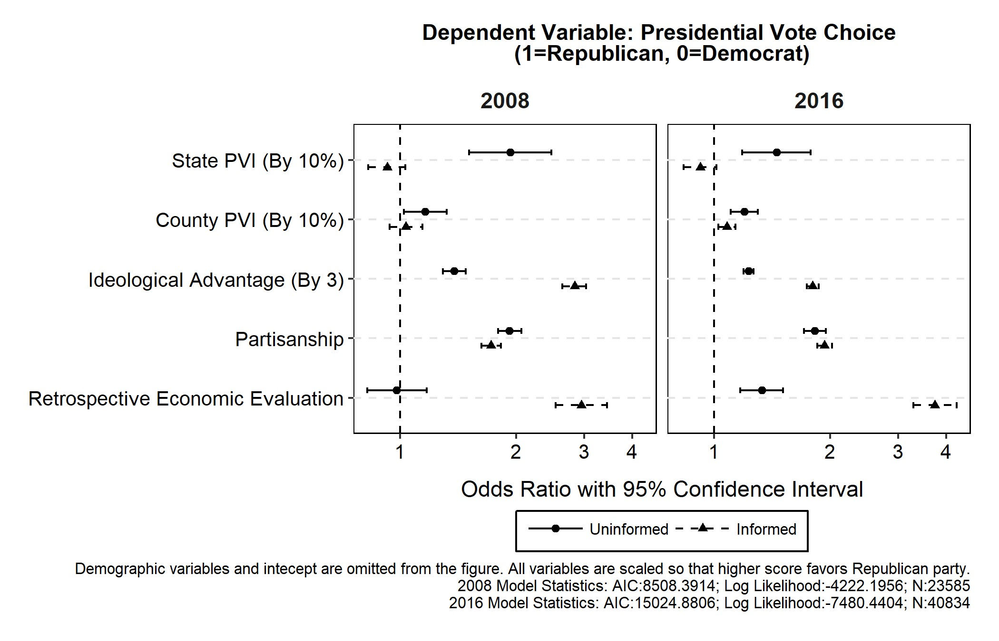

For individual preference variables, the result generally supports H1. Ideology and retrospective economic evaluation variables have significantly larger odds ratios for informed than for uninformed voters. The partisanship variable, on the other hand, has a similar level of power to explain vote choice among informed and uninformed voters. Uninformed voters do not rely on ideological preferences and retrospective evaluations, while using party identity in a way similar to that of informed voters.

Figure 2: Local partisan environments and average predicted probability of Republican vote in CCES (2008, 2016).

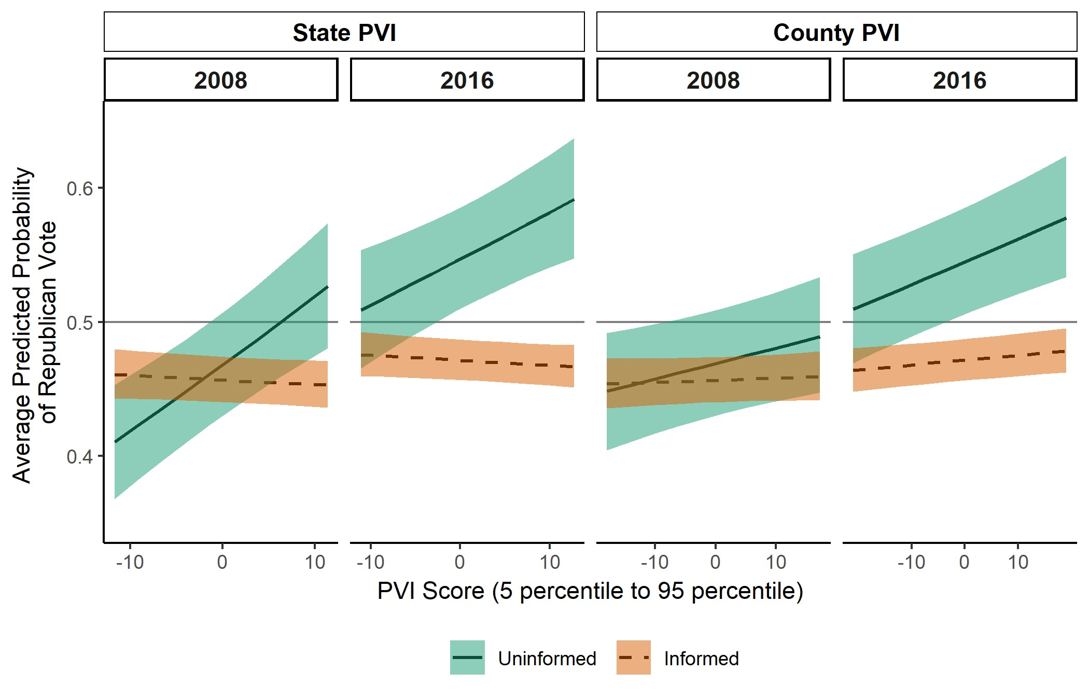

To gain deeper understanding of results regarding contextual variables, I simulate the predicted probability of the Republican vote through the Monte Carlo method. Since the estimated model includes complex sets of interacted variables, the simulation takes two steps. First, I estimated the predicted probability of vote choice for each respondent in surveys by manipulating the values only of the local partisan environment (from 5th percentile to 95th percentile), and political knowledge (0 and 1). Each prediction is made by drawing 1,000 random coefficients according to the multivariate normal distribution, with mean as a point estimate and clustered standard error. Second, I averaged predicted probabilities according to the population weight provided in CCES. This procedure gives the approximation of the average Republican vote probability under the given local partisan environment and knowledge level.

Figure 2 plots the simulation result. The shaded area represents 95% confidence intervals in prediction. Here, uninformed voters strongly respond to the local partisan environment, while informed voters don’t. Especially in 2016, the local partisan environment significantly raises the predicted vote probability of Trump among uninformed voters. The movement from the 5th percentile to the 95th percentile in state PVI and county PVI each correspond with a 1,013% increase in the Republican vote share. The impact of the local partisan environment in the 2008 election is somewhat weaker, but the predicted Republican vote probability for uninformed voters increases from 41*.*0% to 52*.*7% when the state PVI moves from an 11.7% Democratic advantage (5th percentile) to an 11.4% Republican advantage (95th percentile).

The current study highlights the importance of the local partisan environment in explaining uninformed voting (but not informed voting). Uninformed voters show a clear tendency of bandwagoning: to vote in line with the majority in the local environment. Informed voters, on the other hand, rely mostly on their individual responses to make voting decisions and are unresponsive to the local partisan environment.

# Study 2: National Partisan Environment and Uninformed Voting

This section examines the relationship between the national partisan environment and voting choice in American presidential elections. I use the collection of data from American National Election Studies (ANES), conducted during presidential elections that occurred between 1972 and 2016.[7] This dataset covers 12 presidential elections over a 44-year period, which gives sufficient variations to assess the impact of the national partisan environment on uninformed voting. As in Study 1, the national partisan environment at each election is captured by the data obtained from CQ Press Voting and Election Collections.

## Variables

The primary dependent variable for this study is the vote choice in presidential elections. As in Study 1, I focus on the binary choice between Republican and Democratic candidates and drop reported third-candidate choosers and abstainers from the analysis. The interviewer’s rating of knowledge is used as the measure of *political knowledge*. While this measure does not directly reflect the factual knowledge of respondents, it has a favorable quality to ensure comparability across surveys over time. The resultant measure is normalized to the range between 0 and 1, following the procedure that is taken by Bartels (1996). The robustness check using the knowledge measure based on factual test questions yields similar results (see Online Appendix).

The measures of *national partisan environment* are constructed in a way similar to those for the local partisan environment. Specifically, the national PVI uses the following formula for each election cycle *t*:

*[National PVI]t* = {*[National Republican Share]t*−1+

*[National Republican Share]t*−2}*/*2

*National PVI* represents the national advantage of Republican party vote share over the Democratic party. The measure averages two previous elections to adjust for any short-term noise imposed during a single election cycle.

In addition, *individual preference* predictors (i.e., relative ideological advantage is based on squared distance from candidates, partisanship, and the retrospective economic evaluation) and *demographic* controls (i.e., gender, age, race, income, education, and religion) are collected from each survey. All variables are scaled identically to the method used in Study 1.

## Model

In conducting the analysis, pooling all election years into one dataset over-complicates the model, because the distribution and the predictive power of voter characteristics may differ across elections. To cope with this heterogeneity, I follow a three-step procedure. First, the model of vote choice is constructed and estimated for each election year. As in Study 1 and Bartels (1996), each model includes the complete set of interactions between individual preference, demographic predictors and political knowledge, and is estimated by the logistic regression with population weights provided for each survey.

In the second step, following the procedure in Study 1, I simulated the weighted average of predicted probability of the Republican vote for fully informed (political knowledge = 1) and uninformed voters (political knowledge = 0). To control for the change in voter characteristics across years, the prediction is made by fixing the voter profiles to the specific election year. By fixing the voter profile, the simulation gives the prediction of how informed and uninformed voters would have voted in each election if the distribution of individual preferences and demographic characteristics stays constant.

Lastly, simulated Republican vote probabilities are regressed on the national partisan environment using the Estimated Dependent Variable (EDV) model (Lewis and Linzer 2005; Kasara and Suryanarayan 2015). The EDV model incorporates measurement uncertainty in the dependent variable, in the current case the vote probability estimate, in running OLS regression. This procedure allows both flexible modeling of vote choice in each election and controlling of the change in distributions of voter preferences and characteristics over the years.

## Results

Figure 3 shows the conditional coefficients of individual preferences extracted from the vote choice models estimated in each election year. The results are consistent with the findings from Study 1, supporting H1 except for partisanship. The left panel indicates that the coefficient of ideological alignment is larger for informed voters than for uninformed voters in 11 out of 12 elections, except for the year 2000. Similarly, the coefficient of retrospective economic evaluation (the right panel) is larger for informed voters than for uninformed voters in 10 out of 12 elections, except for 1980 and 1996. On the other hand, the results on partisanship variables (the central panel) are mixed. Informed voters have larger coefficients in only seven elections, and uninformed voters have larger coefficients in five other elections.

Following the described modeling procedure, Figure 4 presents the average predicted probabilities of the Republican vote for fully informed (political knowledge = 1) and uninformed (political knowledge = 0) voters in each election year, based on the 1992 voter profile. The voter profile from any given year yields similar results (see Online Appendix).

Figure 3: The impact of individual preferences on presidential vote choice in ANES (1972–2016).

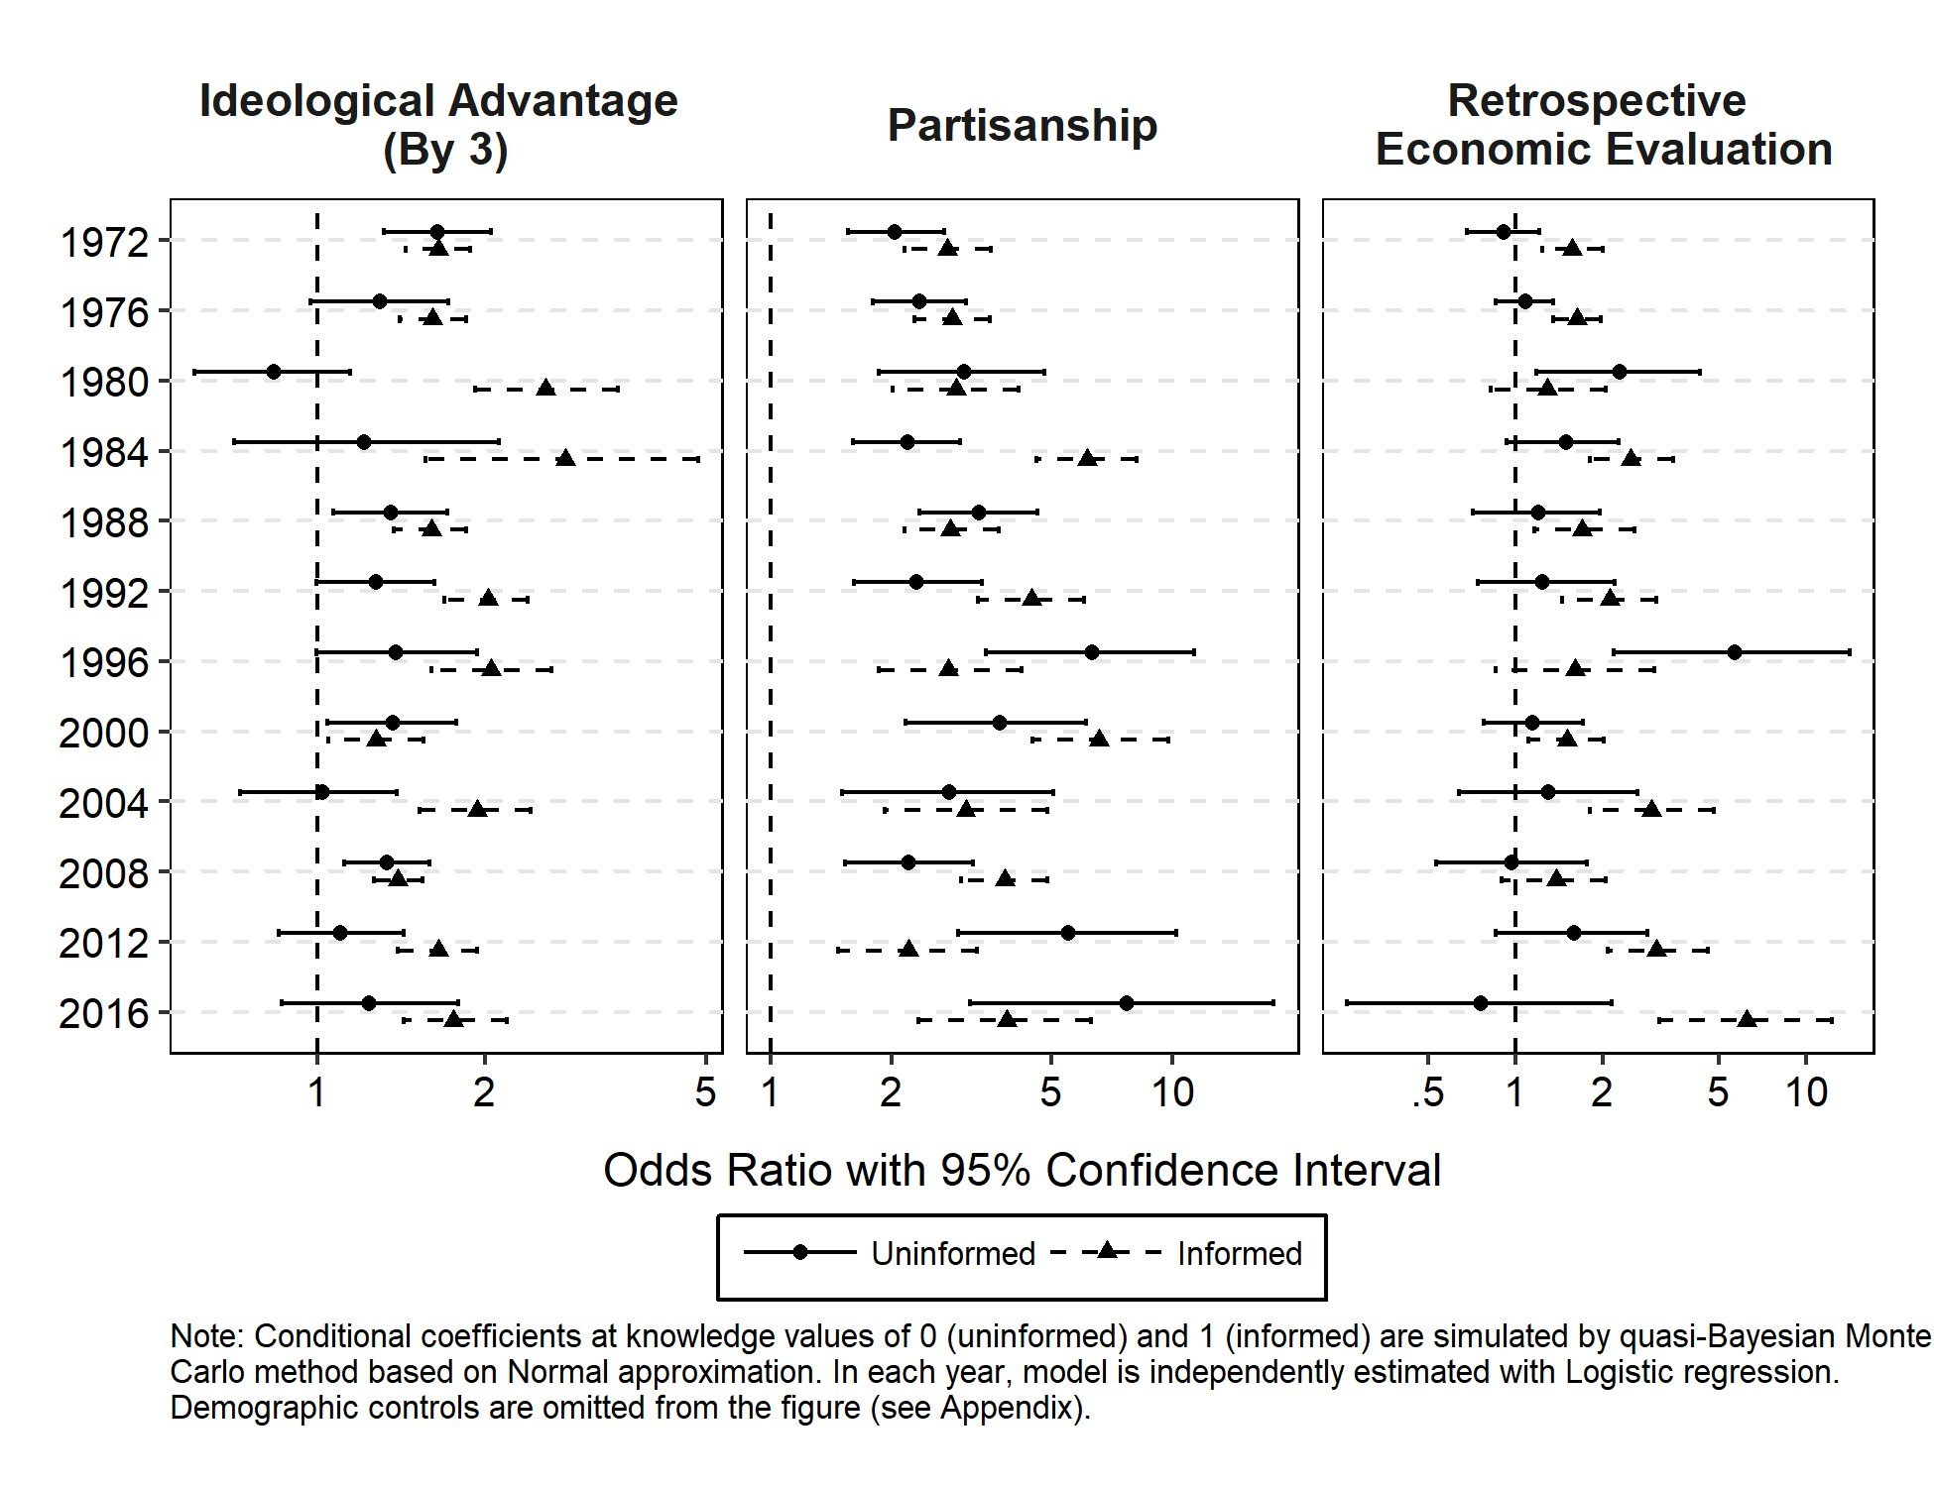

The left panel of Figure 4 implies that the national-level pattern of uninformed voting is a function of two factors: the national partisan environment and the incumbent party. Uninformed voters favor the incumbent party but balance against the overly skewed national partisan environment. The left panel shows that after controlling for the incumbent party, the stronger the partisan skew towards Republican (the higher the score of national PVI), the less likely uninformed voters are to vote for Republican candidates. The fitted lines with the 95% confidence interval from the EDV regression show that two factors produce almost a perfect fit of the variations in average uninformed vote probabilities. The right panel indicates that this pattern does not exist for informed voters: The average predicted probability of informed votes are mostly unresponsive to the change in incumbent party and the national partisan environment.

Figure 4: National partisan environment and predicted presidential vote probability in ANES (1972–2016).

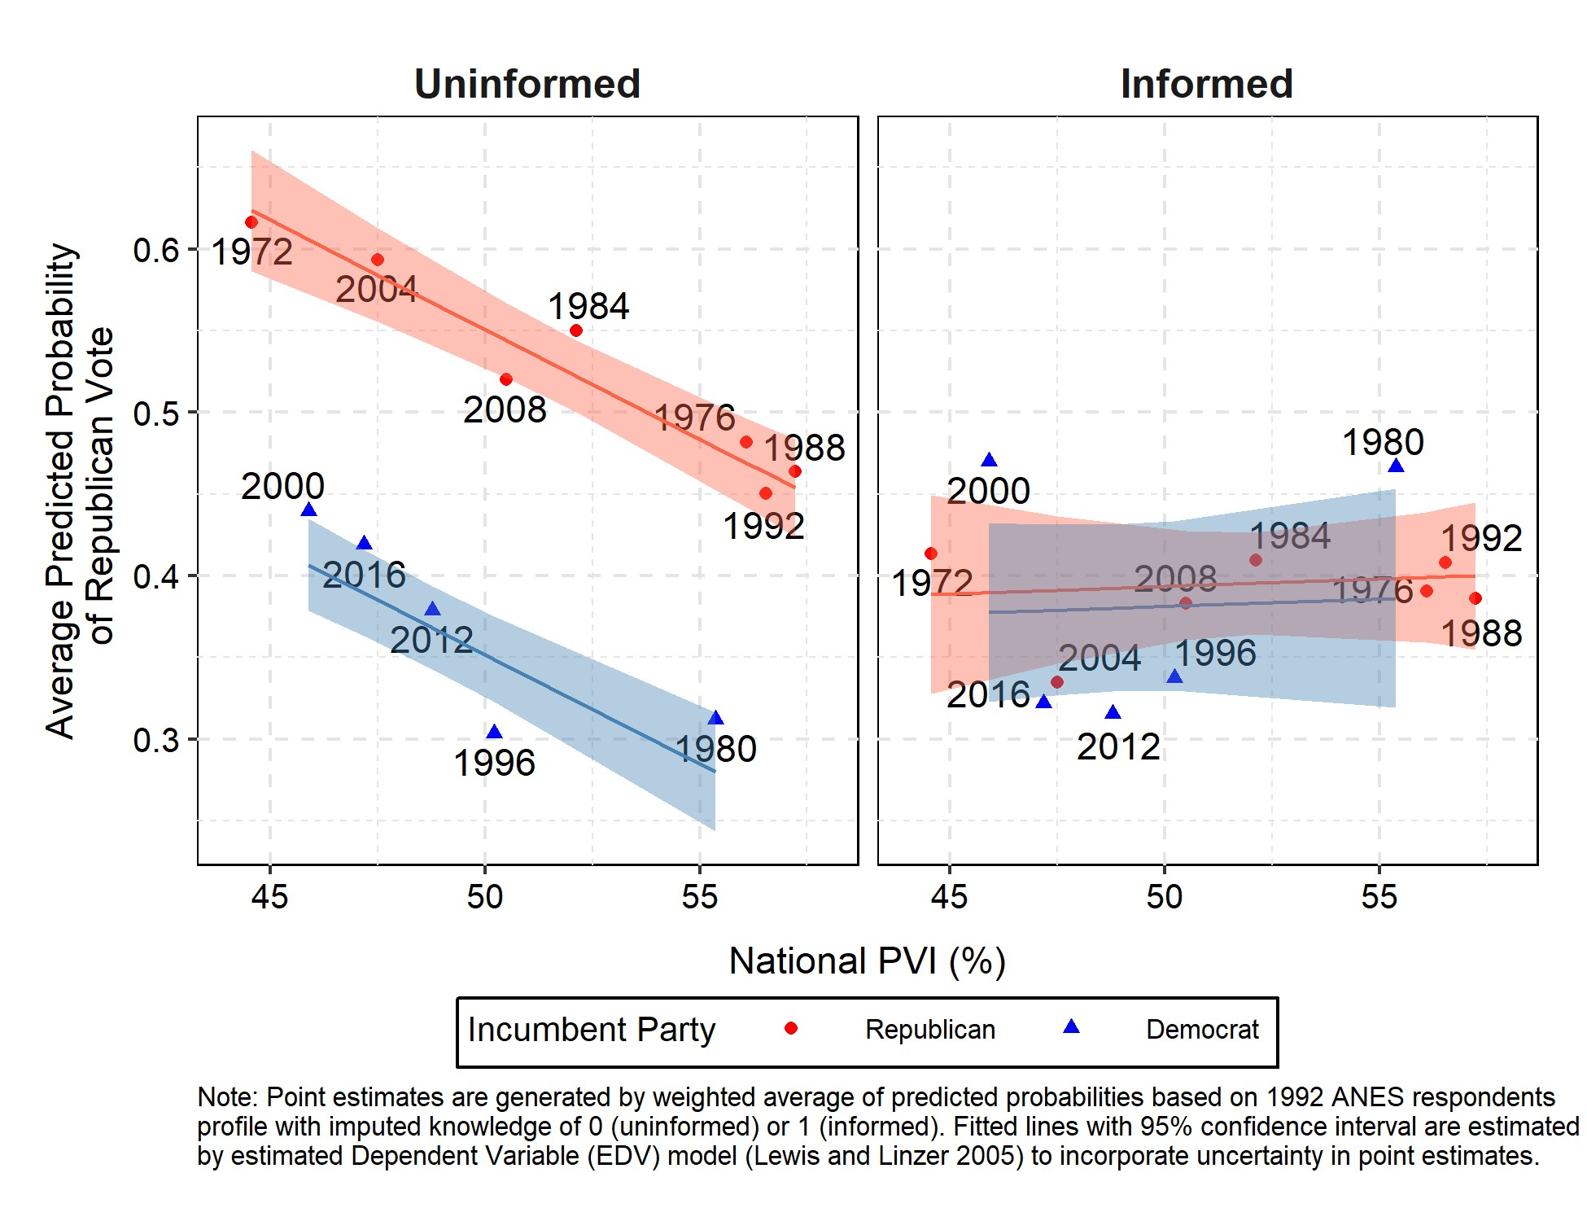

# Study 3: The Consequences of Context-Based Uninformed Voting

Analysis in previous sections show that uninformed voting is explained by partisan environments but not individual preferences. Also, uninformed voters respond differently to local and national partisan contexts. How do those patterns of uninformed voting behavior translate into the electoral utility of voters? Since context-based uninformed voting is a highly complex process of dynamic and interdependent nature, construction of a theoretical model with an analytical solution is difficult. Therefore, this section describes design of an agent-based simulation model to explore the electoral consequences of context-based uninformed voting patterns.

## Model

Simulated elections occur with 2,300 voters distributed over a 54×54 grid space. Each voter *i* occupies a single cell in the space and belongs to one of two equal size groups, *blue* (*g* = −1) or *red* (*g* = 1). Ideology *d* of voter *I,* represented by the function *δi* = *α* + *β* × *gi* + *ϵi*. *Α,* is the baseline level of ideology applied to all voters; *β* is the effect of group membership on ideology; and *ϵi* is a random personal factor that follows a normal distribution with a mean of zero. At each election, two political parties, *j* in *blue* and *red*, are competing for a single seat. Each party has two attributes. One is the ideology ∆*j*, scaled in the same way as voter ideology, and another is the capacity Θ*j,*which is 0 for the opposition party, and takes a non-zero value for the incumbent party.

At each election, voter *i*’s utility from the red party being elected is defined by the following function:

*EUi*(Red Elected) = *B*1 × ([*δi* − ∆*red*]2 − [*δi* − ∆*blue*]2) + *B*2 × (Θ*red* − Θ*blue*) + *B*3 × *gi*

Voter *i* is better off winner being red party than blue party if and only if *EUi*(Red Elected) *>* 0. *B*1, *B*2, and *B*3 represent the importance weight of ideology, capacity, and group identity respectively. Given the evidence in previous sections that party identity influences voting regardless of knowledge levels, *B*3 reflects the non-ideological, identity-based utility to favor the in-group party.

Voters know their identity *gi* and preference weights *B*1, *B*2, and *B*3, but do not observe *α*, *β*, *ϵi*, ∆*j*, and Θ*j* directly. Instead they receive signals of the squared ideological distance from each party and the capacity advantage of red party . Here, the signal random noise for each voter *ηi* is drawn from the normal distribution with mean *µ*×(1−*ki*) and standard deviation *σ*×(1−*ki*). Therefore, the noise is strictly shrining in knowledge level *ki* and when *ki* = 1, a voter is perfectly informed (i.e., *ηi* = 0) about ideological distance from and capacity of each party. Voters observe their levels of knowledge.

Contexts are determined by aggregating past electoral outcomes based on the PVI functions introduced in Studies 1 and 2. National contexts are based on voting of all voters, and local contexts are calculated by dividing the grid space into equal-sized subsets. Nine regions (approximating state) are defined by dividing the space into subsets of 18 × 18 = 324 cells, and 81 sub-regions (approximating county) are defined by dividing each region into subsets of 6 × 6 = 36 cells. At each election, PVIs are calculated at the national, regional, and sub-regional level to represent the partisan environment.

At each election, voters make probabilistic choices based on preference signals and partisan contexts. Based on the average parameter estimates from Studies 1 and 2, the specific voting function is represented as follows (see Online Appendix for the details):

*PREFERENCE* represents individual preference signals (i.e., ideological distance and capacity evaluation. *B*1 = 0*.*198 and *B*2 = 0*.*716.) and *CONTEXT* represents the effect of national and local partisan environments on vote choice. The vote choice probability is determined by the inverse logit function Λ of *PREFERENCE*, *CONTEXT*, and the ingroup party utility (*B*3 = 1*.*215) × *gi*. As discussed in Studies 1 and 2, the effect of individual preferences is increasing in, the effect of contexts is decreasing in, and the effect of partisan group membership is constant across knowledge level *ki*. The voting function assumes that voters are indifferent between two parties (i.e., vote either party by 50%) when *ki* × *PREFERENCE* + (1 − *ki*) × *CONTEXT* + 1*.*215 × *gi* = 0.

In the following analysis, *context-based uninformed voting* refers to the electoral choice according to the above voting function. In contrast, *signal-based uninformed voting* reflects the view in previous studies in which all voters make decisions based on individual preferences.

The voting function under this view can be defined as follows:

*Pr*(Vote Red) =Λ{*PREFERENCE* + 1*.*215 × *gi*}

It is clear from the above formulation that under signal-based uninformed voting, knowledge influences preference formation but not how preference influences voting decisions. Also, signal-based uninformed voting assumes that contexts play no role in vote choice.

## Variables

The single run of simulation consists of 25 consecutive elections with the fixed set of voters.[8] In each simulation run, only the common factor of voter ideology (*α*) and incumbent capacity (Θ*incumbent*) changes randomly across elections.[9] Those changes intend to capture the realistic movement in voter preferences over time.

To experiment on the consequences of uninformed voting, three factors come into consideration when we think about how context-based uninformed voting differs from the previous illustration of uninformed voting as solely based on individual preference signals. The first factor is the inequality in knowledge level across partisan groups. Under signal-based uninformed voting, voters who belong to groups with a higher level of knowledge may benefit more from elections than do voters who belong to groups with a lower level of knowledge. The question is whether the context-based uninformed voting can adjust this group inequality. In the simulation, while the average level of knowledge stays constant at 0*.*65, two voter groups are assigned with differing average levels of knowledge. Specifically, I assign lower mean knowledge levels for the blue group (i.e., ) than for the red group (i.e., ).

The second factor is the extent of common bias in the reception of preference signals. If the strength and direction of bias are randomly distributed across individuals, all biases are expected to cancel out in the aggregated preferences (Page and Shapiro 1992). Under this condition, context-based uninformed voting may produce error rather than improvement in the aggregated electoral outcome. On the other hand, if preference signals are commonly biased toward one direction, context-based uninformed voting may play a role to adjust for signal bias. To explore the above consideration, two types of common bias are introduced in the simulation. The first type is the constant common bias across all elections within each simulation run, and the second type is the common bias that randomly changes across elections.

The third factor is the level of geographic sorting. This factor is potentially important, because if voters select the community with people of similar political preferences (Tam Cho, Gimpel and Hui 2013), local and national partisan environments would look systematically different. In the simulation, the level of geographic sorting is manipulated by running the classic segregation model (Schelling 1969) prior to holding elections. This model starts in the same spatial setting as the current election model. Then agents move around the grid randomly until the proportion of outgroup members in one’s adjacent cells goes below the common tolerance threshold. For example, if the tolerance threshold is 0*.*5, an agent moves around the grid until half or fewer of one’s adjacent cells are filled by outgroup members. It is known that this micro process of segregation has a substantial influence on the segregation at the macro level. I manipulated the level of geographic sorting by setting low (= 0*.*3) and high (= 0*.*8) thresholds of tolerance.

Figure 5: How micro-level segregation translates to macro-level geographic sorting (Tolerance = 0*.*5)

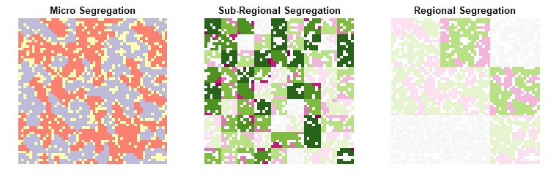

Figure 5 illustrates how the micro-segregation process based on tolerance parameters translates to macro-level geographic sorting. The left panel shows one simulation run of the segregation model with a tolerance parameter = 0*.*5. It shows how blue (light gray) and red (dark gray) group members are distributed on the grid after running the segregation model. The central and right panel illustrate how the micro group segregation influences the distribution of group membership at sub-regional and regional levels. The dark area indicates a high level of skew in the group distribution within a sub-region or region. The effect of micro segregation is more pronounced at the sub-regional level than at the regional level. In this example, the average majority group proportion is 75*.*4% in sub-regions but only 58*.*8% in regions.

The final analysis was conducted by running 4,000 simulations (100,000 elections) with different combinations of the values of the knowledge inequality across partisan groups, the common signal bias, and the level of geographic sorting. Except for those three parameters, all other parameters are fixed to approximate the environment of American presidential elections. Those constants are in a scale comparable to the variables used in Studies 1 and 2, and reflect the average tendency in ANES respondents (see Online Appendix for the details).

## Results

In this section, I focus on the deviation from a “fully informed” electoral outcome to evaluate the voting decisions of partially uninformed voters. Fully informed outcome is generated when all voters are receiving preference signals without noise (i.e., *ki* = 1 → *ηi* = 0 for all voters) in all elections of a simulation run. Then, the quality of context-based and signal-based uninformed voting is assessed by two measures. The first measure is the average loss in utility compared to the fully informed outcome. Here the fully informed voters always maximize the sum of voter utilities. The second measure is the inequality between partisan groups’ average utilities. Here, if both groups are fully informed, the expected inequality is zero. For both measures, the score at each election is averaged across 25 elections within a single simulation run. Then, the focus of the evaluation is on how partially uninformed voters can minimize loss and inequality in average utilities.

Before comparing context-based and signal-based uninformed voting, it is worth noting the effectiveness of mixing local-level bandwagoning and national-level balancing in the context-based uninformed voting. Here, Appendix Figure X shows that in terms of average utility loss, mixing bandwagoning and balancing in context-based uninformed voting outperforms the voting with only one of them across all experimental conditions. It turns out that regardless of contextual conditions, the use of both local-level bandwagoning and national-level balancing is the optimal strategy for uninformed voters to utilize contexts as the voting guide. In terms of inequality between voter groups, all types of context-based voting perform similarly.

Turning to the difference between context-based and signal-based voting **??** shows the comparison in terms of average utility loss. The vertical axis represents the value of average loss, and the horizontal axis represents the knowledge inequality between red and blue voter groups (voters in the red group have a higher knowledge level than those in the blue group). The panel columns indicate the severity of common signal bias (i.e., the severity is increasing toward the right) and the panel rows represent the level of geographic sorting. For each panel, I plot linear fitted lines of outcomes from context-based (solid line) and signal based (dashed line) uninformed voting with 95% confidence intervals.

Figure 6: The loss in average utility under context-based and signal-based uninformed voting.

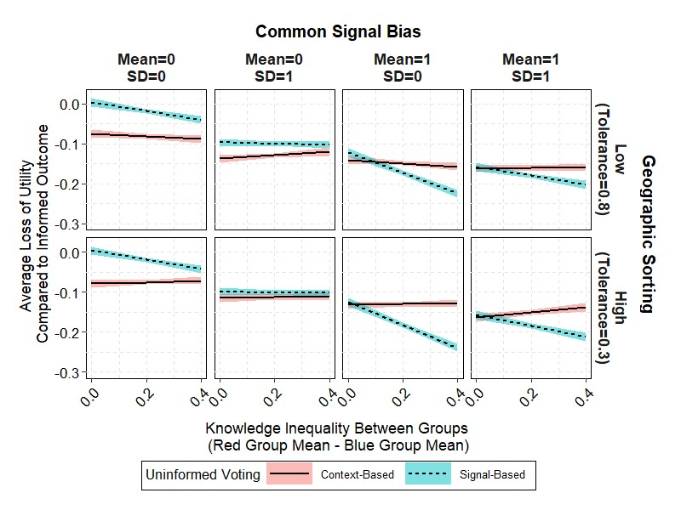

The figure indicates that the common signal bias and knowledge inequality influence the outcome of signal-based uninformed voting: the more severe the signal bias and larger the knowledge inequality, the larger the average loss from signal-based uninformed voting. On the other hand, the outcome of context-based uninformed voting is resistant to the change in knowledge inequality, and has been affected only slightly by the severity of common signal bias. As a result, context-based uninformed voting outperforms signal-based uninformed voting under highly biased signals and highly unequal distribution of knowledge. However, when signal bias or knowledge inequality is low, average utility loss is larger for context-based than for signal-based voting. Geographic sorting does not explain the performance of either signal-based or context-based uninformed voting.

Figure 7: The difference in average utility loss between blue and red voter groups under context-based and signal-based uninformed voting.

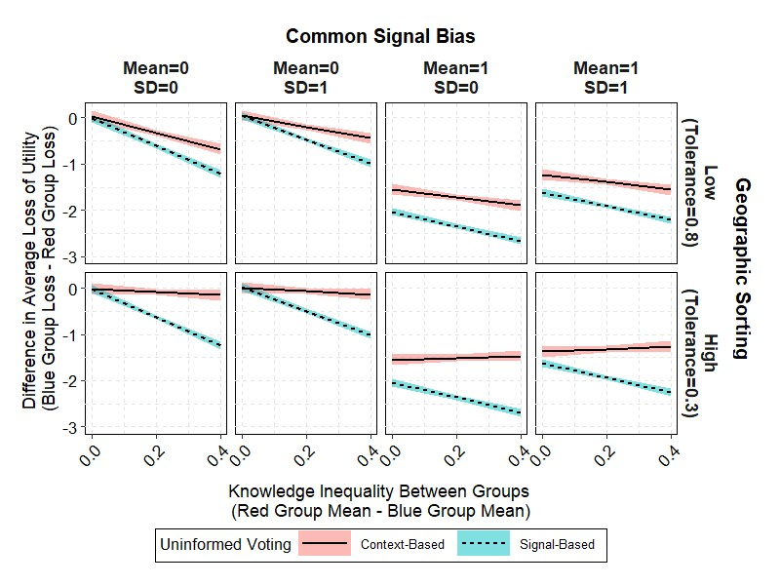

Figure 7 presents the result for the difference in group-level average utility losses. The results can be interpreted in a way similar to that for **??**. The high scores (close to zero) in the vertical axis indicate the small difference in utility loss between two voter groups, while low scores (sizeable negative value) indicate that the blue (less knowledgeable) group voters lose utility more than the red (more knowledgeable) group voters. Under signal-based uninformed voting, this score is highly affected by the knowledge inequality. Across all panels, inequality in group-level utility losses are increasing the inequality in knowledge levels across groups. Again, context-based uninformed voting is resistant to the knowledge inequality across groups. Especially with high geographic sorting, the difference in group level average utility losses from context-based voting is almost unresponsive to the level of knowledge inequality. In fact, context-based voting almost always outperforms signal-based voting, and its advantage is particularly large under high-knowledge inequality and geographic sorting.

# Discussion

Overall, the analysis suggests that local and national partisan environments play a significant role in explaining the behavior of uninformed voters. While informed voting is dominated by individual preferences, uninformed voters bandwagon with the local partisan environment (Study 1) and balance against the national partisan environment (Study 2). Study 3 implies that this context-based uninformed voting can outperform individual preference-based uninformed voting, especially under unequal distribution of knowledge, highly biased signals of individual preference, and high level of geographic sorting.

The result of this study provides consistent evidence that informed and uninformed voters apply different logic in making vote choices. This study offers clues to answer the question left in the empirical studies of information effects: *Why* does information make a systematic difference in the outcome of voting choices? The partisan environment is one of the key variables to understand why informed and uninformed voters act in different ways. The simulation results imply that under certain conditions, applying non-preference based, context-oriented logic is beneficial for uninformed voters. Using this result, the scholarly debate on civic competence can move forward; instead of focusing on how illogical and unpredictable uninformed voters are, the conversation can shift to exploration of how the logic of uninformed voting relates to the quality of democratic outcomes.

Three caveats remain. First, it is not clear if the findings can be generalized outside of the context of presidential elections under a two-party system. Further exploration of voting patterns under parliamentary and multi-party systems is needed. Second, the measurement of the partisan environment has an issue of visibility. The objective measure used in this study does not ensure that this information is directly observed by the respondent. Further research should consider how the knowledge of the partisan environment is communicated to uninformed voters (e.g., social network and public opinion polls). Third, this study ignores the participation incentives of uninformed voters. Many studies suggest that political knowledge plays an important role in participation decisions (Matsusaka 1995; Delli Carpini and Keeter 1996; Feddersen and Pesendorfer 1996; Lassen 2005; Larcinese 2007; Gemenis and Rosema 2014). To fully grasp the picture of uninformed voting, one needs to take abstention incentives into account.

Finally, one promising direction in which to extend the current analysis is exploration of the interactive nature of context-based uninformed voting. The recent developments in game theoretic and simulation research suggest that after accounting for the dynamic interaction process among voters or between voters and a policymaker, the lack of voter information is not crucial for, or even improving, the quality of democratic decisions (Ashworth and Bueno de Mesquita 2014; Couzin et al. 2011). Exploring the implications of those interactions for context-based uninformed voting is an important contribution to this line of inquiry.

# References

Adams, James F., Samuel Merill III, and Bernard Grofman. 2005. *A Unified Theory of Party Competition*. Cambridge: Cambridge University Press.

Alesina, Alberto, and Howard Rosenthal. 1995. *Partisan Politics, Divided Government, and the Economy*. Cambridge: Cambridge University Press.

Ansolabehere, Stephen. 2011. *Guide to the 2008 Cooperative Congressional Election Survey*.

Ansolabehere, Stephen, Brian Schaffner, and Sam Luks. 2017. *Guide to the 2016 Cooperative Congressional Election Survey*.

Arnold, Jason Ross. 2012. “The Electoral Consequences of Voter Ignorance.” *Electoral Studies* 31(4):796–815.

Ashworth, Scott and Ethan Bueno de Mesquita. 2014. “Is Voter Competence Good for Voters?: Information, Rationality, and Democratic Performance.” *The American Political Science Review* 108(3):565–587.

Bartels, Larry M. 1996. “Uninformed Votes: Information Effects in Presidential Elections.” *American Journal of Political Science* 40(1):194–230.

Battaglini, Marco, Rebecca B. Morton, and Thomas R. Palfrey. 2010. “The Swing Voter’s Curse in the Laboratory.” *The Review of Economic Studies* 77(1):61–89.

Battaglini, Marco, Rebecca B. Morton, and Thomas R. Palfrey. 2008. “Information Aggregation and Strategic Abstention in Large Laboratory Elections.” *The American Economic Review* 98(2):194–200.

Bischoff, Ivo and Henrik Egbert. 2013. “Social Information and Bandwagon Behavior in Voting: An Economic Experiment.” *Journal of Economic Psychology* 34:270–284.

Boudreau, Cheryl, Christopher S. Elmendorf, and Scott A. MacKenzie. 2015. “Lost in Space? Information Shortcuts, Spatial Voting, and Local Government Representation.” *Political Research Quarterly* 68(4):843–855.

Broockman, David E. 2016. “Approaches to Studying Policy Representation.” *Legislative Studies Quarterly* 41(1):181–215.

Chaiken, Shelly. 1987. “The Heuristic Model of Persuasion,” in *Social influence: The Ontario Symposium*, Vol. 5. Hillsdale, NJ: Lawrence Erlbaum, pp. 3–39.

Coate, Stephen and Michael Conlin. 2004. “A Group Rule: Utilitarian Approach to Voter Turnout: Theory and Evidence.” *The American Economic Review* 94(5):1476–1504.

Converse, Philip E. 1964. The Nature of Belief System in Mass Publics. In *Ideology and Discontent*, ed. D. E. Apter. New York, NY: Free Press, pp. 206–261.

Couzin, Iain D., Christos C. Ioannou, Güven Demirel, Thilo Gross, Colin J. Torney, Andrew Hartnett, Larissa Conradt, Simon A. Levin, and Naomi E. Leonard. 2011. “Uninformed Individuals Promote Democratic Consensus in Animal Groups.” *Science* 334(6062):1578– 1580.

Dahlgaard, Jens Olav, Jonas Hedegaard Hansen, Kasper M. Hansen, and Martin V. Larsen. 2017. “How Election Polls Shape Voting Behaviour.” *Scandinavian Political Studies* 40(3):330–343.

Delli Carpini, Michael X. and Scott Keeter. 1996. *What Americans Know About Politics and Why It Matters*. New Haven: Yale University Press.

Downs, Anthony. 1957. *An Economic Theory of Democracy*. New York: Harper and Brothers.

Feddersen, Timothy J. and Alvaro Sandroni. 2006*a*. “The Calculus of Ethical Voting.” *International Journal of Game Theory* 35(1):1–25.

Feddersen, Timothy J. and Alvaro Sandroni. 2006*b*. “A Theory of Participation in Elections.” *The American Economic Review* 96(4):1271–1282.

Feddersen, Timothy J. and Wolfgang Pesendorfer. 1996. “The Swing Voter’s Curse.” *The American Economic Review* 86(3):408–424.

Fowler, Anthony and Michele Margolis. 2014. “The Political Consequences of Uninformed Voters.” *Electoral Studies* 34:100–110.

Gemenis, Kostas and Martin Rosema. 2014. “Voting Advice Applications and Electoral Turnout.” *Electoral Studies* 36:281–289.

Hardmeier, S. 2008. “The Effects of Published Polls on Citizens,” in *The SAGE Handbook of Public Opinion Research*, eds. Wolfgang Donsbach and Michael W. Traugott. London: SAGE Publications.

Huckfeldt, Robert and John Sprague. 1987. “Networks in Context: The Social Flow of Political Information.” *The American Political Science Review* 81(4):1197–1216.

Huckfeldt, Robert and John Sprague. 1995. *Citizens, Politics and Social Communication: Information and Influence in an Election Campaign*. Cambridge: Cambridge University Press.

Huckfeldt, Robert, Matthew T. Pietryka, and Jack Reilly. 2014. “Noise, Bias, and Expertise in Political Communication Networks.” *Social Networks* 36:110–121. Special Issue on Political Networks.

Kasara, Kimuli and Pavithra Suryanarayan. 2015. “When Do the Rich Vote Less Than the Poor and Why? Explaining Turnout Inequality across the World.” *American Journal of Political Science* 59(3):613–627.

Kedar, Orit. 2005. “When Moderate Voters Prefer Extreme Parties: Policy Balancing in Parliamentary Elections.” *The American Political Science Review* 99(2):185–199.

Kedar, Orit. 2006. “How Voters Work Around Institutions: Policy Balancing in Staggered Elections.” *Electoral Studies* 25(3):509–527.

King, Gary, James Honaker, Anne Joseph, and Kenneth Scheve. 2001. “Analyzing Incomplete Political Science Data: An Alternative Algorithm for Multiple Imputation.” *American Political Science Review* 95(1):49–69.

Kollman, Ken, John H. Miller, and Scott E. Page. 1992. “Adaptive Parties in Spatial Elections.” *The American Political Science Review* 86(4):929–937.

Kuklinski, James H., Paul J. Quirk, Jennifer Jerit, David Schwieder, and Robert F. Rich. 2000. “Misinformation and the Currency of Democratic Citizenship.” *Journal of Politics* 62(3):790–816.

Larcinese, Valentino. 2007. “Does Political Knowledge Increase Turnout? Evidence from the 1997 British General Election.” *Public Choice* 131(3):387–411.

Lassen, David Dreyer. 2005. “The Effect of Information on Voter Turnout: Evidence from a Natural Experiment.” *American Journal of Political Science* 49(1):103–118.

Lau, Richard R. and David P. Redlawsk. 2001. “Advantages and Disadvantages of Cognitive Heuristics in Political Decision Making.” *American Journal of Political Science* 45(4):951– 971.

Lewis, Jeffrey B. and Drew A. Linzer. 2005. “Estimating Regression Models in Which the Dependent Variable Is Based on Estimates.” *Political Analysis* 13(4):345–364.

Lupia, Arthur. 1994. “Shortcuts Versus Encyclopedias: Information and Voting Behavior in California Insurance Reform Elections.” *American Political Science Review* 88(1):63–76.

Matsusaka, John G. 1995. “Explaining Voter Turnout Patterns: An Information Theory.” *Public Choice* 84(1):91–117.

Miller, Warren E. 1956. “One-Party Politics and the Voter.” *American Political Science Review* 50(3):707–725.

Morton, Rebecca B. and Kai Ou. 2015. “What Motivates Bandwagon Voting Behavior: Altruism or a Desire to Win?” *European Journal of Political Economy* 40(Part B):224– 241. Behavioral Political Economy.

Page, B.I. and R.Y. Shapiro. 1992. *The Rational Public: Fifty Years of Trends in Americans’ Policy Preferences*. Chicago: University of Chicago Press.

Putnam, Robert D. 1966. “Political Attitudes and the Local Community.” *American Political Science Review* 60(3):640–654.

Roy, Jason, Shane P. Singh, Patrick Fournier, and Blake Andrew. 2015. “An Experimental Analysis of the Impact of Campaign Polls on Electoral Information Seeking.” *Electoral Studies* 40(Supplement C):146–157.

Schelling, Thomas C. 1969. “Models of Segregation.” *The American Economic Review* 59(2):488–493.

Tam Cho, Wendy K., James G. Gimpel, and Iris S. Hui. 2013. “Voter Migration and the Geographic Sorting of the American Electorate.” *Annals of the Association of American Geographers* 103(4):856–870.

Tyran, Jean-Robert and Alexander K. Wagner. 2016. “Experimental Evidence on Expressive Voting,” in *The Oxford Handbook of Public Choice*. *https://ssrn.com/abstract=2867954*

van der Meer, Tom W. G., Armen Hakhverdian and Loes Aaldering. 2016. “Off the Fence, Onto the Bandwagon? A Large-Scale Survey Experiment on Effect of Real-Life Poll Outcomes on Subsequent Vote Intentions.” *International Journal of Public Opinion Research* 28(1):46–72.

Zaller, John R. 1992. *The Nature and Origins of Mass Opinion*. Cambridge: Cambridge University Press.

1. The separate set of theoretical studies focuses on the role of bandwagoning to maximize the impersonal utility (Coate and Conlin 2004; Feddersen and Sandroni 2006*b*,*a*) but receives weak-empirical support (Morton and Ou 2015).
2. Technically, American presidential election is a two-step process, but the national level still plays an important role in determining the electoral outcome.
3. <http://library.cqpress.com/elections>. Accessed through subscription at the library of the University of California, Davis.
4. Since the analysis includes the post-election variable of vote choice, post-election weights are used for CCES 2016. General weights are used in CCES 2008 because post-election weights are not provided.
5. Turnout decision and third-candidate voting deserves a separate set of discussions, but that is not the central focus of this paper.
6. <https://www.cookpolitical.com/pvi>
7. I limit the analysis to respondents interviewed in face-to-face or phone mode. Online survey samples are dropped from the analysis, due to comparability issues.
8. If an election occurs every four years, each simulation corresponds to a 100-year period. The actual simulation involves 30 elections at each run. The first five elections are dropped from the analysis to suppress the influence of starting values.
9. Voter ideology is moving, so party ideologies are fixed across elections to avoid over-complication. Since the movement in party ideology and its interaction with voter ideology is a major topic in party politics literature (Downs 1957; Kollman, Miller and Page 1992; Adams, Merill III, and Grofman 2005), subsequent research can explore its implication.