Dear,

From the results you have provided, we hereby add a link and the Google Play logo at the foot of each https://tvsekolah.id site page like one of the following screenshots. To prove that the android application that we want to register on Google Play is really ours as the owner/admin of the tvschool.id

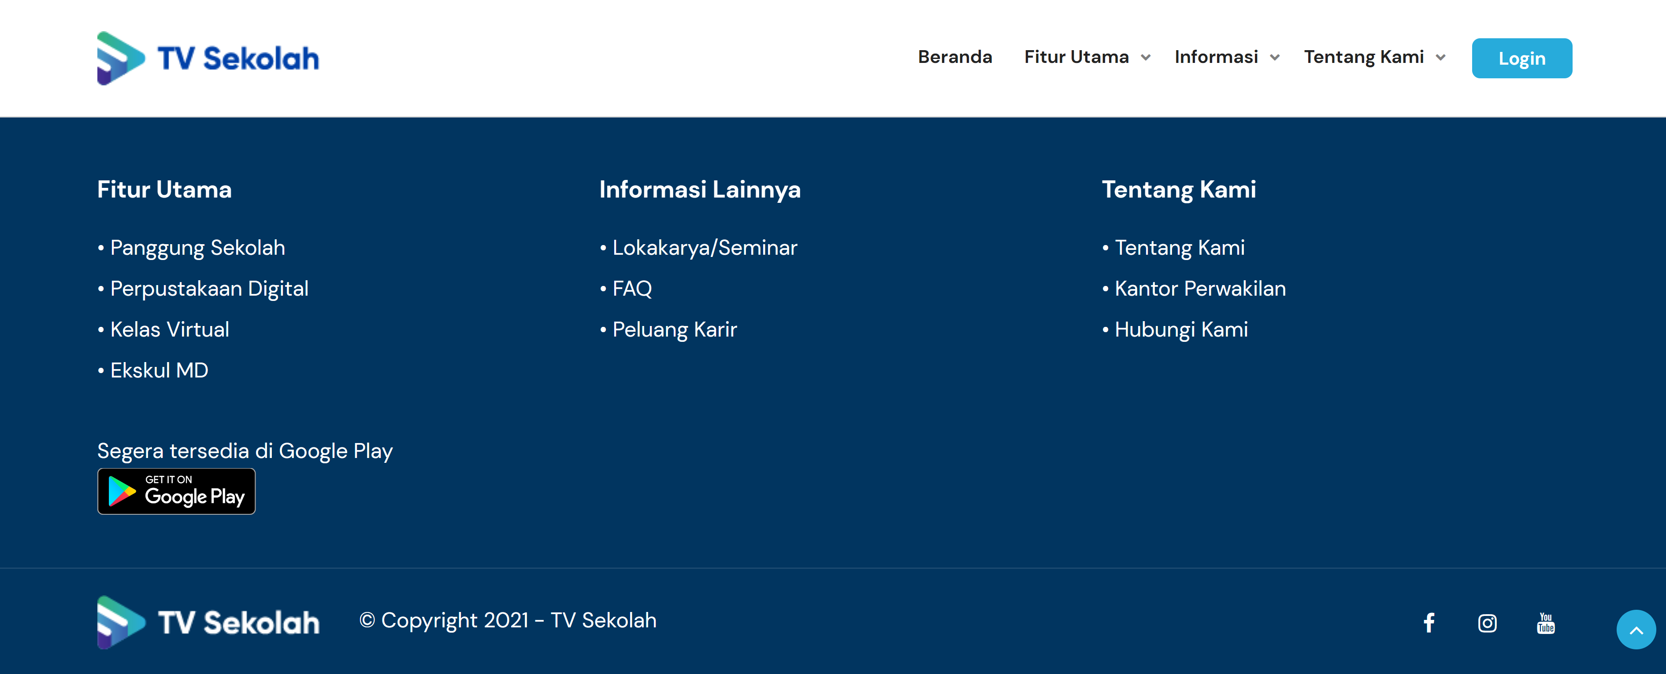

Thank you.