CS1428
Foundations of Computer Science
Style Guide

- Keep every line of code shorter than 80 characters.
- Give variables meaningful names. The name should make the use of the variable obvious.
  - ‘c’ is a bad variable name.
  - ‘number’ is a bad variable name.
  - ‘number_of_students’ is a good variable name.
  - ‘daysUntilGraduation’ is a good variable name.
- Indent every block of code by one tab or four spaces from its parent statement.
  - 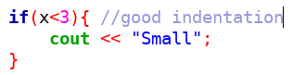
  - 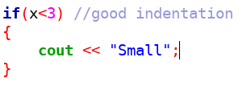
  - 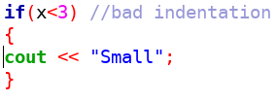
- Comments should be included to explain every “complicated” action.
- Every file should include author, date, and collaborators comments.

