Lab 6: Linux Command Line

Many coders find that they have a much easier time using the Linux operating system,rather than Windows or Mac OS. This is because Linux offers its users many powerful command-line tools as well as many software suites which can easily be imported and installed. And it’s all free.

Linux was first developed in 1991 as successor to Unix, which is an operating systems from the late 1970s. The C programming language was co-developed with Unix. This is one reason that C++ now works so well with Linux; they share a lineage. Linux has now become the OS of choice for most code development and networking. Console commands can be more difficult to work with than Graphic User Interfaces but the console offers some major advantages. One of these is that you can do a lot with just a few lines of text. Any file on a computer can be created, read, altered, or destroyed from the command line assuming you have the proper privileges.
Running programs on remote servers let coders run very complicated code without tying up their local computer for am excessively long time. Code that might take days to run on a personal laptop can run in minutes or hours on a powerful server. Texas state makes two servers available to all CS students:
- zeus.cs.txstate.edu
- eros.cs.txstate.edu
You can connect to either Zeus or Eros using the ssh tool which will be explained below. Upon first connecting to either machine you should see something like:
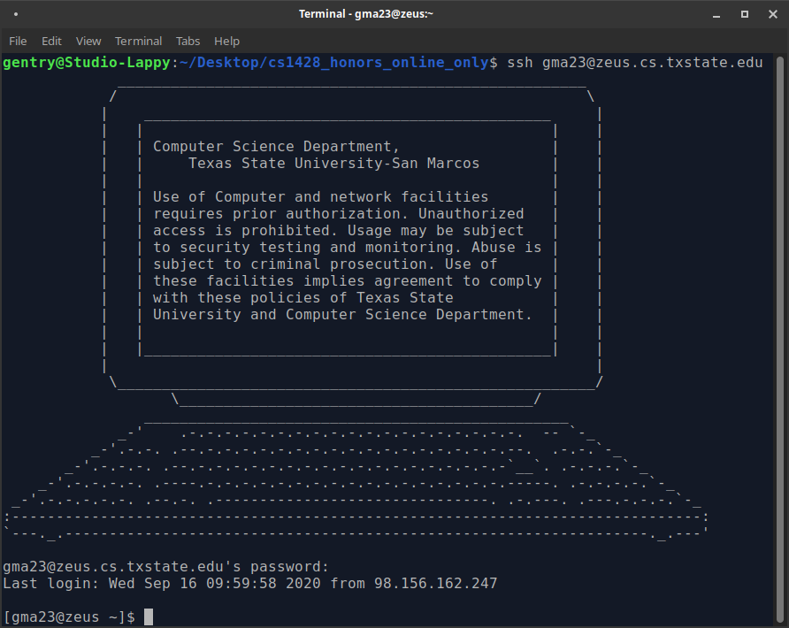
The following commands can be typed on this line to interact with the server:
Command | Description | Usage
ssh | Connects to a remote computer. You will need to enter you password (same as your email) to connect. | ssh <user_id>@zeus.cs.txstate.edu  or  ssh <user_id>@eros.cs.txstate.edu
cd | Change Directory (which is the same as a folder). ".." is the parent of the current directory | cd ..  cd <folder name>
mkdir | Make Directory. Creates a new directory. | mkdir <folder name>
pwd | Print Working Directory. Prints the name of the folder that you are currently in. | pwd
ls | List. Shows all of the files that are in a directory. | ls  ls -a  ls <folder name>
man | Manual. Shows instructions to correctly use any other command. | man <comman name>
echo | Echo. Prints some text on the command line (like cout but not inside of a C++ program). | echo <some text>
mv | Move. Takes a file from one location and puts it in another. Can also be used to rename a file. | mv <current name> <new name>
rm | Remove. Deletes a file. | rm <file name>
rmdir | Remove Directory. Deletes an empty folder. The -r option can be used to also delete the contents of the folder. -rf deletes everything without asking first. | rmdir <folder name>  rmdir -r <folder name>
nano | Launches a simple text editor called Nano. | nano  nano <file name>
g++ | G Plus Plus. Runs the GCC compiler on a C++ file. | g++ <C++ file>  g++ -o <program name> <C++ file name>
logout | Log out. Disconnects from the remote computer. | logout

Commands are interpreted by the computer one at a time (unlike a compiled program where every line of a program is translated to machine language at compile time). Each command listed above will do the same thing as some action in a GUI environment (so cd is the same thing as double clicking on a folder.) You can access a similar interface through the Windows command line or the Mac terminal. The same commands will work on Mac but not windows.

Whole programs can be written from the command line (in fact all of them were prior to GUI becoming common in 1984) but it takes some getting used to. Try connecting to Zeus or Eros and experimenting with some commands before attempting Lab 6.
If you would like to learn more about the Linux shell (which means the same thing as console) try some of these sources:
- https://www.geeksforgeeks.org/basic-shell-commands-in-linux/
- https://www.geeksforgeeks.org/introduction-linux-shell-shell-scripting/
- https://www.learnenough.com/command-line-tutorial/basics

