Meeting Notes
We agreed on three things.
- First action
- Second action
Owner
Ana
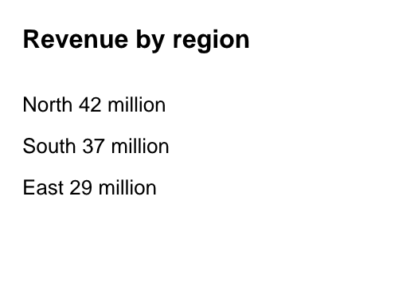

Decided on Monday.

