**FOUNDERSHARE (AKA PMP) - AUTHENTICATION AND SOCIAL MEDIA INTEGRATION ENHANCEMENT - 2**

**Verification Document**

Revision History

|  |  |  |
| --- | --- | --- |
| **Author** | **Revision Number** | **Date** |
| TCSASSEMBLER | 1.0 | 12.17.2015 |
|  |  |  |

1. Organization of Submission 3

2. Application Setup 3

3. Configurations 3

4. Deployment Instructions 7

5. Verification 8

5.1. PMP-247 8

5.2. PMP-237 8

5.3. PMP-202 9

6. Resource Contact List 9

# Organization of Submission

|  |  |
| --- | --- |
| src/ | Folder containing updated Source Code |
| docs/ | Folder with verification documents |
| docs/Verification_Document.docx | This file. |
| docs/gifs | GIF images to verify some requirements |

# Application Setup

No Change. Simply check the deployment guide inside source folder.

# Configurations

I have already configured with my credentials for oauth.io

So you don’t have to make any changes by default. If you wish to do the oAuth.io configurations follow below steps.

You will have to configure Linkedin (OAuth2), Twitter and Facebook.

Configurations are pretty straight forward and you simply have to signup for developer account in above social networks and fill up in the <https://oauth.io> dashboard

1. LinkedIn

Go to <https://www.linkedin.com/developer/apps>

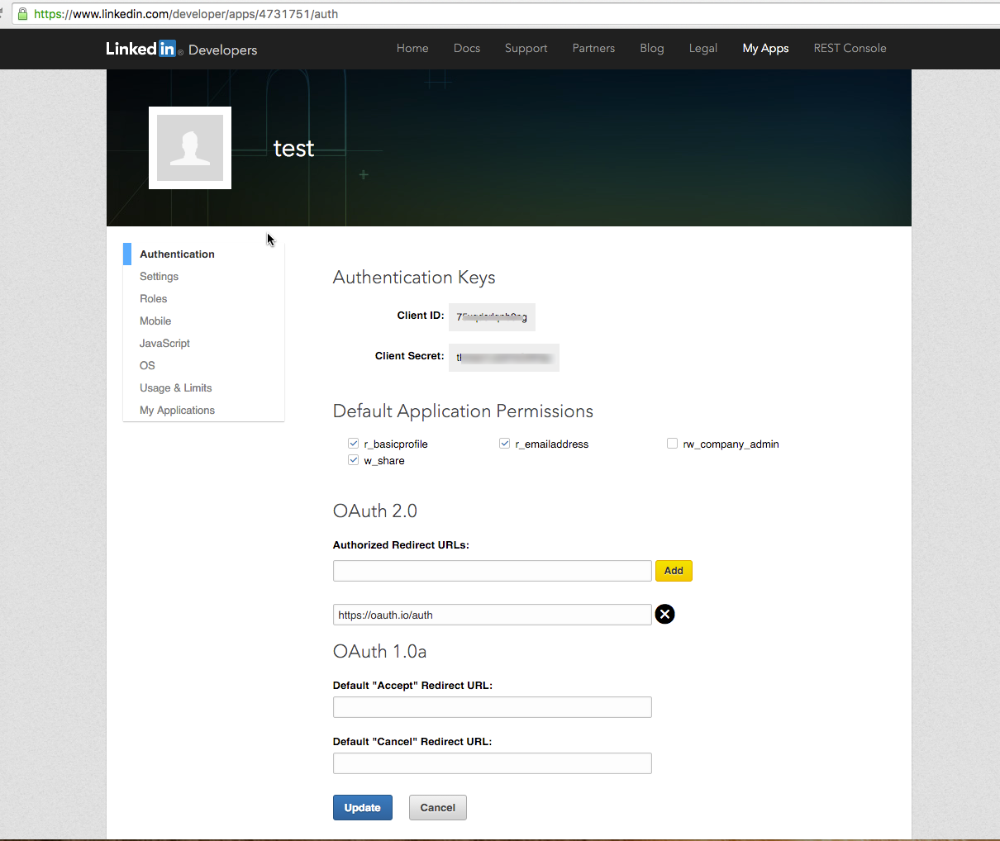

Create application

Copy the Client Id and Client Secret. Add redirect url to <https://oauth.io/auth>

Enable the permissions. Your app page should look like above screenshot

Now go to <https://oauth.io/dashboard>

Click Integrated APIs in left navigation

Click Add APIs at top right corner

Type linkedin2 in search bar and select it

In the resulting window, paste the copied keys and enable scopes as below

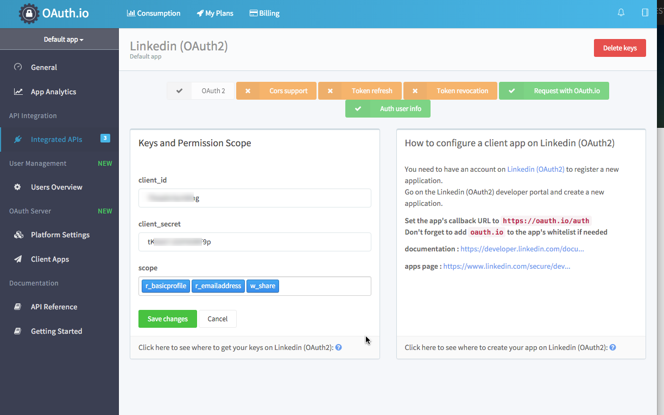

1. Twitter

Go to <https://apps.twitter.com/>

Click Create new app

Copy the keys

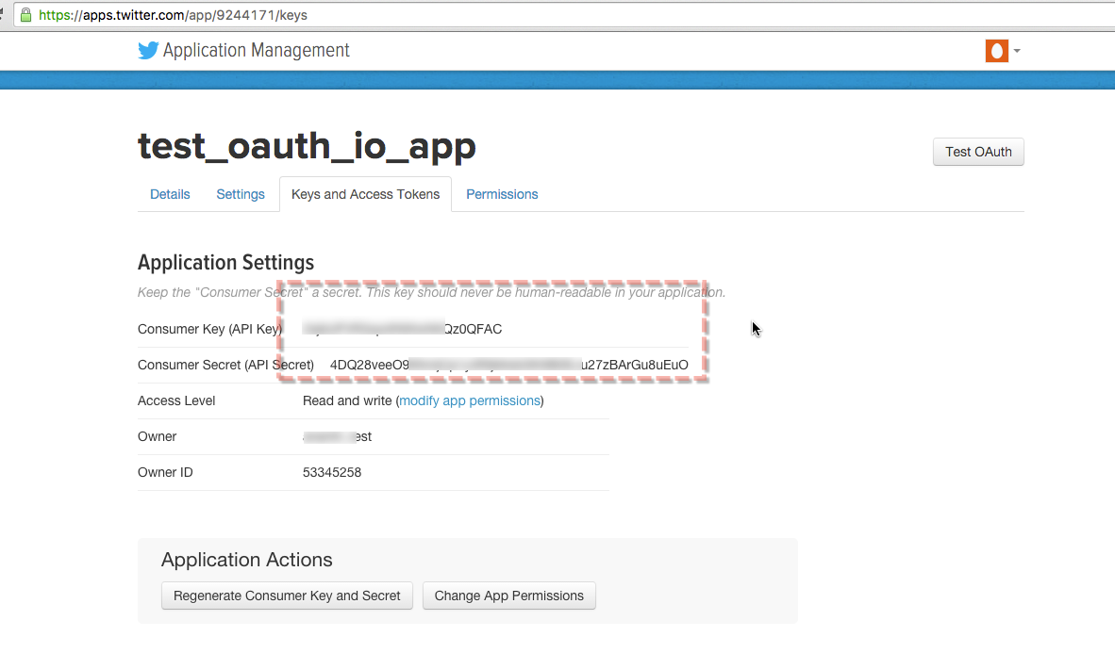

Now go to <https://oauth.io/dashboard>

Click Integrated APIs in left navigation

Click Add APIs at top right corner

Type twitter in search bar and select it

In the resulting window, paste the copied keys

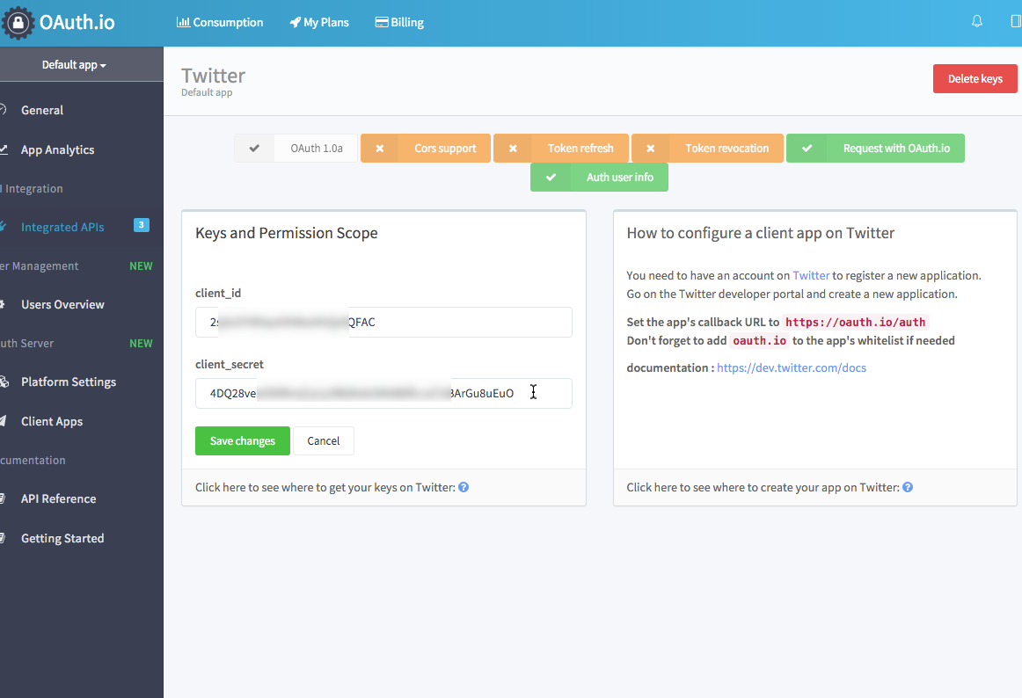

1. Facebook

Go to <https://developers.facebook.com/>

On top Right corner, hover over My Apps button and click Create New app

Select Settings in left nav of new app and copy App ID and APP Secret. Also make sure to add marked data as in image below

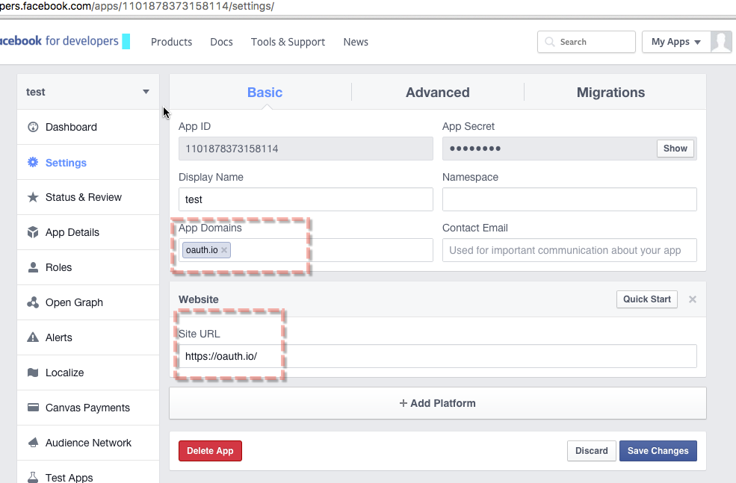

Now select Advanced tab and scroll down to see below section and add redirect url

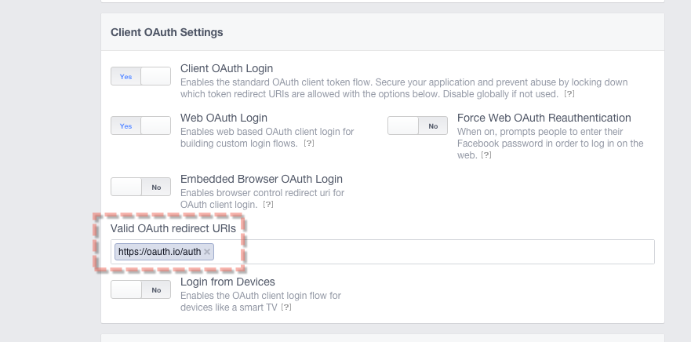

Now go to <https://oauth.io/dashboard>

Click Integrated APIs in left navigation

Click Add APIs at top right corner

Type facebook in search bar and select it

In the resulting window, paste the copied keys and select scopes as shown in below image.

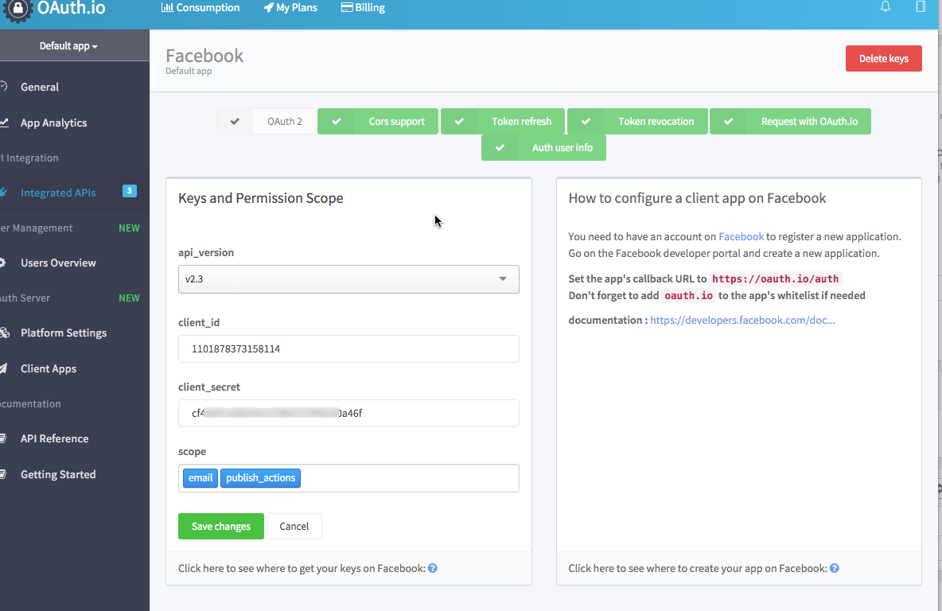

After this you will have to update OAUTH_PUBLIC_KEY in

src/mom_mobile/app/components/config.js and

src/mom_frontend/app/js/config.js

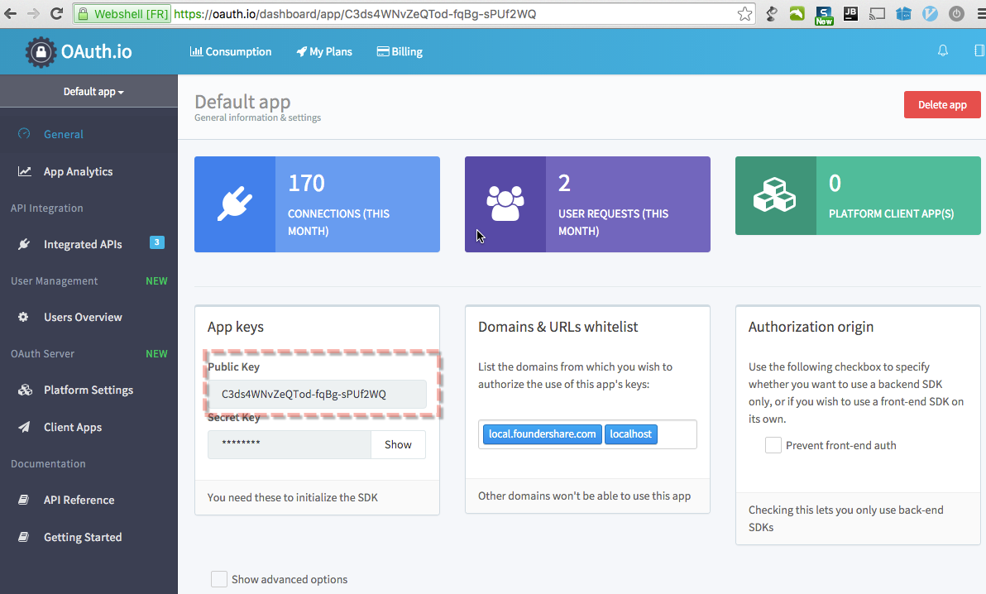

Also update SHARE_URL in src/mom_api/config/default.js to mobile app’s base url.

# Deployment Instructions

No Change. Simply check the deployment guide inside source folder.

# Verification

# PMP-247

**Requirement**: when sharing from Founder$hare Details page (mobile or desktop) user will be able to narrate his sharing (optional, standard UI from Social media side);

**Verification:** Check docs/gif/pmp-247-1.gif, docs/gif/pmp-247-1_1.gif and docs/gif/pmp-247-1_2.gif

**Note**: Google+ won’t support posting to user stream. Check <http://stackoverflow.com/questions/7570327/how-to-post-in-google-plus-wall> so I have gone with google’s native popup. With this popup we cannot prefill any content. So we are doomed to use basic functionality in Google+

For other SoMe, requirements are perfectly met.

For other scenarios, only content is updated, compare it with <https://docs.google.com/spreadsheets/d/1p0oop5WuiCgZyKH0cHFsRCBIufEQg8zVi0IUEpQbPhA/edit?ts=5637cbc5#gid=0>

# PMP-237

1. **Schema update and Signup as business also adds champion account (Requirement 1)**

**Requirement**: If a user signs up as a Business owner he/she is automatically granted a Champions account and notified about it in the popup.  
From the database perspective, "champions" schema must be added. It will contain champion's profile related info: user picture, its privacy flag, auto-sharing flag.  
**Verification**: Signup As business owner and verify your email and login to the app. You will see ‘Toggle To Champion’ flag at to nav.

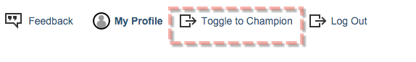

Click this link to go to your champion account.

Check src/DB_CHANGES.md for details about database changes.

To verify migration script, you should revert the src/mom_api/test_files/create-data.js and run

cd src/mom_api && node test_files/create-data.js

node test_files/insert-data.js

node migrate/migrate-12.15.js

1. **Signup as champion (Requirement 2)**

**Requirement:** If a user signs up as a Champion he/she is granted only a Champions account.

**Verification:** This is existing behavior. Signup as champion and verify it.

1. **Toggle Roles (Requirement 3, 4)**

**Requirement:** If a user signs up as a Champion he/she is granted only a Champions account.

**Verification:** Same as step 1

1. **Signup as Business owner (Requirement 5)**

**Requirement:** Users who have only a Champion role in signed-in mode will be able to signed up as Business owner.

**Verification:** Signin in with Champion account you created in step 2 and look for link between profile and logout

1. **Signup with champion Account (Requirement 6)**

**Requirement:** Users who have only a Champion role in signed-in mode will be able to signed up as Business owner.

**Verification:** Go to signup page and try to select Business role. You will get a link and it behaves as per requirement.

1. **Signup as business owner with existing email id (Requirement 7)**

**Requirement:** Users who have only a Champion role in signed-in mode will be able to signed up as Business owner.

**Verification:** Try to signup with email you have used to create champion account step 2 (Note that this will work only if you didn’t add any business account to that user, if you added then try to create new champion account with different email and use it to verify this requirement) and you can verify the steps as in requirement.

# PMP-202

Signup for a champion account with valid email addres.

Run

cd src/mom_api && node src/worker.js

This will send you the reminder email.

Verify the stop reminder by clicking appropriate link and run worker.js again.

# Resource Contact List

|  |  |
| --- | --- |
| **Name** | **Resource Email** |
|  |  |
|  |  |