See: /docs/user_testing.md

~$ ssh -L 5000:localhost:5000 sask-dev
Last login: Tue Jun 2 21:49:11 2026 from 192.168.122.1

[dave@sask-dev:~]$ cd Code/sask-calendar

[dave@sask-dev:~/Code/sask-calendar]$ PYTHONPATH=src .venv/bin/flask --app sask.web run
* Serving Flask app 'sask.web'
* Debug mode: off
WARNING: This is a development server. Do not use it in a production deployment. Use a production WSGI server instead.
* Running on http://127.0.0.1:5000
Press CTRL+C to quit

127.0.0.1 - - [02/Jun/2026 21:54:08] "GET / HTTP/1.1" 200 -
127.0.0.1 - - [02/Jun/2026 21:54:08] "GET /favicon.ico HTTP/1.1" 404 -
127.0.0.1 - - [02/Jun/2026 21:55:57] "GET /?pulse=71642553600 HTTP/1.1" 200 -
127.0.0.1 - - [02/Jun/2026 21:58:50] "GET /?pulse=0 HTTP/1.1" 200 -
127.0.0.1 - - [02/Jun/2026 22:02:00] "GET /?pulse=43200 HTTP/1.1" 200 -
127.0.0.1 - - [02/Jun/2026 22:03:25] "GET /?pulse=43200.7 HTTP/1.1" 200 -

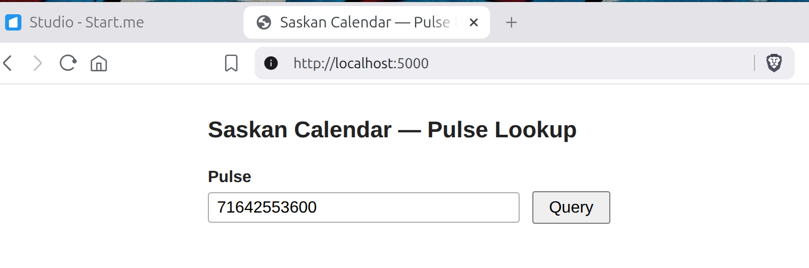

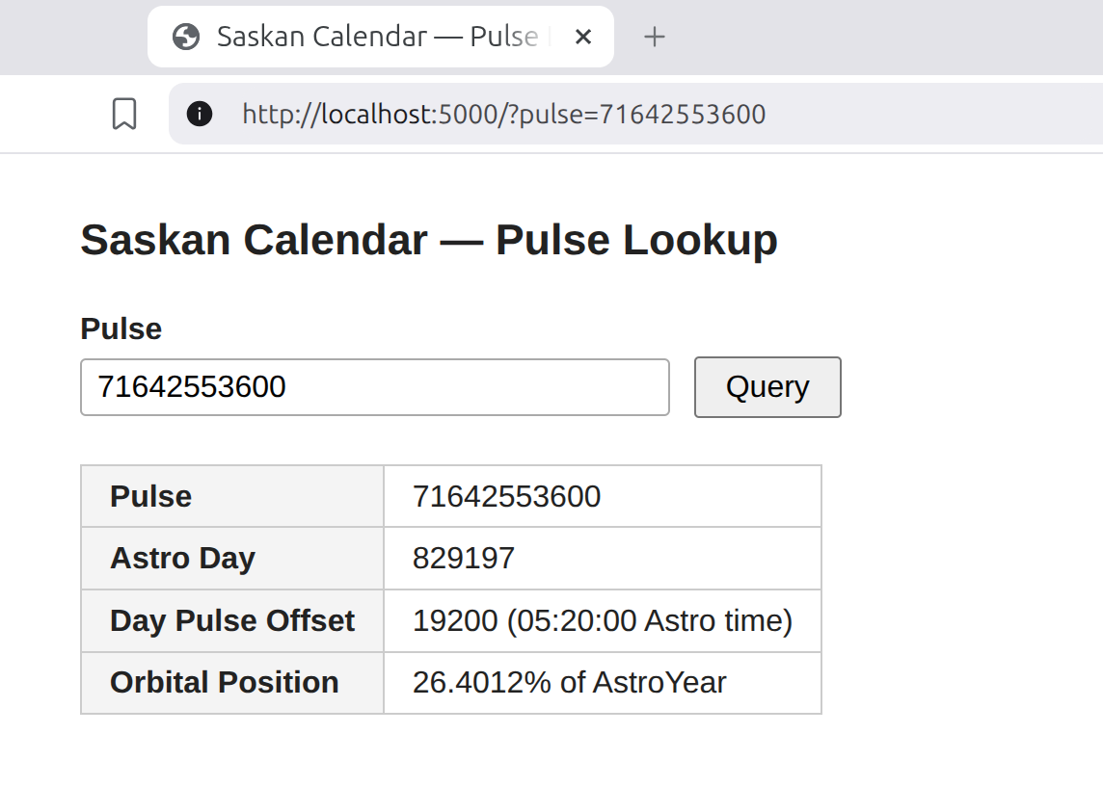
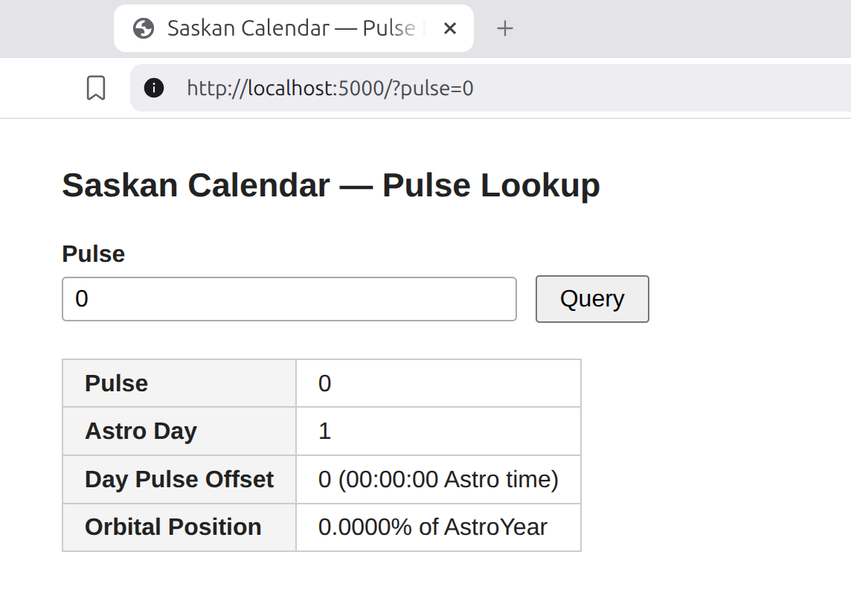

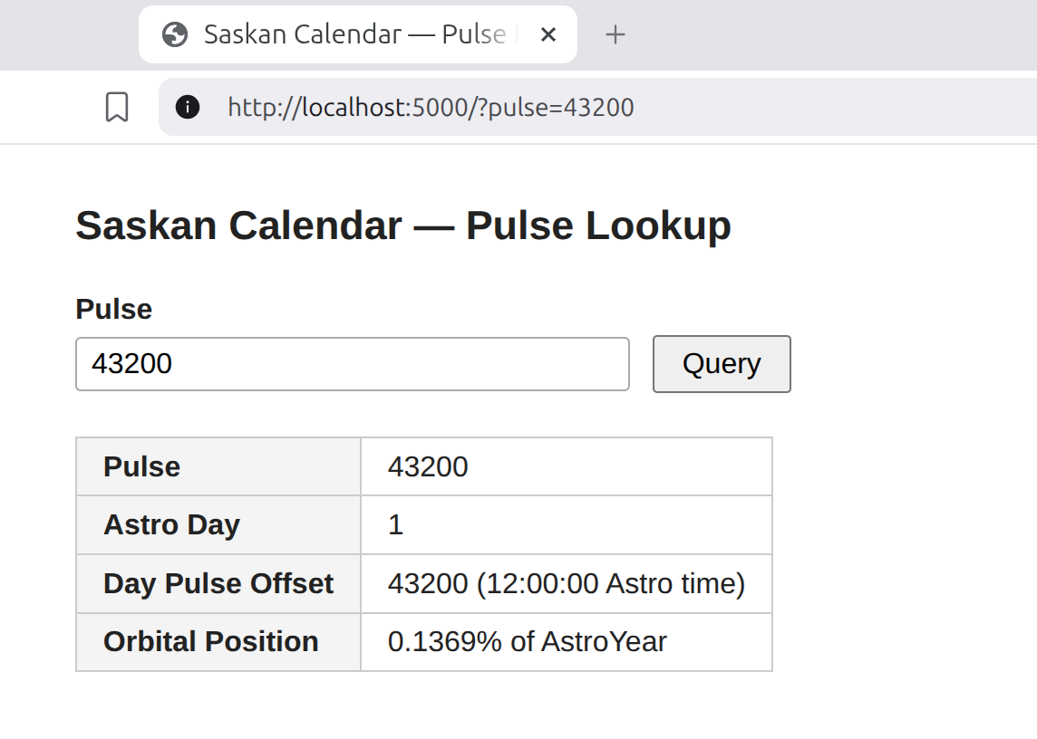
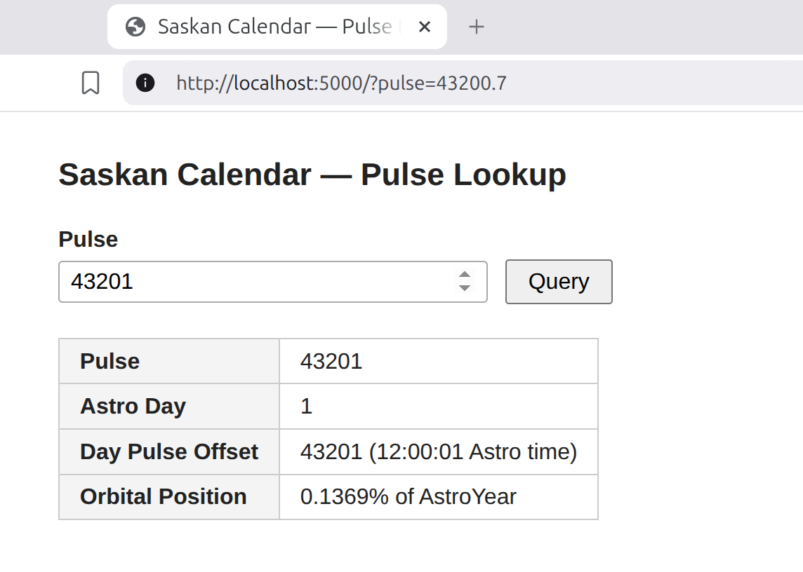

Note: Input field will not accept string input like “abc”. (satsifactory – better than an error msg)

Source code review shows no JavaScript:

<!doctype html>
<html lang="en">
<head>
<meta charset="utf-8">
<meta name="viewport" content="width=device-width, initial-scale=1">
<title>Saskan Calendar — Pulse Lookup</title>
<style>
body {
font-family: sans-serif;
max-width: 720px;
margin: 2rem auto;
padding: 0 1rem;
color: #222;
}
h1 { font-size: 1.4rem; margin-bottom: 1.5rem; }
label { display: block; margin-bottom: .3rem; font-weight: bold; }
input[type=number] {
width: 18rem;
padding: .3rem .5rem;
font-size: 1rem;
border: 1px solid #aaa;
border-radius: 3px;
}
button {
margin-left: .5rem;
padding: .3rem .9rem;
font-size: 1rem;
cursor: pointer;
}
table { border-collapse: collapse; margin-top: 1.5rem; }
th, td { border: 1px solid #ccc; padding: .4rem .9rem; text-align: left; }
th { background: #f4f4f4; white-space: nowrap; }
.error { color: #c00; margin-top: .75rem; }
</style>
</head>
<body>

<h1>Saskan Calendar — Pulse Lookup</h1>

<form method="get" action="/">
<label for="pulse">Pulse</label>
<input type="number" id="pulse" name="pulse" step="any"
value="43201">
<button type="submit">Query</button>
</form>

<table>
<tr><th>Pulse</th> <td>43201</td></tr>
<tr><th>Astro Day</th> <td>1</td></tr>
<tr><th>Day Pulse Offset</th> <td>43201
(12:00:01 Astro time)</td></tr>
<tr><th>Orbital Position</th> <td>0.1369% of AstroYear</td></tr>
</table>

</body>
</html>

